Supplementary Information for
Biophysical studies of cancer cells’ traverse-vessel behaviors under different pressures revealed cells’ motion state transition
Xiao Li^{1,2}, Jialin Shi¹, Ziqing Gao³, Jian Xu¹, Shujing Wang^{1,2}, Qi Ouyang^{1,2,3}, Chunxiong Luo^{1,2,4,5}*
¹The State Key Laboratory for Artificial Microstructures and Mesoscopic Physics, School of Physics, Peking University, China.
²Center for Quantitative Biology, Academy for Advanced Interdisciplinary Studies, Peking University, China.
³Peking-Tsinghua Center for Life Sciences, Peking University, Beijing, China.
⁴Wenzhou Institute University of Chinese Academy of Sciences, Wenzhou, Zhejiang, China.
⁵Oujiang Laboratory, Wenzhou, Zhejiang, China.
*To whom correspondence should be addressed: Chunxiong Luo, pkuluocx@pku.edu.cn.

Supplementary Information Text
S1 Device design and test
Fig. S1A illustrated that the microfluidic devices could capture single cells as designed and the occupied rate of trap units increases with the cell density during the period of cell loading. In order to obtain the more precise estimation, we simulated the fluid flow of the microfluidic device and the pressure drops on single cells using COMSOL (COMSOL Multiphysics) software. In Fig. S1B, as the pressure difference applied on the whole chip increases geometrically, the pressure drops exerted on single cells increase in a similar manner despite occupied rate varied from 20% to 50%. In more detail for the influence of occupied rate to the pressure drops, the three-dimensional chip model and an image of the velocity field under applied pressure difference of 50 mbar are illuminated in Fig. S1C. It’s worth noting that the pressure drops on the single cells vary little with different occupation situation of their trap units (65-85Pa for 1/3 to full occupation).

S2 Dynamic patterns under fixed pressure drops

S3 Modified Newtonian Droplet Model
Yeung and Evans have derived the Newtonian droplet model of suspended cells to simulate the dynamic behaviors of cells into the micropipette [1-2]. The cell cytoplasm is regarded as Newtonian viscous liquid and the cell cortex is modeled as a fluid layer with constant tension. The specific version of this model for micropipette aspiration experiments is described by
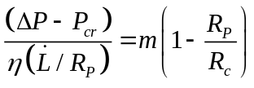 (S1)
where ∆P is the applied pressure to the cell, P_{cr} is the critical excess suction pressure, R_{P} is the radius of the micropipette, R_{c} is the radius of the cell body outside the micropipette, η is the viscosity of the cell. m is a coefficient that depends on the feature of cell structures. For most cases, m≈6. This model is used to explain the dynamic phenomenon of cells under pretty high suction pressures. It doesn’t suit our experiments well and some modifications of this model is needed to simulate cells exposed to far lower suction pressures. In our experiments, by setting R_{P}/R_{c} ≪ 1, 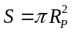, 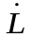 could be derived using Eq. (1)

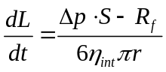 (S2)
where L is the protrusion length of the cell into the microvessel, Δp is the applied pressure difference on a single cell, S is the area of the cross-section of the microvessel, R_{f} is the resistance corresponding to the critical excess suction pressure because of the capillary effect, η_{int} is the intrinsic viscosity of the cell, r is the equivalent radius of the cross-section of the microvessel.

S3.1 Assumptions of the model
According to previous studies, we make a few assumptions to modify the Newtonian droplet model:
1) The great diversity of cancer cells leads to the high statistic dispersion of their mechanical properties inevitably. In this model, we simplify this situation and assume that the cell intrinsic viscosities η_{int} are expected to obey the normal distribution with mean μ and variance σ². This feature won’t change over time,

$η_{\text{int}}\text{\sim }\text{N}\text{(}\text{μ}\text{, }{\text{σ}}^{\text{2}}\text{)}$ (S3)
Besides, to describe potential changes of cell viscosities during our experiments, we introduce cell apparent viscosities η_{app} into the model, which could be calculated through the following equation:

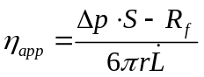 (S4)
For convenience, we use the average speed of cellular protrusion during the whole dynamic process to estimate the apparent viscosity. That is, if no other factors interfere, the equation η_{app} = η_{int} could be derived through the equation (S4).
2) During experiments, cells would attach to the material surface over time. In this model, we assume that this entire dynamic process of cell attachment, A(t), could be described using a logistic curve as previous researches illuminated [3-4]. It’s obvious that the curve profile depends on the cell type and surrounding environments shown in Fig. S3A. In our simulations, cancer cells adhesion strength gradually increases according to the following equation,
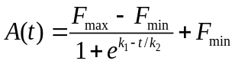 (S5)
where k₁ and k₂ could be determined using the beginning and end of cell adhesion, T_{Ad0} and T_{Ad1}, which satisfy the following equations:
$\text{A}\text{(}{\text{T}}_{\text{Ad0}}\text{) = }{\text{F}}_{\text{min}}\text{ + 0.01·(}{\text{F}}_{\text{max}}-{\text{F}}_{\text{min}}\text{)}$ (S6)
$\text{A}\text{(}{\text{T}}_{\text{Ad1}}\text{) = }{\text{F}}_{\text{min}}\text{ + 0.99·(}{\text{F}}_{\text{max}}-{\text{F}}_{\text{min}}\text{)}$ (S7)
3) Cell apparent viscosities increase with the adhesion strength A(t). When cells adhere to the material surface completely, cell apparent viscosities η_{app} should reach their maximum meanwhile and be much greater than cell intrinsic viscosities.
η_{app} ≫ η_{int} (S8)
4) Traction forces f(t) exerted by adherent cancer cells are coupled with the mechanical properties of cells and the interaction with surrounding environment. In our model, cells generate these forces in random directions after cell attachment. The value of these forces f(t) is tuned by the protrusion length of cells g(L) as Fig. S3B shown and we assume that the change per unit time of the forces is limited to 1/n of the strength of cell attachment A(t).
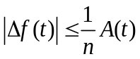 (S9)
Given all assumptions above all, Eq. (S2) could be modified as
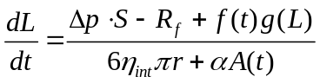 (S10)
where α is the constant coefficient between cell adhesion and extra viscosity. The apparent viscosity is still calculated through Equation (S4), and it’s obvious that η_{app} ≫ η_{int} in these conditions.

S3.2 Parameters of the model
Many previous researches in this field could be referred to determine the range of parameters in the model.

S3.3 Results of the model

S4 Distribution analysis of cell behaviors illustrated mode switch
In our experiments, the probability density distribution of apparent viscosities in the early stages seemed to follow a Gaussian distribution closely in a logarithmic scale. It inspired us to fit the probability density distribution of cell apparent viscosities using a Gaussian mixture model with two components. Specifically, we fitted the rising edge of probability density distribution and determined parameters of the left peak (i.e. the major peak), then subtracted the left peak from probability density distribution and fitted the residual of probability density distributions to find the appropriate parameters of the right peak (i.e. the minor peak). All distribution fitting was completed using MATLAB.
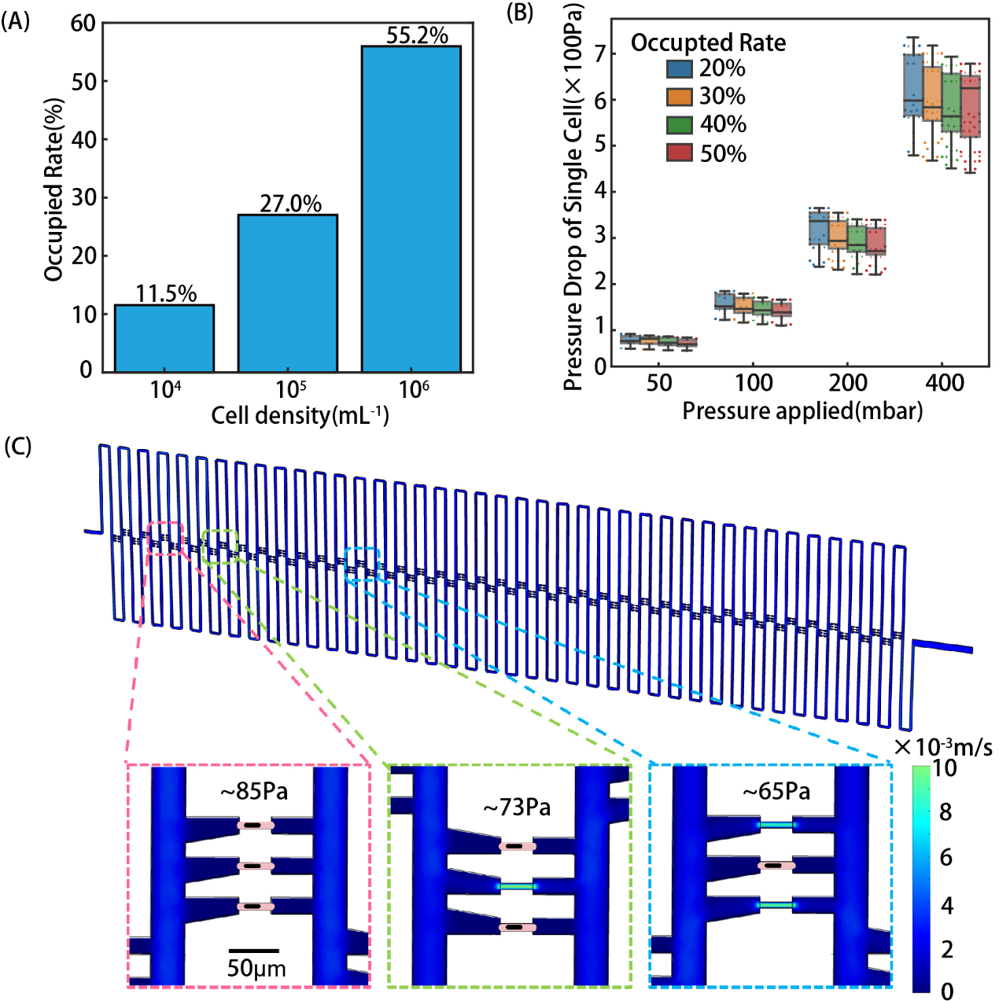
Fig. S1. (A) Percentage of cell occupied rate with increased cell densities. (B) The simulation results of pressure drops on single cells at different cell occupied rates under different applied pressure differences. (C) Simulation of the velocity field under applied pressure difference of 50mbar. The enlarged views of three trap units indicate that different amounts of captured cells could influence the pressure drop of single cells.
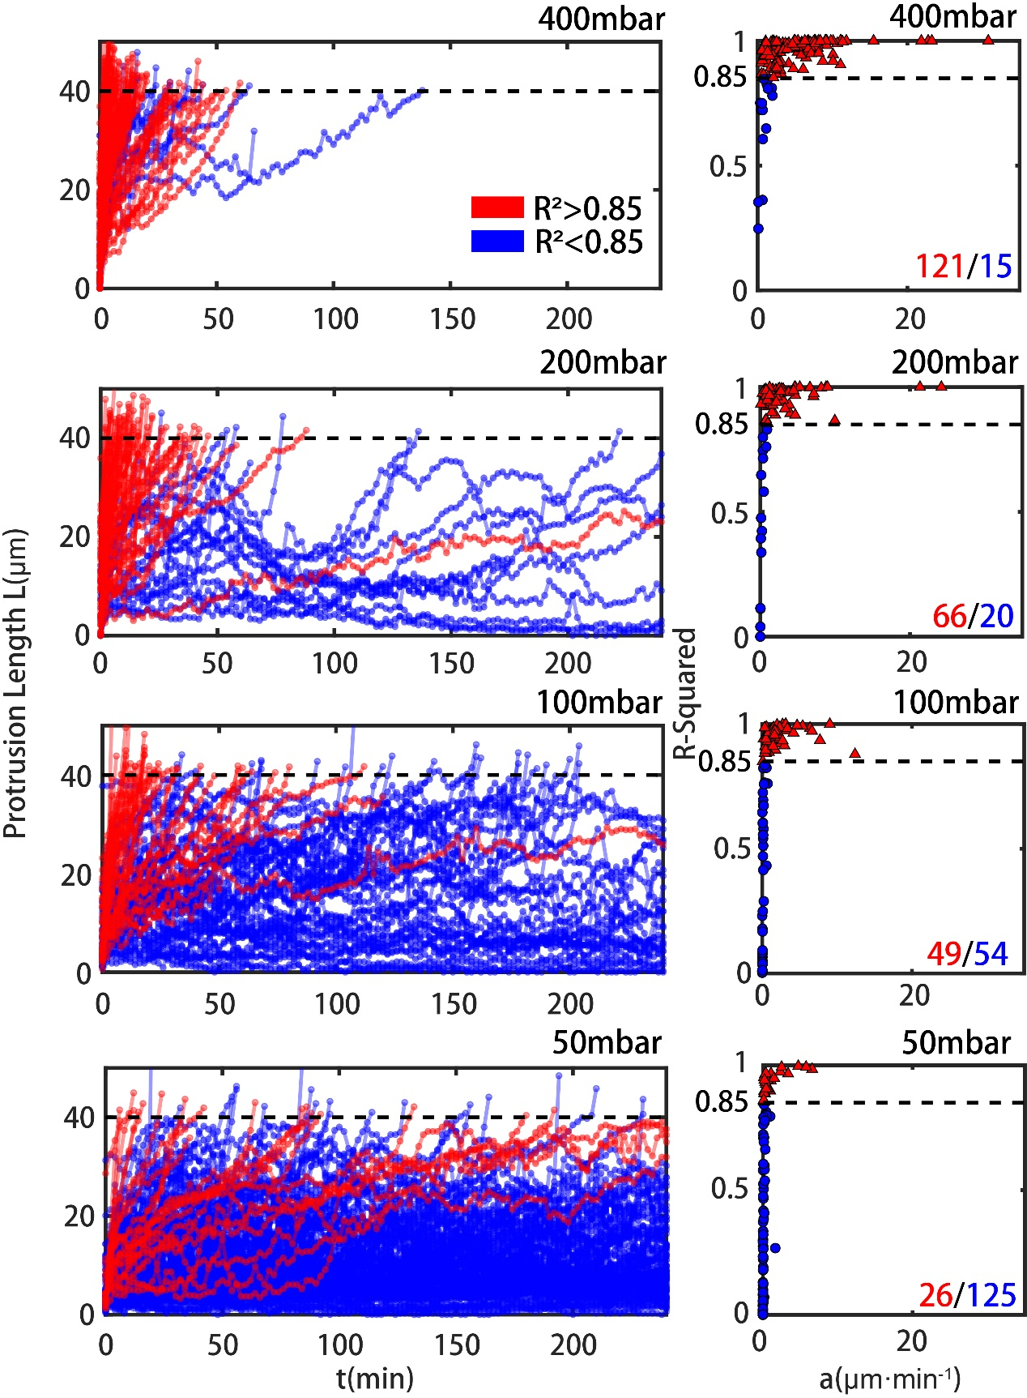
Fig. S2. Left: Dynamic behaviors of cancer cells traversing microvessels with 6 μm × 5 μm × 40 μm over time under four applied pressure differences $\text{Δ}\text{P}$ (400 mbar, 200 mbar, 100 mbar, and 50 mbar); Right: Scatter plot of R-square and fitting velocities for cells traversing microvessels with 6 μm × 5 μm × 40 μm under four applied pressure differences $\text{Δ}\text{P}$ (400 mbar, 200 mbar, 100 mbar and 50 mbar). Red lines and Blue lines indicate cells with R-Squared of linear fitting larger or smaller than 0.85.
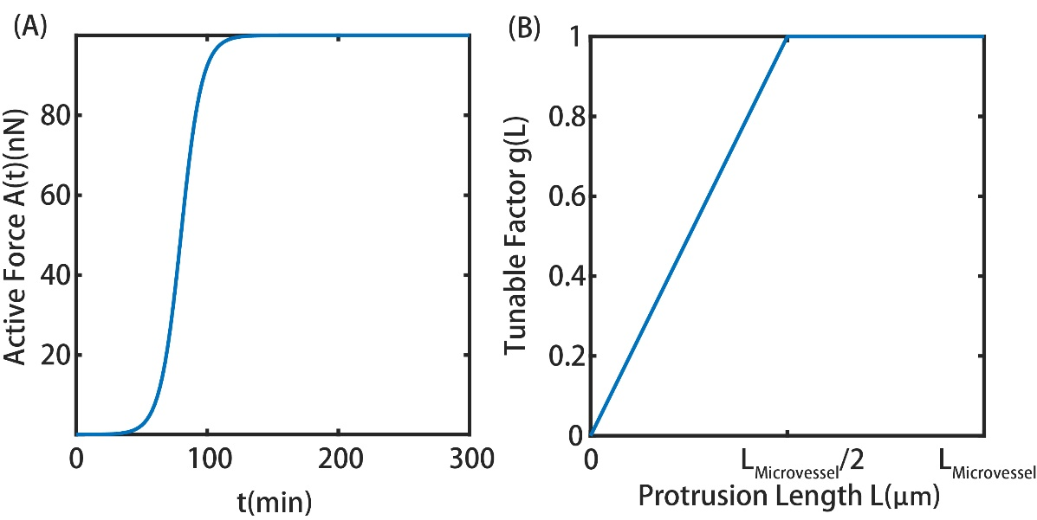
Fig.S3. (A) Active force A(t) as a function of time. (B) Tunable factor g(L) as a function of the protrusion length L.
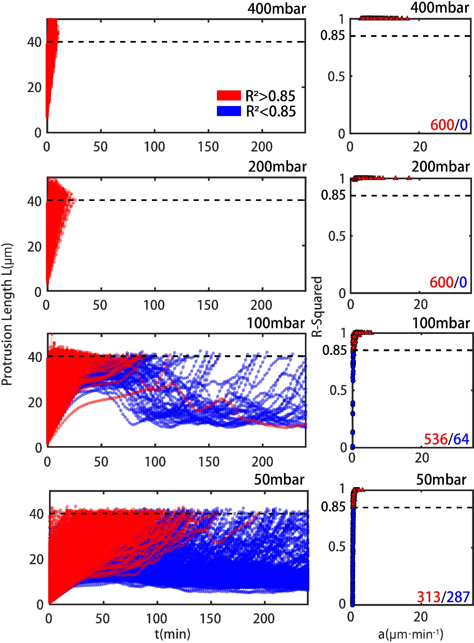
Fig. S4. The simulation of dynamic behaviors under four applied pressure differences (400mbar, 200mbar, 100mbar and 50mbar) using the microfluidic chips with the size 7.5μm×6μm×40μm of microvessels, left; Scatter plot of R-square vs. fitting velocities for cells under four applied pressure differences (400mbar, 200mbar, 100mbar and 50mbar), right.

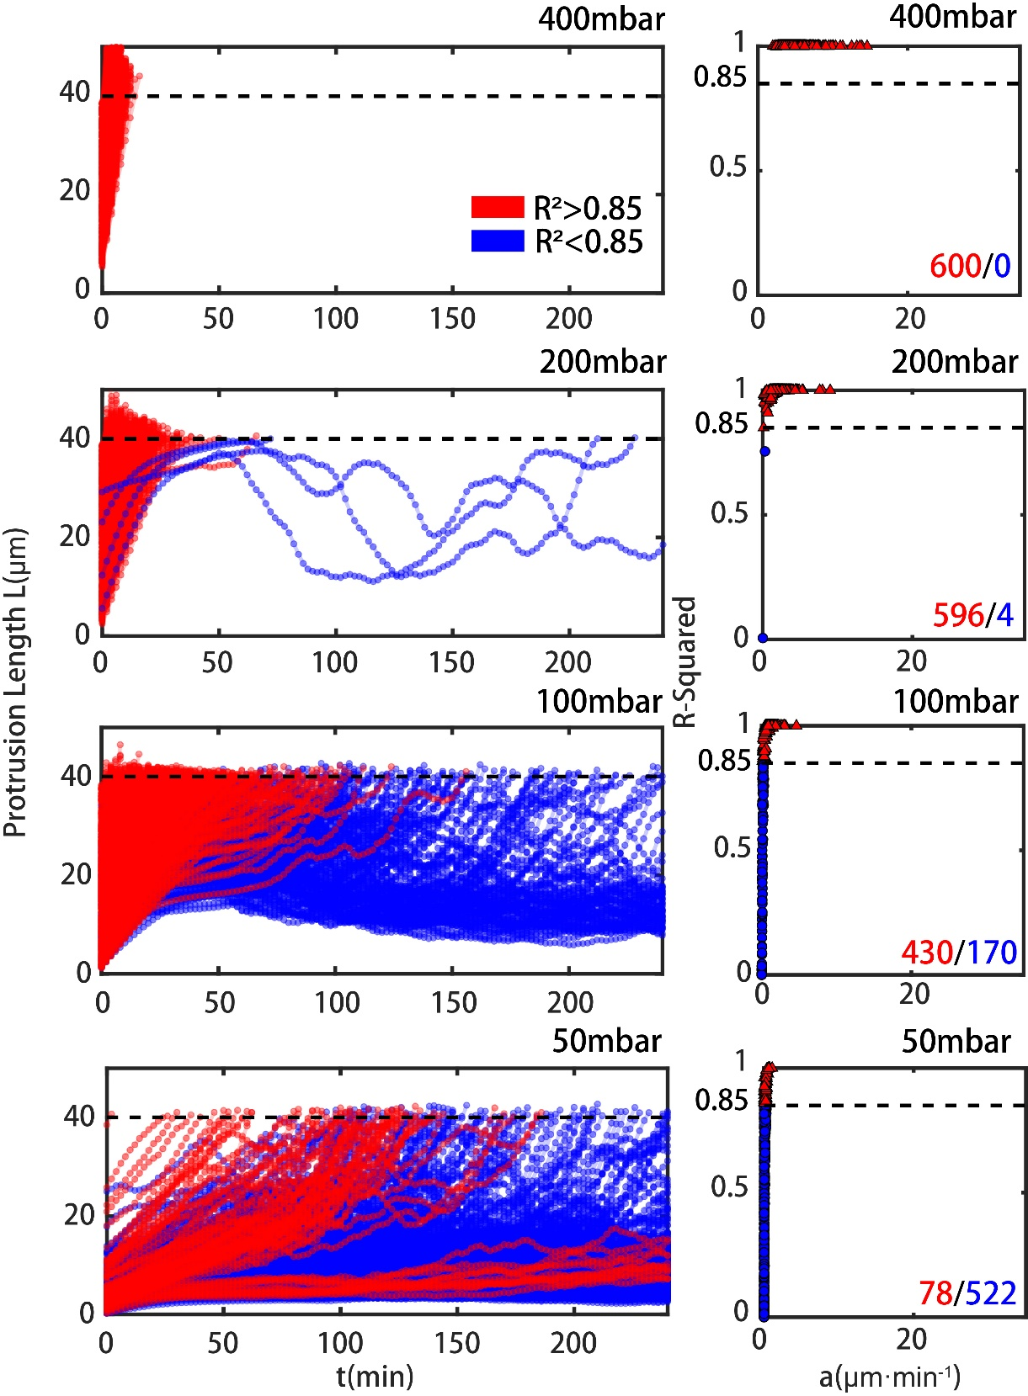
Fig. S5. The simulation of dynamic behaviors under four applied pressure differences (400mbar, 200mbar, 100mbar and 50mbar) using the microfluidic chips with the size 6μm×5μm×40μm of microvessels, left; Scatter plot of R-square vs. fitting velocities for cells under four applied pressure differences (400mbar, 200mbar, 100mbar and 50mbar), right.
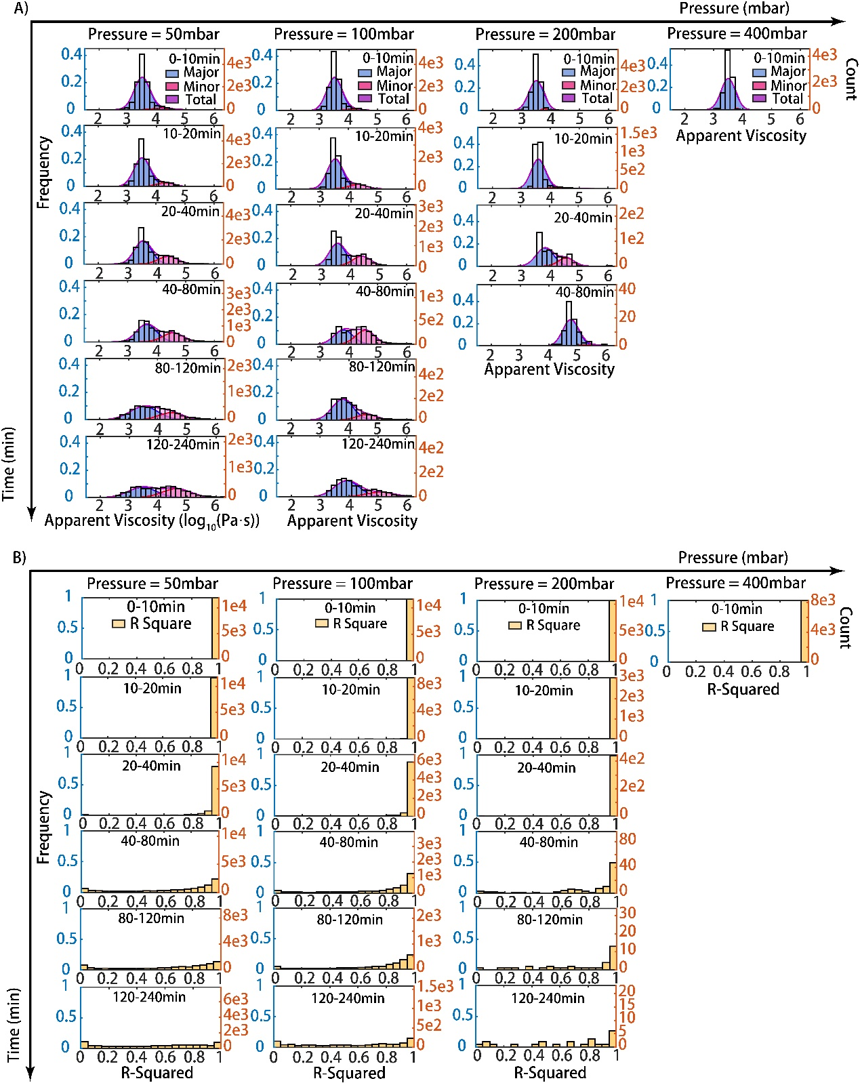
Fig. S6. Distribution analyze of cells’ behaviors illustrated transition for experiments (A) Probability density distribution of cell apparent viscosities for 50, 100, and 200 and 400 mbar at all various periods (0-10,10-20,20-40,40-80,80-120,120-240 mins). Major peak in blue, minor peak in pink and total in purple. (B) Probability density distribution of the R-Squared of linear fitting for 50, 100, and 200 and 400 mbar at various times. The left y-axis shows frequencies and the right y-axis gives counts for both (A) and (B).
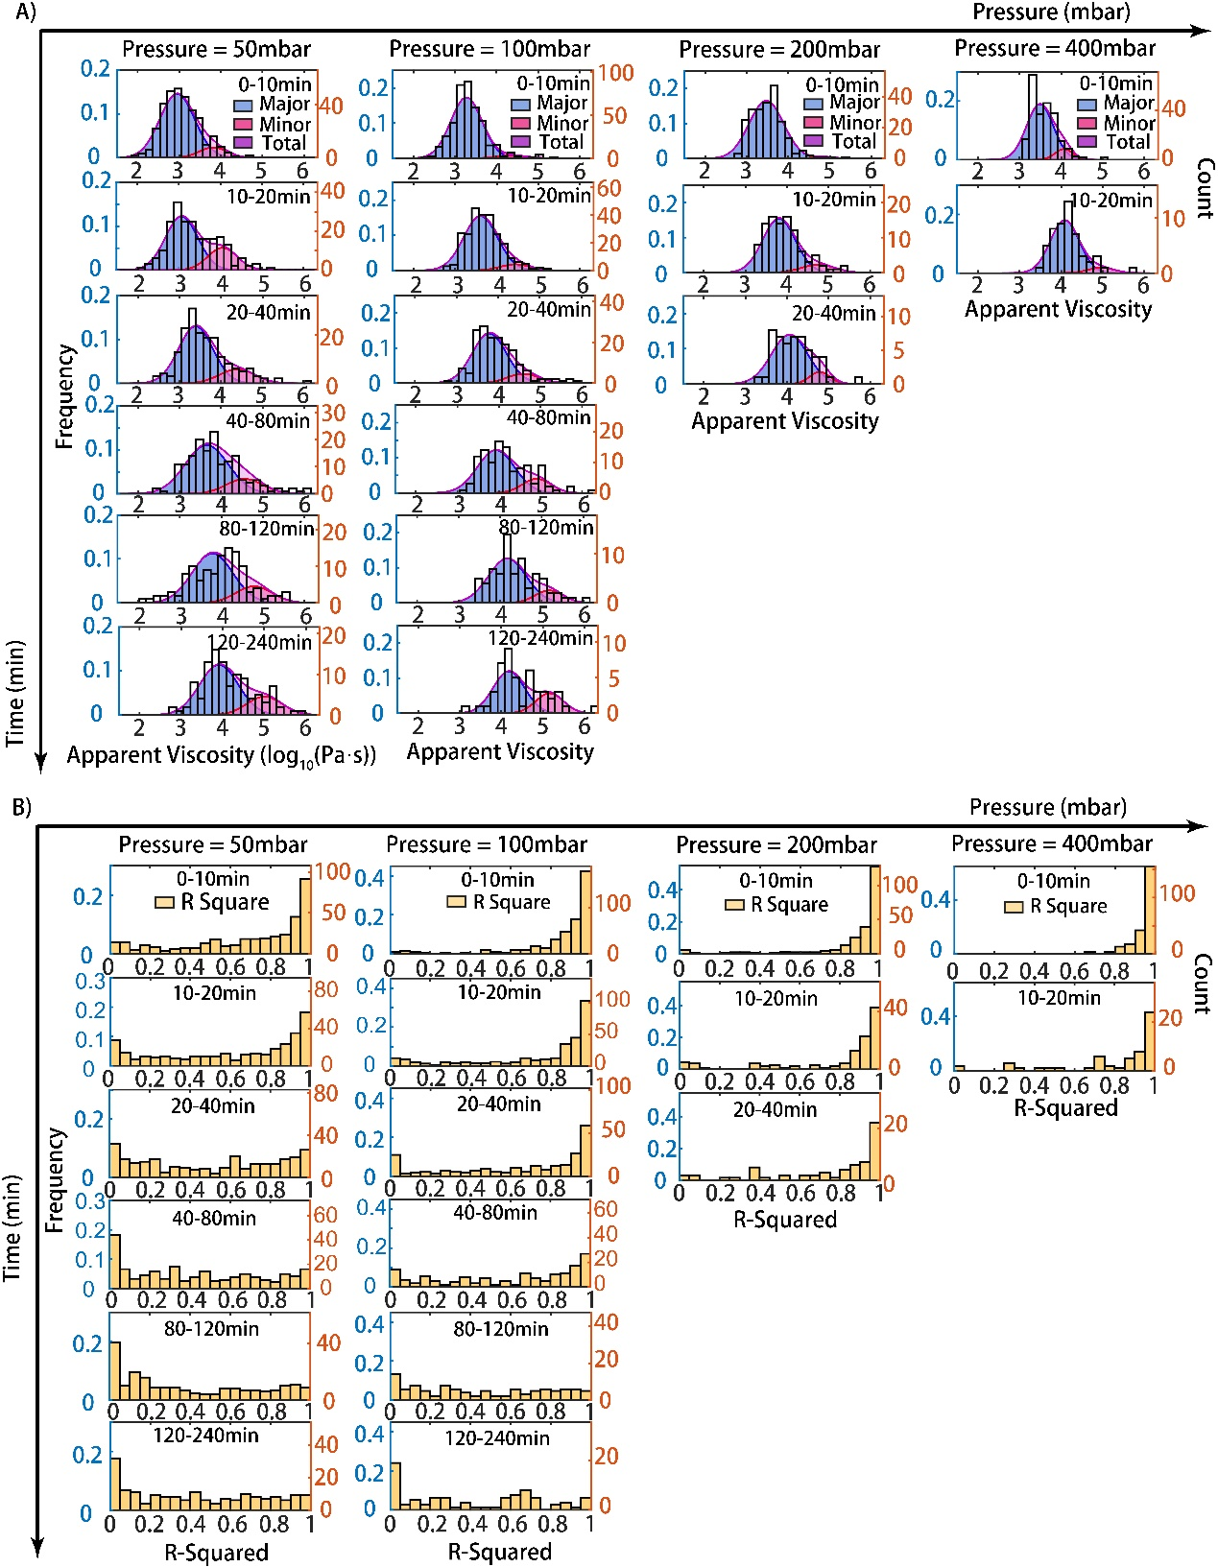
Fig. S7. Distribution analyze of cells’ behaviors illustrated the transition for simulations (A) Probability density distribution of cell apparent viscosities for 50, 100, and 200 and 400 mbar at all various periods (0-10,10-20,20-40,40-80,80-120,120-240 mins). Major peak in blue, minor peak in pink and total in purple. (B) Probability density distribution of the R-Squared of linear fitting for 50, 100, and 200 and 400 mbar at various times. The left y-axis shows frequencies and the right y-axis gives counts for both (A) and (B).
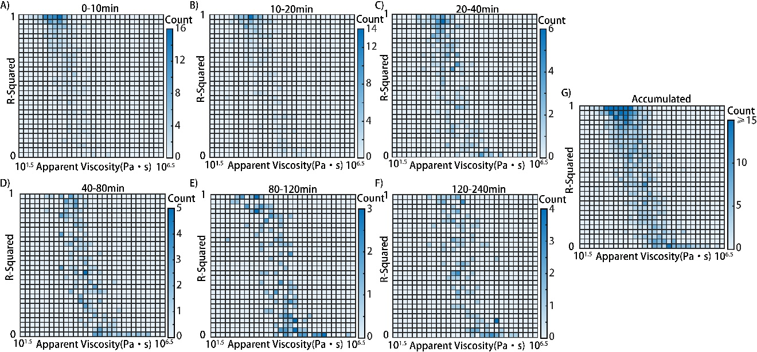
Fig. S8. (A-F) Heatmap depicting the number of cells with corresponding R-Squared and apparent viscosities under the pressure difference 50 mbar at all various periods in experiments. (G) Heatmap depicting the accumulation of the numbers of cells with corresponding R-Squared and apparent viscosities under the pressure difference 50 mbar in experiments.
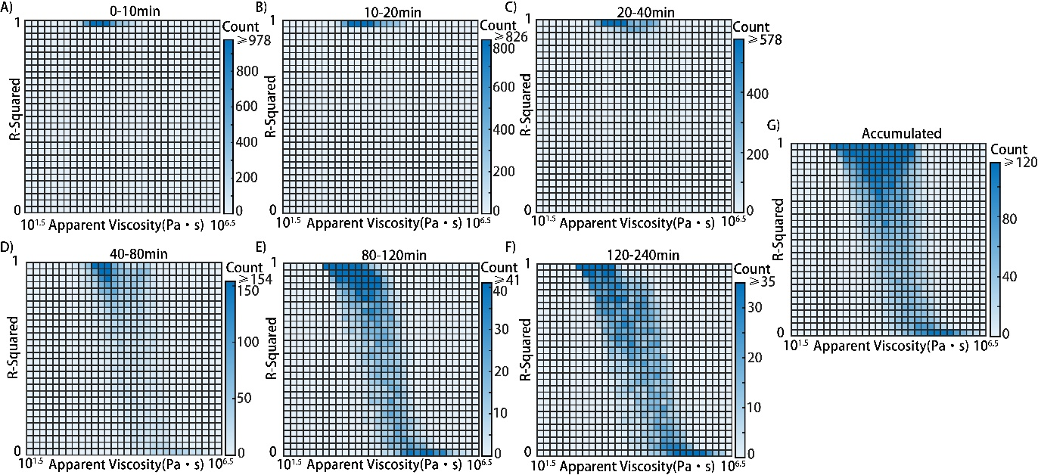
Fig. S9. (A-F) Heatmap depicting the number of cells with corresponding R-Squared and apparent viscosities under the pressure difference 50 mbar at all various periods in simulations. (G) Heatmap depicting the accumulation of the numbers of cells with corresponding R-Squared and apparent viscosities under the pressure difference 50 mbar in simulations.

Table S1. Parameters used in simulations.

Name | Value | Source
μ | 2675Pa·s | Determined by experiments.
σ | μ/3 | Obtained from previous studies [3].
F_{max} | 100nN | Obtained from previous studies [3][4]
F_{min} | 0.1nN | Obtained from previous studies [3][4]
T_{Ad0} | 40min | Obtained from previous studies [6].
T_{Ad1} | 120min | Obtained from previous studies [6].
k₁ | 10 | Derivated from (S6) and (S7) using T_{Ad0} and T_{Ad1}.
k₂ | 8 | Derivated from (S6) and (S7) using T_{Ad0} and T_{Ad1}.
n | 3 | Speculation.
R_{f} / S | 30Pa (for 7.5×6μm) and 50Pa (for 6×5μm) | Determined by experiments.
r | 3.3μm (for 7.5×6μm) and 2.7μm (for 6×5μm) | Determined by experiments.
α | 40s/μm | Speculation.
Movie S1 (separate file). Movie of one typical cell under applied pressure difference $\text{Δ}\text{P}$, 200 mbar.

Movie S2(separate file) Movie of one typical cell under applied pressure difference $\text{Δ}\text{P}$, 100 mbar.

SI References
[1] Evans, E. & Yeung, A. Apparent viscosity and cortical tension of blood granulocytes determined by micropipette aspiration. Biophysical Journal 56, 151-160 (1989).
[2] Needham, D. & Hochmuth, R. Rapid Flow of Passive Neutrophils Into a 4 μm Pipet and Measurement of Cytoplasmic Viscosity. Journal of Biomechanical Engineering 112, 269-276 (1990).
[3] Sagvolden, G., Giaever, I., Pettersen, E. & Feder, J. Cell adhesion force microscopy. Proceedings of the National Academy of Sciences 96, 471-476 (1999).
[4] Sabass, B., Gardel, M., Waterman, C. & Schwarz, U. High Resolution Traction Force Microscopy Based on Experimental and Computational Advances. Biophysical Journal 94, 207-220 (2008).
[5] Wang, K. et al. Characterization of cytoplasmic viscosity of hundreds of single tumour cells based on micropipette aspiration. Royal Society Open Science 6, 181707 (2019).
[6] Schlie, S., Gruene, M., Dittmar, H. & Chichkov, B. Dynamics of Cell Attachment: Adhesion Time and Force. Tissue Engineering Part C: Methods 18, 688-696 (2012).

