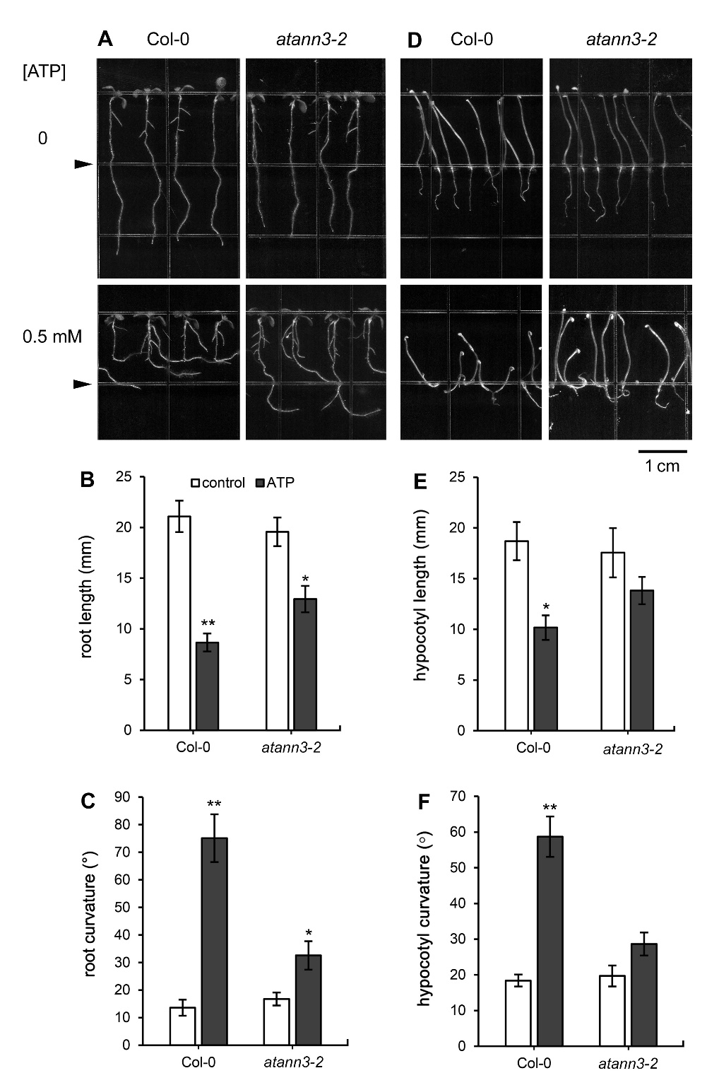
Fig. S1 AtANN3 null mutant atann3-2 seedlings respond to eATP stimulation. Figure A-C note seedlings which were growing on combined medium (the concentration of ATP in the lower compartment was 0.5 mM). Figure A shows the photograph of growing seedlings. The triangles mark the border between the two media. Figure B and C show the root length and curvature, respectively. Figure D-F note seedling which were growing on 0.5 mM ATP-containing medium in the dark for 5 days. Figure D shows the photograph of growing seedlings. Figure E and F note the hypocotyl length and curvature, respectively. The scale bar for A and D is shown in the lower-right corner. In each experiment, at least 30 seedlings were measured and data from at least three replicates were combined to obtain mean ± SD. Student’s t-test p-values: * p<0.05, ** p<0.01.

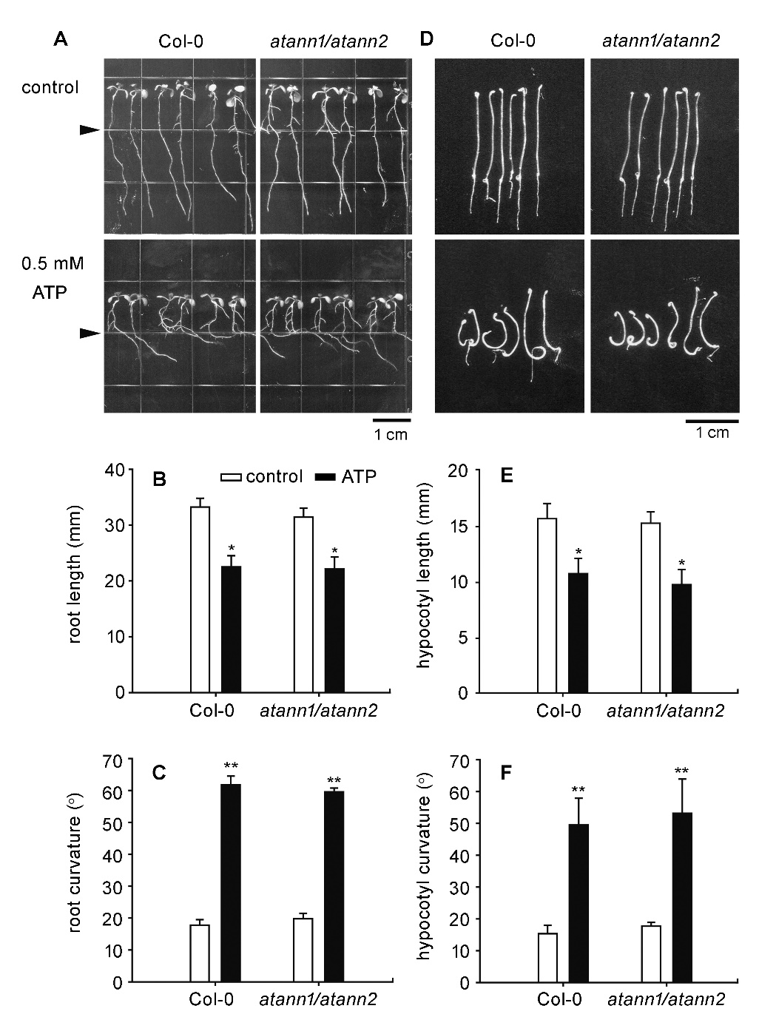
Fig. S2 AtANN1/AtANN2 double null mutant (atann1/atann2) seedlings respond to eATP stimulation. Figure A-C note seedlings which were growing on combined medium (the concentration of ATP in the lower compartment was 0.5 mM). Figure A shows the photograph of growing seedlings. The triangles mark the border between the two media. The scale bar is shown in the lower-right corner. Figure B and C show the root length and curvature, respectively. Figure D-F note seedling which were growing on 0.5 mM ATP-containing medium in the dark for 5 days. Figure D shows the photograph of growing seedlings. The scale bar is shown in the lower-right corner. Figure E and F note the hypocotyl length and curvature, respectively. In each experiment, at least 30 seedlings were measured and data from at least three replicates were combined to obtain mean ± SD. Student’s t-test p-values: * p<0.05, ** p<0.01.

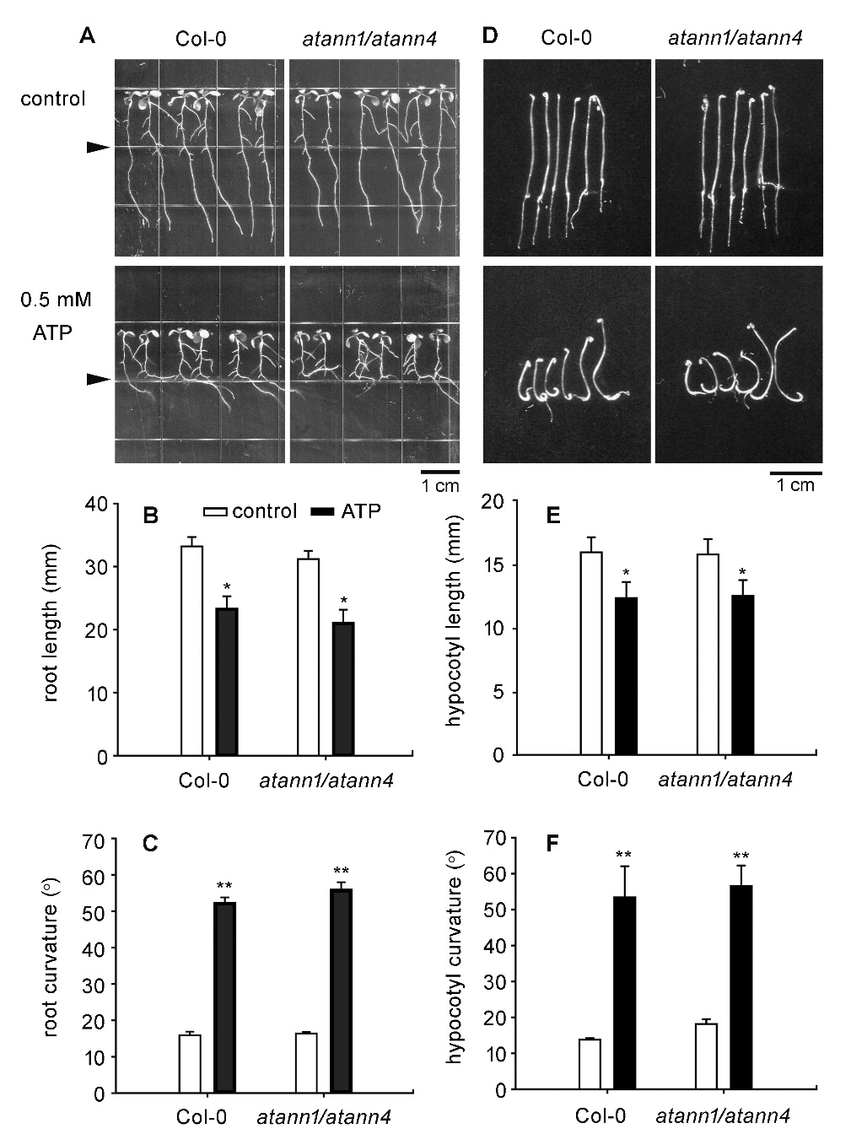
Fig. S3 AtANN1/AtANN4 double null mutant (atann1/atann4) seedlings respond to eATP stimulation. Figure A-C note seedlings which were growing on combined medium (the concentration of ATP in the lower compartment was 0.5 mM). Figure A shows the photograph of growing seedlings. The triangles mark the border between the two media. The scale bar is shown in the lower-right corner. Figure B and C show the root length and curvature, respectively. Figure D-F note seedling which were growing on 0.5 mM ATP-containing medium in the dark for 5 days. Figure D shows the photograph of growing seedlings. The scale bar is shown in the lower-right corner. Figure E and F note the hypocotyl length and curvature, respectively. In each experiment, at least 30 seedlings were measured and data from at least three replicates were combined to obtain mean ± SD. Student’s t-test p-values: * p<0.05, ** p<0.01.

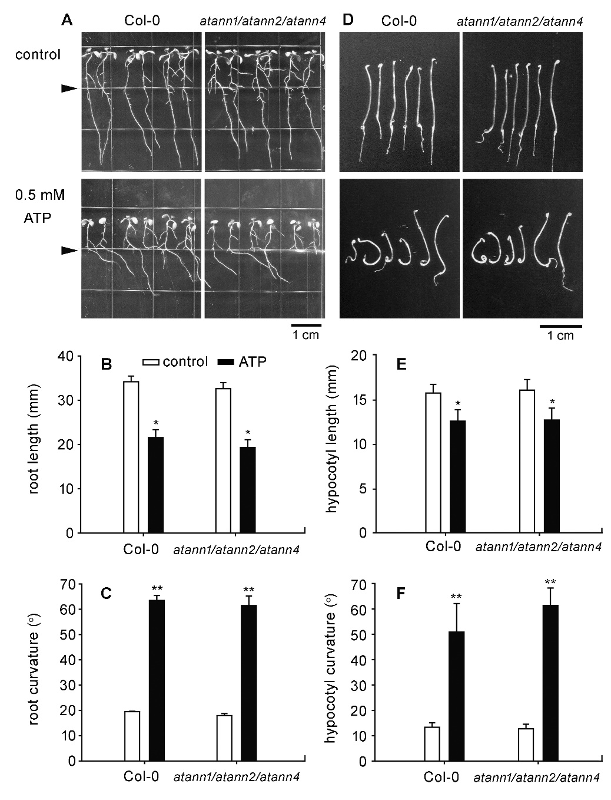
Fig. S4 AtANN1/AtANN2/AtANN4 triple null mutant (atann1/atann2/atann4) seedlings respond to eATP stimulation. Figure A-C note seedlings which were growing on combined medium (the concentration of ATP in the lower compartment was 0.5 mM). Figure A shows the photograph of growing seedlings. The triangles mark the border between the two media. The scale bar is shown in the lower-right corner. Figure B and C show the root length and curvature, respectively. Figure D-F note seedling which were growing on 0.5 mM ATP-containing medium in the dark for 5 days. Figure D shows the photograph of growing seedlings. The scale bar is shown in the lower-right corner. Figure E and F note the hypocotyl length and curvature, respectively. In each experiment, at least 30 seedlings were measured and data from at least three replicates were combined to obtain mean ± SD. Student’s t-test p-values: * p<0.05, ** p<0.01.

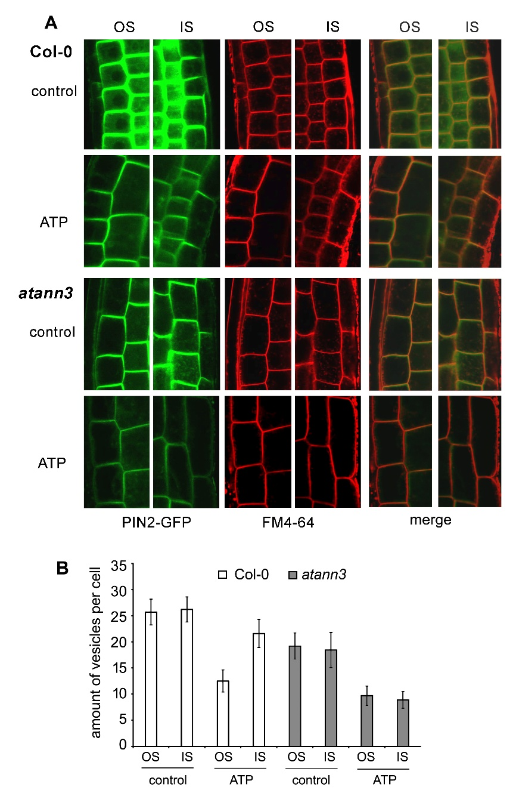
Fig. S5 AtANN3 is involved in eATP-regulated PIN2-GFP-containing vesicle abundance in root tip cells. 4-d-old PIN2-GFP transparent seedlings were transplanted onto combined medium, which containing 0.5 mM ATP in the lower compartment, and cultured for 2 more days. Then root tips were stained with FM4-64 to visualize plasma membrane and vesicles. A. Images of cells at the inner-side (IS) and outer-side (OS). B. Number of vesicles in root cells. In each experiment, at least 40 cells in 5-6 seedlings were measured and data from three replicates were combined to obtain mean ± SD.

