Supplementary information

Carbon-nitrogen bond formation on Cu electrodes during CO₂ reduction in NO₃⁻ solution

Piotr M. Krzywda^{a,b}, Ainoa Paradelo Rodríguezª, Nieck E. Benes^{b}, Bastian T. Meiª, Guido Mul^{a,*}
ª Photocatalytic Synthesis Group, Faculty of Science & Technology, University of Twente,
PO Box 217, Enschede, The Netherlands.
^{b} Membrane Science and Technology Cluster, Faculty of Science & Technology, University of Twente, PO Box 217, Enschede, The Netherlands.
* Corresponding author. E-mail address: g.mul@utwente.nl

Nature Catalysis
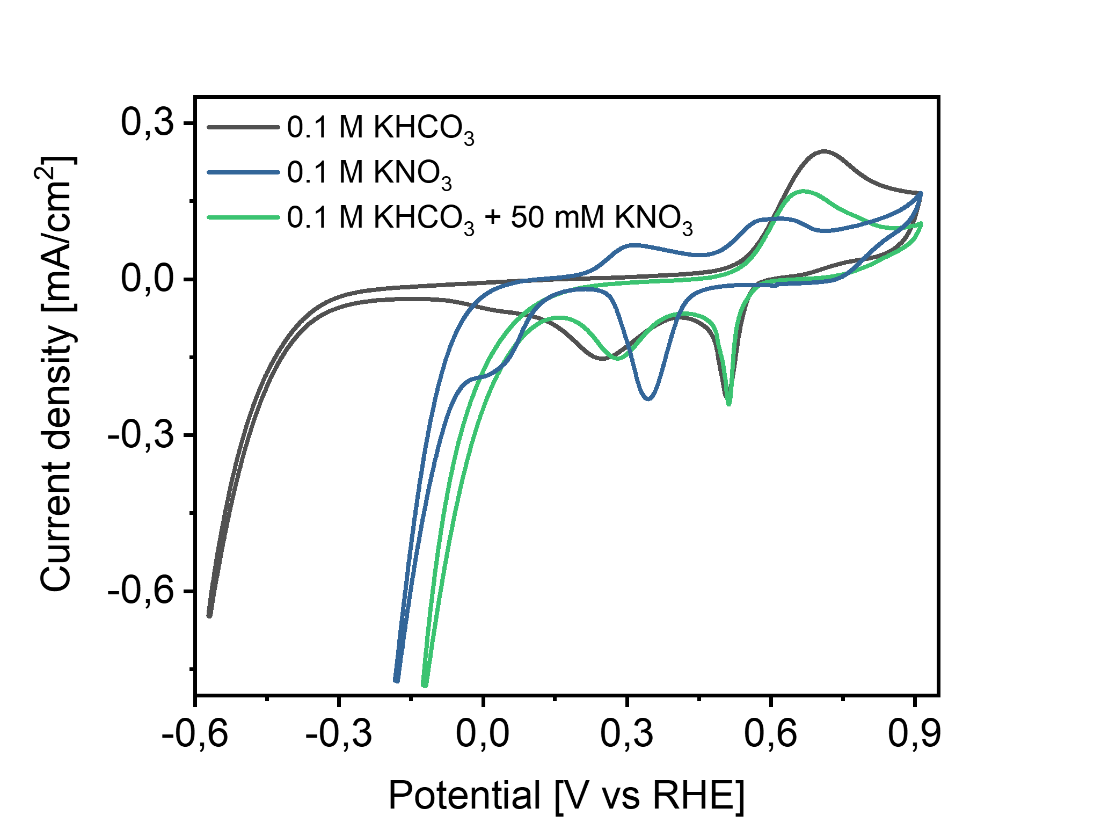
Figure S1. Cyclic voltammetry of the applied Cu electrode in different electrolytes. CVs were recorded in the EC-MS set-up.

Table S1. Standard reduction potentials of several CO₂ and NO₃⁻ electroreduction reactions.
Reaction | E⁰ vs RHE
Standard reduction potentials of NO₃⁻ ¹
${NO}_{3}^{-}+{2H}^{+}+e^{-}⇌{NO}_{2}+H_{2}O$  ${NO}_{3}^{-}+{2H}^{+}+{2e}^{-}⇌{NO}_{2}^{-}+H_{2}O$  ${NO}_{3}^{-}+{4H}^{+}+{3e}^{-}⇌NO+{2H}_{2}O$  ${2NO}_{3}^{-}+{10H}^{+}+{8e}^{-}⇌N_{2}O+{5H}_{2}O$  $2{NO}_{3}^{-}+{12H}^{+}+{10e}^{-}⇌N_{2}+{6H}_{2}O$  ${NO}_{3}^{-}+{7H}^{+}+{6e}^{-}⇌{NH}_{2}OH+{2H}_{2}O$  $2{NO}_{3}^{-}+{16H}^{+}+{14e}^{-}⇌N_{2}H_{4}+6H_{2}O$  ${NO}_{3}^{-}+{9H}^{+}+{8e}^{-}⇌{NH}_{3}+{3H}_{2}O$ | 0.77  0.94  0.96  1.12  1.25  0.73  0.82  0.88
Standard reduction potentials of CO₂ ²
${CO}_{2}+{2H}^{+}+{2e}^{-}⇌HCOOH$  ${CO}_{2}+{2H}^{+}+{2e}^{-}⇌CO+H_{2}O$  ${2CO}_{2}+{12H}^{+}+{12e}^{-}⇌C_{2}H_{4}+{4H}_{2}O$  ${CO}_{2}+{8H}^{+}+{8e}^{-}⇌{CH}_{4}+H_{2}O$ | -0.25  -0.11  0.06  0.17

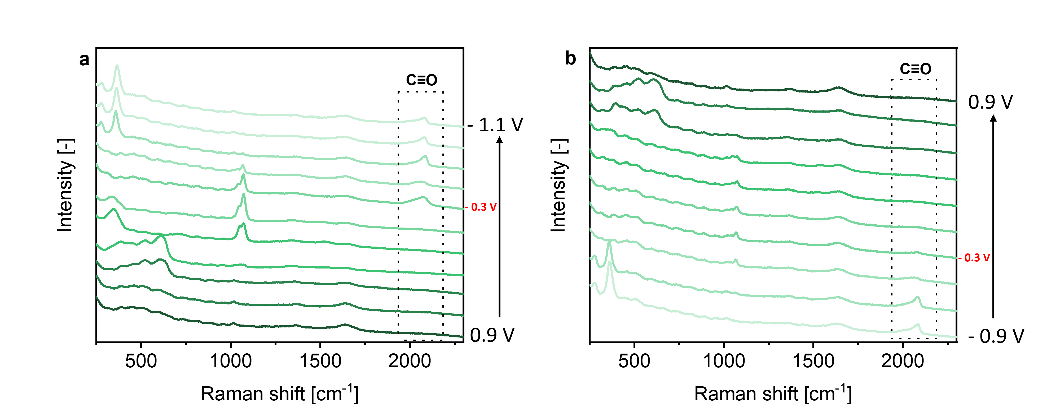
Figure S2. In situ SERS of a Cu surface in CO₂ saturated 0.1 M KHCO₃ at variable potential. Recorded during (a) a reductive scan and (b) an oxidative scan.

SERS experiments performed with Cu electrodes in CO₂ saturated 0.1 M KHCO₃ (Figure S2) show typical signals related to CO₂ reduction on a rough Cu surface in agreement with literature^{3,4}. Signals related to Cu₂O are discussed in the main article. The bands at 350 and 1540 cm⁻¹ indicate adsorbed carbonate – the asymmetric C-O stretching mode of strongly adsorbed bidentate carbonate^{3,5,6}. Other species such as carboxylate⁴ or a (CO)₂-dimer⁷ were also proposed to be responsible for those signals, but are less likely⁶. Below 0.3 V vs RHE, the C-O symmetric stretching modes of chemisorbed CO₃²⁻ can be observed at 1072 cm⁻¹ ⁴. This signal is growing with potential, disappears at -0.7 V and shows up again (low intensity) in an oxidative scan. At negative potentials, starting from -0.3 V, a broad, weak signal at ~2070 cm⁻¹ appears, which corresponds to the C≡O stretching mode of adsorbed CO on Cu^{3,4}. More sharp signals at 360 and 275 cm⁻¹, starting at -0.7 V in the reductive scan, can also be assigned to CO adsorbed on Cu (Cu-CO), and are in agreement with other studies^{3,8}. In the oxidative scan at around -0.4 V all CO signals disappear.

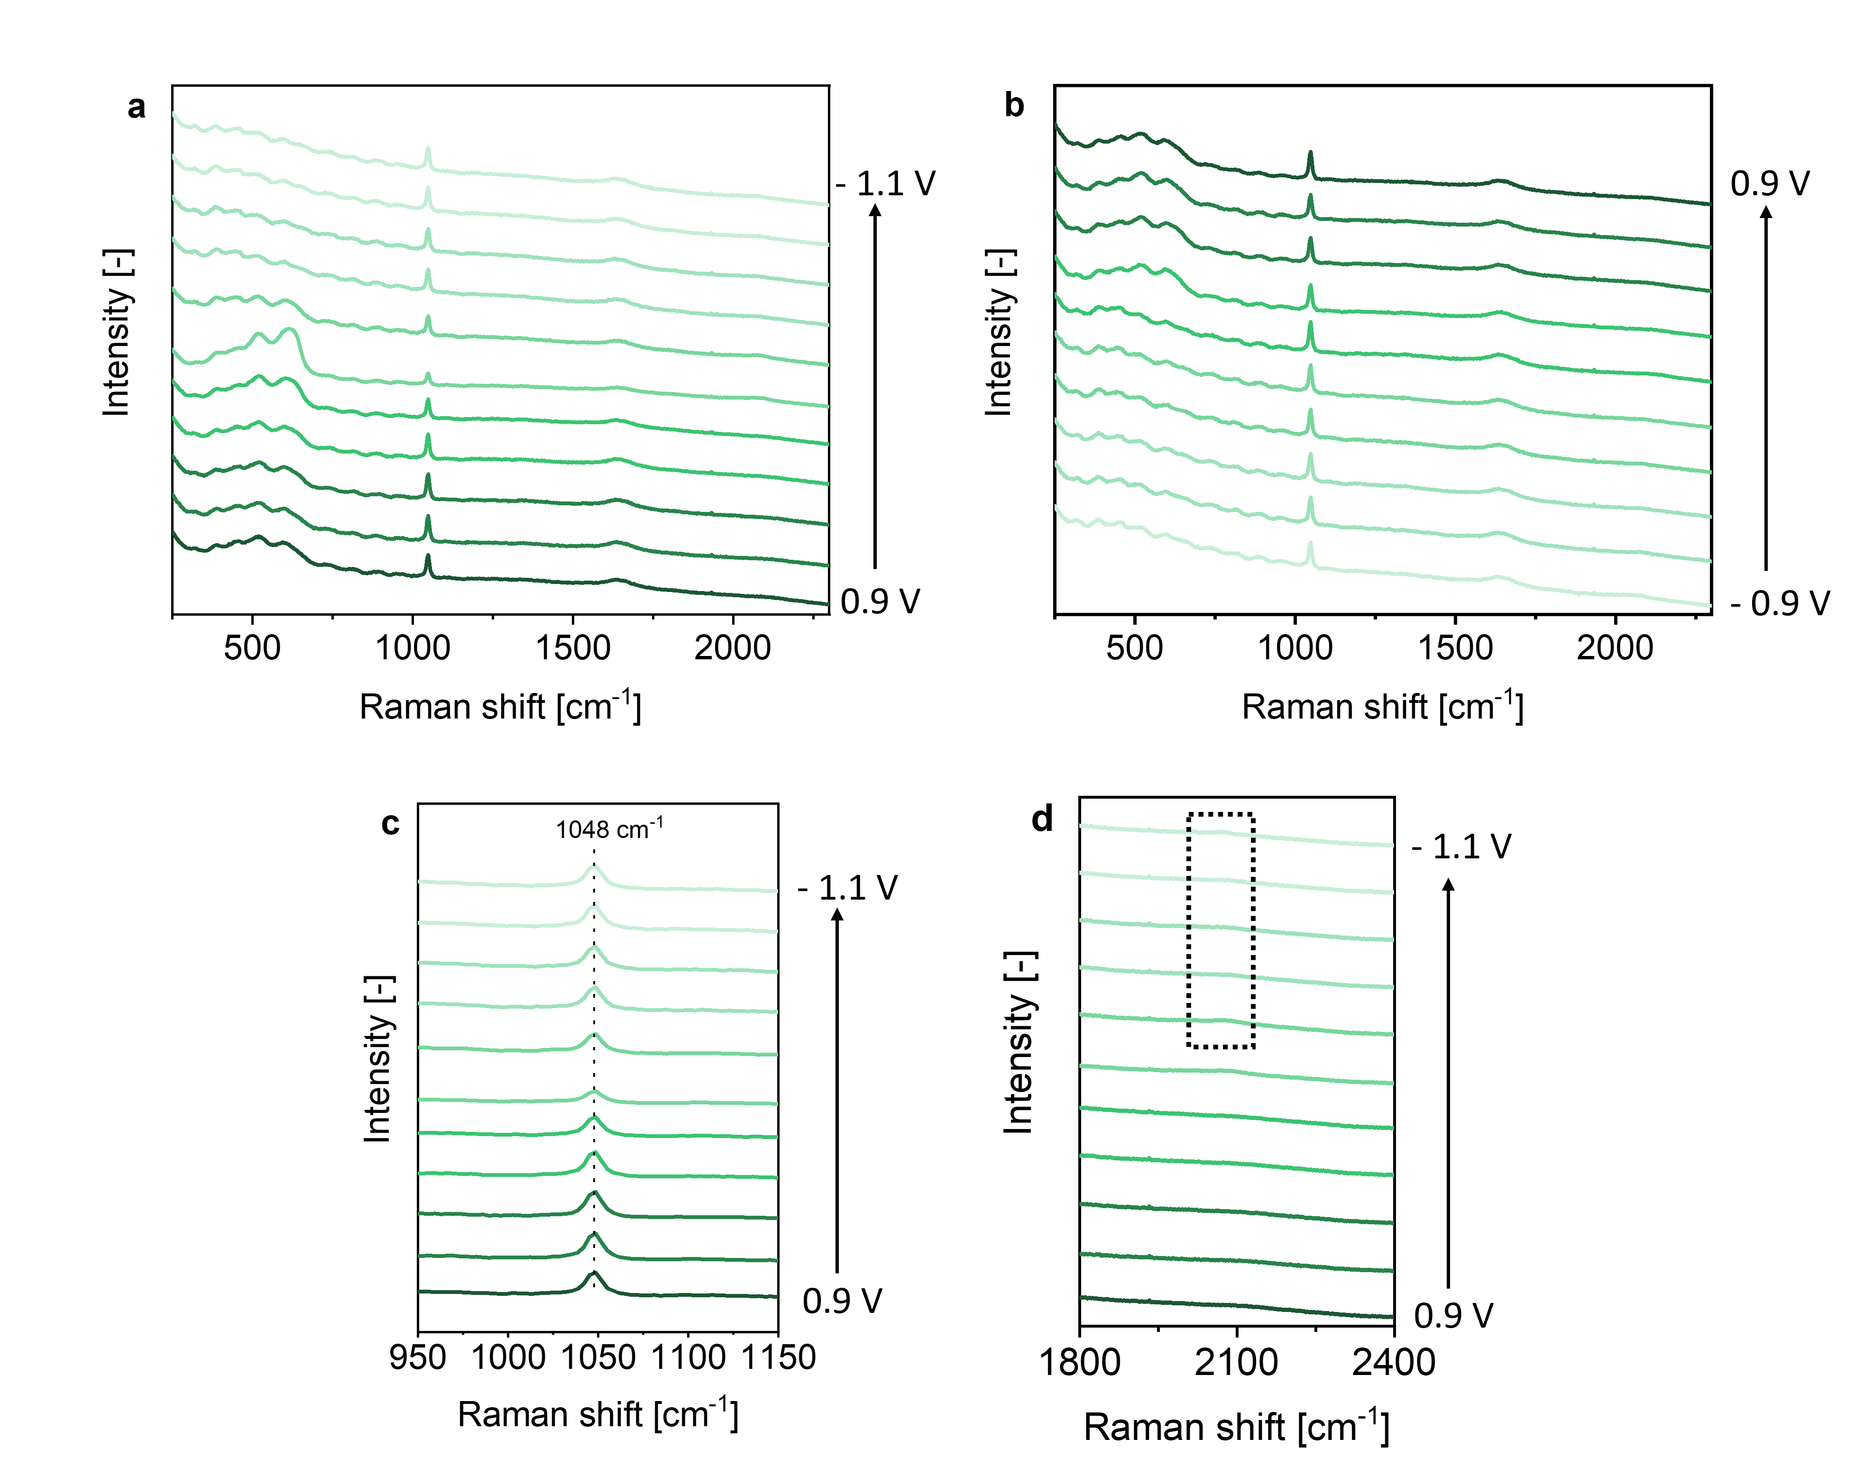
Figure S3. In situ SERS of a Cu surface in Ar saturated 0.1 M KNO₃. Recorded during (a) a reductive scan and (b) an oxidative scan of cyclic voltammetry. Magnification into (c) the 1048 cm⁻¹ peak and (d) the 2080 cm⁻¹ peak in the reductive scan.

SERS experiments performed with Cu electrodes in Ar saturated 0.1 M NO₃⁻ show the spectral fingerprint of copper oxidation and reduction and the H₂O signal at 1640 cm⁻¹ (Figure S3a and b), in agreement with previous experiments. In addition a signal at 1048 cm⁻¹ is present which is assigned to the symmetric NO₃⁻ stretch vibration ^{9,10,11}. Considering that a stark shift was not observed (Figure S3c) the signal likely originates from NO₃⁻ in solution rather than from any adsorbed form on the Cu surface¹². No reduction products of NO₃⁻ were detected by SERS. Only a very weak band at 2080 cm⁻¹ can be observed (Figure S3d). Although such band has been assigned to N₂O, a potential reduction product of NO₃⁻, such interpretation is based on conversion of NO in the gas phase in ultra-high vacuum¹³, and therefore this assignment is not very likely in the conditions applied here (note that N₂ and N₂O were not observed in EC-MS experiments).

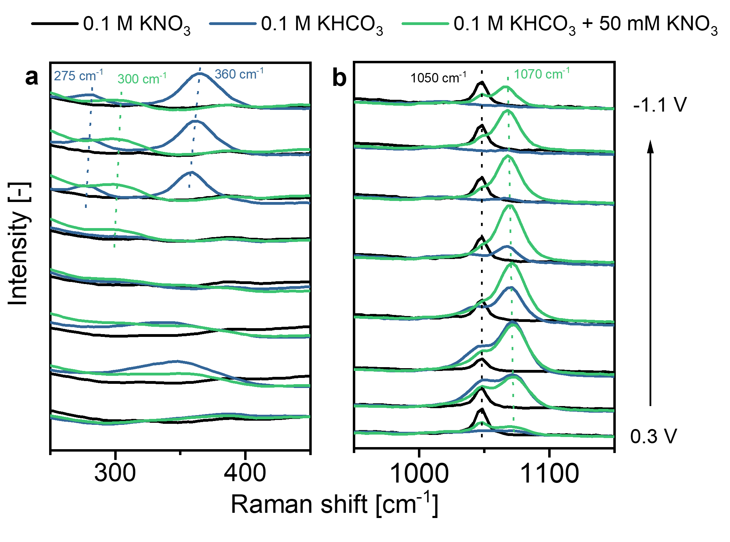
Figure S4. Comparison of selected signals in different electrolytes. In the region of
(a) 250 – 450 cm⁻¹ and (b) 950 – 1150 cm⁻¹.

In Figure S4a Cu-CO signals in 0.1 M KHCO₃ can be observed at more negative potentials, which are absent when NO₃⁻ is present. Interestingly, a signal at ~300 cm⁻¹ is observed in 0.1 M KHCO₃ with 50 mM KNO₃ electrolyte. Based on similar signals detected at 290 cm⁻¹ on Au electrodes in presence of CN⁻ ¹⁴, the position of the band suggests a Cu-CN bending mode. In Figure S4b comparison of the 1070 cm⁻¹ peak in different electrolytes is shown.
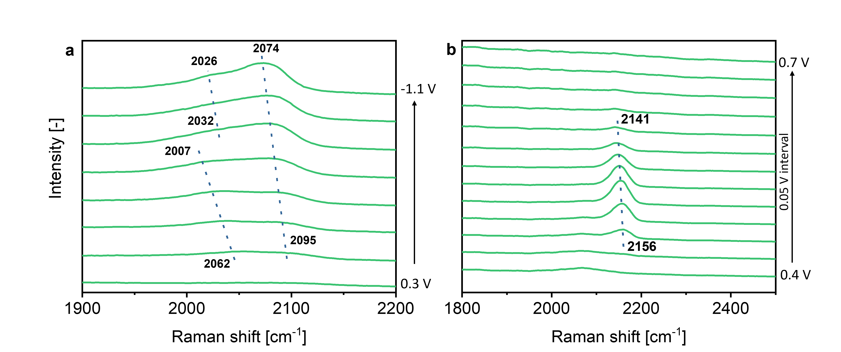
Figure S5. Stark effect of the ~2080cm⁻¹ and 2150cm⁻¹ peaks. Recorded during (a) a reductive and (b) an oxidative scan of cyclic voltammetry (magnification in relevant potential region).

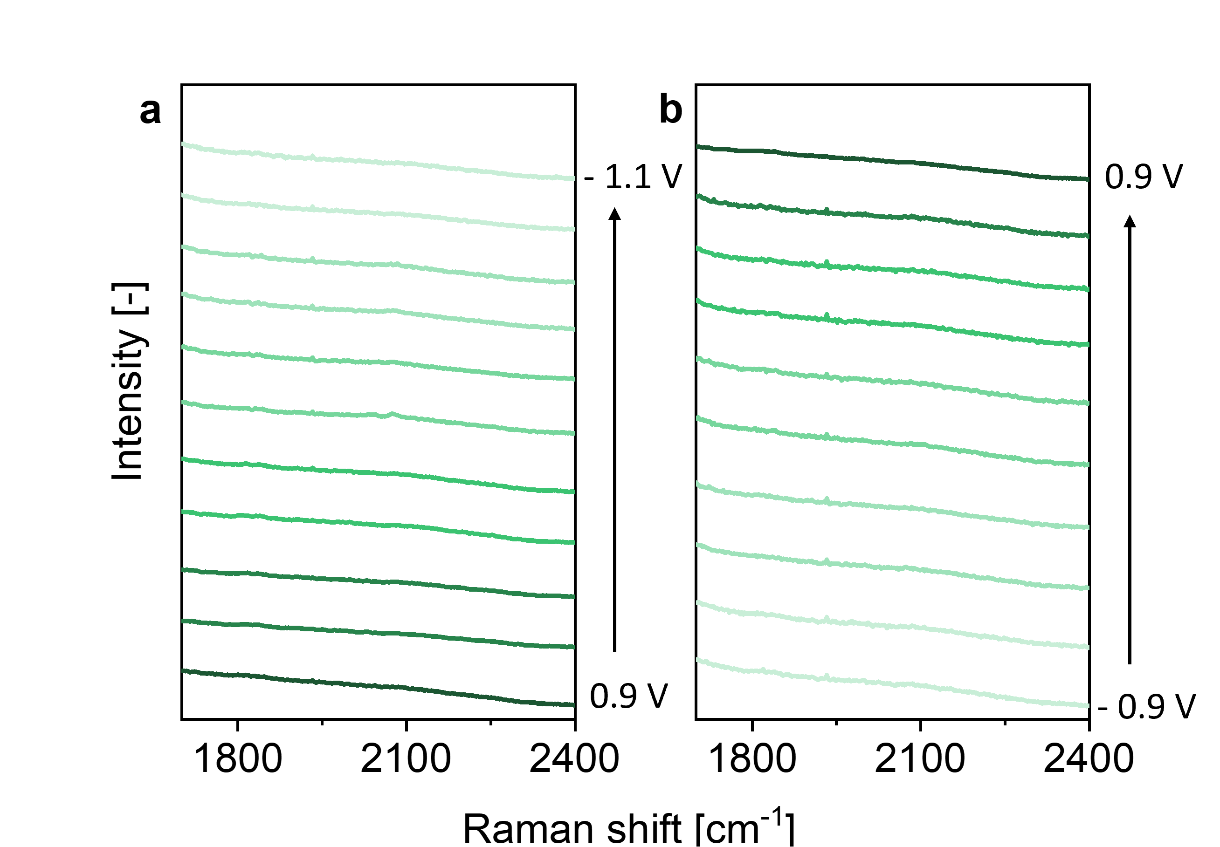
Figure S6. In situ SERS of a Cu surface in Ar saturated 0.1 M KClO₄. Recorded during (a) a reductive scan and (b) an oxidative scan of cyclic voltammtery.

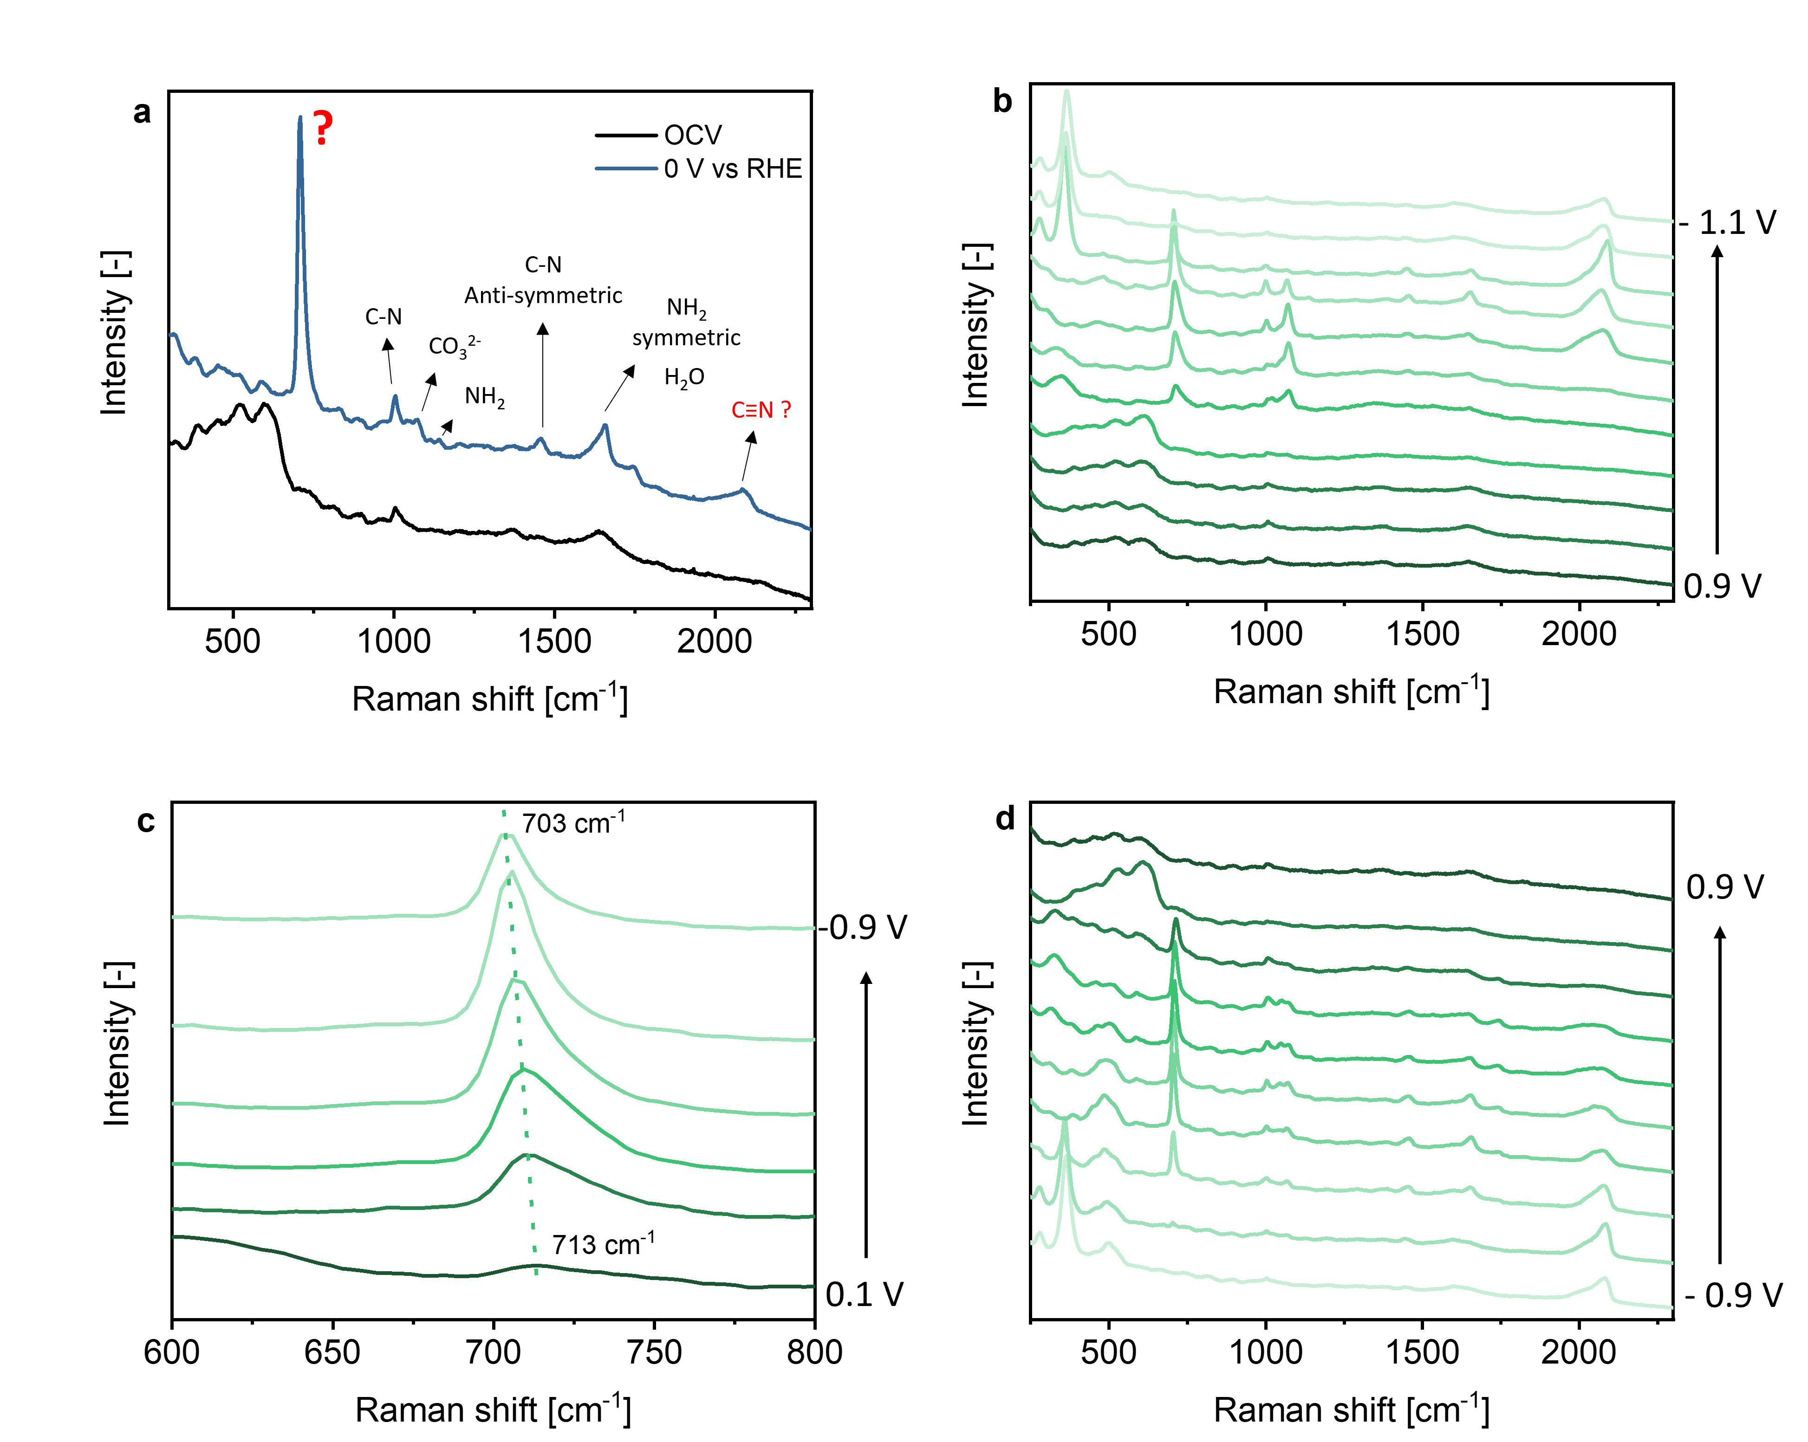
Figure S7. In situ SERS of a Cu surface in CO₂ saturated 0.1 M KHCO₃ in the presence of 50 mM urea. (a) at OCV and 0 V vs RHE; (b) during a reductive scan with (c) magnification into the ~710 cm⁻¹ signal; (d) during an oxidative scan.

At OCV there is only one signal which could be assigned to urea which is the symmetric stretching vibration of C-N at 1005 cm⁻¹ (Figure S7a)¹⁵. Surprisingly, at 0 V vs RHE additional Raman signals appear which could be related to adsorption of urea on the Cu surface. It is known that urea can adsorb on metallic electrodes such as Pt¹⁶, Au¹⁷, Ag¹⁸ or Cu¹⁹ under reductive potentials and is therefore frequently studied as inhibitor of Cu corrosion in neutral and alkaline media²⁰. Most of the signals can be assigned to urea and bicarbonate^{3,15}. The most intense band at ~709 cm⁻¹ can’t be assigned according to existing literature. As a Stark effect in the CV cycle (Figure S7c) is observed, this band originates from an adsorbed species, likely adsorbed urea on the Cu surface. When the system goes back to OCV, all signals disappear and only urea in solution is observed, which is explained by a reversible adsorption of urea on metallic electrodes, and oxidation of the adsorbed CN species.

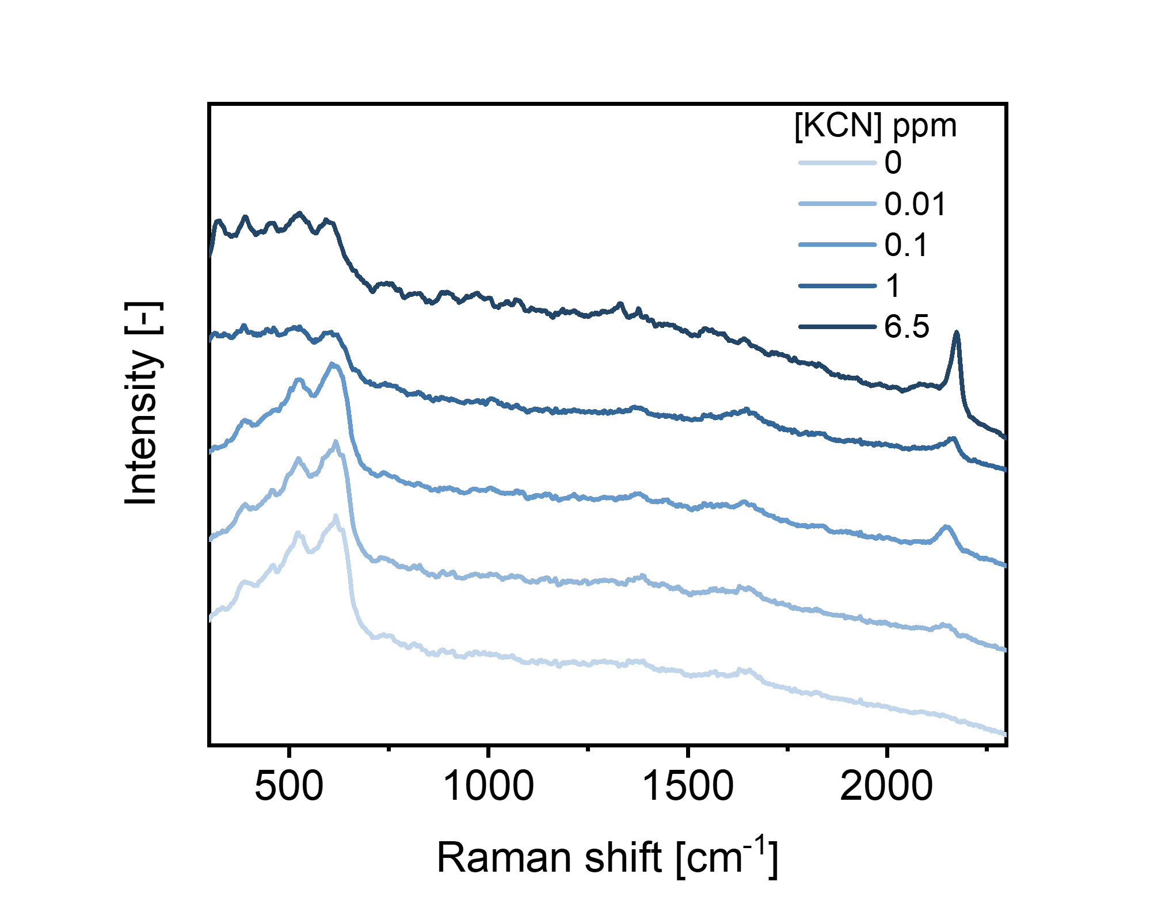
Figure S8. In situ SERS of a Cu surface in CO₂ saturated 0.1 M KHCO₃ with increasing concentration of KCN. Spectra were recorded at open circuit potential.

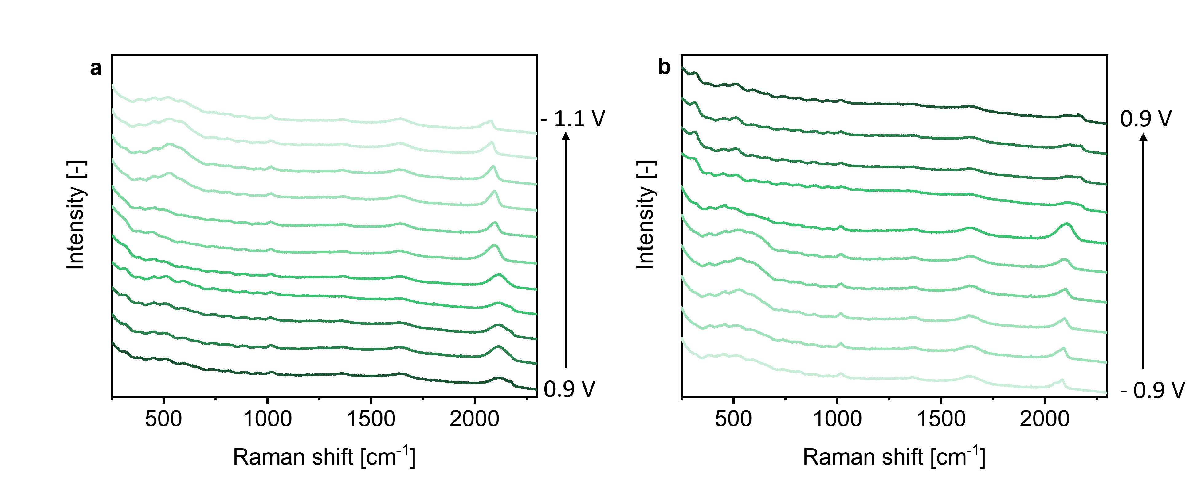
Figure S9. In situ SERS of a Cu surface in CO₂ saturated 0.1 M KHCO₃ with 10mM KCN. Recorded during (a) a reductive scan and (b) an oxidative scan of cyclic voltammetry.

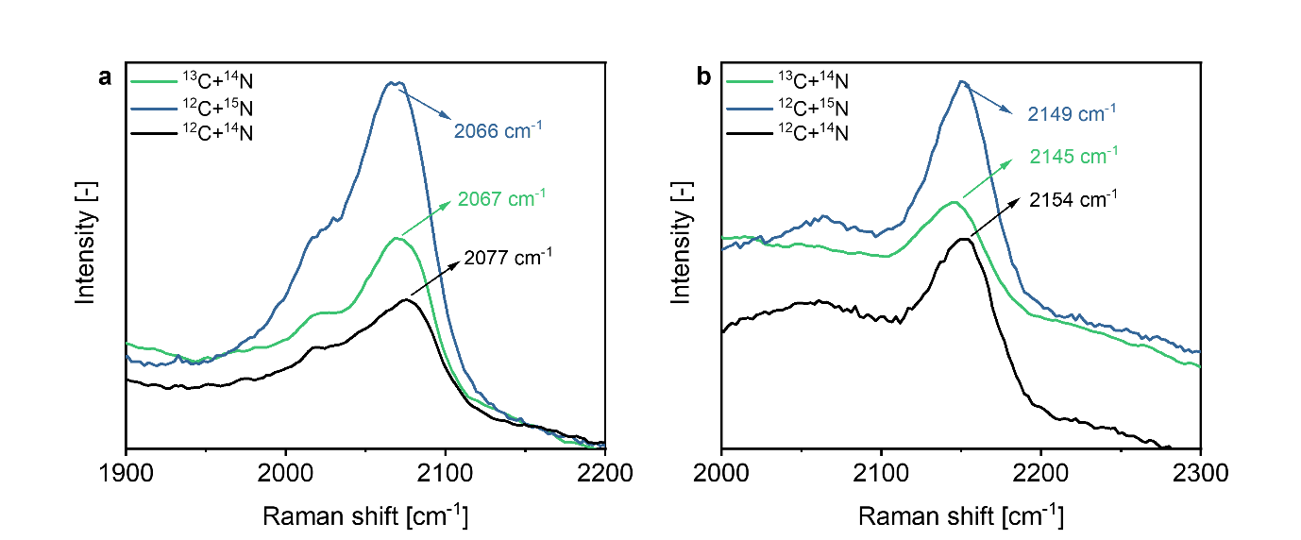
Figure S10. In situ SERS of a Cu surface in CO₂ saturated 0.1 M KHCO₃ with 50 mM KNO₃ with isotopically labelled carbon (¹³C) and nitrogen (¹⁵N). Recorded during (a) a reductive scan at -1 V vs RHE and (b) an oxidative scan at 0.5 V vs RHE.

With both ¹³C and ¹⁵N-labeled compounds in solution, the Raman signal observed in the reductive scan shifts by approx. 10 cm⁻¹ to lower wavenumbers. According to literature, the expected peak shift for CN⁻ in aqueous solution for ¹³C or ¹⁵N-labeled compounds is 43 cm⁻¹ and 32 cm⁻¹, respectively²¹. Here, the observed peak is rather broad and likely consists of 2 or 3 overlapping signals which makes it difficult to indicate the exact peak position. Moreover, calculated theoretical shift likely deviate from experimental observations considering the simplifications used in the harmonic oscillator model.
In the oxidative scan, the peak at ~2150 cm⁻¹ also seems to shift. However, it is difficult to identify the exact value of the peak shift, due to the fact that position of this peak can depend on the concentration of CN⁻ in solution. In case of experiments with ¹²C + ¹⁵N the peak appears to have slightly higher intensity. Considering that it is still shifted to lower wavelengths this observation confirms the response of the peak to a ¹⁴N/¹⁵N exchange. In case of ¹³C + ¹⁴N experiments, the peak intensity is lower than observed during blank experiments.

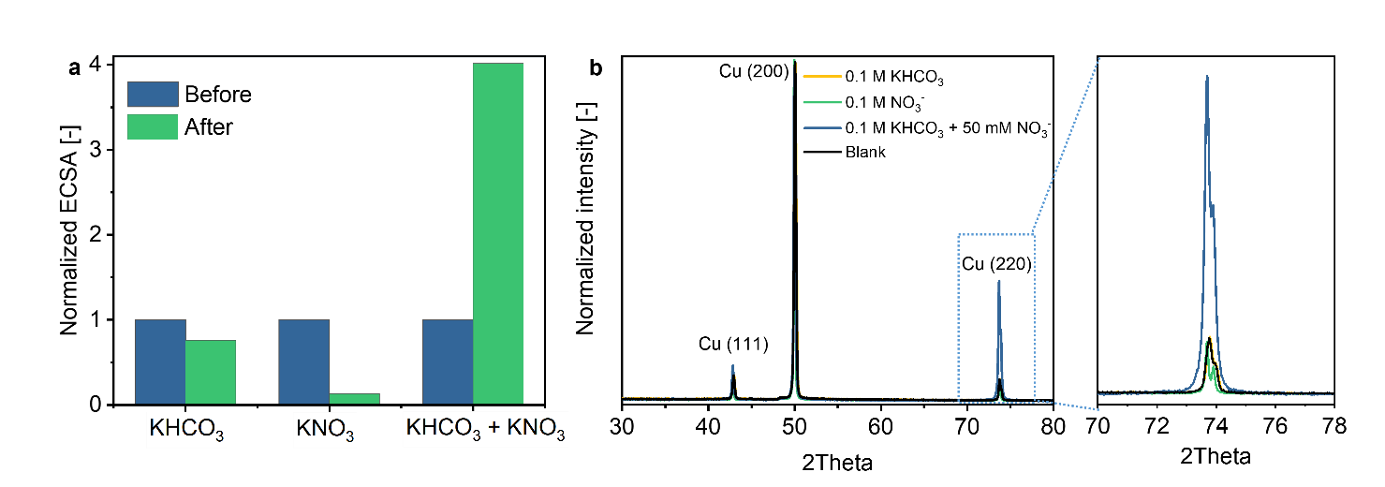
Figure S11. Surface change after 30 min of chronoamperometry at -0.3 V vs RHE. (a) ECSA before and after as well as (b) XRD patterns of the Cu surface.

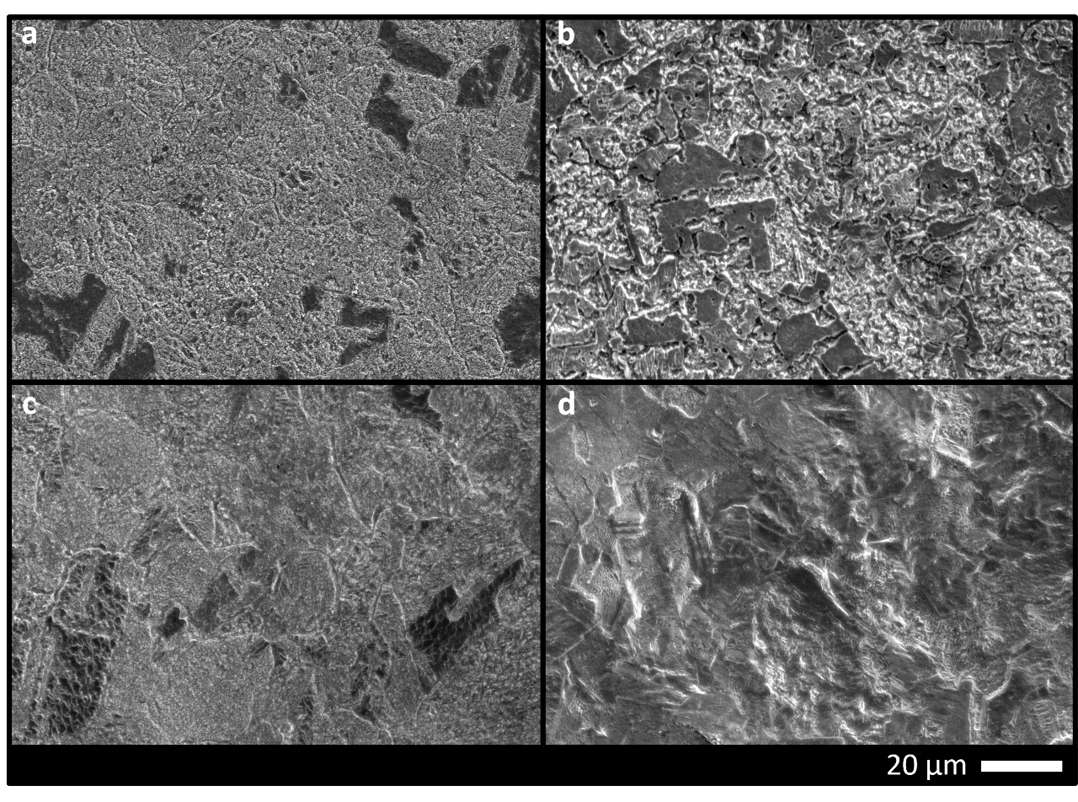
Figure S12. SEM images of the Cu surface after 30 min chronoamperometry at -0.3 V vs RHE. (a) blank electrode; after chronoamperometry in (b) 0.1 M KHCO₃, (c) 0.1 M KNO₃, and (d) 0.1 M KHCO₃ + 50 mM KNO₃.
Formation of cyanide complexes can be furthermore confirmed by a change of the Cu surface upon attack of CN⁻. Chronoamperometry at -0.3 V vs RHE was performed in all electrolytes tested. ECSA before and after each experiment was measured and in fact a significant increase in surface area was observed after electrolysis in 0.1 M KHCO₃ with 50 mM KNO₃ (Figure S11a) which could be related to surface roughening in the presence of cyanide. Moreover, the corresponding XRD pattern shows an increase of the Cu (220) facet which also indicates a surface change (Figure S11b). In addition, SEM images (Figure S12) reveal a change in morphology of the Cu surface after chronoamperometry.

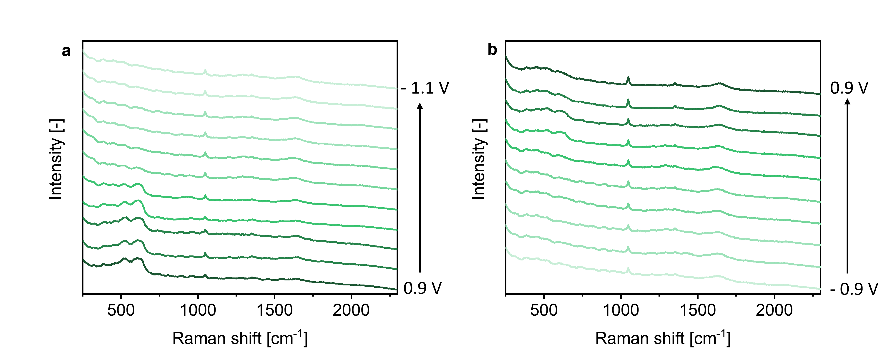
Figure S13. In situ SERS of a Cu surface in Ar saturated 50 mM HCOOK with 50 mM KNO₃. Recorded during (a) a reductive scan and (b) an oxidative scan of cyclic voltammetry.

SERS of a Cu surface in Ar saturated 0.1 M HCOOK with 50 mM KNO₃ during CV (Figure S13) does not show signals associated with cyanide. The only signals observed are the ones from Cu₂O, NO₃⁻, H₂O and HCOO⁻ at 1353 cm⁻¹ ³. This result suggests that CO₃²⁻ adsorbed on the surface is necessary for cyanide formation.
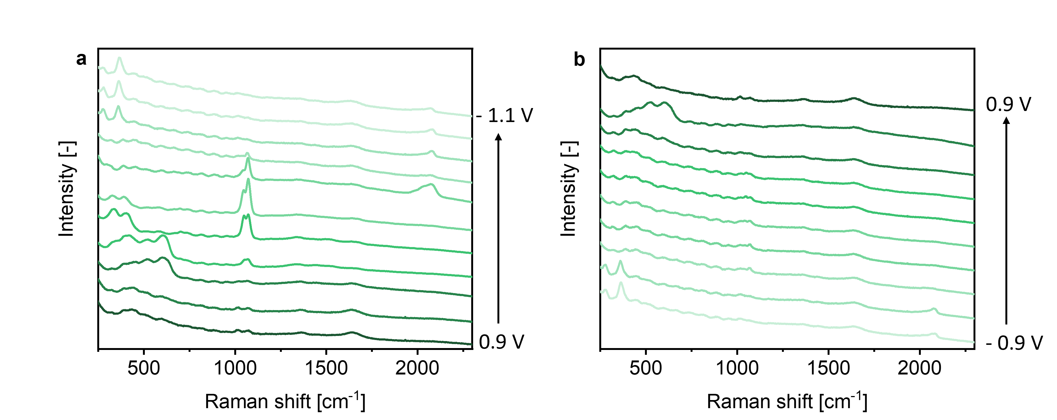
Figure S14. In situ SERS of a Cu surface in CO₂ saturated 0.1 M KHCO₃ with 20 mM (NH₄)HCO₃. Recorded during (a) a reductive scan and (b) an oxidative scan of cyclic voltammetry.

SERS of a Cu surface in CO₂ saturated 0.1 M KHCO₃ with 20 mM (NH₄)HCO₃ (Figure S14) does not show signals associated with cyanide. A weak signal at 410 to 383 cm⁻¹ can be observed when metallic Cu is formed, which can be assigned to Cu-N from adsorbed ammonia. However further experiments are necessary to convincingly prove this hypothesis. On a Ag electrode, Ag-N formation was reported at 325 cm⁻¹ but only at high concentrations²². Relatively strong signals of NH₃ can be found above 3000 cm⁻¹ ²³ being out of the range of wavenumbers detectable with our Raman system.

In-situ EC-MS
All measured m/z signals are shown in Figure S15, Figure S16 and Figure S17. The potential range for the CV experiments conducted with the EC-MS does not match the SERS experiments completely, due to the intrinsic limitations of the small-volume cell used. However, SERS signals are observed already at 0.3 V vs RHE in a reductive scan, thus the selected potential range is sufficient to correlate conclusions of various experiments. 2 cyclic voltammetry cycles are shown in each case.

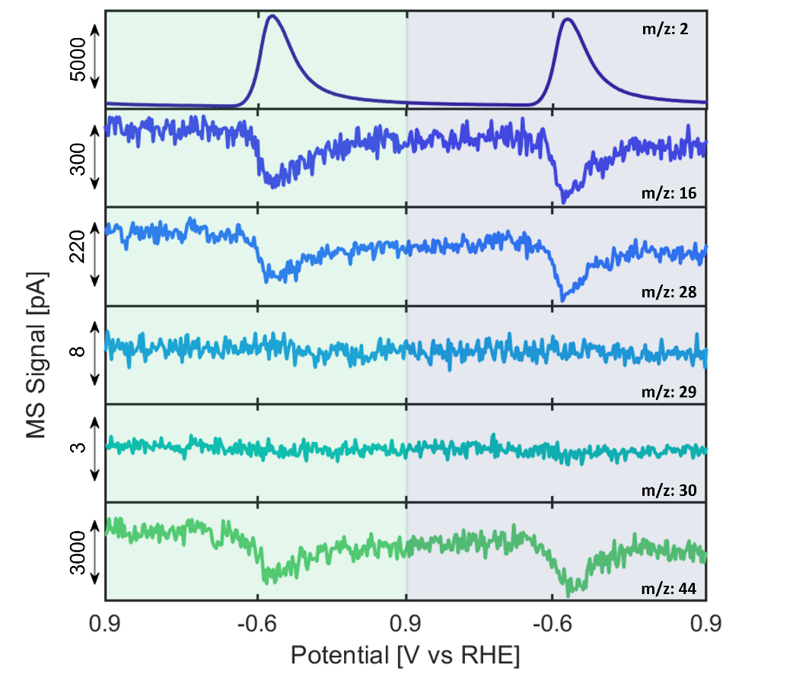
Figure S15. EC-MS analysis of desorbed products from the Cu surface during cyclic voltammetry in CO₂ saturated 0.1 M KHCO₃.
The only gas product detected in CO₂ saturated 0.1M KHCO₃ (Figure S15) was H₂ at potentials below -0.4 V. MS fragments from CO₂ overlap with the signals of the most common CO₂ reduction products (CO). Therefore it is difficult to detect products using MS. However, a dip in the m/z signals related to CO₂ confirm its conversion.
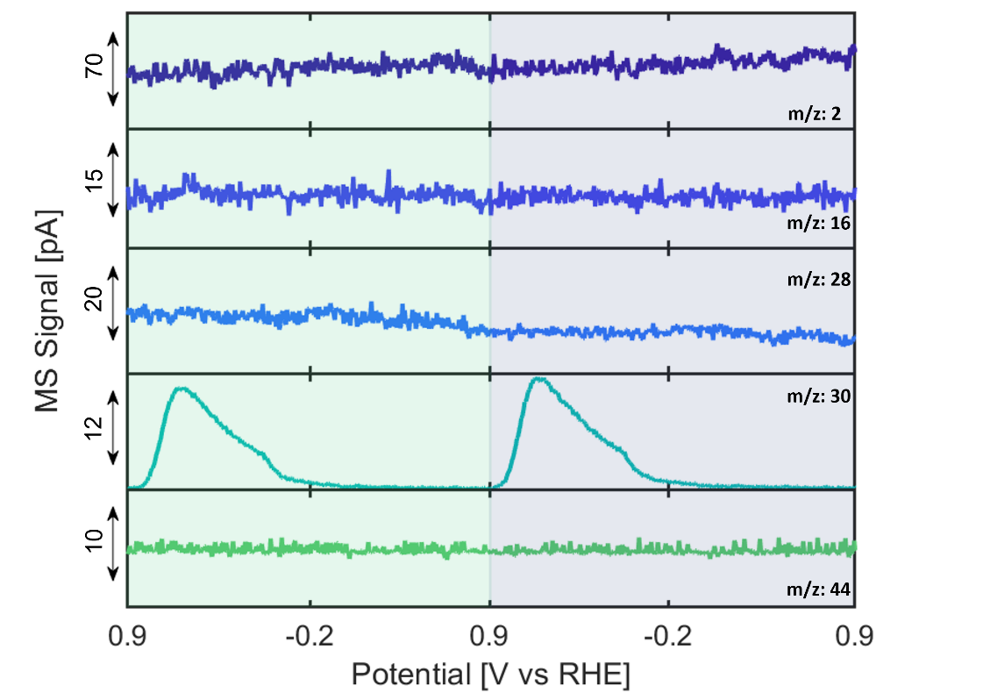
Figure S16. EC-MS analysis of desorbed products from the Cu surface during cyclic voltammetry in Ar saturated 0.1 M KNO₃.
In Ar saturated 0.1 M KNO₃ electrolyte electroreduction of nitrate is detected in a reductive scan starting at 0.8 V (Figure S16) by an increase in the m/z: 30 signal (nitric oxide). Since no signals are observed in the first cycle, the 2nd and 3rd cycles are shown. Other gas products are not detected, which suggests formation of non-volatile compounds at more negative potentials, likely NH₄⁺. NO formation was not observed in the oxidative scan, which suggests that copper oxide is necessary to reduce NO₃⁻ to NO. Previous reports did not show gas products on Cu electrodes in NO₃⁻ electroreduction. However, in the potential range (0.25 V to -1 V) of that study, copper oxide is not expected to be present²⁴.
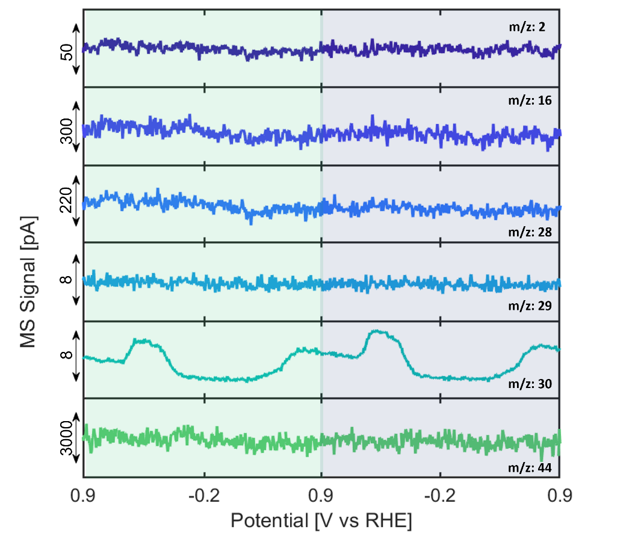
Figure S17. EC-MS analysis of desorbed products from the Cu surface during cyclic voltammetry in CO₂ saturated 0.1 M KHCO₃ with 50 mM KNO₃.

In CO₂ saturated KHCO₃ with 50mM KNO₃ (Figure S17), other gas products than NO were not detected. Since were absent in a reductive scan of the first CV cycle, the 2nd and 3rd cycles are shown, which show an increased signal of NO at the beginning, resulting from NO formed in the oxidative scan of previous cycles).

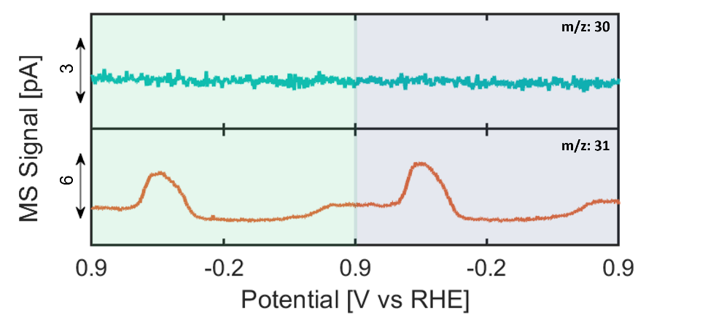
Figure S18. EC-MS analysis of m/z: 30 and m/z: 31 desorbed from the Cu surface during cyclic voltammetry in CO₂ saturated 0.1 M KHCO₃ with 50 mM K¹⁵NO₃.

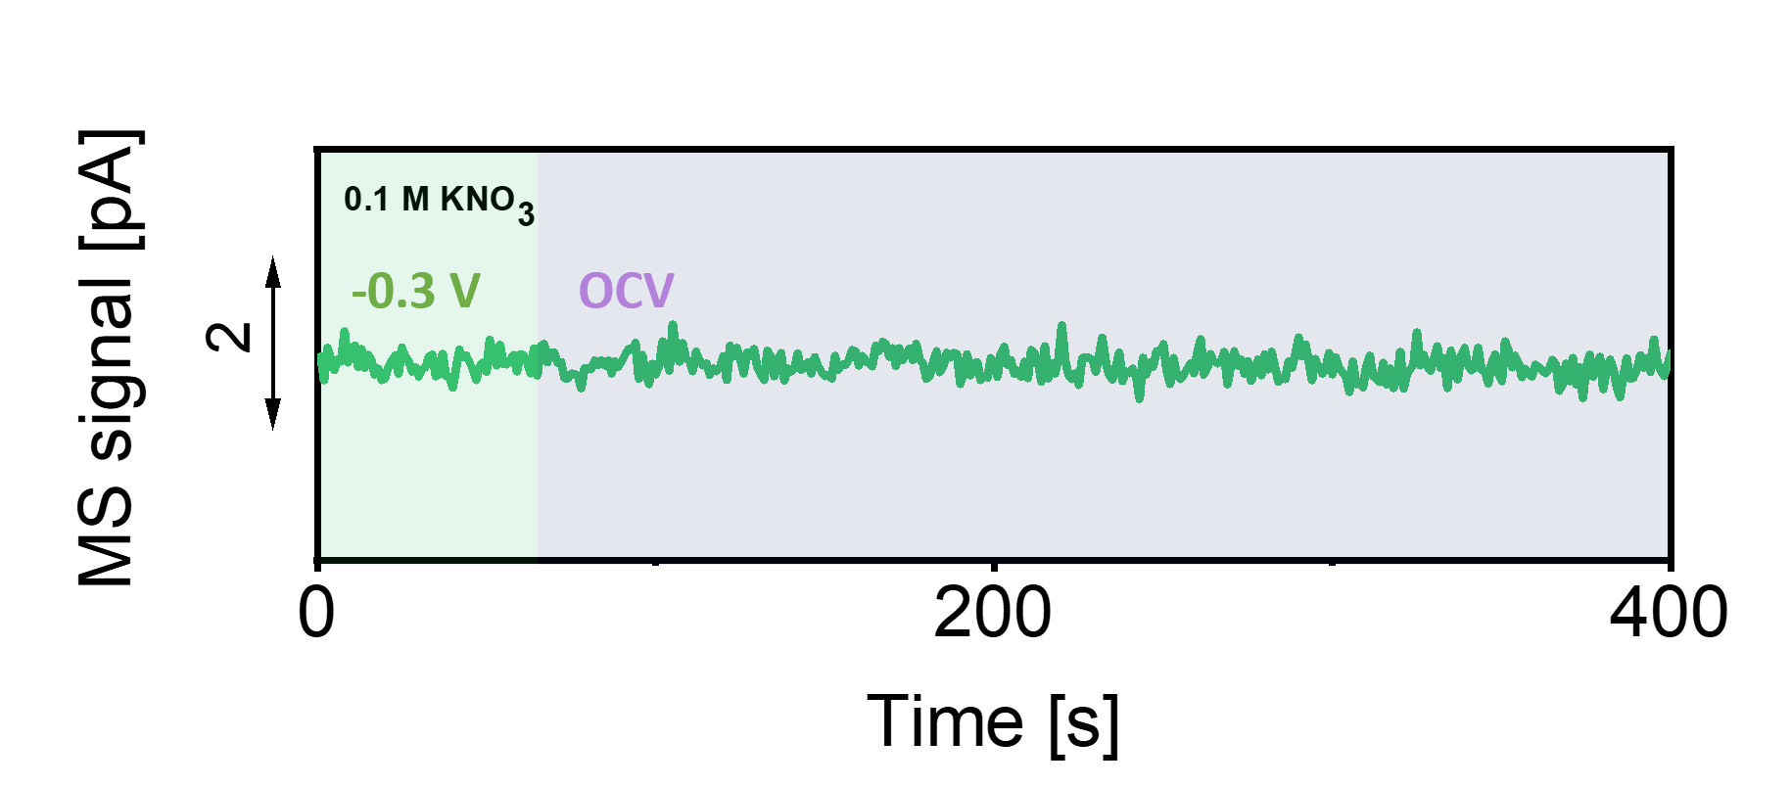
Figure S 19. MS analysis of nitric oxide (m/z: 30) desorbed from the Cu surface during chronoamperometry at -0.3 V vs RHE and subsequent OCV in Ar saturated 0.1 M KNO₃.

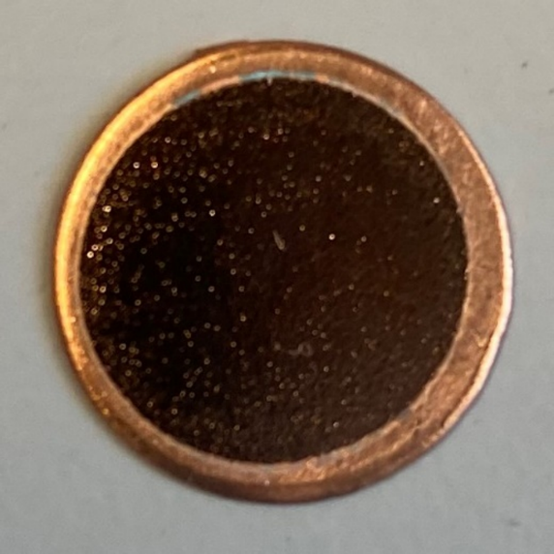
Figure S20. Photograph of the Cu electrode used in the SERS experiments.

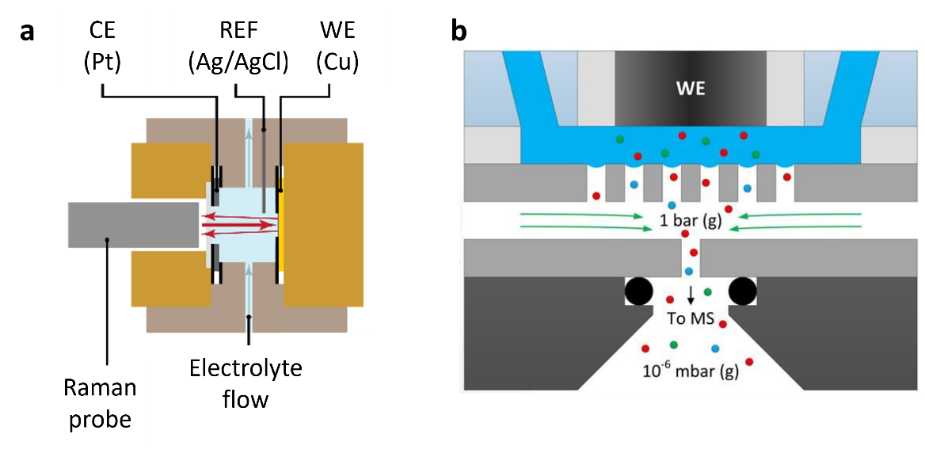
Figure S21. Schematic representation of techniques used in this study. (a) The SERS set-up and (b) the EC-MS principles.

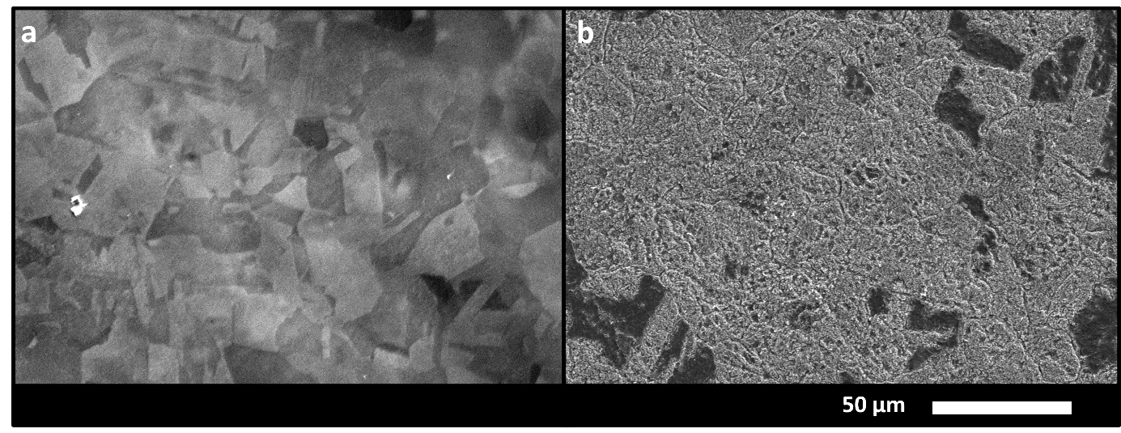
Figure S22. SEM of the Cu electrode used in the SERS experiments. (a) Before and (b) after electrochemical activation.

References
1. McEnaney, J. M. et al. Electrolyte Engineering for Efficient Electrochemical Nitrate Reduction to Ammonia on a Titanium Electrode. ACS Sustain. Chem. Eng. 8, 2672–2681 (2020).
2. Vickers, J. W., Alfonso, D. & Kauffman, D. R. Electrochemical Carbon Dioxide Reduction at Nanostructured Gold, Copper, and Alloy Materials. Energy Technol. 5, 775–795 (2017).
3. Moradzaman, M. & Mul, G. In Situ Raman Study of Potential-Dependent Surface Adsorbed Carbonate, CO, OH, and C Species on Cu Electrodes During Electrochemical Reduction of CO2. ChemElectroChem 8, 1478–1485 (2021).
4. Chernyshova, I. V., Somasundaran, P. & Ponnurangam, S. On the origin of the elusive first intermediate of CO2 electroreduction. Proc. Natl. Acad. Sci. U. S. A. 115, E9261–E9270 (2018).
5. Chernyshova, I. V., Ponnurangam, S. & Somasundaran, P. Linking interfacial chemistry of CO2 to surface structures of hydrated metal oxide nanoparticles: Hematite. Phys. Chem. Chem. Phys. 15, 6953–6964 (2013).
6. Moradzaman, M. & Mul, G. Infrared Analysis of Interfacial Phenomena during Electrochemical Reduction of CO₂ over Polycrystalline Copper Electrodes. ACS Catal. 10, 8049–8057 (2020).
7. Kim, Y. et al. Time-resolved observation of C-C coupling intermediates on Cu electrodes for selective electrochemical CO2reduction. Energy Environ. Sci. 13, 4301–4311 (2020).
8. Gunathunge, C. M. et al. Spectroscopic Observation of Reversible Surface Reconstruction of Copper Electrodes under CO2 Reduction. J. Phys. Chem. C 121, 12337–12344 (2017).
9. Zhou, Z., Huang, G. G., Kato, T. & Ozaki, Y. Experimental parameters for the SERS of nitrate ion for label-free semi-quantitative detection of proteins and mechanism for proteins to form SERS hot sites: A SERS study. J. Raman Spectrosc. 42, 1713–1721 (2011).
10. Mosier-Boss, P. A. & Lieberman, S. H. Detection of nitrate and sulfate anions by normal Raman spectroscopy and SERS of cationic-coated, silver substrates. Appl. Spectrosc. 54, 1126–1135 (2000).
11. Zhou, Z., Huang, G. G. & Ozaki, Y. Label-free rapid semiquantitative detection of proteins down to sub-monolayer coverage by using surface-enhanced raman scattering of nitrate ion. Chem. Lett. 39, 1203–1205 (2010).
12. Butcher, D. P. & Gewirth, A. A. Nitrate reduction pathways on Cu single crystal surfaces: Effect of oxide and Cl−. Nano Energy 29, 457–465 (2016).
13. Lust, M., Pucci, A. & Otto, A. SERS and infrared reflection-absorption spectroscopy of NO on cold-deposited Cu. J. Raman Spectrosc. 37, 166–174 (2006).
14. Lauridsen, R. K. et al. Towards quantitative SERS detection of hydrogen cyanide at ppb level for human breath analysis. Sens. Bio-Sensing Res. 5, 84–89 (2015).
15. Durickovic, I., Thiebaud, L., Bourson, P., Kauffmann, T. & Marchetti, M. Spectroscopic characterization of urea aqueous solutions: Experimental phase diagram of the urea-water binary system. Appl. Spectrosc. 67, 1205–1209 (2013).
16. Climent, V. et al. Urea adsorption on platinum single crystal stepped surfaces. Langmuir 17, 8260–8269 (2001).
17. Holze, R. & Schomaker, S. New results on the electrosorption of urea and thiourea on gold electrodes. Electrochim. Acta 35, 613–620 (1990).
18. Lukomska, A. & Sobkowski, J. Adsorption of urea on a polycrystalline silver electrode; comparison of electrochemical and radiometric methods. J. Solid State Electrochem. 9, 277–283 (2005).
19. Łukomska, A. & Sobkowski, J. Adsorption of urea on a polycrystalline copper electrode. J. Solid State Electrochem. 11, 253–258 (2007).
20. Altaf, F., Qureshi, R., Ahmed, S., Khan, A. Y. & Naseer, A. Electrochemical adsorption studies of urea on copper surface in alkaline medium. J. Electroanal. Chem. 642, 98–101 (2010).
21. Yoshikawa, S., O’Keeffe, D. H. & Caughey, W. S. Investigations of cyanide as an infrared probe of hemeprotein ligand binding sites. J. Biol. Chem. 260, 3518–3528 (1985).
22. Sanchez, L. A., Lombardi, J. R. & Birke, R. L. Surface enhanced Raman scattering of ammonia. Chem. Phys. Lett. 108, 45–50 (1984).
23. Liu, Y. et al. Facile All-Optical Method for In Situ Detection of Low Amounts of Ammonia. iScience 23, 101757 (2020).
24. Pérez-Gallent, E., Figueiredo, M. C., Katsounaros, I. & Koper, M. T. M. Electrocatalytic reduction of Nitrate on Copper single crystals in acidic and alkaline solutions. Electrochim. Acta 227, 77–84 (2017).

