Supplementary Materials for
Distributed brain networks for anticipatory modulation of human response times
Ashwin G Ramayya¹*, Vivek Buch², Andrew Richardson¹, Timothy Lucas¹, and Joshua I. Gold⁵
Correspondence to: ashwinramayya@gmail.com

This PDF file includes:

Materials and Methods
Supplementary Text
Figs. S1 to S12
Tables S1 to S7

Materials and Methods
Subjects
We studied 23 patients with medically refractory epilepsy who underwent surgical implantation of intracranial electrodes for seizure localization (table S1). Patients provided informed consent to perform cognitive testing as part of our research study while they were admitted to the hospital. Our study was approved by the University of Pennsylvania Institutional Review Board. Clinical circumstances alone determined the number and placement of implanted electrodes.

Stimulus detection task
Subjects performed a stimulus-detection task with a variable foreperiod delay. Subjects viewed visual stimuli on a laptop computer screen and responded by pressing a button on a game controller with their right thumb. Each trial began with the presentation of a small white box at a randomized location on the screen as a fixation target (one of nine locations on a 3 x 3 grid). The stimulus changed color to yellow after one of two randomly selected foreperiod delays: 1) short delay=500 ms, or 2) long delay=1500 ms. We measured response time (RT) as the time between color change (stimulus) and button press (response). If a response was provided within a predefined response interval (1000 ms after color change), visual feedback was provided as follows: 1) for RTs ≤ 150 ms, salient positive feedback was shown, consisting of a smiley face with text below (“wow!”) 2) for RTs > 150 ms, the RT was shown, color-coded by binned values (green for 150–300 ms, yellow for 300–600 ms, red for 600–1000 ms). If a response occurred before the color change of the stimulus (“anticipatory false alarm”) or if no response was provided within 1000 ms after color change, the subject was shown a blank screen for 2500–2750 ms (random inter-trial jitter). During each session, the subject performed blocks of 9 trials each. After six blocks, the subject was provided with an option of performing additional blocks of trials. On average, subjects performed a mean of 149 trials (i.e., 1.34 sessions). Two subjects performed additional trials with a 1000 ms foreperiod delay, which we excluded from our analyses.

Extended LATER model of RT
All model-fitting procedures described below were implemented by finding the minimum of the appropriate objective function using the SciPy Optimization package (Python). We modeled RT distributions using an extended version the LATER model (13,14). This rise-to-bound model describes RTs as measuring the time it takes for a latent variable to rise linearly from a starting value (S₀) at stimulus presentation to a threshold value (S_{t}) at response. The model accounts for trial-to-trial RT variability by assuming that the rate-of-rise of this process varies stochastically from trial-to-trial per a Gaussian process. The basic form of the LATER model describes an RT distribution using two free parameters, as follows:
$$RT\sim \frac{1}{N\left(μ,σ^{2}\right)}$$Where N represents a Gaussian distribution with mean $μ$ and standard deviation $σ$. Note that this version assumes that the threshold value S_{t}=1; an equivalent formulation assumes that $σ$=1, and S_{t} is a free parameter. These parameters are estimated by fitting a Gaussian probability density function to reciprocal RTs, which typically resembles a Gaussian distribution (13).
We extended this basic model to account for anticipatory false alarms, which we modeled as arising from a parallel LATER unit that was triggered at target onset (Fig. S1). For these and other RT analyses, we assumed that false alarms included responses made either before stimulus onset or within 250 ms after stimulus onset (“fast responses”), because these fast responses are thought to arise from processes distinct from those driving slower RTs (we chose 250 ms as a conservative cutoff to ensure that our neural analyses do not conflate these two processes) (2, 13). Specifically, each subject’s RT distribution for a given foreperiod delay condition was modeled as a weighted average of: 1) the anticipatory LATER unit fit to anticipatory false alarms that occurred between 500 ms prior to and 250 ms following stimulus onset, and 2) the reactive LATER unit fit to RTs between 250–1000 ms. Because anticipatory false alarms were associated with negative RTs when measured relative to stimulus onset, we introduced a 500 ms offset such that all RTs were positive values. Thus, this extended LATER model included two LATER units (each with a mean $μ$ and standard deviation $σ$) and a weighting factor (“anticipatory bias”) that determined the overall probability of triggering an anticipatory false alarm. We first fit this extended LATER model to behavior on the short-delay trials and then modeled delay-related changes in behavior from long-delay trials using two free parameters representing delay-related changes in: 1) the weighting factor determining the probability of triggering anticipatory responses (“∆ anticipatory bias”), and 2) the variance ($σ^{2}$) associated with reactive LATER unit (“∆ variance”). We evaluated the overall model fits by computing an R² value comparing the (z-scored) model-predicted probability distributions and an empirically estimated probability distribution based on a Gaussian-smoothed reciprocal RT histograms (including all responses from 500 ms prior to stimulus onset to 1000 ms following stimulus onset, with an offset such that all RTs on anticipatory false alarms were positive values and RTs on short and long-delay trials were aligned relative to stimulus onset; fig. S1c,d; tables S2,S3).

Intracranial neural recordings via intraparenchymal electrodes
Patients were implanted exclusively with intraparencymal depth electrodes (“stereo EEG,” Ad-tech, 1.1 diameter, 4 contacts spaced 5 mm apart), except in one patient who also had subdural grid electrodes (Subject#142, Ad-tech, 4 mm contacts, spaced 10 mm apart). iEEG was recorded using a Natus recording system. Based on the amplifier and the discretion of the clinical team, signals were sampled at either 512 or 1024 Hz. Signals were converted to a bipolar montage by taking the difference of signals between each pair of immediately adjacent contacts on the same electrode. The resulting bipolar signals were treated as new virtual electrodes (henceforth, “electrodes”), originating from the midpoint between each electrode pair (40). Digital pulses synchronized the electrophysiological recordings with task events. We excluded electrodes that recorded prominent 60 Hz electrical line noise, defined as electrodes that showed greater spectral power in the 58–62 Hz range compared to the 18–22 Hz range, or electrodes that were disconnected (standard deviation=0). We excluded trials with prominent noise artifacts (e.g., if voltage data were not recorded due to saturation, or if the mean or standard deviation of voltage was >10 standard deviations of all trials). We did not specifically exclude electrodes based on epileptic activity because our analyses focused on behaviorally linked neural activity, which should not be influenced systematically by epileptic networks (41). We analyzed data from 2,609 electrodes (Fig. S2).
Anatomical localization of electrodes
Intracranial electrodes were identified manually on each post-operative CT scan and contact coordinates recorded using custom software based on the center of density of the radiodense contacts on thresholded images. To obtain contact locations in each patient's native anatomic space as well as a common reference space (MNI coordinates), we used Advanced Normalization Tools (42) to register post-operative CT to pre-operative MRI and each MRI to the Montreal Neurological Institute (MNI) average brain and the Neuromorphometrics whole brain atlas (43). Electrodes were assigned anatomical labels in a hierarchical manner. First, electrodes were labeled using the Neuromorphometrics atlas. Second, for all electrodes labelled as “Cerebral White Matter,” we assigned a specific white-matter tract label by relating MNI coordinates of each electrode to the XTRACT Human Connectome Project Probabilistic atlas (44). Third, for white-matter electrodes that remained without a specific tract label, we assigned a lobe-based label using the MNI Structural Atlas (e.g., “parietal white matter” or “frontal white matter”) (45). For electrodes that were not assigned to an anatomical structure based on the above procedures, we assigned the label associated with the nearest labelled electrode in MNI coordinate space (using Euclidean distance). We grouped electrodes into regions of interest (ROI) based on manual grouping of anatomical labels (table S4). We illustrate our method in Figure S2 using an example electrode in MNI coordinate space with overlying gray and white matter segmentations (Harvard-Oxford Cortical Structural Atlas is shown in place of the Neuromorphometrics, which is not in standard MNI152 space).
Extracting high-frequency activity (HFA)
We extracted 5000 ms segments of iEEG data surrounding the following task events: 1) 2000 ms prior to target onset, 2) 5000 ms after target onset, 3) the stimulus color change, and 4) onset of the motor response. For each segment, we extracted spectral power using 5 complex-valued Morlet wavelets (wave number 3, to increase temporal resolution) with logarithmically spaced center frequencies from 70 to 200 Hz. We squared and log-transformed the wavelet convolutions to obtain power estimates at each time sample. We removed 1000 ms buffers at the beginning and end of each segment to avoid contamination from edge artifacts. We averaged these power estimates across the 5 wavelets, resulting in a single power value for each time sample. We convolved each power-time series with a Gaussian kernel (half-width of 75 ms), resulting in a continuous representation of high-frequency activity (HFA) surrounding each task event. We z-scored HFA by the mean and standard deviation of the distribution of HFA values obtained from randomly selected segments of iEEG data recorded from that session clips (matched to the number of total task events) to not bias values towards any particular task-related event (40). We henceforth refer to z-scored HFA as “HFA.”
Measuring and preprocessing electrode-specific activation functions
We quantified the activity pattern recorded by each electrode by measuring the average HFA around target onset during, measured separately on short-delay and long-delay trials (subsequently referred to as “activation functions”). We measured target-locked activation functions from 1000 ms prior to and 4000 ms following target onset.
To ensure that all subsequent analyses focused on modulations of the activation functions that were separate from the immediate sensory and motor responses, we preprocessed the data as follows (all curve fits were performed using the SciPy Optimization package in Python (“cuve_fit”):
First, we estimated the overall trend in HFA that occurred over the course of the trial independent of changes that occurred immediately following stimulus presentation using the target-locked activation function (averaged across both trial types). Specifically, we fit a line to estimate how HFA changed over time using during two short segments of this activation function: 1) 1000 ms to -500 before target onset, and 2) 1000 ms after the long-delay color change occurred (2500 ms to 3000 ms after target onset). We subtracted this trend line from each target-locked activation function to obtain detrended functions.
Second, we estimated the changes in activity that occurred immediately after target onset across both trial types. Specifically, if the detrended target-locked activation function (averaged across both trial types, from target onset to 500 ms afterwards) contained any activity peaks or troughs that were outside of the electrode’s baseline activity range, we fit a Gaussian distribution to model these activity excursions. If both a peak and trough were detected in a given electrode’s activation function, we modeled whichever one was larger. We then removed the post-target Gaussian from each target-locked activation function. For long-delay trials, we also fit a Gaussian to the 500–1500 ms interval after target onset and subtracted it from the activation function to remove any expectation-related changes in activity that occurred in response to the target not changing color.
Third, we modeled activity locked to the color change separately for short- and long-delay trials. Specifically, we first fit a Gaussian to a short time segment after the color change (0–500 ms post-stimulus) to capture any changes in activity that occurred immediately after color change. We also fit any residual peaks or troughs over a longer time segment (0–1000 ms post-stimulus). We then subtracted these fit Gaussians from the activation function from each trial.
Fourth, we modeled activity locked to the motor response separately for short- and long-delay trials. Specifically, we fit separate Gaussians to the 500 ms preceding the response, to capture any pre-response ramping activity or any smeared stimulus-locked activity from the preceding color change, and to any residual peaks or troughs during the 500 ms post-response interval, to capture further changes in activity related to either the response or feedback presentation. We then subtracted these fit Gaussians from the activation function from each trial.
In summary, these procedures resulted in residual trial-by-trial HFA measures that were time-locked to four task events: 1) target-locked, short delay, 2) target-locked, long delay, 3) response-locked, short delay, 4) response-locked, long delay.
Relating residual neural activity to stochastic RT variability
We measured stochastic RT variability for each subject as follows. First, we transformed RTs during correct responses (excluding “fast response” RTs < 250 ms) by taking the negative reciprocal ($-1/RT$), which transforms right-tailed RTs into an approximately Gaussian distribution (the negative sign is applied for convenience such that long RTs are still associated with larger values) (13). Then, we removed delay-related RT variability by z-scoring reciprocal RTs within each delay condition.
We assessed whether stochastic RT variability was related to neural activity at a given electrode after removing stimulus- and response-locked components of the activation function, including ramping components (Fig. S5, S6). We extracted several trial-by-trial neural features locked to trial events: 1) baseline interval prior to target onset (500 ms), 2) baseline interval prior to stimulus (500 ms), 3) post-stimulus activity (250 ms), 4) post-stimulus buildup rate (slope of a line fit to HFA trend 250 ms following stimulus), 5) pre-response buildup rate (slope of a line fit to HFA 250 ms prior to response), and 6) pre-response activity (250 ms).
We performed an omnibus test to assess for any relationship between neural activity and stochastic RT variability using a multi-variate linear regression model. The dependent variable was stochastic RT variability across all trials, and the independent variables were each of the neural features described above. We measured the predictive power of this model using the sum squared error of residuals (SSE). We also assessed specific relationships between each neural feature and stochastic RT variability using Spearman correlations.
We assigned non-parametric z-statistics and p values for each of these tests by comparing each of these “true” statistics (SSE of multi-variate model, and Spearman’s rho for each neural features) to null distributions generated for each electrode by misaligning RTs and neural data (using a circular shift procedure, 1000 iterations, to account for any autocorrelation in RTs). For the omnibus test, we assigned a one-tailed p value (i.e., if the true SSE was <5% of null SSE values, we assigned a p value of 0.05). For Spearman correlations, we assigned a two-tailed p value (i.e., if $ρ$ was >2.5% of null rho values, we assigned a p value of 0.05).
Relating neural activity to foreperiod delay
For each electrode, we assessed whether there were categorical differences in the activation function observed during short- and long-delay trials (Fig. S7). We compared the following features of the activation function for long- versus short-delay trials via an independent-sample t-test (assuming unequal variance): 1) baseline interval prior to stimulus (500 ms), 2) post-stimulus activity (250 ms), 3) post-stimulus buildup rate (slope of a line fit to HFA trend 250 ms following stimulus), 4) pre-response buildup rate (slope of a line fit to HFA 250 ms prior to response), and 5) pre-response activity (250 ms). We assigned non-parametric z-statistics and p values (two-tailed) to each of these tests by comparing each t-statistic to their respective null distributions generated by randomly re-assigning category labels for each trial (permutation procedure, 1000 iterations).
Hierarchical clustering of neural populations based on functional properties
We used data-driven unsupervised clustering to group all electrodes based on similar functional properties (fig. S8). This approach allowed us to study neural representations of specific task-related processing that were distributed across many regions and to avoid arbitrarily aggregating activity from nearby neural populations that might have heterogeneous functions. For each electrode, we defined a multi-variate feature representing the magnitude of (linear) relationships between each of the five features of the activation function listed above (e.g., baseline, post-stimulus buildup rate, etc.) and stochastic RT variability (i.e., z-scored RT computed separately for short- and long-delay trials, thus removing any mean difference in RT for the two delay conditions) and foreperiod delay (a binary variable corresponding to short- or long-delay trials), using a multinomial distribution indicating the presence and direction of a significant effect (non-parametric p < 0.05; 0 indicates no relation, 1 indicates relatively increased activity with long RTs or long-delay trials, and -1 indicates relatively increased activity with short RTs or short-delay trials). We used an agglomerative clustering algorithm (scikit learn, Python) to group all electrodes using Euclidean distance as a measure of pairwise similarity and a linkage function that merges clusters to minimize the variance within all clusters. We identified 20 clusters that were grouped by similar functional profiles using an objective function maximized the number of clusters that were observed in at least 5 subjects and 50 electrodes (figs. S8, S9, S11, S12).
Cluster-based analyses
For each cluster, we tested the null hypothesis that the electrode group was a random subsample from the population of electrodes, against the alternative hypothesis that the electrode group represented an anatomically or functionally distinct subpopulation. We categorized each electrode based on several anatomical and functional properties that were not used in the clustering algorithm, including: 1) hemisphere (left vs. right), 2) brain region of interest, 3) various activation function features as defined by the curve-fitting algorithm (i.e., the presence, increase, or decrease in post-target activity, pre-response activity during short-delay trials, or post-response activity), 4) spatial selectivity (post-target activity modulation by the spatial location of the target; one-way ANOVA, p < 0.05), 5) post-error increase or decrease in activity (independent samples t-test comparing average activity 1000 ms post-response in error vs. non-error trials, p < 0.05), 6) post-reward increase or decrease in activity (independent samples t-test comparing average activity 1000 ms post-response in RTs < 300 vs. other trials, p < 0.05), and 7) positive or negative correlation between post-target activity (500 ms) and timing of false alarms made after 500 ms (Spearman correlation, p < 0.05). For each cluster of electrodes, we compared the observed counts in each of these categories as compared to the expected counts based on the overall frequency of these categorical assignments across all electrodes via $χ^{2}$ test (Fig. S10, table S7).
Measuring global neural state dynamics between and response
For each subject, we assessed global neural-state dynamics by analyzing simultaneous HFA measurements across all implanted electrodes (excluding electrodes with major noise components, fig. S3). We measured neural state (n) at a given time sample as a vector representing neural activity from all electrodes at that time sample (z-scored HFA after removing stimulus- and response-locked components). The length of n equaled the number of electrodes in the given subject. On each correct trial with RT > 250 ms, we measured n at stimulus onset (s) and response onset (r) and summarized the trajectory of the intervening dynamics using the following measures (fig. S3E): 1) s-r distance, the Euclidean distance between s and r; 2) s-r speed, the mean change in distance travelled per time sample; 3) post-stimulus trajectory, the ratio between s-r distance and n-r distance at 200 ms after stimulus onset (values > 1 indicate relatively direct trajectories, whereas values < 1 indicate relatively indirect trajectories); and 4) s-r variability, the variance in n for all time samples between s and r (measured as distance from r). We used Principal Components Analysis (PCA) to visualize these high-dimensional stimulus-response trajectories in a reduced three-dimensional space.
Figure S3A–E illustrates how brain-state vectors were constructed in an example subject (Subject #179). For this subject, brain state varied in a high-dimensional space (83 components needed to explain 95% of the variance using PCA; fig. S3C). Across subjects, the dimensionality of brain state variability increased with increasing number of implanted electrodes (Spearman’s rho= 0.98, p < 0.001, Fig. S3F, right panel), but with a slope of <1 (0.59 dimensions/electrode), suggesting somewhat, but not completely, independent contributions from each electrode.
Relating global neural state dynamics to foreperiod delay
For each subject, we assessed whether neural-state dynamics showed categorical differences between the two foreperiod delay conditions. We measured differences in the mean of each neural-state metric (fig. S3E) observed during long- and short-delay trials and assigned non-parametric z-statistics and two-tailed p values by comparing these difference scores to their respective null distributions generated by randomly re-assigning foreperiod delay condition labels via permutation procedure (1000 iterations). Additionally, we measured the discriminability between observations of s on long- and short-delay trials using multi-variate binary classifiers (“pre-stimulus discriminability”), and also performed the same procedure for observations of r (“pre-response discriminability”; fig. S3E, right panel). In each case, we trained a logistic regression model to predict the trial type (long vs. short delay) using the activity pattern observed across all electrodes during stimulus presentation (“s discriminability”) and at the time of response (“r discriminability”). We performed L2 regularization and evaluated model performance using the area under the receiver operating characteristic curve (AUC) via 10-fold cross validation. We tuned the regularization strength hyperparameter (controlling model complexity) over 10 log-spaced values (ranging from 0.0001 to 10,000). We assigned non-parametric z-statistic and two-tailed p values to each classifier by comparing each AUC measure to their respective null distributions generated by randomly re-assigning foreperiod delay condition labels via permutation procedure (1000 iterations).
We assessed whether these various measures of global neural-state dynamics between stimulus and response (fig. S3E) were significantly modulated by delay condition via permutation procedure (p < 0.05). We assessed how frequently we observed significant delay-related differences in each of these measures across subjects and assessed whether these rates significantly exceeded the false-positive rate (5%, fig. S3G). All measured neural dynamics showed significant differences between delay conditions ($χ^{2}$ test, FDR-corrected ps < 0.001) and were significantly modulated in at least 5 individual subjects (false-positive rate, 5% = 1.15 subjects). These results suggest that network-wide activity was modulated in several ways as quantified by these measures. We assessed the behavioral relevance of these delay-related modulations for RTs by studying relations with subject-to-subject variability in behavior.

Relating individual differences in behavior and global neural state dynamics
We related individual differences in delay-related changes in behavior, as quantified by best-fitting rise-to-bound model parameters (∆ anticipatory bias and ∆ variance), with delay-related changes in various neural-state dynamics via Spearman correlation. We assessed the relative contributions of various electrode groups (cluster or brain regions) to these across-subject correlations by repeating the analysis (beginning from the measurement of neural state dynamics) without the respective electrode group and computing a relative contribution score for that electrode group as the ratio between the original correlation coefficient and the correlation coefficient obtained after removing the electrode group. Scores >1 imply that including electrode group strengthened the across-subject correlation (“adds signal” in Fig. 4), whereas scores < 1 imply that the electrode group weakened the correlation (“adds noise” in Fig. 4). We assigned a non-parametric p-value to each relative contribution score using the following permutation procedure. For each across-subject correlation analysis, we generated a null distribution for relative contribution scores by removing a random sample of electrodes (1000 iterations, removing 50–150 electrodes on each iteration). We excluded electrode groups that were outliers in their sample size for this analysis (n > 200 electrodes, corresponding to cluster 0 and prefrontal and temporal regions).
Statistical tests
We performed non-parametric statistical tests as described above, when appropriate. Otherwise, we performed t-tests to compare continuous distributions and $χ^{2}$ tests to compare categorical distributions (counts data). We used False Discovery Rate (FDR) correction for multiple comparisons (46) and considered an FDR-corrected p value < 0.05 to be statistically significant. We report FDR-corrected p values when indicated, otherwise reported p values are uncorrected. We performed analyses using Python using both custom code and publicly available packages (e.g., NumPy for numerical computing, SciPy for statistics and signal processing, MNE for spectral analyses, and statsmodels for regression modeling).

Data sharing and Code Accessibility:
Behavioral and neural data used for this study and associated code will be made available upon request.

Supplementary Text
Model-fitting results and alternatives
As detailed above, we modeled behavioral responses using a modified version of the LATER model to account for both false alarms and anticipatory modulations of RT distributions within the same framework (fig. S1A). This model had two free parameters that could account for anticipation-dependent behaviors (i.e., a dependence of false-alarm rate and/or RT on delay condition) along independent dimensions of individual differences (Fig. 1E), as follows.
The first parameter ($Δ$ anticipation bias) governed the relative contributions of the target- versus stimulus-driven rise-to-bound processes for long- versus short-delay trials (positive values imply a stronger target-driven contribution and more false alarms on long-delay trials). This parameter was intended to account for not just the increased frequency of false alarms on long- versus short-delay trials (Fig. 1D) but also the associated increase in faster RTs with more false-alarms on long-delay trials (r = 0.47, p = 0.023). Accordingly, variability in best-fitting values of this model parameter across subjects captured delay-dependent increases in RT (r = 0.63, p < 0.001, Fig. S1B) that were associated with increases in false-alarm rate (r = 0.76, p < 0.001, Fig. S1C).
The second parameter ($Δ$ variance) captured delay-dependent changes in RT in terms of changes in the variance of the stimulus-triggered rise-to-bound process on long- versus short-delay trials. Variability in best-fitting values of this model parameter captured increases in RT that, unlike those captured by $Δ$ anticipation bias, were independent of false-alarms (r = 0.60, p = 0.002, fig. S1D,E). This parameter also captured individual differences in delay-related changes in RT variability (increased rise-to-bound variance correlates with faster RTs on long delay trials; r = 0.71, p < 0.001).
We also tested several alternatives to$Δ$ variance to explain anticipatory modulations in RTs that were not captured by the $Δ$ anticipation bias parameter, all of which provided a similar goodness-of-fit (mean R² across subjects was between 0.82–0.84 for each of these alternative models, compared to 0.84 for our main model). Within the LATER framework, a change in a rise-to-bound process can be modeled using any two of the following three parameters (for each pair, a change in the other parameter can always be matched by a certain coupled change in the value of each parameter in the pair): 1) a change in the mean of the rate-of-rise, 2) a change in the variance of the rate-of-rise, or 3) a change in the distance travelled (13). We rejected all models that accounted for delay-related changes using three free parameters chosen from any two of the above plus $Δ$ anticipation bias because none resulted in a noticeable improvement in goodness-of-fit, despite the extra parameter. Neither alternative two-parameter models (a delay-related change in either the mean of the stimulus-triggered rise-to-bound process or the distance travelled, plus the $Δ$ anticipation bias) captured delay-related changes in RT variability, and both had much stronger correlations in the values of the best-fitting model parameters across subjects than for our main model. We therefore conclude that the model parameterization we used, with $Δ$ variance and $Δ$ anticipation bias, provided the most parsimonious description of the behavioral data in terms of two distinct computational factors responsible for delay-related modulations of RT.
Relating global neural-state dynamics to behavior
We related global neural-state dynamics to anticipatory modulation of RT variability quantified by the LATER model (fig. S4). In the main text, we report two primary across-subject, delay-related relationships: 1) a positive relationship between the delay-related change in the neural post-stimulus trajectory and the behavioral anticipation bias (more direct neural trajectories were associated with more false alarms and faster RTs for long- versus short-delay trials), and 2) a positive relationship between the pre-stimulus neural discriminability and the behavioral change model variance (increased neural discriminability was associated with bigger increases in model rate-of-rise variance for long- versus short-delay trials; Spearman correlations, FDR-corrected ps < 0.022). In addition, we found a positive correlation between $Δ$ post-stimulus trajectory and $Δ$ variance (Spearman’s $ρ$= 0.55, FDR-corrected p = 0.021). The relationships between $Δ$ post-stimulus trajectory and both $Δ$ anticipation bias and $Δ$ variance remained reliable when computed via a partial-correlation analysis (Spearman partial rhos> 0.47, ps = 0.025), which is consistent with the finding that best-fitting values of $Δ$ anticipation bias and $Δ$ variance were not correlated with each other across subjects (Fig. 1E). We did not observe any other significant correlations between best fitting rise-to-bound model parameters and neural state dynamics (FDR-corrected ps > 0.4)
We also assessed relationships between global neural-state dynamics and model-free measures of behavior. We found that faster post-stimulus brain-state trajectories were correlated with faster mean RTs on long-delay trials (Spearman’s rho= 0.77, FDR, corrected p < 0.001), and increased pre-stimulus discriminability trended towards a significant correlation with increased RT variance on long-delay trials (Spearman’s rho= 0.48, uncorrected p = 0.019, FDR-corrected p = 0.1). These results are consistent with the results presented in Fig. 2C, D and support the idea that those results were not an artifact of the model fits.
Neural correlates of stochastic RT variability
Neural correlates of stochastic, trial-to-trial RT variability were distributed widely across the brain (n=638/2609, or 24.3% of electrodes; $χ^{2}=2,078, p<0.001$). Although these correlates of stochastic RT variability were most common in sensory (occipital, n=28/81, or 34.5% of electrodes) and motor (perirolandic, n=56/145, or 38.6% of electrodes) regions, they were also observed frequently in almost all sampled regions including deep structures such as the insula and MTL ($χ^{2}$ test, FDR-corrected ps < 0.05 for each colored region in Fig. 3a, except striatum). Moreover, the neural activity patterns that were modulated by stochastic RT were heterogeneous. For example, most brain regions included separate neural populations that showed increases and decreases in activity with faster RTs (fig. S6, table S5). The correlates of stochastic RT variability that we identified were also dynamic and varied throughout the course of a trial (Fig. 2, fig. S6).
Neural correlates of foreperiod delay
Neural correlates of the foreperiod delay condition were, like for neural correlates of stochastic RT variability (Fig. 3A), widespread, heterogeneous, and dynamic (table S6, fig. S7). These representations included electrodes that appeared to be driven by sensory events such target onset (e.g., long < short delay activity during prestimulus baseline in occipital cortex), sensory events with modulation by delay condition (e.g., long > short delay activity during prestimulus buildup rate in occipital cortex), preparatory motor activity modulated by delay (long < short delay activity during prestimulus baseline in occipital and insula cortices), and ramping signals modulated by temporal expectations (e.g., long > short delay activity during pre-stimulus baseline with widespread anatomical distribution).
Cluster properties
We clustered neural populations based on their relationships to stochastic RT variability and foreperiod delay using data-driven hierarchical clustering. This approach allowed us to study specific neural representations of task-relevant events that were distributed across many regions and avoid arbitrarily aggregating activity from nearby neural populations that might have heterogeneous response properties and functions. We identified 20 clusters with similar activity profiles using an objective function that maximized the identification of distinct activity patterns that were reproducible across subjects in our dataset (fig. S8). We evaluated each of these clusters based on several additional properties that were not used in the clustering algorithm: 1) anatomical distribution; 2) activation function; and 3) other task-related response properties including spatial selectivity, feedback-related changes in activity, and correlation with the timing of anticipatory responses. Below we highlight clusters that showed properties that deviated from the null hypothesis that they were a random sub-sample of all electrodes ($χ^{2}$ test, FDR-corrected p’s < 0.05; figs. S11, S12, table S7; fig. S10 illustrates null-hypothesis for a given cluster). These clusters can be considered to represent widespread, functionally distinct neural representations that are relevant for RT variability and anticipatory processing.
We observed several clusters that mapped qualitatively onto components of the rise-to-bound model. The first (cluster 6, Figs. 3, S11) had activity that was modulated by RT primarily before stimulus onset (higher activity corresponded to faster RTs), which was followed by a largely RT-independent rate of rise before the motor response. This cluster was composed of electrodes that tended to be in perirolandic regions and modulated by error feedback. The second (cluster 9, fig. S11; similar to cluster 14, fig. S12) had activity that also had a rising phase between cue and motor onset, but in this case the rate of rise was modulated by RT (steeper rises corresponded to faster RTs). This cluster was composed of electrodes that tended to be located in insular regions and be modulated by anticipatory responses. The third (cluster 7, Fig. S11; similar to cluster 11, fig. S12) had stronger visual activations and relatively high RT modulations in the rate of rise just before response onset (steeper rises corresponded to faster RTs). This cluster was composed of electrodes that tended to be in occipital regions and have strong spatial selectivity. Additionally, we identified clusters with activity patterns that appeared to be relevant for anticipatory information processing, including several clusters with activity modulations related to the short- versus long-delay conditions (e.g., clusters 2, 3, 8, 11–13, and 19), including ramping signals that might represent temporal expectation signals (clusters 3, 13). We observed qualitatively similar results using other clustering levels (fig. S8C).

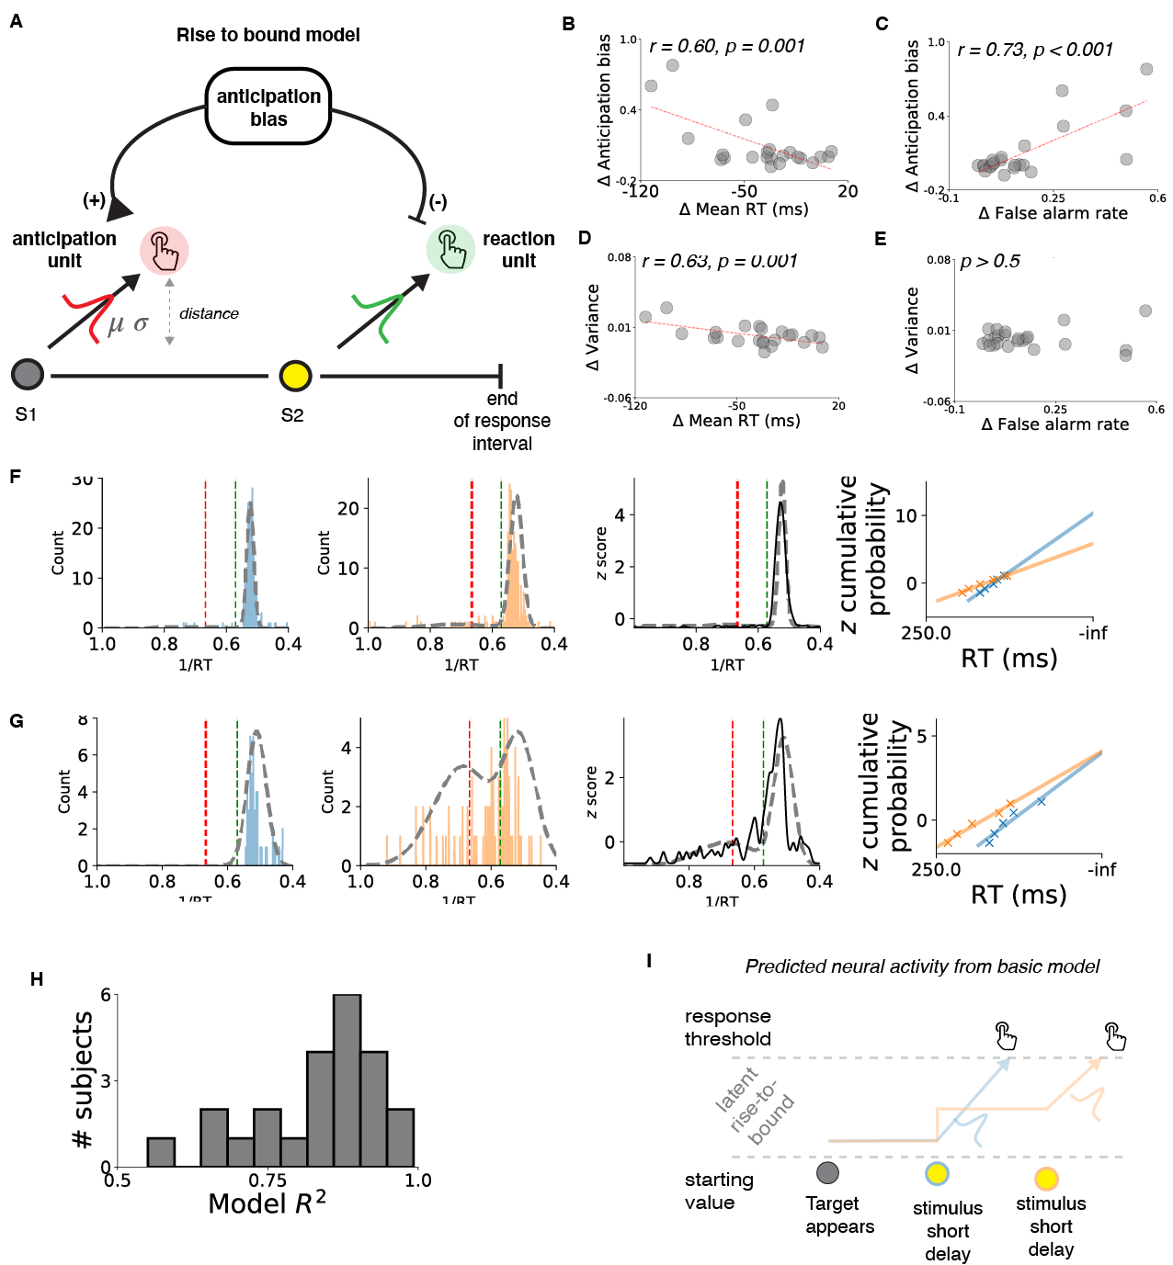

Fig. S1.
Rise-to-bound model of RT variability. (A) Model schematic. (B–E) Scatterplots showing relationships between model parameters (ordinates) and delay-related changes in model-free measures of RT (abscissas). (F,G) RT distributions and model-fits (dashed lines) for two example subjects. Panels from left-to-right: 1) reciprocal RTs (blue) and model-fits on short-delay trials; 2) reciprocal RTs (orange) and model-fits on long-delay trials; 3) full reciprocal RT distribution and model fits (z-scored probability distribution); and 4) RTs from each delay condition (points are binned data, lines are model fits) shown on a reciprobit axis (13). (H) Distribution of R² values indicating goodness-of-fit across subjects. (I) Schematic illustrating neural activity predicted by algorithmic “rise-to-bound” models of RT variability (13).

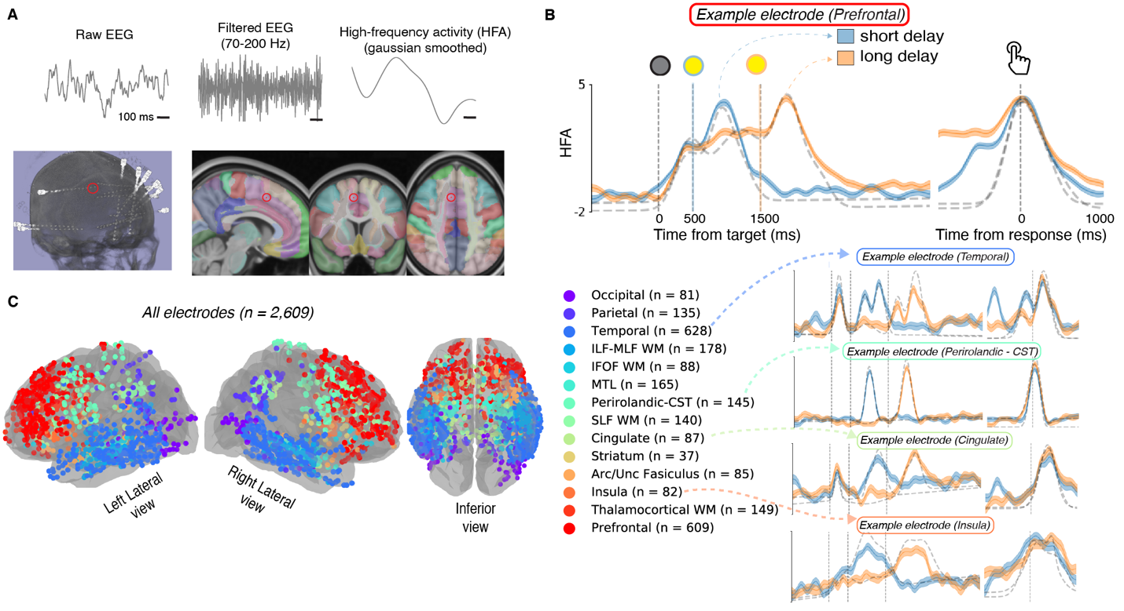

Fig. S2
Measuring local neural activity in widespread brain regions (A) The left panel shows the electrode coverage in one subject (#179), illustrated using a three-dimensional representation of a Computed Tomography (CT) scan. The red circle indicates the location of the electrode pair used to generate data in panels A and B. We estimated local neural activity near each bipolar electrode pair by extracted continuous high-frequency activity (HFA; 70–200 Hz power) from iEEG using wavelet convolution of the voltage time series. We estimated the anatomical location of the source of each HFA signal by relating the mid-point between the pair of electrodes used to record that signal to volume-based white-matter and gray-matter atlases. The right panel shows the estimated location (red circles) in standard Montreal Neurologic Institute (MNI) space with overlying white and gray matter segmentation. Each color represents a different anatomical region. (B) Task-driven activation functions for the electrode in panel A (average z-scored HFA locked to target and response) separately for short- (blue) and long- (orange) delay trials. Lines and ribbons are mean±sem across trials. Dashed grey lines indicate model fits from the Gaussian curve-fitting algorithm. (C) Brain plot showing electrode locations from all subjects in standard MNI coordinates. Colors indicate regions of interest (table S4). Right panel shows four example activation functions illustrating heterogeneity of responses we observed across the brain, many of which reflected task-events with high temporal resolution.

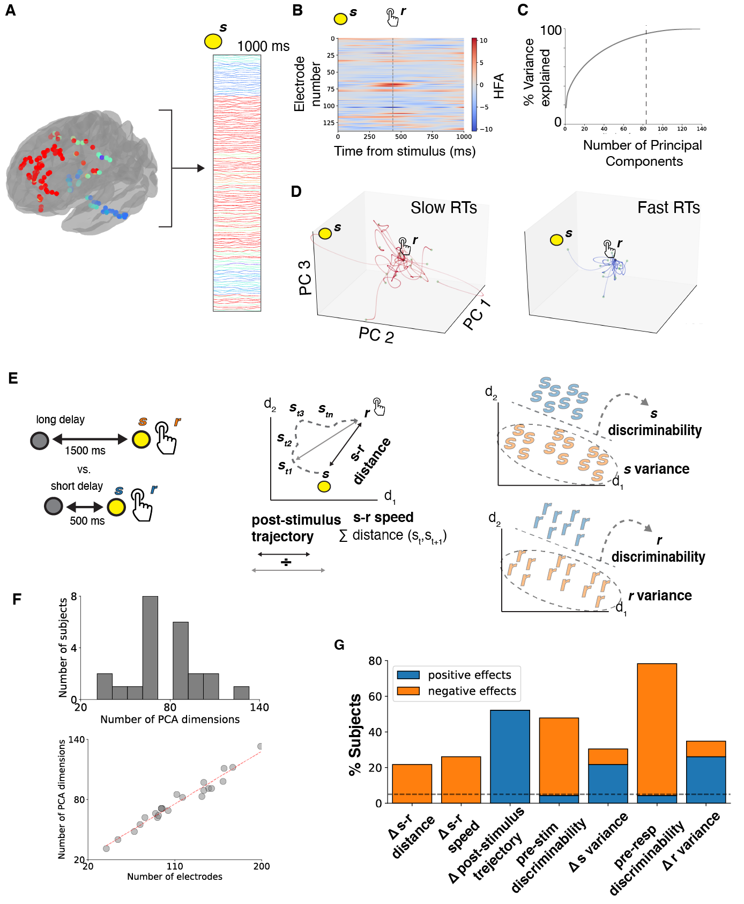

Fig. S3.
Measuring widespread neural-state dynamics using simultaneous multi-site recordings. (A) We defined neural state as the widespread pattern of HFA across all electrodes at a moment in time. Brain plot illustrates electrode locations in standardized MNI coordinates for a single subject. Right panel shows example segments of HFA from each electrode for a single trial (1000 ms following stimulus onset, yellow circle; each row indicates an electrode). Colors in both panels indicate each electrode’s assigned region of interest (Figure 3 for legend). (B) Color plot representing multi-site recordings. Same data as A. Red indicates positive HFA values, blue indicates negative HFA values (z-scored). Grey vertical dashed line indicates time of response on this trial (finger press). Neural-state dynamics are computed between time of stimulus and response on each trial. (C) Neural-state variability across electrodes over time was high dimensional (83 Principal components were required to explain 95% of variability). (D) Trajectories illustrating how the neural state fluctuates over time from stimulus onset to response onset using a reduced 3-dimensional representation (i.e., the first three principal components) for the 15 slowest RTs (red, left panel) and 15 fastest RTs (blue, right panel) for Subject #179. Each trajectory is drawn centered on the neural state at the time of the motor response (finger press, black dot). Yellow circle represents neural state at the start of one trial. (E) Schematic illustrating measures used to quantify trial-to-trial variability neural-state dynamics. Left panel shows identification of stimulus and response neural states for short and long-delay trials. Middle panel illustrates measurement of within-trial measures using a schematic 2-dimensional representation of neural-state space. We compared these measures across delay conditions ($Δ$ s-r distance, $Δ$ post-stimulus trajectory, $Δ$ s-r speed). Right panel illustrates additional across-trial measures (discriminability and variance for stimulus and response neural states). (F) Neural-state dynamics show high dimensional variability at the group level. (Top) Histogram of the number of components needed to explain 95% of the variance across subjects. (Bottom) Correlation between number of components and the number of implanted electrodes in each subject. (G) Number of subjects that showed significant delay-related modulations in neural-state dynamics (non-parametric test, p < 0.05)

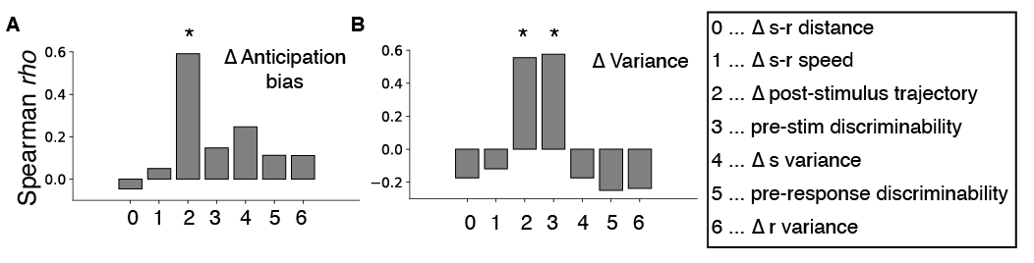

Fig. S4.
Relating neural-state dynamics to anticipatory modulation of RT variability (A,B) Spearman correlations between individual differences in delay-related changes in rise-to-bound model parameters and various neural dynamics (fig. S3). “*” indicates FDR-corrected p < 0.05

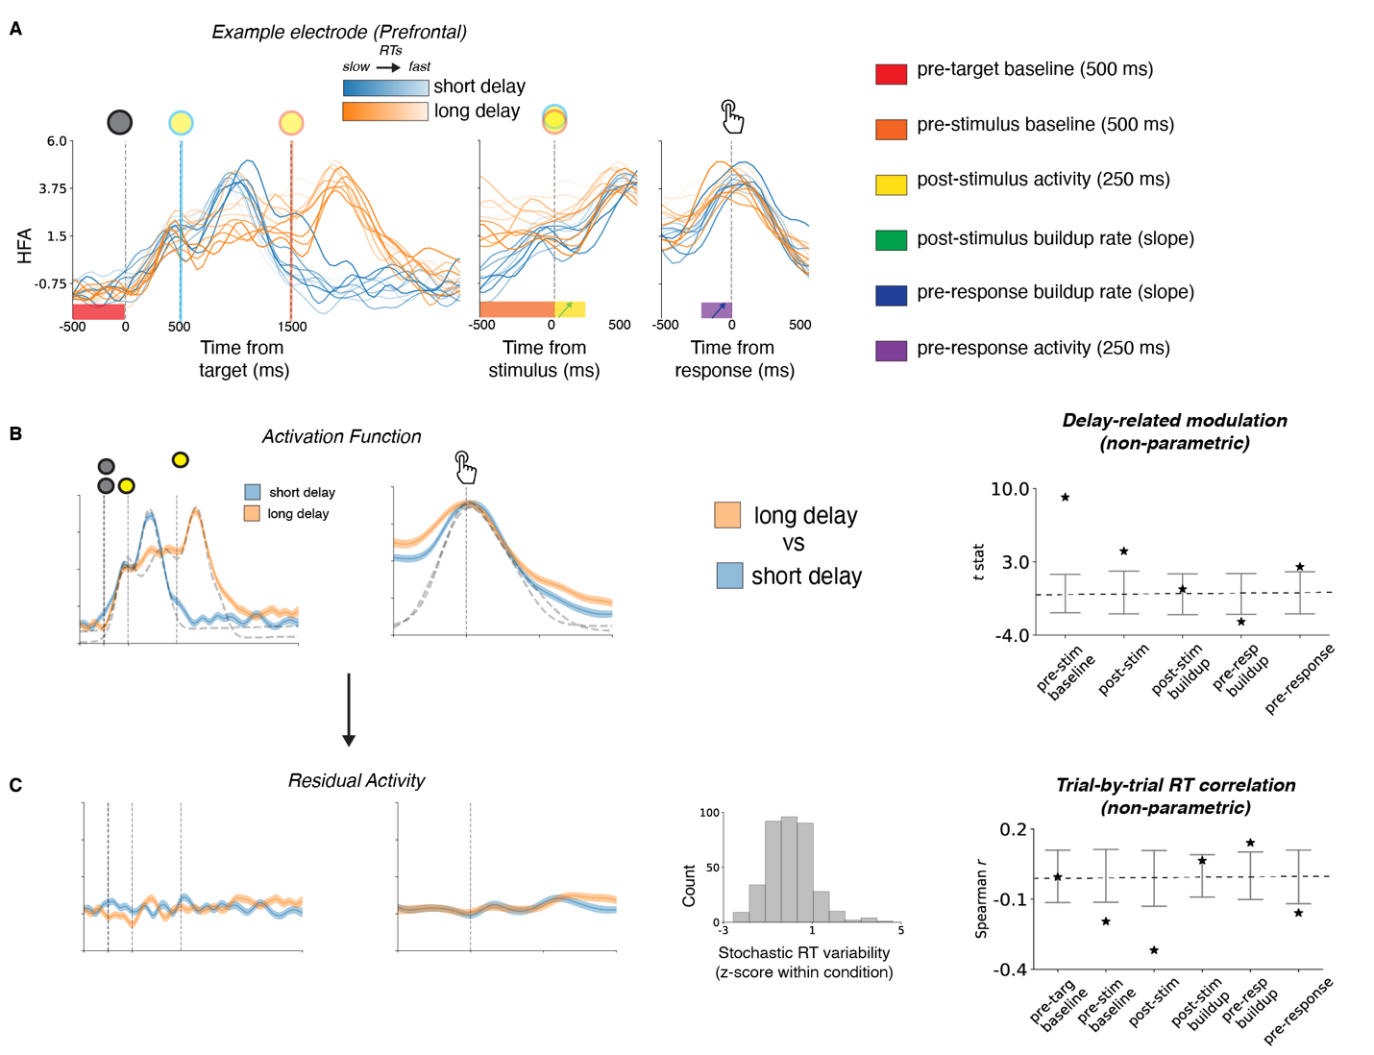

Fig. S5.
Overview of the methods used to relate each electrode’s activation function to the delay condition and stochastic RT variability. (A) Example target-, stimulus- and response-locked activation functions from a single electrode, same electrode as in Fig. 2b. The legend to the right shows the specific within-trial activity measures that we analyzed for delay- and RT-related modulations. (B) Delay-related differences for each within-trial activity measure were assessed using the raw activation functions. Error bars on the right panel indicate 95% confidence intervals from non-parametric shuffle procedure of the t statistic indicating the difference on short- versus long-delay trials.”*” indicates two-tailed p < 0.05. (C) Each within-trial activity measure was assessed for trial-to-trial correlations with stochastic RT variability (histogram in middle panel) using the residual activation function. Right panel shows non-parametric 95% confidence intervals (shown as in B except using Spearman’s $ρ$)

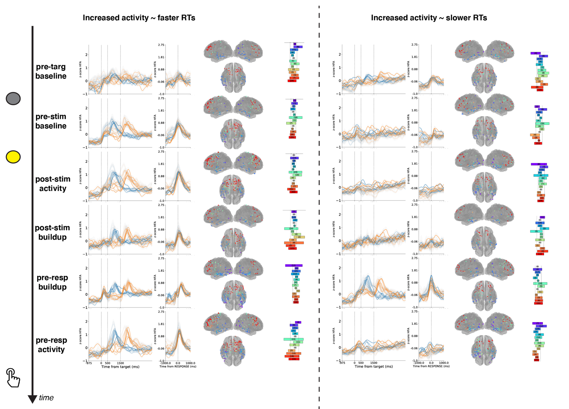

Fig. S6.
Neural representations of stochastic RT variability. Each row shows groups of electrodes with activity that showed correlations with stochastic, trial-to-trial RT variability during a specific within-trial interval. Left column shows negative correlations (increased activity with faster RTs); right columns shows positive correlations (increased activity with slower RTs). Rows represent different task epochs, as indicated (see fig. S5). Each panel depicts the average activation function, brain plots showing electrode locations in standard MNI coordinates space, and horizontal bar plots summarizing anatomical distributions for the given groups of electrodes, plotted as in Fig. 3.

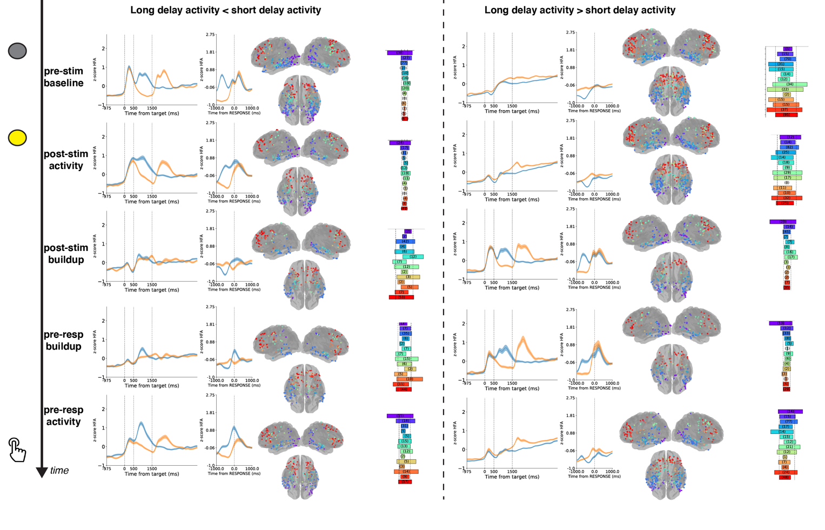

Fig. S7.
Neural representations of foreperiod delay. Each row shows groups of electrodes with activity that was weaker (left column) or stronger (right column) on long- versus short-delay trials during a specific within-trial interval. Rows represent different task epochs, as indicated (see fig. S5). Each panel depicts the average activation function, brain plots showing electrode locations in standard MNI coordinates space, and horizontal bar plots summarizing anatomical distributions for the given groups of electrodes, plotted as in Fig. S3, except that we do not show neural activity binned by RTs.

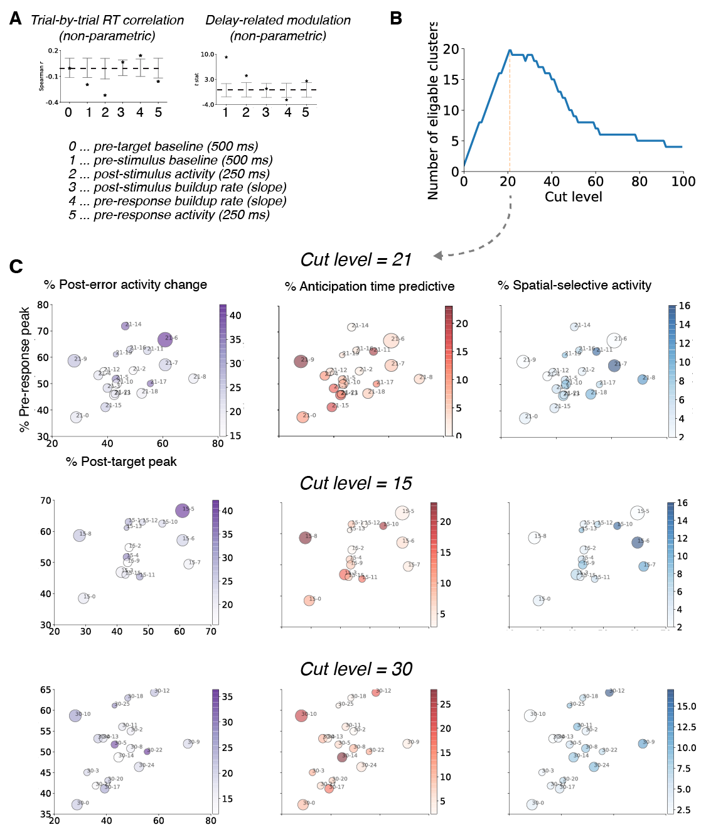

Fig. S8.
Overview of the hierarchical clustering algorithm. (A) Example feature vector for a single electrode, representing the presence and direction of a significant modulation by stochastic RT and foreperiod delay (p < 0.05, non-parametric tests, 0 for non-significant relation, -1 for significant negative relation, and +1 for significant positive relation; same data as fig. S5 b and c). (B) We identified a level of clustering based on an objective function that maximized the number of clusters that were well sampled in our dataset (i.e., each cluster consisted of at least 50 electrodes from at least 5 subjects). (C) Scatter plots illustrating various functional properties of each cluster that were independent of the clustering algorithm. Each row represents a different clustering level (the main analyses used a clustering level of 21, resulting in 20 eligible clusters, as depicted in the top row). Each circle represents an electrode cluster. Location within each scatter plot represents two properties of the average task-related activation function for each luster as defined by a Gaussian fit (Abscissa shows percentage of electrodes showing post-target peaks in activity; Ordinate shows percentage of electrodes showing pre-response peaks in activity). Size of circles indicate degree of anatomical localization (larger circles are more localized, based on $χ^{2}$ statistics comparing anatomical distribution to uniform). Color axes indicate additional task-related functional properties (based on parametric statistical tests) as follows. Left column (purple) shows percentage of electrodes that showed altered activity following errors (as compared to control trials, t-test, p < 0.05). Middle column (red) shows percentage of electrodes that showed correlations between post-target activity and timing of anticipatory false alarms (Spearman correlation, p < 0.05). Right column (blue) shows percentage of electrodes that showed differential post-target activity based on the location of the target on the screen (one way ANOVA, p < 0.05). Bottom two rows show functional properties of clusters for two different clustering levels, illustrating qualitatively similar functional properties.

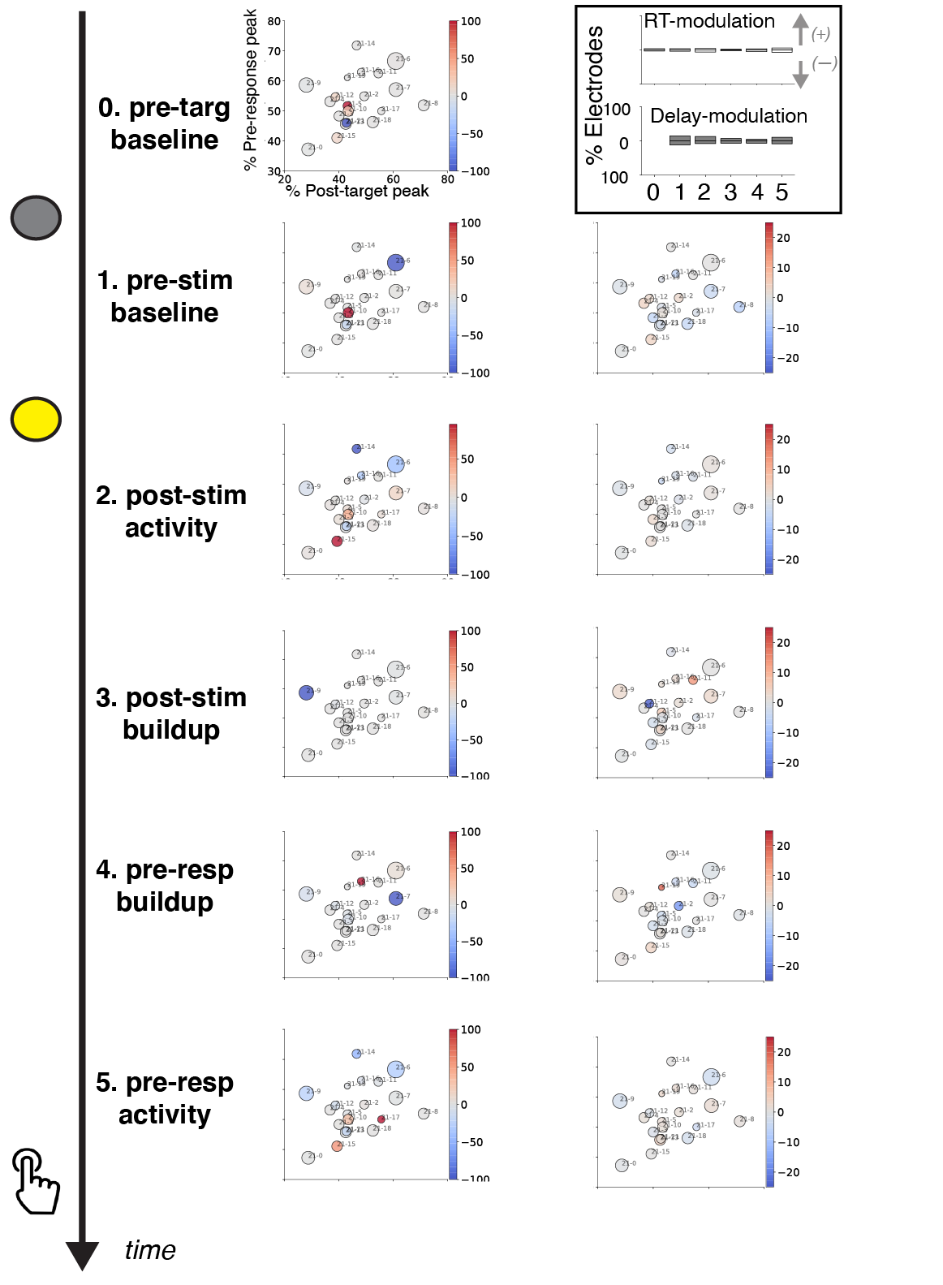

Fig. S9.
Defining functional properties for each electrode cluster. Each scatterplot summarizes cluster-specific properties (see Figs. 3C, S8). RT- (left column) and delay- (right column) related modulations for each cluster. Each row represents a distinct within-trial interval, as indicated. Red shading indicates frequency of positive effects (for RT, increased activity correlated with slower RTs; for delay, stronger activity on long-delay, as compared to short-delay trials). Blue shading indicates frequency of negative effects (for RT, increased activity correlated with faster RTs; for delay, stronger activity on short-delay, as compared to long-delay trials). (Inset, Top Right) Bar plot showing frequency of RT- and delay-modulation at various time intervals across all electrodes. Positive and negatively values indicate frequency of electrodes showing positive effects and negative effects, respectively (as described above).

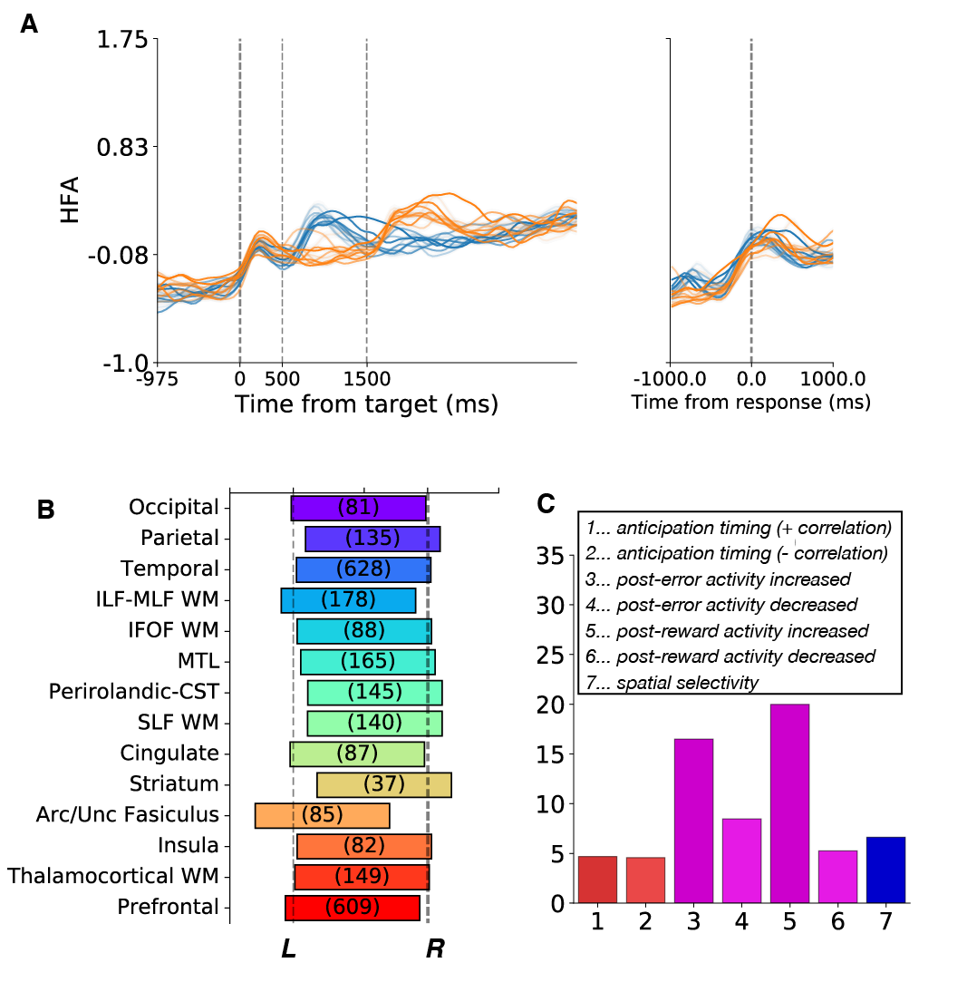

Fig. S10. Independent functional and anatomical properties used to evaluate clusters. (A) Average activation function for all electrodes. (B) anatomical distribution of all electrodes, shown in the same format as Fig. 3a. (C) Bar plot indicating the frequency of “secondary” selectivity effects (p < 0.05) across all electrodes, including several task-dependent functional properties that were not related to stochastic RT and foreperiod delay but instead were correlated with: 1, 2) false-alarm response times; 3, 4) post-error changes in activity; 5, 6) post-reward changes in activity and 7) spatial location of the stimulus.

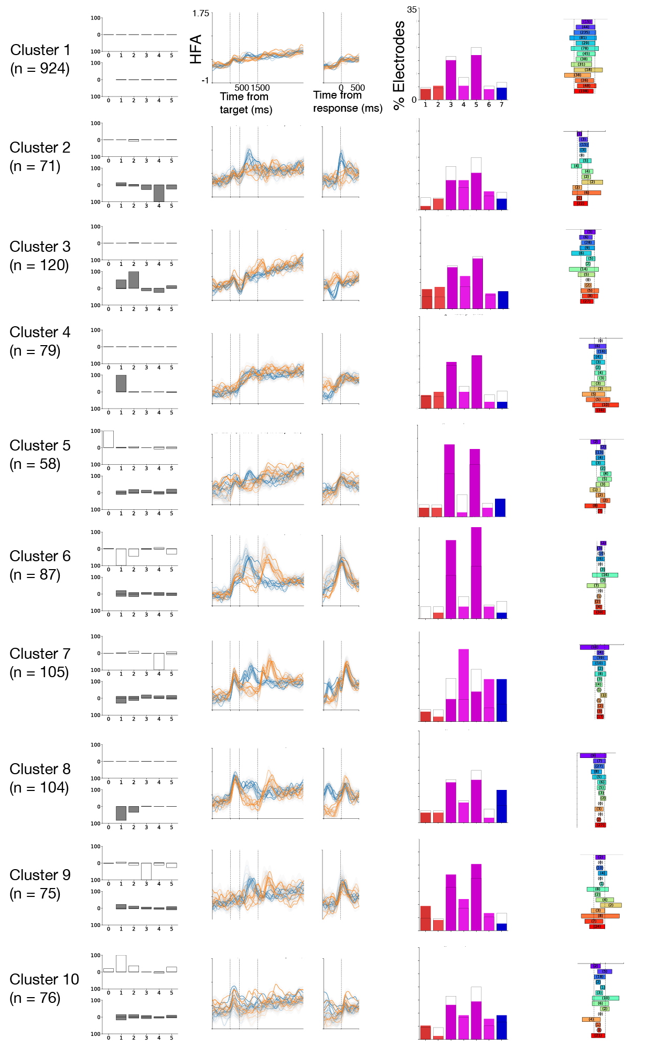

Fig. S11. Electrode clusters 1-10. For each cluster, we show stochastic RT and foreperiod delay relations (left, same as fig. S9, Inset), average target- and response-locked activation functions (middle-left, plotted as in Fig. 3D), functional properties independent of the clustering algorithm (middle-right, see fig. S10), and anatomical distribution (right panel, see Fig. 3A).

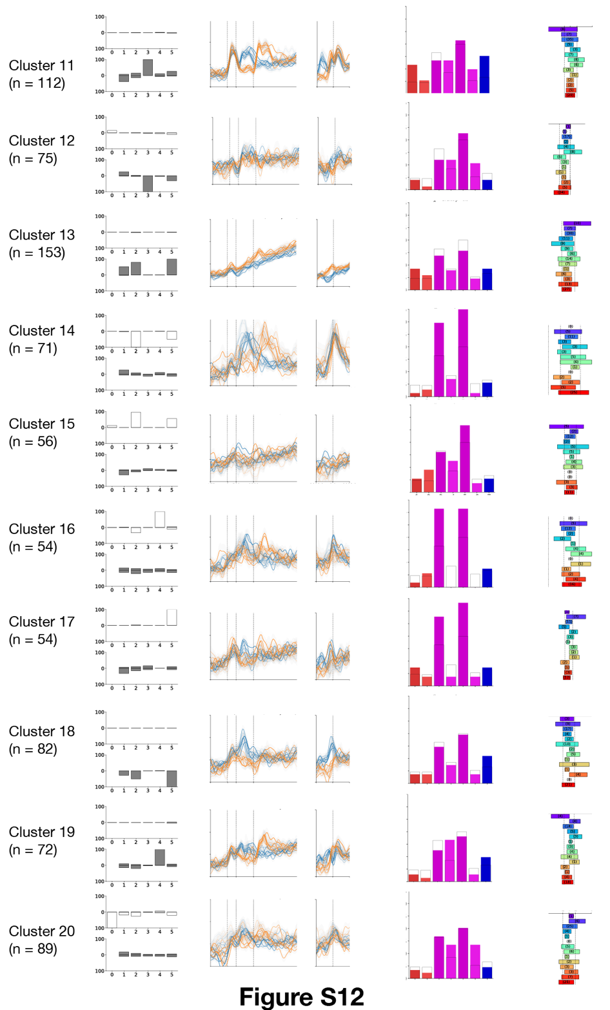

Fig. S12. Electrode clusters 11-20. Same as Fig. S11

Table S1.
Subject characteristics

Subject ID | Gender | Age at implant | Number of electrodes
133 | Female | 52 | 51
136 | Female | 57 | 103
140 | Female | 48 | 39
142 | Male | 30 | 68
143 | Female | 30 | 97
145 | Male | 21 | 96
146 | Male | 19 | 96
150 | Male | 16 | 90
152 | Female | 33 | 79
153 | Female | 56 | 92
154 | Female | 43 | 199
157 | Male | 25 | 145
160 | Female | 46 | 148
165 | Female | 20 | 93
168 | Male | 27 | 170
171 | Male | 49 | 160
178 | Female | 38 | 140
179 | Female | 19 | 140
181 | Female | 31 | 138
182 | Female | 25 | 118
184 | Male | 22 | 161
187 | Male | 24 | 74
191 | Female | 32 | 112

Table S2.
Subject Behavior
Subject | n. trials | n. sessions | mean RT on long delay (ms) | std RT on long delay (ms) | mean RT on short delay (ms) | std RT on short delay (ms) | anticipatory false alarm rate on short delay | anticipatory false alarm rate on long delay | lapse rate on short delay | lapse rate on long delay
HUP133 | 248 | 2 | 352.32 | 100.83 | 465.22 | 122.59 | 0.00 | 0.28 | 0.03 | 0.01
HUP136 | 236 | 1 | 425.99 | 53.87 | 489.51 | 95.57 | 0.06 | 0.08 | 0.00 | 0.03
HUP139 | 119 | 1 | 455.97 | 103.75 | 475.06 | 76.10 | 0.00 | 0.07 | 0.05 | 0.07
HUP140 | 177 | 1 | 428.92 | 52.22 | 422.20 | 53.46 | 0.01 | 0.15 | 0.00 | 0.00
HUP142 | 115 | 1 | 425.36 | 59.68 | 460.05 | 87.90 | 0.04 | 0.03 | 0.02 | 0.03
HUP143 | 110 | 1 | 487.45 | 92.09 | 531.96 | 56.92 | 0.00 | 0.02 | 0.02 | 0.00
HUP145 | 167 | 1 | 364.29 | 31.22 | 396.15 | 64.73 | 0.01 | 0.05 | 0.01 | 0.00
HUP146 | 234 | 1 | 375.09 | 50.71 | 373.64 | 46.95 | 0.01 | 0.16 | 0.01 | 0.00
HUP150 | 167 | 1 | 467.87 | 76.21 | 479.84 | 68.42 | 0.01 | 0.05 | 0.00 | 0.00
HUP152 | 164 | 1 | 398.42 | 53.55 | 389.61 | 72.92 | 0.08 | 0.57 | 0.01 | 0.00
HUP153 | 124 | 1 | 529.43 | 123.42 | 595.26 | 141.85 | 0.00 | 0.12 | 0.11 | 0.05
HUP154 | 120 | 1 | 501.74 | 90.12 | 533.73 | 122.79 | 0.02 | 0.10 | 0.02 | 0.01
HUP157 | 116 | 1 | 379.88 | 46.81 | 444.45 | 65.56 | 0.03 | 0.09 | 0.00 | 0.02
HUP160 | 174 | 1 | 523.43 | 81.61 | 547.32 | 103.38 | 0.00 | 0.05 | 0.09 | 0.01
HUP165 | 166 | 1 | 400.61 | 95.09 | 435.12 | 63.88 | 0.00 | 0.05 | 0.00 | 0.00
HUP168 | 130 | 1 | 373.69 | 28.14 | 422.86 | 82.53 | 0.00 | 0.28 | 0.00 | 0.00
HUP171 | 157 | 1 | 366.53 | 72.75 | 464.91 | 62.67 | 0.02 | 0.59 | 0.01 | 0.00
HUP178 | 260 | 2 | 451.93 | 91.35 | 478.19 | 110.55 | 0.02 | 0.20 | 0.05 | 0.05
HUP179 | 403 | 3 | 390.27 | 79.01 | 423.30 | 72.34 | 0.02 | 0.09 | 0.01 | 0.01
HUP181 | 263 | 2 | 451.22 | 139.21 | 539.17 | 152.55 | 0.02 | 0.17 | 0.11 | 0.05
HUP182 | 225 | 2 | 399.13 | 43.01 | 402.90 | 61.81 | 0.03 | 0.05 | 0.00 | 0.01
HUP187 | 290 | 2 | 323.76 | 40.88 | 354.84 | 77.84 | 0.00 | 0.49 | 0.00 | 0.01
HUP191 | 231 | 2 | 372.18 | 50.44 | 386.12 | 63.19 | 0.00 | 0.12 | 0.00 | 0.00

Table S3.
Model parameters

Subject | Mean target rise-to-bound) | Std. of target rise-to-bound | Mean of short delay rise-to-bound | Std. of short delay rise-to-bound | Anticipation bias on short delay trials | Mean long delay rise-to-bound | Std. of long delay rise-to-bound | Anticipation bias on long delay trials | R²
HUP133 | 0.69 | 0.09 | 0.51 | 0.03 | 0.00 | 0.51 | 0.05 | 0.60 | 0.55
HUP136 | 0.68 | 0.06 | 0.50 | 0.02 | 0.07 | 0.50 | 0.02 | 0.07 | 0.68
HUP139 | 0.97 | 0.01 | 0.51 | 0.02 | 0.00 | 0.51 | 0.02 | 0.04 | 0.90
HUP140 | 0.73 | 0.10 | 0.52 | 0.01 | 0.05 | 0.52 | 0.01 | 0.05 | 0.99
HUP142 | 0.79 | 0.10 | 0.51 | 0.02 | 0.04 | 0.51 | 0.02 | 0.04 | 0.86
HUP143 | 0.57 | 0.10 | 0.49 | 0.01 | 0.00 | 0.49 | 0.03 | 0.00 | 0.86
HUP145 | 0.73 | 0.00 | 0.53 | 0.02 | 0.01 | 0.53 | 0.01 | 0.00 | 0.86
HUP146 | 0.69 | 0.10 | 0.53 | 0.01 | 0.07 | 0.53 | 0.01 | 0.07 | 0.99
HUP150 | 0.70 | 0.00 | 0.51 | 0.02 | 0.01 | 0.51 | 0.02 | 0.00 | 0.92
HUP152 | 0.68 | 0.09 | 0.53 | 0.02 | 0.28 | 0.53 | 0.02 | 0.32 | 0.86
HUP153 | 0.61 | 0.03 | 0.48 | 0.03 | 0.05 | 0.48 | 0.03 | 0.03 | 0.72
HUP154 | 0.67 | 0.09 | 0.49 | 0.03 | 0.14 | 0.49 | 0.02 | 0.06 | 0.87
HUP157 | 0.82 | 0.10 | 0.51 | 0.02 | 0.03 | 0.51 | 0.02 | 0.05 | 0.73
HUP160 | 0.87 | 0.00 | 0.49 | 0.02 | 0.00 | 0.49 | 0.02 | 0.01 | 0.86
HUP165 | 0.62 | 0.06 | 0.52 | 0.02 | 0.01 | 0.52 | 0.03 | 0.06 | 0.80
HUP168 | 0.71 | 0.09 | 0.52 | 0.02 | 0.06 | 0.52 | 0.01 | 0.37 | 0.89
HUP171 | 0.74 | 0.10 | 0.51 | 0.02 | 0.04 | 0.51 | 0.05 | 0.82 | 0.91
HUP178 | 0.66 | 0.07 | 0.51 | 0.03 | 0.14 | 0.51 | 0.02 | 0.08 | 0.82
HUP179 | 0.71 | 0.10 | 0.52 | 0.01 | 0.05 | 0.52 | 0.02 | 0.12 | 0.86
HUP181 | 0.71 | 0.10 | 0.49 | 0.04 | 0.02 | 0.49 | 0.04 | 0.18 | 0.67
HUP182 | 0.67 | 0.06 | 0.53 | 0.02 | 0.06 | 0.53 | 0.01 | 0.01 | 0.93
HUP187 | 0.72 | 0.10 | 0.55 | 0.03 | 0.04 | 0.55 | 0.01 | 0.48 | 0.76
HUP191 | 0.69 | 0.10 | 0.53 | 0.01 | 0.08 | 0.53 | 0.01 | 0.08 | 0.94

Table S4.
Anatomical labels used to define Regions of Interest

Occipital' | MOG middle occipital gyrus', 'SOG superior occipital gyrus', 'OFuG occipital fusiform gyrus', 'IOG inferior occipital gyrus','LiG lingual gyrus','Occipital Lobe_wm','Optic Radiation L', 'Optic Radiation R','Forceps Major', 'Vertical Occipital Fasciculus L', 'Vertical Occipital Fasciculus R'
'Parietal' | AnG angular gyrus', 'PCu precuneus', 'SPL superior parietal lobule', 'SMG supramarginal gyrus', 'PO parietal operculum', 'Parietal Lobe_wm'
'Temporal' | FuG fusiform gyrus', 'ITG inferior temporal gyrus', 'PT planum temporale', 'MTG middle temporal gyrus', 'FuG fusiform gyrus/"BA36', 'PHG parahippocampal gyrus', 'STG superior temporal gyrus', 'TTG transverse temporal gyrus', 'PP planum polare', 'TMP temporal pole', 'Temporal Lobe_wm', 'Acoustic Radiation L', 'Acoustic Radiation R'
'ILF-MLF WM' | Inferior Longitudinal Fasciculus L', 'Inferior Longitudinal Fasciculus R', 'Middle Longitudinal Fasciculus L', 'Middle Longitudinal Fasciculus R'
'MTL' | Hippocampus', 'Amygdala', ' entorhinal area', 'Fornix L', 'Fornix R'
'Perirolandic-CST' | 'PoG postcentral gyrus', 'CO central operculum', 'PrG precentral gyrus','Corticospinal Tract L', 'Corticospinal Tract R'
'IFOF WM' | Inferior Longitudinal Fasciculus L', 'Inferior Longitudinal Fasciculus R', 'Middle Longitudinal Fasciculus L', 'Middle Longitudinal Fasciculus R'
'SLF WM' | Superior Longitudinal Fasciculus 1 L', 'Superior Longitudinal Fasciculus 1 R', 'Superior Longitudinal Fasciculus 2 L', 'Superior Longitudinal Fasciculus 2 R', 'Superior Longitudinal Fasciculus 3 L', 'Superior Longitudinal Fasciculus 3 R'
'Cingulate' | ACgG anterior cingulate gyrus', 'PCgG posterior cingulate gyrus', 'MCgG middle cingulate gyrus', 'Cingulum subsection: Dorsal L', 'Cingulum subsection: Dorsal R', 'Cingulum subsection: Peri-genual L', 'Cingulum subsection: Peri-genual R', 'Cingulum subsection: Temporal L', 'Cingulum subsection: Temporal R'
'Striatum' | Putamen', 'Caudate_wm', 'Caudate', 'Putamen_wm'
'Arc/Unc Fasiculus' | Arcuate Fasciculus L', 'Arcuate Fasciculus R', 'Uncinate Fasciculus L', 'Uncinate Fasciculus R'
'Insula' | PIns posterior insula', 'AIns anterior insula', 'Insula_wm'
'Thalamocortical WM' | Anterior Thalamic Radiation R', 'Anterior Thalamic Radiation L', 'Superior Thalamic Radiation L', 'Superior Thalamic Radiation R', 'Frontal Aslant Tract L', 'Frontal Aslant Tract R'
'Prefrontal' | FO frontal operculum', 'OpIFG opercular part of the inferior frontal gyrus', 'OrIFG orbital part of the inferior frontal gyrus', 'MFG middle frontal gyrus', 'TrIFG triangular part of the inferior frontal gyrus', 'SMC supplementary motor cortex', 'POrG posterior orbital gyrus', 'SFG superior frontal gyrus', 'GRe gyrus rectus', 'MOrG medial orbital gyrus', 'MFC medial frontal cortex', 'MSFG superior frontal gyrus medial segment', 'AOrG anterior orbital gyrus', 'FRP frontal pole', 'Forceps Minor', 'Anterior Commissure', 'Frontal Lobe_wm'

Table S5.
Frequency of electrodes showing correlations with stochastic RT variability by region

roi | obs (omnibus) | tot | % | chiSq | p_corr | obs_pos (univariate) | obs_neg (univariate) | chiSq_PosVNeg | p_posVNeg_corr
Occipital | 28 | 81 | 34.57 | 149.08 | 0 | 14 | 17 | 0.29 | 0.65
Parietal | 34 | 135 | 25.19 | 115.8 | 0 | 25 | 25 | 0 | 1
Temporal | 152 | 628 | 24.2 | 487.57 | 0 | 91 | 118 | 3.49 | 0.22
ILF-MLF WM | 23 | 178 | 12.92 | 23.51 | 0 | 18 | 31 | 3.45 | 0.22
IFOF WM | 19 | 88 | 21.59 | 51 | 0 | 17 | 9 | 2.46 | 0.27
MTL | 26 | 165 | 15.76 | 40.2 | 0 | 23 | 15 | 1.68 | 0.34
Perirolandic-CST | 56 | 145 | 38.62 | 345.05 | 0 | 27 | 50 | 6.87 | 0.06
SLF WM | 40 | 140 | 28.57 | 163.76 | 0 | 27 | 31 | 0.28 | 0.65
Cingulate | 17 | 87 | 19.54 | 38.72 | 0 | 12 | 17 | 0.86 | 0.49
Striatum | 3 | 37 | 8.11 | 0.75 | 0.39 | 3 | 5 | 0.5 | 0.61
Arc/Unc Fasiculus | 14 | 85 | 16.47 | 23.54 | 0 | 10 | 16 | 1.38 | 0.37
Insula | 19 | 82 | 23.17 | 57 | 0 | 14 | 24 | 2.63 | 0.27
Thalamocortical WM | 32 | 149 | 21.48 | 85.16 | 0 | 25 | 36 | 1.98 | 0.32
Prefrontal | 175 | 609 | 28.74 | 722.31 | 0 | 100 | 146 | 8.6 | 0.05

Table S6.
Frequency of electrodes showing modulation by foreperiod delay by region

Region | Total | Number positive effect | Number negative effect | $χ^{2}$ statistic | p-value
Occipital | 81 | 14 | 15 | 0.03 | 0.92
Parietal | 135 | 15 | 18 | 0.27 | 0.77
Temporal | 628 | 77 | 31 | 19.59 | 0
ILF-MLF WM | 178 | 17 | 5 | 6.55 | 0.04
IFOF WM | 88 | 14 | 5 | 4.26 | 0.09
MTL | 165 | 15 | 15 | 0 | 1
Perirolandic-CST | 145 | 12 | 13 | 0.04 | 0.92
SLF WM | 140 | 21 | 12 | 2.45 | 0.21
Cingulate | 87 | 12 | 2 | 7.14 | 0.04
Striatum | 37 | 1 | 5 | 2.67 | 0.2
Arc/Unc Fasiculus | 85 | 7 | 3 | 1.6 | 0.32
Insula | 82 | 4 | 14 | 5.56 | 0.05
Thalamocortical WM | 149 | 24 | 9 | 6.82 | 0.04
Prefrontal | 609 | 48 | 57 | 0.77 | 0.53

Table S7.
Number of observations for each electrode cluster and $χ^{2}$ test assessing deviation of counts data from null

Cluster number | Number of electrodes | $χ^{2}$ statistic | p value ( FDR -corrected)
21-0 | 924 | 136.83 | 0
21-2 | 71 | 61.54 | 0.03
21-3 | 120 | 111.15 | 0
21-4 | 79 | 40.97 | 0.45
21-5 | 58 | 46.78 | 0.25
21-6 | 87 | 154.05 | 0
21-7 | 105 | 150.24 | 0
21-8 | 104 | 110.97 | 0
21-9 | 75 | 73.45 | 0
21-10 | 76 | 59.38 | 0.04
21-11 | 112 | 94.66 | 0
21-12 | 75 | 62.19 | 0.03
21-13 | 153 | 171.68 | 0
21-14 | 71 | 82.69 | 0
21-15 | 56 | 35.77 | 0.66
21-16 | 54 | 50.39 | 0.16
21-17 | 54 | 53.08 | 0.11
21-18 | 82 | 103.97 | 0
21-19 | 72 | 44.97 | 0.3
21-20 | 89 | 52.85 | 0.11

