Supplementary material

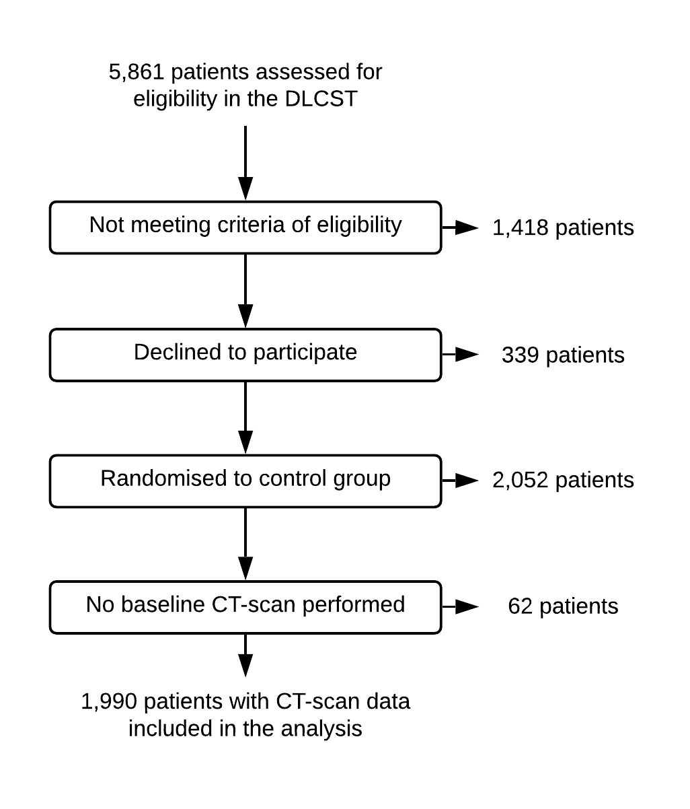
Supplementary figure 1: Flowchart of inclusion of patients in the follow-up study. DLCST. Danish lung cancer screening trial.

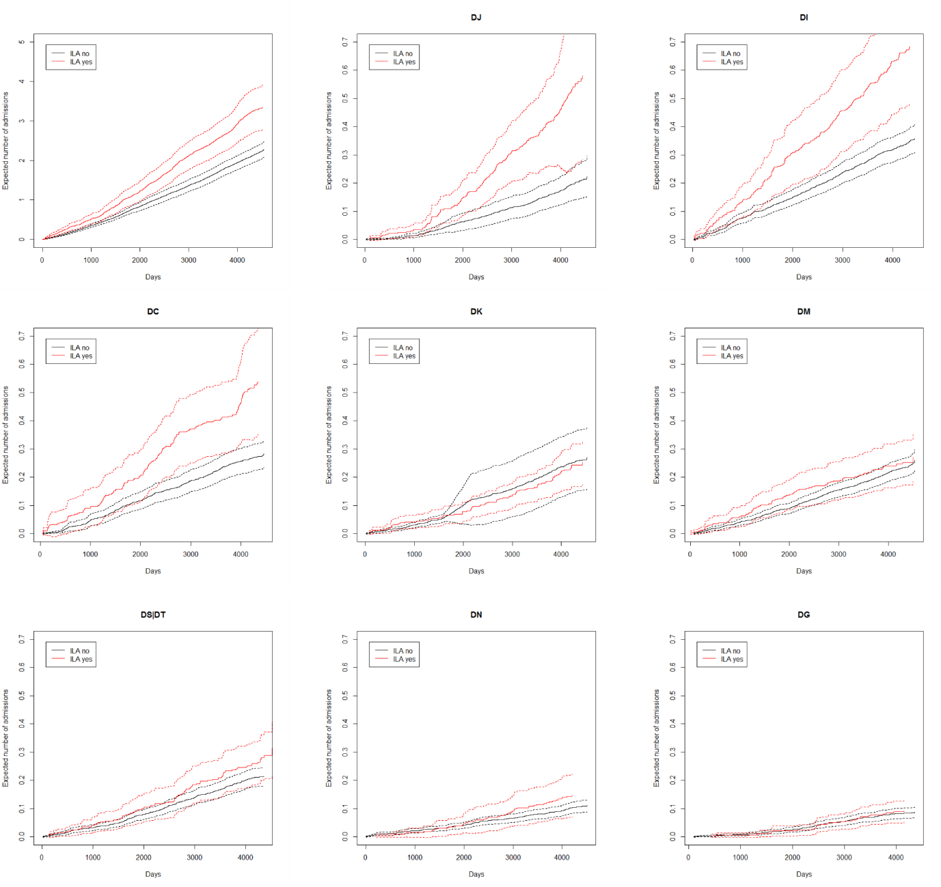
Supplementary figure 2: Expected number of hospital admissions in participants with ILA and without ILA respectively based on a marginal Cox proportional hazards model of a recurrent event model (hospital admissions) with gap times and a terminal event model (death). Dashed lines indicate standard errors. Note the different scales. DJ: respiratory disease, DI: cardiovascular disease, DC: malignant disease, DK: gastrointestinal disease, DM: diseases of the musculoskeletal system, DS and DT: injury and poisoning, DN: genitourinary disease, DG: nervous system disease
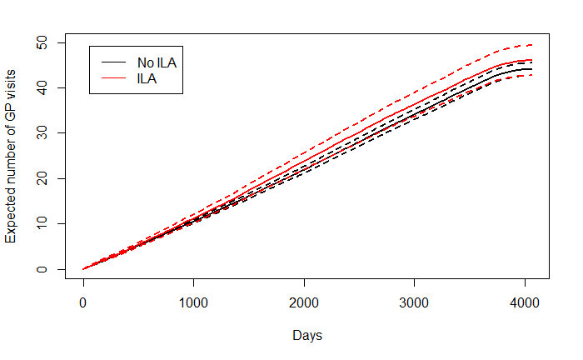
Supplementary figure 3: Expected number of visits to a general practitioner in participants with ILA and without ILA respectively based on a marginal Cox proportional hazards model of a recurrent event model (GP visits) and a terminal event model (death).

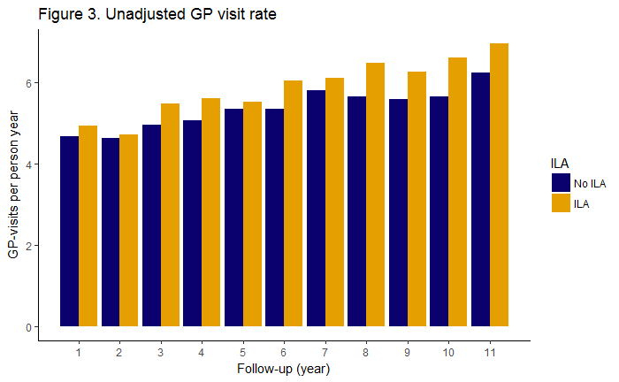
Supplementary figure 4: Unadjusted GP-visit rates in participants with ILA and participants without ILA. ILA: interstitial lung abnormalities

Disease group | ICD-10 codes
Respiratory disease | DJ00–DJ99
COPD | DJ40–DJ44
Pneumonia | DJ09–DJ18
Asthma | DJ45
Pleural empyema or lung abscess | DJ85–DJ86
Interstitial lung disease | DJ84, DJ60–DJ64, DJ67
Respiratory failure | DJ96
Cardiovascular disease | DI00–DI99
Heart failure | DI50
Pulmonary embolism | DI26
Atrial fibrillation/atrial flutter | DI48
Ischemic heart disease | DI20–DI25
Cerebral infarction | DI63
Peripheral vascular disease | DI73
Malignant neoplasm | DC00–DC99
Lung cancer | DC34
Non-pulmonary cancer | DC00–DC29, DC40–DC99
Gastrointestinal disease | DK00–DK99
GERD, gastritis or ulcer disease | DK20–DK30
Functional intestinal disorders | DK59
Diseases of the musculoskeletal system and connective tissue | DM00–DM99
Inflammatory polyarthropathies | DM04–DM14
Supplementary table 1: ICD10 codes for the classification of contact diagnoses for the analysis of development of disease and hospital admission rates.

Medicine group | ATC code
Inhalation therapy | R03A, R03B
Antibiotic therapy | J01
Prednisolone | H02AB06
Proton pump inhibitors | A02BC
Antithrombotic therapy | B01A
Antihypertensive therapy | C02
Loop diuretics | C03C
Lipid lowering agents | C10
Antidiabetics | A10
Supplementary table 2: ATC codes used to classify medicine groups for the analysis of medicine use.

CT finding | N (%)
All ILA | 332 (16.7%)
Ground glass | 115 (5.8%)
Nodular pattern | 155 (7.8%)
Reticular pattern | 162 (8.1%)
Honeycombing | 12 (0.6%)
Supplementary table 3: Number of the specific ILA findings on the CT scans. Some scans had more than one type of ILA.

Diagnosis | ILA (%) | No ILA (%) | HR | 95% CI | P-value
Respiratory | 116 (34.9) | 361 (21.8) | 1.44 | 1.16-1.79 | < 0.001
COPD | 55 (16.6) | 159 (9.6) | 1.24 | 0.90-1.71 | 0.190
Pneumonia | 56 (16.9) | 126 (7.6) | 1.74 | 1.25-2-41 | < 0.001
Asthma | 4 (1.2) | 47 (2.8) | 0.36 | 0.13-1.02 | 0.054
Pleural empyema or lung abscess | 5 (1.5) | 3 (0.2) | 5.55 | 1.24-24.77 | 0.025
Interstitial lung disease | 8 (2.4) | 8 (0.5) | 4.56 | 1.67-12.49 | 0.003
Respiratory failure | 25 (7.5) | 61 (3.7) | 2.02 | 1.09-3.75 | 0.025
Malignant neoplasm | 93 (28.0) | 317 (19.1) | 1.33 | 1.05-1.68 | 0.019
Lung cancer | 39 (11.7) | 71 (4.3) | 2.36 | 1.57-3.53 | < 0.001
Non-pulmonary cancer | 67 (20.2) | 266 (16.0) | 1.16 | 0.89-1.53 | 0.280
Cardiovascular | 157 (47.3) | 652 (39.3) | 1.18 | 0.99-1.41 | 0.072
Heart failure | 19 (5.7) | 47 (2.8) | 1.37 | 0.78-2.39 | 0.270
Pulmonary embolism | 8 (2.4) | 22 (1.3) | 1.79 | 0.78-4.12 | 0.170
Atrial fibrillation/atrial flutter | 27 (8.1) | 95 (5.7) | 1.26 | 0.82-1.96 | 0.296
Ischemic heart disease | 50 (15.1) | 174 (10.5) | 1.36 | 0.98-1.87 | 0.065
Cerebral infarction | 18 (5.4) | 59 (3.6) | 1.25 | 0.73-2.16 | 0.420
Peripheral vascular disease | 21 (6.3) | 50 (3.0) | 1.72 | 1.01-2.92 | 0.044
Gastrointestinal | 125 (37.7) | 489 (29.5) | 1.29 | 1.06-1.58 | 0.012
GORD, gastritis or ulcer disease | 25 (7.5) | 95 (5.7) | 1.27 | 0.81-1.99 | 0.30
Functional intestinal disorders | 28(8.4) | 66(4.0) | 2.11 | 1.34-3.31 | 0.001
Musculoskeletal system and connective tissue | 140 (42.2) | 739 (44.6) | 1.00 | 0.84-1.21 | 0.940
Inflammatory polyarthropathies | 8 (2.4) | 57 (3.4) | 0.72 | 0.34-1.52 | 0.380
Supplementary table 4: Risk of receiving a specific diagnosis during follow-up in participants with and without ILA, respectively. Cox regression analysis is adjusted for age, sex, BMI, pack-years and FEV₁. ILA: interstitial lung abnormalities, HR: hazard ratio, COPD: chronic obstructive pulmonary disease, GORD: gastro-oesophageal reflux disease

