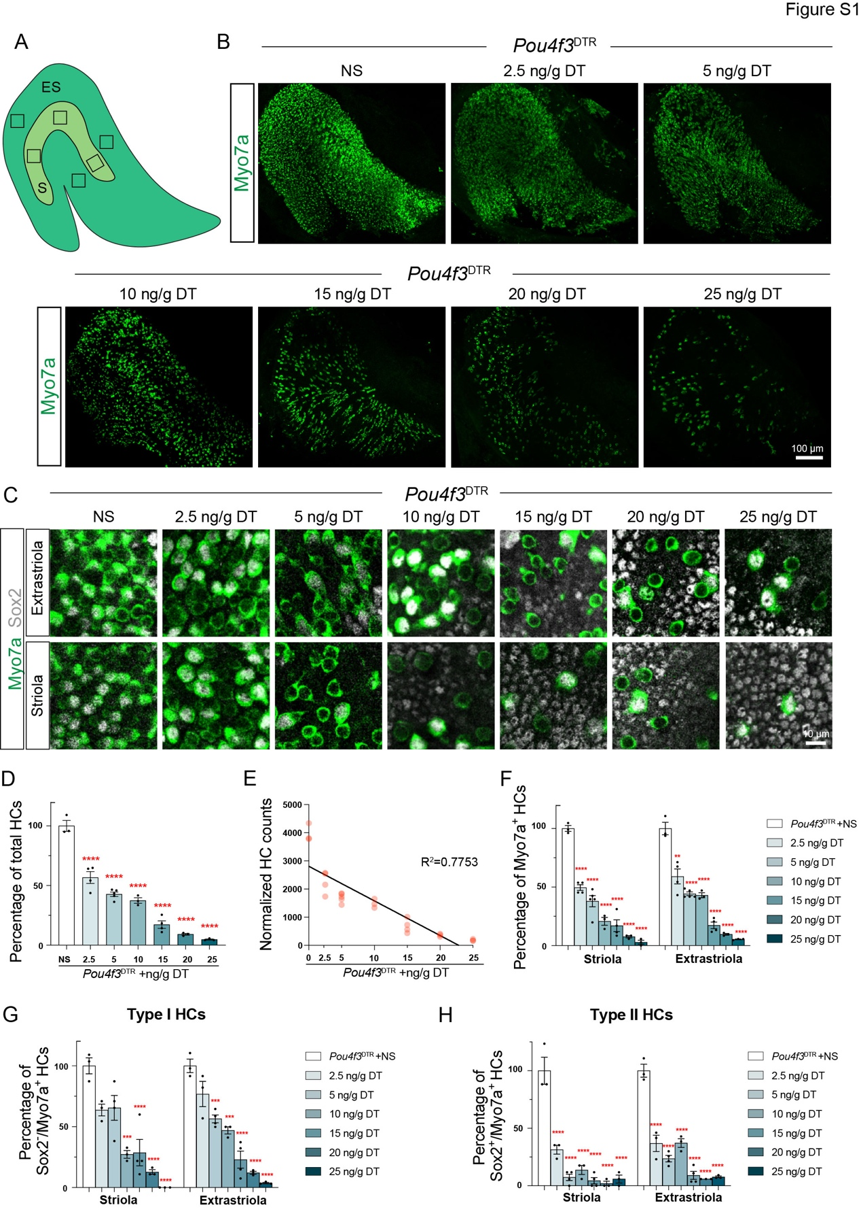

Figure S1. DT injection induced dose-dependent injury of saccular HCs. Related to Figure 3.
(A) Schematic of the saccule and its different zones, including the striola (S) and the extrastriola (ES). Squares indicate sampling regions for quantitative statistics.
(B) Low-magnification images showing a decrease in Myo7a⁺ HC density with increasing doses of DT.
(C) Representative images demonstrating a decrease in Myo7a⁺, Sox2⁻/Myo7a⁺, and Sox2⁺/Myo7a⁺ HCs in both the striola and extrastriola following increasing doses of DT
(D) Total HC counts expressed as percentages of the control group.
(E) The number of residual saccular HCs correlates with the doses of DT (simple linear regression, p < 0.0002).
(F-H) Counts of Myo7a⁺ HCs (F), Sox2⁻/Myo7a⁺ type I HCs (G) and Sox2⁺/Myo7a⁺ type II HCs (H) in the striola and extrastriola expressed as percentages of the control group.
Scale bars: 100 µm in B; 10 µm in C. Red asterisks indicate statistical significance compared with the NS group. One-way ANOVA was performed for D, F-H. * p < 0.05, ** p < 0.01, *** p < 0.001, **** p < 0.0001.

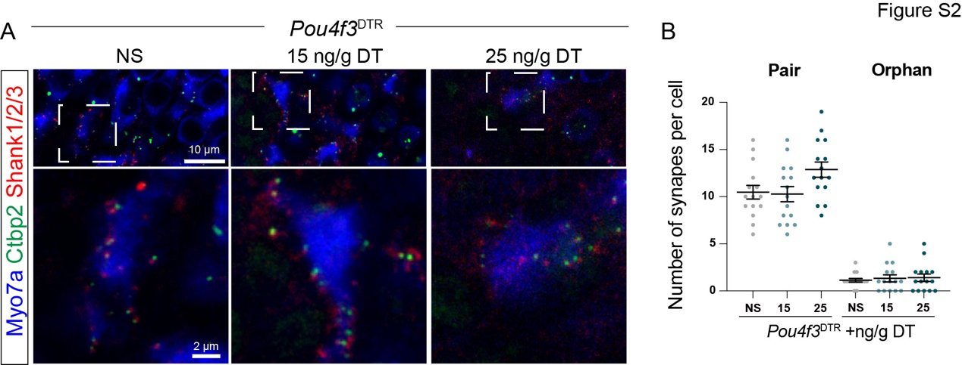
Figure S2. Synapses of the residual utricular HCs after DT treatment. Related to Figure 4.
(A) Representative immunofluorescence images of Ctbp2, Shank1/2/3 and Myo7a.
(B) Quantification of Ctbp2⁺/ Shank1/2/3⁺paired synapses and orphan Ctbp2⁺ puncta (per HC). No significant differences were found among the three groups.
Scale bars: 2 µm. One-way ANOVA was performed for B.

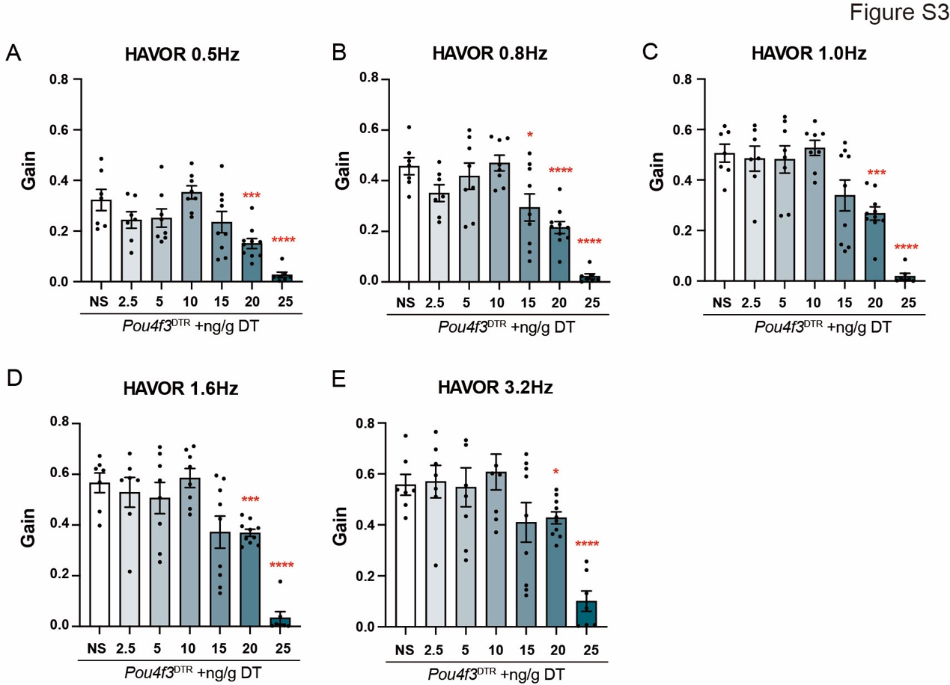
Figure S3 HAVOR test results from DT-injected Pou4f3^{DTR} mice. Related to Figure 5.
(A-E) Gain values in the HAVOR tests at various frequencies. Red asterisks indicate statistical significance compared with the NS group. One-way ANOVA was performed for A-E. * p < 0.05, ** p < 0.01, *** p < 0.001, **** p < 0.0001.

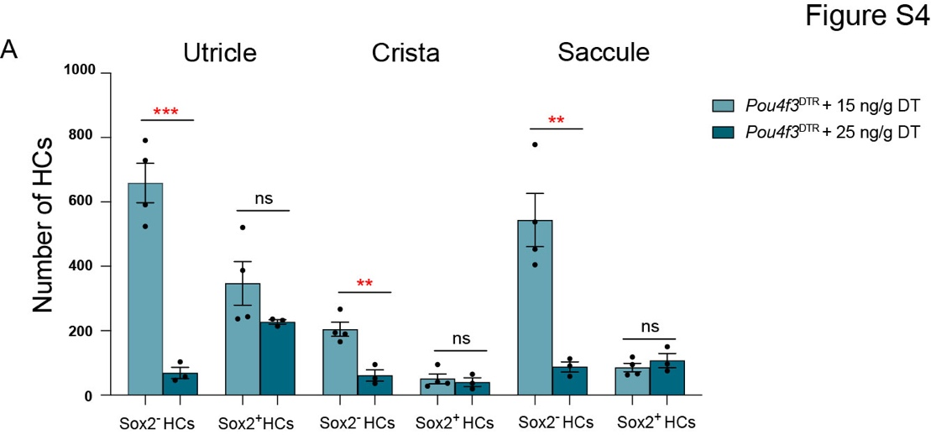
Figure S4 Quantification of Sox2⁻ type I and Sox2⁺ type II vestibular HCs in Pou4f3^{DTR} mice treated with 15 or 25 ng/g DT. Related to Figure 6.
(A) The number of Sox2⁺ type II HCs was comparable between the two groups, whereas Sox2⁻ type I HCs were significantly reduced in the 25 ng/g DT group. Data were analyzed by unpaired t-test. ** p < 0.01; ns, not significant.
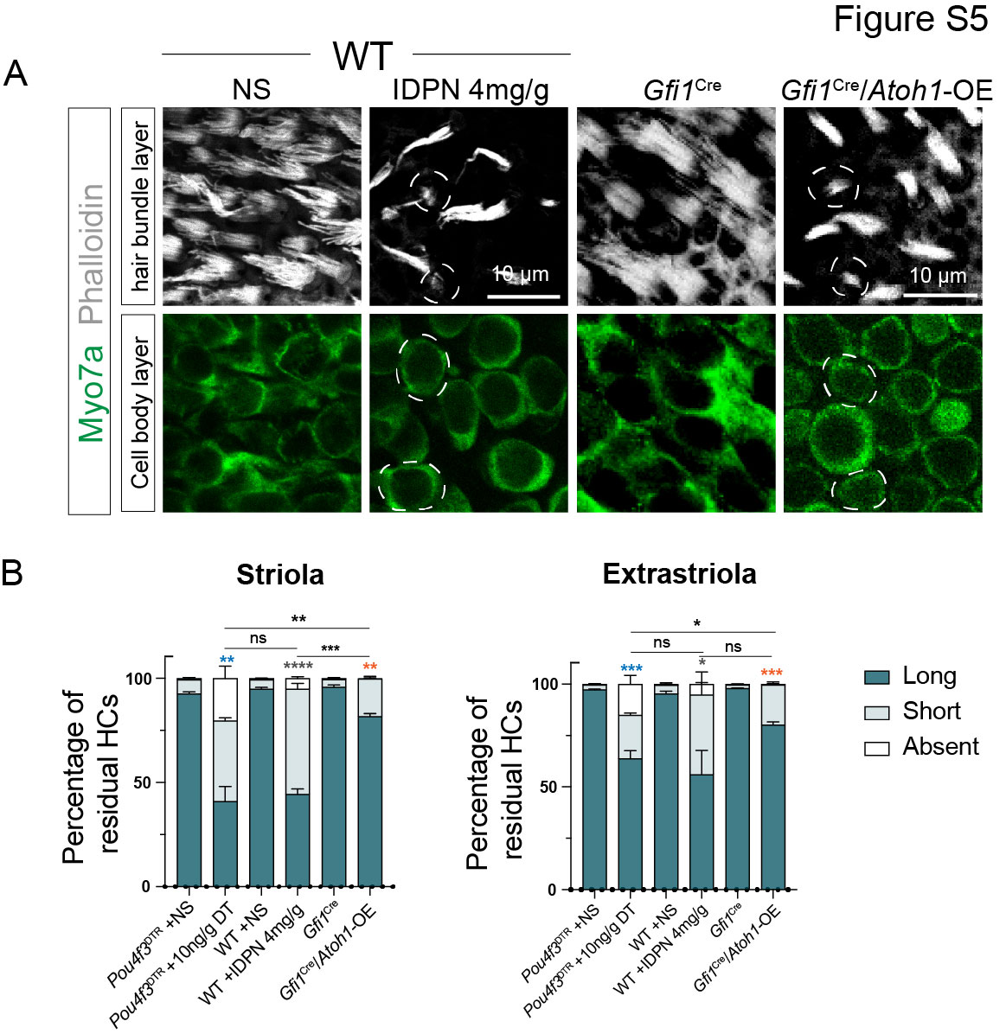

Figure S5 The effect of IDPN and Atoh1 overexpression on stereociliary bundles and innervation of utricular HCs. Related to Figure 6.
(A) High-magnification images of Phalloidin-labeled HC bundles. The white dashed lines mark HCs with short bundles.
(B) Statistical data showing the percentages of residual HCs with long, short, or no bundles. Statistical significance for the percentages of HCs with long bundles is indicated on the graph.
Scale bars: 10 μm in A. Blue, grey, and orange asterisks indicate statistical significance compared with the respective controls. Black asterisks indicate statistical significance between the two groups marked by the straight lines. Unpaired t-test was performed in B. * p < 0.05, ** p < 0.01, *** p < 0.001, **** p < 0.0001, ns, not significant.

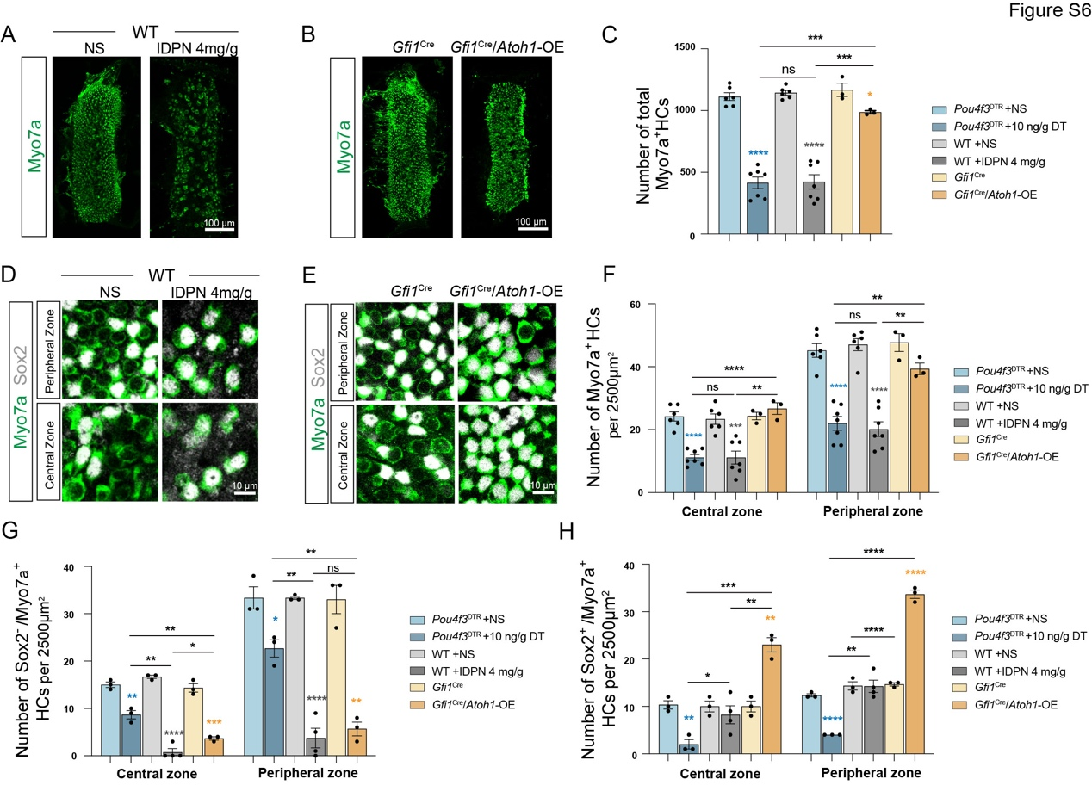
Figure S6 IDPN injection or Atoh1 overexpression reduced crista type I HCs. Related to Figure 6.
(A-B) Low-magnification images showing Myo7a⁺ HC density in the cristae.
(C) Quantification of total crista HC numbers.
(D-E) Representative images demonstrating that most crista HCs in IDPN-treated mice (D) or Gfi1^{Cre}/Atoh1-OE mice (E) were Sox2⁺ HCs in both the central and peripheral zones.
(F-H) Quantification of Myo7a⁺ HCs (F), Sox2–/Myo7a⁺ HCs (G) and Sox2⁺/Myo7a⁺ HCs (H) in the central and peripheral zones.
Scale bars: 100 μm in A and B; 10 μm in D and E. Blue, grey, and orange asterisks indicate statistical significance compared with the respective controls. Black asterisks indicate statistical significance between the two groups marked by the straight lines. Unpaired t-test was performed for C, F-H. * p < 0.05, ** p < 0.01, *** p < 0.001, **** p < 0.0001, ns, not significant.

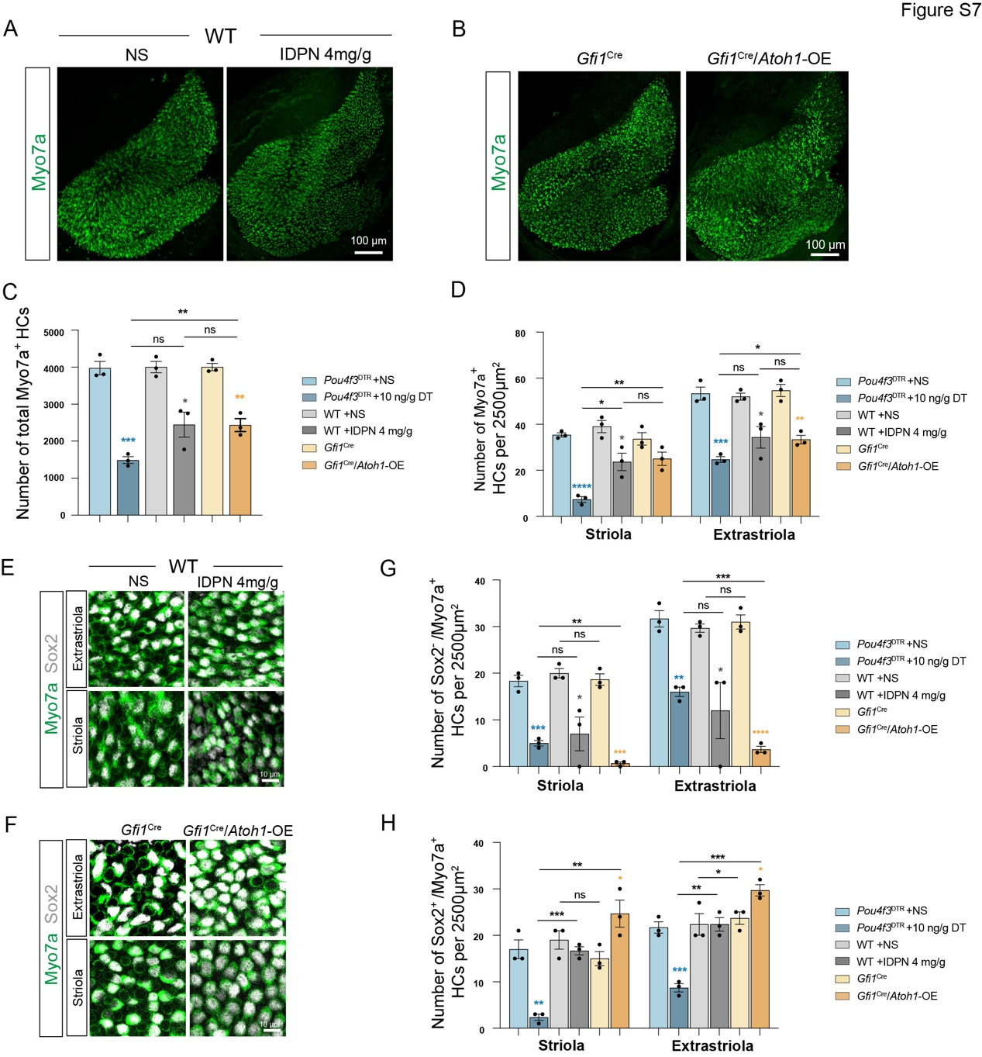
Figure S7 IDPN injection or Atoh1 overexpression reduced saccular type I HCs. Related to Figure 6.
(A-B) Low-magnification images showing the density of Myo7a⁺ HCs in the saccules.
(C) Quantification of total saccular HC numbers.
(D) Quantification of Myo7a⁺ HCs in the striola and extrastriola.
(E-F) Representative images demonstrating that most saccular HCs in IDPN-treated mice (E) or Gfi1^{Cre}/Atoh1-OE mice (F) were Sox2⁺ HCs in both the striola and extrastriola.
(G-H) Quantification of Sox2–/Myo7a⁺ HCs (G) and Sox2⁺/Myo7a⁺ HCs (H) in the striola and extrastriola.
Scale bars: 100 μm in A and B; 10 μm in E and F. Blue, grey, and orange asterisks indicate statistical significance compared with the respective controls. Black asterisks indicate statistical significance between the two groups marked by the straight lines. Unpaired t-test was performed for C, D, G, H. *p < 0.05, **p < 0.01, *** p < 0.001, ****p < 0.0001, ns, not significant.
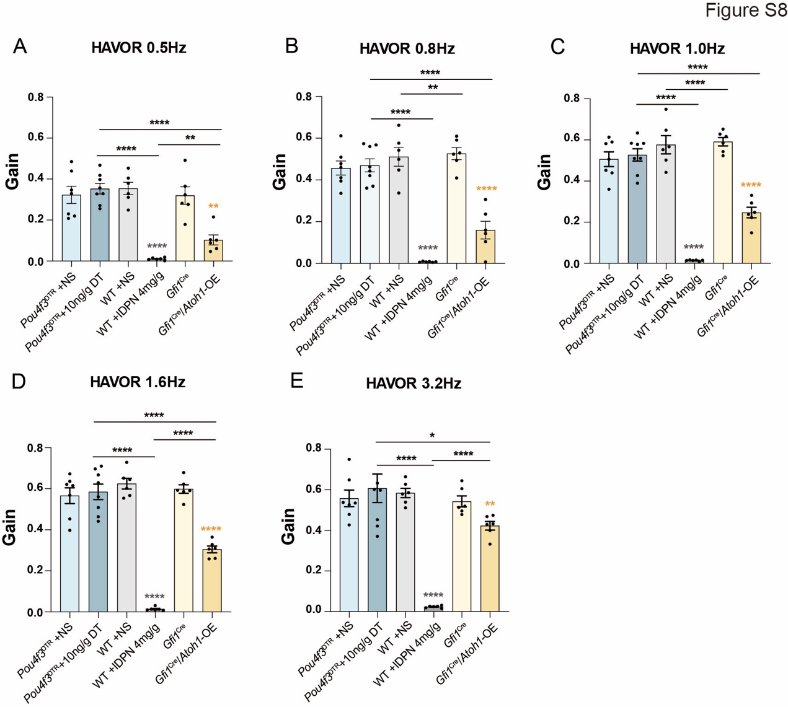
Figure S8 HAVOR test results from 10ng/g DT-treated Pou4f3^{DTR}, IDPN-injured and Gfi1^{Cre}/Atoh1-OE mice. Related to Figure 8.
(A-E) Gain values in the HAVOR tests at various frequencies. Blue, grey, and orange asterisks indicate statistical significance compared with the respective controls. Black asterisks indicate statistical significance between the two groups marked by the straight lines. Unpaired t-test was performed for A-E. * p < 0.05, ** p < 0.01, *** p < 0.001, **** p < 0.0001.

