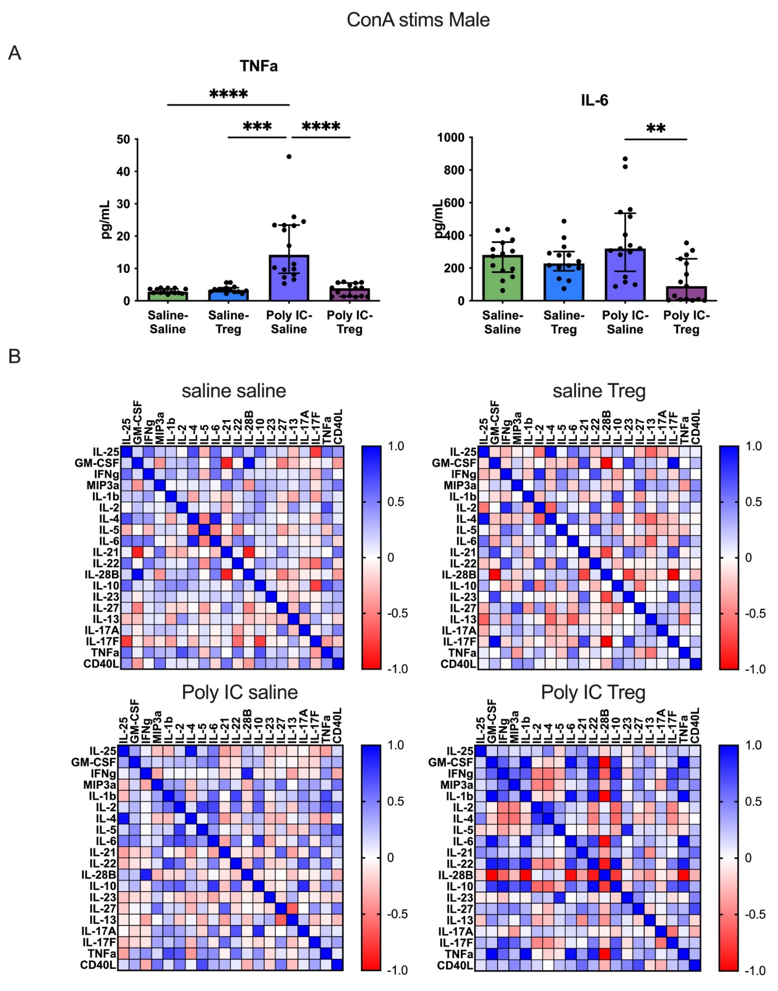
Figure S1 Splenocytes from male offspring were stimulated with Concanavalin A for 48 hours. Cytokines from cell culture supernatant were measured using Multiplex Luminex assays. (A)TNFα and IL-6 were significantly downregulated in male Poly I:C-Tregs offspring compared to their Poly I:C-Saline counterparts. (B) Cytokine correlations matricies following Con A stimulation in each group. In male Poly I:C-Tregs offspring, several cytokines were strongly correlated, whereas this was not observed in other study groups.

