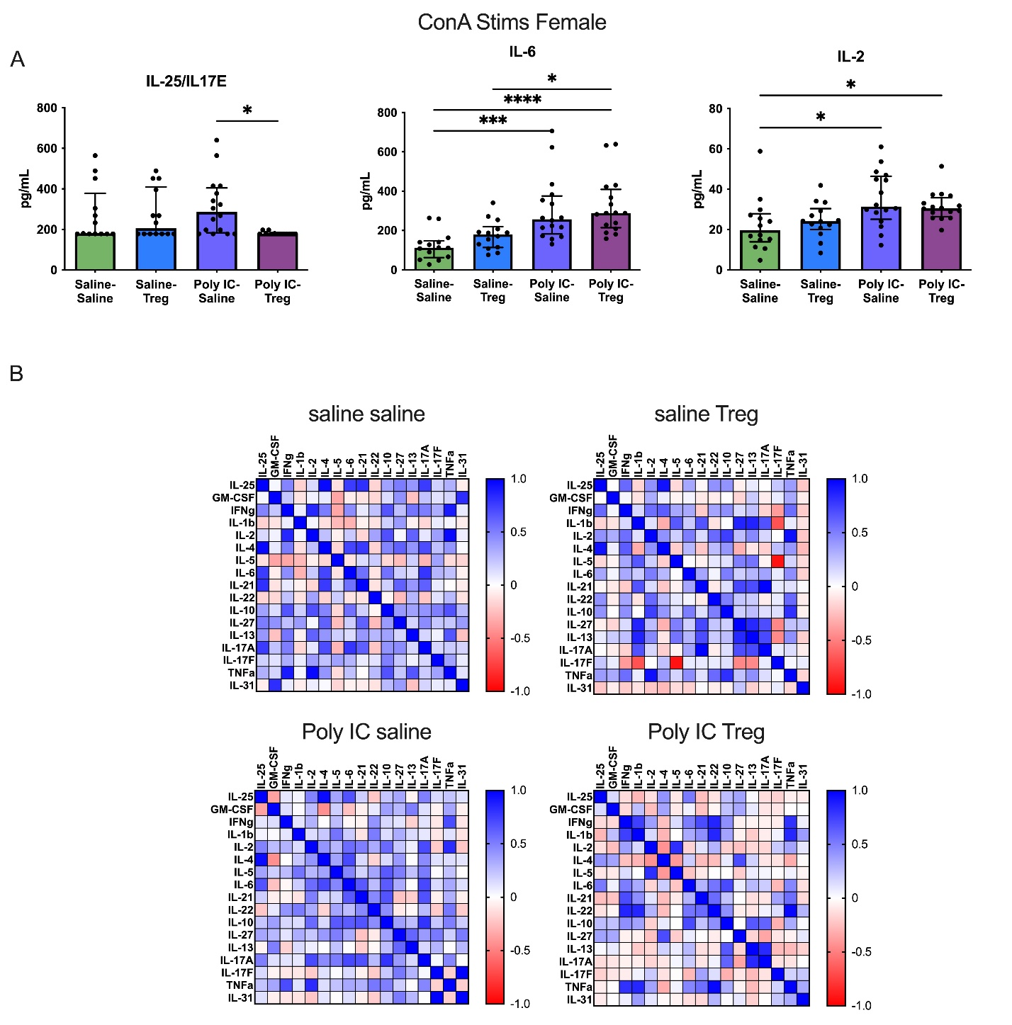
Figure S2 Splenocytes from female offspring were stimulated with Concanavalin A for 48 hours. Cytokines from cell culture supernatant were measured using Multiplex Luminex assays. (A) IL-25, IL-6 and IL-2 were significantly different across various study groups. (B) Cytokine correlations in female Saline-Saline, Saline-Tregs, and Poly I:C-Saline study groups all had strong cytokine production that correlated with each other. However, in female Poly I:C-Tregs offspring, many of these strong correlations were not observed.

