Supplementary Material for Neural and behavioral reward responsiveness in early adolescence: longitudinal associations with childhood adversity and resilience

BIS/BAS Item Description
BIS/BAS Module | Item Number | Wording
Behavioral Inhibition | BIS1 | ‘I worry about making mistakes’
 | BIS2 | ‘Criticism or scolding hurts me quite a bit’
 | BIS3 | ‘I feel pretty worried or upset when I think or know somebody is angry at me’
 | BIS4 | ‘I feel worried when I think I have done poorly at something important
Reward Responsiveness | RWD1 | ‘When I get something I want, I feel excited and energized’
 | RWD2 | ‘When I'm doing well at something I love to keep at it’
 | RWD3 | ‘It would excite me to win a contest’
 | RWD4 | ‘When I see an opportunity for something I like I get excited right away’
Drive | DRIVE1 | ‘When I want something I usually go all-out to get it’
 | DRIVE2 | ‘I go out of my way to get things I want’
 | DRIVE3 | ‘If I see a chance to get something I want I move on it right away’
 | DRIVE4 | ‘When I go after something I use a no holds barred approach

Table S1: Table of items in the revised BIS/BAS questionnaire, adapted from Pagliaccio et al. (2015)^{1,2}. The Reward Responsiveness module used in the analyses is highlighted in blue. Respondents have the option to rank each item on 4-point Likert scale (‘Strongly Agree’-‘Strongly Disagree’, ‘Very true for me’-‘Very false for me’, or ‘Not True’-‘Very True’). Higher scores on BAS Reward responsiveness module indicate higher levels of reward responsiveness.

Adversity Factor Item Missingness
Table S2: Missingness for each observed survey variable in the factor loadings matrix.

Multiple Imputation Validation
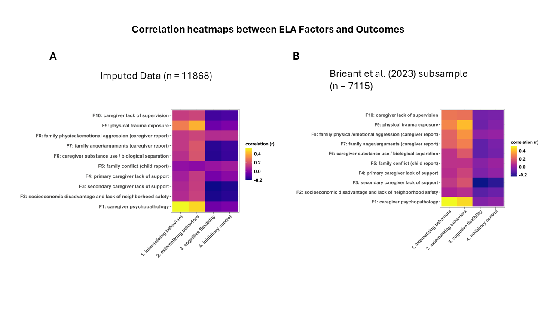

Figure S1: Comparison between (A) 1 imputed dataset (n=11868) and (B) the Brieant et al (2023) sample (7115)³. Correlation heatmaps of adversity factors and psychological outcomes at baseline.

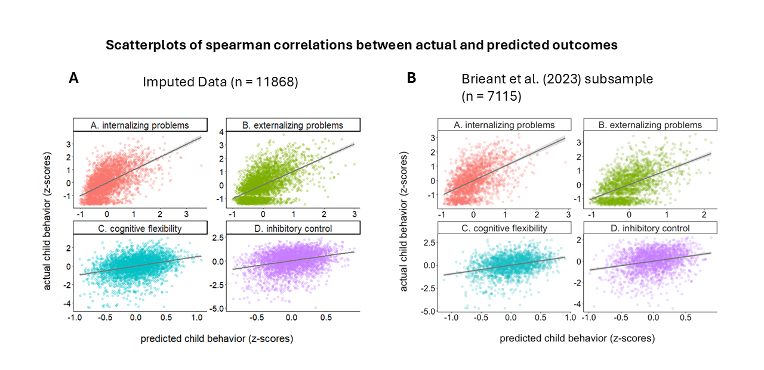
Figure S2: Comparison between (A)1 imputed dataset (n=11868) and (B) the Brieant et al. (2023) sample (7115)³. Scatterplots of spearman correlation between actual and predicted psychological outcomes at baseline using model parameters from Brieant et al (2023).

BAS Reward Responsiveness and Age
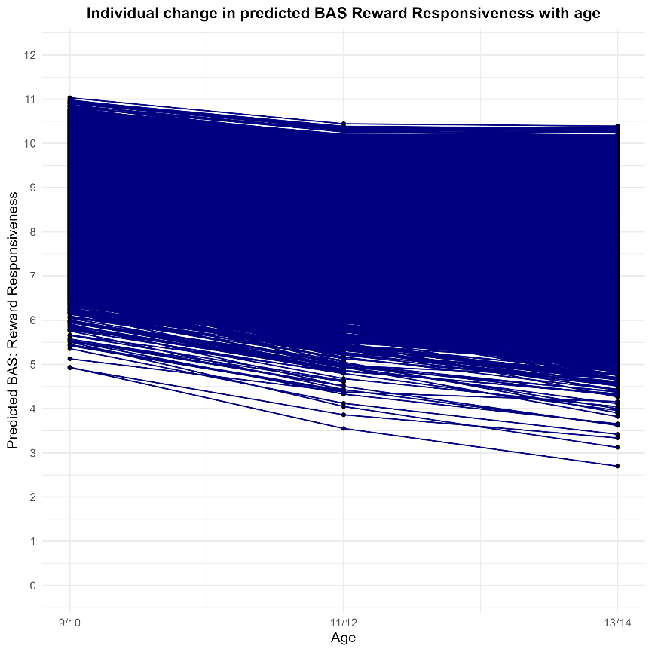
Figure S3: Plot of predicted individual BAS reward responsiveness change with age using BAS Reward Responsiveness and adversity random slope model.

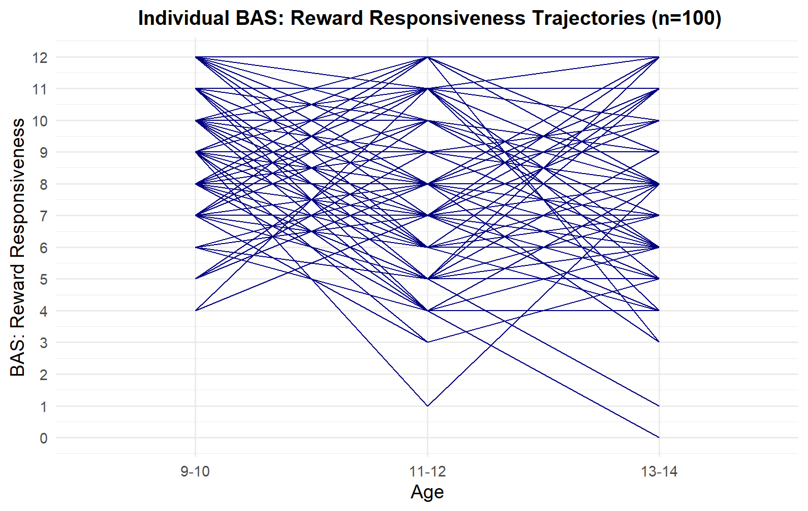
Figure S4: Plot of 100 randomly selected individual BAS reward responsiveness trajectories (with data available at all 3 timepoints) with age.

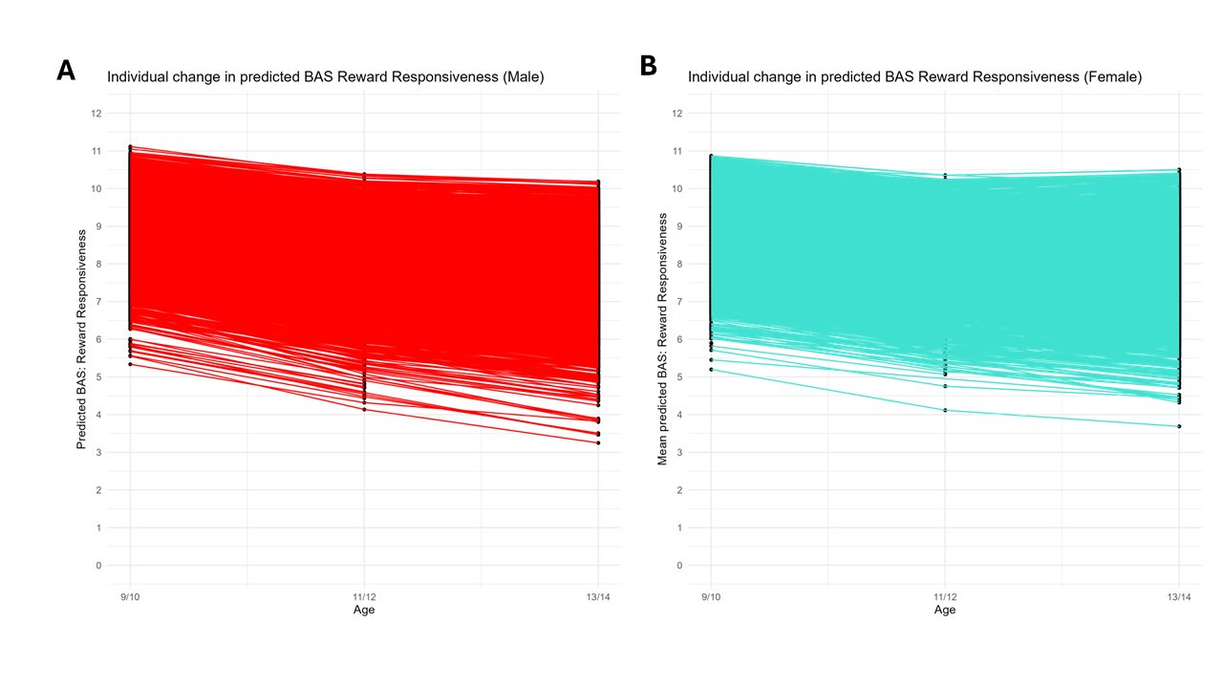

Figure S5: Plots of predicted individual reward responsiveness change with age using sex-stratified models of reward responsiveness and adversity factors. (A) Male. (B) Female.

Neural Reward Responsiveness and Age
Model | estimate | std.error | p.value | conf.low | conf.high
Anticipatory Nacc | 0.002038 | 0.004684 | 6.63E-01 | -0.00714 | 1.12E-02
Anticipatory Caudate | 0.015778 | 0.003756 | 2.67E-05 | 0.008416 | 0.023141
Anticipatory Putamen | 1.02E-02 | 0.003101 | 1.02E-03 | 0.004112 | 0.01627
Consummatory Nacc | -0.00108 | 0.004741 | 8.20E-01 | -0.01037 | 0.008215
Consummatory Caudate | -0.00187 | 0.003977 | 6.38E-01 | -0.00967 | 0.005922
Consummatory Putamen | -0.00568 | 0.003347 | 8.98E-02 | -0.01224 | 0.000883

Table S3: Pooled estimates for the age term in the models of ELA factors and neural reward responsiveness, using monetary incentive delay contrasts for each subcortical region. Nucleus accumbens is abbreviated to Nacc.

Model | estimate | std.error | p.value | conf.low | conf.high
Anticipatory Nacc | -0.0024 | 0.001262 | 5.73E-02 | -0.00487 | 7.43E-05
Anticipatory Caudate | -0.00361 | 0.001014 | 3.79E-04 | -0.00559 | -0.00162
Anticipatory Putamen | -1.49E-03 | 0.000838 | 7.62E-02 | -0.00313 | 0.000156
Consummatory Nacc | -0.00119 | 0.001279 | 3.54E-01 | -0.00369 | 0.001321
Consummatory Caudate | 0.000423 | 0.00107 | 6.92E-01 | -0.00167 | 0.002521
Consummatory Putamen | 0.00062 | 0.000903 | 4.92E-01 | -0.00115 | 0.002389

Table S4: Pooled estimates for the age squared term in the models of ELA factors and neural reward responsiveness, using monetary incentive delay contrasts for each subcortical region. Nucleus accumbens is abbreviated to Nacc.

Supplementary analysis: Age 9/10 Adversity, Perceived Racial Discrimination and BAS Reward Responsiveness
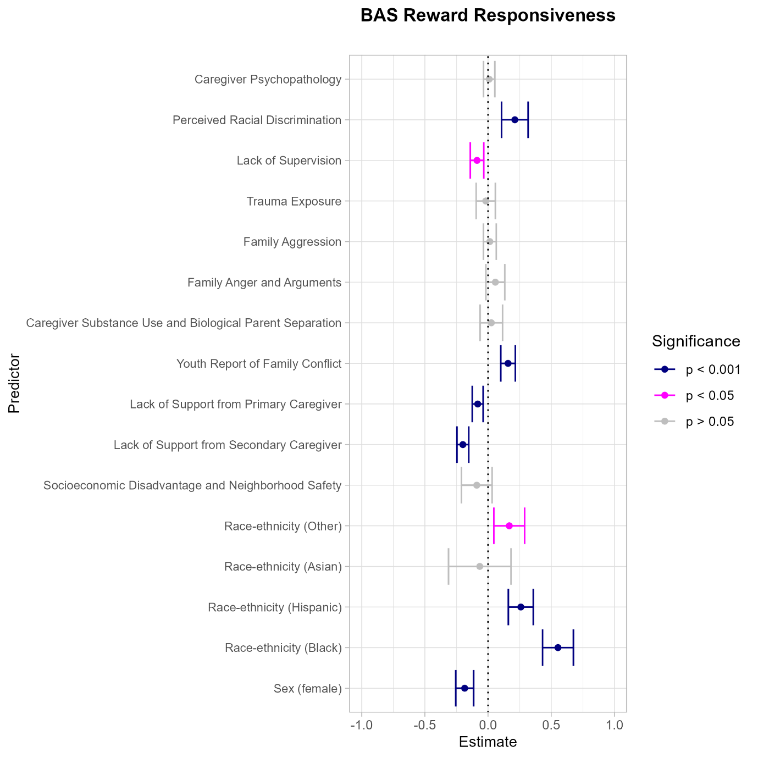
Figure S6: Forest plot of pooled coefficients of models of BAS Reward Responsiveness and adversity factors including Perceived Racial Discrimination as a covariate in random slope model. Significance level is indicated by color.

Supplementary analysis: Age 9/10 Adversity, Perceived Racial Discrimination and anticipatory reward responsiveness in the striatum
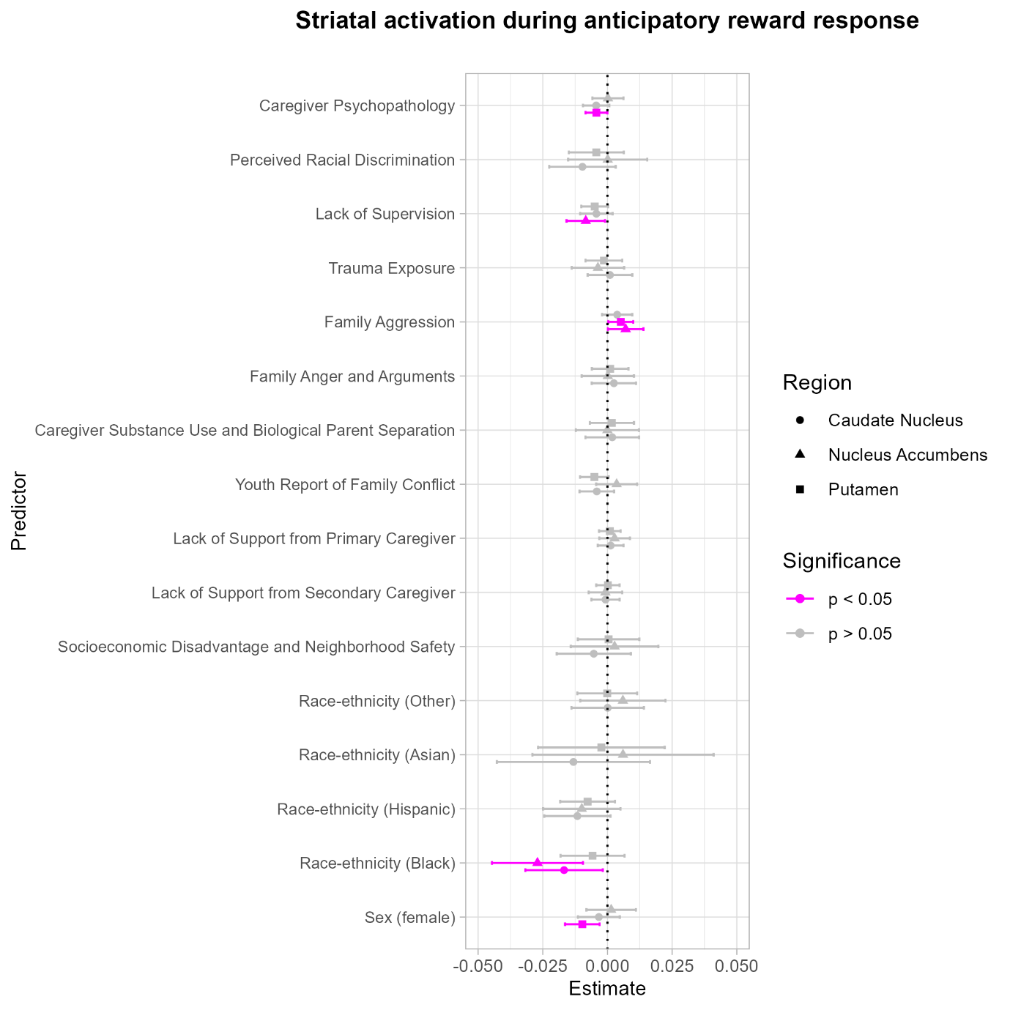
Figure S7: Forest plot of pooled coefficients of models of anticipatory reward response during the monetary incentive delay task, adversity and resilience factors including Perceived Racial Discrimination as a covariate. Significance level is indicated by color, and striatal subregion by shape.

Supplementary analysis: Age 9/10 Adversity, Perceived Racial Discrimination and consummatory reward responsiveness in the striatum
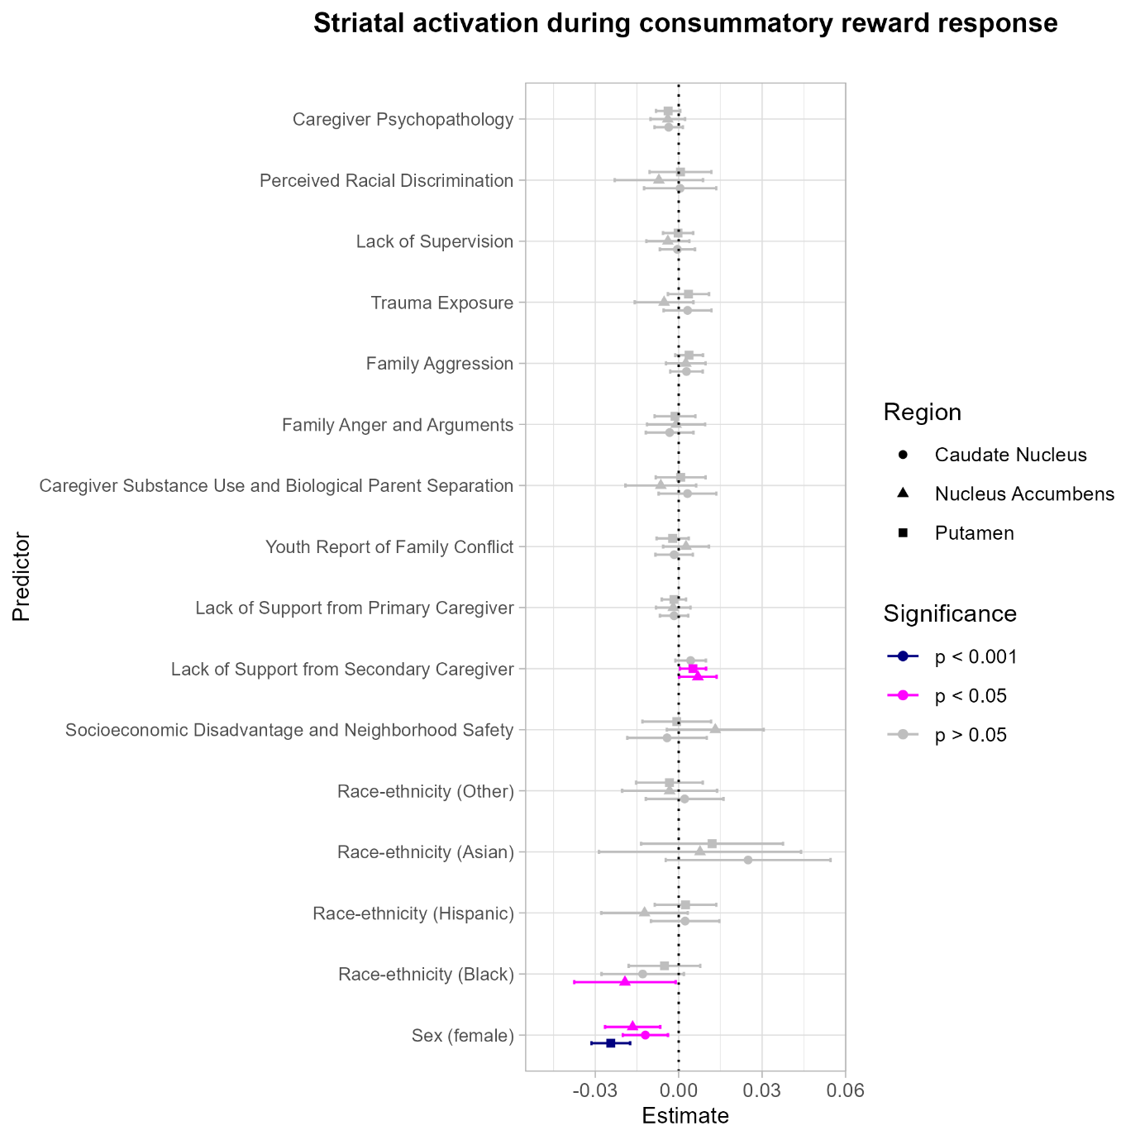
Figure S8: Forest plot of pooled coefficients of models of anticipatory reward response during the monetary incentive delay task, adversity and resilience factors including Perceived Racial Discrimination as a covariate. Significance level is indicated by color, and striatal subregion by shape.

Sensitivity Analysis: Poisson regression of baseline BAS Reward Responsiveness
term | estimate | std.error | p.value | conf.low | conf.high
(Intercept) | 2.169318 | 0.00538 | 0 | 2.158773 | 2.179863
race_ethnicityBlack | 0.071987 | 0.010094 | 1.06E-12 | 0.052201 | 0.091774
race_ethnicityHispanic | 0.042028 | 0.008531 | 8.50E-07 | 0.025305 | 0.05875
race_ethnicityAsian | 0.012099 | 0.022476 | 0.590392 | -0.03196 | 0.056155
race_ethnicityOther | 0.025061 | 0.010582 | 0.017885 | 0.004319 | 0.045803
sexFemale | -0.03414 | 0.006291 | 5.87E-08 | -0.04647 | -0.0218
cg_psych | 0.000163 | 0.003871 | 0.966363 | -0.00742 | 0.007751
ses_dis_nsafety | 0.00373 | 0.010457 | 0.721321 | -0.01677 | 0.02423
cg2_lack_support | -0.02962 | 0.004201 | 1.88E-12 | -0.03786 | -0.02139
cg1_lack_support | -0.01394 | 0.003881 | 0.000331 | -0.02155 | -0.00633
yp_family_conflict | 0.032874 | 0.005116 | 1.36E-10 | 0.022846 | 0.042901
cg_sub_use_bio_sep | 0.002038 | 0.007695 | 0.791091 | -0.01305 | 0.017123
family_anger_arg | 0.012245 | 0.006504 | 0.059764 | -0.0005 | 0.024994
family_aggression | 0.001754 | 0.004362 | 0.687645 | -0.0068 | 0.010305
trauma_exposure | -0.00892 | 0.006711 | 0.184084 | -0.02207 | 0.00424
lack_supervision | -0.01163 | 0.004722 | 0.013758 | -0.02089 | -0.00238

Table S5: Output of Poisson regression sensitivity analysis of adversity factors and BAS: Reward Responsiveness at the baseline wave.

term | estimate | std.error | p.value | conf.low | conf.high
(Intercept) | 2.174226 | 0.005225 | 0 | 2.163985 | 2.184468
race_ethnicityBlack | 0.083969 | 0.008901 | 4.68E-21 | 0.066522 | 0.101415
race_ethnicityHispanic | 0.041979 | 0.008083 | 2.10E-07 | 0.026135 | 0.057823
race_ethnicityAsian | -0.01008 | 0.022143 | 0.649067 | -0.05348 | 0.033327
race_ethnicityOther | 0.025624 | 0.010499 | 0.014677 | 0.005044 | 0.046203
sexFemale | -0.04765 | 0.006323 | 5.23E-14 | -0.06004 | -0.03525
ps_behav | 0.035089 | 0.003386 | 4.65E-25 | 0.028452 | 0.041726
pos_school_env | 0.017001 | 0.003313 | 2.91E-07 | 0.010508 | 0.023494

Table S6: Output of Poisson regression sensitivity analysis of resilience factors and BAS: Reward Responsiveness at the baseline wave.

Supplementary analysis: Sex-stratified models including pubertal development scale
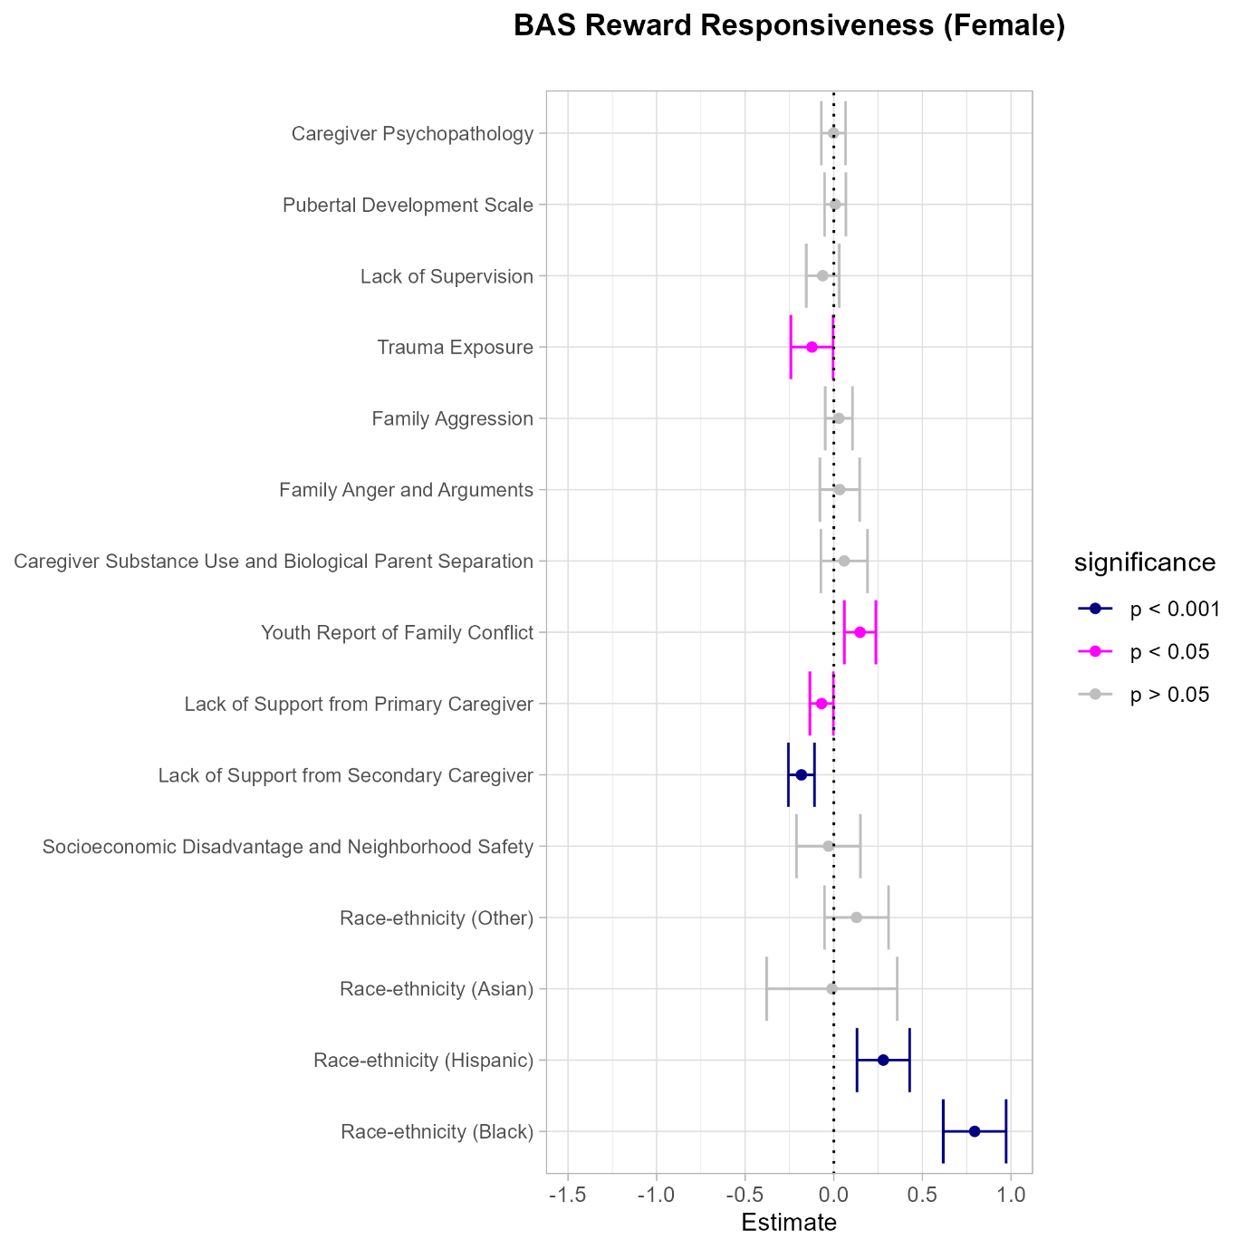

Figure S9: Forest plot of pooled coefficients of models of BAS Reward Responsiveness and adversity factors within the female sample – including female pubertal development score as a covariate in the random slope model. Significance level is indicated by color.

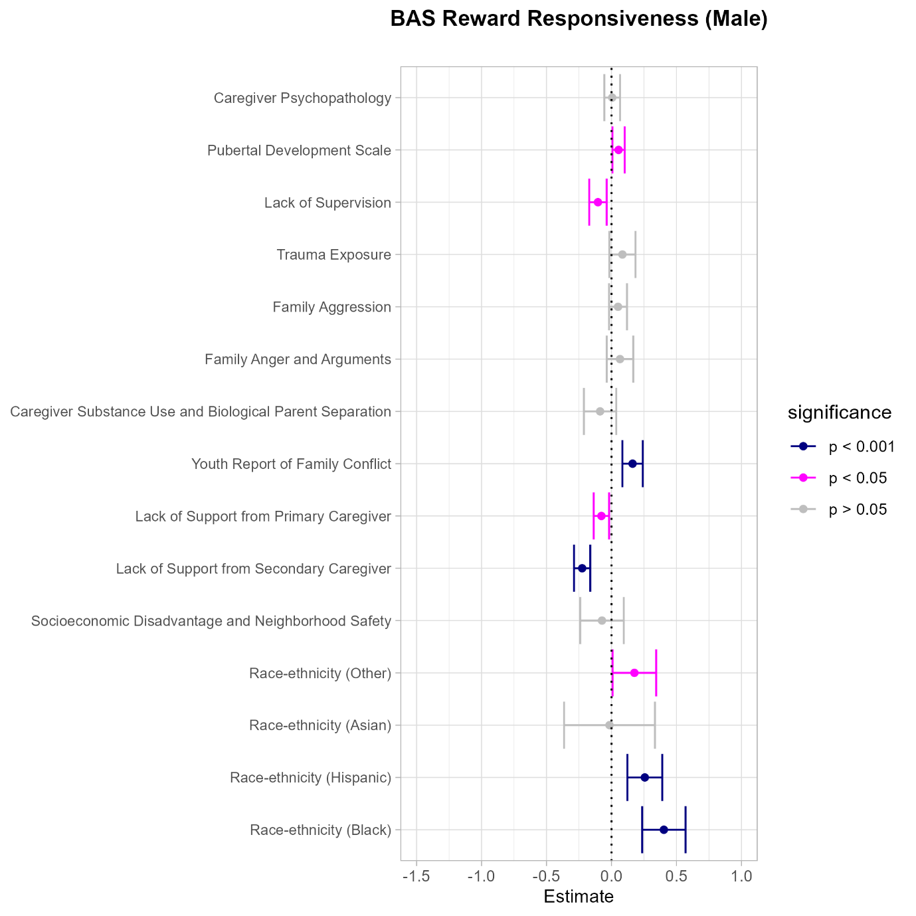
Figure S10: Forest plot of pooled coefficients of models of BAS Reward Responsiveness and adversity factors within the male sample – including female pubertal development score as a covariate in the random slope model. Significance level is indicated by color.

Unadjusted models
BAS Reward Responsiveness
term | estimate | std.error | p.value | conf.low | conf.high
(Intercept) | 8.82428 | 0.022476 | 0 | 8.780225 | 8.868335
cg_psych | -0.02792 | 0.021988 | 0.204185 | -0.07102 | 0.015178
ses_dis_nsafety | 0.140812 | 0.055558 | 0.011274 | 0.031908 | 0.249717
cg2_lack_support | -0.18698 | 0.022947 | 3.85E-16 | -0.23196 | -0.142
cg1_lack_support | -0.08097 | 0.021285 | 0.000143 | -0.12269 | -0.03925
yp_family_conflict | 0.144424 | 0.028457 | 3.90E-07 | 0.088647 | 0.200201
cg_sub_use_bio_sep | -0.05142 | 0.043682 | 0.239196 | -0.13704 | 0.034206
family_anger_arg | 0.107108 | 0.036765 | 0.003579 | 0.035047 | 0.179169
family_aggression | 0.038846 | 0.025023 | 0.120573 | -0.0102 | 0.087892
trauma_exposure | -0.03189 | 0.037324 | 0.392831 | -0.10505 | 0.041266
lack_supervision | -0.08897 | 0.025904 | 0.000594 | -0.13974 | -0.0382
age | -0.56799 | 0.025654 | 1.14E-107 | -0.61827 | -0.5177
age_sq | 0.066389 | 0.006815 | 2.17E-22 | 0.053032 | 0.079746

Table S7: Pooled coefficients for unadjusted models of adversity and BAS Reward Responsiveness.

term | estimate | std.error | p.value | conf.low | conf.high
(Intercept) | 8.823143 | 0.022503 | 0 | 8.779036 | 8.867249
pos_school_env | 0.096327 | 0.018168 | 1.15E-07 | 0.060718 | 0.131937
ps_behav | 0.237772 | 0.018134 | 3.69E-39 | 0.202229 | 0.273316
age | -0.56572 | 0.025667 | 9.83E-107 | -0.61603 | -0.51542
age_sq | 0.065379 | 0.006817 | 9.41E-22 | 0.052018 | 0.07874

Table S8: Pooled coefficients for unadjusted models of resilience and BAS Reward Responsiveness.

Anticipatory reward activation
Nucleus accumbens
term | estimate | std.error | p.value | conf.low | conf.high
(Intercept) | 0.096513 | 0.006165 | 6.87E-55 | 0.084429 | 0.108597
cg_psych | 0.001542 | 0.002951 | 0.601243 | -0.00424 | 0.007327
ses_dis_nsafety | -0.00534 | 0.007846 | 0.495891 | -0.02072 | 0.010037
cg2_lack_support | -0.00145 | 0.003177 | 0.64835 | -0.00768 | 0.004778
cg1_lack_support | 0.004195 | 0.002912 | 0.149714 | -0.00151 | 0.009902
yp_family_conflict | 0.003538 | 0.003913 | 0.365884 | -0.00413 | 0.011208
cg_sub_use_bio_sep | 0.001749 | 0.005968 | 0.769526 | -0.00995 | 0.013447
family_anger_arg | -0.00163 | 0.004988 | 0.743526 | -0.01141 | 0.008145
family_aggression | 0.007962 | 0.003376 | 0.018343 | 0.001346 | 0.014579
trauma_exposure | -0.00192 | 0.004997 | 0.700344 | -0.01172 | 0.007871
lack_supervision | -0.01045 | 0.003604 | 0.003749 | -0.01751 | -0.00338
age | 0.002051 | 0.004682 | 0.661323 | -0.00713 | 0.011229
age_sq | -0.00237 | 0.001262 | 0.060623 | -0.00484 | 0.000106

Table S9: Pooled coefficients for unadjusted models of adversity and anticipatory reward activation (nucleus accumbens).
term | estimate | std.error | p.value | conf.low | conf.high
(Intercept) | 0.097211 | 0.006212 | 7.64E-55 | 0.085035 | 0.109388
pos_school_env | 0.002342 | 0.002516 | 0.351791 | -0.00259 | 0.007274
ps_behav | -0.0013 | 0.002502 | 0.604529 | -0.0062 | 0.003609
age | 0.001909 | 0.004691 | 0.684111 | -0.00729 | 0.011103
age_sq | -0.00233 | 0.001264 | 0.065051 | -0.00481 | 0.000145

Table S10: Pooled coefficients for unadjusted models of resilience and anticipatory reward activation (nucleus accumbens).

Caudate nucleus
term | estimate | std.error | p.value | conf.low | conf.high
(Intercept) | 0.098685 | 0.005829 | 8.23E-64 | 0.087259 | 0.11011
cg_psych | -0.00196 | 0.002512 | 0.43409 | -0.00689 | 0.002959
ses_dis_nsafety | -0.01493 | 0.006707 | 0.026114 | -0.02807 | -0.00178
cg2_lack_support | -0.00164 | 0.002693 | 0.542112 | -0.00692 | 0.003637
cg1_lack_support | 0.002868 | 0.002457 | 0.243156 | -0.00195 | 0.007683
yp_family_conflict | -0.00274 | 0.003315 | 0.408699 | -0.00924 | 0.003759
cg_sub_use_bio_sep | 0.004822 | 0.005103 | 0.344652 | -0.00518 | 0.014825
family_anger_arg | 0.000524 | 0.004258 | 0.902074 | -0.00782 | 0.00887
family_aggression | 0.002012 | 0.002872 | 0.483538 | -0.00362 | 0.007641
trauma_exposure | 0.001781 | 0.004281 | 0.677429 | -0.00661 | 0.010174
lack_supervision | -0.00542 | 0.00305 | 0.07557 | -0.0114 | 0.000558
age | 0.015784 | 0.003755 | 2.65E-05 | 0.008423 | 0.023144
age_sq | -0.00358 | 0.001014 | 0.000418 | -0.00557 | -0.00159

Table S11: Pooled coefficients for unadjusted models of adversity and anticipatory reward activation (caudate nucleus).

term | estimate | std.error | p.value | conf.low | conf.high
(Intercept) | 0.100166 | 0.006201 | 2.69E-58 | 0.088011 | 0.11232
pos_school_env | 0.000938 | 0.002131 | 0.659736 | -0.00324 | 0.005115
ps_behav | 0.002553 | 0.00212 | 0.22857 | -0.0016 | 0.006709
age | 0.015468 | 0.003761 | 3.93E-05 | 0.008096 | 0.022841
age_sq | -0.00347 | 0.001016 | 0.000627 | -0.00547 | -0.00148

Table S12: Pooled coefficients for unadjusted models of resilience and anticipatory reward activation (caudate nucleus).

Putamen
term | estimate | std.error | p.value | conf.low | conf.high
(Intercept) | 0.06206 | 0.004903 | 1.44E-36 | 0.05245 | 0.071671
cg_psych | -0.00339 | 0.002081 | 0.103049 | -0.00747 | 0.000686
ses_dis_nsafety | -0.00488 | 0.005563 | 0.37993 | -0.01579 | 0.006022
cg2_lack_support | 8.64E-05 | 0.002237 | 0.969184 | -0.0043 | 0.004471
cg1_lack_support | 0.00188 | 0.002078 | 0.365834 | -0.0022 | 0.005955
yp_family_conflict | -0.0042 | 0.002749 | 0.126357 | -0.00959 | 0.001186
cg_sub_use_bio_sep | 0.002279 | 0.004207 | 0.588062 | -0.00597 | 0.010525
family_anger_arg | 0.000656 | 0.003521 | 0.852249 | -0.00625 | 0.007558
family_aggression | 0.004466 | 0.002382 | 0.060872 | -0.0002 | 0.009136
trauma_exposure | 0.000216 | 0.003538 | 0.951416 | -0.00672 | 0.007151
lack_supervision | -0.0046 | 0.002532 | 0.069432 | -0.00956 | 0.000366
age | 0.010327 | 0.0031 | 0.000867 | 0.00425 | 0.016404
age_sq | -0.0015 | 0.000837 | 0.073338 | -0.00314 | 0.000142

Table S13: Pooled coefficients for unadjusted models of adversity and anticipatory reward activation (putamen).

term | estimate | std.error | p.value | conf.low | conf.high
(Intercept) | 0.063049 | 0.00501 | 3.65E-36 | 0.053228 | 0.072869
pos_school_env | 0.002807 | 0.001767 | 0.11206 | -0.00066 | 0.00627
ps_behav | 0.000311 | 0.001758 | 0.859788 | -0.00313 | 0.003756
age | 0.010035 | 0.003105 | 0.001232 | 0.003949 | 0.016121
age_sq | -0.00142 | 0.000839 | 0.089571 | -0.00307 | 0.00022

Table S14: Pooled coefficients for unadjusted models of resilience and anticipatory reward activation (putamen).

Consummatory reward activation
Nucleus accumbens
term | estimate | std.error | p.value | conf.low | conf.high
(Intercept) | 0.145726 | 0.006605 | 1.69E-106 | 0.132779 | 0.158673
cg_psych | -0.00296 | 0.003046 | 0.331761 | -0.00893 | 0.003014
ses_dis_nsafety | 0.002869 | 0.0081 | 0.723234 | -0.01301 | 0.018748
cg2_lack_support | 0.005545 | 0.003303 | 0.093246 | -0.00093 | 0.012019
cg1_lack_support | -0.00111 | 0.003045 | 0.715481 | -0.00708 | 0.00486
yp_family_conflict | 0.005344 | 0.004066 | 0.188789 | -0.00263 | 0.013314
cg_sub_use_bio_sep | -0.00368 | 0.006201 | 0.553206 | -0.01583 | 0.008478
family_anger_arg | -0.00102 | 0.005151 | 0.843154 | -0.01112 | 0.009078
family_aggression | 0.001357 | 0.003485 | 0.697063 | -0.00547 | 0.008188
trauma_exposure | -0.00445 | 0.005212 | 0.392893 | -0.01467 | 0.005763
lack_supervision | -0.00294 | 0.003744 | 0.431576 | -0.01028 | 0.004394
age | -0.00073 | 0.00474 | 0.877326 | -0.01002 | 0.00856
age_sq | -0.00122 | 0.001278 | 0.340192 | -0.00373 | 0.001286

Table S15: Pooled coefficients for unadjusted models of adversity and consummatory reward activation (nucleus accumbens).

term | estimate | std.error | p.value | conf.low | conf.high
(Intercept) | 0.146215 | 0.006433 | 8.13E-113 | 0.133606 | 0.158825
pos_school_env | -0.00018 | 0.002611 | 0.946078 | -0.0053 | 0.004942
ps_behav | -0.0007 | 0.002598 | 0.786501 | -0.0058 | 0.004388
age | -0.00076 | 0.004748 | 0.872927 | -0.01006 | 0.008546
age_sq | -0.00123 | 0.00128 | 0.335423 | -0.00374 | 0.001276

Table S16: Pooled coefficients for unadjusted models of resilience and consummatory reward activation (nucleus accumbens).

Caudate nucleus
term | estimate | std.error | p.value | conf.low | conf.high
(Intercept) | 0.052909 | 0.003828 | 3.06E-43 | 0.045406 | 0.060412
cg_psych | -0.0038 | 0.002509 | 0.129389 | -0.00872 | 0.001113
ses_dis_nsafety | -0.00786 | 0.006598 | 0.233509 | -0.0208 | 0.005073
cg2_lack_support | 0.003977 | 0.002704 | 0.141333 | -0.00132 | 0.009278
cg1_lack_support | -0.0013 | 0.002521 | 0.605251 | -0.00625 | 0.00364
yp_family_conflict | -0.00066 | 0.003329 | 0.841841 | -0.00719 | 0.005862
cg_sub_use_bio_sep | 0.003221 | 0.005078 | 0.525839 | -0.00673 | 0.013174
family_anger_arg | -0.00281 | 0.004227 | 0.505909 | -0.0111 | 0.005473
family_aggression | 0.002101 | 0.002867 | 0.463702 | -0.00352 | 0.00772
trauma_exposure | 0.003604 | 0.004242 | 0.395542 | -0.00471 | 0.01192
lack_supervision | 0.000897 | 0.003068 | 0.7701 | -0.00512 | 0.006911
age | -0.00172 | 0.003973 | 0.664945 | -0.00951 | 0.006066
age_sq | 0.000384 | 0.00107 | 0.719623 | -0.00171 | 0.002482

Table S17: Pooled coefficients for unadjusted models of adversity and consummatory reward activation (caudate nucleus).

term | estimate | std.error | p.value | conf.low | conf.high
(Intercept) | 0.053068 | 0.003837 | 2.76E-43 | 0.045547 | 0.060589
pos_school_env | 0.001926 | 0.002138 | 0.367688 | -0.00227 | 0.006118
ps_behav | 0.000669 | 0.002127 | 0.753034 | -0.0035 | 0.004838
age | -0.00165 | 0.003977 | 0.679051 | -0.00944 | 0.006149
age_sq | 0.000349 | 0.001071 | 0.74483 | -0.00175 | 0.002449

Table S18: Pooled coefficients for unadjusted models of resilience and consummatory reward activation (caudate nucleus).

Putamen
term | estimate | std.error | p.value | conf.low | conf.high
(Intercept) | 0.132458 | 0.005653 | 1.12E-119 | 0.121378 | 0.143539
cg_psych | -0.004 | 0.002152 | 0.062919 | -0.00822 | 0.000216
ses_dis_nsafety | -0.00381 | 0.005729 | 0.505791 | -0.01504 | 0.007419
cg2_lack_support | 0.004627 | 0.002328 | 0.046852 | 6.44E-05 | 0.00919
cg1_lack_support | -0.00126 | 0.002153 | 0.559323 | -0.00548 | 0.002965
yp_family_conflict | -0.00148 | 0.002866 | 0.604942 | -0.0071 | 0.004135
cg_sub_use_bio_sep | 0.00036 | 0.004396 | 0.934771 | -0.00826 | 0.008978
family_anger_arg | -0.00013 | 0.003638 | 0.970838 | -0.00726 | 0.006999
family_aggression | 0.003848 | 0.00246 | 0.117887 | -0.00098 | 0.00867
trauma_exposure | 0.004905 | 0.003666 | 0.180895 | -0.00228 | 0.01209
lack_supervision | 0.002631 | 0.002635 | 0.317999 | -0.00253 | 0.007796
age | -0.00519 | 0.003348 | 0.121469 | -0.01175 | 0.001377
age_sq | 0.000526 | 0.000903 | 0.560484 | -0.00124 | 0.002295

Table S19: Pooled coefficients for unadjusted models of adversity and consummatory reward activation (putamen).

term | estimate | std.error | p.value | conf.low | conf.high
(Intercept) | 0.132296 | 0.005666 | 7.56E-119 | 0.121189 | 0.143403
pos_school_env | -0.00144 | 0.001837 | 0.433566 | -0.00504 | 0.002163
ps_behav | -0.00127 | 0.001828 | 0.486729 | -0.00485 | 0.002312
age | -0.00501 | 0.003352 | 0.135157 | -0.01158 | 0.001562
age_sq | 0.00046 | 0.000904 | 0.610834 | -0.00131 | 0.002232

Table S20: Pooled coefficients for unadjusted models of resilience and consummatory reward activation (putamen).

References
1 Carver CS, White TL. Behavioral inhibition, behavioral activation, and affective responses to impending reward and punishment: The BIS/BAS Scales. J Pers Soc Psychol 1994; 67: 319–333.
2 Pagliaccio D, Luking KR, Anokhin AP, Gotlib IH, Hayden EP, Olino TM et al. Revising the BIS/BAS to Study Development: Measurement Invariance and Normative Effects of Age and Sex from Childhood through Adulthood. Psychol Assess 2016; 28: 429–442.
3 Brieant A, Vannucci A, Nakua H, Harris J, Lovell J, Brundavanam D et al. Characterizing the dimensional structure of early-life adversity in the Adolescent Brain Cognitive Development (ABCD) Study. Dev Cogn Neurosci 2023; 61: 101256.

