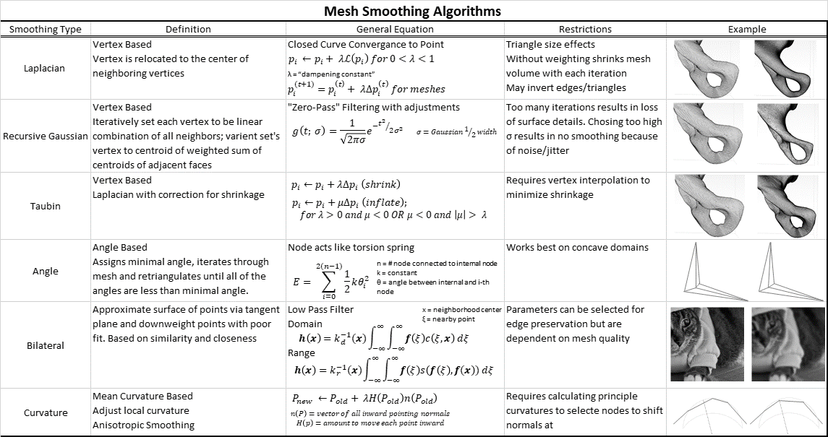
Table 1: Summary of most common smoothing algorithms used in segmentation software (20-26) Images in Example column demonstrate implementation of the algorithm before (left) and after (right) implementation.

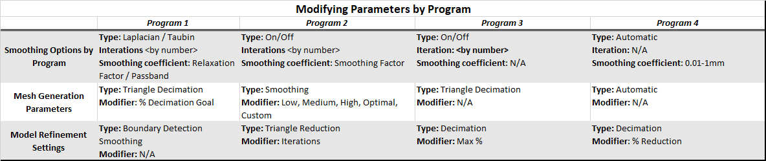
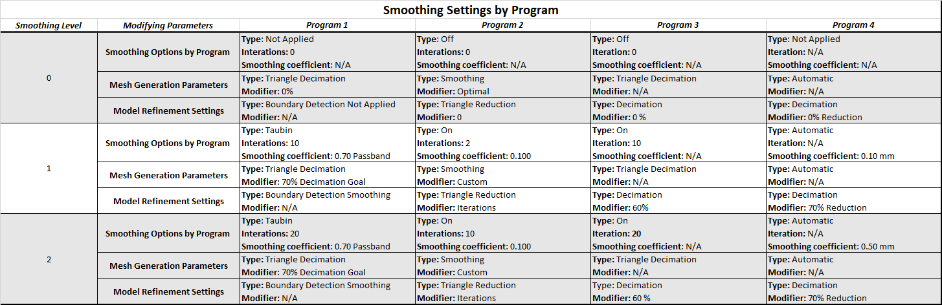
Table 2: Smoothing settings for each program given the available smoothing options. Groupings were assigned to generate comparable options from disparate software nomenclature and may not represent exact definitions or labels in their respective software. The volume and surface areas of the three models generated at each smoothing level were averaged and used for statistical analysis.

