Electronic Supplementary Material

Figure 1A. Published research by country and year
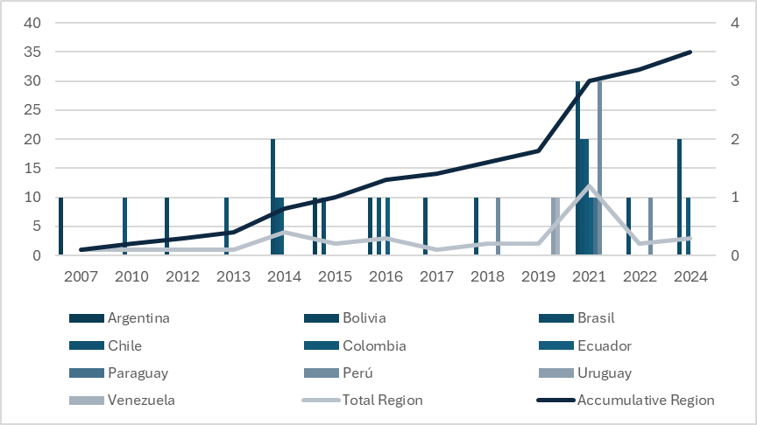

Table 1A. Research output of South American countries
Rank | Country | Documents | Citable documents | Citations
1 | Brazil | 36.295 | 35.769 | 390.825
3 | Colombia | 6.102 | 5.959 | 49.184
4 | Argentina | 4.785 | 4.713 | 90.769
5 | Chile | 4.603 | 4.451 | 83.602
6 | Peru | 2.268 | 2.240 | 17.917
7 | Venezuela | 1.702 | 1.680 | 14.912
9 | Ecuador | 1.443 | 1.422 | 18.103
11 | Uruguay | 655 | 626 | 12.591
14 | Bolivia | 201 | 196 | 4.380
17 | Paraguay | 83 | 82 | 1.198
23 | French Guiana | 48 | 48 | 2.325
29 | Guyana | 24 | 22 | 430
34 | Suriname | 16 | 15 | 828

Table 2A. South American countries’ vulnerability position according to the ND-GAIN Country Index
Country | Overall vulnerability rank |  | Food score rank
Country | Rank | Score | Rank | Score
Chile | 28 | 0.334 | 15 | 0.238
Brazil | 49 | 0.363 | 46 | 0.358
Argentina | 59 | 0.372 | 52 | 0.369
Venezuela | 61 | 0.374 | 58 | 0.392
Paraguay | 75 | 0.391 | 65 | 0.406
Uruguay | 75 | 0.391 | 72 | 0.419
Colombia | 81 | 0.403 | 84 | 0.444
Peru | 83 | 0.406 | 85 | 0.450
Bolivia | 111 | 0.447 | 86 | 0.452
Ecuador | 125 | 0.465 | 97 | 0.466
Source: https://gain.nd.edu/our-work/country-index/rankings/

Table 3A. South American countries’ rural population, rural employment and share of agricultural GDP
Country | Most Recent Year of measurement | % rural population | % rural employment | % of Agriculture on GDP
Argentina | 2023 | 8 | 1 | 5,9
Bolivia | 2023 | 29 | 24 | 13,5
Brazil | 2023 | 12 | 8 | 6,2
Chile | 2023 | 12 | 6 | 3,5
Colombia | 2023 | 18 | 14 | 8,7
Ecuador | 2023 | 35 | 30 | 7,7
Paraguay | 2023 | 37 | 17 | 7,2
Peru | 2023 | 21 | 24 | 11,3
Uruguay | 2023 | 4 | 9 | 5,6
Venezuela | 2023 | 12 | 11 | s/i
Source: https://data.worldbank.org/indicator/SL.AGR.EMPL.ZS?end=2023&locations=AR-UY-BO-BY-CL-EC-PE-BR-CO-VE&name_desc=false&start=2023&view=map

