Supplement Information
Oxalate enhanced photochemical decomplexation of Cu(II)-EDTA in a Cu-Fenton system

Chengyu Wang¹, Yuhang Zhang¹, Zhijun Luo^{1,3,}*, Lingling Qu^{1,}*

^{1.} School of the Environment and Safety Engineering, Jiangsu University, 301 Xuefu Road Zhenjiang 212013, China.
^{2.} School of Chemistry and Chemical Engineering, Jiangsu University, 301 Xuefu Road Zhenjiang 212013, China.
³ School of the Environment and Safety Engineering, Key Laboratory of Zhenjiang, Jiangsu University, Zhenjiang 212013, China

*Corresponding authors:
Dr. Zhijun Luo
E-mail: lzj@ujs.edu.cn

Dr. Lingling Qu
E-mail: llqu@ujs.edu.cn

Text S1. Chemicals and reagents
All chemicals and reagents were purchased from Aladdin Reagent Co., Ltd. without additional purification. Copper(II) sulfate pentahydrate (CuSO₄·5H₂O), Ethylenediamine tetraaceticacid disodium salt dihydrate (Na₂-EDTA·2H₂O), hydrogen peroxide (H₂O₂), bathocuproine (BC, C₂₆H₂₀N₂), cuprous chloride (CuCl), oxalic acid dihydrate (C₂H₂O₄·2H₂O), sodium hydroxide (NaOH), sulfuric acid (H₂SO₄), sodium bicarbonate (NaHCO₃), sodium carbonate (Na₂CO₃), ammonium acetate (CH₃COONH₄), acetic acid (C₂H₄O₂), ethanol (C₂H6O), tert-butanol (TBA, C₄H₁₀O), furfuryl alcohol (FFA, C₅H₆O₂), and 1,4-benzoquinone (BQ, C₆H₄O₂). Cu(II)-EDTA solution was obtained by mixing CuSO₄·5H₂O and Na₂-EDTA·2H₂O with the molar ratio of 1:1.
Text S2. Detection of Cu(I)
The concentration of Cu⁺ was determined spectrophotometrically using bathocuproine (BC) as the chromogenic reagent [1]. The measurement procedure was as follows: 0.05 mL of sample, 1.5 mL of buffer solution, and 1.5 mL of BC solution (containing 0.05 mM BC and 0.25 mM EDTA) were sequentially added to a colorimetric tube and diluted with distilled water to a final volume of 50 mL. The mixture was allowed to stand for 5 min to ensure the formation of Cu(BC)₂. Finally, the absorbance was measured at 484 nm.
Text S3. Detection of Cu(III)
The direct detection of Cu(III) in aqueous solutions is hindered by its high redox potential. To overcome this challenge, Cu(III) can be stabilized through complexation with periodate, forming a Cu(III)-periodate complex. This specific complex exhibits a distinct UV-Vis absorption peak at 415 nm, which serves as a basis for its quantification[2]. The detection procedure was carried out as follows: In a 10 mL centrifuge tube, a mixture was prepared by sequentially adding 1 mL of 100 mM NaIO₄, 0.2 mL of 1 M NaOH, and 1.3 mL of deionized water. Then, 2.5 mL of the sample solution was introduced. After a reaction time of 30 seconds, the absorbance of the resulting mixture was immediately measured at 415 nm using a DR3900 (HACH, USA).
Text S4. Analysis of byproducts generated by ion chromatography (IC) and Gas chromatography–mass spectrometry (GC–MS)
(1) IC analysis
The anions and low-molecular-weight organic acids produced during the Cu(II)-EDTA decomplexation were determined using a ion chromatograph (Metrohm 861, Switzerland). Samples to be analyzed were diluted 25 times, filtered through a 0.22 μm membrane, and stored in a refrigerator at 4 ℃. The anion detection system mainly consisted of an anion column, conductivity detector, and carbonate inhibitor. The mobile phase consisted of Na₂CO₃ (3.2 mM) and NaHCO₃ (1.0 mM), and the flow rate was 0.7 mL/min. The injection volume of each sample was 20 µL, and the elution time was 18 min. For the anion analysis column, a regenerated solution was prepared by diluting 5 mL of concentrated sulfuric acid into 1 L
(2) GC-MS analysis
Samples were pretreated following a previously reported method [3]. The intermediates remaining in the samples were extracted three times with ethyl acetate. The combined extracts were concentrated to near dryness using a rotary evaporator. Subsequently, 200 µL of dioxane and 100 µL of a silane reagent mixture (trifluoroacetamide and trimethylchlorosilane) were added to the concentrated extracts. The resulting mixture was then incubated at 60 °C for 30 min.
Gas chromatography–mass spectrometry (GC–MS, 6890N/5975B, Agilent) was employed to identify intermediates formed during Cu(II)-EDTA decomplexation. Electron ionization mode was used as the ion source, and helium served as the carrier gas. The scan range of the mass spectra was 35–500 m/z. For GC–MS analysis, the injector temperature was set at 250 °C. The column temperature program was as follows: initially 50 °C for 5 min, increased to 100 °C at a rate of 5 °C/min and held for 1 min, then increased to 250 °C at 10 °C/min and held for 1 min. The source and quadrupole temperatures were set at 230 °C and 150 °C, respectively.

Text S5. Phytotoxicity tests
Phytotoxicity tests were conducted based on the growth indices of lettuce. Lettuce cultivation was performed in a controlled growth chamber. Five lettuce seedlings were planted into a plastic pot containing 15 g soil. Forty-five seedlings were divided into three groups, and each group of seedlings was irrigated with deionized water, CuEDTA solution, and the treated CuEDTA solution respectively. These pots were maintained at 22 °C (day) and 16 °C (night), with a 16-hour light/8-hour dark cycle and 70% relative humidity. After 14 days of cultivation, the length and fresh weight of lettuces were measured for comparison.
Differences on length and fresh weight of lettuces between treatment groups and the control were analyzed by using one-way analysis of variance (ANOVA), performed in SPSS Statistics software (version 26).

Reference:
1. Huang, X., Wang, Y., Li, X., Guan, D., Li, Y., Zheng, X., Zhao, M., Shan, C., & Pan, B. (2019). Autocatalytic Decomplexation of Cu(II)-EDTA and Simultaneous Removal of Aqueous Cu(II) by UV/Chlorine. Environmental Science and Technology, 53(4), 2036-2044. https://doi.org/10.1021/acs.est.8b05346
2. Wu, Z., Zou, J., Li, S., He, L., Li, Q., Zhou, Z., Huang, Y., Yang, Z., & Ma, J. (2024). Strong enhancement on tetrabromobisphenol A removal in natural water matrix by adding cysteine into Cu(II)/peroxymonosulfate system over the wide pH range of 4–12: Efficiency and mechanism. Chemical Engineering Journal, 501. https://doi.org/10.1016/j.cej.2024.157548
3. Hong, Y., Luo, Z., Zhang, N., Qu, L., Zheng, M., Suara, M. A., Chelme-Ayala, P., Zhou, X., & Gamal El-Din, M. (2022). Decomplexation of Cu(II)-EDTA by synergistic activation of persulfate with alkali and CuO: Kinetics and activation mechanism. Science of the Total Environment, 817, 152793. https://doi.org/10.1016/j.scitotenv.2021.152793

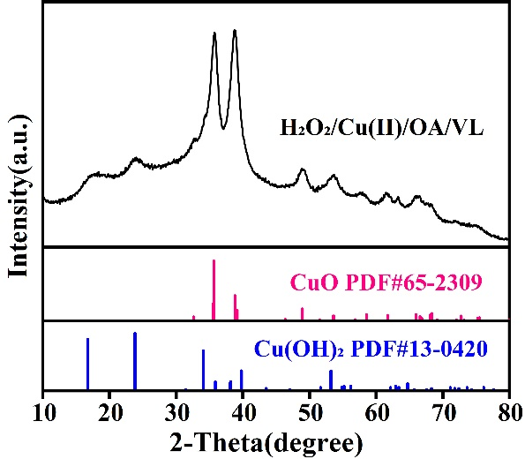
Fig. S1. XRD pattern of Cu-containing precipitation obtained from Cu(II)-EDTA treated by H₂O₂/Cu(II)/OA/VL combined with alkaline precipitation.

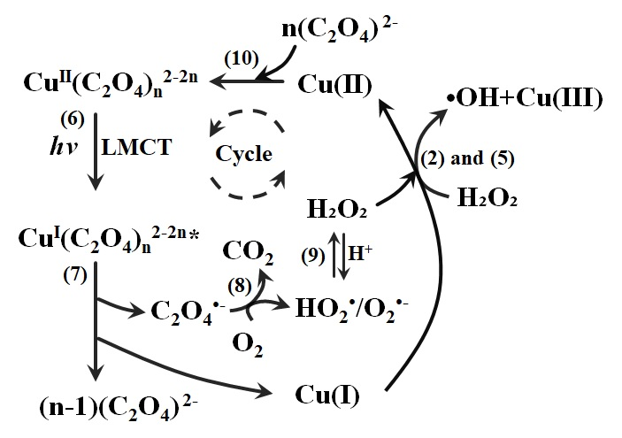
Fig. S2. Possible catalytic mechanism of the H₂O₂/Cu(II)/OA/VL system

Table S1. Retention time and structural formula of by-products
Number | Retention time（min） | m/z | Name | Structure
1 | 3.377 | 60 | Acetic acid
2 | 4.621 | 45 | Ethylamine
3 | 4.962 | 102 | N-Acetylethylenediamine
4 | 5.709 | 75 | Glycine
5 | 5.885 | 132 | Oxalacetic acid
6 | 7.812 | 88 | Ethanediamide
7 | 8.32 | 45 | Dimethylamine
8 | 11.149 | 46 | Formic acid

Table S2.
Phytotoxic effects in lettuces irrigated by using Cu(II)-EDTA solution and Cu(II)-EDTA solution treated by H₂O₂/Cu(II)/OA/VL (treatment). lettuces irrigated by deionized water (control) was considered to evaluate the expected normal development of the lettuces. Groups with the same letter are not statistically signiﬁcant different from each other (p value < 0.05).
 | Shoot length  (cm) | Root length  (cm) | Shoot weight  (g) | Root weight  (g)
 | Mean ± standard deviation
Control | 6.39±0.09^{A} | 3.31±0.11ª | 0.060±0.0010^{A} | 0.019±0.0010^{A}
Treatment | 6.24±0.10^{A} | 3.23±0.09ª | 0.059±0.0006^{A} | 0.015±0.0006^{A}
Cu(II)-EDTA | 2.73±0.13^{B} | 1.30±0.10^{b} | 0.021±0.0010^{A} | 0.006±0.0010^{A}

