Tumor ferroptosis status demonstrated vulnerability to chemotherapy and reflected immune-activation in colorectal cancer
Supplementary materials content

Supplementary tables
Supplementary table S1 Ferroptosis related genes according to publications
Supplementary table S2 Relationship between significant markers and clinical characteristics in CRC patients
Supplementary table S3 Univariate and multivariate analysis for OS among 911 CRC patients
Supplementary table S4 Baseline clinicopathological characteristics of training and validation cohorts
Supplementary table S5 Comparison of predictive accuracies of prognostic models

Supplementary figures
Supplementary figure S1 PPI network of ferroptosis panel constructed based on TCGA database. Abbreviation: PPI, protein-to-protein interaction; TCGA, the cancer genome atlas.
Supplementary figure S2 (A) Kaplan-meier analysis of up-regulated genes on CRC OS; (B) Kaplan-meier analysis of down-regulated genes on OS. Abbreviation: OS, overall survival; CRC, colorectal cancer.
Supplementary figure S3 (A) IHC score between cancer tissue and normal epithelium based on CRC TMA; (B) mRNA expression between cancer tissue and normal epithelium in CRC. Abbreviation: IHC, immunohistochemistry; CRC, colorectal cancer; TMA, tissue microarray.
Supplementary figure S4 ROC curves and AUC value for GPX4 (A), NOX1 (B) and FACL4 (C) on CRC OS and Time-dependent AUC for OS on GPX4 (D), NOX1 (E) and FACL4 (F). Abbreviation: ROC, receiver operating characteristic; OS, overall survival.
Supplementary figure S5 Internal validation of ferroptosis score on 3 years, 5 years and 7 years’ survival based on training cohort data.
Supplementary figure S6 Kaplan-meier analysis of ferroptosis score on OS stratification and Cox proportional hazards regression analysis for comparisons of OS in stage I (A), stage II (B), stage III (C) and stage IV (D) CRC; Abbreviation: OS, overall survival; CRC, colorectal cancer.
Supplementary figure S7 Kaplan-meier analysis of GPX4 (A), NOX1 (B) and ACSL4 (C) on PFS based on TCGA analysis. Abbreviation: PFS, progression free survival; TCGA, the cancer genome atlas.
Supplementary figure S8 In low ferroptosis score cohort, stage II and III patients received ACT had better duration of PFS (A) and OS (D) than no ACT patients; In medium ferroptosis score, stage II and III patients received ACT had better duration of PFS (B) and OS (E) than no ACT patients; In high ferroptosis score, patients received ACT had the similar duration of PFS (C) and OS (G) than no ACT patients. Abbreviation: CRC, colorectal cancer; PFS, progression free survival; ACT, adjuvant chemotherapy; OS, overall survival.
Supplementary figure S9 Kaplan-meier analysis of IFN-γ on CRC RFS. Abbreviation: CRC, colorectal cancer; RFS, relapse free survival.

Supplementary information
Supplementary information 1 Exploration of Ferroptosis-related gene in pubmed
Supplementary information 2 Tissue microarray construction, immunohistochemical staining
Supplementary information 3 Evaluation of the stability and repeatability of the detection method for ferroptosis-related genes
Supplementary information 4 Comparison between normal sections and tissue microarray for immunohistochemical staining

Table S1: ferroptosis related gene according to publications
Iron Metabolism | NCOA4^{1,2}, ACO1², FTH1³, STEAP3⁴, FANCD2^{4,5}, NFS1^{6,7}, TFRC^{8,9}, PHKG2¹⁰, IREB2¹¹, HSBP1¹², HMOX1^{13,14}, CISD1/mitoNEET¹⁵,
Lipid Metabolism | ACSF2¹¹, CS(citrate synthase )¹¹, LPCAT3¹⁶ , ACSL4^{16,17}, ACSL3¹⁸, ACACA¹⁶, GPX4¹⁹, AKR1C²⁰, LOX^{10,21}, PEBP1²², ZEB1²³, SQS/FDFT1^{24,25}, SQLE²⁵, HMGCR²⁴, FADS2²⁶
Energy Metabolism | SLC1A5⁸, GLS2⁸, GOT1⁸, G6PD^{2,11}, PGD¹¹
Oxidant Metabolism | NRF2^{3,27}, KEAP1²⁸, HMOX1²⁹, NQO1³, SLC7A11¹¹, GCLC¹⁹, CARS³⁰, CBS³⁰, NOX1¹¹, ABCC1/MRP1²
References:
1. Hou W, Xie Y, Song X, et al. Autophagy promotes ferroptosis by degradation of ferritin. Autophagy. 2016;12(8):1425-1428.
2. Gao M, Monian P, Pan Q, Zhang W, Xiang J, Jiang X. Ferroptosis is an autophagic cell death process. Cell Res. 2016;26(9):1021-1032.
3. Sun X, Ou Z, Chen R, et al. Activation of the p62-Keap1-NRF2 pathway protects against ferroptosis in hepatocellular carcinoma cells. Hepatology. 2016;63(1):173-184.
4. Song X, Xie Y, Kang R, et al. FANCD2 protects against bone marrow injury from ferroptosis. Biochem Biophys Res Commun. 2016;480(3):443-449.
5. Li C, Zhang Y, Liu J, Kang R, Klionsky DJ, Tang D. Mitochondrial DNA stress triggers autophagy-dependent ferroptotic death. Autophagy. 2020:1-13.
6. Alvarez SW, Possemato R. Leveraging the iron-starvation response to promote ferroptosis. Oncotarget. 2018;9(13):10830-10831.
7. Alvarez SW, Sviderskiy VO, Terzi EM, et al. NFS1 undergoes positive selection in lung tumours and protects cells from ferroptosis. Nature. 2017;551(7682):639-643.
8. Gao M, Monian P, Quadri N, Ramasamy R, Jiang X. Glutaminolysis and Transferrin Regulate Ferroptosis. Mol Cell. 2015;59(2):298-308.
9. Yang WS, Stockwell BR. Synthetic lethal screening identifies compounds activating iron-dependent, nonapoptotic cell death in oncogenic-RAS-harboring cancer cells. Chem Biol. 2008;15(3):234-245.
10. Yang WS, Kim KJ, Gaschler MM, Patel M, Shchepinov MS, Stockwell BR. Peroxidation of polyunsaturated fatty acids by lipoxygenases drives ferroptosis. Proc Natl Acad Sci U S A. 2016;113(34):E4966-4975.
11. Dixon SJ, Lemberg KM, Lamprecht MR, et al. Ferroptosis: an iron-dependent form of nonapoptotic cell death. Cell. 2012;149(5):1060-1072.
12. Sun X, Ou Z, Xie M, et al. HSPB1 as a novel regulator of ferroptotic cancer cell death. Oncogene. 2015;34(45):5617-5625.
13. Hassannia B, Wiernicki B, Ingold I, et al. Nano-targeted induction of dual ferroptotic mechanisms eradicates high-risk neuroblastoma. J Clin Invest. 2018;128(8):3341-3355.
14. Chang LC, Chiang SK, Chen SE, Yu YL, Chou RH, Chang WC. Heme oxygenase-1 mediates BAY 11-7085 induced ferroptosis. Cancer Lett. 2018;416:124-137.
15. Yuan H, Li X, Zhang X, Kang R, Tang D. CISD1 inhibits ferroptosis by protection against mitochondrial lipid peroxidation. Biochem Biophys Res Commun. 2016;478(2):838-844.
16. Dixon SJ, Winter GE, Musavi LS, et al. Human Haploid Cell Genetics Reveals Roles for Lipid Metabolism Genes in Nonapoptotic Cell Death. ACS Chem Biol. 2015;10(7):1604-1609.
17. Vanden Berghe T, Hassannia B, Vandenabeele P. An outline of necrosome triggers. Cell Mol Life Sci. 2016;73(11-12):2137-2152.
18. Magtanong L, Ko PJ, To M, et al. Exogenous Monounsaturated Fatty Acids Promote a Ferroptosis-Resistant Cell State. Cell Chem Biol. 2019;26(3):420-432 e429.
19. Yang WS, SriRamaratnam R, Welsch ME, et al. Regulation of ferroptotic cancer cell death by GPX4. Cell. 2014;156(1-2):317-331.
20. Dixon SJ, Patel DN, Welsch M, et al. Pharmacological inhibition of cystine-glutamate exchange induces endoplasmic reticulum stress and ferroptosis. Elife. 2014;3:e02523.
21. Seiler A, Schneider M, Forster H, et al. Glutathione peroxidase 4 senses and translates oxidative stress into 12/15-lipoxygenase dependent- and AIF-mediated cell death. Cell Metab. 2008;8(3):237-248.
22. Wenzel SE, Tyurina YY, Zhao J, et al. PEBP1 Wardens Ferroptosis by Enabling Lipoxygenase Generation of Lipid Death Signals. Cell. 2017;171(3):628-641 e626.
23. Viswanathan VS, Ryan MJ, Dhruv HD, et al. Dependency of a therapy-resistant state of cancer cells on a lipid peroxidase pathway. Nature. 2017;547(7664):453-457.
24. Shimada K, Skouta R, Kaplan A, et al. Global survey of cell death mechanisms reveals metabolic regulation of ferroptosis. Nat Chem Biol. 2016;12(7):497-503.
25. Garcia-Bermudez J, Baudrier L, Bayraktar EC, et al. Squalene accumulation in cholesterol auxotrophic lymphomas prevents oxidative cell death. Nature. 2019;567(7746):118-122.
26. Zhang Y, Tan H, Daniels JD, et al. Imidazole Ketone Erastin Induces Ferroptosis and Slows Tumor Growth in a Mouse Lymphoma Model. Cell Chem Biol. 2019;26(5):623-633 e629.
27. Roh JL, Kim EH, Jang H, Shin D. Nrf2 inhibition reverses the resistance of cisplatin-resistant head and neck cancer cells to artesunate-induced ferroptosis. Redox Biol. 2017;11:254-262.
28. Fan Z, Wirth AK, Chen D, et al. Nrf2-Keap1 pathway promotes cell proliferation and diminishes ferroptosis. Oncogenesis. 2017;6(8):e371.
29. Adedoyin O, Boddu R, Traylor A, et al. Heme oxygenase-1 mitigates ferroptosis in renal proximal tubule cells. Am J Physiol Renal Physiol. 2018;314(5):F702-F714.
30. Hayano M, Yang WS, Corn CK, Pagano NC, Stockwell BR. Loss of cysteinyl-tRNA synthetase (CARS) induces the transsulfuration pathway and inhibits ferroptosis induced by cystine deprivation. Cell Death Differ. 2016;23(2):270-278.

Table S2. Relationship between significant markers and clinical characteristics in CRC patients
 | Ferroptosis markers
 | GPX4 |  |  | NOX1 |  |  | FACL4
Factors | Low (%) | High (%) | P | Low (%) | High (%) | P | Low (%) | High (%) | P
All patients | 463 | 448 |  | 459 | 452 |  | 450 | 461
Age (years) |  |  | 0.088 |  |  | 0.228 |  |  | 0.358
≤60 | 187 (40.4) | 206 (46.0) |  | 189 (41.2) | 204 (45.1) |  | 201 (44.7) | 192 (41.6)
>60 | 276 (59.6) | 242 (54.0) |  | 270 (58.8) | 96 (54.9) |  | 249 (55.3) | 269 (58.4)
Gender |  |  | 0.753 |  |  | 0.500 |  |  | 0.609
Male | 266 (57.5) | 262 (58.5) |  | 261 (56.9) | 267 (59.1) |  | 257 (57.1) | 271 (58.8)
Female | 197 (42.5) | 186 (41.5) |  | 198 (43.1) | 185 (40.9) |  | 193 (42.9) | 190 (41.2)
CEA (ng/ml) |  |  | 0.423 |  |  | 0.353 |  |  | 0.142
≤ 5 | 252 (54.4) | 222 (49.6) |  | 232 (50.5) | 242  (53.5) |  | 220 (48.9) | 254 (55.1)
> 5 | 200 (43.2) | 215 (48.0) |  | 213 (46.4) | 202 (44.7) |  | 217 (48.2) | 198 (43.0)
Unknown | 11  (2.4) | 11 (2.5) |  | 14 (3.1) | 8 (1.8) |  | 13 (2.9) | 9 (2.0)
Tumor location |  |  | 0.192 |  |  | 0.393 |  |  | 0.637
Right-sided colon | 121 (26.1) | 133 (29.7) |  | 136 (29.6) | 118 (26.1) |  | 129 (28.7) | 125 (27.1)
Left-sided colon | 112 (24.2) | 122 (27.2) |  | 120 (26.1) | 114 (25.2) |  | 117 (26.0) | 117 (25.4)
Rectum | 230 (49.7) | 193 (43.1) |  | 203 (44.2) | 220 (48.7) |  | 204 (45.3) | 219 (47.5)
Tumor size |  |  | 0.001 |  |  | 0.001 |  |  | 0.001
≤4.0cm | 256 (55.3) | 129 (28.8) |  | 123 (26.8) | 262 (58.0) |  | 263 (59.4) | 122 (26.5)
>4.0cm | 207 (44.7) | 319 (71.2) |  | 336 (73.2) | 190 (42.0) |  | 180 (40.6) | 339 (73.5)
Primary histological type |  |  | 0.427 |  |  | 0.468 |  |  | 0.949
Non-mucinous | 387 (83.6) | 383 (85.5) |  | 384 (83.7) | 386 (85.4) |  | 380 (84.4) | 390 (84.6)
Mucinous | 76 (16.4) | 65 (14.5) |  | 75 (16.3) | 66 (14.6) |  | 70 (15.6) | 71 (15.4)
Primary differentiation |  |  | 0.009 |  |  | 0.425 |  |  | 0.868
Well/moderate | 349 (73.8) | 295 (65.8) |  | 330 (71.1) | 314 (68.7) |  | 317 (69.7) | 327 (70.2)
Poor/anaplastic | 124 (26.2) | 153 (34.2) |  | 134 (28.9) | 143 (31.3) |  | 138 (30.3) | 139 (29.8)
T stage |  |  | 0.960 |  |  | 0.001 |  |  | 0.565
T1/T2 | 224 (48.4) | 216 (48.2) |  | 180 (39.2) | 260 (57.5) |  | 213 (47.3) | 227 (49.2)
T3/T4 | 239 (51.6) | 232 (51.8) |  | 279 (60.8) | 192 (41.8) |  | 237 (52.7) | 234 (50.8)
N stage |  |  | 0.029 |  |  | 0.937 |  |  | 0.096
N0 | 269 (58.1) | 228 (50.9) |  | 251 (54.7) | 246 (54.4) |  | 233 (51.8) | 264 (57.3)
N1/N2 | 194 (41.9) | 220 (49.1) |  | 208 (45.3) | 206 (45.6) |  | 217 (48.2) | 197 (42.7)
Vascular/nerve invasion |  |  | 0.891 |  |  | 0.001 |  |  | 0.021
No | 386 (83.4) | 375 (83.7) |  | 356 (77.6) | 405 (89.6) |  | 363 (80.7) | 398 (86.3)
Yes | 77 (16.6) | 73 (16.3) |  | 103 (22.4) | 47 (10.4) |  | 87 (19.3) | 63 (13.7)
M stage |  |  | 0.057 |  |  | 0.136 |  |  | 0.001
M0 | 363 (78.4) | 327 (73.0) |  | 338 (73.6) | 352 (77.9) |  | 313 (69.9) | 377 (81.8)
M1 | 100 (21.6) | 121 (27.0) |  | 121 (26.4) | 100 (22.1) |  | 137 (30.4) | 84 (18.2)
Abbreviations: T, tumor invasion depth; N, lymph node involvement; M, metastasis.

Characteristics | Univariate analysis |  |  | Multivariate analysis
Characteristics | Pvalue | HR | 95%CI | Pvalue | HR | 95%CI
Gender | 0.078
Male |  | 1(Reference) | 1(Reference)
Female |  | 1.223 | 0.843-1.526
Age | 0.945
≥60 |  | 1(Reference) | 1(Reference)
<60 |  | 1.008 | 0.809-1.255
Primary site | 0.085
Left sided colon |  | 1(Reference) | 1(Reference)
Right sided colon |  | 0.173 | 0.024-1.246
Rectum |  | 0.122 | 0.024-1.267
Tumor size | 0.035 |  |  | 0.163
≤4.0cm |  | 1(Reference) | 1(Reference) |  | 1(Reference) | 1(Reference)
>4.0cm |  | 1.235 | 1.012-1.561 |  | 1.185 | 0.934-1.505
Differentiation | 0.001 |  |  | 0.023
Well/moderate |  | 1(Reference) | 1(Reference) |  | 1(Reference) | 1(Reference)
Poor/anaplastic |  | 1.654 | 1.321-2.069 |  | 1.331 | 1.040-1.703
T stage | 0.001 |  |  | 0.197
T1/T2 |  | 1(Reference) | 1(Reference) |  | 1(Reference) | 1(Reference)
T3/T4 |  | 2.813 | 1.884-4.201 |  | 1.341 | 0.859-2.904
N stage | 0.001 |  |  | 0.001
N0 |  | 1(Reference) | 1(Reference) |  | 1(Reference) | 1(Reference)
N1/N2 |  | 2.886 | 2.297-3.626 |  | 1.724 | 1.315-2.259
M stage | 0.001 |  |  | 0.001
M0 |  | 1(Reference) | 1(Reference) |  | 1(Reference) | 1(Reference)
M1 |  | 8.197 | 6.579-10.309 |  | 2.631 | 2.315-2.994
Vascular/nerve invasion | 0.078
No |  | 1(Reference) | 1(Reference)
Yes |  | 0.625 | 0.446-1.372
GPX4 | 0.001 |  |  | 0.014
High expression |  | 1(Reference) | 1(Reference) |  | 1(Reference) | 1(Reference)
Low expression |  | 0.678 | 0.542-0.837 |  | 0.740 | 0.581-0.941
NOX1 | 0.001 |  |  | 0.026
High expression |  | 1(Reference) | 1(Reference) |  | 1(Reference) | 1(Reference)
Low expression |  | 1.491 | 1.203-1.845 |  | 1.311 | 1.033-1.665
FACL4 | 0.001 |  |  | 0.015
High expression |  | 1(Reference) | 1(Reference) |  | 1(Reference) | 1(Reference)
Low expression |  | 1.47 | 1.12-1.75 |  | 1.336 | 1.213-1.656
Table S3: Univariate and multivariate analysis for OS among 911 CRC patients

Table S4. Baseline clinicopathological characteristics of training and validation cohorts
 | Training set |  | Validation set |  | P-value
Factors | No. | % | No. | % | P-value
All patients | 455 | 100.0 | 456 | 100
Age (years) |  |  |  |  | 0.660
≤ 60 | 193 | 42.4 | 200 | 43.9
> 60 | 262 | 57.6 | 256 | 56.1
Gender |  |  |  |  | 0.969
Male | 264 | 58.0 | 264 | 58.0
Female | 191 | 42.0 | 192 | 42.0
CEA (ng/ml) |  |  |  |  | 0.097
≤ 5 | 238 | 52.3 | 236 | 51.8
> 5 | 211 | 46.4 | 204 | 44.7
Unknown | 6 | 1.3 | 16 | 3.5
Tumor location |  |  |  |  | 0.906
Right-sided colon | 128 | 28.1 | 126 | 27.6
Left-sided colon | 121 | 26.6 | 122 | 26.8
Rectum | 206 | 45.3 | 217 | 47.6
Tumor size |  |  |  |  | 0.399
≤ 4.0cm | 186 | 40.9 | 199 | 43.6
> 4.0cm | 269 | 59.1 | 257 | 56.4
Primary histological type |  |  |  |  | 0.938
Non-mucinous | 385 | 84.6 | 385 | 84.4
Mucinous | 70 | 15.4 | 71 | 15.6
Primary differentiation |  |  |  |  | 0.477
Well/moderate | 323 | 71.8 | 321 | 69.6
Poor/ anaplastic | 127 | 28.2 | 140 | 30.4
T stage |  |  |  |  | 0.574
T1/T2 | 224 | 49.2 | 216 | 47.4
T3/T4 | 231 | 50.8 | 240 | 52.6
N stage |  |  |  |  | 0.442
N0 | 254 | 55.8 | 243 | 53.3
N1/N2 | 201 | 44.2 | 213 | 46.7
Nerve/Vascular invasion |  |  |  |  | 0.988
No | 375 | 82.4 | 376 | 82.5
Yes | 80 | 17.6 | 80 | 17.5
M stage |  |  |  |  | 0.406
M0 | 350 | 76.9 | 340 | 74.6
M1 | 105 | 23.1 | 116 | 25.4

Table S5. Comparison of predictive accuracies of prognostic models
 | Training cohort |  |  | Validation cohort
Factor | C-index | 95%CI | P-value | C-index | 95%CI | P-value
Ferroptosis score with TNM | 0.721 | 0.682-0.751 | Reference | 0.715 | 0.693-0.742 | Reference
Ferroptosis score | 0.692 | 0.654-0.739 | <0.001 | 0.681 | 0.665-0.716 | <0.001
GPX4 | 0.570 | 0.537-0.616 | <0.001 | 0.565 | 0.535-0.621 | <0.001
NOX1 | 0.526 | 0.492-0.573 | <0.001 | 0.531 | 0.502-0.585 | <0.001
FACL4 | 0.562 | 0.528-0.614 | <0.001 | 0.554 | 0.532-0.608 | <0.001
Pathological T stage | 0.622 | 0.565-0.668 | <0.001 | 0.632 | 0.598-0.674 | <0.001
Lymph nodes metastasis | 0.610 | 0.545-0.654 | <0.001 | 0.601 | 0.573-0.645 | <0.001
Distant metastasis | 0.682 | 0.643-0.726 | <0.001 | 0.665 | 0.638-0.728 | <0.001
TNM | 0.701 | 0.635-0.745 | 0.035 | 0.697 | 0.675-0.721 | 0.029
Abbreviations: C-index, Harrell’s Concordance index; TNM, tumor node metastasis; CI, confidence interval.

Supplementary Figure S1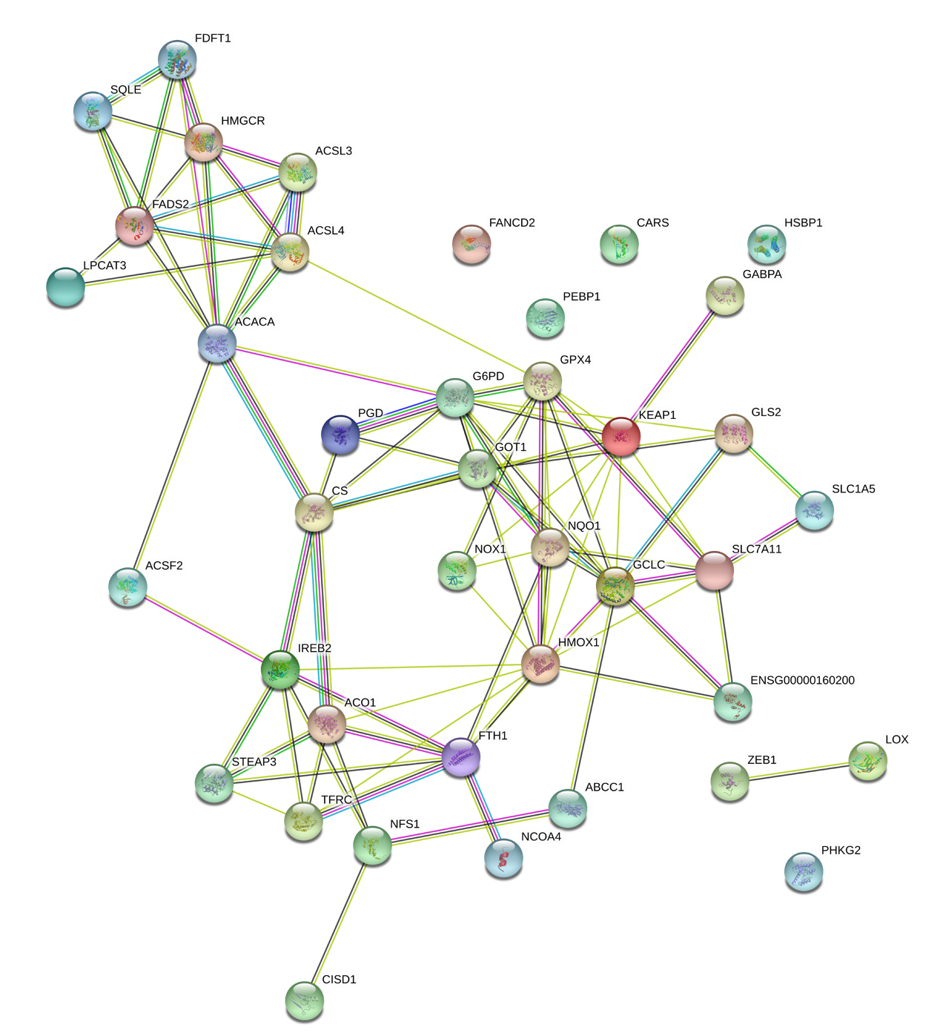

Supplementary Figure S2

Supplementary Figure S3

Supplementary Figure S4

Supplementary Figure S5

Supplementary Figure S6

Supplementary Figure S7

Supplementary Figure S8

Supplementary Figure S9

Supplementary information 1
Exploration of Ferroptosis-related gene in pubmed
We searched the “pubmed” database for ferroptosis-related genes in cancer. The Keywords were “ferroptosis” OR “ferroptotic” AND “cancer” OR “tumor” OR “neoplasm”. The date was from 1. July. 1966 to 1. July.2020. The number of references was as follows:
Database | Key words | Number of reference
PubMed  (1966-2020-7-1) | Ferroptosis OR ferroptotic | 1189
PubMed  (1966-2020-7-1) | Ferroptosis OR ferroptotic AND cancer OR tumor OR neoplasm | 623
PubMed  (1966-2020-7-1) | Ferroptosis OR ferroptotic AND cancer OR tumor OR neoplasm; article type: “article” OR “review” | 174
With the 174 publications, we further determined 42 ferroptosis related genes in Table S1.

Supporting information 2
Tissue microarray construction, immunohistochemical staining
- Tissue microarray construction
As a retrospective study, all samples were formalin-fixed paraffin-embedded (FFPE) tissue blocks retrieved from Department of Pathology, Zhongshan Hospital, Fudan University. These FFPE tissue blocks were made for routine pathological examination after surgery, according to Chinese Standardization Criteria for Tumor Pathology Diagnosis (by National Health Commission of China). In this study, FFPE blocks of tumor tissues without necroses were selected as “Tumor samples”. The position of tissue blocks on the surgical specimen is shown as Figure 1. In Figure 1 was a surgical specimen of radical right hemicolectomy. Tumor region was marked by dotted line, and the necrotic region at tumor center was marked by solid line. FFPE tissue blocks sampled in the annular region between dotted and solid lines were selected as “Tumor samples”. Two pieces of “Tumor samples” were selected, located at different side of the tumor (in our Zhongshan Hospital, Fudan University, each tumor was required to sample more than 4 pieces at different side in this annular region for routine pathological examination, providing sufficient FFPE tissue blocks for selection). At the same time, normal mucosa tissues at colon resection margin were selected as “Normal mucosa sample”, as shown in Figure 1.
For tumor and normal specimen, tissue microarray (TMA) was constructed using FFPE tissue blocks as previously reported (PMID: 30988081). The diameter of tissue core was 2 mm. All samples were reviewed histologically by hematoxylin and eosin staining. Representative areas were marked on the paraffin blocks away from necrotic and hemorrhagic materials. Histological review was also constructed to avoid necrotic and hemorrhagic tumor regions.
For each patient, two cores of tumor tissues were taken from two tumor specimen as was shown in Figure 2(A). Tumor cores were taken in the middle of tumor sample piece, which were away from necrotic area. Correlated normal mucosa tissues were taken from two different areas of one “normal mucosa” in the middle of resection line (Figure 2B). Thus TMA was constructed (Figure 2C).
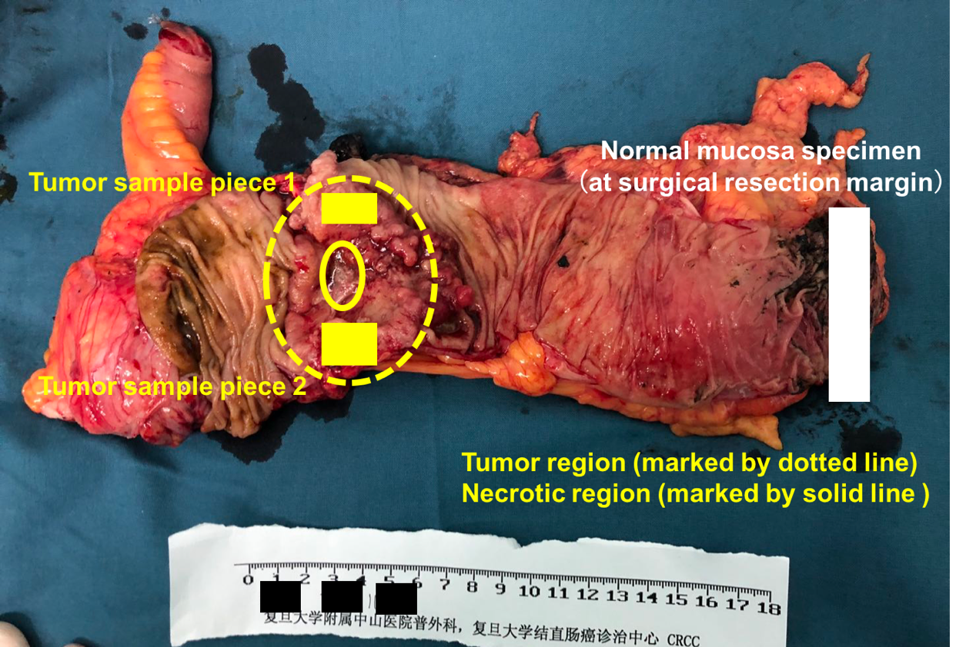
Figure 1: Position of the tissue blocks on surgical specimen

Figure 2: (A) Making tumor tissue cores; (B) Making normal mucosa tissue cores; (C) Tissue microarray of CRC cohort; (D) and (E) representative image of total immunohistochemical staining for tissue microarray.

- Immunohistochemical staining
Briefly, sections were deparaffinized in xylene and graded alcohols, hydrated, and washed in phosphate-buffered saline. After the endogenous peroxidase was inhibited by 3% H₂O₂ for 30 minutes, the sections were heated in a pressure cooker for 5 minutes in unmasking solution (0.01 M sodium citrate buffer, pH = 6) and then incubated in 10% normal goat serum for 30 minutes. Primary antibodies were applied overnight in a moist chamber at 4°C. After the primary antibody was washed off, the EnVision Detection System (Peroxidase/DAB, Rabbit/Mouse, Dako) was used according to the instructions. Then the sections were counterstained with hematoxylin, dehydrated and mounted.

Supplementary information 3
Evaluation of the stability and repeatability of the detection method for ferroptosis-related genes
In our study, 2 pathologists, Dr Lingli Chen (Pathologist A) and Dr Jiamei Yao (Pathologist B) from Department of Pathology, Zhongshan Hospital, Fudan University performed the work of detecting ferroptosis-related markers, including the proportion of positive tumor cells in the tissues and the average intensity of positive tumor cells. For each patient, there were 2 tumor cores named as tumor core 1 and tumor core 2. And for each tumor core, 3 photos of HPF (200x) were taken at different area. A total of 2683 photos were taken for tumor cores of all patients. The IHC score from Pathologist A and Pathologist B were compared on each photo, using intraclass correlation coefficient (ICC) to evaluate the stability and repeatability of our detection method. According to the comparison between Pathologist A and B, in all photos of each tumor core, the R square were in high value > 0.95, showing good consistency. This confirmed the stability and repeatability of our detection method of IHC score. Details were as follows:

Figure 1: (A) GPX4 expression of all photos from Tumor Core 1 and Tumor Core 2 were compared from Pathologist A; (B) GPX4 expression of all photos from Tumor Core 1 and Tumor Core 2 were compared from Pathologist B; (C) GPX4 expression of all photos from Tumor Core 1 were compared between Pathologist A and B; (D) GPX4 expression of all photos from Tumor Core 2 were compared between Pathologist A and B. All these results demonstrated good consistency.

Figure 2: (A) NOX1 expression of all photos from Tumor Core 1 and Tumor Core 2 were compared from Pathologist A; (B) NOX1 expression of all photos from Tumor Core 1 and Tumor Core 2 were compared from Pathologist B; (C) NOX1 expression of all photos from Tumor Core 1 were compared between Pathologist A and B; (D) NOX1 expression of all photos from Tumor Core 2 were compared between Pathologist A and B. All these results demonstrated good consistency.

Figure 2: (A) FACL4 expression of all photos from Tumor Core 1 and Tumor Core 2 were compared from Pathologist A; (B) FACL4 expression of all photos from Tumor Core 1 and Tumor Core 2 were compared from Pathologist B; (C) FACL4 expression of all photos from Tumor Core 1 were compared between Pathologist A and B; (D) FACL4 expression of all photos from Tumor Core 2 were compared between Pathologist A and B. All these results demonstrated good consistency.

Supplementary information 4
Comparison between normal sections and tissue microarray for immunohistochemical staining
Immunohistochemical staining of Ferroptosis markers was compared between using normal sections and using tissue microarray. Intraclass correlation coefficient (ICC) was used to evaluate the consistency of normal sections and tissue microarray. ICC parameter selected as: two-way mixed model; absolute agreement; single measures. Details are as follows:

Figure 1: For GPX4 expression, IHC score detected using normal section versus tissue microarray

Figure 2: For NOX1 expression, IHC score detected using normal section versus tissue microarray

Figure 3: For FACL4 expression, IHC score detected using normal section versus tissue microarray

