Hydrodynamic Metamaterials Enable Radial Fingering Instabilities of Liquid Metals via Cartesian Topography
Yahua He^{1,2}, Jing You^{1,3}, Jianbo Tang⁴, Zhao Wang⁵, Anthony E. Somers⁶, Wenrong Yang²*, Michael D. Dickey⁷*, Xiaolin Wang¹*
Affiliations:
¹Institute for Superconducting and Electronic Materials, Faculty of Engineering and Information Sciences, University of Wollongong, Wollongong, New South Wales 2500, Australia.
²School of Life and Environmental Sciences, Faculty of Science, Engineering and Built Environment, Deakin University, Waurn Ponds, Victoria 3216, Australia.
³School of Chemical Engineering, Faculty of Engineering, University of New South Wales, Sydney, New South Wales 2052, Australia.
⁴Department of Materials Science and Engineering, School of Engineering, Westlake University, Hangzhou, Zhejiang 310030, China.
⁵Hubei Key Laboratory of Micro/Nano-Electronic Materials and Devices, School of Integrated Circuits, Hubei University, Wuhan, Hubei 430062, China
⁶Institute for Frontier Materials, Deakin University, Burwood, Victoria 3125, Australia.
⁷Department of Chemical and Biomolecular Engineering, North Carolina State University, 911 Partners Way, Raleigh, North Carolina 27695, USA.

*Correspondence to:
wenrong.yang@deakin.edu.au, mddickey@ncsu.edu, and xiaolin@uow.edu.au

This supplementary information file includes:
Section I: Legends for videos S1 to S16
Section II: Figures S1 to S31
Section III: Calculation details of fractal dimension D
Section IV: Discussion of filling process of liquid metal on pillar arrays

Other supplementary information for this manuscript includes the following:
Videos S1 to S16
Section I: Supporting Videos
Video S1. Fingering patterns of anodic liquid metals (30 μL) on bare substrate (no topographical structures) with applied voltage of 1.75 V, 1 M NaOH solution, circular cathode.
Video S2. Fingering patterns of anodic liquid metals (30 μL) on pillar array (l = s = 200 μm, abbreviated as A200) with applied voltage of 1.75 V, 1 M NaOH solution, circular cathode.
Video S3. Fingering patterns of anodic liquid metals (30 μL) on pit array (l = s = 200 μm, abbreviated as B200) with applied voltage of 1.75 V, 1 M NaOH solution, circular cathode.
Video S4. Fingering patterns of small anodic liquid metal droplets (10 μL) on pillar array with larger square-unit size (l = s = 500 μm, abbreviated as A500) with applied voltage of 1.75 V, 1 M NaOH solution, circular cathode.
Video S5. Fingering patterns of anodic liquid metals (20 μL) on combined pillar arrays (A100 inside/A300 outside) with applied voltage of 3.0 V, 1 M NaOH solution, circular cathode.
Video S6. Fingering patterns of anodic liquid metals (20 μL) on combined pit arrays (B100 up/B300 down) with applied voltage of 1.75 V, 1 M NaOH solution, circular cathode.
Video S7. Fingering patterns of anodic liquid metals (20 μL) on combined pillar and pit arrays (A200 left/B200 right) with applied voltage of 1.75 V, 1 M NaOH solution, circular cathode.
Video S8. Bottom-view of anodic liquid metals (30 μL) on bare substrate (no topographical structures) with applied voltage of 1.75 V, 1 M NaOH solution, circular cathode.
Video S9. Bottom-view of anodic liquid metals (30 μL) on pillar array with applied voltage of 1.75 V, 1 M NaOH solution, circular cathode.
Video S10. Bottom-view of anodic liquid metals (30 μL) on pit array with applied voltage of 1.75 V, 1 M NaOH solution, circular cathode.
Video S11. Bottom-view of formation of slender fingers on pillar array with applied voltage of 1.75 V, 1 M NaOH solution, circular cathode.
Video S12. Fingering patterns of anodic liquid metals (30 μL) on filter paper (pore size of ~ 20 μm) with applied voltage of 1.75 V, 1 M NaOH solution, circular cathode.
Video S13. Fingering patterns of anodic liquid metals (300 μL) on pillar arrays (A300) with applied voltage of 5.0 V, 1 M NaOH solution, point cathode.
Video S14. Fingering patterns of anodic liquid metals (300 μL) on pit arrays (B300) with applied voltage of 5.0 V, 1 M NaOH solution, point cathode.
Video S15. Fingering patterns of anodic liquid metals (300 μL) on combined pit arrays (B100 inside/B500 outside) with applied voltage of 5.0 V, 1 M NaOH solution, point cathode.
Video S16. Fingering patterns of anodic liquid metals (300 μL) on combined pit and pillar arrays (B300 left/A300 right) with applied voltage of 5.0 V, 1 M NaOH solution, point cathode.

Section II: Supporting Figures

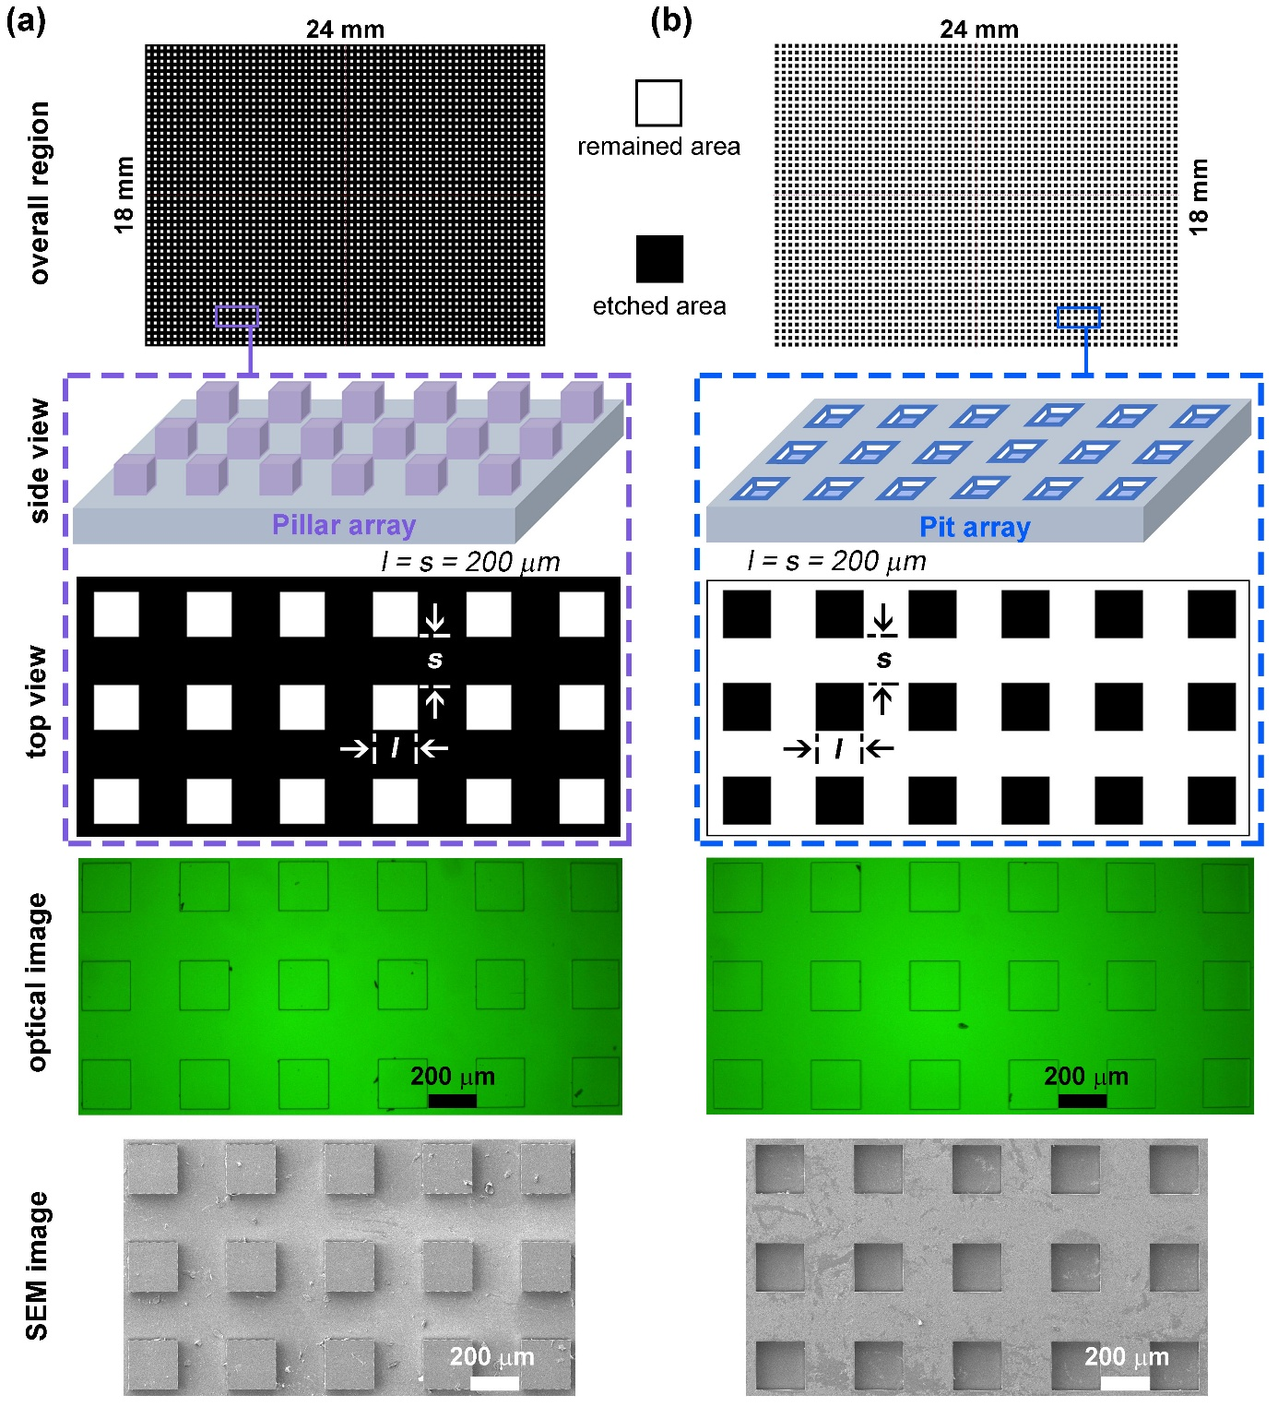

Figure S1. Detailed information of two topographical structures. Each row demonstrates the overall region size, side view and top view illustration, optical images, and SEM images of (a) pillar array, (b) pit array. l = s = 200 μm, l stands for length of square unit and s is for spacing between square units

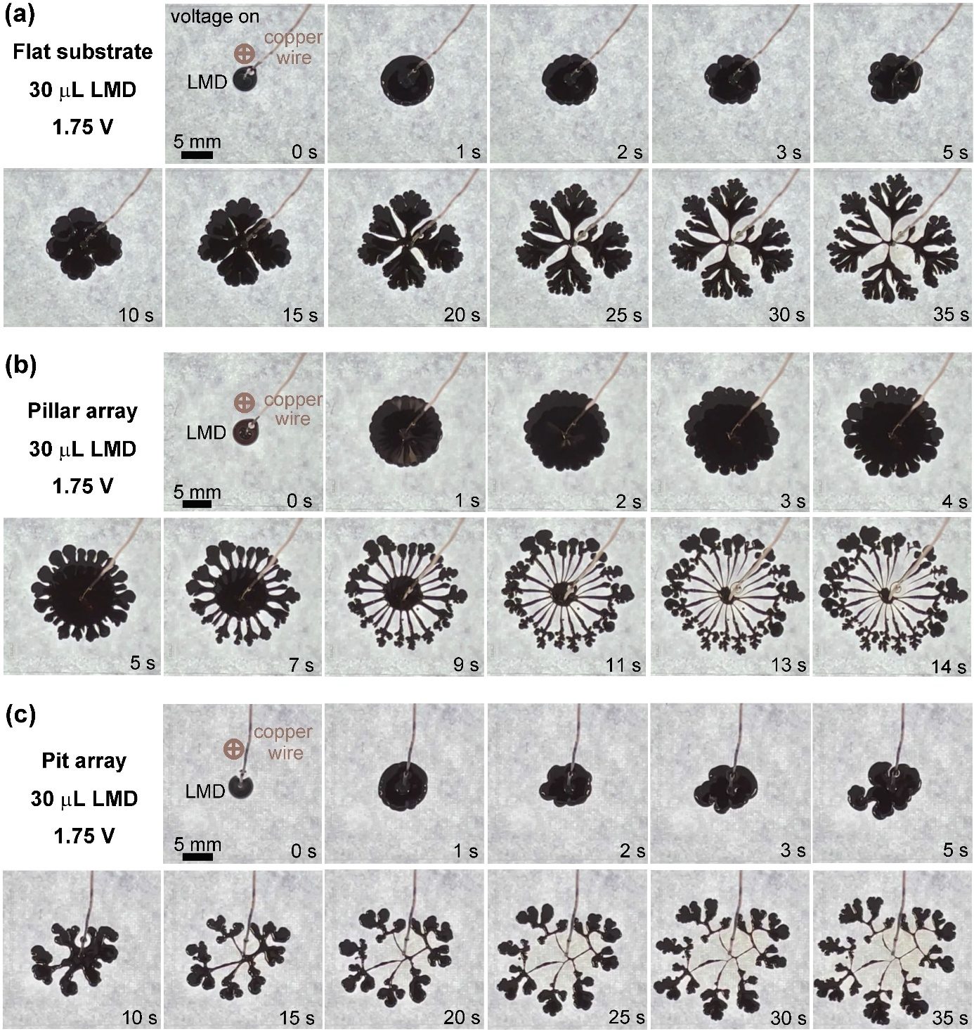

Figure S2. Detailed images of fingering instabilities of liquid metal droplets with different topographical structures. (a) Flat glass substrate (i.e., no topographical structures), (b) pillar array, and (c) pit array. All experiments are conducted in 1 M NaOH solution.

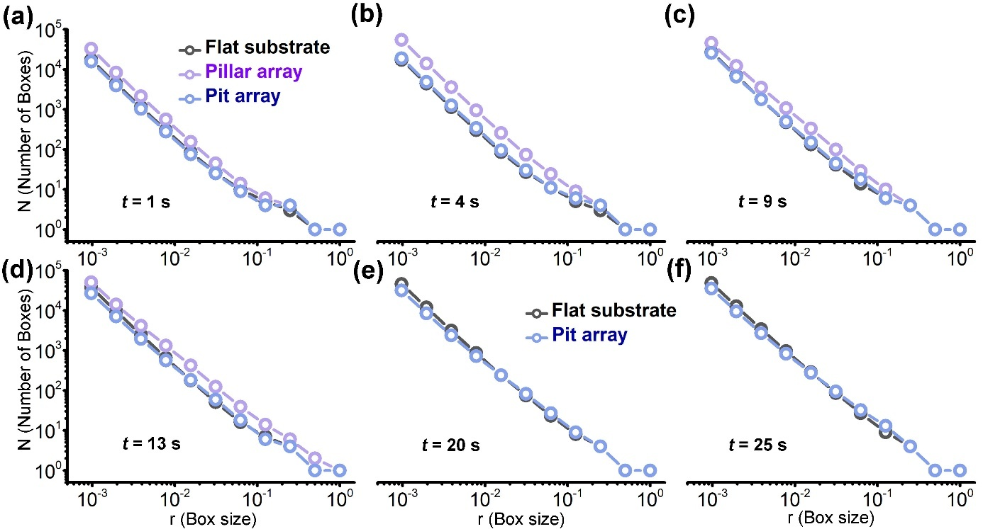

Figure S3. Detailed box-counting plots as a function of time on different topographical structures. (a) t = 1 s; (b) t = 4 s; (c) t = 9 s; (d) t = 13 s; (e) t = 20 s; (f) t = 25 s. The fractal dimension (i.e., Hausdorff dimension) $D≡\lim_{r→0}{[{logN(r)}/{log⁡(\frac{1}{r})}]}$ using a box-counting algorithm, where r is the box size and N is the number of boxes covering the area.

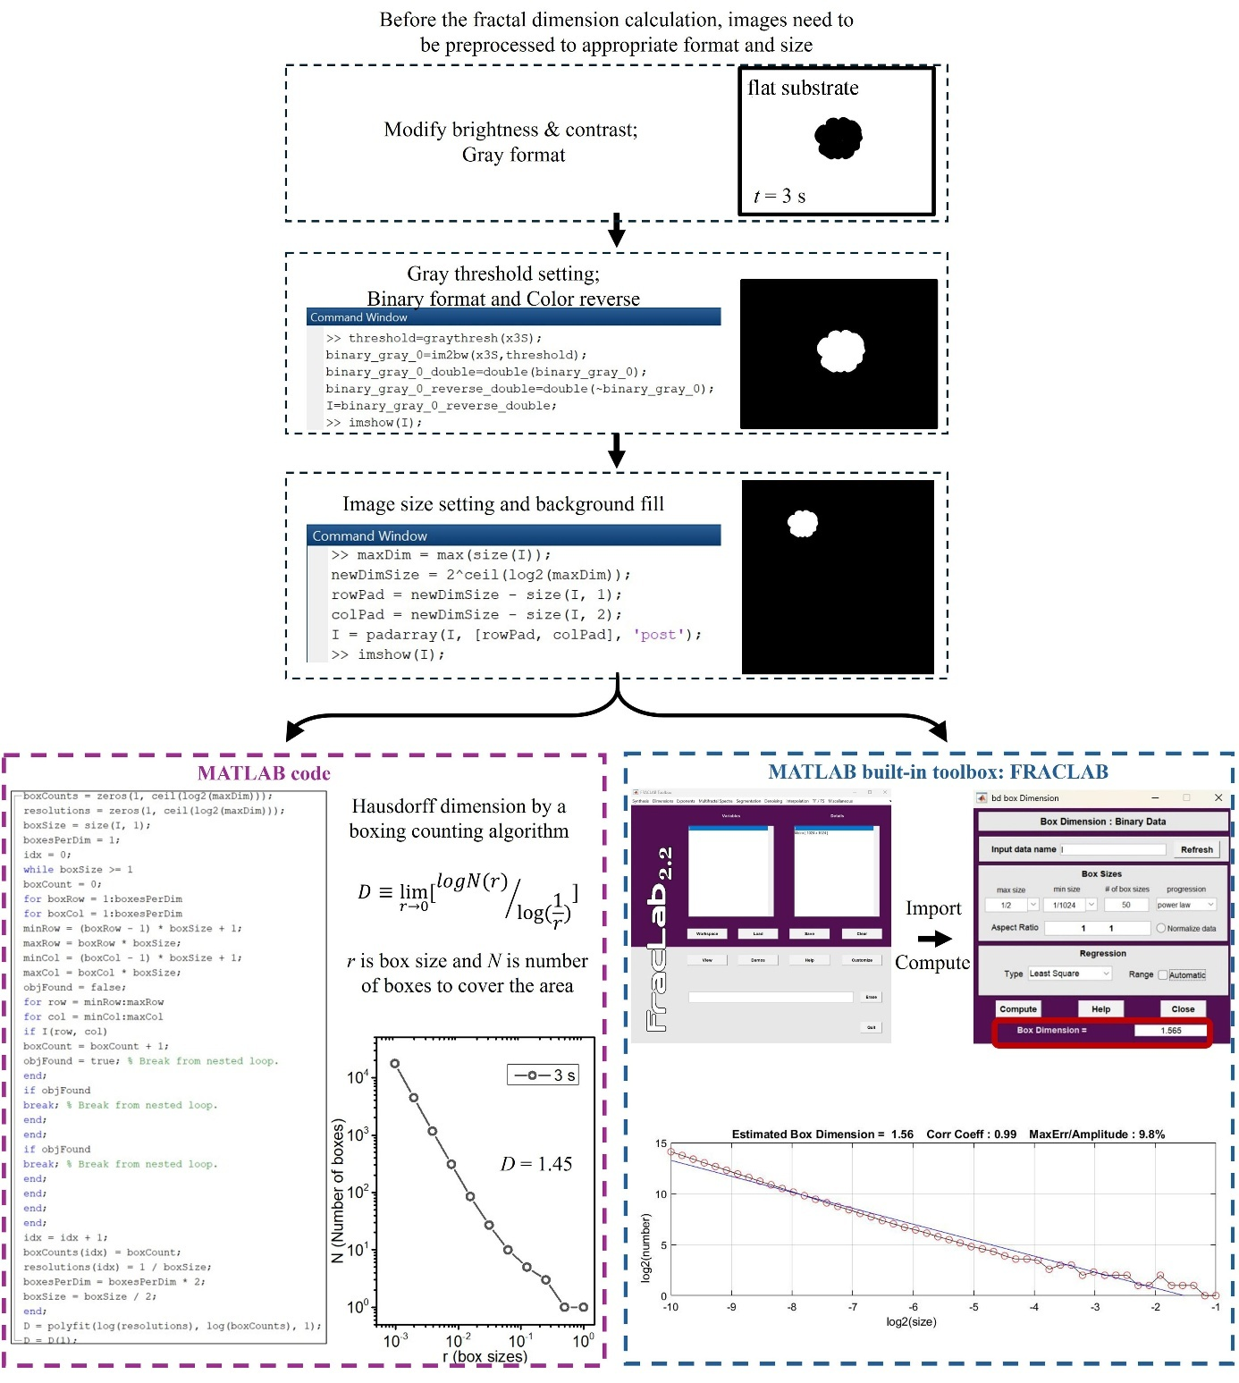

Figure S4. Flow diagram for fractal dimension calculated by two different methods: (1) the MATLAB code and (2) the MATLAB built-in toolbox: FRACLAB.

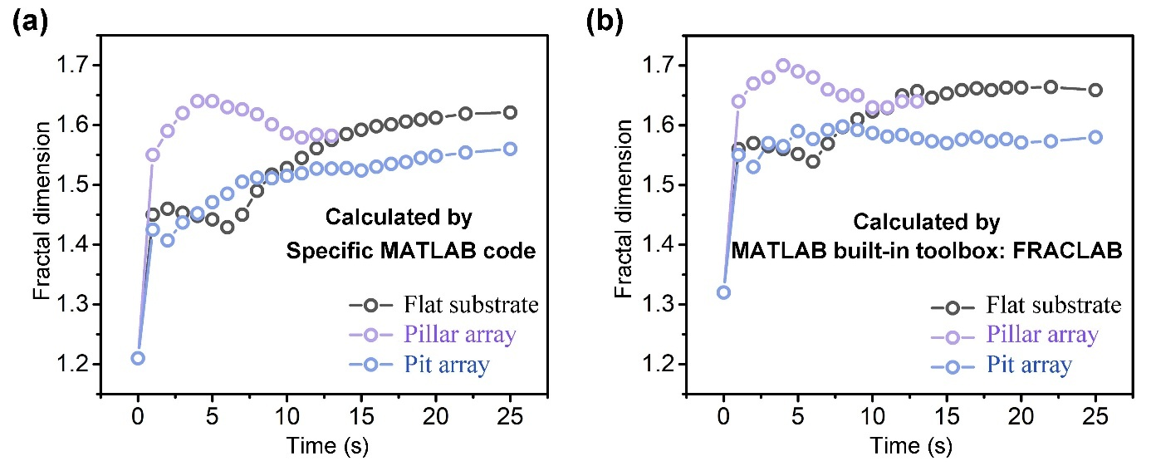

Figure S5. Fractal dimension calculated by two different methods. (a) Calculated by specific MATLAB code. (b) Calculated by MATLAB built-in toolbox: FRACLAB. The calculated fractal dimension demonstrates similar trends with variations in specific value.

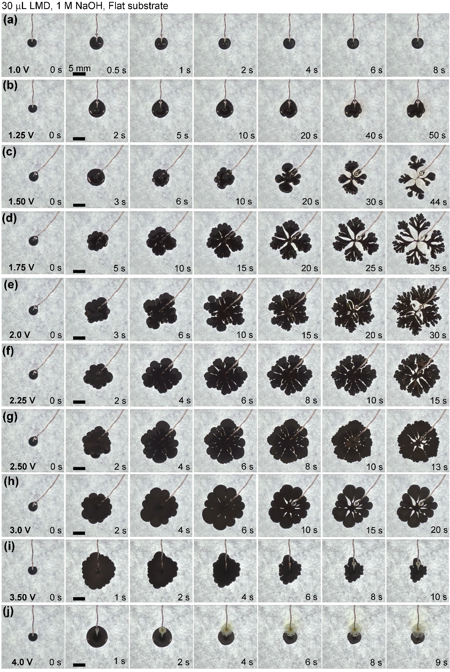

Figure S6. The evolution of fingering instabilities of 30 μL liquid metal droplet on flat glass substrate (i.e., no topographical structures), with applied voltages from 1.0 to 4.0 V. All experiments are conducted in 1 M NaOH solution. All scale bars are 5 mm.
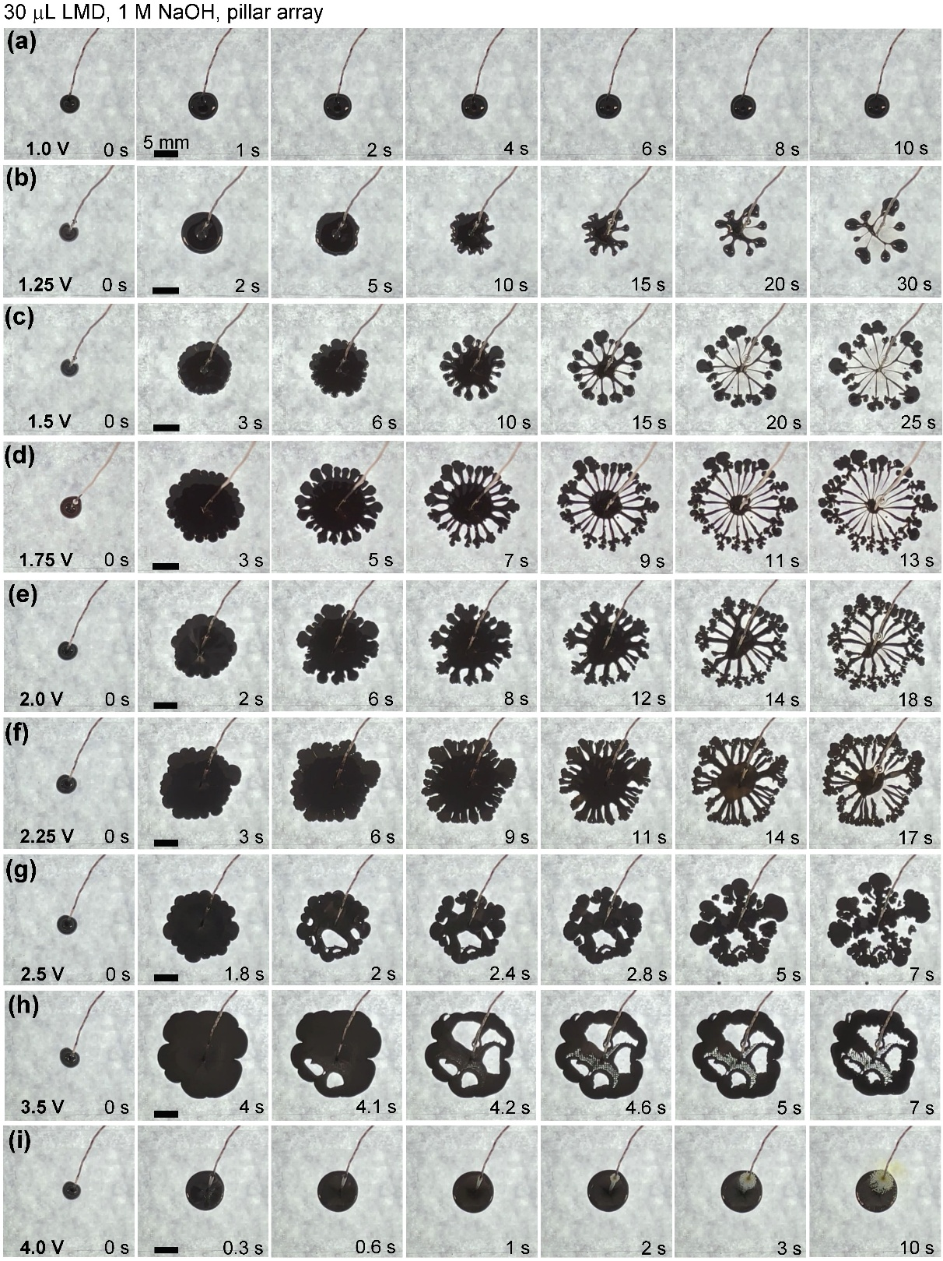

Figure S7. The evolution of fingering instabilities of 30 μL liquid metal droplet on pillar array, with applied voltages from 1.0 to 4.0 V. All experiments are conducted in 1 M NaOH solution. All scale bars are 5 mm.

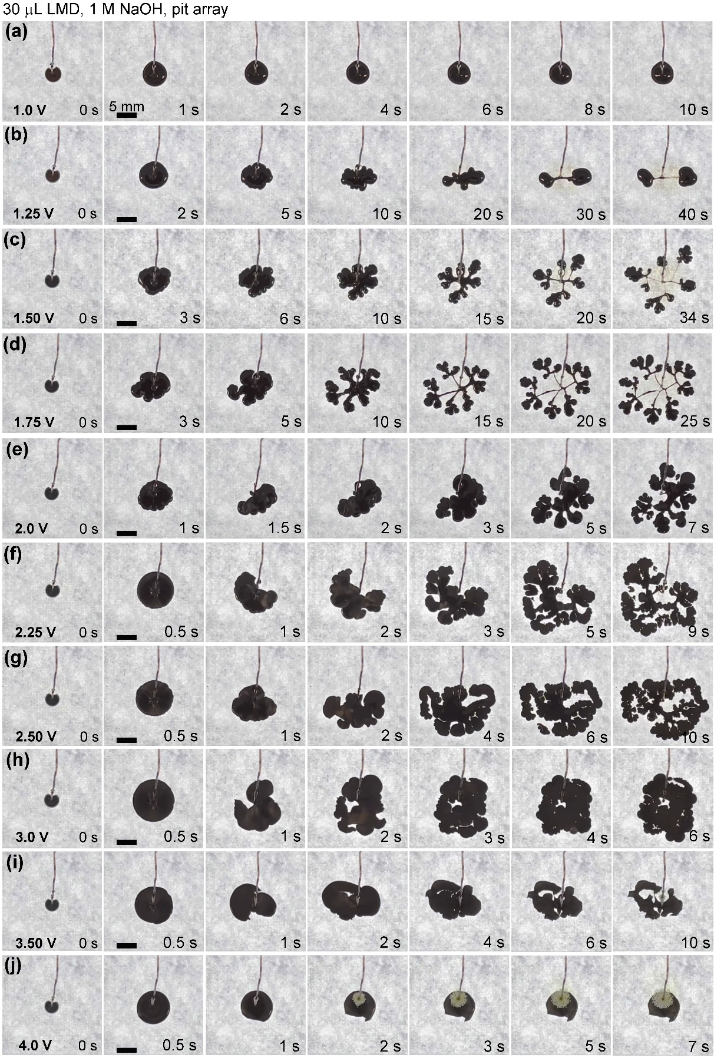

Figure S8. The evolution of fingering instabilities of 30 μL liquid metal droplet on pit array, with applied voltages from 1.0 to 4.0 V. All experiments are conducted in 1 M NaOH solution. All scale bars are 5 mm.
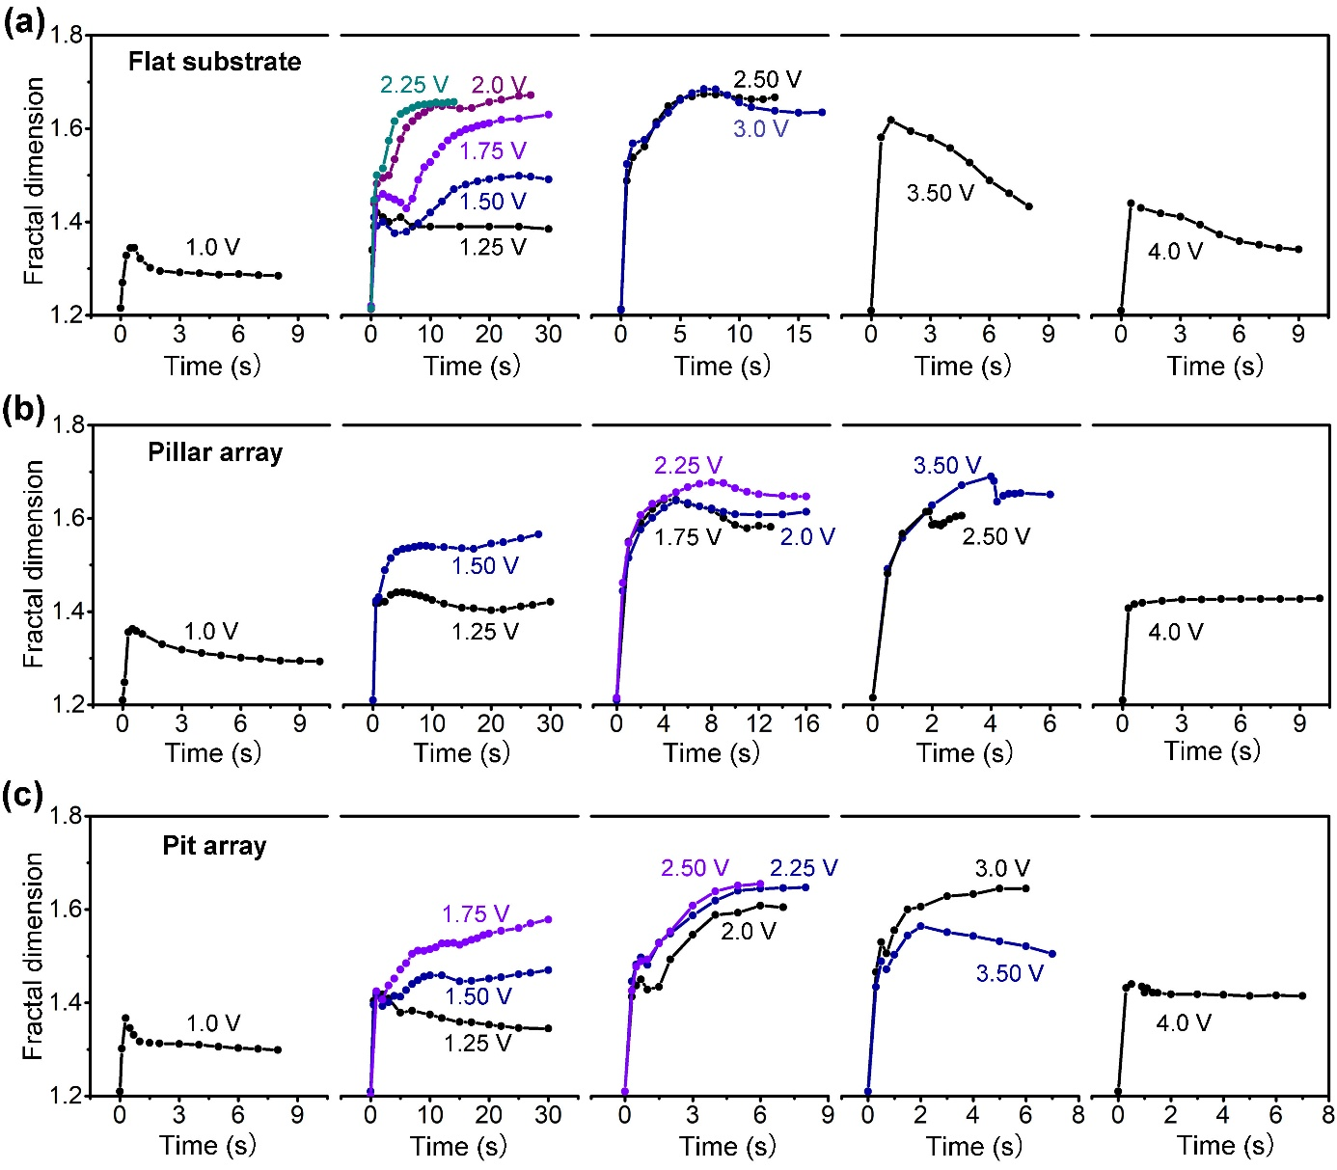

Figure S9. Fractal dimension of liquid metal droplets (30 μL) on different topographical structures with applied voltages from 1.0 to 4.0 V. (a) Flat substrate (i.e., no topographical structures), (b) pillar array, and (c) pit array. All experiments are conducted in 1 M NaOH solution.

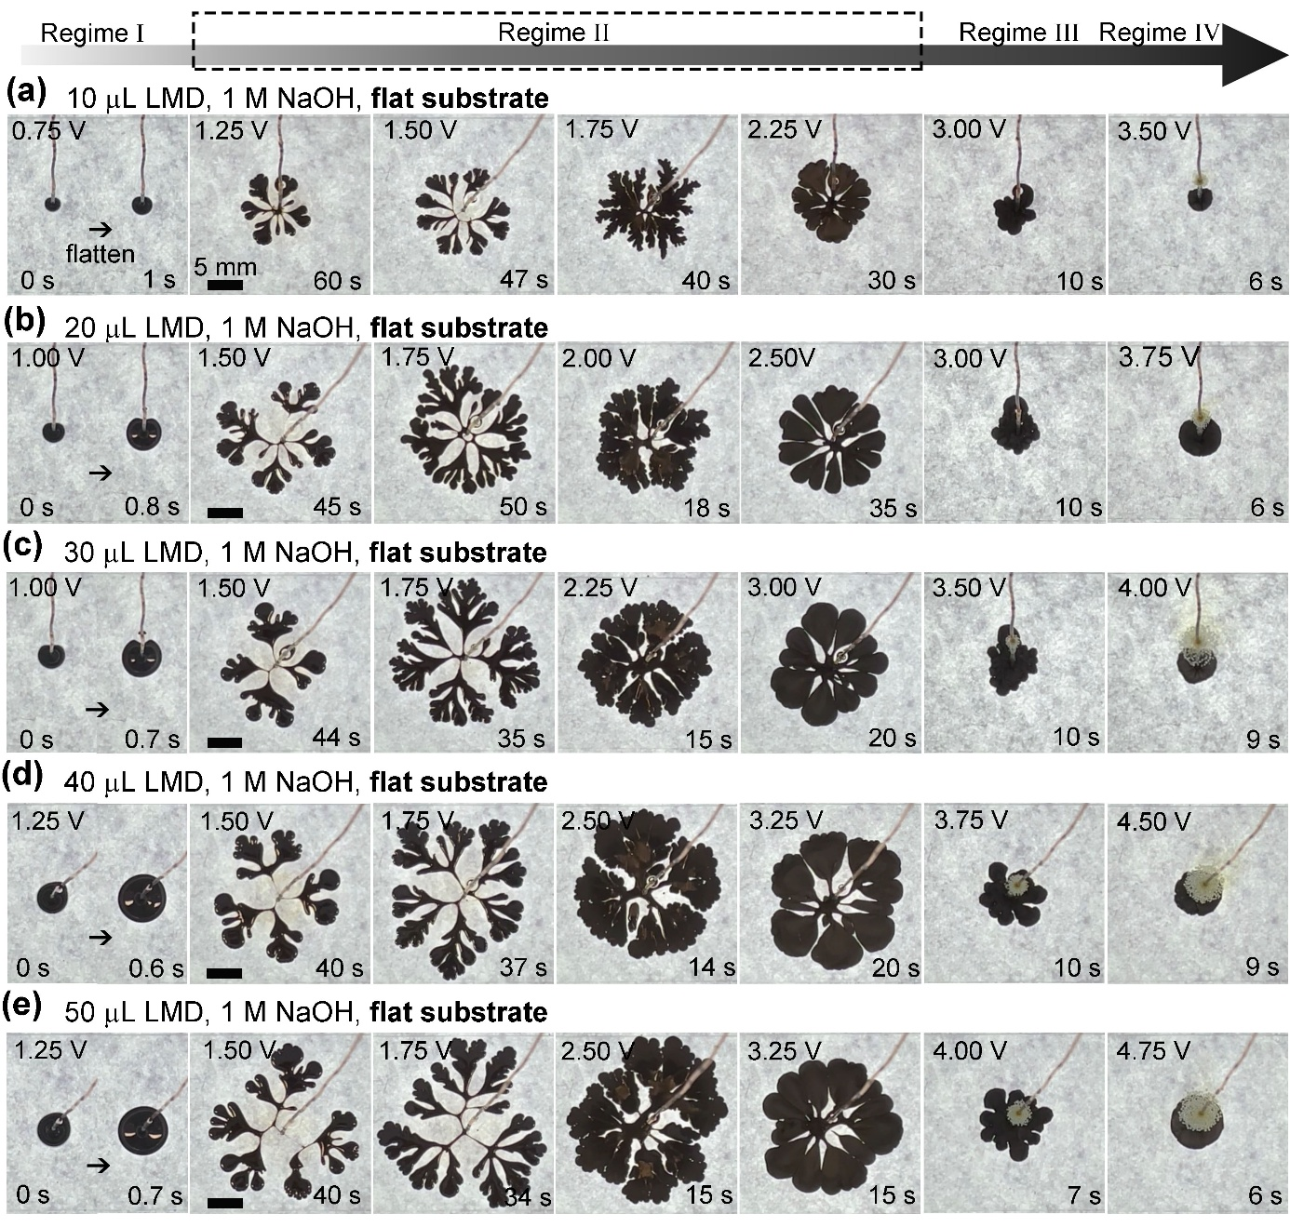

Figure S10. Four regimes of fingering instabilities of liquid metal droplets with different volumes and different voltages on flat substrate (i.e., no topographical structures). (a) 10μL, (b) 20 μL, (c) 30 μL, (d) 40 μL, and (e) 50 μL. All experiments are conducted in 1 M NaOH solution. All scale bars are 5 mm.

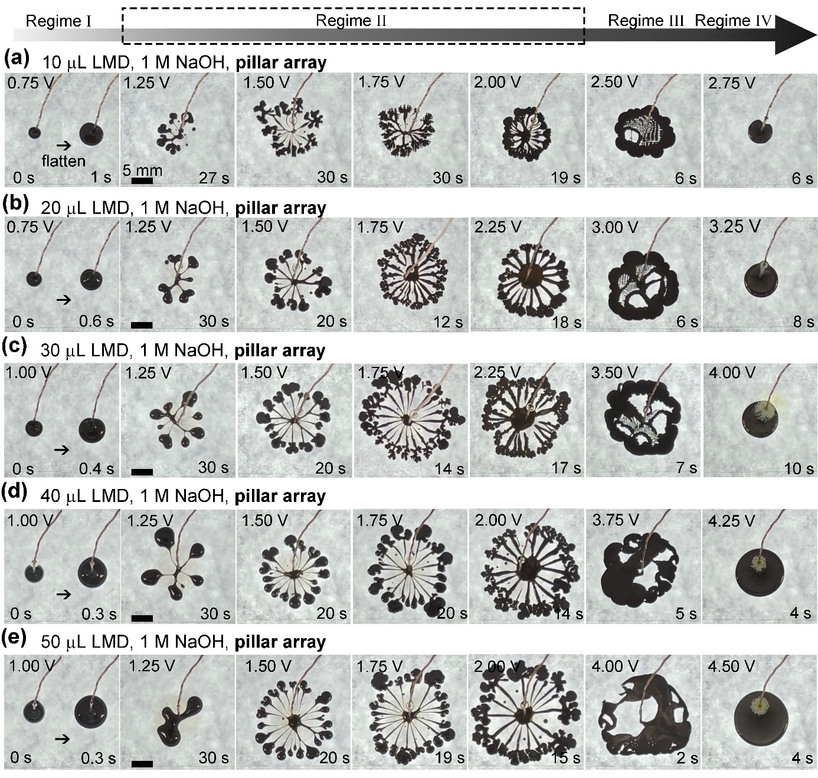

Figure S11. Four regimes of fingering instabilities of liquid metal droplets with different volumes and different voltages on pillar array. (a) 10μL, (b) 20 μL, (c) 30 μL, (d) 40 μL, and (e) 50 μL. All experiments are conducted in 1 M NaOH solution. All scale bars are 5 mm.

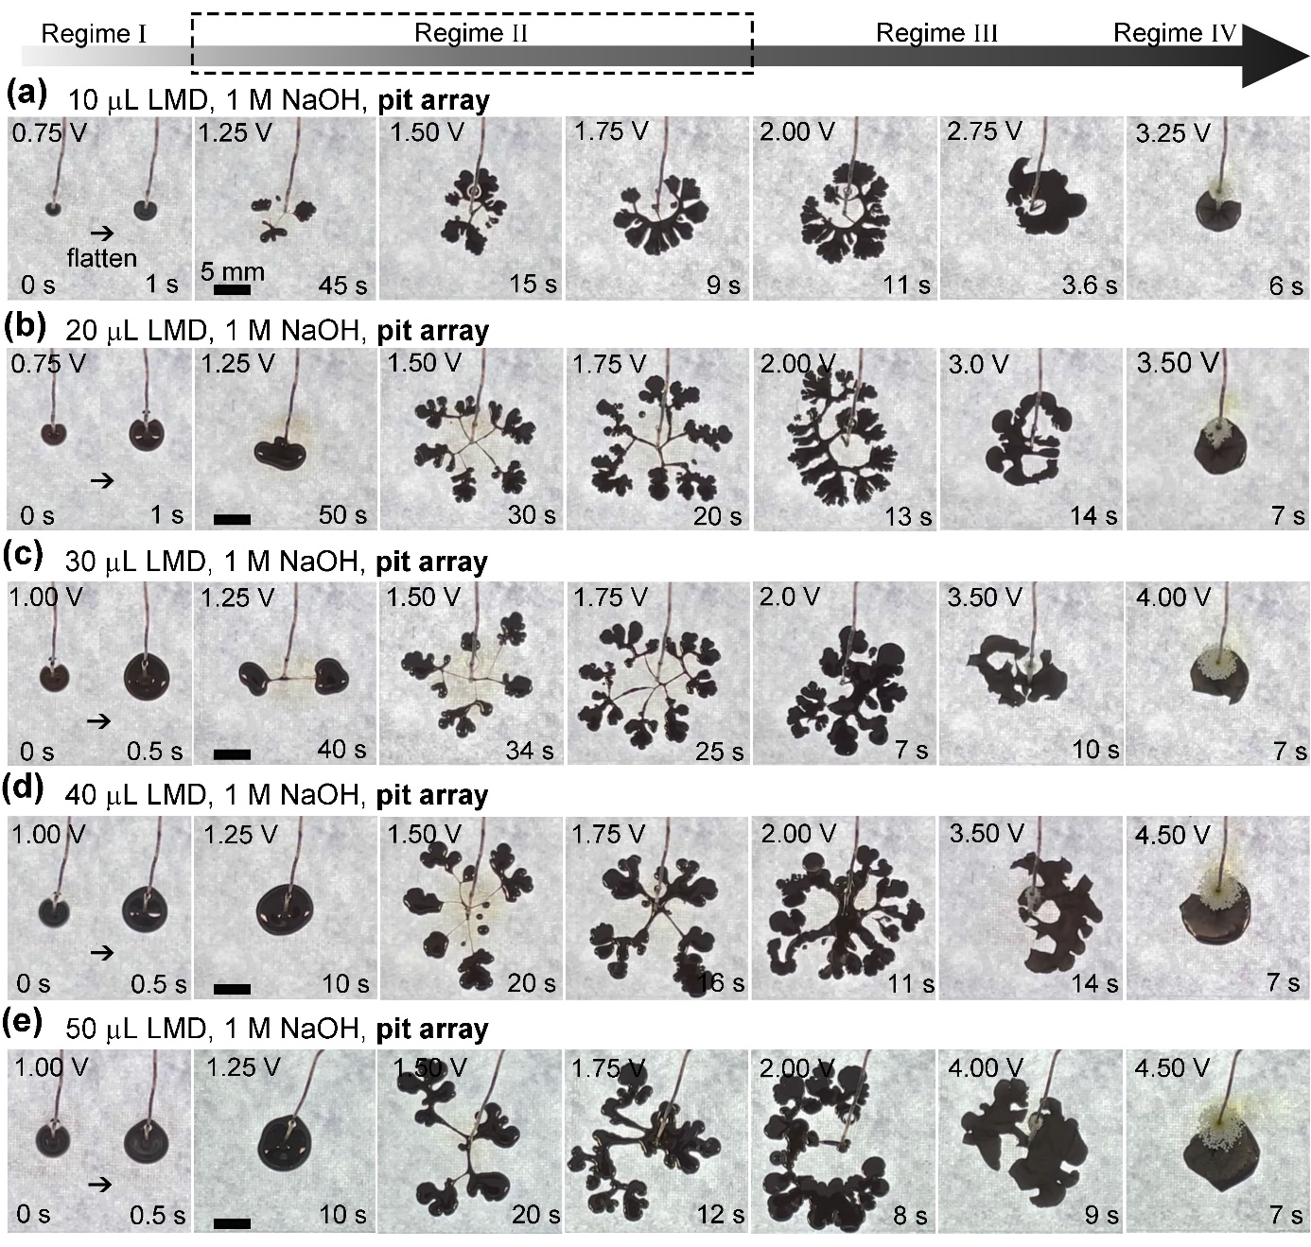

Figure S12. Four regimes of fingering instabilities of liquid metal droplets with different volumes and different voltages on pit array. (a) 10μL, (b) 20 μL, (c) 30 μL, (d) 40 μL, and (e) 50 μL. All experiments are conducted in 1 M NaOH solution. All scale bars are 5 mm.

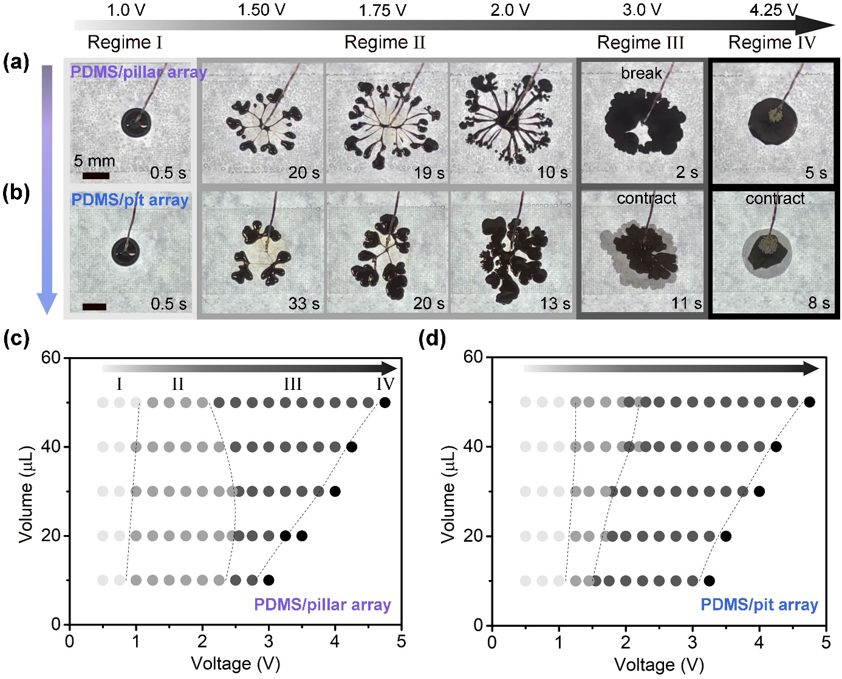

Figure S13. Representative images for four regimes of 40 μL liquid metal droplets on PDMS substrates. (a) PDMS/pillar array and (b) PDMS/pit array. Phase diagrams of fingering patterns as a function of potential and volume with (c) PDMS/pillar array, and (d) PDMS/pit array. l = s = 200 μm, l stands for length of square unit and s is for spacing between square units (c.f., Figure S1). All experiments are conducted in 1 M NaOH solution and scale bars are 5 mm.

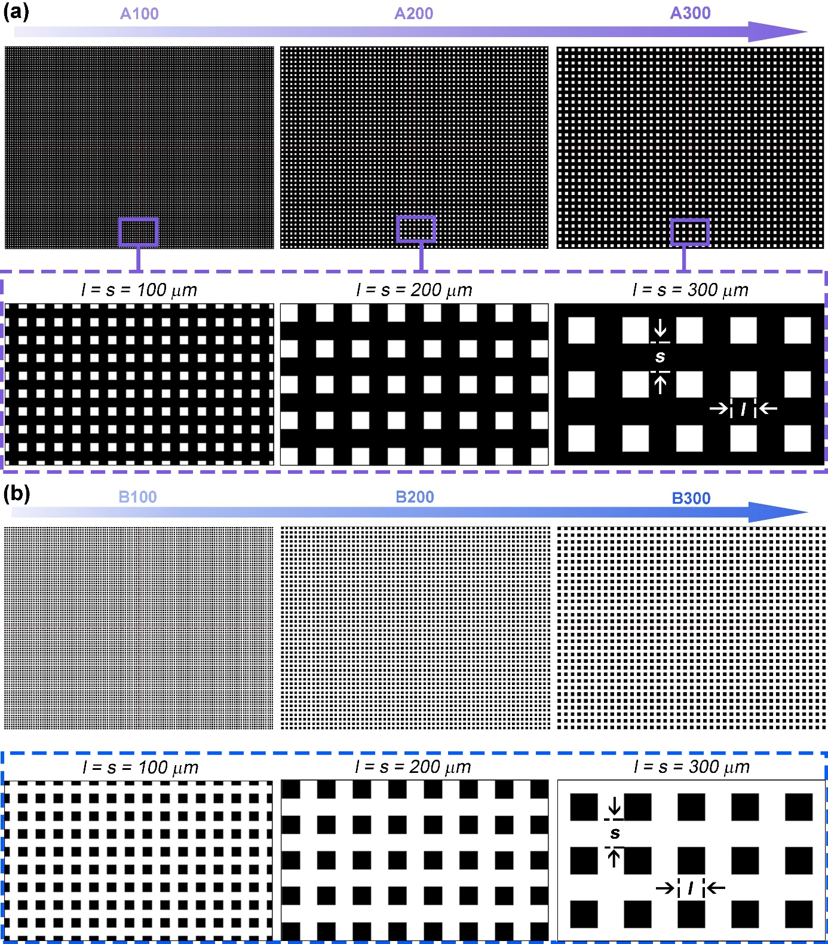

Figure S14. The structure illustration of topographical structures with different l/s values from 100 to 300 μm. (a) pillar arrays A100 – 300. (b) pit arrays B100 – 300. The letters A and B stand for pillar and pit arrays, respectively, and the number after the letter is for the size of the l and s (l = s).

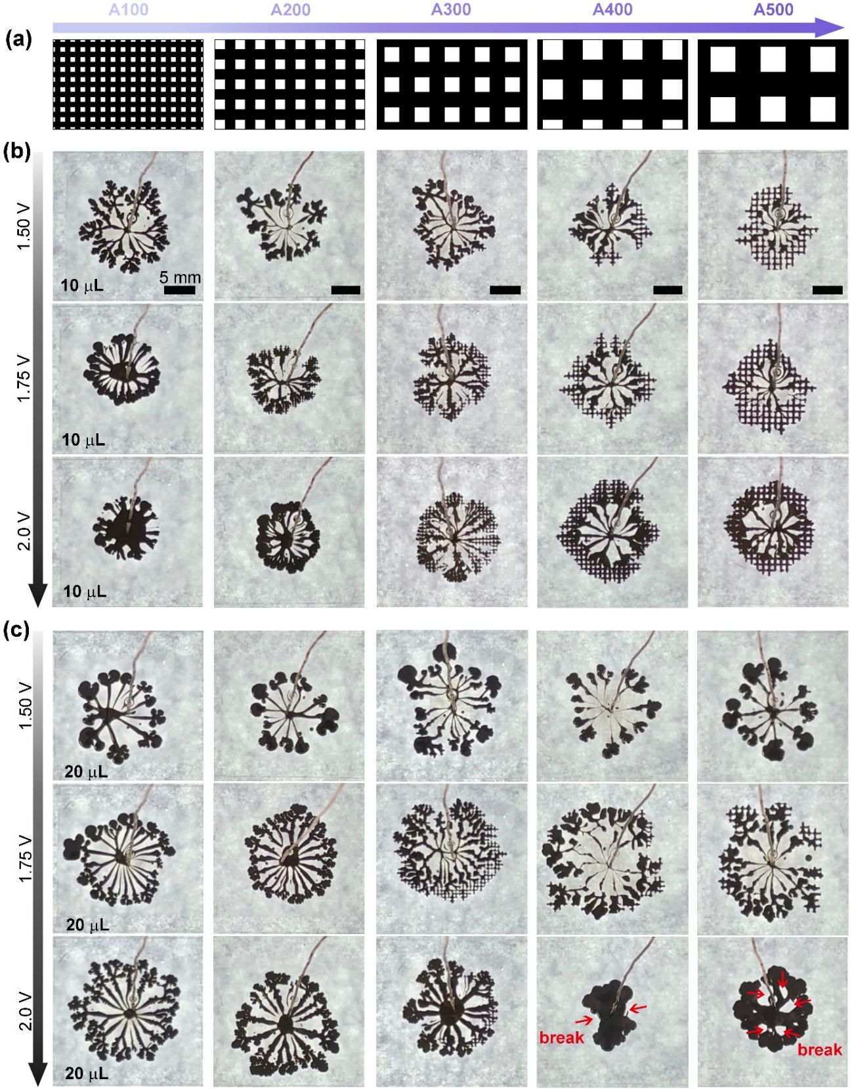

Figure S15. Different fingering instabilities of small liquid metal droplets on different pillar arrays (A100 – 500) with applied voltage ranging from 1.50 to 2.0 V. (a) Structure diagram of topographical structures. Time evolution of fingering patterns for small droplets of (b) 10 μL and (c) 20 μL. All experiments are conducted in 1 M NaOH solution. All scale bars are 5 mm.

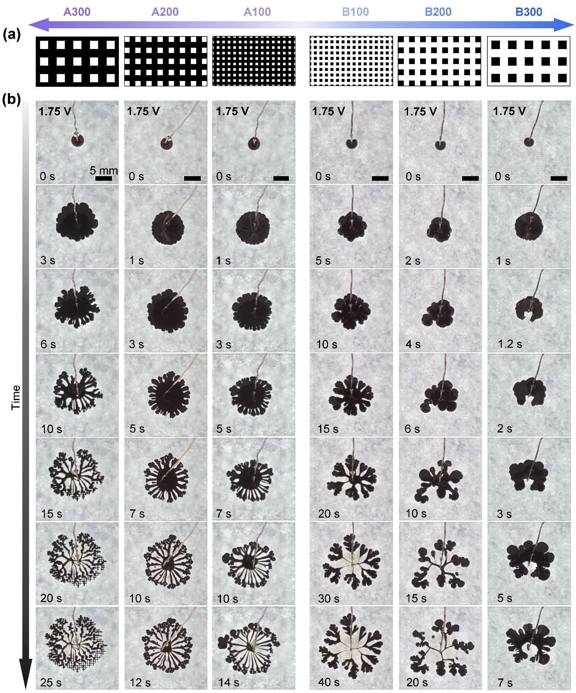

Figure S16. Different fingering instabilities of liquid metal droplets (20 μL) on different topographical structures (pillar arrays A100 – 300 and pit arrays B100 – 300) with applied voltage of 1.75 V. (a) Structure diagram of topographical structures and (b) Time evolution of fingering patterns. All experiments are conducted in 1 M NaOH solution. All scale bars are 5 mm.

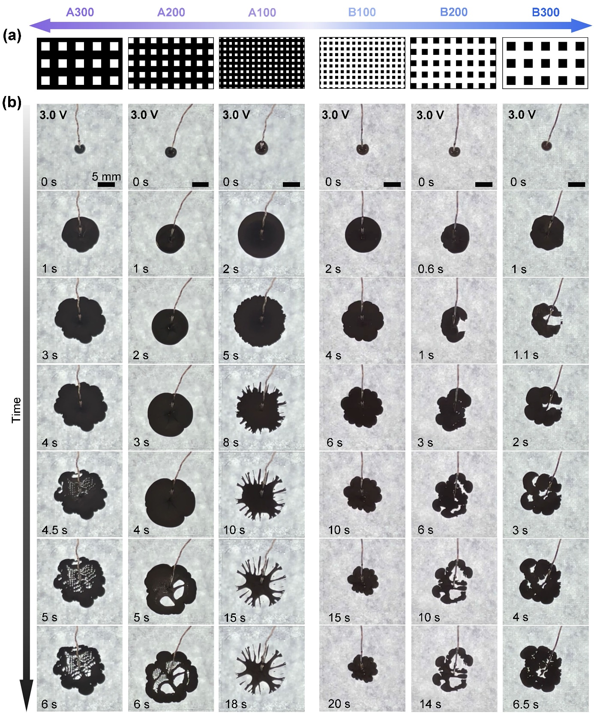

Figure S17. Different fingering instabilities of liquid metal droplets (20 μL) on different topographical structures (pillar arrays A100 – 300 and pit arrays B100 – 300) with applied voltage of 3.0 V. (a) Structure diagram of topographical structures and (b) Time evolution of fingering patterns. All experiments are conducted in 1 M NaOH solution. All scale bars are 5 mm.

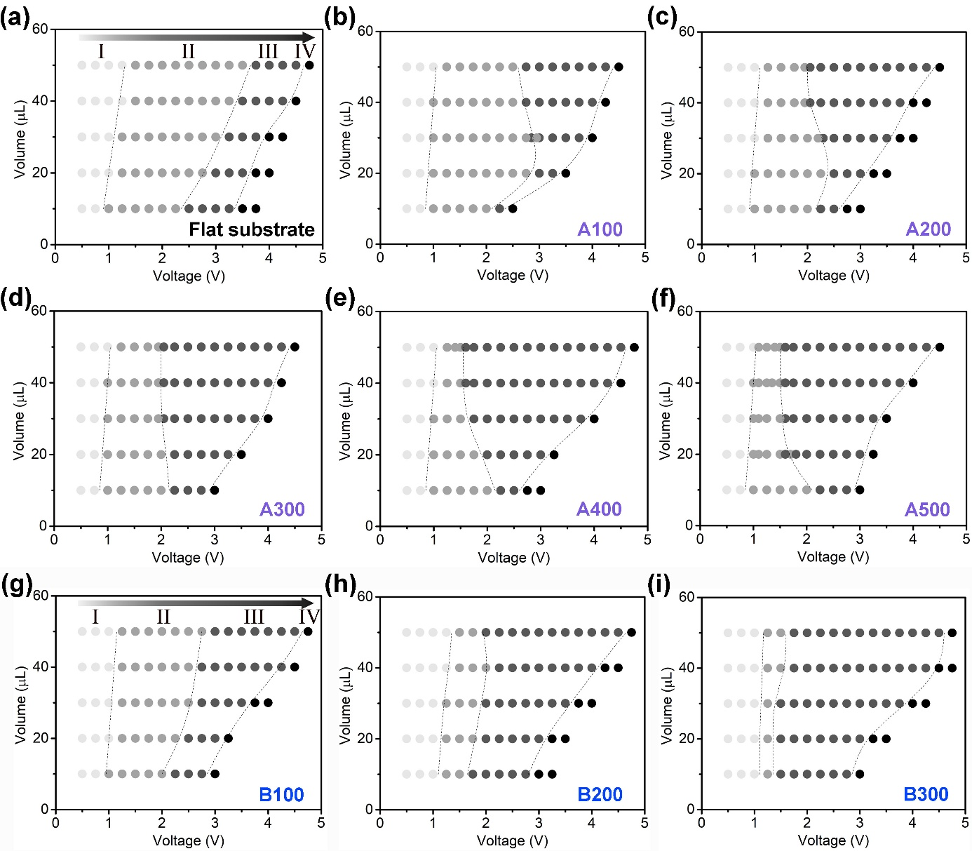

Figure S18. Phase diagrams of fingering patterns as a function of potential and volume with different topographical structures. (a) Flat substrate (i.e., no topographical structures). (b-f) Pillar arrays A100 – 500. (g-i) Pit arrays B100 – 300.

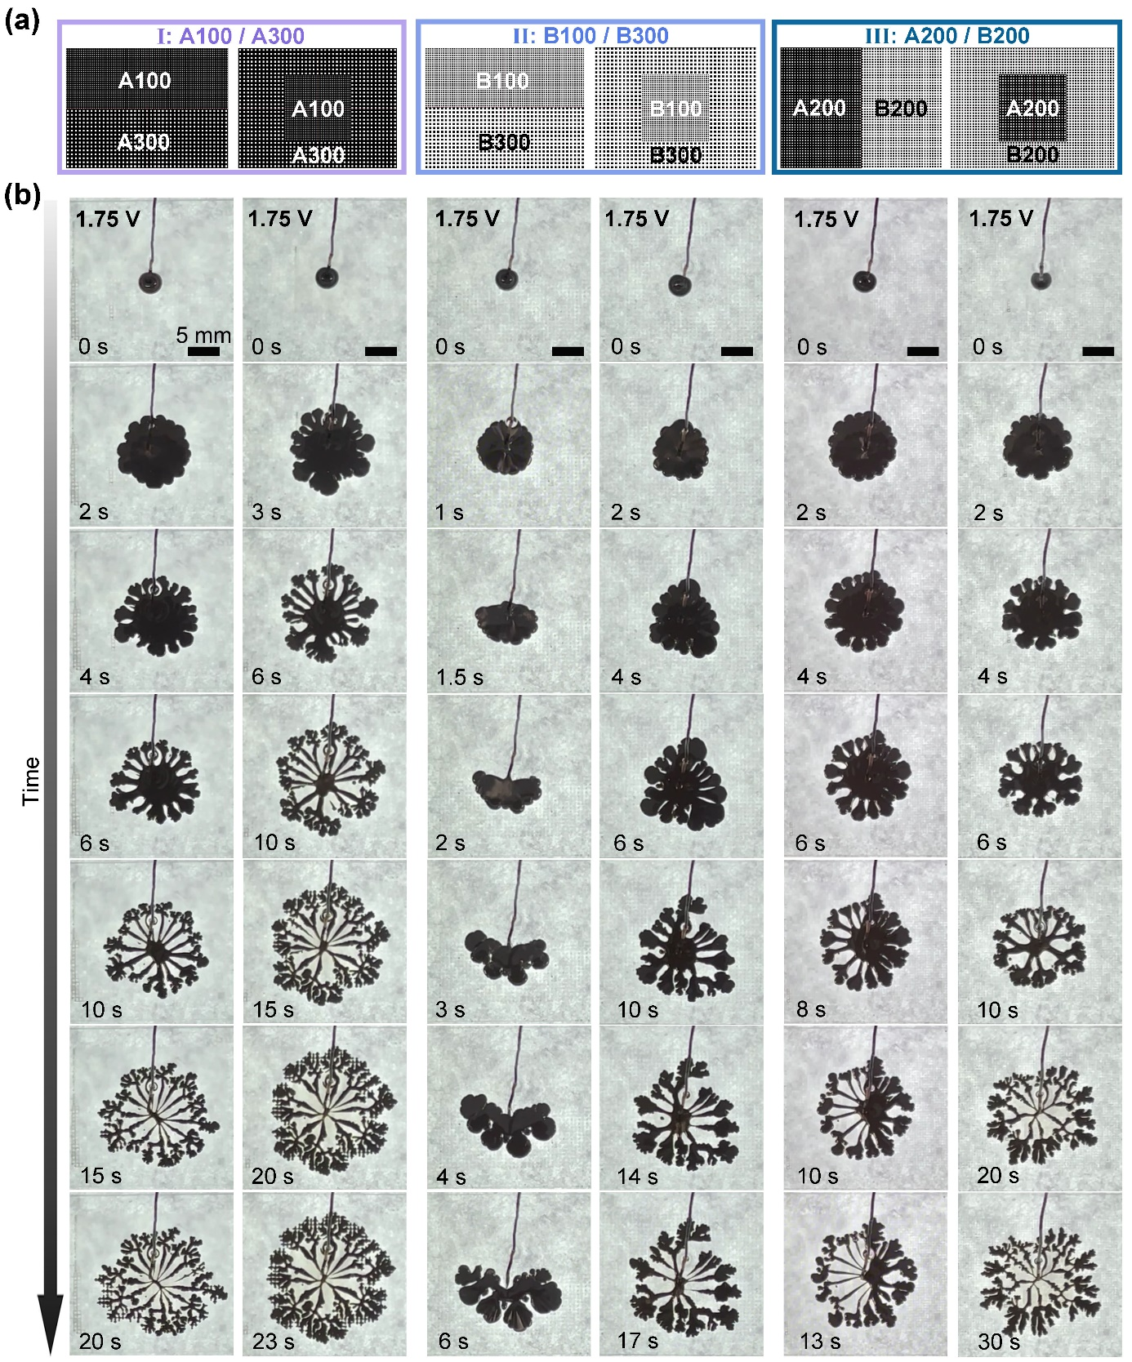

Figure S19. Different fingering instabilities of liquid metal droplets (20 μL) with different combinations of topographical structures (A100/300, B100/300, and A200/B200) with applied voltage of 1.75 V. (a) Structure diagram of combinations of topographical structures and (b) Time evolution of fingering patterns. All experiments are conducted in 1 M NaOH solution. All scale bars are 5 mm.

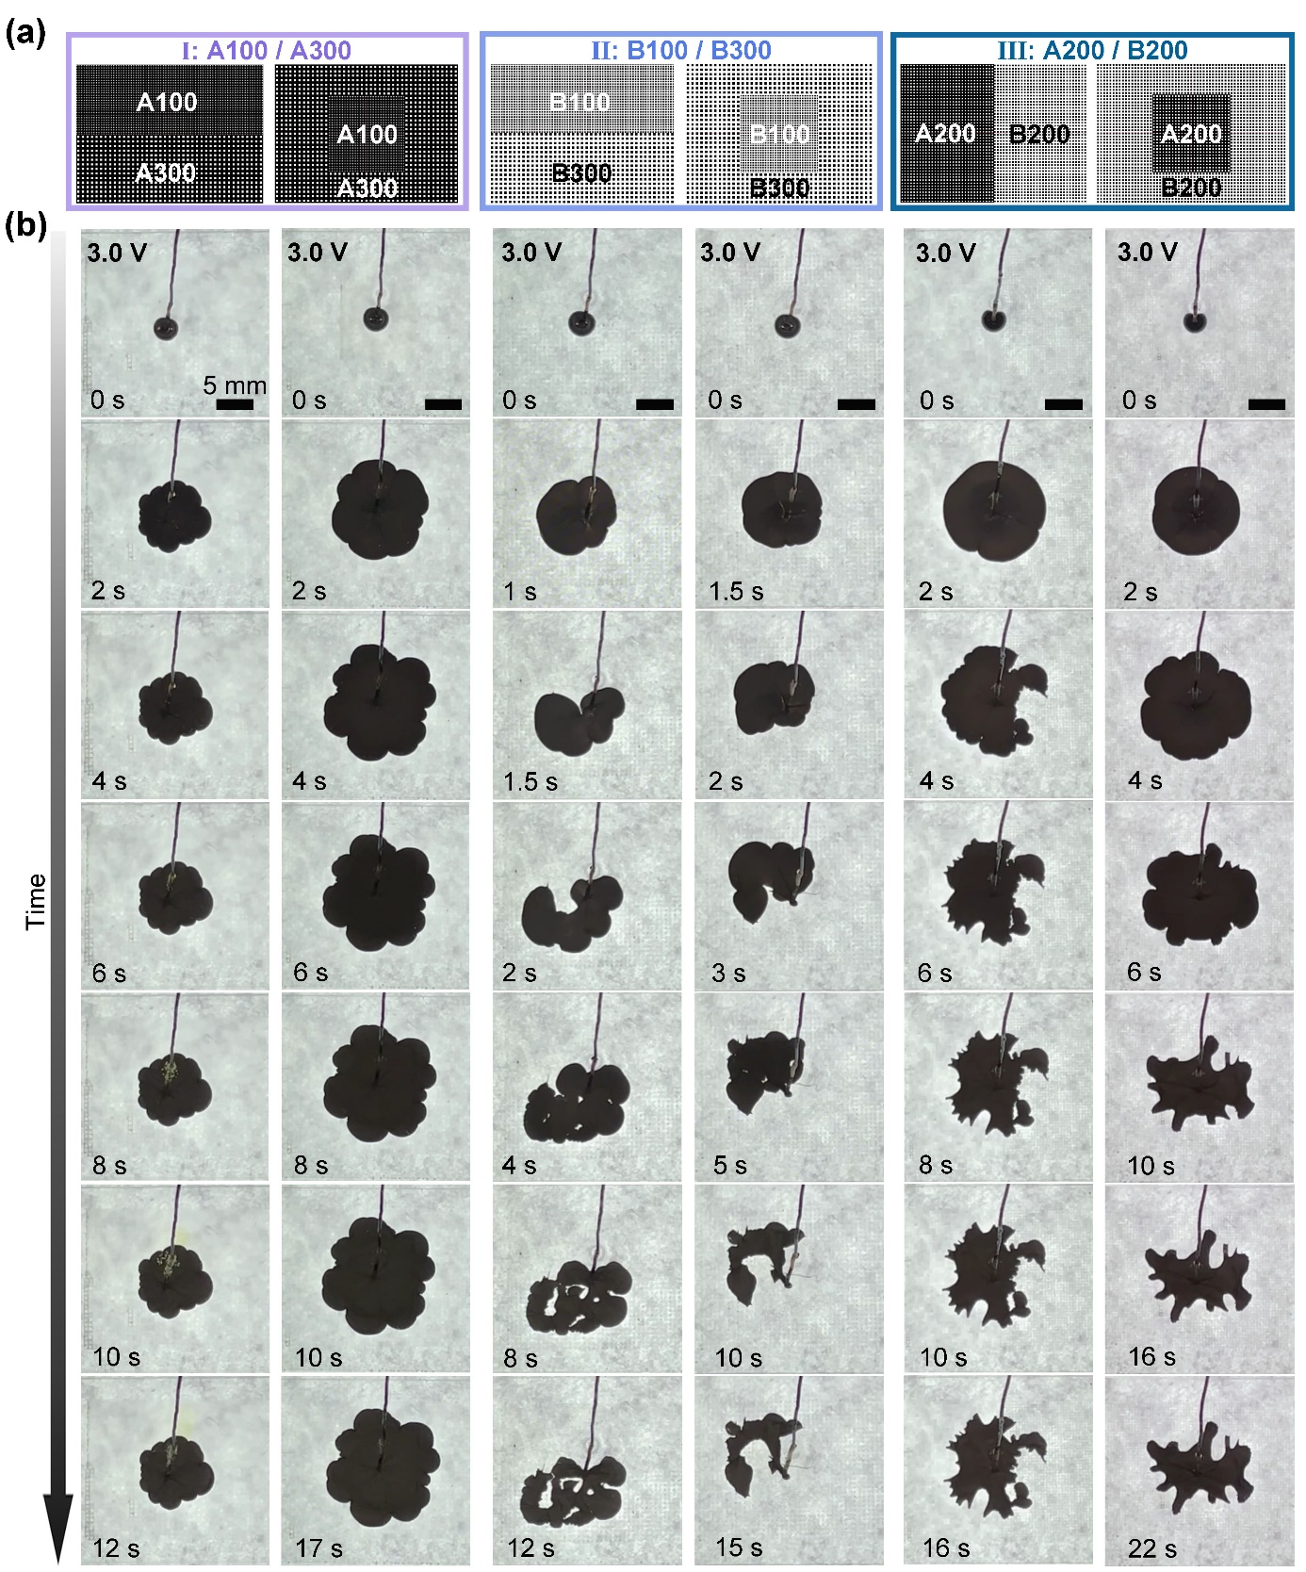

Figure S20. Different fingering instabilities of liquid metal droplets (20 μL) with different combinations of topographical structures (A100/300, B100/300, and A200/B200) with applied voltage of 3.0 V. (a) Structure diagram of combinations of topographical structures and (b) Time evolution of fingering patterns. All experiments are conducted in 1 M NaOH solution. All scale bars are 5 mm.

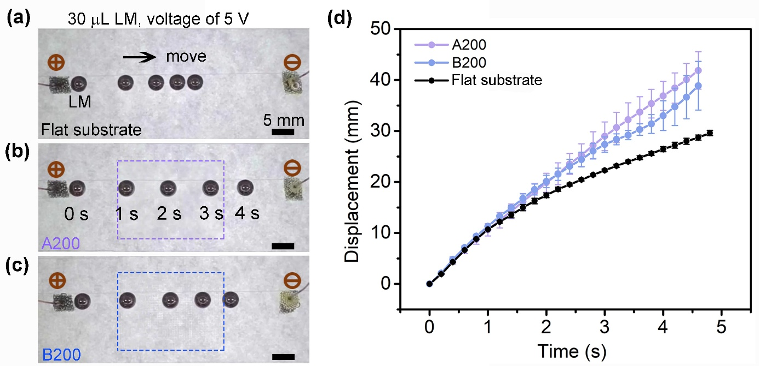

Figure S21. Continuous electrowetting velocity is employed to assess the effect of friction of LM droplets with the same interfacial distribution. The droplets move from anode to cathode with a voltage of 5 V. (a-c) Real time images of droplet position on flat substrate, pillar array A200, and pit array B200 from 0 – 4 s. (d) Statistical data of droplet displacement over time. All experiments are conducted in 1 M NaOH solution with scale bars are 5 mm.



Figure S22. Illustration of bottom-view imaging by an inverted microscope. The lens is pre-placed at different positions where LM will spread and reach, marked as center, middle, and edge positions.

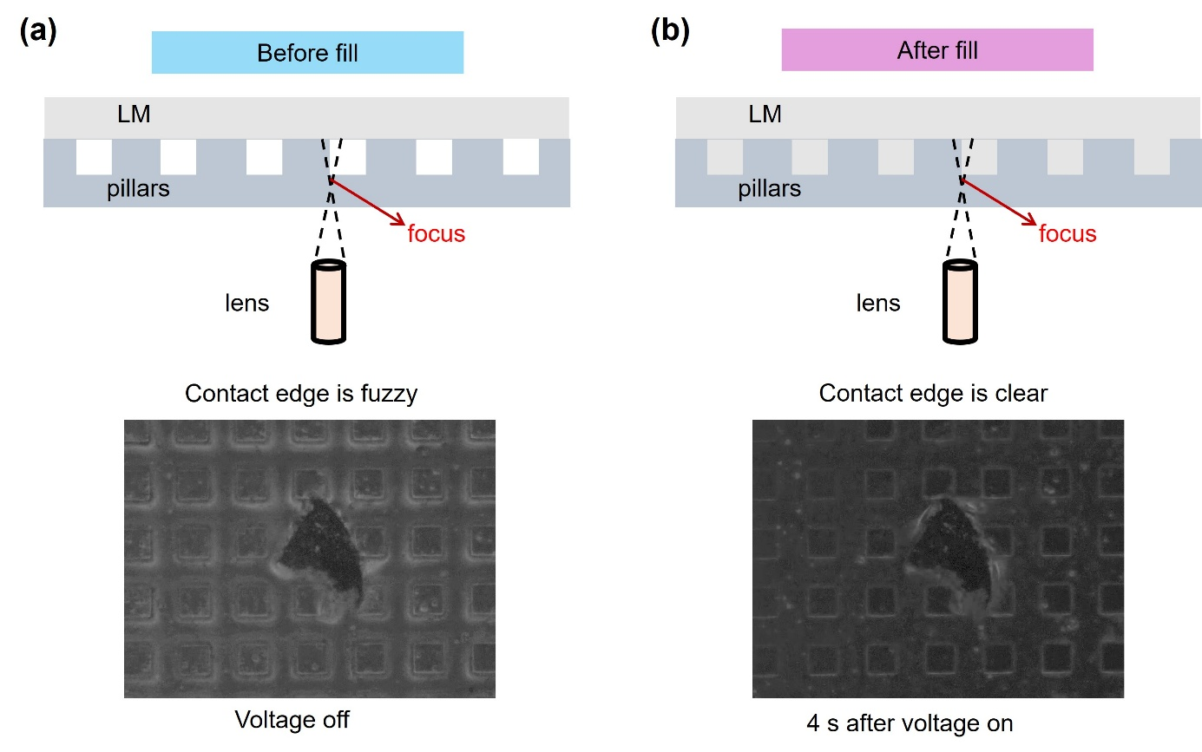
Figure S23. Comparison of contact edge between LM and pillars before/after filling the channels between pillars. The focus of microscope is located at the bottom of the pillars; the lens is located at the center position. The higher resolution imaging indicates the filling process.

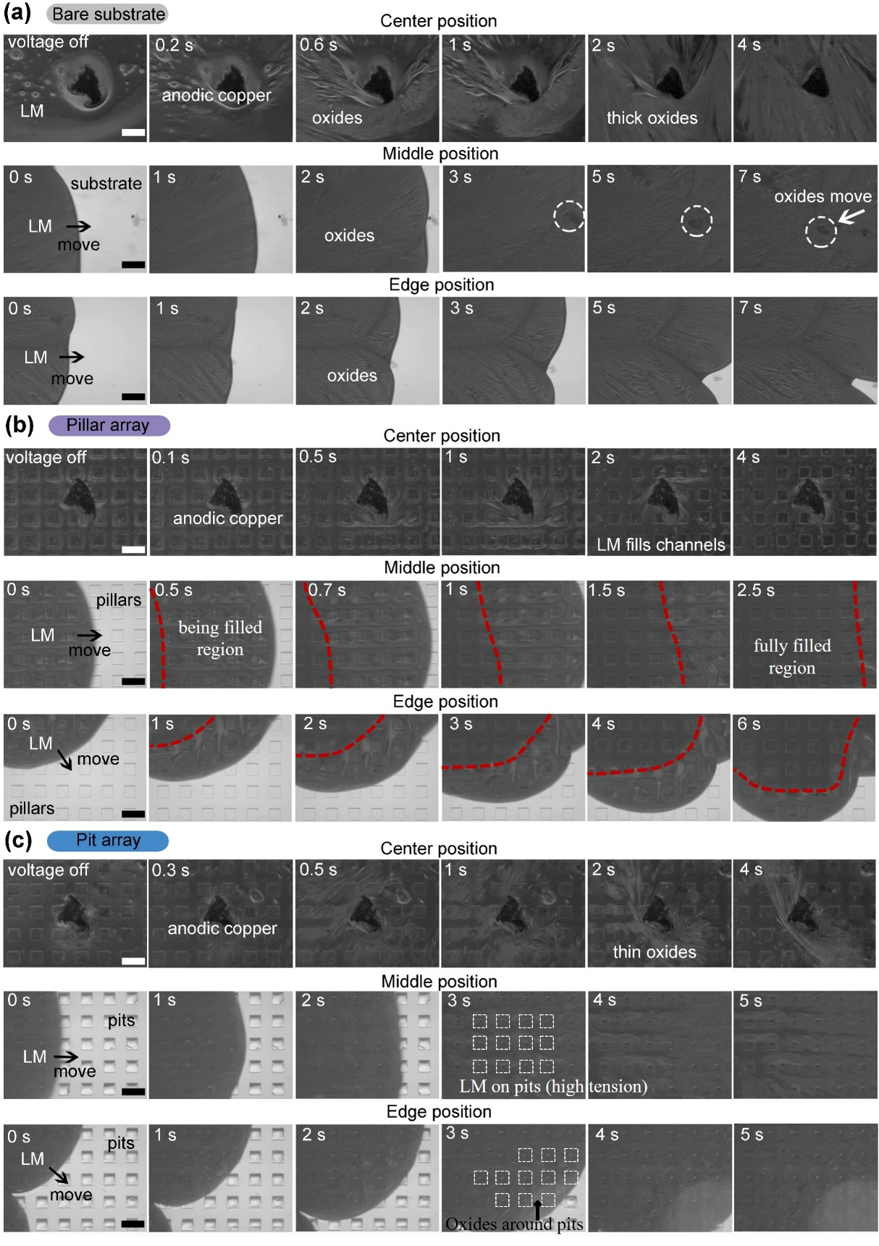

Figure S24. Bottom-view images of LM at different positions with different topographical structures. (a) Flat substrate, (b) pillar array, and (c) pit array. Obvious oxides on flat substrate, a filling process of LM into channels with a significant dividing line on pillar array, and high-tension LM on pits with surrounding oxides are observed. All experiments are conducted with 1.75 V voltage in 1 M NaOH solution. All scale bars are 200 μm.
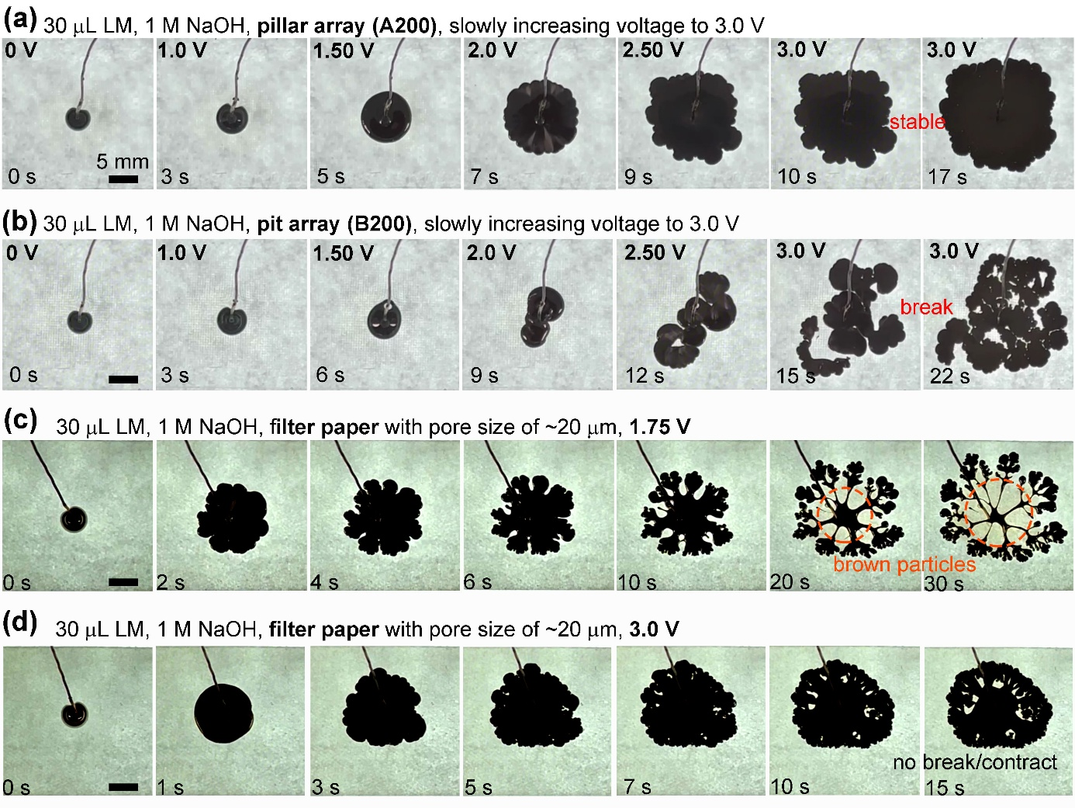

Figure S25. Different control experiments to illustrate the spreading and instability of liquid metal droplets (30 μL) on different substrates. Slowly increasing the voltage to 3.0 V on (a) pillar array A200 and (b) pit array B200. Fingering patterns on filter paper with ~20 μm pores with different voltages of (c) 1.75 V and (d) 3.0 V. All experiments are conducted in 1 M NaOH solution. All scale bars are 5 mm.

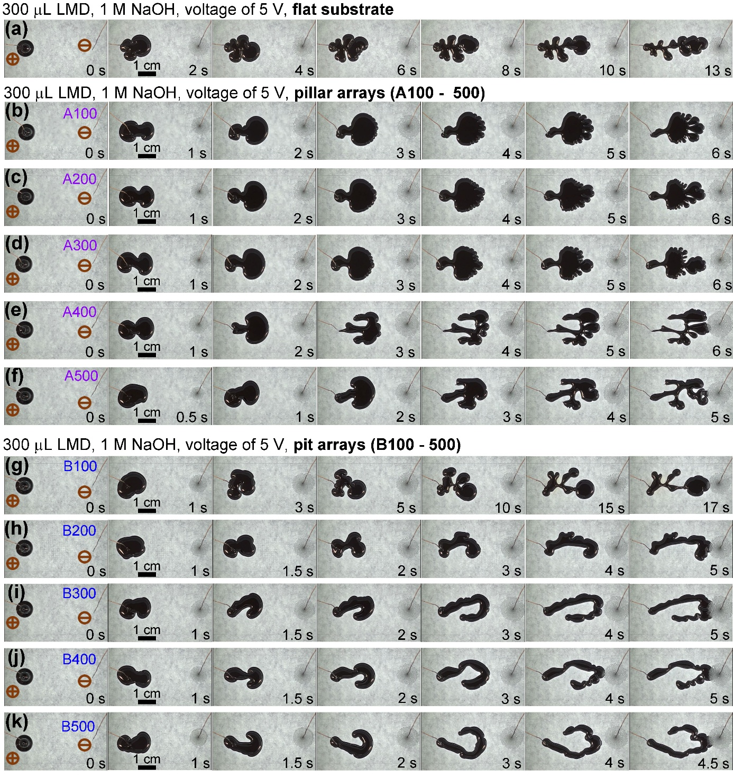

Figure S26. Different fingering instabilities of liquid metal droplets (300 μL) on different topographical structures with applied voltage of 5 V. (a) Flat substrate, (b-f) pillar arrays A100 – 500, and (g-k) pit arrays B100 – 500. All experiments are conducted in 1 M NaOH solution. All scale bars are 1 cm.

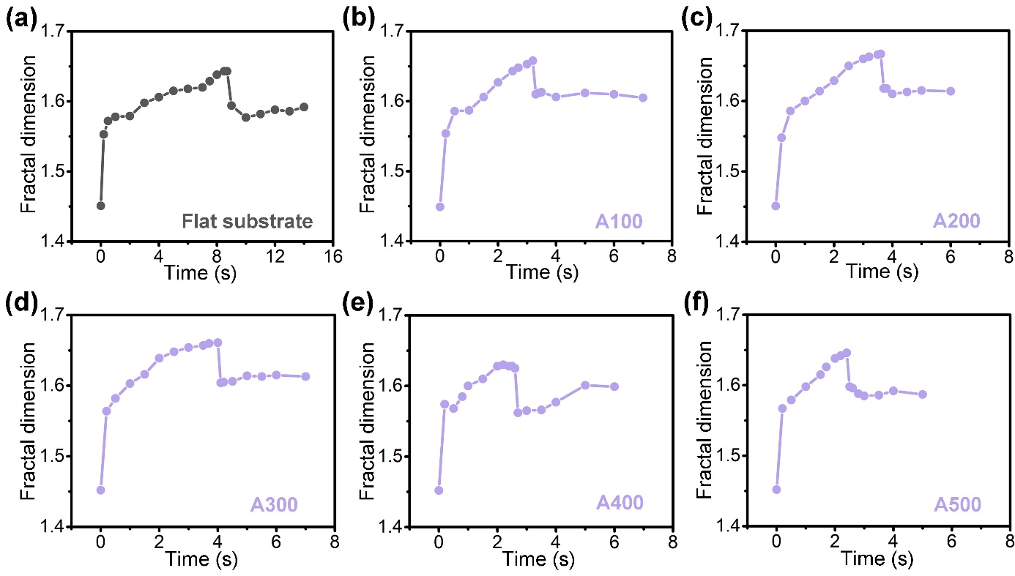

Figure S27. Fractal dimension of liquid metal droplets (300 μL) with applied voltages of 5.0 V. (a) Flat substrate, (b-f) pillar arrays A100 – 500. All experiments are conducted in 1 M NaOH solution.

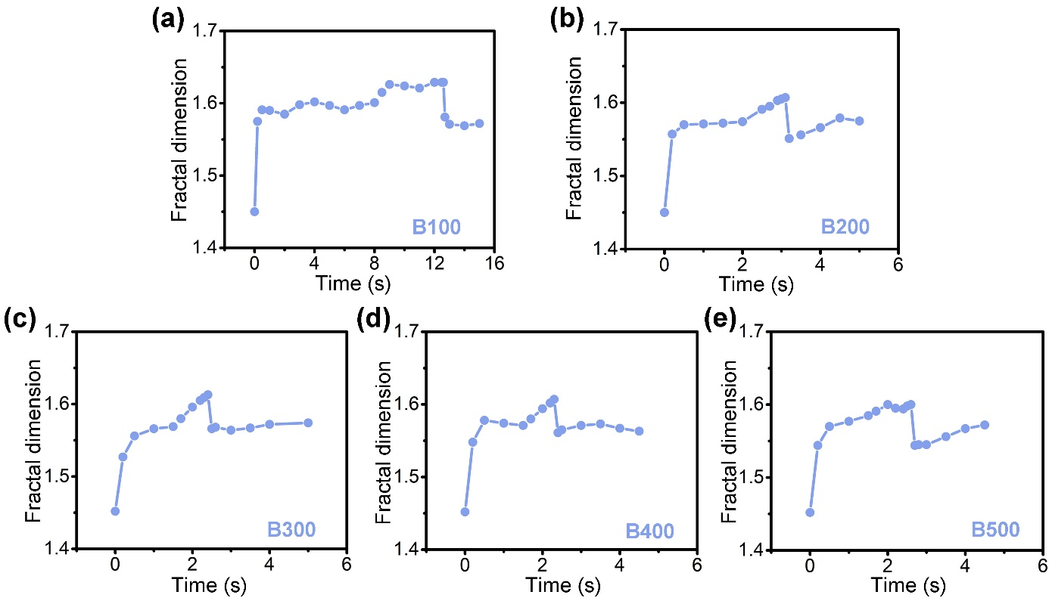

Figure S28. Fractal dimension of liquid metal droplets (300 μL) with applied voltages of 5.0 V. (a-e) pit arrays B100 – 500. All experiments are conducted in 1 M NaOH solution.

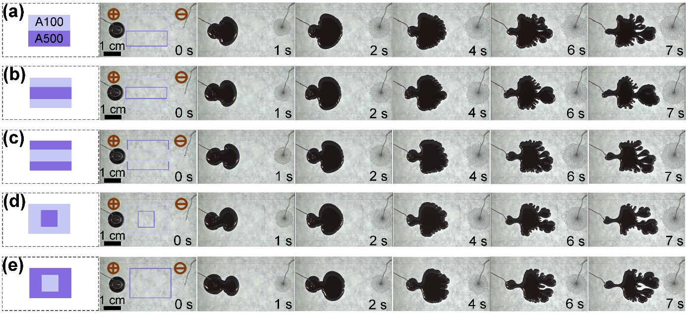

Figure S29. Different fingering instabilities of liquid metal droplets (300 μL) on different combinations of A100 and A500 (pillar-pillar type) with applied voltage of 5 V. All experiments are conducted in 1 M NaOH solution. All scale bars are 1 cm.

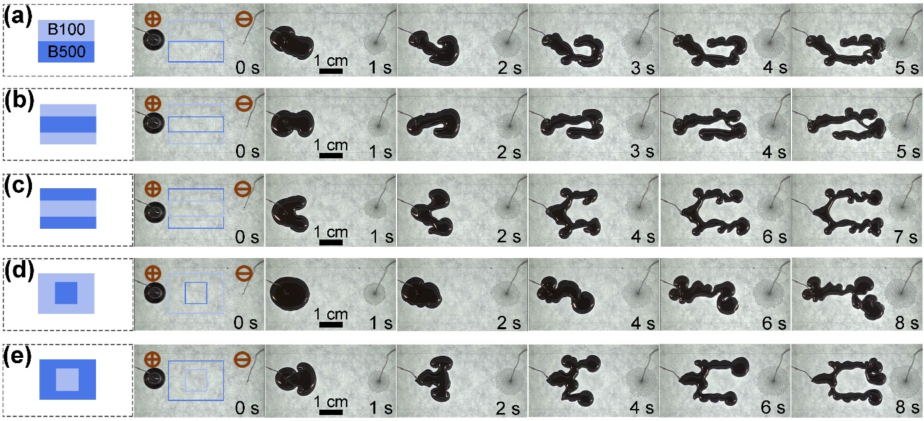

Figure S30. Different fingering instabilities of liquid metal droplets (300 μL) on different combinations of B100 and B500 (pit-pit type) with applied voltage of 5 V. All experiments are conducted in 1 M NaOH solution. All scale bars are 1 cm.

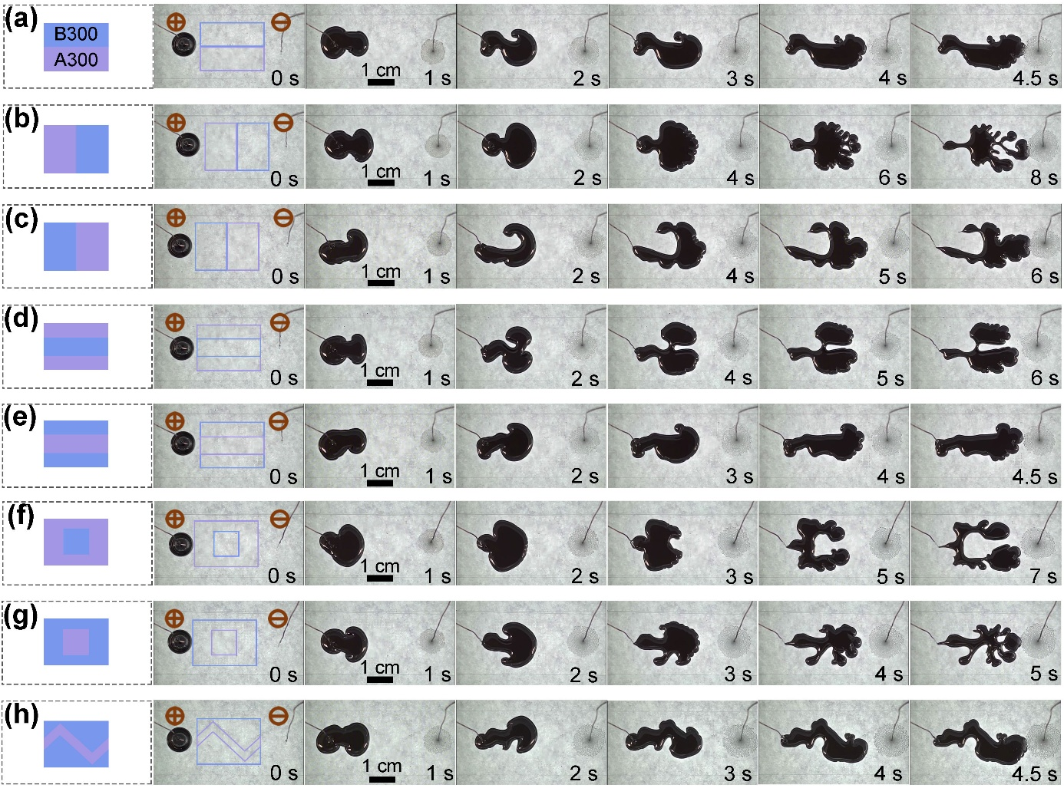

Figure S31. Different fingering instabilities of liquid metal droplets (300 μL) on different combinations of A300 and B300 (pillar-pit type) with applied voltage of 5 V. All experiments are conducted in 1 M NaOH solution. All scale bars are 1 cm.

Section III: Calculation details of fractal dimension D
To quantify the morphology of the fingering patterns, we measure the Hausdorff dimension $D≡\lim_{r→0}{logN(r)/\log{(1/r)}}$ using a box-counting algorithm, where r is the box size and N is the number of boxes to cover surface area.^{[36,50]} The variations and final values of D reflect the differing space-filling capacities of LMs controlled by topographical structures.
The detailed box-counting plots as a function of time on different topographical structures are shown in Figure S3. In this work, MATLAB code is used to calculate D, while the MATLAB built-in toolbox (FRACLAB) is also employed for comparison. A detailed workflow diagram of the two methods is presented in Figure S4. The calculated D values exhibit similar relative trends between substrates, yet the D values from the two methods differ by 0.02 to 0.12 (Figure S5). Given the differences in D values between the different calculation methods, this work focuses on comparing the relative changes in D for different topographical structures rather than emphasizing absolute values.

Section IV: Discussion of filling process of liquid metal on pillar arrays
Figure S22 illustrates the experimental setup of inverted microscope for bottom-view images of LM spreading on substrate at different positions: the center, middle, and edge positions, where the LM is expected to spread.
- The focus of inverted microscope fixed at the bottom of the pillars
The bottom-view images of LM spreading on pillar array at different positions are shown in Figure S24b. During the spreading, the images demonstrate different local resolutions. For example, for lens located at center position, the image is fuzzy when voltage is off. It turns clear after 4 s when voltage is turned on. For lens located at middle and edge positions, the image for leading edge of LM is fuzzy while the following area is clear, with a clear boundary line. Considering the focus of the inverted microscope is at the bottom of the pillars, as illustrated in Figure S23. We reason that the image is fuzzy when LM is above the pillars, and it turns clear after LM fills the channels. Only when the LM fully fills the space between the pillars, will the contact edge between the LM and pillars be clear in the microscope, as shown in Figure S23.
- The absence of oxides (wrinkles) at the bottom of LM on pillar array
There are no wrinkles (i.e., oxides) for LM spreading on the pillar arrays. The smooth appearance indicated that the LM has either filled the space or the NaOH has dissolved oxides to help keep LM smooth without filling the space. We compared the different morphology observed on pillar and pit arrays (Figure S24b and c). If LM stays on the pillar top without oxides, the surface of LM cannot be flat due to high density. In other words, the morphology should be similar to that observed on pit arrays, the non-flat surface. It is reasonable to assume that the LM has filled space between the pillars without surface oxides.

