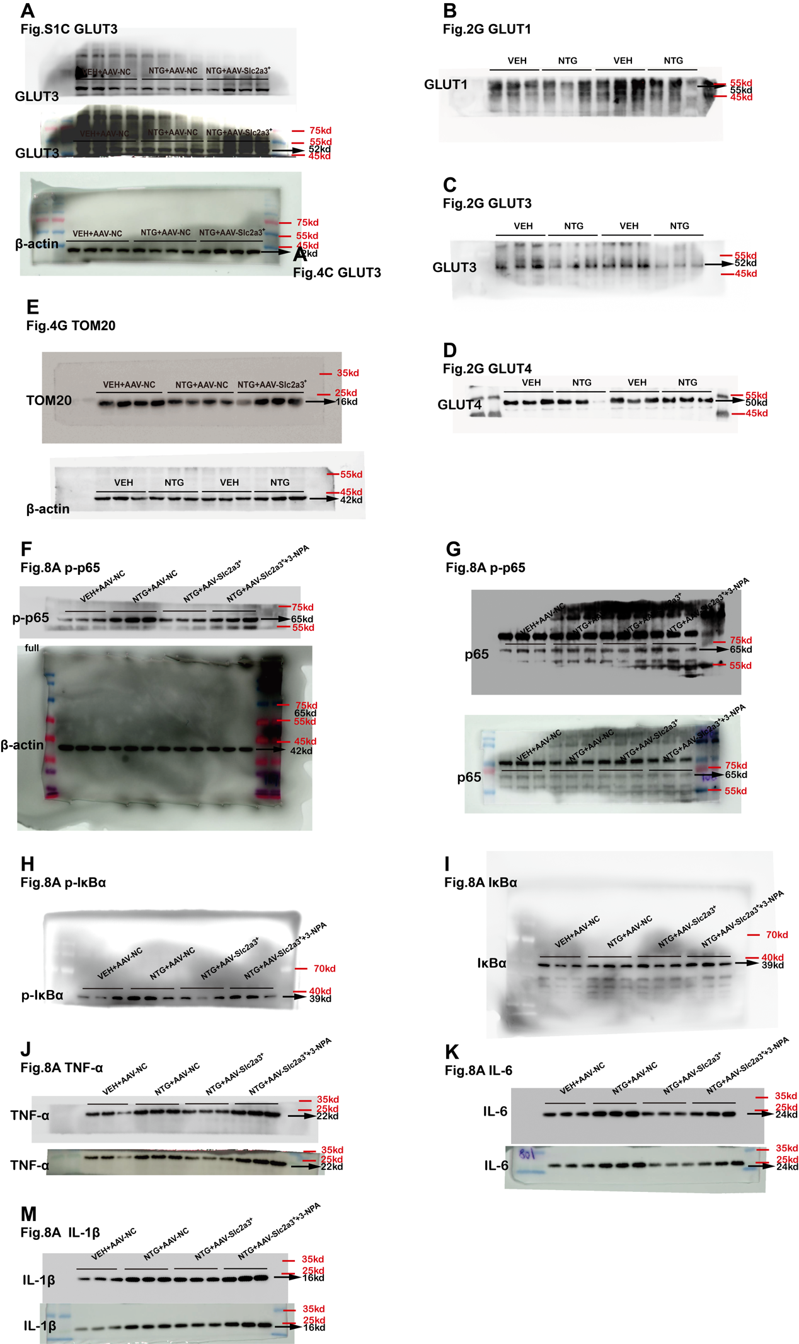
Original WB Data
(A) (corresponding to original Fig.S1C) ：Detects the expression of GLUT3, with β-actin as the internal control. (B) (corresponding to original Fig.2G) ：Detects the expression of GLUT1. (C) (corresponding to original Fig.2G) ：Detects the expression of GLUT3. (D) (corresponding to original Fig.2G) ：Detects the expression of GLUT4. (E) (corresponding to original Fig.4G) ：Detects the expression of TOM20, with β-actin as the internal control. (F) (corresponding to original Fig.8A) ：Detects the expression of phosphorylated p65 (p-p65), with β-actin as the internal control. (G) (corresponding to original Fig.8A) ：Detects the expression of phosphorylated p65 (p-p65) and total p65. (H) (corresponding to original Fig.8A) ：Detects the expression of phosphorylated IκBα (p-IκBα). (I) (corresponding to original Fig.8A) ：Detects the expression of total IκBα. (J) (corresponding to original Fig.8A) ：Detects the expression of TNF-α. (K) (corresponding to original Fig.8A) ：Detects the expression of IL-6. (M) (corresponding to original Fig.8A) ：Detects the expression of IL-1β.

