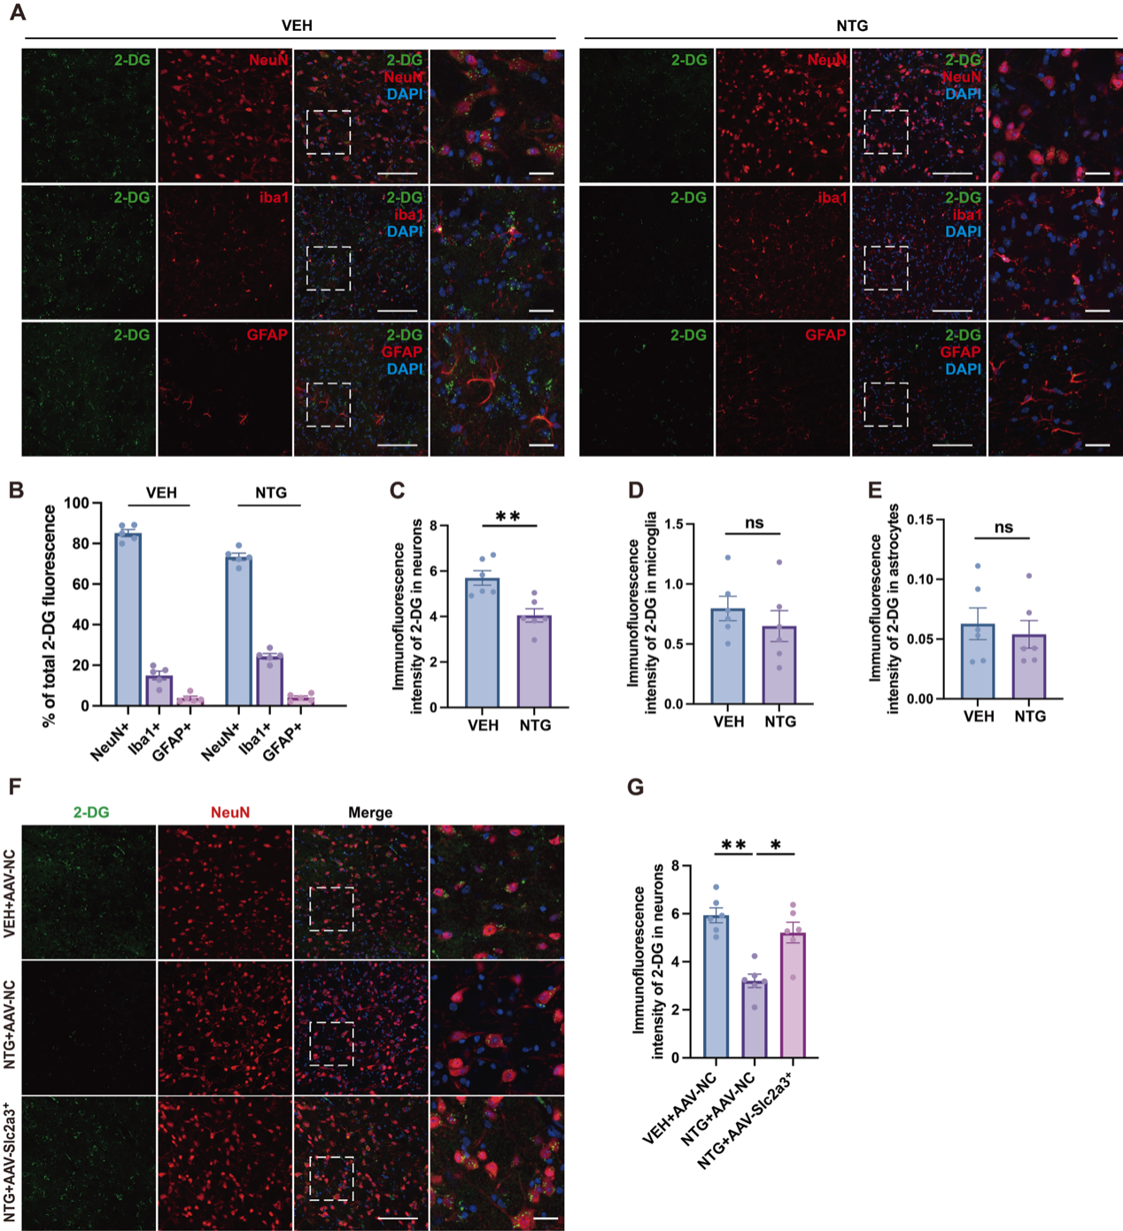
Figure S1. Neurons are the major glucose-uptaking cells in the TNC and GLUT3 overexpression rescues NTG-induced reduction in neuronal glucose uptake.
(A) Immunofluorescence co-localization images showing IRDye 800CW 2-DG (glucose uptake probe, green) with NeuN, Iba1, or GFAP (red) in the TNC. Scale bar = 100 μm, 30 μm (enlarged images). (B) Percentage distribution of total IRDye 800CW 2-DG fluorescence signal among NeuN⁺ neurons, Iba1⁺ microglia, and GFAP⁺ astrocytes in the TNC. In both VEH and NTG groups, neurons accounted for the majority of glucose uptake, with minimal changes in the proportion of glucose uptake by microglia and astrocytes (n = 5 mice/group). (C-E) Quantitative analyses of IRDye 800CW 2-DG immunofluorescence intensity in NeuN⁺ neurons, Iba1⁺ microglia, and GFAP⁺ astrocytes, respectively. NTG treatment significantly decreased glucose uptake in TNC neurons, whereas glucose uptake in microglia and astrocytes showed no statistically significant difference between groups. (F) Immunofluorescence images of IRDye 800CW 2-DG (glucose uptake probe, green) and NeuN (red). scale bar = 100 μm, 30 μm (enlarged images). (G) Quantitative analysis of IRDye 800CW 2-DG fluorescence intensity in NeuN⁺ neurons, confirming that NTG-induced reduction in neuronal glucose uptake was reversed by GLUT3 overexpression (n = 5 mice/group). All data are presented as mean ± SEM; ns, not significant; *p < 0.05, **p < 0.01. Statistical significance was determined by unpaired two-tailed t-test.

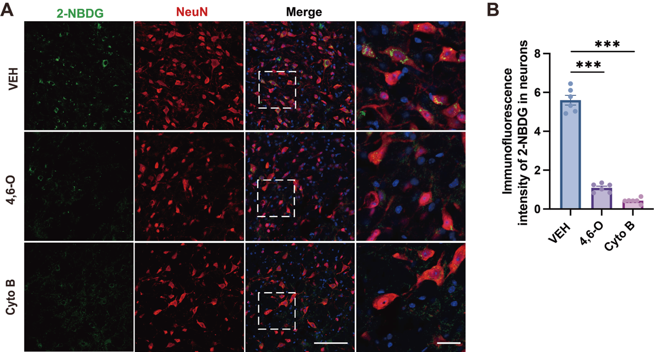
Figure. S2. 2-NBDG uptake is dependent on glucose transporters in TNC neurons.
- Immunofluorescence co-localization images of 2-NBDG (glucose uptake probe, green) and the neuronal marker NeuN (red) in the TNC. Scale bar = 100 μm, 30 μm (enlarged panels). (B) Quantitative analysis of 2-NBDG immunofluorescence intensity in neurons: Compared with the VEH group, the fluorescence intensity was significantly reduced in both the 4,6-O and Cyto B groups, confirming that 2-NBDG uptake in TNC neurons is mediated by GLUT (n = 6 mice/group). All data are presented as mean ± SEM; ***p < 0.001. Statistical significance was determined by unpaired two-tailed t-test.

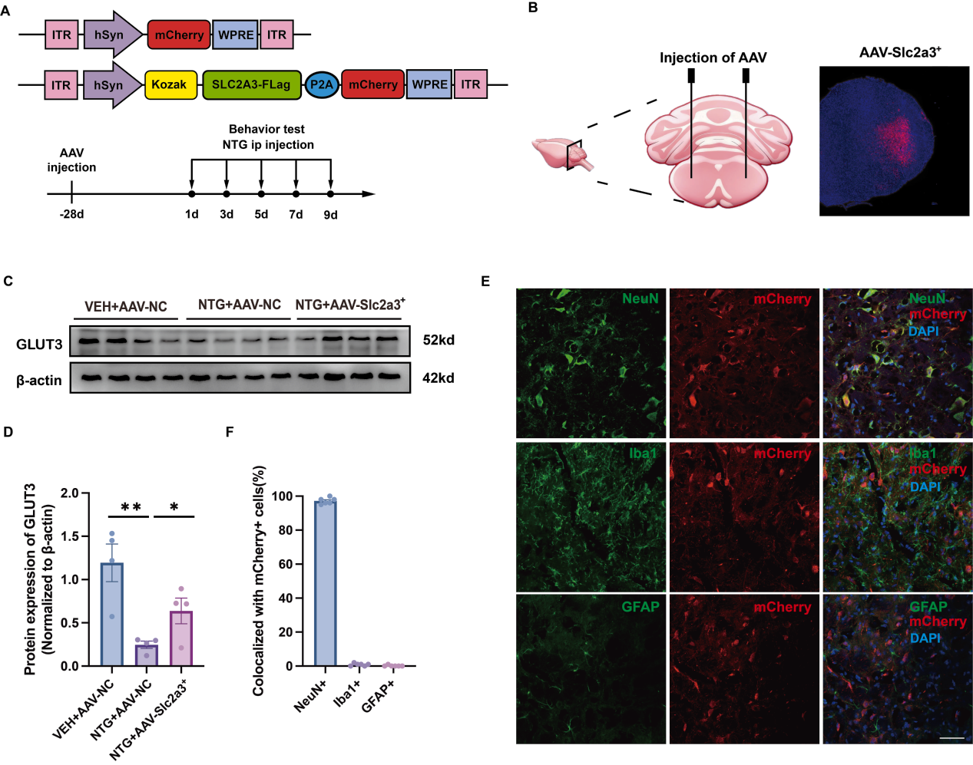
Figure S3. Validation of neuron-specific GLUT3 overexpression via AAV-hSyn-GLUT3 in mouse TNC.
(A) Schematic of AAV constructs: AAV-hSyn-GLUT3 and AAV-hSyn-mCherry with neuron-specific hSyn promoter, ITR, WPRE, and mCherry reporter. (B) Schematic of stereotaxic AAV injection into TNC, followed by behavioral tests and NTG injection. (C) Representative WB blots of GLUT3. (D) Quantitative analysis of GLUT3 protein expression, showing marked reduction in NTG-AAV-NC group and recovery in NTG+AAV-Slc2a3⁺ group. (E) Immunofluorescence images showing mCherry (AAV reporter, red) co-localization with NeuN, but not GFAP or Iba1 (green). Scale bar = 50 μm. (F) Quantitative analysis of mCherry⁺ cell co-localization with NeuN, GFAP, or Iba1. Data are mean ± SEM. n = 6 mice per group. *p<0.05, **p<0.01. D: Statistical significance determined by one-way analysis of variance with Tukey’s post-hoc test.
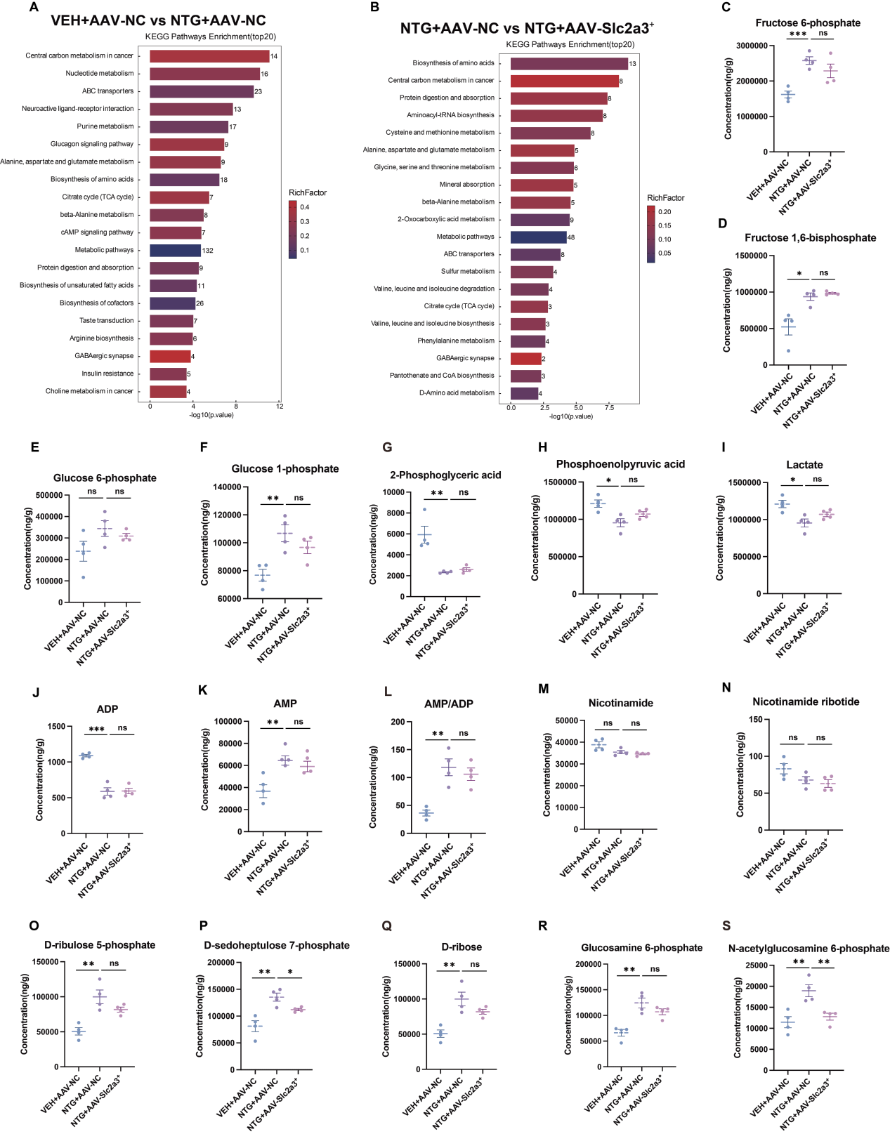
Figure S4. Abnormal glycolysis/PPP/OXPHOS in the NTG-induced CM mice.
(A) KEGG pathway enrichment (VEH+AAV-NC vs NTG+AAV-NC): Glucose metabolism pathways were significantly enriched in NTG-induced differential metabolites (n = 4 mice/group). (B) KEGG pathway enrichment (NTG+AAV-NC vs NTG+AAV-Slc2a3⁺): Glucose metabolism pathways were reversed in the NTG+AAV-Slc2a3⁺ group relative to NTG+AAV-NC group. n = 4 mice/group. (C–U) Quantitative analysis of glycolysis/OXPHOS/PPP metabolites: NTG altered concentrations of Fructose 6-phosphate (C) , Fructose 1,6-bisphosphate (D) , Glucose 6-phosphate (F) , 2-Phosphoglyceric acid (G) , Phosphoenolpyruvic acid (H) , Lactate (I) , ADP (J) , AMP (K) , AMP/ADP (L) , Nicotinamide (M) , Nicotinamide ribotide (N) , D-ribulose 5-phosphate (O) , D-sedoheptulose 7-phosphate (P) , D-ribose (Q) , Glucosamine 6-phosphate (R) , N-acetylglucosamine 6-phosphate (S) (n = 4 mice/group). All data are presented as mean ± SEM. Statistical significance was determined by one-way analysis of variance followed by Tukey’s post-hoc test. *p < 0.05, **p < 0.01, ***p < 0.001.

