Fig. S1.
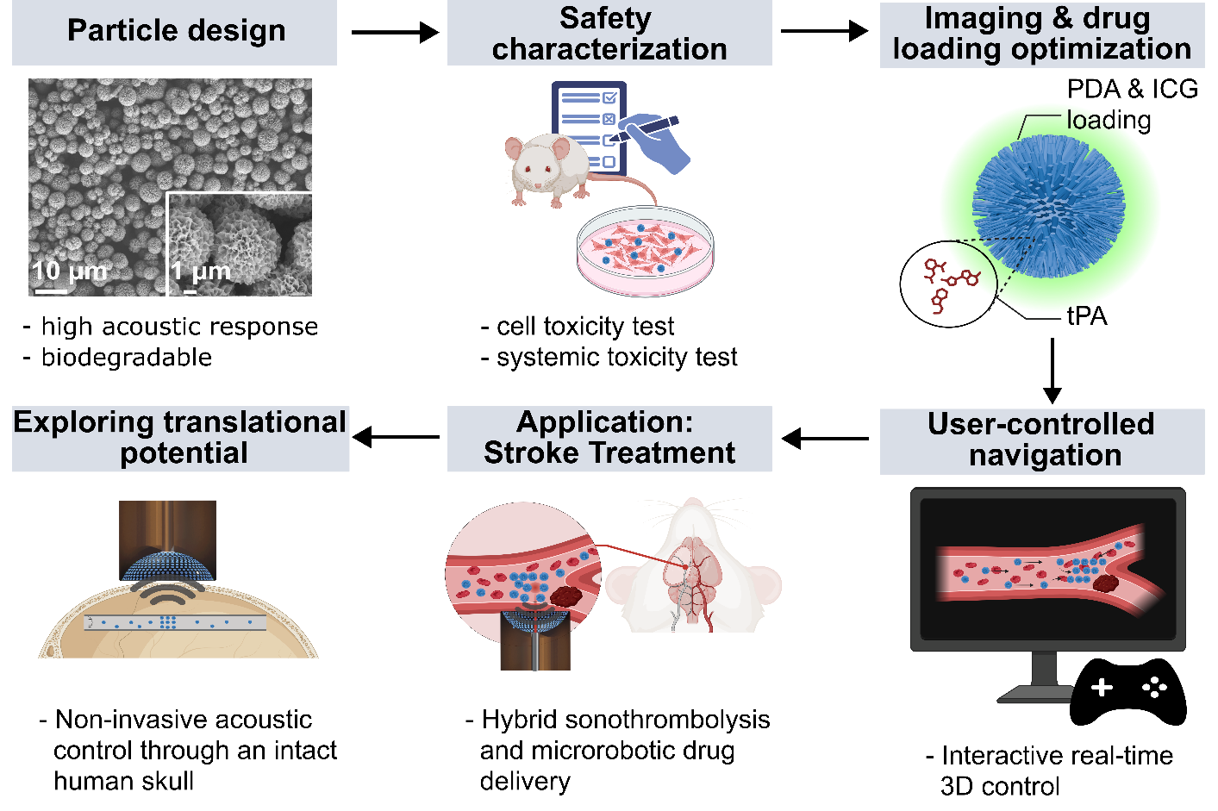
Fig. S1: Development and evaluation of the focused ultrasound (FUS) trappable hydroxyapatite microrobots (HAp-MRs) for targeted drug delivery and recanalization via concurrent acoustic actuation and real-time optoacoustic imaging feedback. Biodegradable HAp-MRs (SEM image, top left) were synthesized and characterized for biocompatibility using in vitro cell assays and in vivo systemic toxicity studies. Drug and contrast agent loading protocols for polydopamine (PDA), indocyanine green (ICG), and tissue plasminogen activator (rt-PA) were optimized. Next, a user-controlled acoustic navigation scheme was developed. The multifunctional HAp-MRs were subsequently evaluated for hybrid sonothrombolysis and microrobotic drug delivery in a model of rt-PA-resistant thrombotic lessions. Finally, transcranial acoustic trapping was demonstrated through an intact human skull to assess translational potential.

Fig. S2.
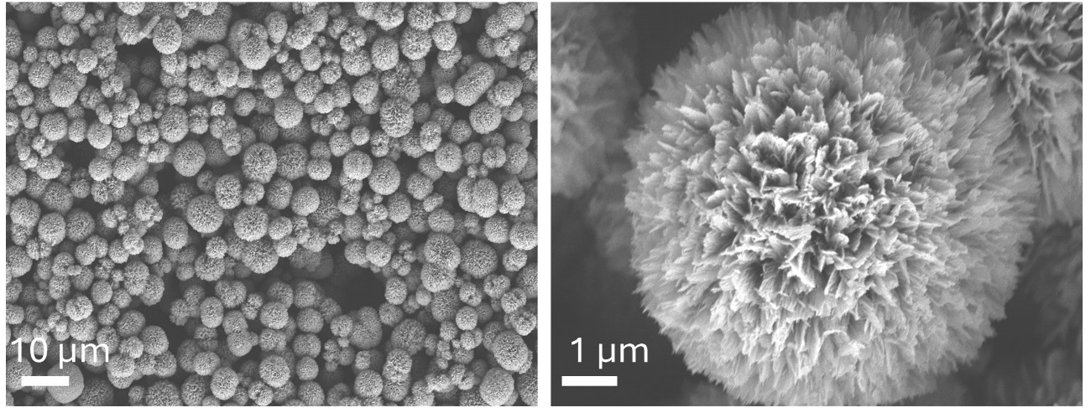
Fig. S2: SEM images of hydroxyapatite nanoflower microparticles.

Fig. S3.

Fig. S3: In vitro cytotoxicity assessed using 48h and 72h coincubation of HAp-MRs with human fibroblasts (BJ cells) and murine macrophages (J774A1 cells), showing no severe toxicity on both cell lines at various particle concentrations.

Fig. S4.
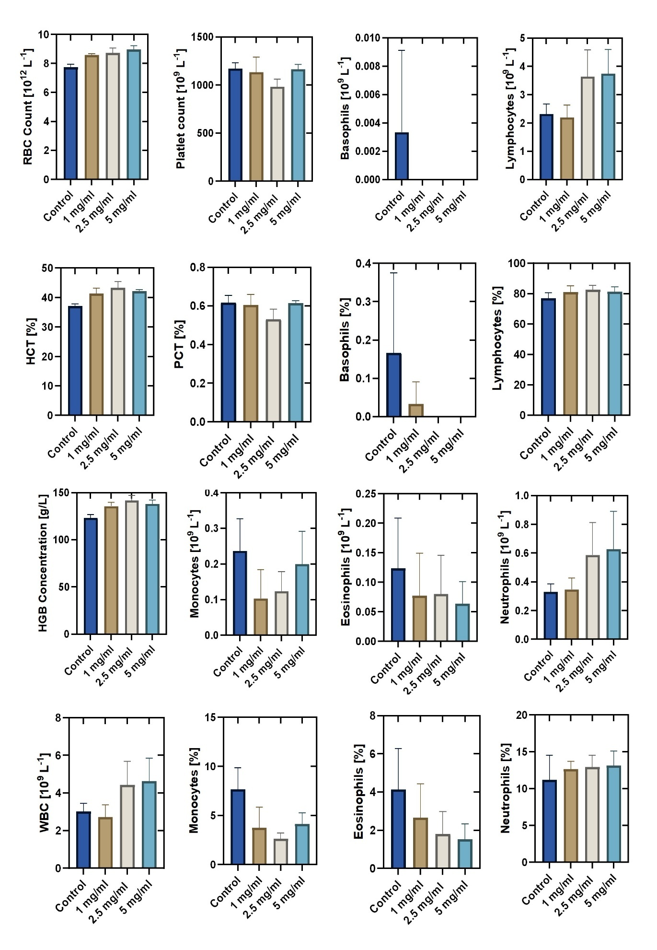
Fig. S4: Hematological parameters used to assess hemocompatibility of hydroxyapatite nanoflower microparticle based microrobots. Mice (n = 3 per group) were injected with 100 µL of 1, 2.5, or 5 mg/mL HAp-NFs or left untreated (control). Blood samples were analyzed for red and white blood cell counts (RBC, WBC), hemoglobin (HGB), hematocrit (HCT), and other cellular components. No significant abnormalities were observed across groups.

Fig. S5.
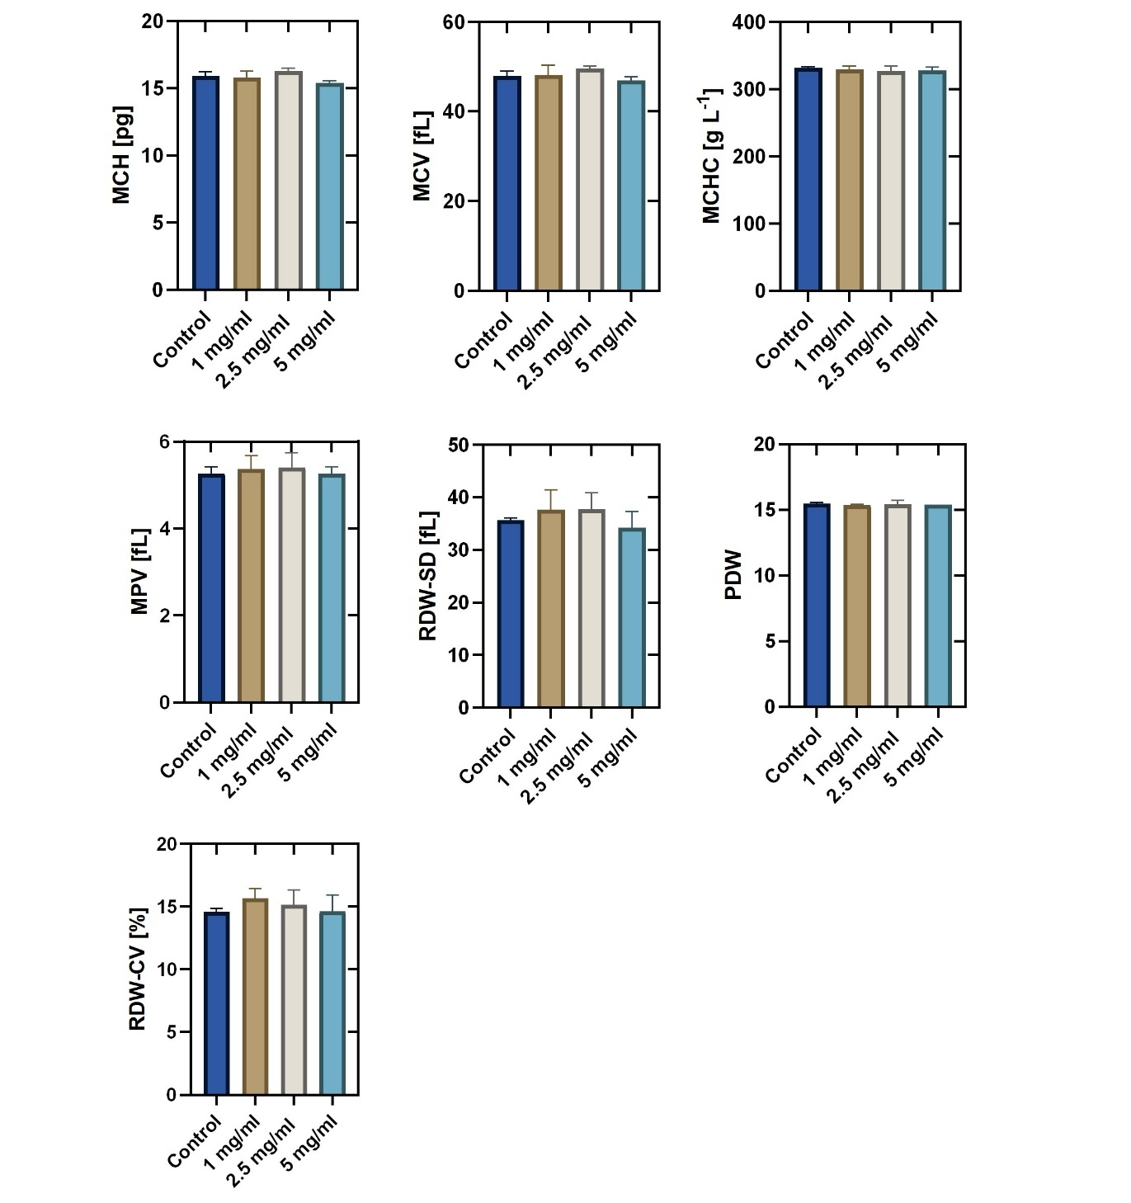
Fig. S5: Additional hematological markers after hydroxyapatite nanoflower microparticle based microrobots injection to evaluate hemocompatibility. Same mouse cohorts as in Fig. S2. Parameters include Mean Corpuscular Hemoglobin (MCH), Mean Corpuscular Volume (MCV), Mean Corpuscular Hemoglobin Concentration (MCHC), Mean Platelet Volume (MPV), Platelet Distribution Width (PDW), and Red Cell Distribution Width (RDW-CV, RDW-SD). All values remained within physiologically acceptable ranges.

Fig. S6.
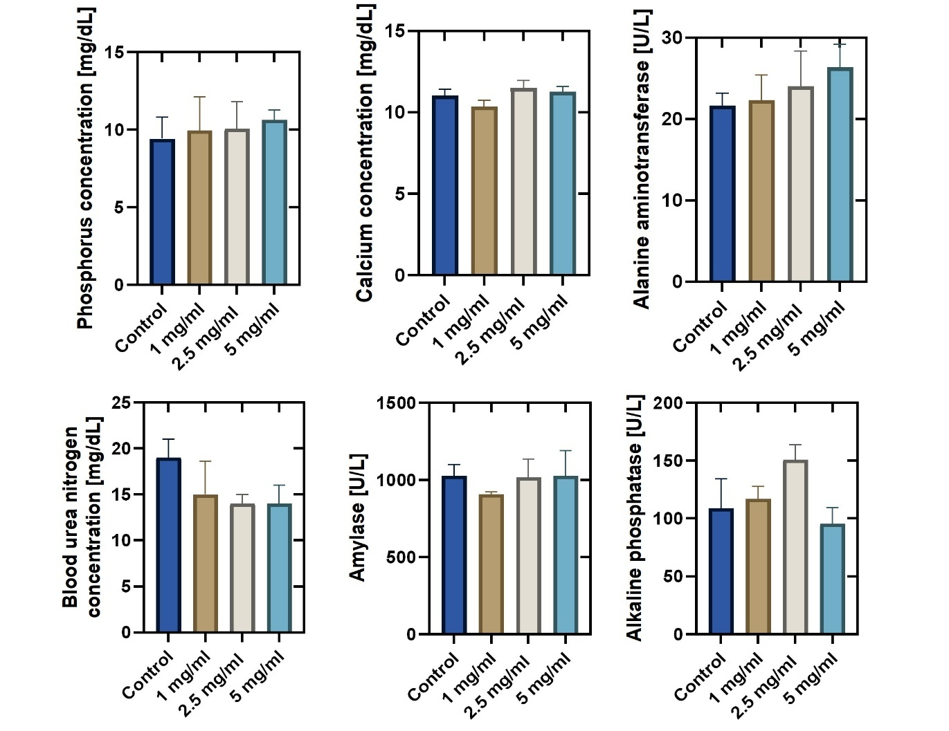
Fig. S6: Serum biochemical analysis following hydroxyapatite nanoflower microparticle based microrobots injection to assess systemic biosafety. Mice (n = 3 per group) were injected intravenously with 0, 1, 2.5, or 5 mg/mL of HAp-NFs. No toxicologically relevant alterations were detected.

Fig. S7.
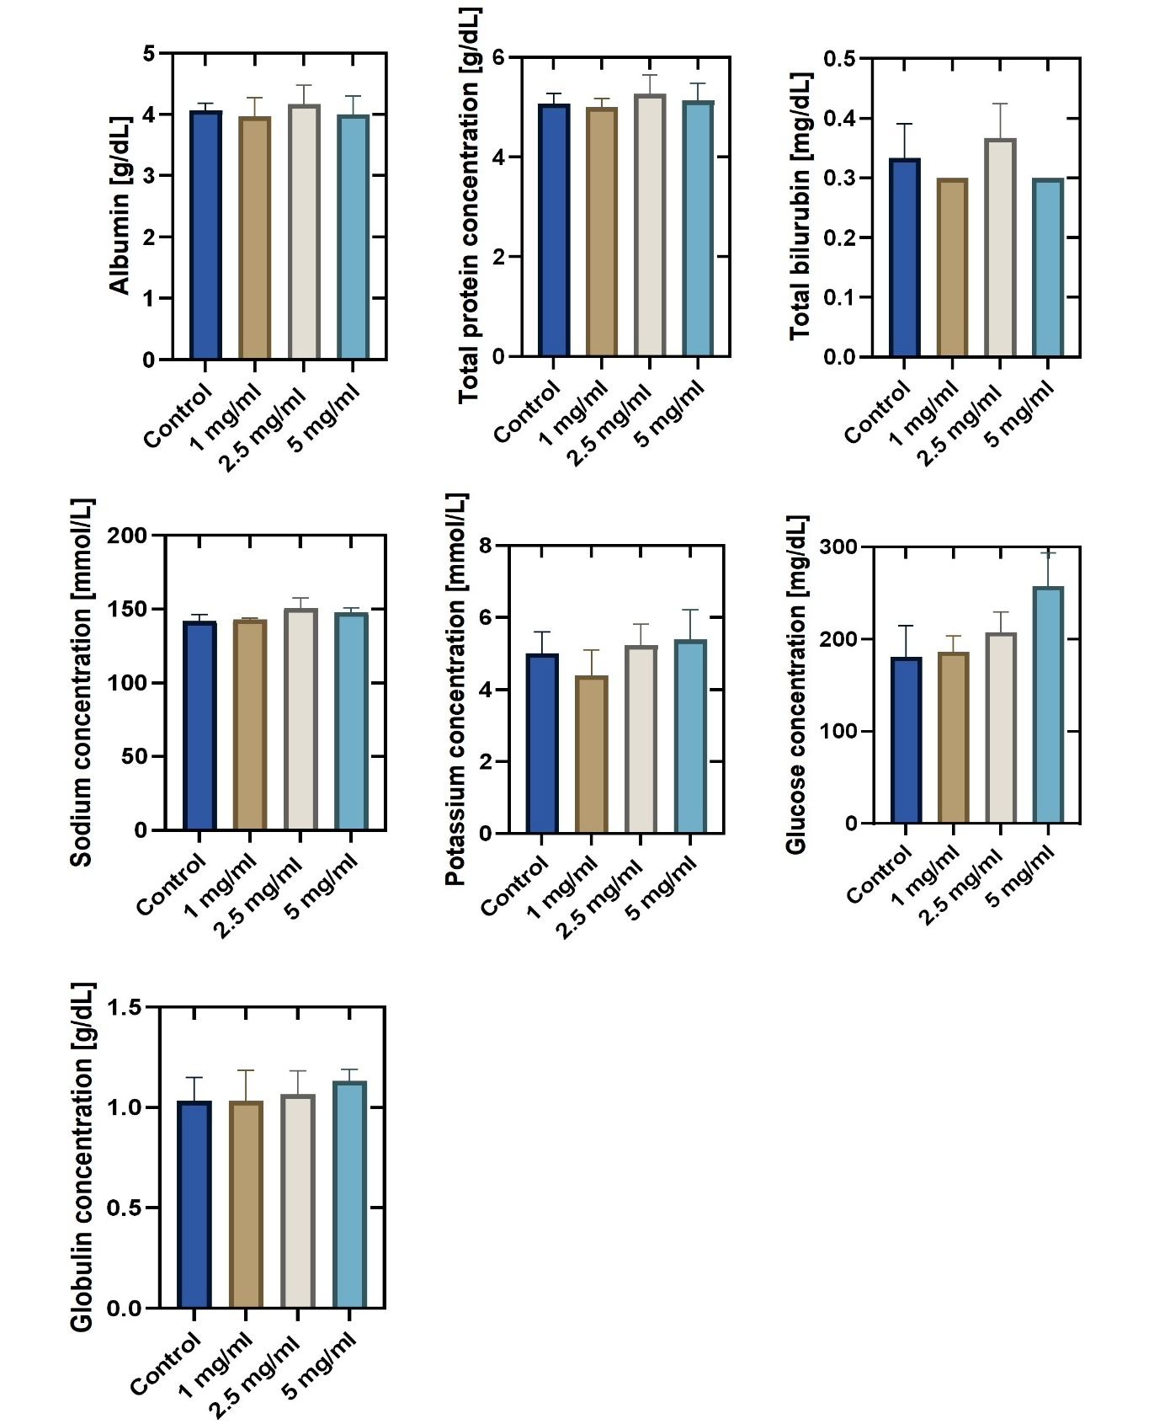
Fig. S7: Expanded panel of serum biochemical markers for systemic toxicity assessment. Same dosing groups as in Fig. S8. Additional functional markers were evaluated to comprehensively assess systemic biocompatibility following hydroxyapatite nanoflower microparticle based microrobots injection.

Fig. S8.
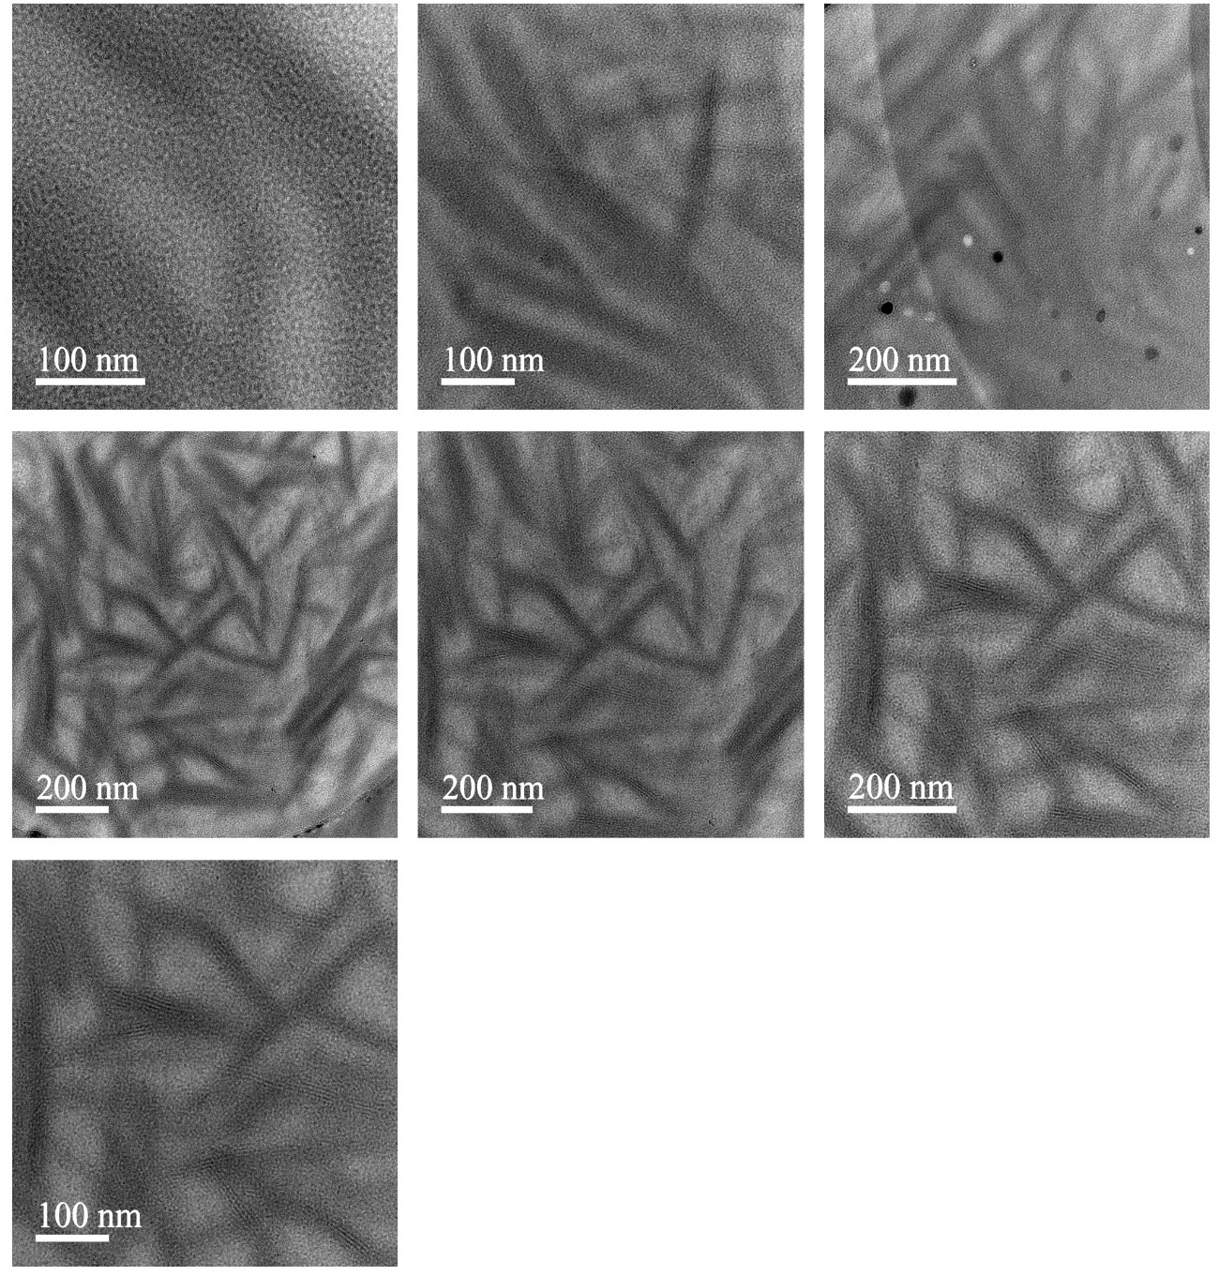
Fig. S8: High-resolution transmission electron microscopy (HRTEM) images of hydroxyapatite nanoplates. The images show the highly crystalline morphology of the microparticles.

Fig. S9.
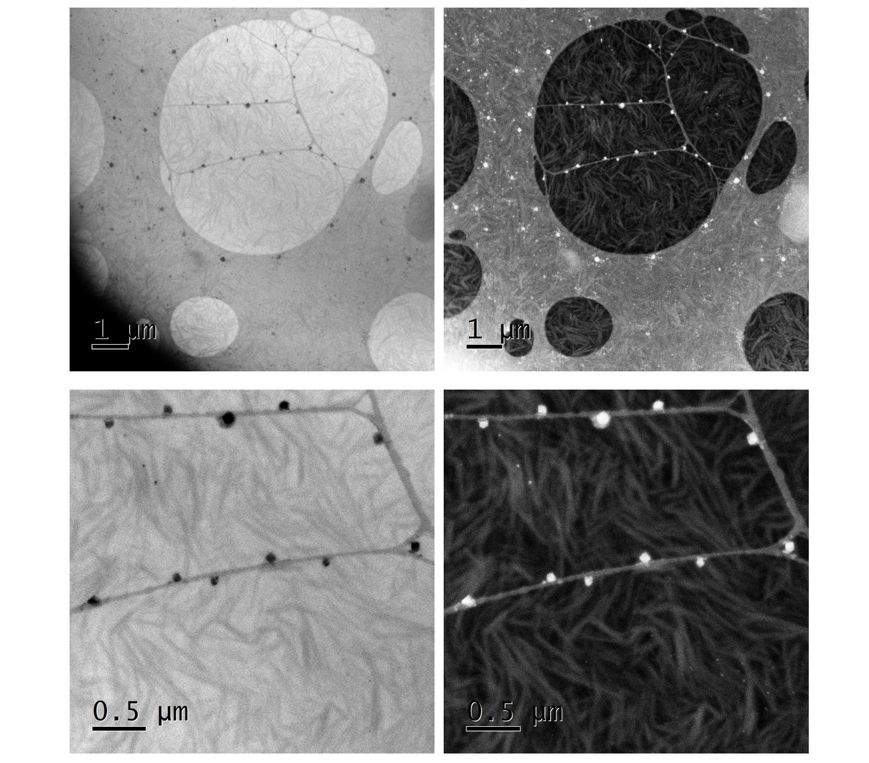
Fig. S9: Bright-field and high-angle annular dark-field scanning transmission electron microscopy (BF-STEM and HAADF-STEM) images of hydroxyapatite nanoplates. Top and bottom left panels show BF-STEM images; top and bottom right panels show HAADF-STEM images. The images reveal the highly crystalline, hierarchical morphology characteristic of HAp-NFs.

Fig. S10.
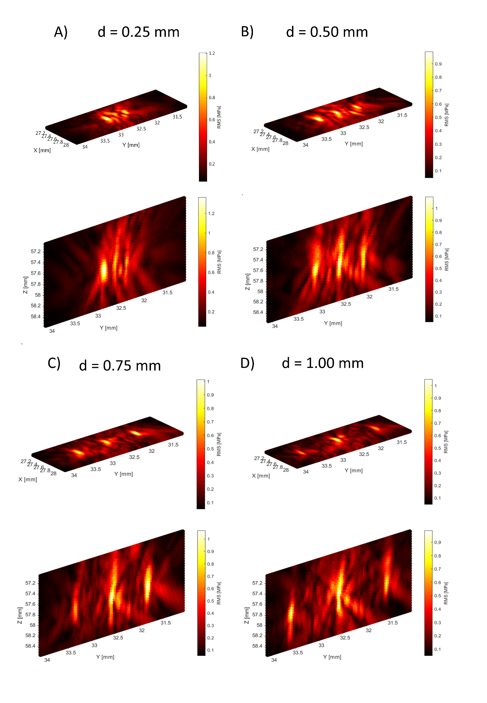
Fig. S10: Acoustic pressure profiles for different inter-focal distances in three-foci trapping sequences. Pressure distributions were measured at 5 V_{pp} for inter-focal distances of 0.25 mm (A), 0.50 mm (B), 0.75 mm (C), and 1.00 mm (D). Each panel shows the spatial pressure distribution in the xy-plane (top) and xz-plane (bottom). Color scale indicates relative pressure amplitude. Measurements demonstrate the spatial characteristics of pressure fields as a function of inter-focal distance.

Fig. S11.
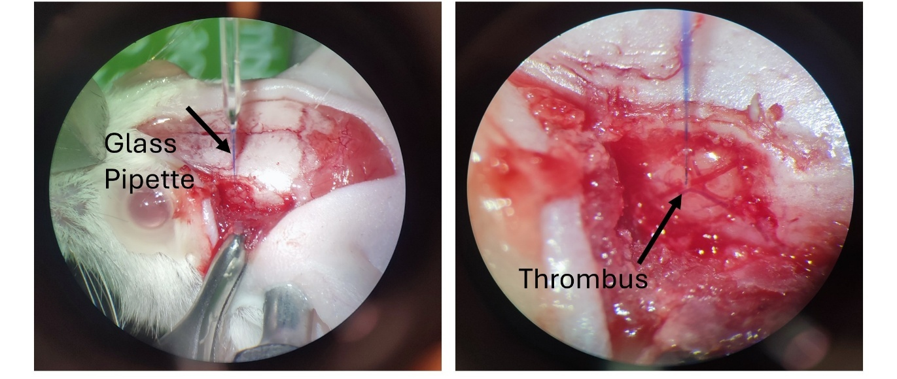
Fig. S11: Thrombotic lesion induction using the ferric chloride model. After drilling a 3 × 3 mm cranial window, a glass pipette was positioned above the target cortical vessel (left). A droplet of ferric chloride solution was applied, inducing localized thrombus formation visible in the right panel.

Fig. S12. 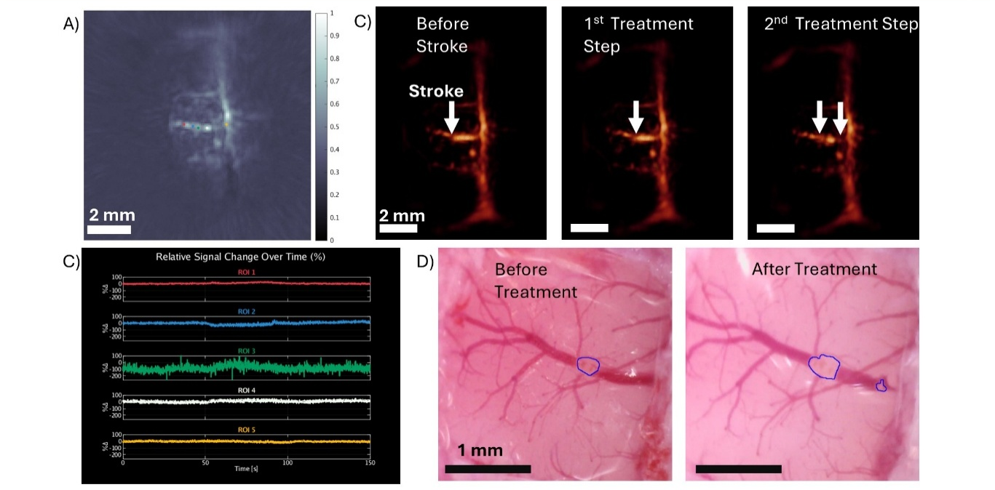
Fig. S12: Treatment summary for Mouse ID 5 (focused ultrasound (FUS) and recombinant tissue plasminogen activator (rt-PA)-coated hydroxyapatite nanoflower microparticle based microrobots (HAp-MRs)). (A) Optoacoustic (OA) xy image slice showing the stroke area and surrounding vasculature. (B) Maximum intensity projections acquired pre-treatment (left), after step 1 (center), and after step 2 (right). (C) Relative OA signal change over time for regions marked in (A), color-coded accordingly. (D) Bright-field microscopy of the occluded vessel before (left) and after (right) therapy, with stroke area outlined in blue.

Fig. S13.
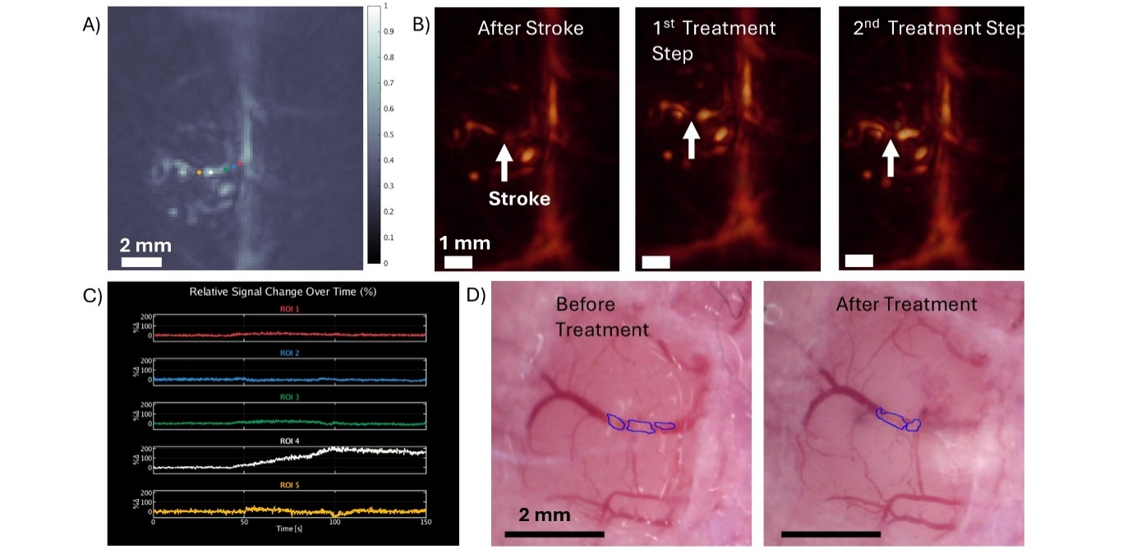
Fig. S13: Treatment summary for Mouse ID 6 (focused ultrasound (FUS) and recombinant tissue plasminogen activator (rt-PA)-coated hydroxyapatite nanoflower microparticle based microrobots (HAp-MRs)). (A) Optoacoustic (OA) xy image slice showing the stroke area and surrounding vasculature. (B) Maximum intensity projections acquired pre-treatment (left), after step 1 (center), and after step 2 (right). (C) Relative OA signal change over time for regions marked in (A), color-coded accordingly. (D) Bright-field microscopy of the occluded vessel before (left) and after (right) therapy, with stroke area outlined in blue.

Fig. S14.
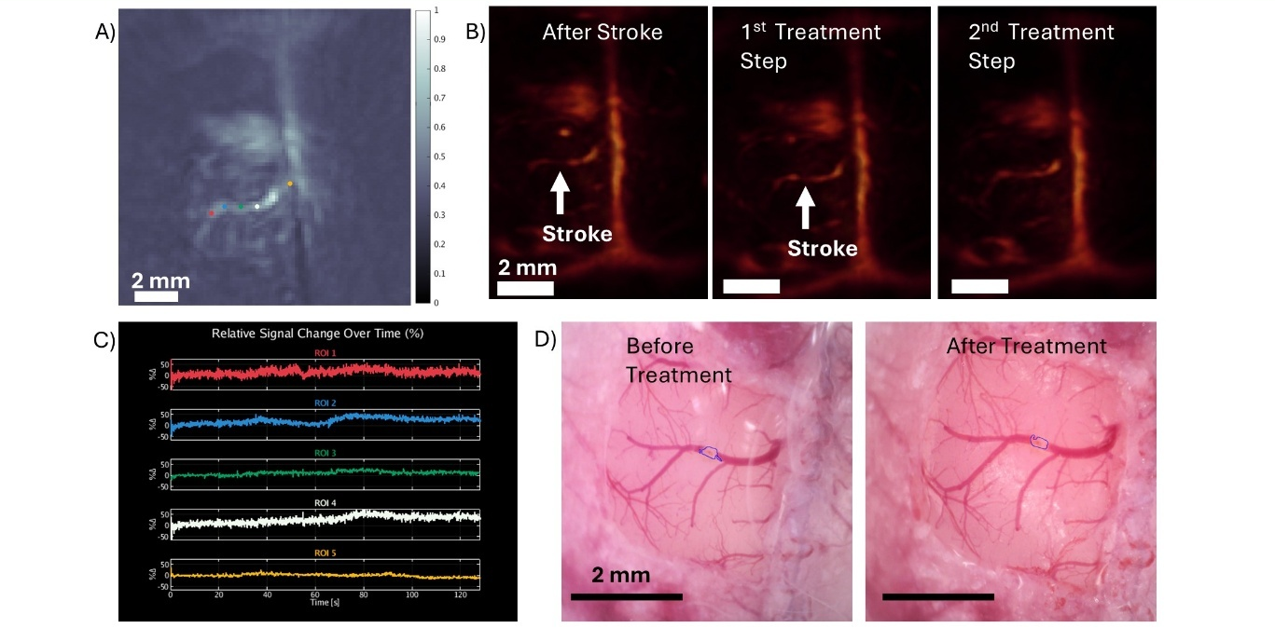
Fig. S14: Treatment summary for Mouse ID 7 (focused ultrasound (FUS) and recombinant tissue plasminogen activator (rt-PA)-coated hydroxyapatite nanoflower microparticle based microrobots (HAp-MRs)). (A) Optoacoustic (OA) xy image slice showing the stroke area and surrounding vasculature. (B) Maximum intensity projections acquired pre-treatment (left), after step 1 (center), and after step 2 (right). (C) Relative OA signal change over time for regions marked in (A), color-coded accordingly. (D) Bright-field microscopy of the occluded vessel before (left) and after (right) therapy, with stroke area outlined in blue.

Fig. S15.
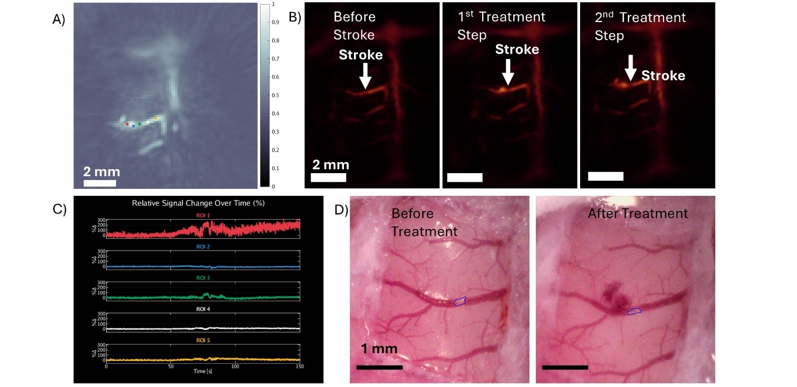
Fig. S15: Treatment summary for Mouse ID 8 (focused ultrasound (FUS) and recombinant tissue plasminogen activator (rt-PA)-coated hydroxyapatite nanoflower microparticle based microrobots (HAp-MRs)). (A) Optoacoustic (OA) xy image slice showing the stroke area and surrounding vasculature. (B) Maximum intensity projections acquired pre-treatment (left), after step 1 (center), and after step 2 (right). (C) Relative OA signal change over time for regions marked in (A), color-coded accordingly. (D) Bright-field microscopy of the occluded vessel before (left) and after (right) therapy, with stroke area outlined in blue. This mouse showed hemorrhage after the second treatment likely due to a sudden change in blood pressure within the vessel after recanalization

Fig. S16.

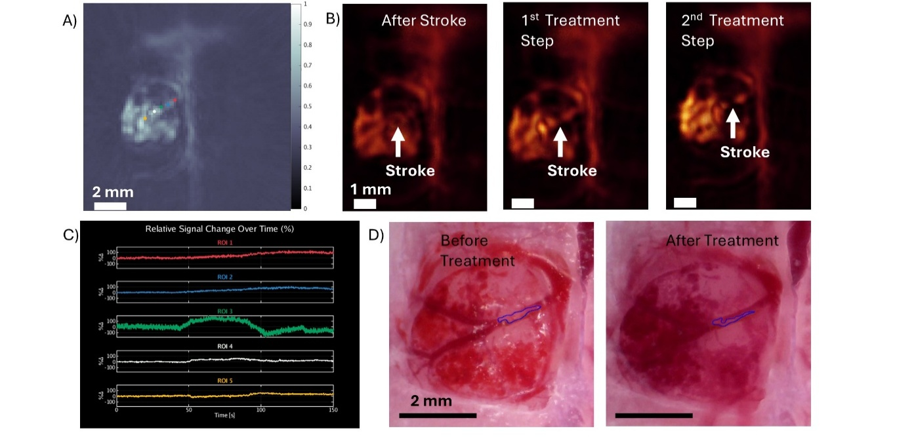
Fig. S16: Treatment summary for Mouse ID 9 (focused ultrasound (FUS) and recombinant tissue plasminogen activator (rt-PA)-coated hydroxyapatite nanoflower microparticle based microrobots (HAp-MRs)). In this mouse we had bleedings coming in from the side of the craniotomy window required for stroke induction. It is not caused by the FUS treatment but occurred during surgery. (A) Optoacoustic (OA) xy image slice showing the stroke area and surrounding vasculature. (B) Maximum intensity projections acquired pre-treatment (left), after step 1 (center), and after step 2 (right). (C) Relative OA signal change over time for regions marked in (A), color-coded accordingly. (D) Bright-field microscopy of the occluded vessel before (left) and after (right) therapy, with stroke area outlined in blue.

Fig. S17.
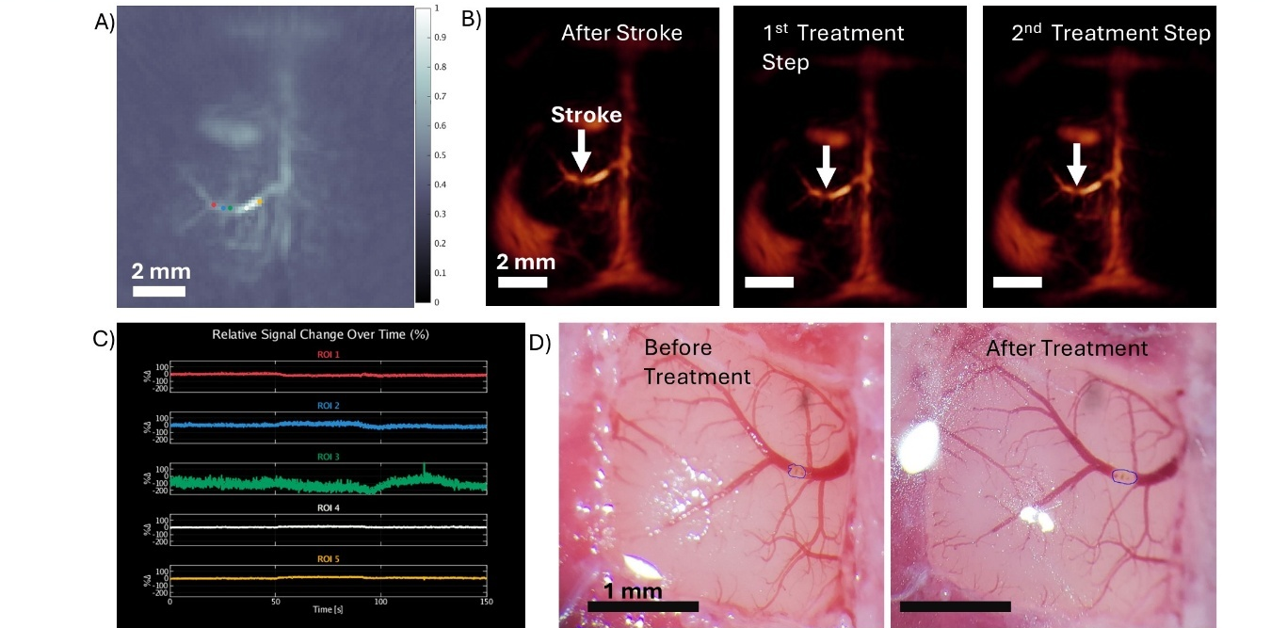
Fig. S17: Treatment summary for Mouse ID 10 (focused ultrasound (FUS) only). (A) Optoacoustic (OA) xy image slice showing the stroke area and surrounding vasculature. (B) Maximum intensity projections acquired pre-treatment (left), after step 1 (center), and after step 2 (right). (C) Relative OA signal change over time for regions marked in (A), color-coded accordingly. (D) Bright-field microscopy of the occluded vessel before (left) and after (right) therapy, with stroke area outlined in blue.
.

Fig. S18.
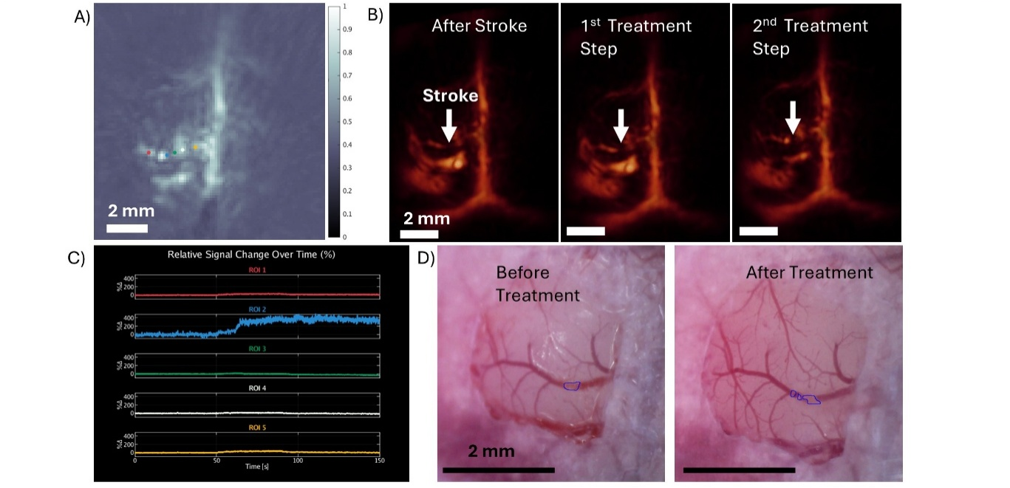
Fig. S18: Treatment summary for Mouse ID 13 (focused ultrasound (FUS) only). (A) Optoacoustic (OA) xy image slice showing the stroke area and surrounding vasculature. (B) Maximum intensity projections acquired pre-treatment (left), after step 1 (center), and after step 2 (right). (C) Relative OA signal change over time for regions marked in (A), color-coded accordingly. (D) Bright-field microscopy of the occluded vessel before (left) and after (right) therapy, with stroke area outlined in blue.

Fig. S19.
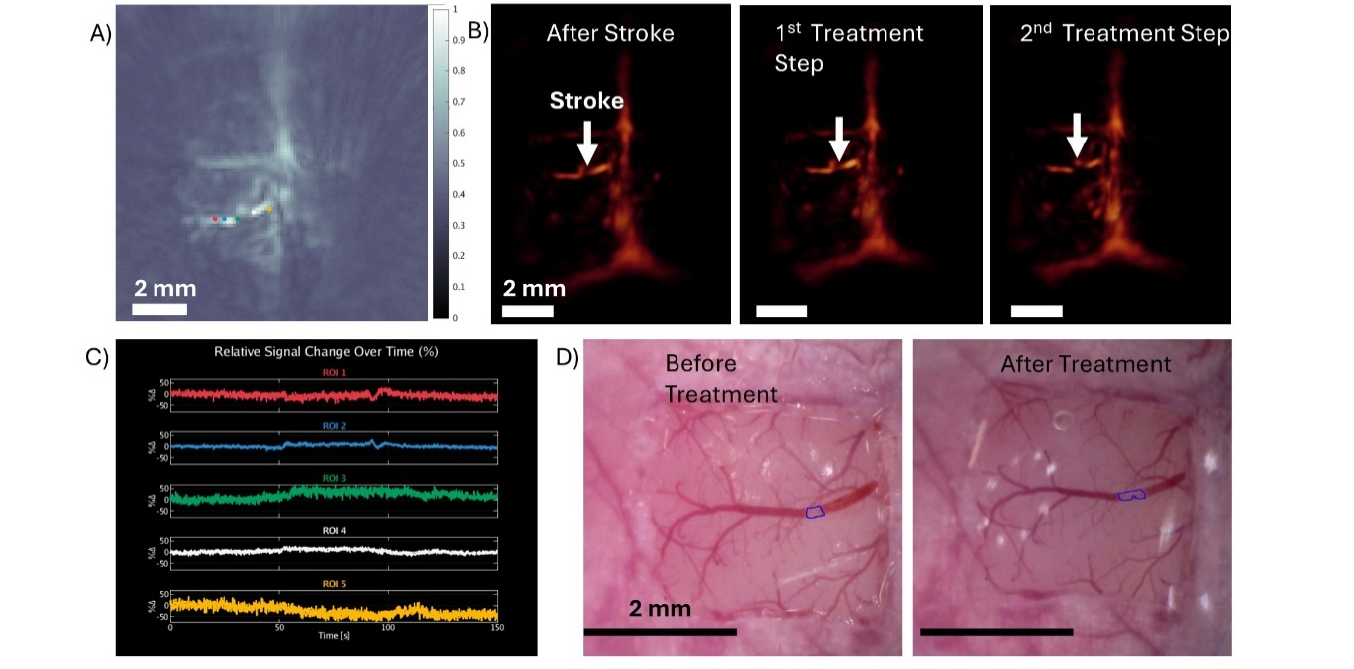
Fig. S19: Treatment summary for Mouse ID 14 (focused ultrasound (FUS) only). (A) Optoacoustic (OA) xy image slice showing the stroke area and surrounding vasculature. (B) Maximum intensity projections acquired pre-treatment (left), after step 1 (center), and after step 2 (right). (C) Relative OA signal change over time for regions marked in (A), color-coded accordingly. (D) Bright-field microscopy of the occluded vessel before (left) and after (right) therapy, with stroke area outlined in blue.

Fig. S20.
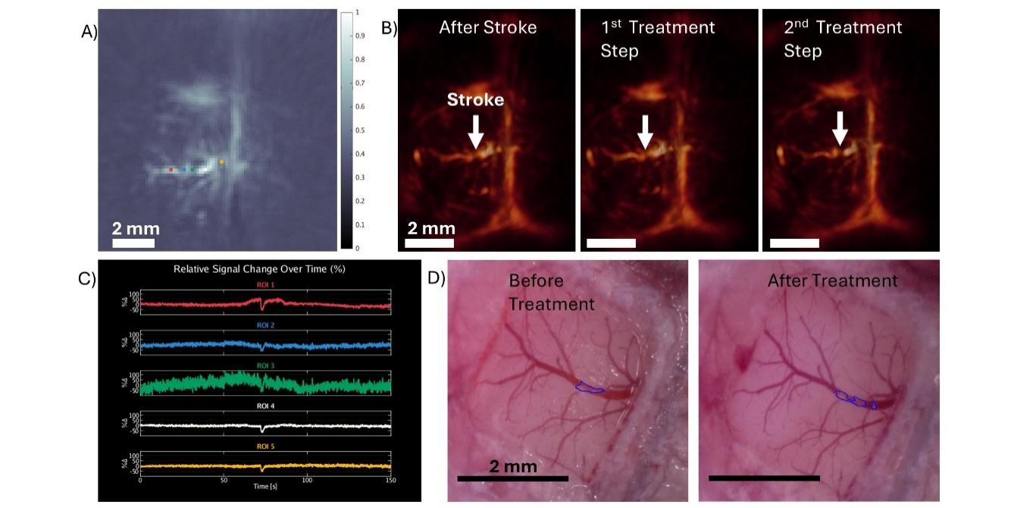
Fig. S20: Treatment summary for Mouse ID 15 (focused ultrasound (FUS) only). (A) Optoacoustic (OA) xy image slice showing the stroke area and surrounding vasculature. (B) Maximum intensity projections acquired pre-treatment (left), after step 1 (center), and after step 2 (right). (C) Relative OA signal change over time for regions marked in (A), color-coded accordingly. (D) Bright-field microscopy of the occluded vessel before (left) and after (right) therapy, with stroke area outlined in blue.

Fig. S21.
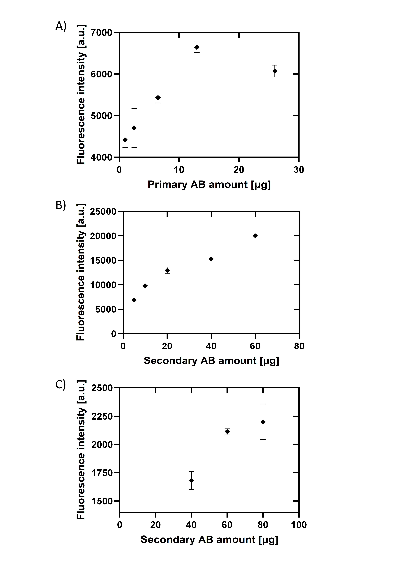
Fig. S20: Optimization of primary and secondary antibody (AB) concentrations for rt-PA detection via fluorescence plate reader measurements. (A) Fluorescence intensity as a function of primary AB concentration, measured at a fixed HAp-MR concentration (100 µg/mL), rt-PA concentration (300 µg/mL), and secondary AB concentration (100 µg/mL). The curve saturates beyond 13 µg of primary AB, indicating this as the optimal concentration under the given conditions. (B, C) Fluorescence intensity as a function of secondary AB concentration, using fixed HAp-MR (100 µg/mL), rt-PA (300 µg/mL), and primary AB (13 µg/mL) concentrations. In (B), the curve does not saturate, suggesting insufficient secondary AB to label all bound rt-PA and primary AB. In (C), saturation is observed beyond 60 µg of secondary AB, confirming this as the required amount for complete labeling under the tested conditions.

