Dynamic regulation of a domesticated DNA transposon-derived gene in human germline and early embryonic development
Tanuja Bhardwaj, Sharmistha Majumdar*
Department of Biological Sciences and Engineering, Indian Institute of Technology Gandhinagar, Gujarat, India
bhardwajtanuja@iitgn.ac.in ; *Corresponding Author: sharmistham@iitgn.ac.in

Supplementary Figures

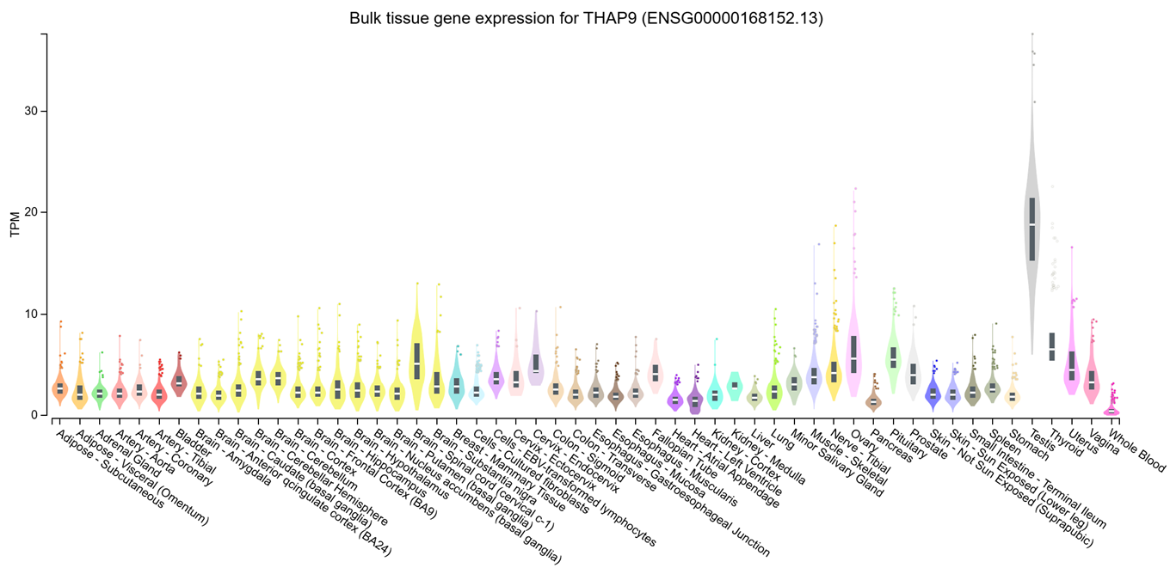
Supplementary Figure 1: Tissue-specific expression profile of THAP9 gene across human tissues: Violin plots displaying bulk tissue gene expression data for THAP9 (ENSG00000168152.13) showing transcripts per million (TPM) values across diverse human tissues from the GTEx (Genotype-Tissue Expression) portal. The width of each violin represents the density of samples at different expression levels, and black bars within violins indicate median expression values. Data obtained from the GTEx portal (https://gtexportal.org/home/gene/THAP9)

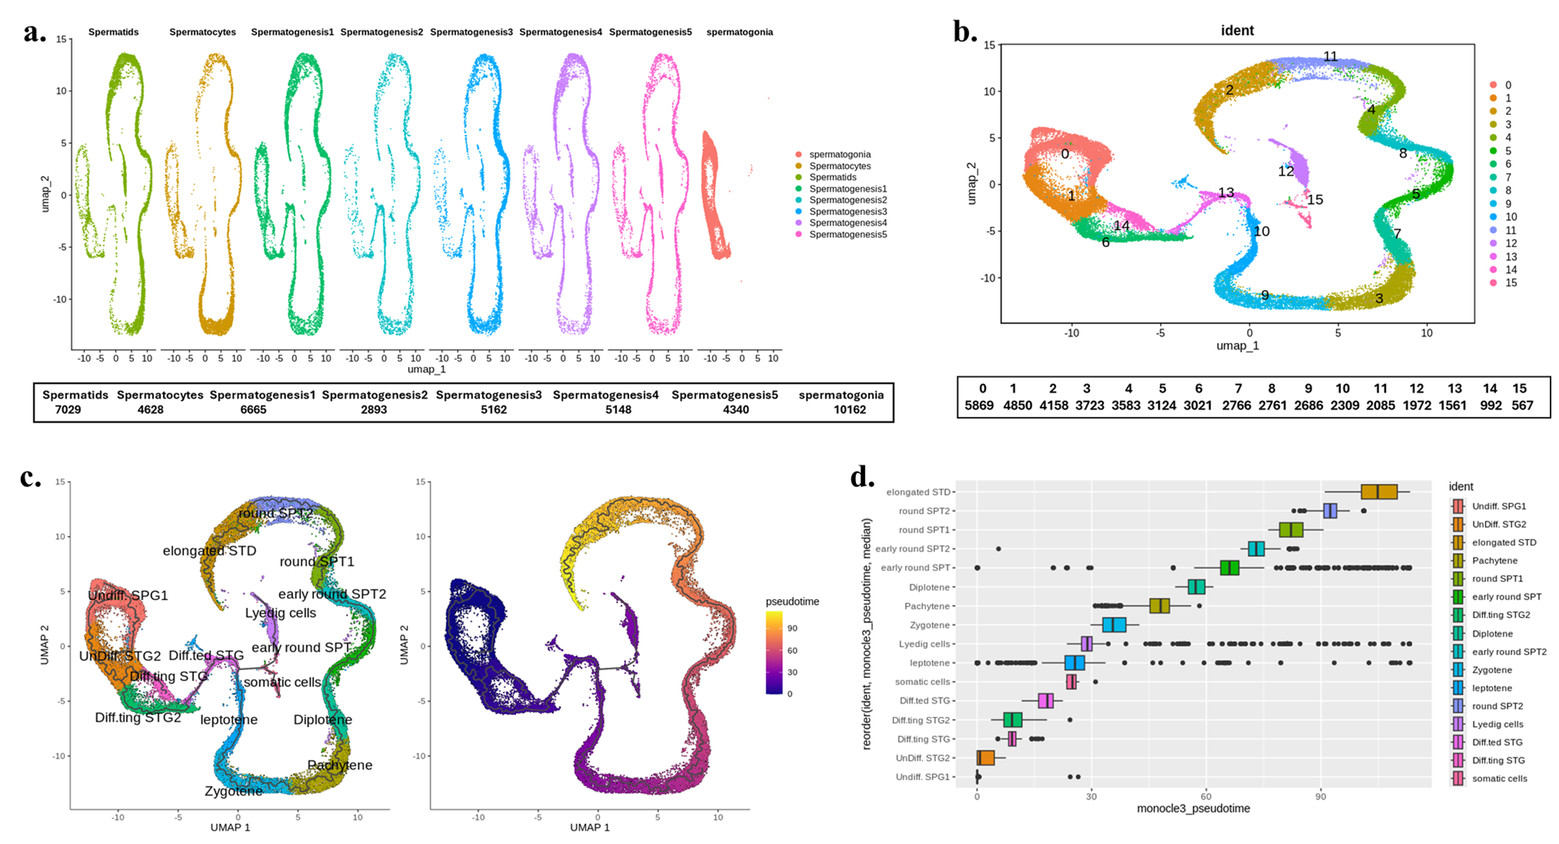Supplementary Figure 2: Single-cell RNA sequencing analysis reveals dataset integration, clustering, and developmental trajectory during spermatogenesis. (a) UMAP visualisation showing the integration of different spermatogenesis datasets, with each dataset colored separately. Cell numbers for each dataset are indicated below (b) UMAP plot displaying 16 distinct cell clusters (0-15) identified through unsupervised clustering of the integrated dataset, with the number of cells in each cluster listed below (c) Pseudotime analysis using trajectory inference to reconstruct the developmental progression during spermatogenesis. Left panel shows the inferred trajectory path overlaid on cell populations, while the right panel displays the same trajectory colored by pseudotime values, indicating the temporal ordering of developmental stages (d) Hierarchical ordering of cell stages along the developmental trajectory, showing the sequential progression from undifferentiated spermatogonial populations through various differentiated stages including spermatocytes, round spermatids, and elongated spermatids, as determined by pseudotime analysis.

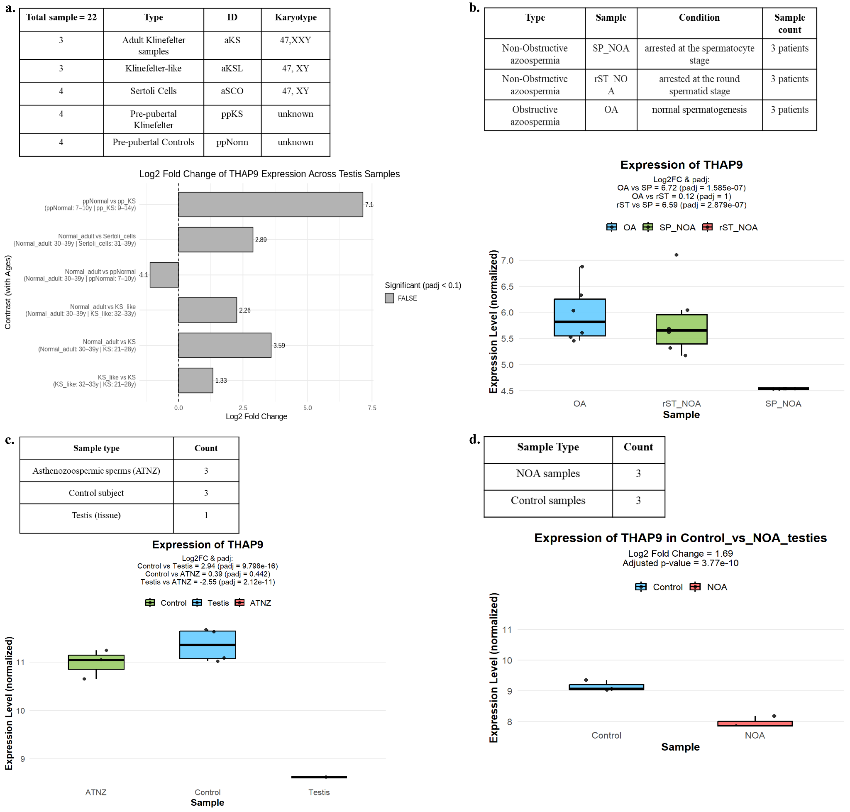
Supplementary Figure 3: Differential expression analysis of THAP9 across various human testicular and spermatogenic conditions. Panels show THAP9 transcript levels across multiple independent human testicular and sperm datasets, comparing normal tissue/cell types to those diagnosed with impaired spermatogenesis. (a) Comparison of THAP9 expression across testicular samples representing different karyotypes and developmental stages. The study included 22 total samples comprising adult Klinefelter samples (aKS, 47, XXY), Klinefelter-like samples (aKSL, 47, XY), Sertoli cell samples (aSCO, 47, XY), pre-pubertal Klinefelter samples (ppKS, karyotype unknown), and pre-pubertal control samples (ppNorm, karyotype unknown) (GSE103905; [33]). Bars represent Log2 fold change relative to adult Klinefelter samples; significance indicated for adjusted padj < 0.1. (b) THAP9 expression levels in patients with non-obstructive azoospermia (NOA) arrested at the spermatocyte (SP_NOA) or round spermatid (rST_NOA) stage, and in obstructive azoospermia (OA) with normal spermatogenesis (GSE238078;[34]). Box plots show normalised expression values; THAP9 expression is markedly reduced in SP_NOA relative to rST_NOA and OA samples (log2FC and adjusted p-values indicated). (c) Expression of THAP9 in asthenozoospermic sperm (ATNZ), control sperm, and testis tissue samples (GSE92578; [35]). Box plots indicate normalised expression values (log2FC and adjusted p-values shown). (d) Testicular biopsies from secondary idiopathic non-obstructive azoospermia (NOA) and obstructive azoospermia (OA) were taken as controls (GSE190752; [36]).

