Supplementary Material to: “Using Visual Patient Heart to improve anaesthesia professionals’ ECG Interpretation and Arrhythmia Situation Awareness: A Quantitative Study”

Cynthia A. Hunn†, Max Ebensperger†, Tadzio R. Roche, Arend Rahrisch, Achilles Delis, Florian Piekarski, Florian J. Raimann, Julia Braun, Sayeh Bagheri, Svenja Letz, Gregor Massoth, Kai Zacharowski, David W. Tscholl

† These authors contributed equally to this publication

*Corresponding author: david.tscholl@usz.ch

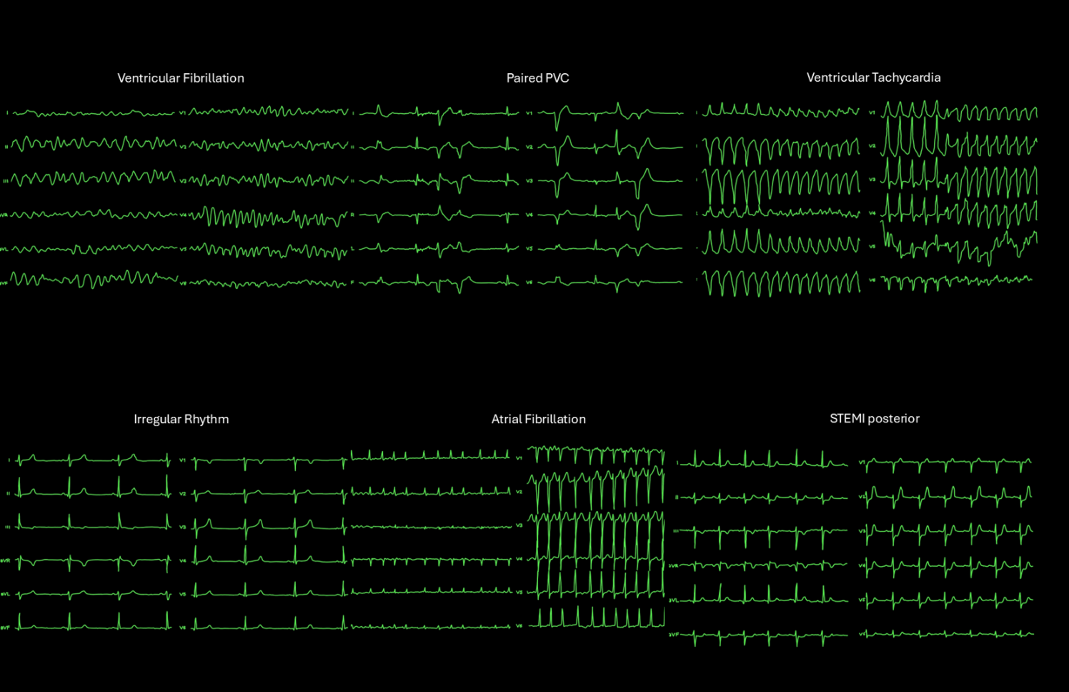Supplementary Figure S1: 12-lead ECG displays created with “procreate” software.
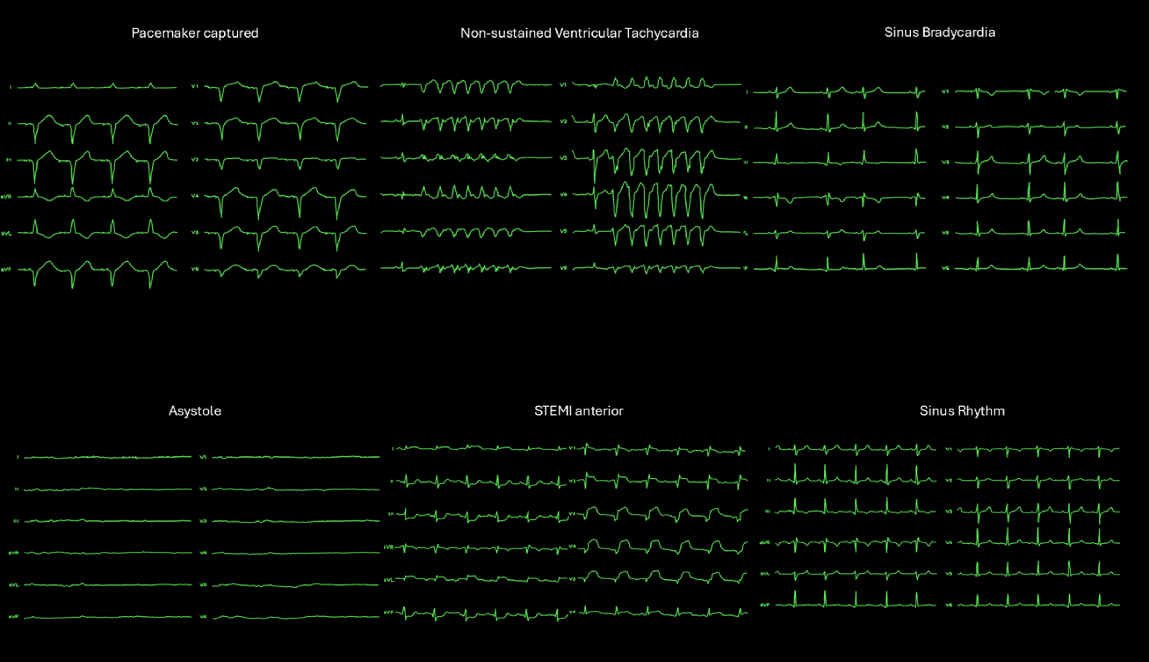Supplementary Figure S2: 12-lead ECG displays created with “procreate” software.
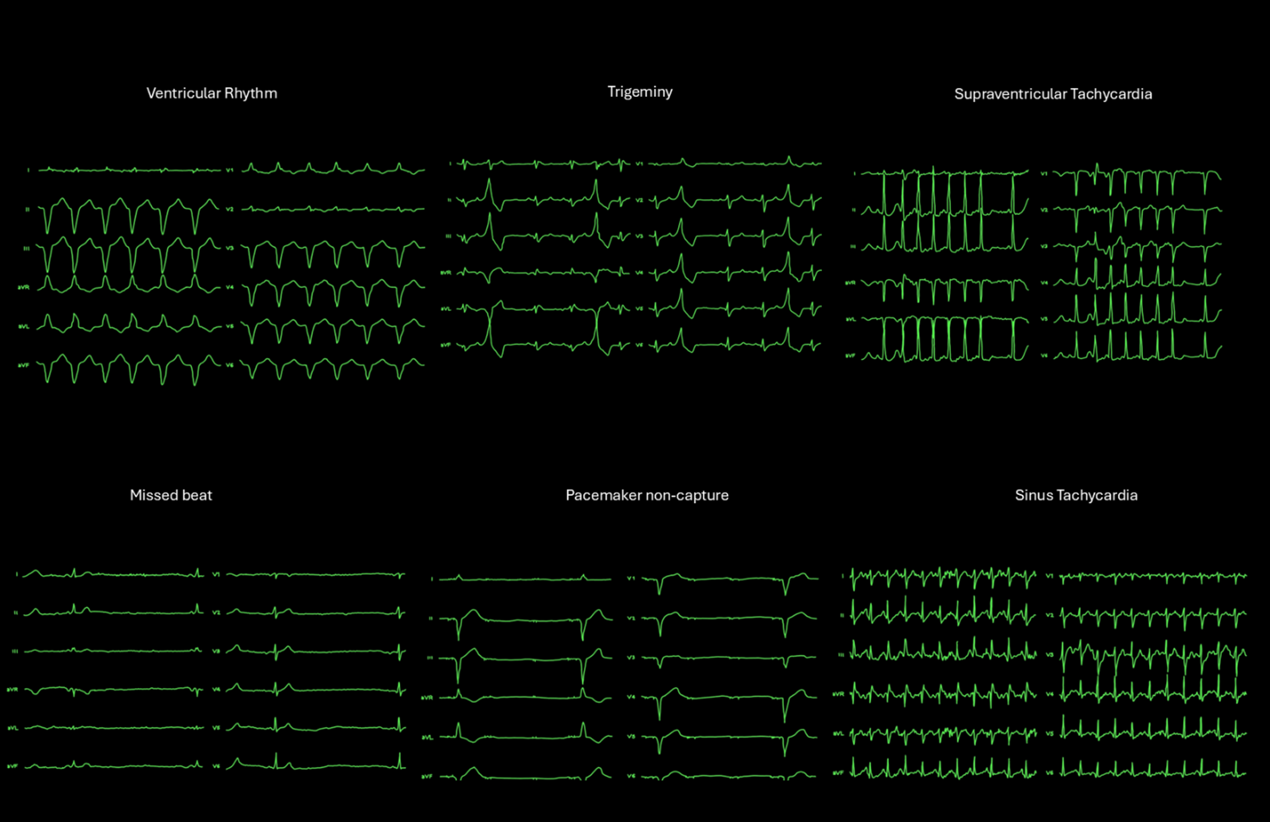Supplementary Figure S3: 12-lead ECG displays created with “procreate” software.

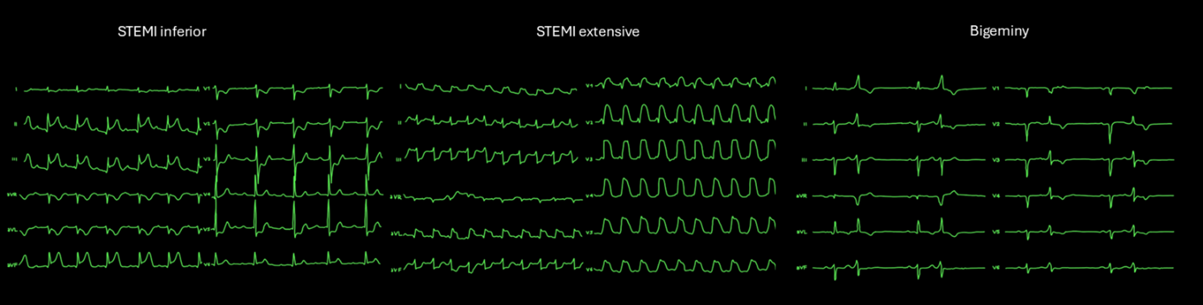
Supplementary Figure S4: 12-lead ECG displays created with “procreate” software.

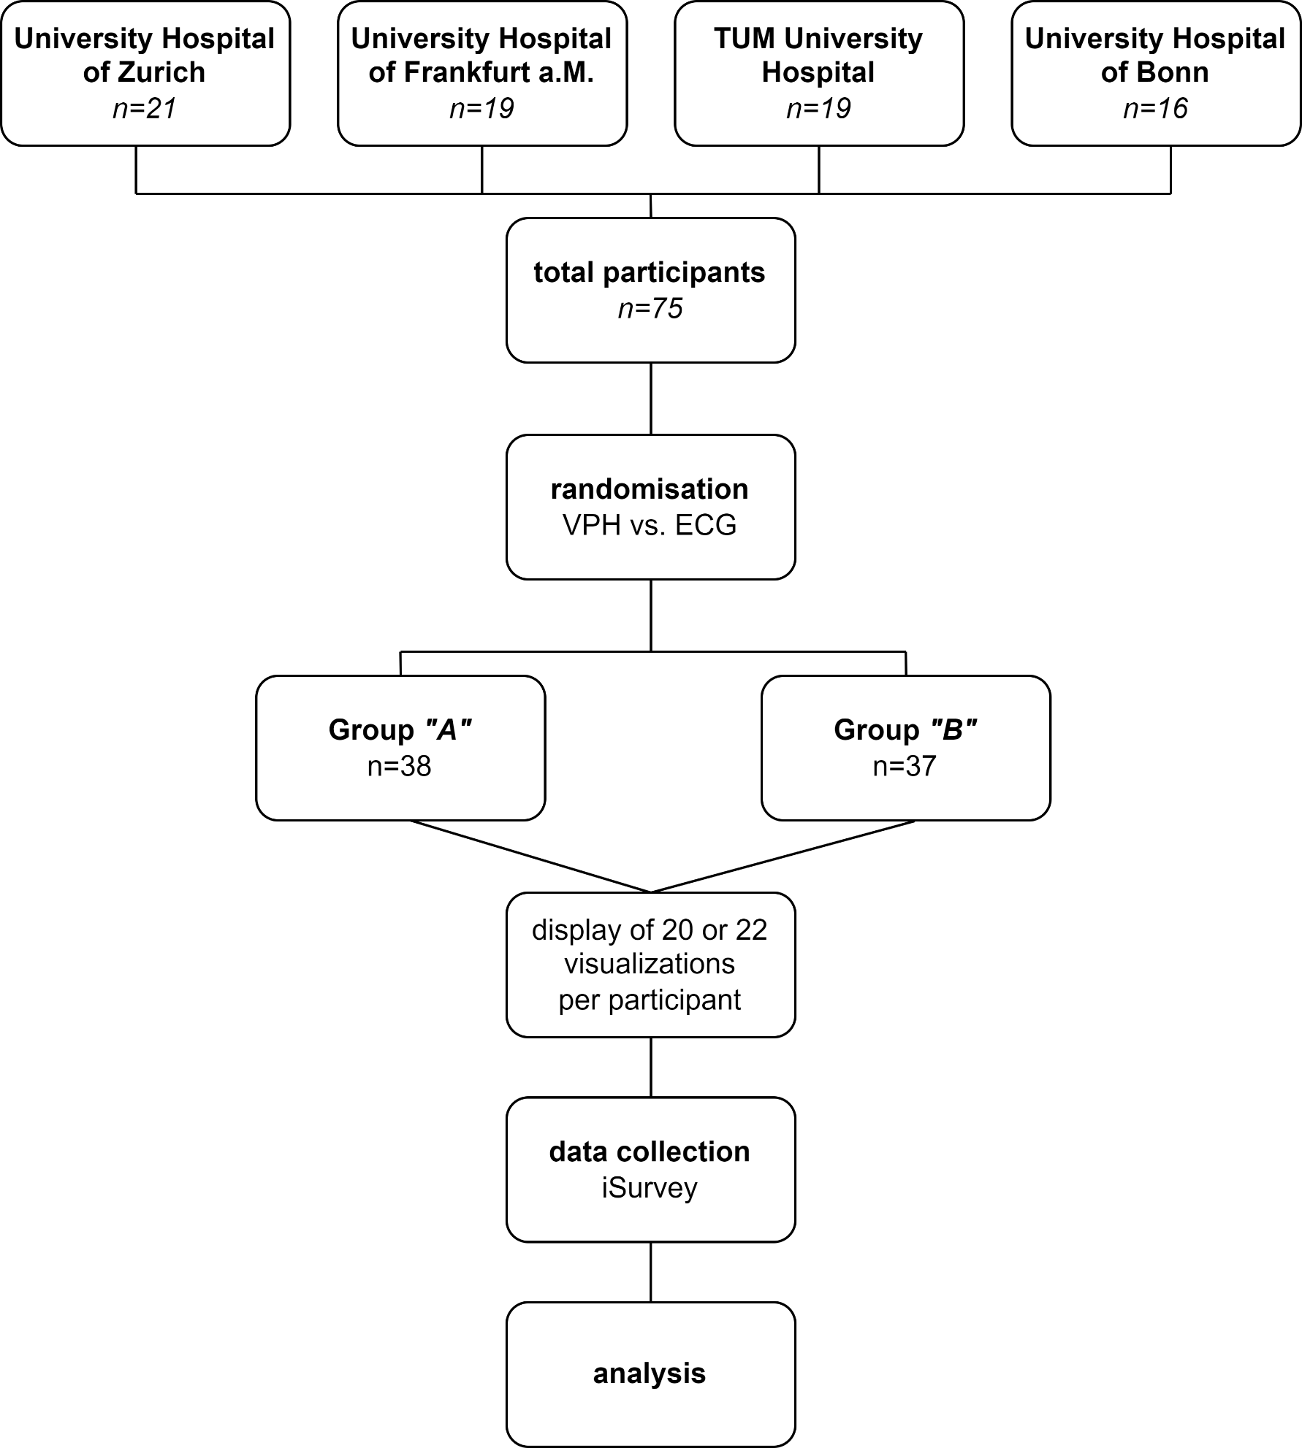
Supplementary Figure S5: Flowchart of Study design

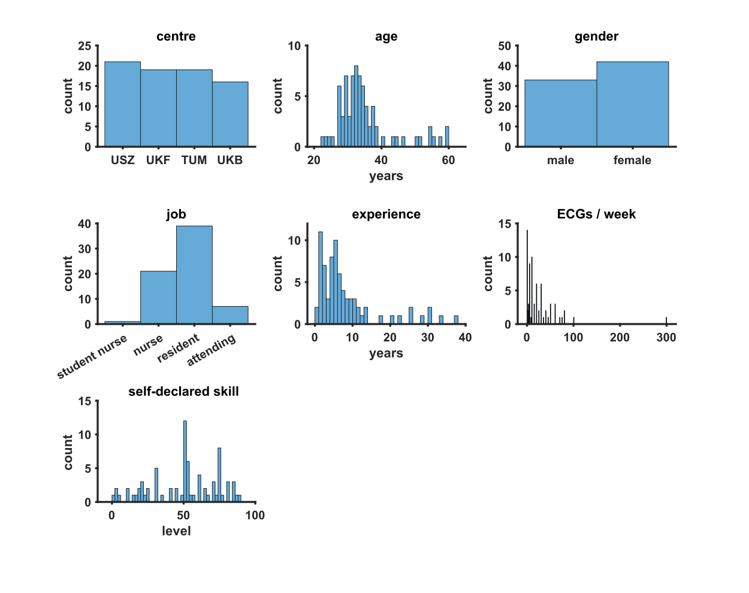
Supplementary Figure S6: Participants' demographics

Correctness (logistic)
 | Odds Ratio | CI upper | CI lower | p-value
Intercept | 0.87 | 0.62 | 1.2 | 0.39
Modality: VPH | 6.06 | 4.79 | 7.66 | <0.001
Order | 0.98 | 0.97 | 1 | 0.08
ECG/week | 1 | 0.99 | 1 | 0.79
Confidence (linear)
 | Coefficient | CI upper | CI lower | p-value
Intercept | 50.51 | 45.86 | 55.17 | <0.001
Modality: VPH | 24.38 | 21.95 | 26.8 | <0.001
Order | 0.23 | 0.004 | 0.42 | 0.002
ECG/week | 0.06 | -0.02 | 0.15 | 0.15
NASA-TLX (linear)
 | Coefficient | CI upper | CI lower | p-value
Intercept | 55.05 | 51.22 | 58.88 | <0.001
Modality: VPH | -25.5 | -27.34 | -23.66 | <0.001
Order | -0.11 | -0.25 | 0.03 | 0.14
ECG/week | -0.06 | -0.13 | 0.001 | 0.13
Supplementary Table 1: Results of mixed logistic and linear models (CI: confidence interval)

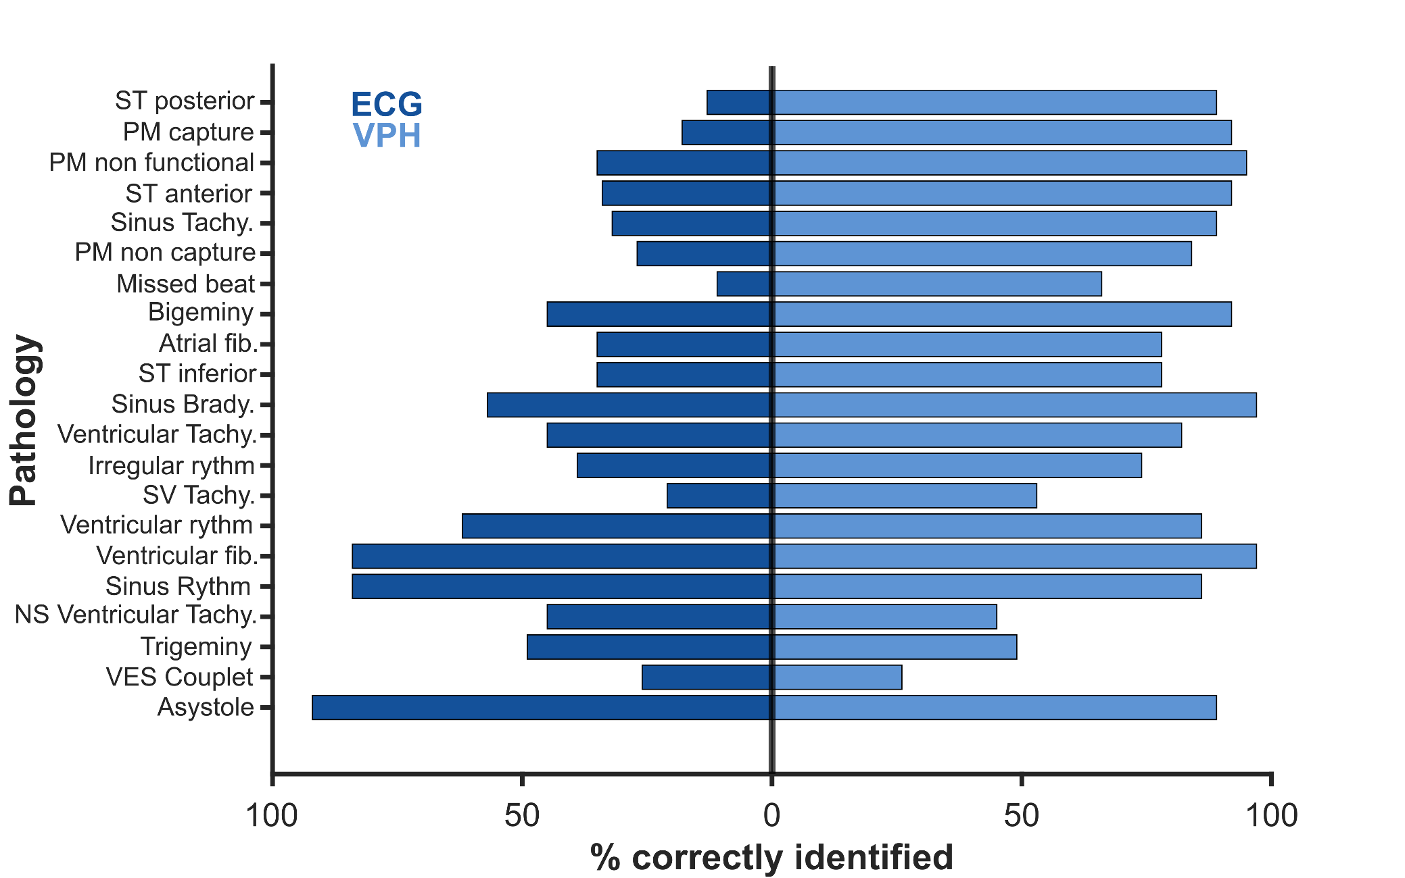
Supplementary Figure S7: Bar chart indicates the difference in percentage of correctly identified pathologies for Visual Patient Heart (VPH) minus 12-lead ECG.
The pathologies are ranked with descending differences in the percentages, i.e., the top pathology shows the highest superiority for correctness of VPH.

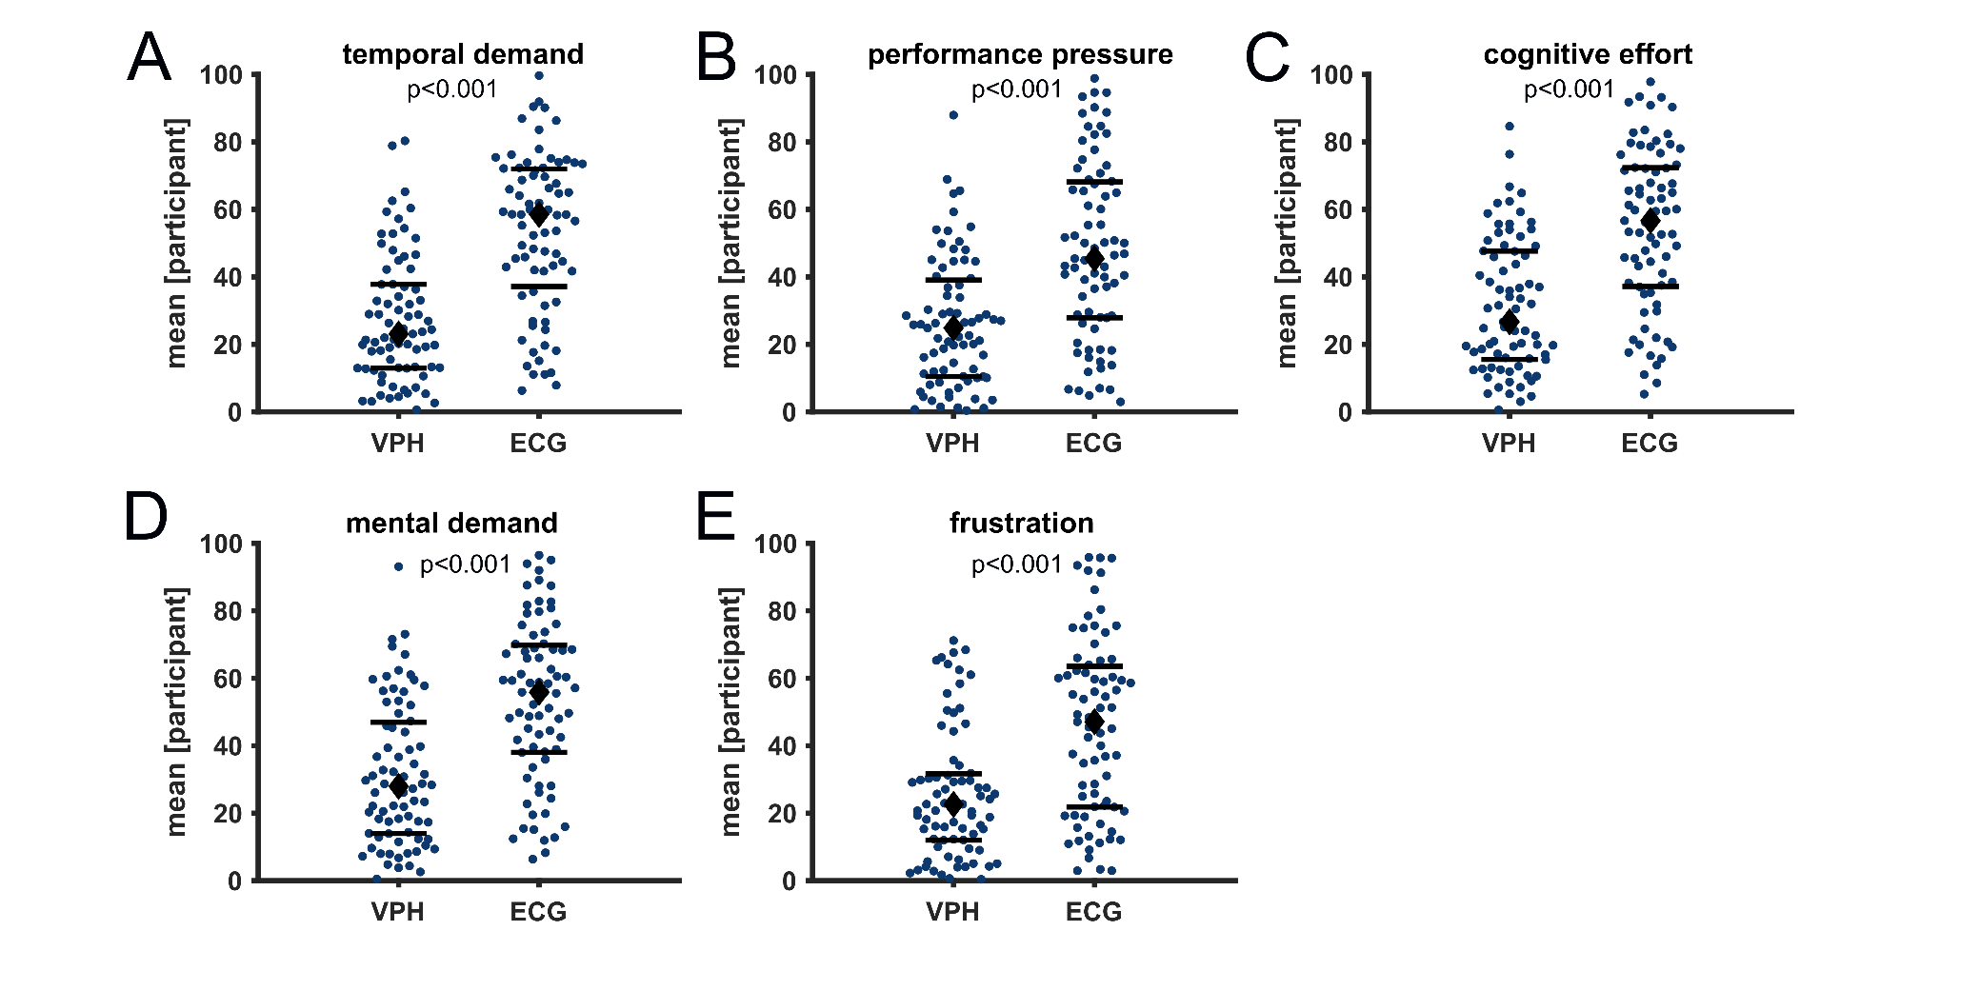
Supplementary Figure S8: Scatter Plots of secondary outcomes of the NASA-TLX questionnaire.

