Table 1. Observation result of Joglo Juwana
Code | House plan |  | Initial Room Layout | Number of Changed Rooms | Changed Rooms
A | 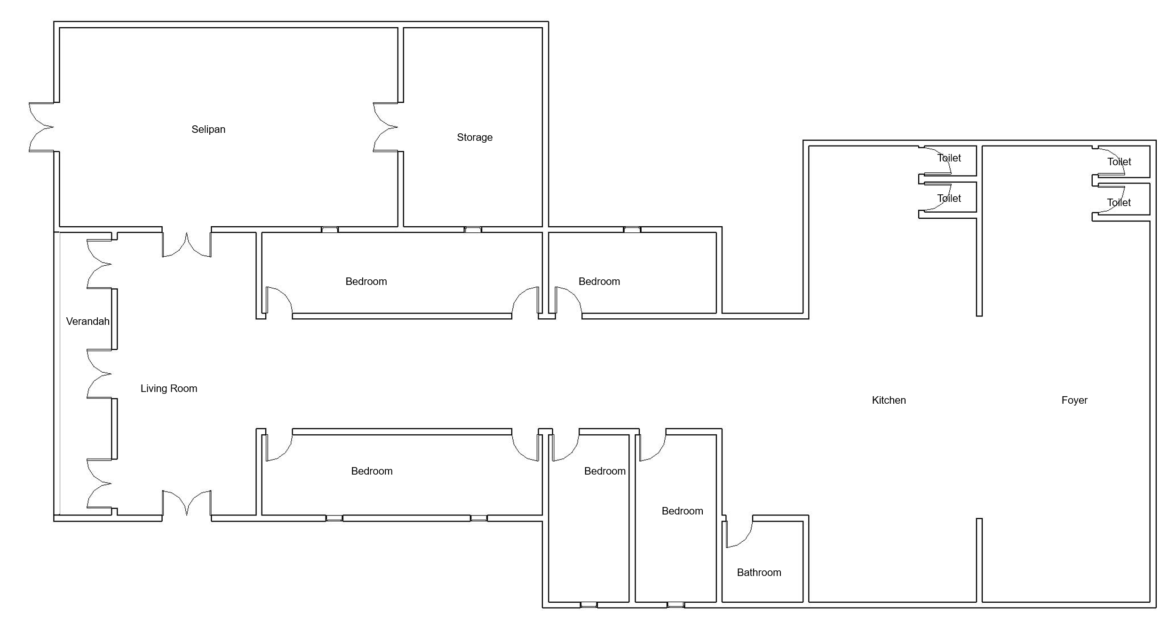 | foyer, 4 toilet, kitchen, bathroom, 4 bedrroms, storage, selapan (paddy processing room), living room, verandah. | Living room; Bedroom; Service area | 2 | Bedroom
B | 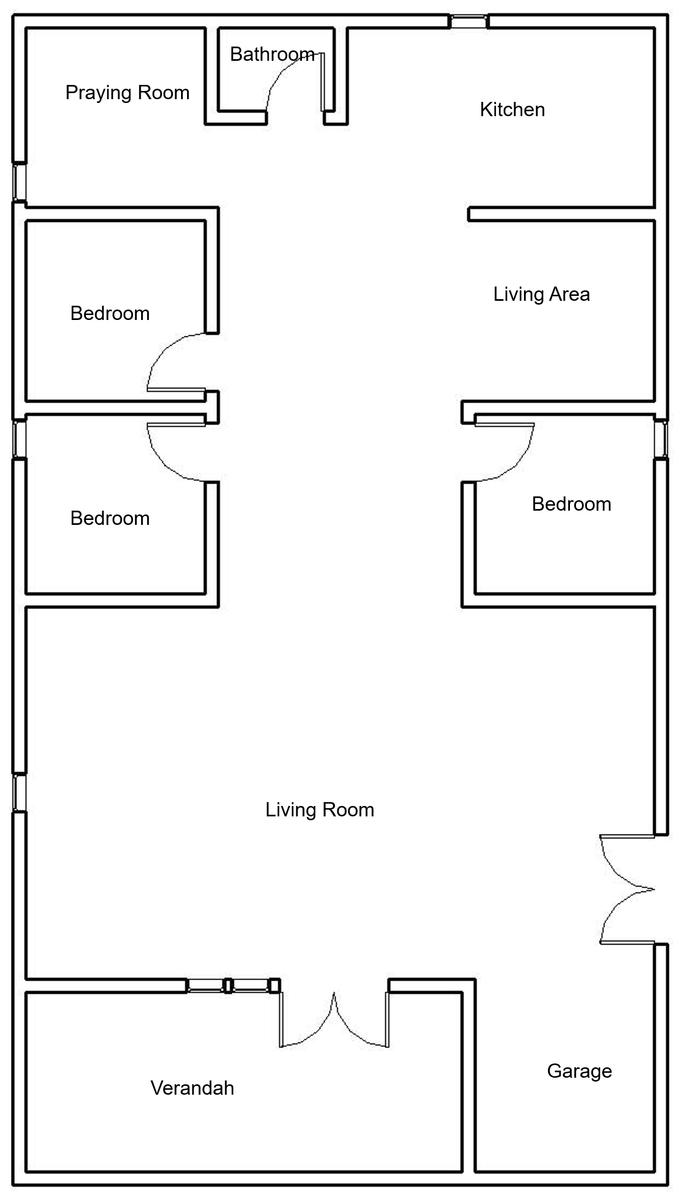 | verandah, garage, living room, 3 bedrooms, family room, kitchen, praying room, bathroom, toilet. | Living room; Bedroom; Service area | 1 | Back of the house
C | 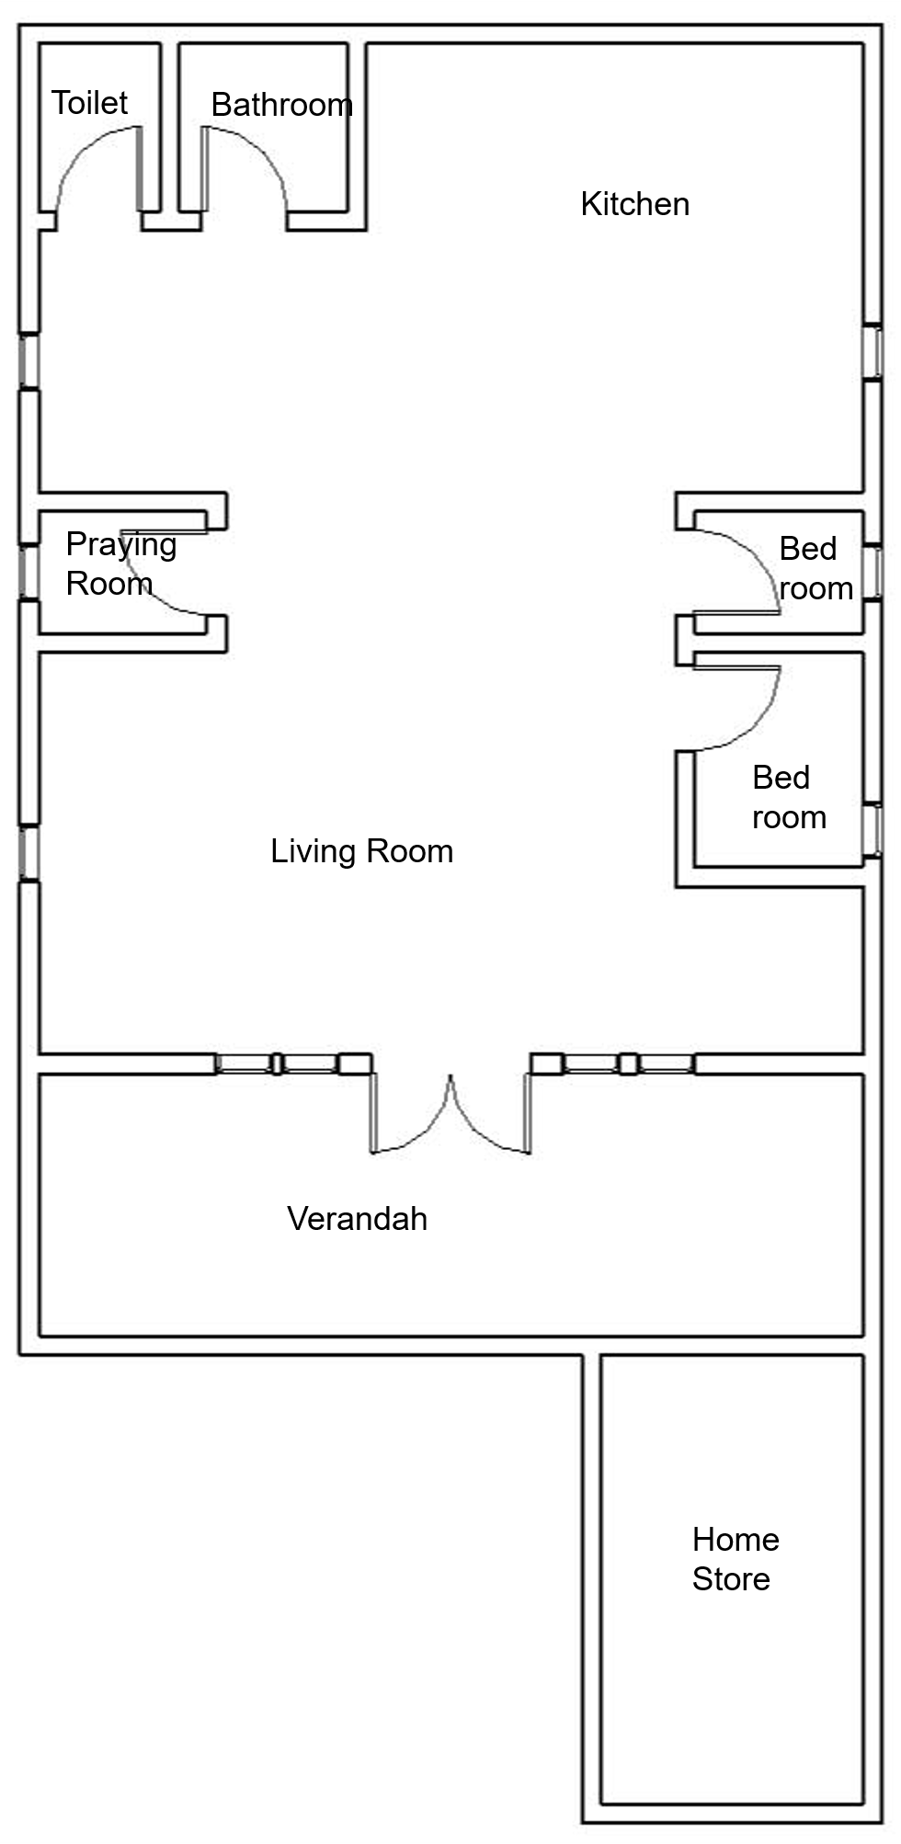 | verandah, homestore, living room, kitche, 3 bedrooms, bathroom, toilet, praying room. | Living room; Bedroom | 2 | -
D | 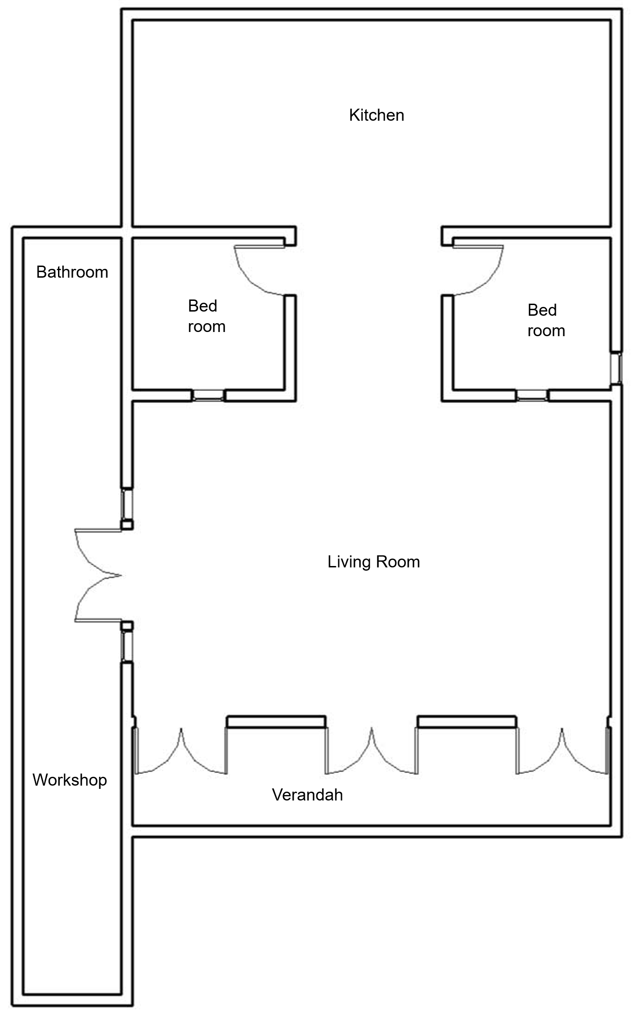 | verandah, living room, workshop, bathroom, 2 bedroom, kitchen, toilet & bathroom | Living room; Bedroom; Service area (toilet & bathroom) | 4 | -
E | 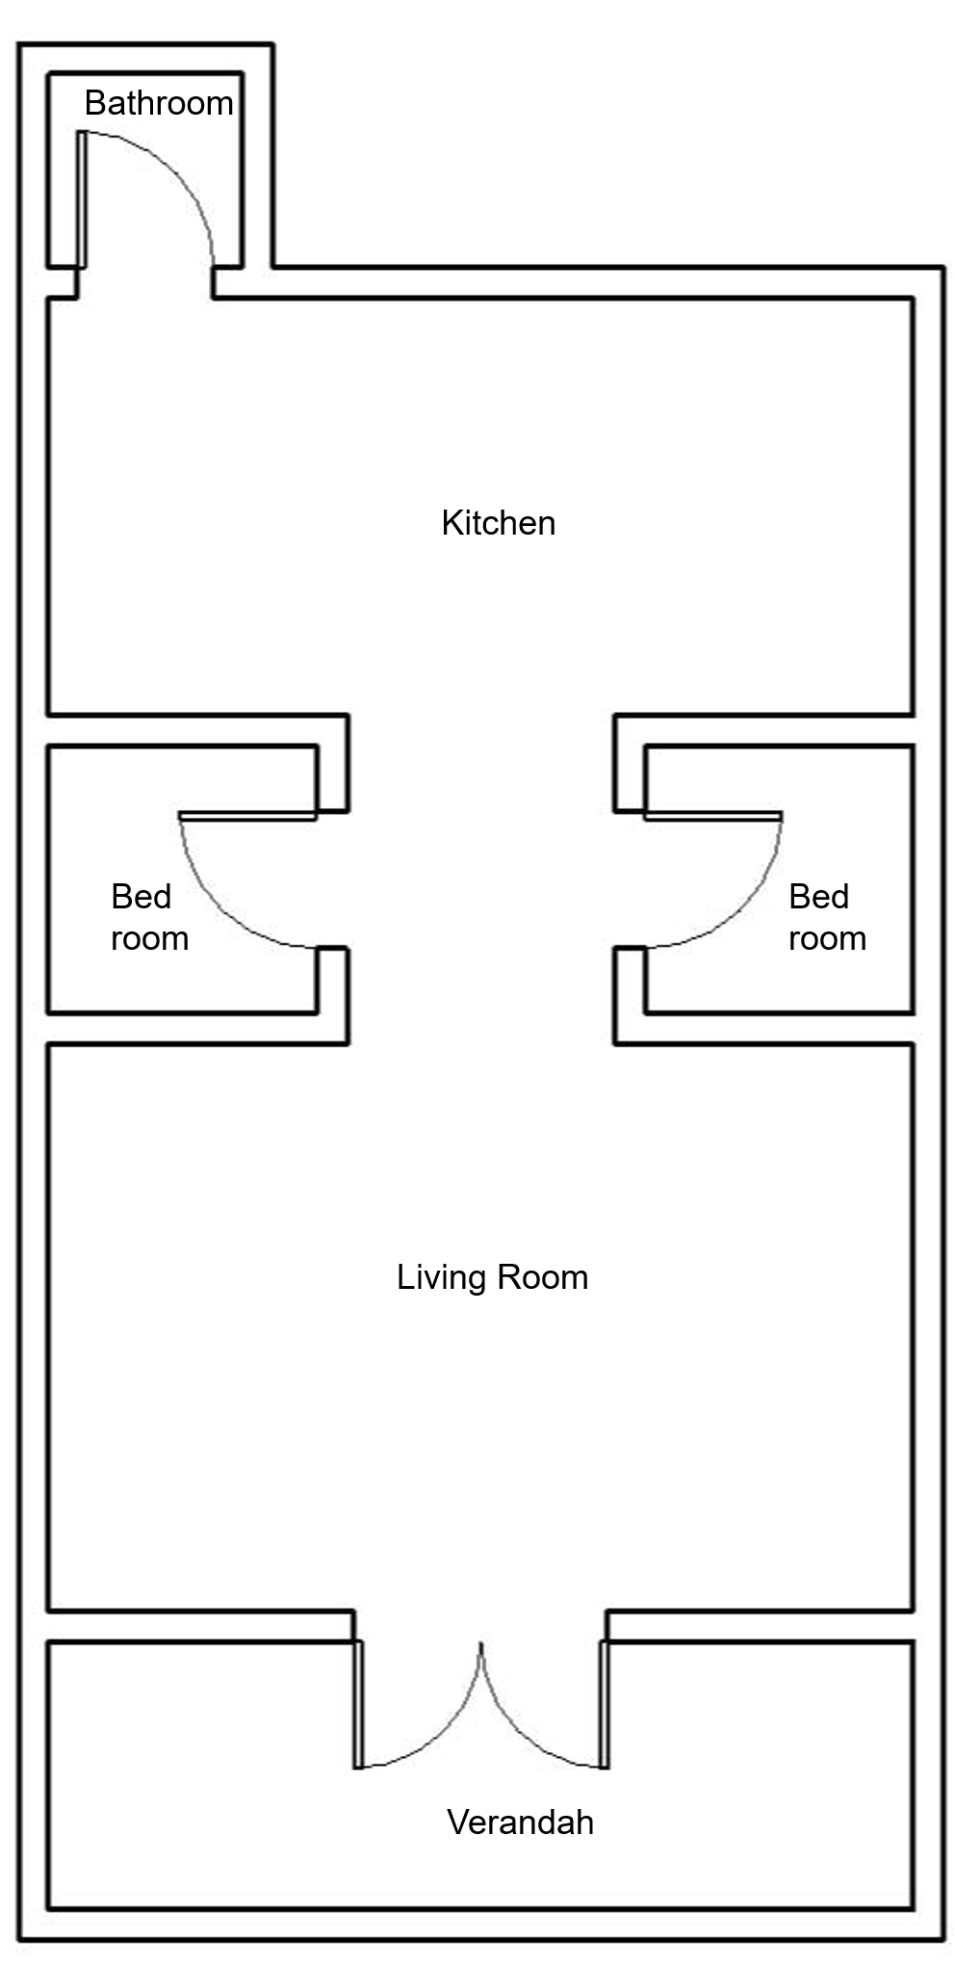 | verandah, living room, workshop, bathroom, 2 bedroom, kitchen, toilet & bathroom | Living room; Bedroom; Service area | 3 | -
F | 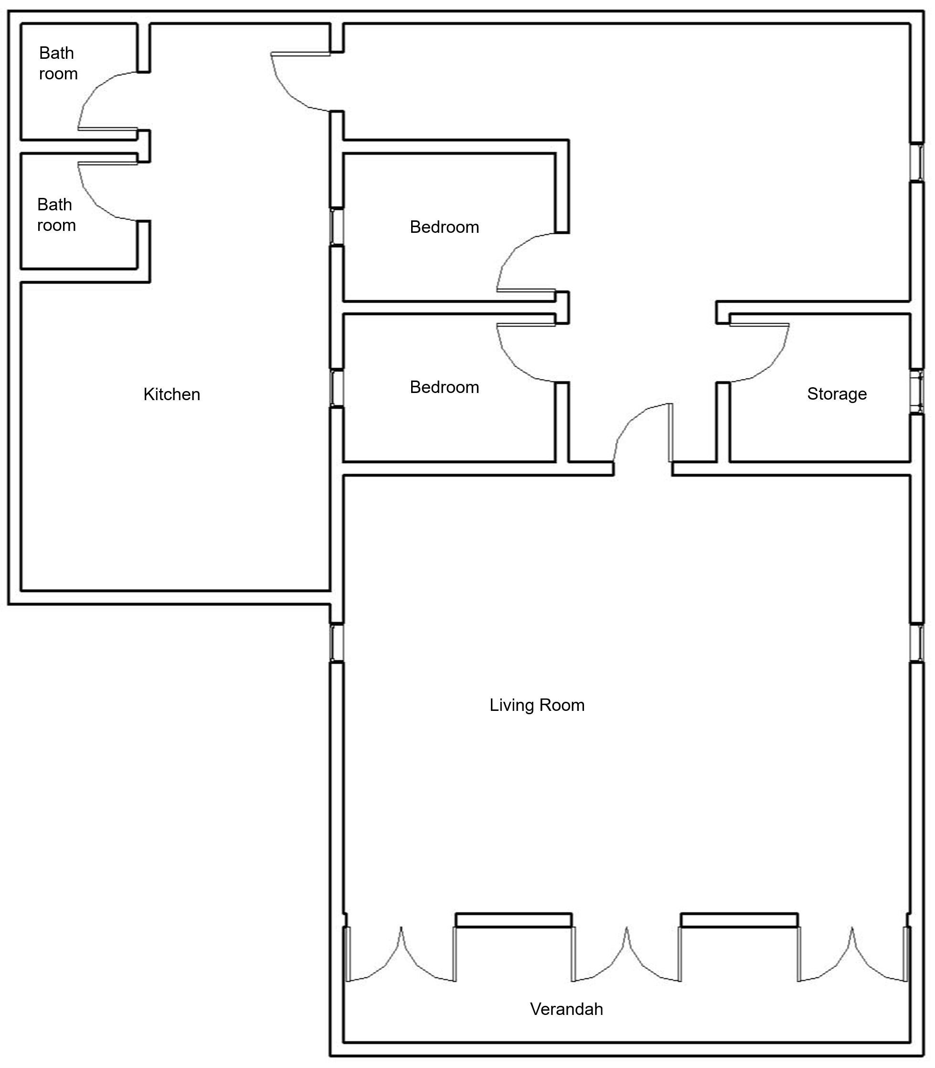 | verandah, living room, 2 bedroom, storage, kitchen, bathroom, toilet. | Living room; Bedroom; Service area | -2 | Bedroom
G | 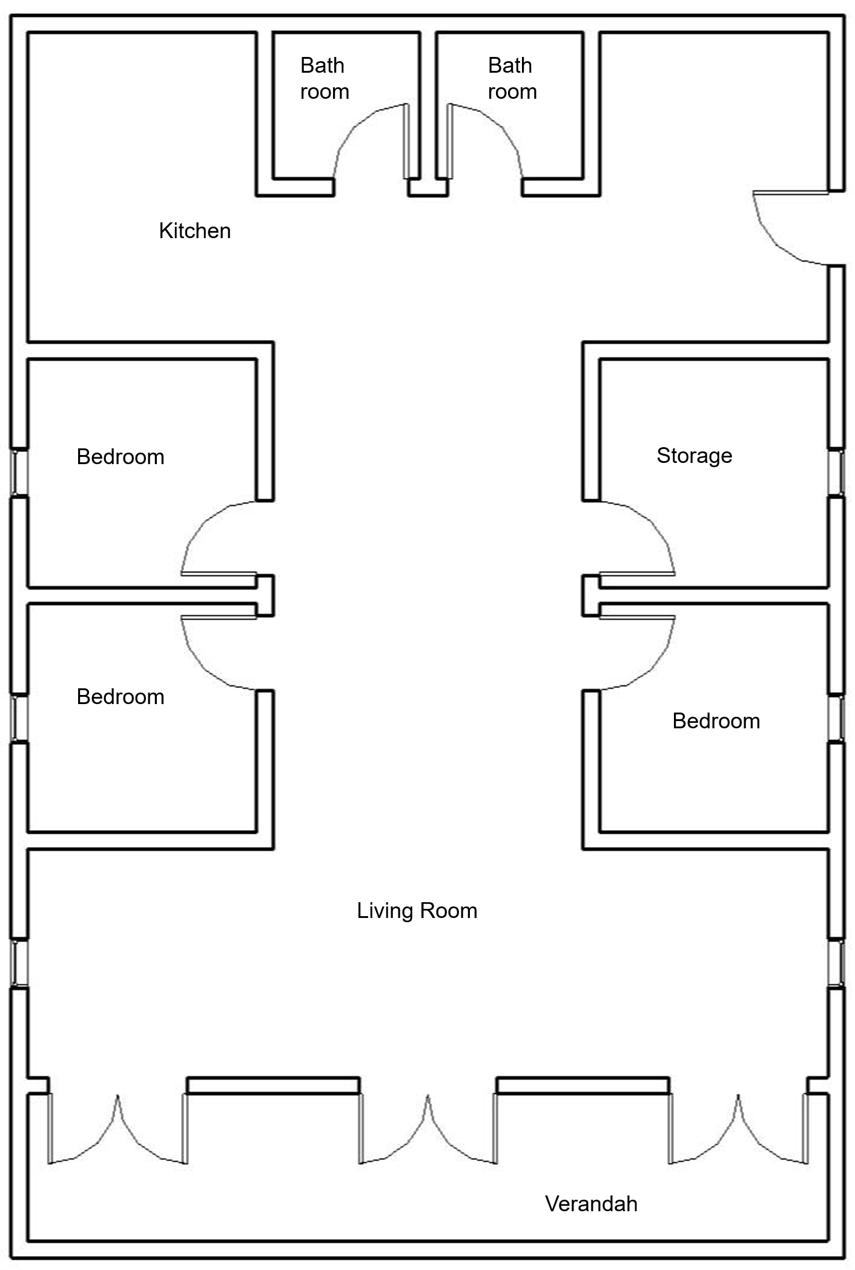 | : verandah, living room, 3 bedroom, storage, kitchen, bathroom, toilet. | Living room; Bedroom; Service area | 3 | Addition of bedrooms and prayer room
H | 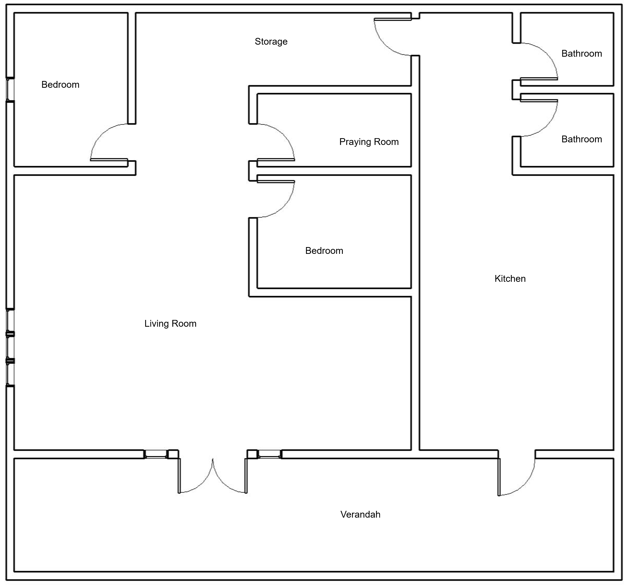 | verandah, living room, 2 bedroom, storage, praying room, kitchen, bathroom, toilet. | - | 2 | Existing
I | 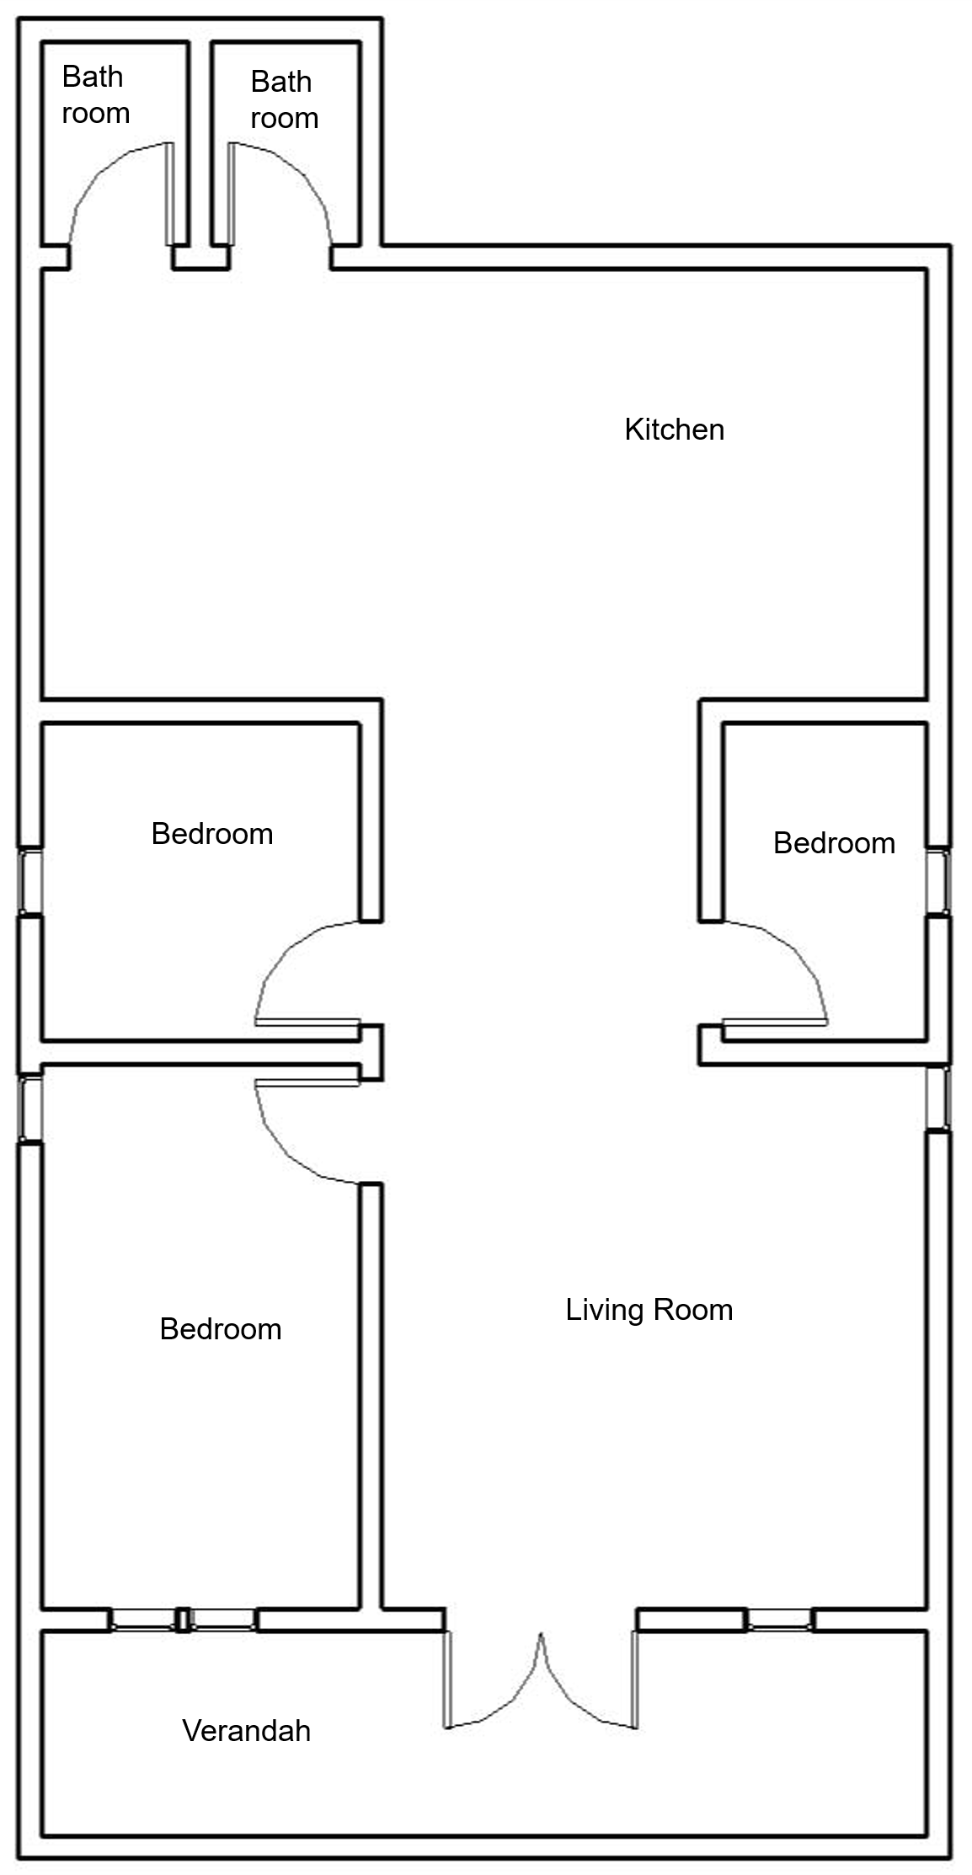 | verandah, living room, 3 bedroom, kitchen, bathroom, toilet | - | 1 | Back area
J | 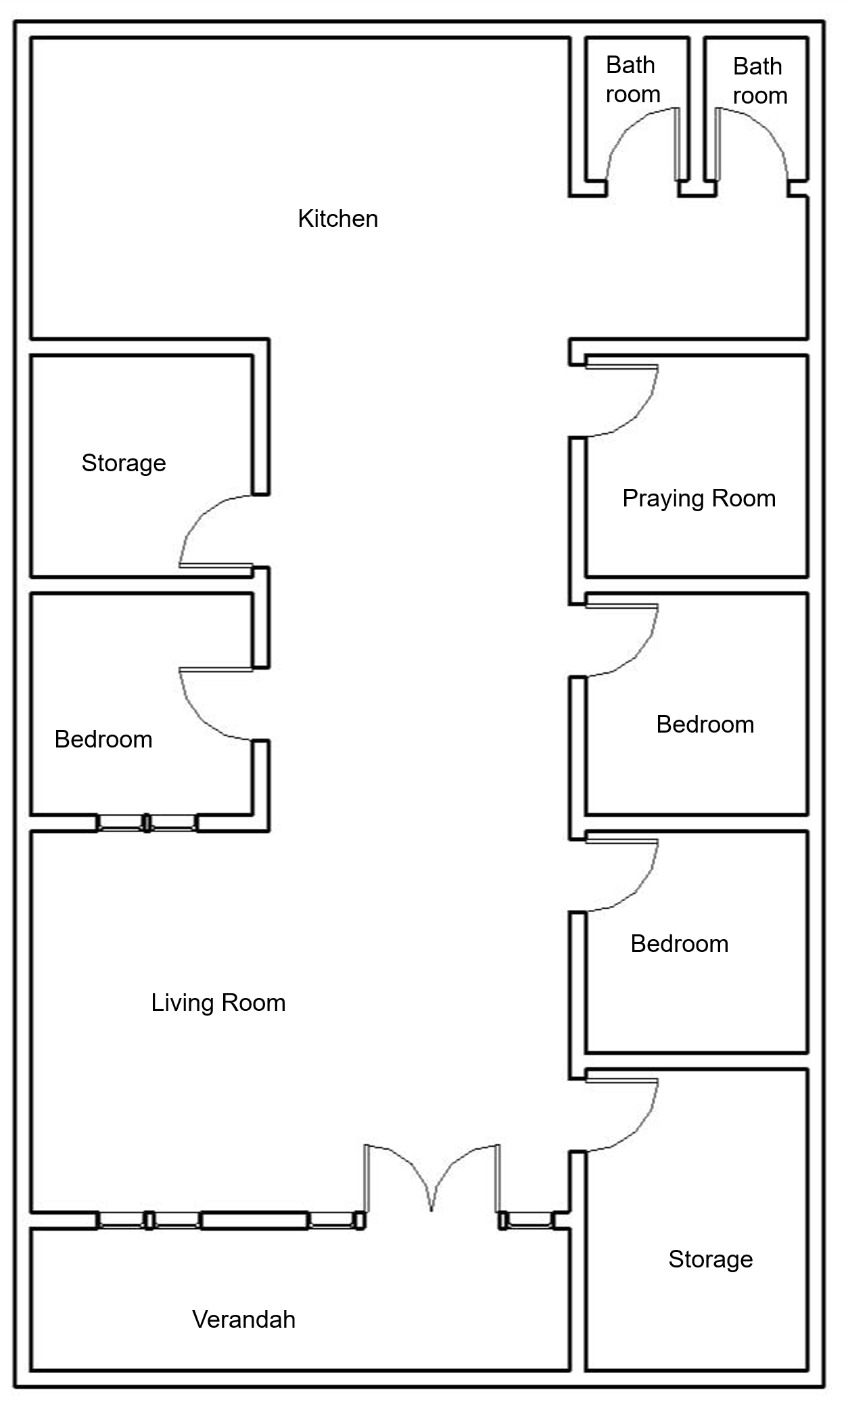 | verandah, living room, 3 bedroom, 2 storage, praying room, kitchen, bathroom, toilet. | Living room; Bedroom | 2 | Addition of kitchen and bathroom
K | 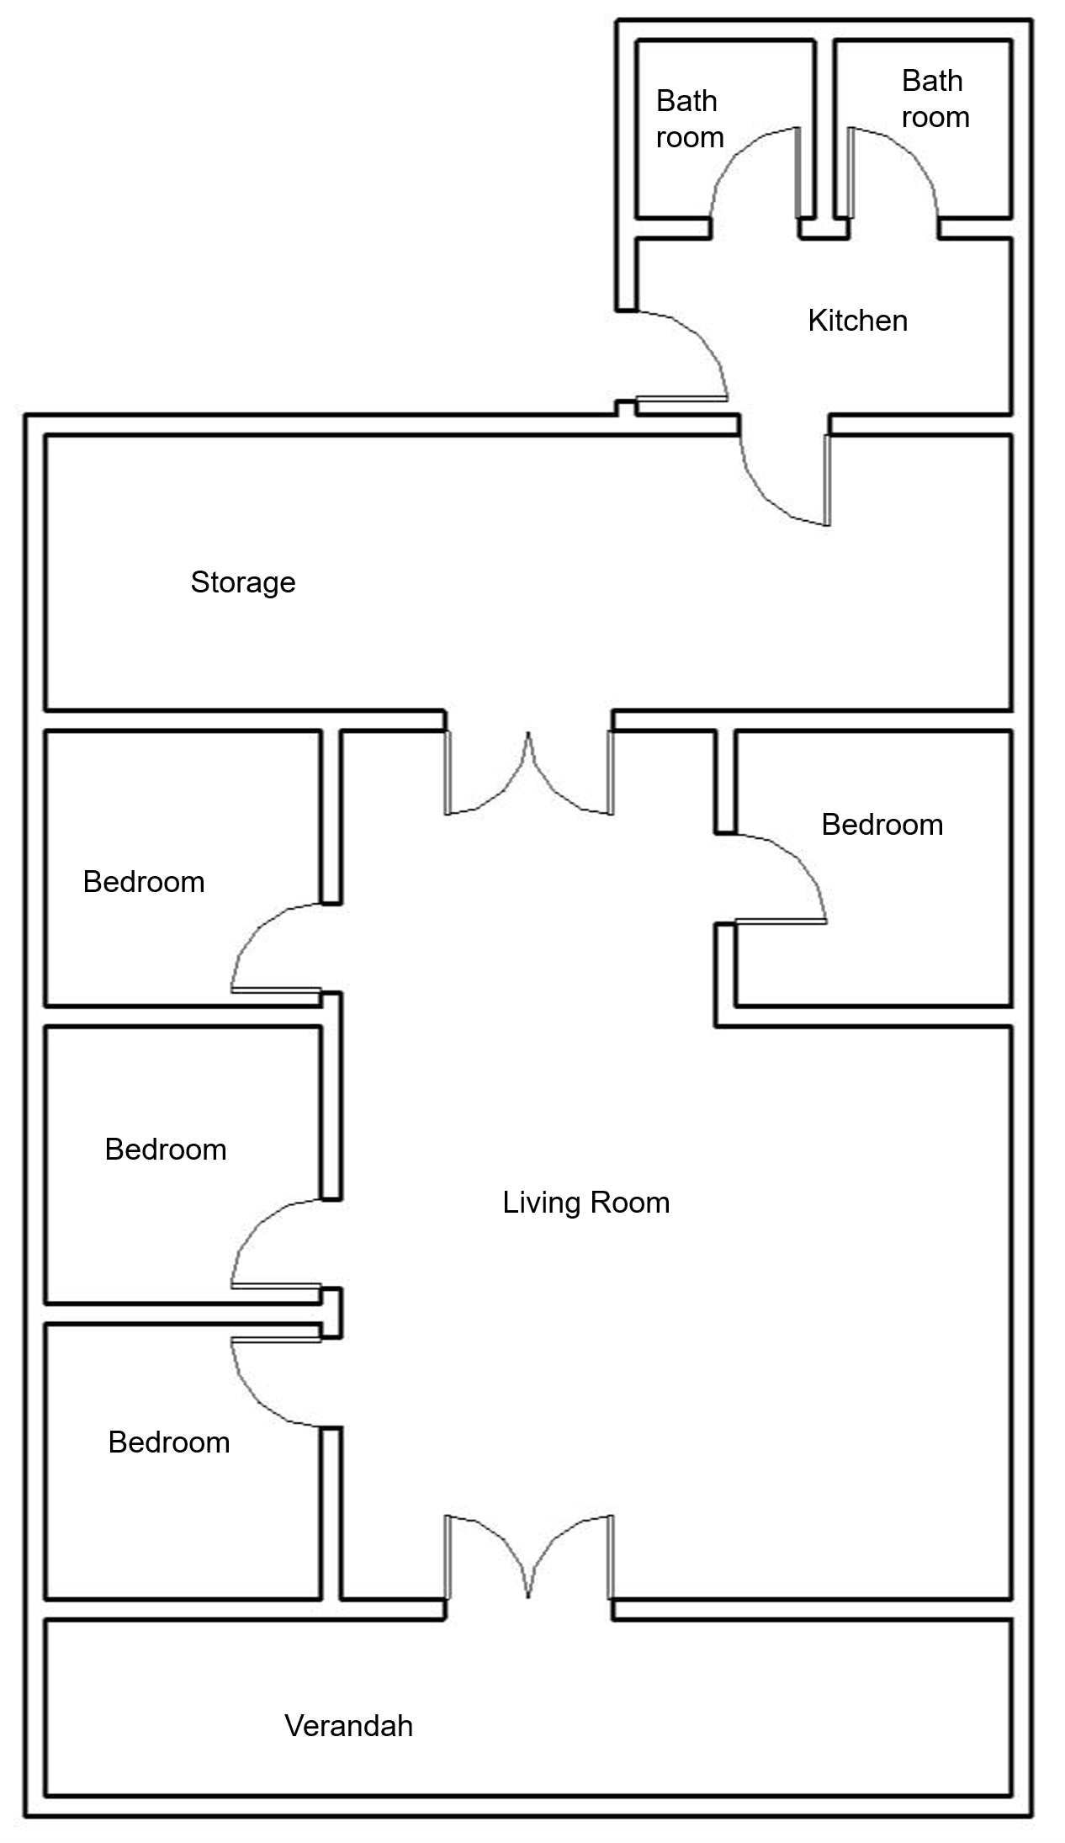 | verandah, living room, 4 bedroom, storage, kitchen, bathroom, toilet. | Living room; Bedroom | 2 | None
L | 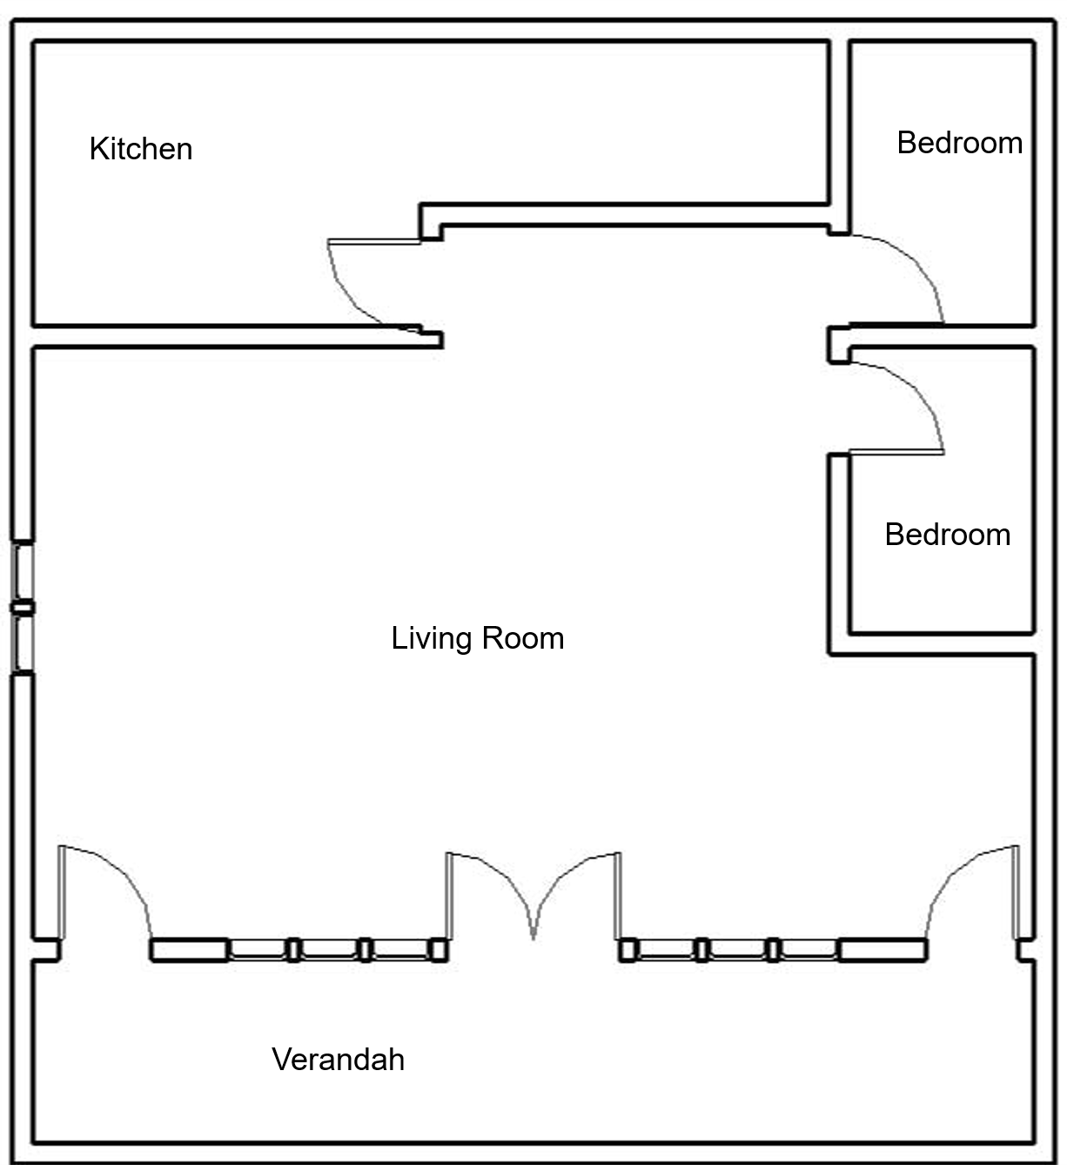 | verandah, living room, 2 bedroom, kitchen, bathroom, toilet. | Living room; Bedroom | 2 | Addition of kitchen and bathroom
M | 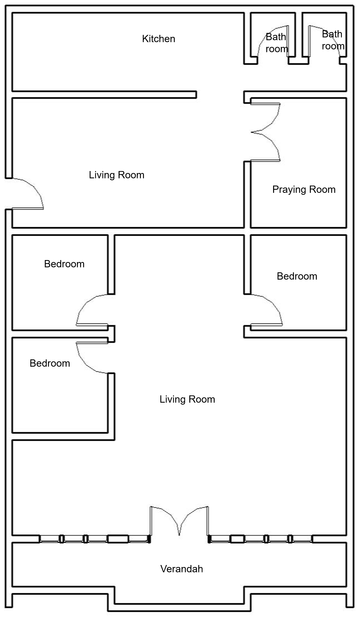 | verandah, living room, family room, 3 bedroom, storage, praying room, kitchen, bathroom, toilet. | Living room; Bedroom; Service area | 2 | Living room, Family room
N |  | verandah, living room, 4 bedroom, praying room, kitchen, bathroom, toilet. | Living room; Bedroom | 1 | Bedroom
O | 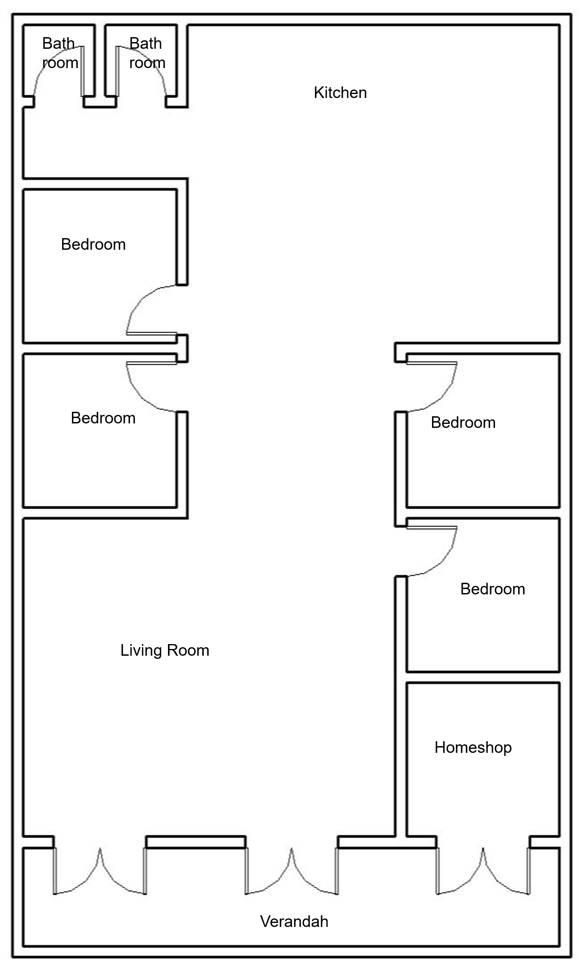 | verandah, living room, 4 bedroom, home storage, kitchen, bathroom, toilet. | Living room; Bedroom | 2 | Bedroom and Commercial space (shop)

