Isolation and Molecular characterization of a Novel Bacteriophage SVV09-A: Targeted to Staphylococcus ureilyticus from Diabetic Wounds
Lakshmi Sharvani K.S.¹, Pritam Kanti Guha², Swetha Vallabhaneni², Guru Prasad C²., Vaishnavi R³
Renuka Pallem⁴., Krishna Vamsi M⁴., Vijaya Lakshmi D¹., Vijaya Raghava Prasad D¹.

Supplementary figures:

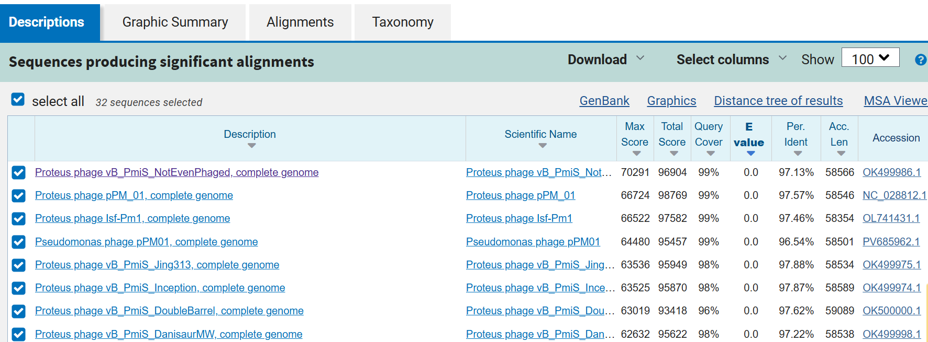
Fig S1: Blast search against the Staphylococcus ureilyticus SVV09-A phage genome
Fig S2: Multiple sequence alignment results of Staphylococcus ureilyticus SVV09-A phage sequence

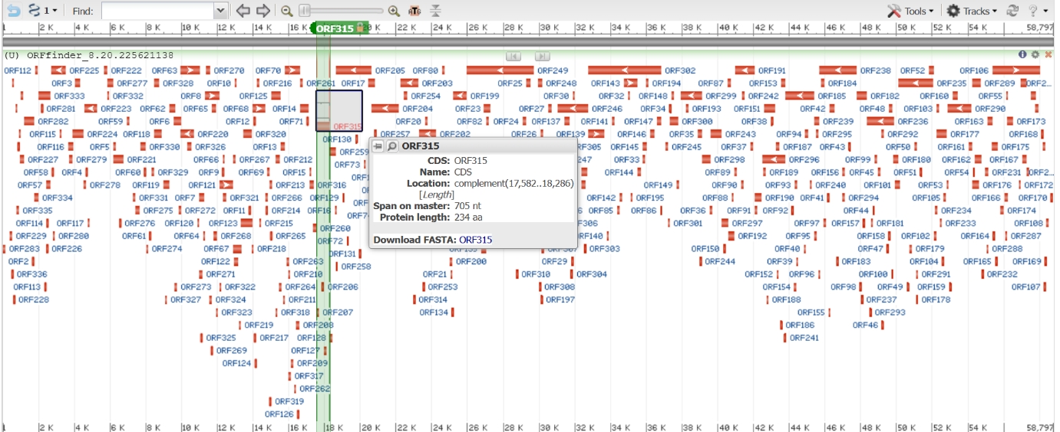
Fig S3: A total of 336 potential ORF’s found from the SVV09-A Phage whole genome
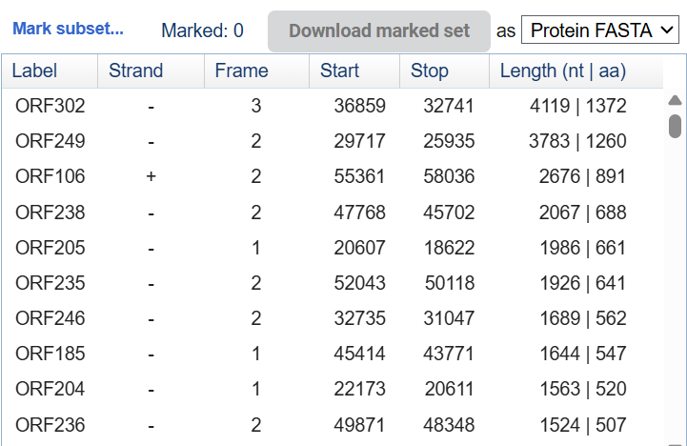
Fig : S4 ORF table
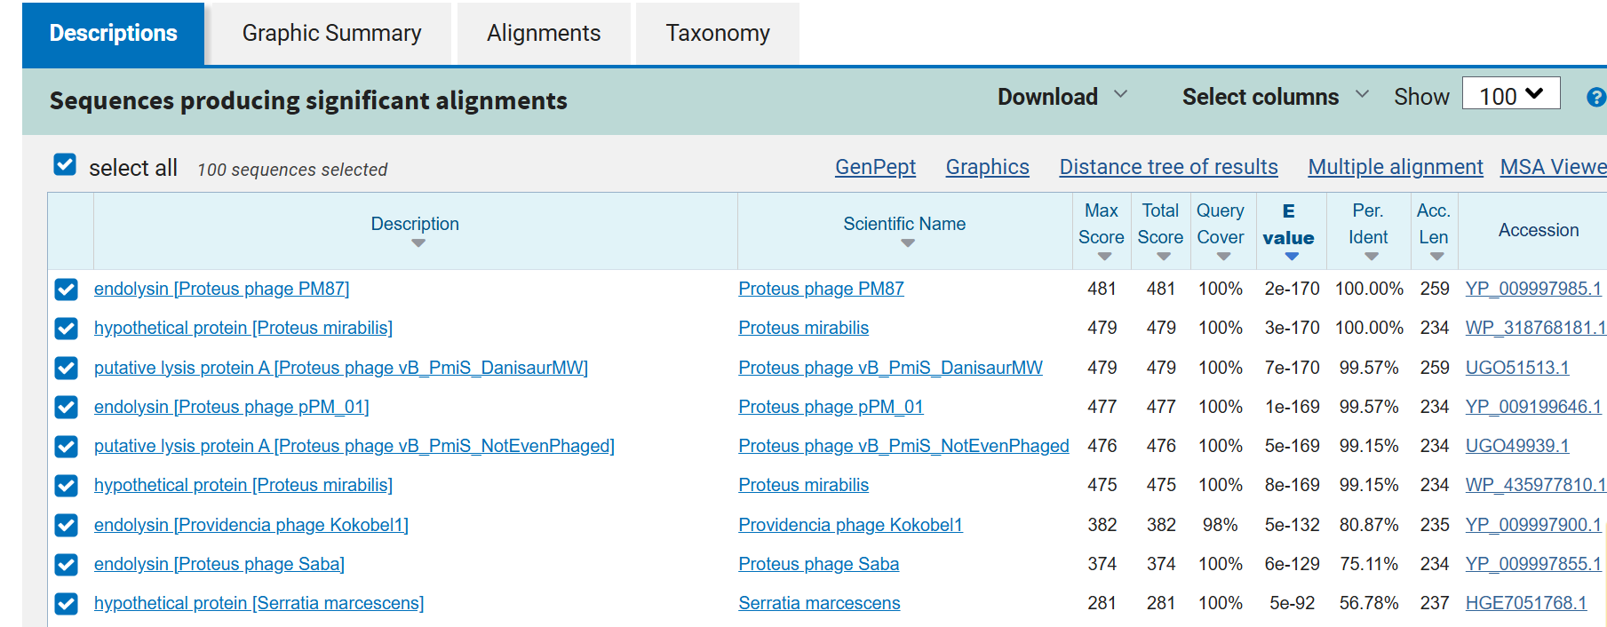Fig S5: The protein showed the greatest similarity to the amino acid sequence of endolysin from Proteus phage PM87, displaying 100% identity.
Gene of Interest with maximum hit

Divergence observed in MSA

Fig S6: MSA of Putative Endolysin protein with orthologs.

