Supporting information
Repurposing watermelon aerial parts to provide D-sorbitol for plant-specific growth
Xiaoyang Wan^{2,11,12}*, Huixian Cheng^{4,11}, Jiefei Niu^{5,6,7,11}, Shufang Wang⁸, Lanxin Li^{9,10}, Xinwei Wang^{3,12}*, Hongyang Wu^{1,12}*

¹ State Key Laboratory for Quality Ensurance and Sustainable Use of Dao-di Herbs, Institute of Medicinal Plant Development, Chinese Academy of Medical Sciences and Peking Union Medical College, Beijing 100193, China.
² College of Agriculture and Biotechnology, Zhejiang University, Hangzhou 310058, China.
³ College of Agriculture and Forestry, Hebei North University, Zhangjiakou 075000, China.
⁴ College of Economics and Management, China Agricultural University, Beijing 100193, China.
⁵ Research Unit of Molecular Epidemiology, Helmholtz Zentrum München, Neuherberg 85764, Germany.
⁶ Institute of Epidemiology, Helmholtz Zentrum München, Neuherberg 85764, Germany.
⁷ Faculty of Medicine, Ludwig-Maximilians-University München, Munich 81377, Germany.
⁸ State Key Laboratory of Forage Breeding-by-Design and Utilization, Institute of Botany, Chinese Academy of Sciences, Beijing 100093, China.
⁹ Frontiers Science Center for Molecular Design Breeding (MOE), China Agricultural University, Beijing, China.
¹⁰ Beijing Key Laboratory of Development and Quality Control of Ornamental Crops, Department of Ornamental Horticulture, College of Horticulture, China Agricultural University, Beijing, China.
¹¹ These authors contributed equally: Xiaoyang Wan, Huixian Cheng, Jiefei Niu
¹² These authors jointly supervised this work: Xiaoyang Wan, Xinwei Wang, Hongyang Wu

*Corresponding author at: State Key Laboratory for Quality Ensurance and Sustainable Use of Dao-di Herbs, Institute of Medicinal Plant Development, Chinese Academy of Medical Sciences and Peking Union Medical College, Beijing 100193, P.R. China. E-mail address: Hongyang Wu (wuhongyang0829@foxmail.com), Xinwei Wang (wangxw@hebeinu.edu.cn) Xiaoyang Wan (wanxiaoyang_w@163.com)

Content
Extended Data Fig. 1 Global watermelon cultivation scale and survey site distribution 3
Extended Data Fig. 2 Demographic characteristics and basic cultivation practices in the watermelon industry 5
Extended Data Fig. 3 Survey on continuous cropping obstacles in watermelon cultivation 7
Extended Data Fig. 4 Survey on watermelon aerial parts disposal practices 8
Extended Data Fig. 5 LP-WCFS1 is the dominant bacterial group in the LP-WCFS1-mediated rapid fermentation system 9
Extended Data Fig. 6 The microbial community and functions in the LP-WCFS1-mediated rapid fermentation system are superior to those in the long-term fermentation system 11
Extended Data Fig. 7 Long-term fermentation mediated by LP-WCFS1 leads to the specific accumulation of metabolites in pathways cinnamic acids and derivatives and coumarins and derivatives in the fermentation liquid 13
Extended Data Fig. 8 In both LP-WCFS1-mediated rapid and long-term fermentation systems, LP-WCFS1 correlates with differential metabolites in the fermentation liquid 15
Extended Data Fig. 9 Foliar application of Lactobacillus plantarum (LP-WCFS1)-mediated rapid fermentation liquid promotes Brassica rapa growth under greenhouse conditions 17
Extended Data Fig. 10 D-sorbitol as the effector component of the fermentation liquid from the LP-WCFS1-mediated rapid fermentation system, promotes the growth of Brassica rapa 18
Extended Data Fig. 11 Foliar application of D-sorbitol promotes Brassica rapa growth 20
Extended Data Fig. 12 D-sorbitol increases the maximum leaf size of Brassica rapa 22
Extended Data Fig. 13 D-sorbitol affects the contents of starch and D-sorbitol without influencing the total sugar content in Brassica rapa leaves 23
Extended Data Fig. 14 D-sorbitol had little effects on mineral element uptake in Brassica rapa leaves 24
Extended Data Fig. 15 D-sorbitol had little effects on chlorophyll content in Brassica rapa leaves 25
Extended Data Fig. 16 D-sorbitol exerts no stress effect on the photosynthetic system in Brassica rapa leaves 26
Extended Data Fig. 17 D-sorbitol does not affect the activity of antioxidant enzymes in Brassica rapa leaves 27
Extended Data Fig. 18 D-sorbitol regulates gene expression in pathways such as carbohydrate metabolism in Brassica rapa leaves 28
Extended Data Fig. 19 D-sorbitol regulates metabolic pathways such as galactose metabolism and ABC transporters in Brassica rapa leaves 29
Extended Data Fig. 20 Foliar application of D-sorbitol has no significant effect on the growth of non-angiosperm plants 30
Extended Data Fig. 21 Foliar application of D-sorbitol specifically regulates the growth of angiosperms 32
Extended Data Fig. 22 Light intensity and D-sorbitol -induced regulation of growth and energy metabolism across plant species 33
Extended Data Fig. 23 Light intensity and D-sorbitol has no significant effect on the growth of multiple model plants 34
Extended Data Fig. 24 Light intensity-sugar specific interaction regulates Brassica rapa growth 35
Extended Data Fig. 25 Light intensity and D-sorbitol induces the upregulation of canonical D-sorbitol-metabolizing enzymes gene expression in Brassica rapa and Lactuca sativa 36
Extended Data Fig. 26 Sequence alignment and structural analysis of canonical D-sorbitol-metabolizing enzymes and their orthologous proteins in angiosperms 37
Extended Data Fig. 27 The LP-WCFS1-mediated rapid fermentation system significantly reduces the abundance of metabolites in the cinnamic acids and derivatives pathway in fresh watermelon aerial parts 39
Extended Data Fig. 28 Returning fermentation residues from the LP-WCFS1-mediated rapid fermentation system to the root zone alleviates the growth inhibition of Brassica rapa compared with returning fresh stems and leaves to the root zone 41
Extended Data Fig. 29 Returning fermentation residues from the LP-WCFS1-mediated rapid fermentation system to the root zone alleviates the inhibition of Zea mays growth and yield compared with returning fresh stems and leaves to the root zone 42
Extended Data Fig. 30 Returning fermentation residues from the LP-WCFS1-mediated rapid fermentation system to the root zone changed the rhizosphere microbial community structure 43
Extended Data Fig. 31 LP-WCFS1 rapid fermentation residues improve the rhizosphere microbial community structure of Chinese cabbage and reduce rhizosphere microbial fermentation functions 45
Extended Data Fig. 32 Metabolite differences between fresh watermelon aerial parts and fermentation residues influence the rhizosphere microbial community 46
Extended Data Fig. 33 Microorganisms in the LP-WCFS1-mediated rapid fermentation system influence the metabolite composition of rapid fermentation residues 47

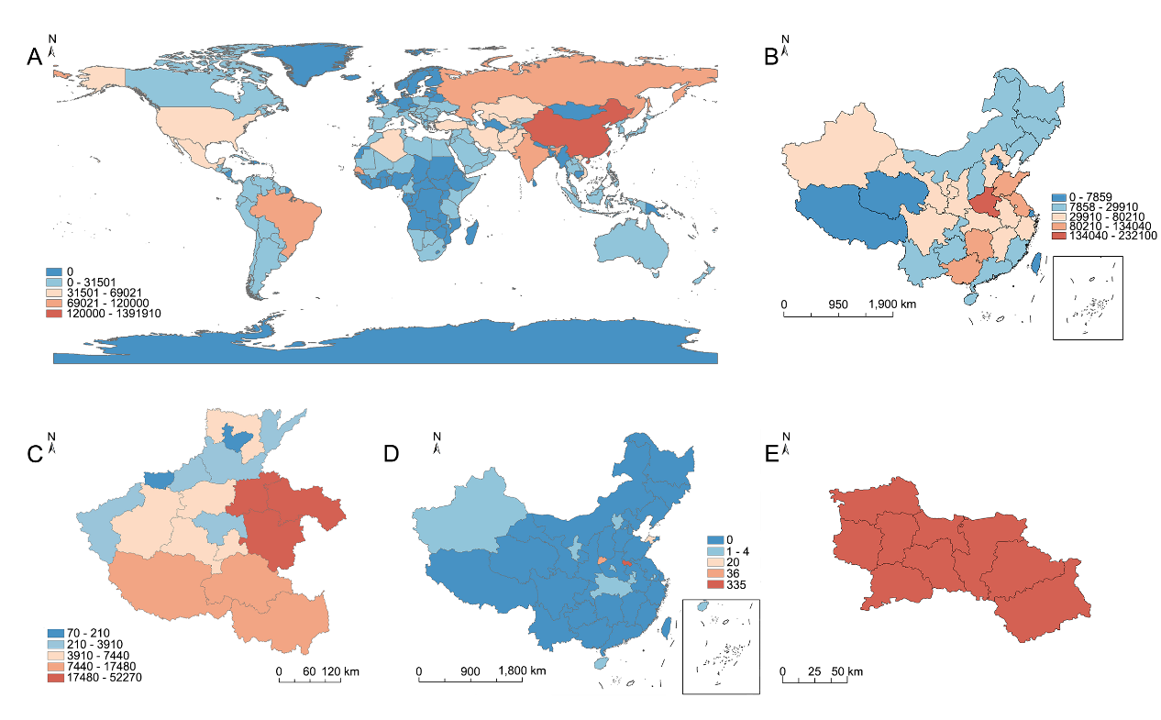

Extended Data Fig. 1 Global watermelon cultivation scale and survey site distribution
A. Global distribution of watermelon-producing regions (2024). China is the world’s leading producer (>60%); color intensity (blue to red) indicates cultivation area ⁽²¹⁾.
B. Distribution of watermelon-producing regions in China (2024). Henan is a representative major producer; color intensity (blue to red) indicates cultivation area ⁽²²⁾.
C. Distribution of watermelon-producing regions in Henan Province (2024). Shangqiu City is a representative major production area ⁽²²⁾; color intensity (blue to red) indicates cultivation area.
D. Survey scale and geographical distribution (n = 406). Primary surveys were conducted in Shangqiu City, Henan Province (>20,000 ha) ⁽²²⁾, a major watermelon-producing area, yielding >300 responses. Color intensity (blue to red) indicates increasing number of questionnaires.
E. Topography of Shangqiu City, Henan Province (a major watermelon-producing area >20,000 ha) ⁽²²⁾, where primary surveys yielded >300 valid responses.
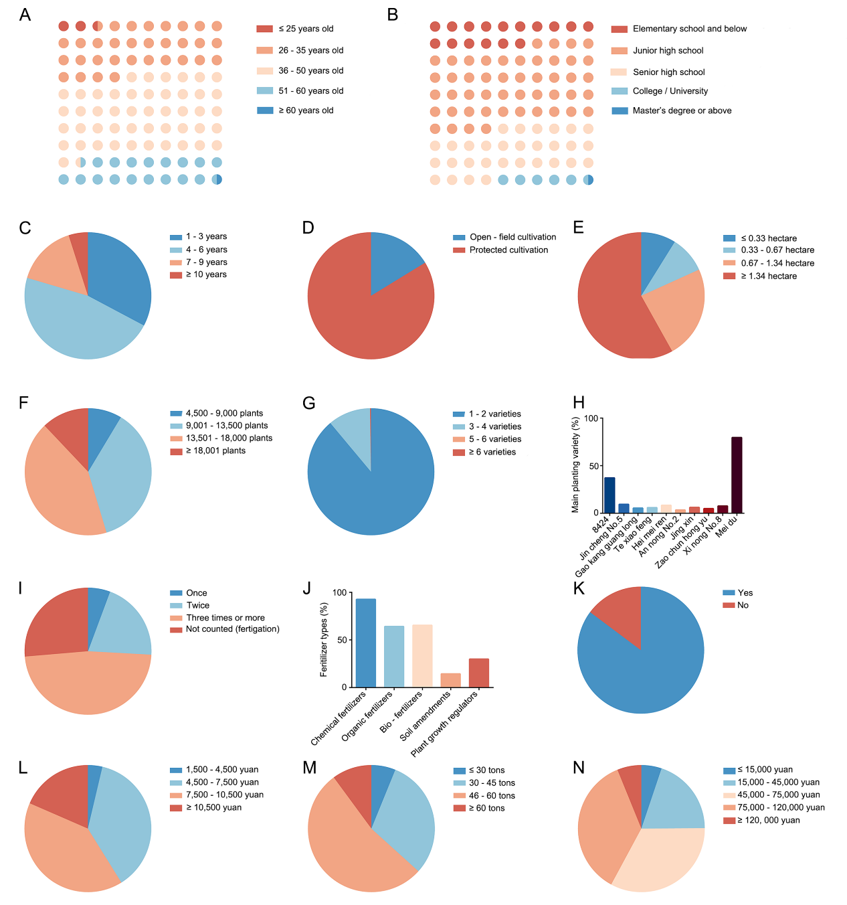

Extended Data Fig. 2 Demographic characteristics and basic cultivation practices in the watermelon industry
A. Age distribution of respondents (single-choice question; n = 406). Color intensity (blue to red) indicates increasing age. Most respondents were aged 26–60 years.
B. Educational background of respondents (single-choice question; n = 406). Color intensity (blue to red) indicates higher educational attainment. Most respondents lacked higher education.
C. Duration of farming experience. Pie chart showing the proportion of farmers surveyed (single-choice question; n = 406).
D. Cultivation methods. Pie chart showing the distribution of growing locations among farmers (single-choice question; n = 406).
E. Cultivation area. Pie chart showing the proportion of farmers by land area under watermelon cultivation (single-choice question; n = 406).
F. Planting density. Pie chart showing the proportion of farmers by plants per hectare (single-choice question; n = 406).
G. Number of cultivars grown. Pie chart showing the proportion of farmers by the number of watermelon cultivars planted (single-choice question; n = 406).
H. Dominant cultivars. Bar chart identifying major cultivars (x-axis: cultivar names; y-axis: proportion of respondents). ‘Meidu’ and ‘8424’ were the most prevalent (multiple-choice question; n = 406).
I. Fertilization frequency. Pie chart showing the proportion of farmers by fertilization events per crop cycle (single-choice question; n = 406).
G. Types of fertilizers used. Bar chart showing fertilizer categories (x-axis: fertilizer types; y-axis: proportion of farmers using each type) (multiple-choice question; n = 406).
K. Preference for organic fertilizers. Pie chart showing farmers’ inclination toward organic fertilizer use (single-choice question; n = 406).
L. Fertilizer costs. Pie chart showing the proportion of farmers by fertilizer expenditure (single-choice question; n = 406).
M. Watermelon yield. Pie chart showing the distribution of yields (tons/ha) among farmers (single-choice question; n = 406).
N. Net profit. Pie chart showing the distribution of net profits (yuan/ha) from watermelon cultivation (single-choice question; n = 406).
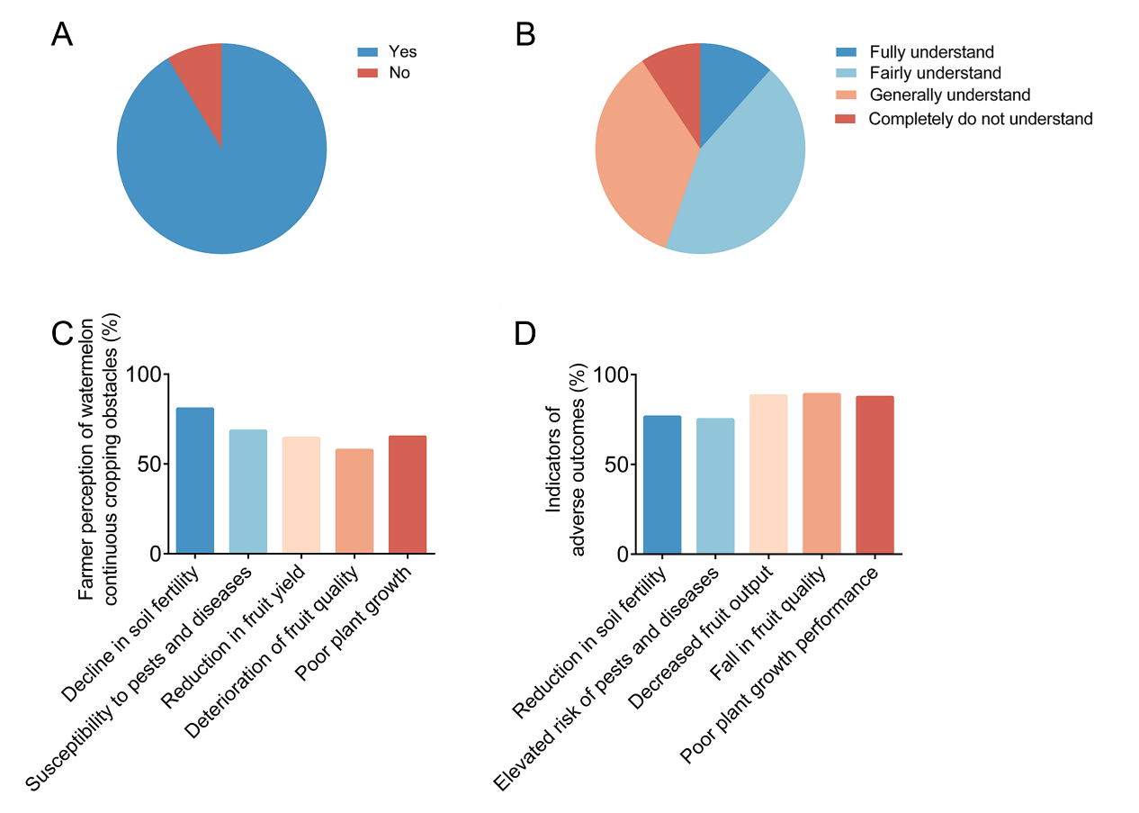

Extended Data Fig. 3 Survey on continuous cropping obstacles in watermelon cultivation
A. Subjective assessment of continuous cropping impacts on subsequent crops. Pie chart showing the proportion of farmers’ judgments (single-choice question; n = 128).
B. Level of awareness about continuous cropping obstacles. Pie chart showing the distribution of farmers’ knowledge levels (single-choice question; n = 406).
C. Crop performance under continuous cropping. Bar chart displaying potential impacts of continuous cropping obstacles (x-axis: reported effects; y-axis: proportion of respondents who subjectively identified each effect). Farmers could select multiple outcomes (multiple-choice question; n = 128).
D. Consequences of continuous cropping obstacles. Bar chart summarizing perceived impacts (x-axis: consequences; y-axis: proportion of respondents aware of each consequence). Farmers could select multiple outcomes (multiple-choice question; n = 128).
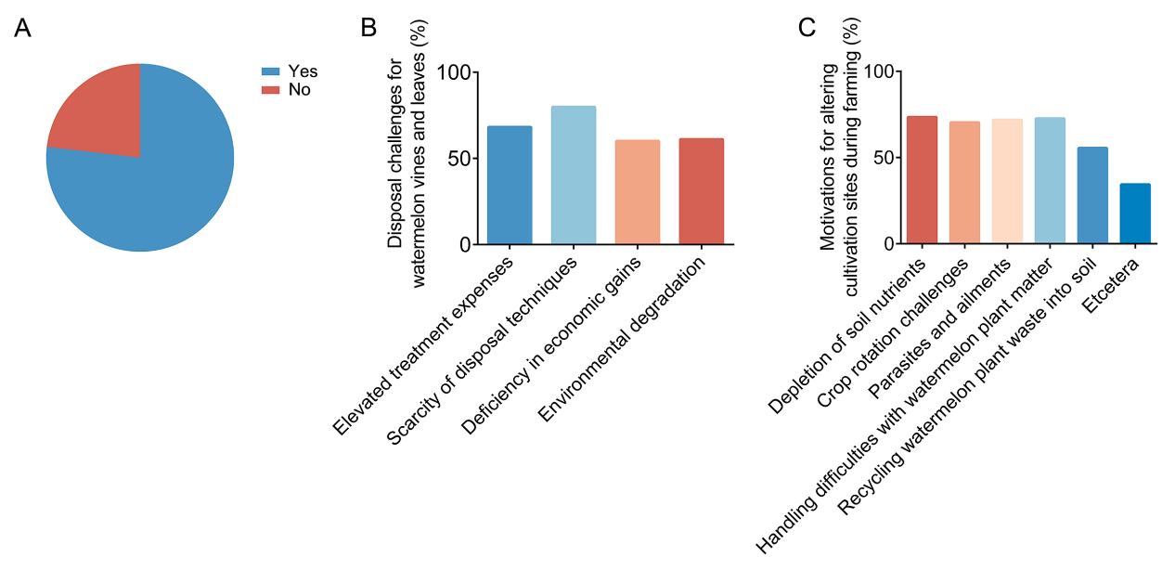

Extended Data Fig. 4 Survey on watermelon aerial parts disposal practices
A. Willingness to recycle watermelon aerial parts. Pie chart showing the proportion of farmers’ willingness to recycle vines/leaves post-harvest (single-choice question; n = 406).
B. Challenges in vine/leaf disposal. Bar chart displaying reported disposal challenges (x-axis: identified challenges; y-axis: proportion of respondents who subjectively recognized each challenge). Farmers could select multiple challenges (multiple-choice question; n = 406).
C. Motivations for changing cultivation sites. Bar chart summarizing reasons for relocating watermelon plantings (x-axis: reported reasons; y-axis: proportion of respondents who subjectively cited each reason). Farmers could select multiple reasons (multiple-choice question; n = 128).
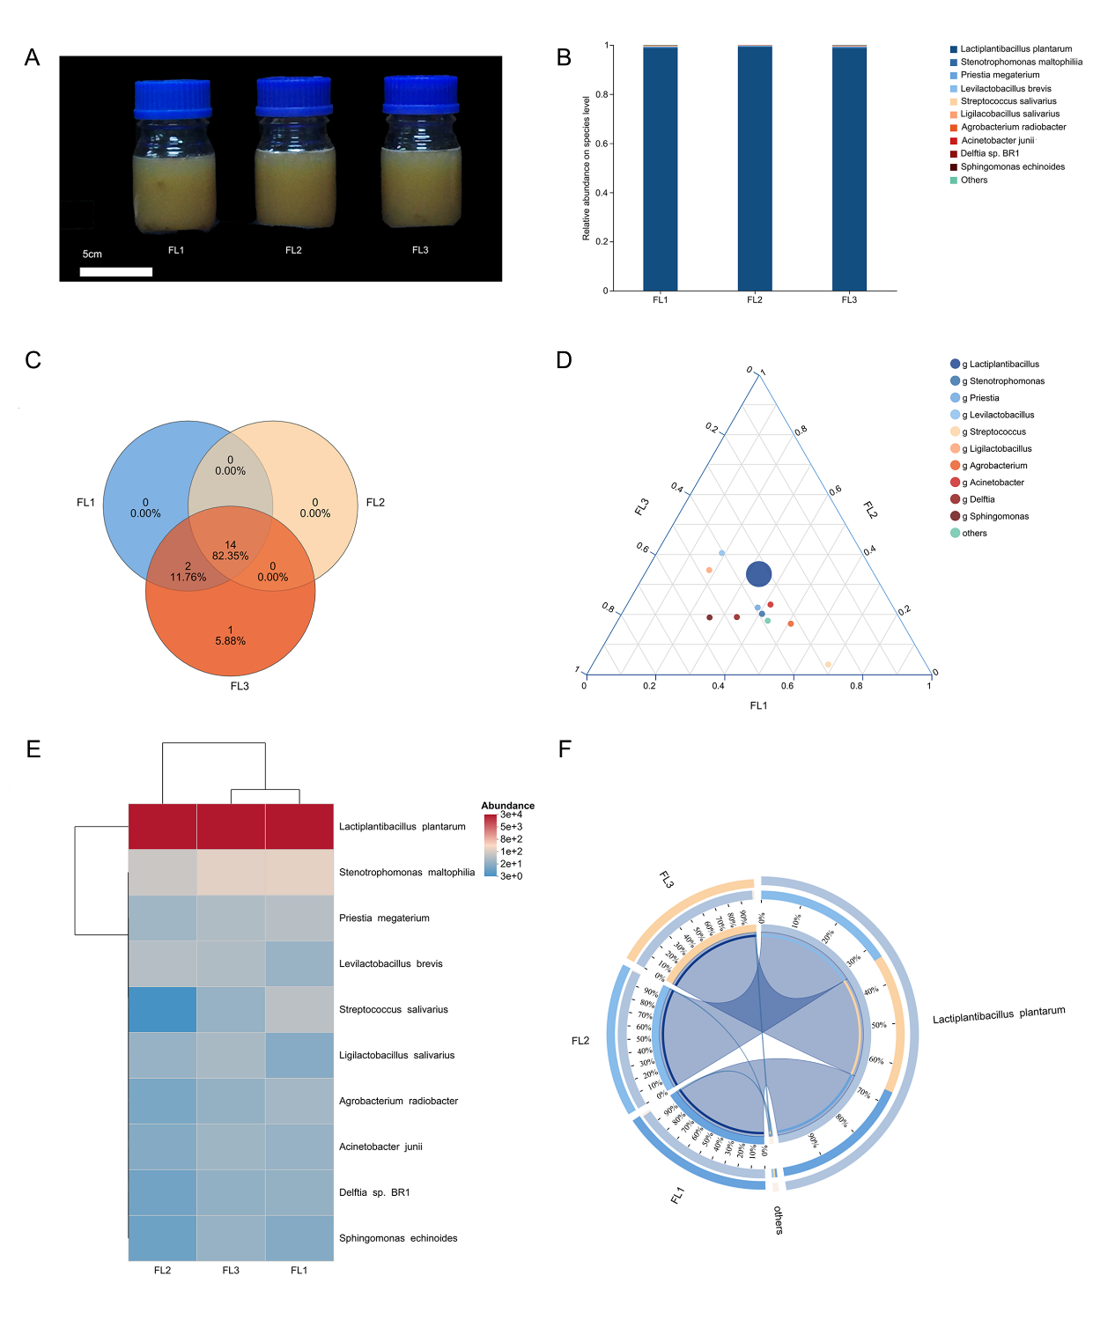

Extended Data Fig. 5 LP-WCFS1 is the dominant bacterial group in the LP-WCFS1-mediated rapid fermentation system
A. Schematic workflow of the LP-WCFS1-mediated rapid fermentation system. Fresh watermelon aerial parts are mixed with water and sucrose at defined ratios, followed by sealed fermentation for 14 days, yielding two products: a fermented liquid and residual fermented biomass.
B. Phenotype of the fermented liquid after rapid fermentation (FL, 14 d). Scale bar, 5 cm.
C. Venn diagram of microbial community structure. Over 80% of microbial taxa are shared among the three biological replicates.
D. Ternary plot. LP-WCFS1 exhibits equivalent proportional distribution across the three samples, emerging as the absolute dominant taxon.
E. Heatmap of top 10 dominant taxa. Color intensity (blue to red) indicates increasing relative abundance; LP-WCFS1 ranks as the most abundant taxon across all three samples.
F. Circos plot of species-sample relationships. The three samples show similar patterns in microbial community composition and taxon abundance trends.
FL (rapid fermentation system, 14d). In A-D, n = 3 biological replicates.
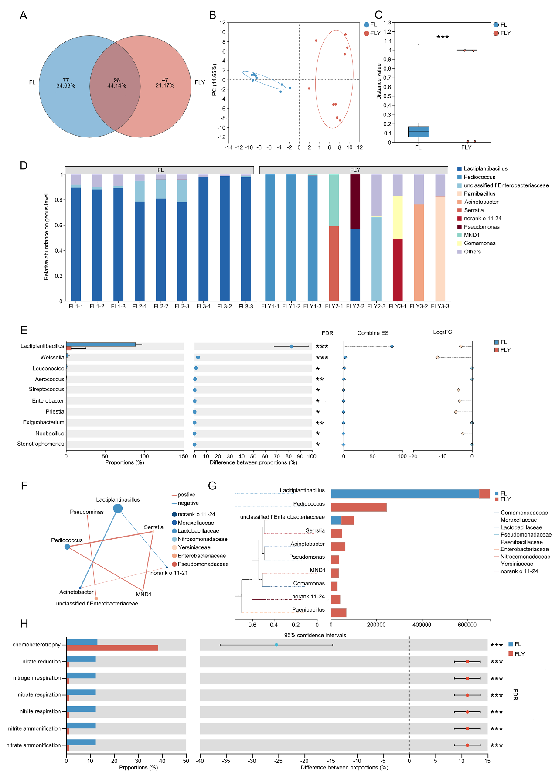

Extended Data Fig. 6 The microbial community and functions in the LP-WCFS1-mediated rapid fermentation system are superior to those in the long-term fermentation system
A. Venn diagram of microbial community structure. FL and FLY share fewer than 50 overlapping taxa.
B. Principal Component Analysis. Principal Component Analysis (PCA) plot showing sample distribution. FL and FLY groups are in blue or red, respectively; replicates of the same treatment are encircled.
C. Analysis of between-group differences in beta diversity. y-axis: pairwise beta diversity distances within groups. FL and FLY differ significantly in community structure.
D. Stacked bar chart of community composition. x-axis: sample names; y-axis: relative abundance of taxa. Among the top 10 most abundant taxa in all FL samples, LP-WCFS1 is the most prevalent, whereas FLY exhibits complex taxonomic composition.
E. Significance test of interspecific differences between groups. Compared with FL, the abundance of LP-WCFS1 in FLY is significantly reduced.
F. Single-factor correlation network among taxa. LP-WCFS1 negatively correlates with other taxa.
G. Phylogenetic tree of taxa across samples. LP-WCFS1 is phylogenetically most distant from other taxa.
H. FAPROTAX functional prediction and between-group difference test. x-axis: functional categories; y-axis: percentage of functional abundance in samples. FLY shows significantly reduced functions such as elemental transformation.
FL (rapid fermentation system, 14d), FLY (long-term fermentation system, 365d). In A-H, n = 3 biological replicates, Two-tailed Student’s t-test was used to determine p values (p < 0.05, p < 0.01, p < 0.001). Data are presented as mean ± SD. All analyses were performed at the genus level.
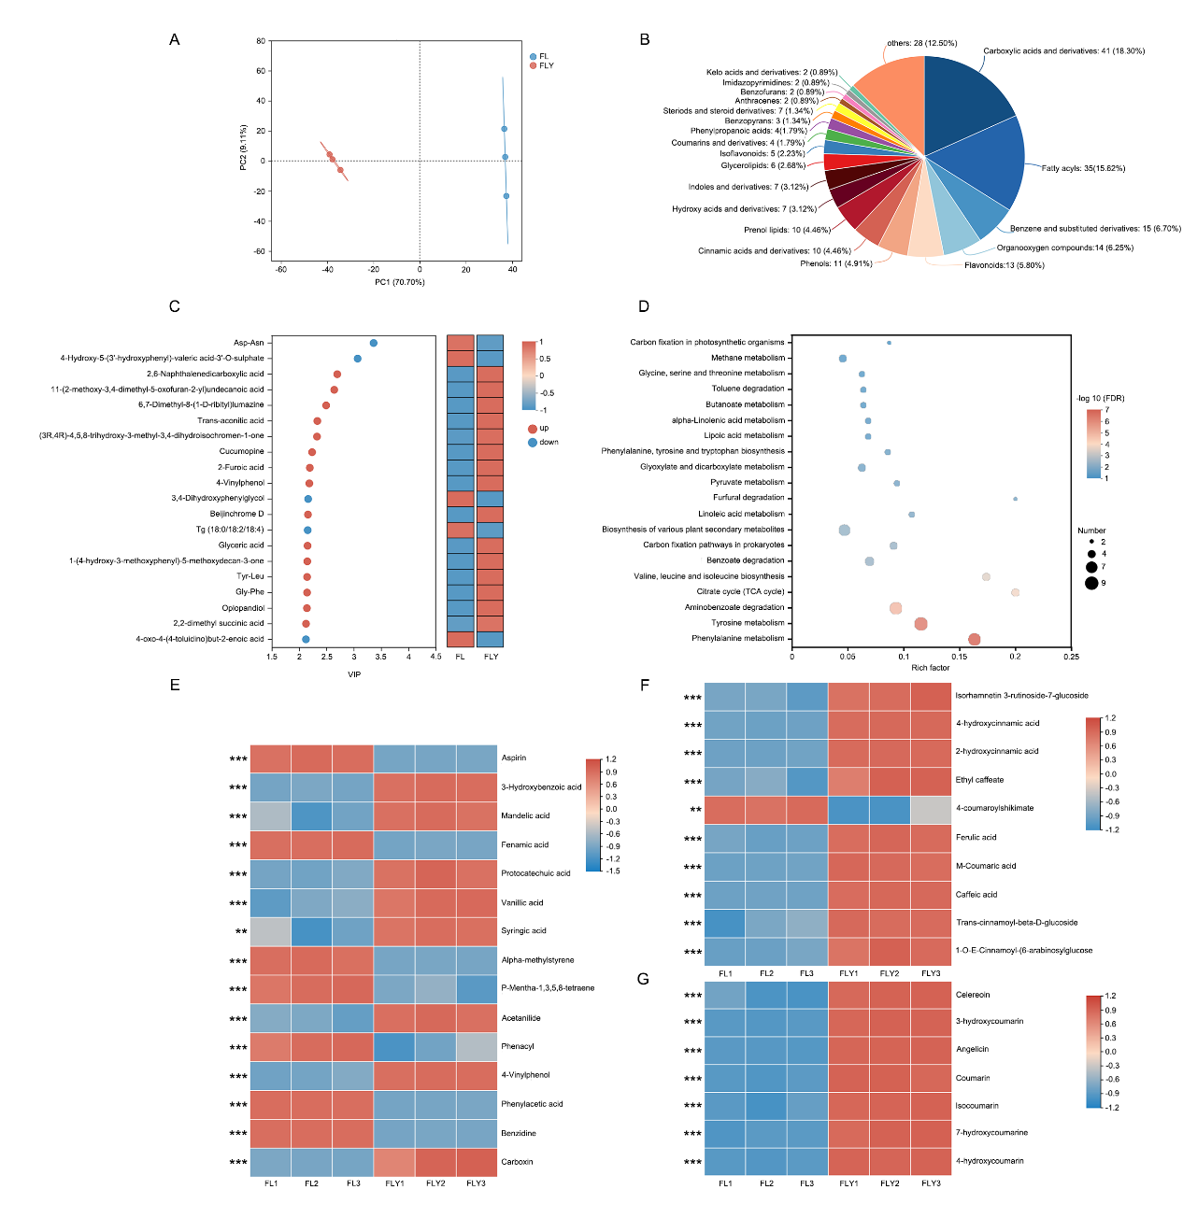

Extended Data Fig. 7 Long-term fermentation mediated by LP-WCFS1 leads to the specific accumulation of metabolites in pathways cinnamic acids and derivatives and coumarins and derivatives in the fermentation liquid
A. Principal Component Analysis. Principal Component Analysis (PCA) plot showing sample distribution. FL and FLY groups are in blue or red, respectively; replicates of the same treatment are encircled.
B. HMDB compound classification (class level). Color segments in each pie chart represent distinct HMDB classes; segment area indicates the relative proportion of metabolites in each class.
C. VIP (variable importance in projection) value analysis. Left: VIP bubble plot (y-axis: metabolites; x-axis: VIP values), with metabolites ordered by decreasing VIP values. Among the top 20 VIP metabolites in FLY, 16 exhibit significantly higher abundance than in FL.
D. KEGG pathway enrichment analysis. Bubble size corresponds to the number of compounds enriched in each pathway; color intensity (blue to red) reflects decreasing significance p-values.
E. Differential metabolites in benzene and substituted derivatives. FL and FLY differ significantly in the abundance of 15 metabolites, 8 of which are significantly elevated in FLY.
F. Differential metabolites in cinnamic acids and derivatives. FL and FLY differ significantly in the abundance of 10 metabolites, 9 of which are significantly elevated in FLY.
G. Differential metabolites in coumarins and derivatives. Seven metabolites show significantly higher abundance in FLY compared to FL.
FL (rapid fermentation system, 14d), FLY (long-term fermentation system, 365d). In A-G, n = 3 biological replicates, Two-tailed Student’s t-test was used to determine p values (p < 0.05, p < 0.01, p < 0.001). Data are presented as mean ± SD. All differential metabolite analyses were based on FDR (false discovery rate) analysis.
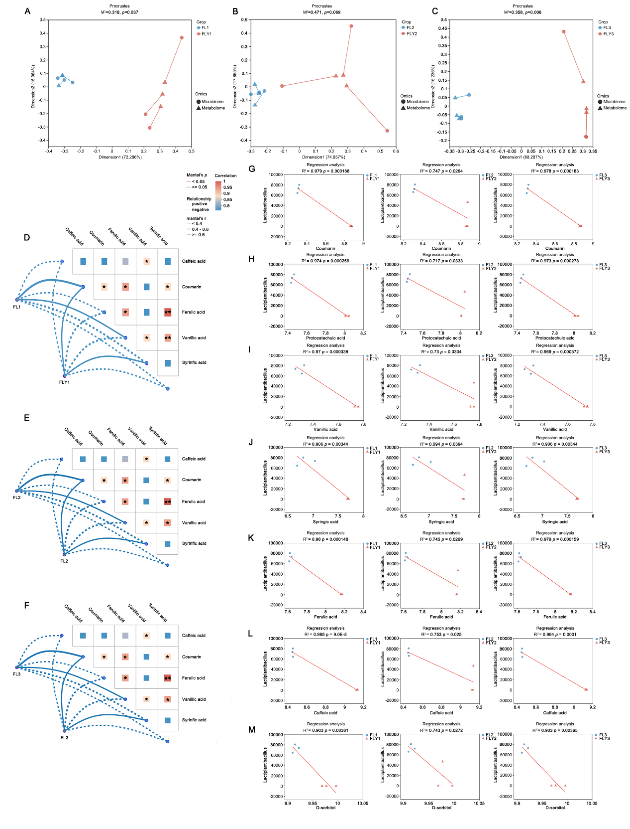

Extended Data Fig. 8 In both LP-WCFS1-mediated rapid and long-term fermentation systems, LP-WCFS1 correlates with differential metabolites in the fermentation liquid
A–C. Procrustes analyses showing correlations between microbial communities and global metabolite profiles in FL1 (A), FL2 (B), and FL3 (C), revealing consistent community–metabolite coupling across batches.
D–F. Mantel-test network heatmaps for FL1 (D), FL2 (E), and FL3 (F), indicating significant positive correlations between major microbial taxa and metabolites.

G–M. Linear regressions between LP-WCFS1 abundance and individual metabolites—including coumarin (G), protocatechuic acid (H), vanillic acid (I), syringic acid (J), ferulic acid (K), caffeic acid (L), and D-sorbitol (M)—across FL1, FL2, and FL3.
FL (rapid fermentation system, 14d), FLY (long-term fermentation system, 365d). In G-M, LP-WCFS1 exhibits significant positive correlations with the respective metabolites. In A-M, n = 3 biological replicates, A two-tailed Student’s t-test was used to determine p values. * p < 0.05, ** p < 0.01, ***p < 0.001. Values are presented as the mean ± SD.
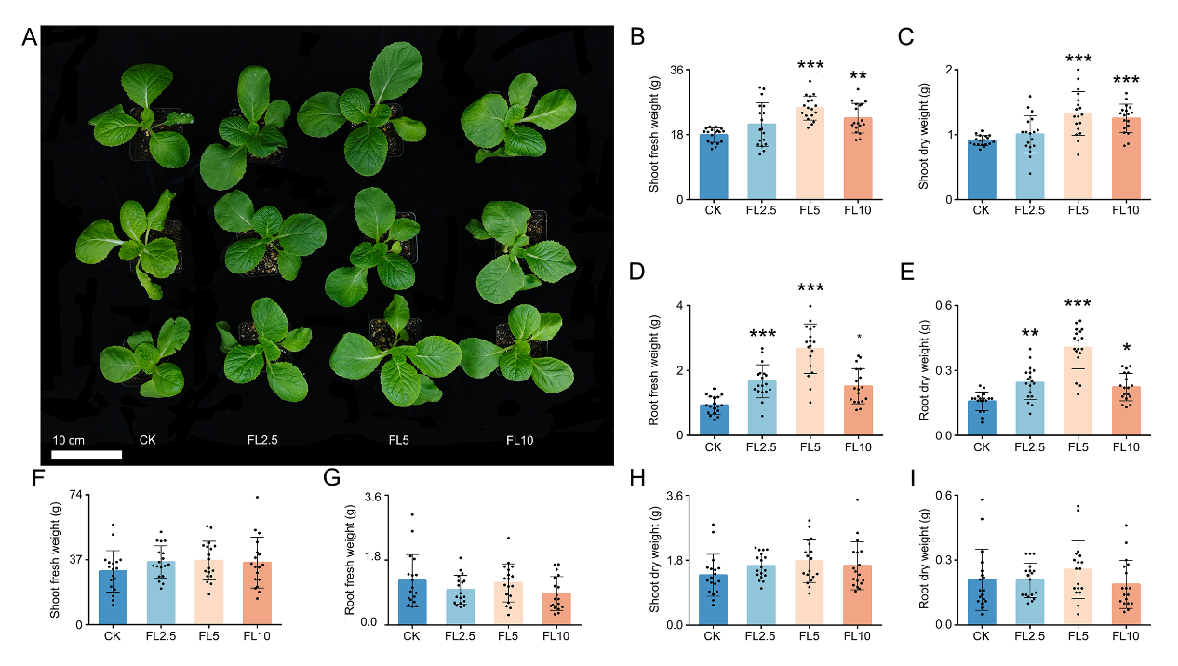

Extended Data Fig. 9 Foliar application of Lactobacillus plantarum (LP-WCFS1)-mediated rapid fermentation liquid promotes Brassica rapa growth under greenhouse conditions
A. Phenotypic comparison of Brassica rapa plants treated with foliar sprays of FL at different concentrations.
B, F. Shoot fresh weight in the Zhangjiakou (2023) and Beijing (2024) greenhouse trials, respectively.
C, G. Shoot dry weight in the Zhangjiakou (2023) and Beijing (2024) greenhouse trials, respectively.
D, H. Root fresh weight in the Zhangjiakou (2023) and Beijing (2024) greenhouse trials, respectively.
E, I. Root dry weight in the Zhangjiakou (2023) and Beijing (2024) greenhouse trials, respectively.
FL (rapid fermentation liquid). Treatment groups: CK (0 mL/L FL), FL2.5 (2.5 mL/L FL), FL5 (5 mL/L FL), FL10 (10 mL/L FL). In B-I, n = 18 biological replicates, one-way analysis of variance (ANOVA) followed by Tukey’s multiple comparison test was used to determine the p values. * p < 0.05, ** p < 0.01, ***p < 0.001. Values are presented as the mean ± SD.
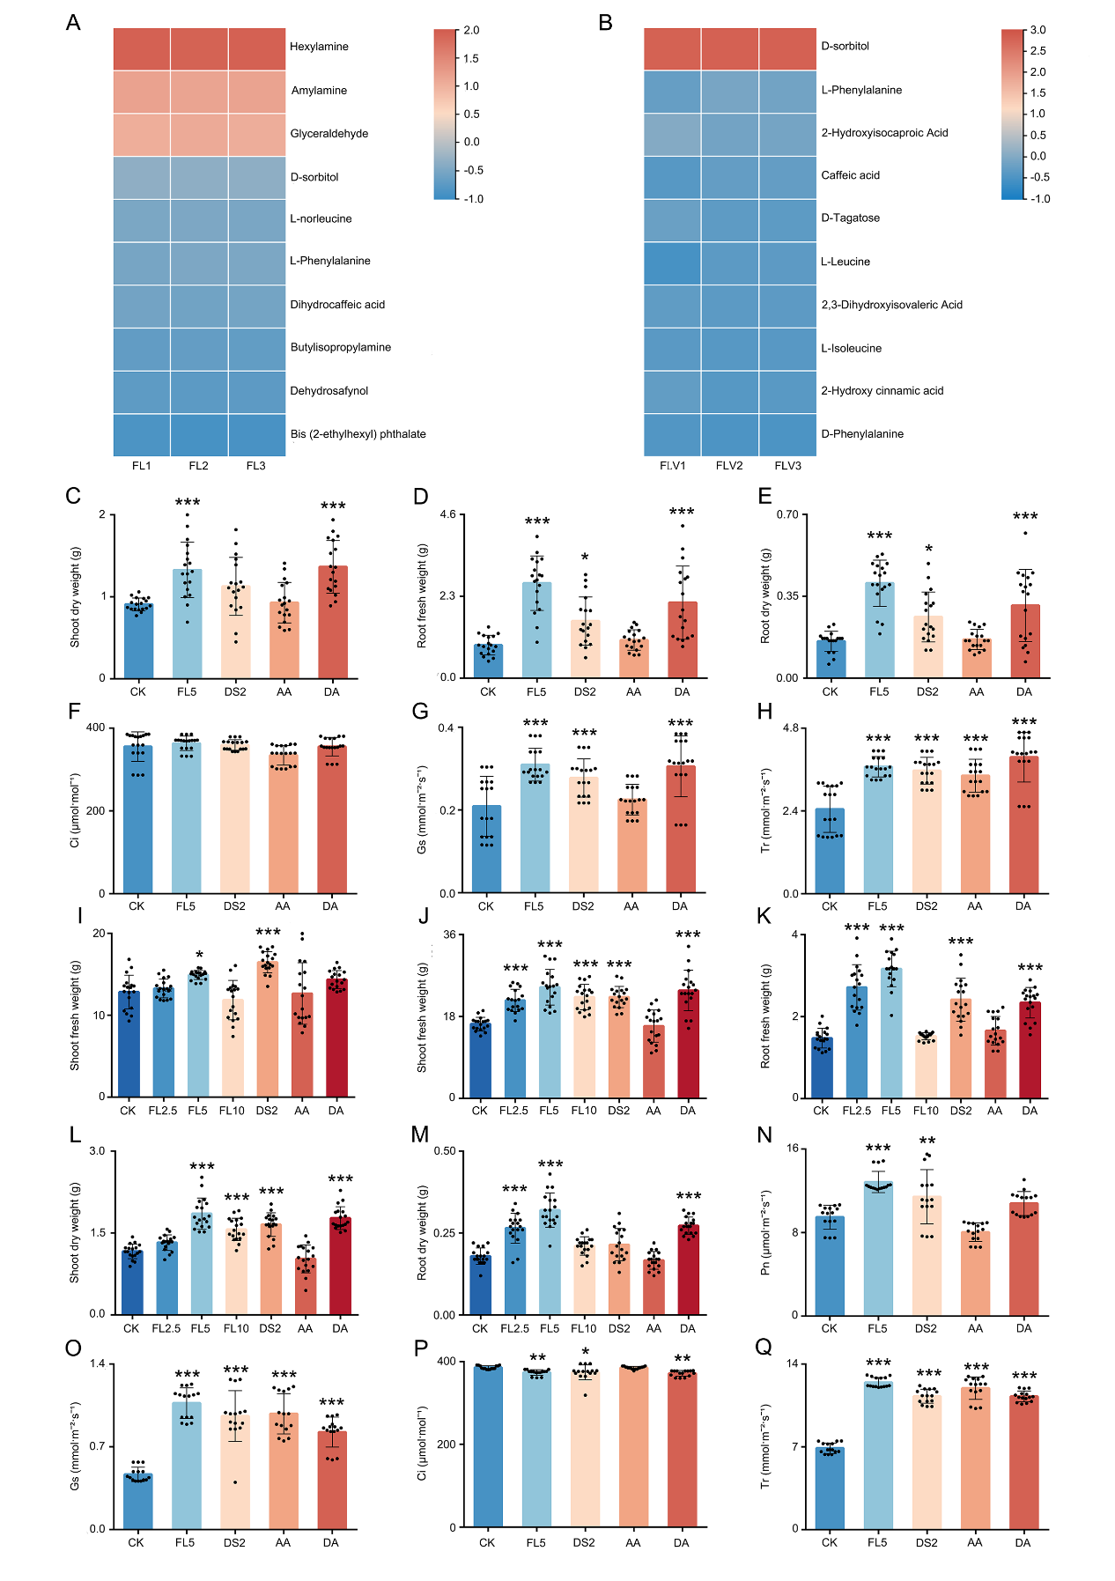

Extended Data Fig. 10 D-sorbitol as the effector component of the fermentation liquid from the LP-WCFS1-mediated rapid fermentation system, promotes the growth of Brassica rapa
A, B. Top 10 metabolites by abundance in rapid fermentation liquids from rapid fermentation systems: FL (rapid fermentation liquids, Beijing, 2023; A) and FLV (repeated validation of rapid fermentation liquids, Zhangjiakou, 2024; B). Both FL and FLV include D-sorbitol and phenylalanine among their most abundant metabolites; these were therefore selected as primary components for functional validation (n = 3 biological replicates).
C–E. Brassica rapa biomass under effector component treatments: shoot dry weight (C), root fresh weight (D), and root dry weight (E).
F–H. Leaf gas-exchange parameters under effector component treatments: intercellular CO₂ concentration (Ci; F), stomatal conductance (Gs; G), and transpiration rate (Tr; H).
I–M. Brassica rapa biomass under FL and effector component treatments: shoot fresh weight (Beijing, 2024; I; general results in J), shoot dry weight (K), root fresh weight (L), and root dry weight (M).
N–Q. Leaf photosynthetic parameters under effector component treatments: net photosynthetic rate (Pn; N), intercellular CO₂ concentration (Ci; O), stomatal conductance (Gs; P), and transpiration rate (Tr; Q).
Treatment groups: CK (water), FL2.5 (2.5 ml/L FL), FL5 (5 ml/L FL), FL10 (10 ml/L FL), DS2 (2g/L D-sorbitol), AA (0.2g/L Phenylalanine), DA (2g/L D-sorbitol + 0.2g/L Phenylalanine). In C-H, Conducted in Zhangjiakou greenhouse trial (2024). I, Conducted in Beijing greenhouse trial (2024). In J-Q, Conducted in Hangzhou growth chamber conditions (2024). In C-E, I-M, n = 18 biological replicates. In F-H, n = 6 biological replicates. In N-Q, n = 5 biological replicates. In C-Q, one-way analysis of variance (ANOVA) followed by Tukey’s multiple comparison test was used to determine the p values. * p < 0.05, ** p < 0.01, ***p < 0.001. Values are presented as the mean ± SD.
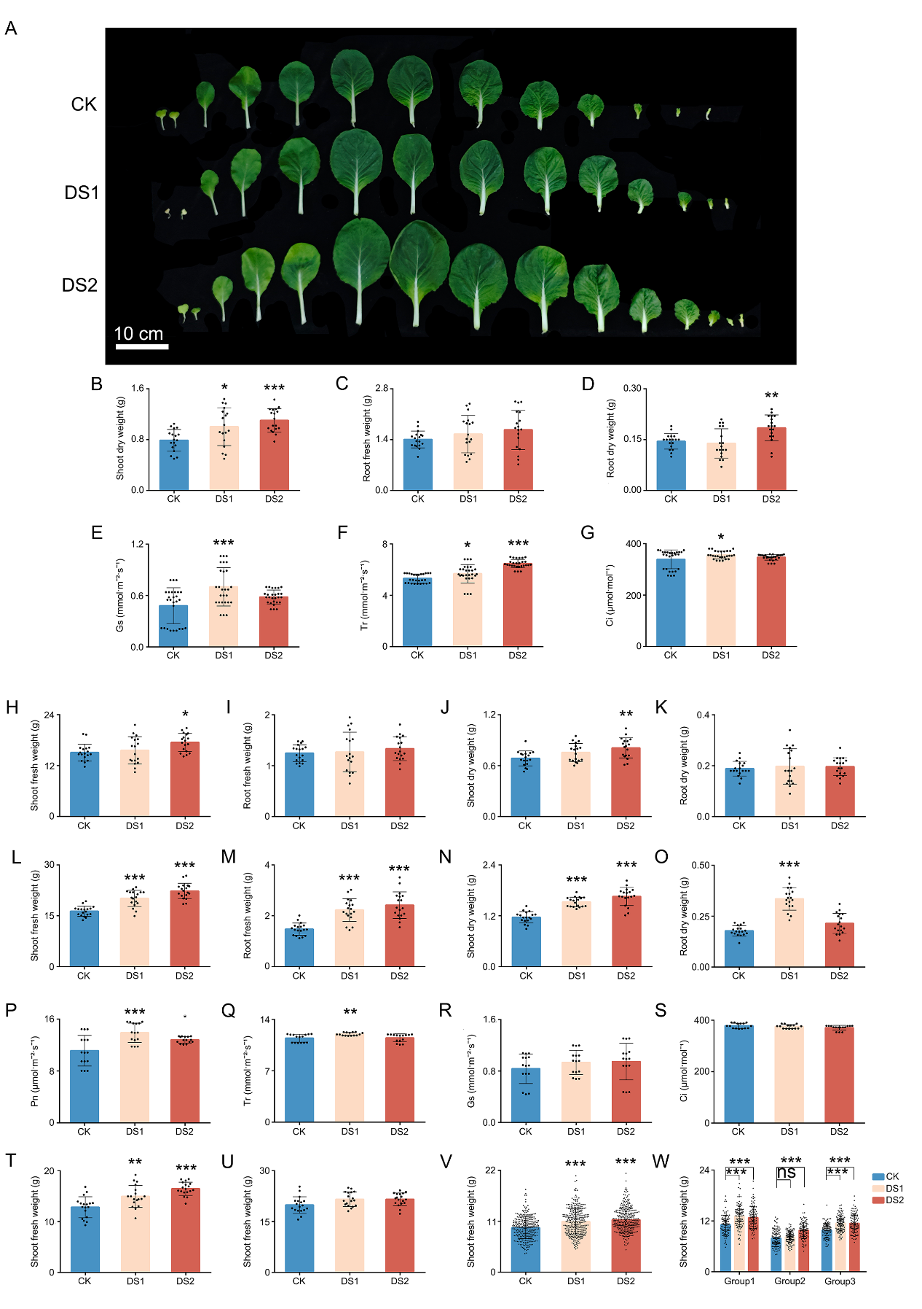

Extended Data Fig. 11 Foliar application of D-sorbitol promotes Brassica rapa growth
A. Growth phenotype of Brassica rapa under D-sorbitol treatment.
B–G. Zhangjiakou greenhouse trial, 2024. B–D. Brassica rapa biomass (n = 18): shoot dry weight (B), root fresh weight (C), root dry weight (D). E–G. Leaf gas-exchange parameters (n = 9): intercellular CO₂ concentration (Ci, E), stomatal conductance (Gs, F), transpiration rate (Tr, G).
H–O. Beijing greenhouse trial, 2024. H–K, L–O. Brassica rapa biomass (n = 18): shoot fresh weight (H, L), shoot dry weight (I, M), root fresh weight (J, N), root dry weight (K, O).
P–S. Beijing greenhouse trial, 2024. Leaf gas-exchange parameters (n = 5): net photosynthetic rate (Pn, P), transpiration rate (Tr, Q), stomatal conductance (Gs, R), intercellular CO₂ concentration (Ci, S).
T–W. Zhangjiakou growth chamber conditions, 2024–2025. T–U. Brassica rapa shoot fresh weight (n = 18, T; n = 18, U). V. Shoot fresh weight (n = 300). W. Shoot fresh weight across experimental blocks (n = 3 plots, 100 plants per plot).
CK: 0g/L D-sorbitol, DS1: 1g/L D-sorbitol, DS2: 2g/L D-sorbitol. In B-W, one-way analysis of variance (ANOVA) followed by Tukey’s multiple comparison test was used to determine the p values. * p < 0.05, ** p < 0.01, ***p < 0.001. Values are presented as the mean ± SD.
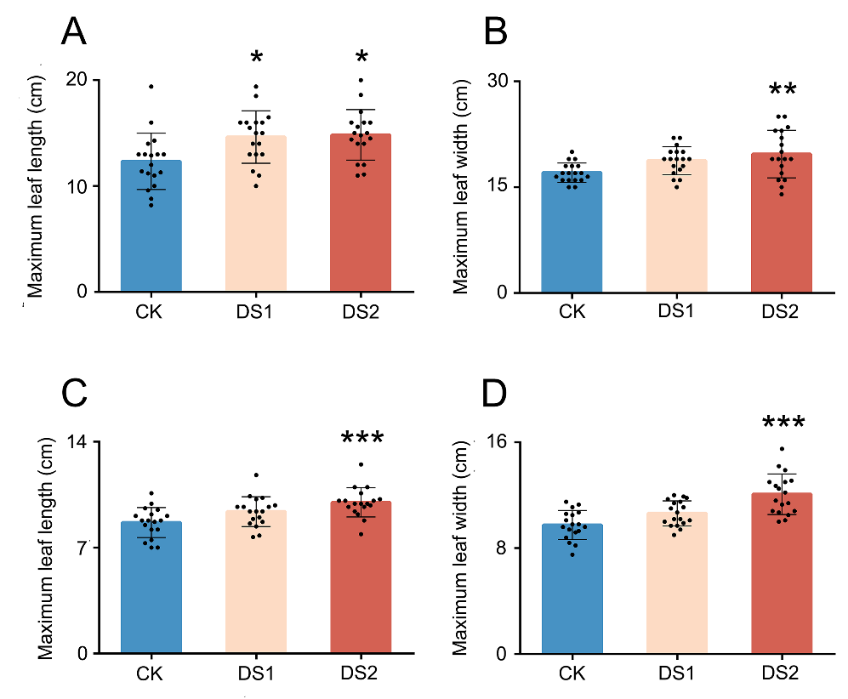

Extended Data Fig. 12 D-sorbitol increases the maximum leaf size of Brassica rapa
A, B. Maximum leaf length (A) and width (B) of Brassica rapa in the Beijing greenhouse trial, 2024 (n = 18).
C, D. Maximum leaf length (C) and width (D) of Brassica rapa under Zhangjiakou growth chamber conditions, 2024 (n = 18).
CK: 0g/L D-sorbitol, DS1: 1g/L D-sorbitol, DS2: 2g/L D-sorbitol. Data are presented as mean ± SD. *p* values were determined by one‑way ANOVA followed by Tukey’s multiple comparison test (*p < 0.05, **p < 0.01, ***p < 0.001).
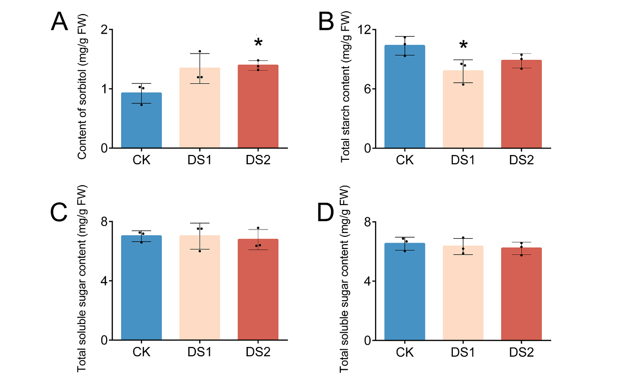

Extended Data Fig. 13 D-sorbitol affects the contents of starch and D-sorbitol without influencing the total sugar content in Brassica rapa leaves
A, B, D. Brassica rapa leaf content under Beijing growth chamber conditions, 2024: D-sorbitol (A), total starch (B), and total sugar (D).
C. Total sugar content in Brassica rapa leaves under Zhangjiakou growth chamber conditions, 2025.
CK: 0g/L D-sorbitol, DS1: 1g/L D-sorbitol, DS2: 2g/L D-sorbitol. In A-D, n = 3 biological replicates, one-way analysis of variance (ANOVA) followed by Tukey’s multiple comparison test was used to determine the p values. * p < 0.05, ** p < 0.01, ***p < 0.001. Values are presented as the mean ± SD.
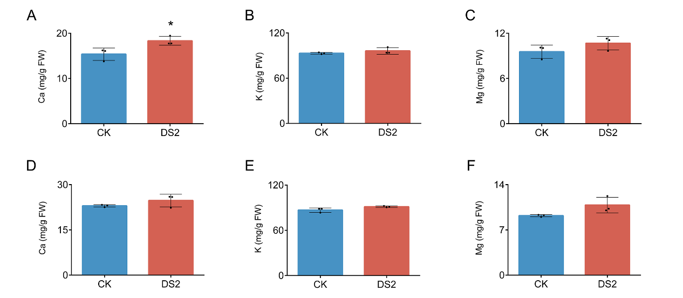

Extended Data Fig. 14 D-sorbitol had little effects on mineral element uptake in Brassica rapa leaves
A–C. Mineral content in the Zhangjiakou greenhouse trial, 2024: Ca (A), K (B), and Mg (C).
D–F. Mineral content in the Beijing greenhouse trial, 2024: Ca (D), K (E), and Mg (F).
CK: 0g/L D-sorbitol, DS2: 2g/L D-sorbitol. In A-F, n = 3 biological replicates, a two-tailed Student’s t-test was used to determine p values. * p < 0.05, ** p < 0.01, ***p < 0.001. Values are presented as the mean ± SD.
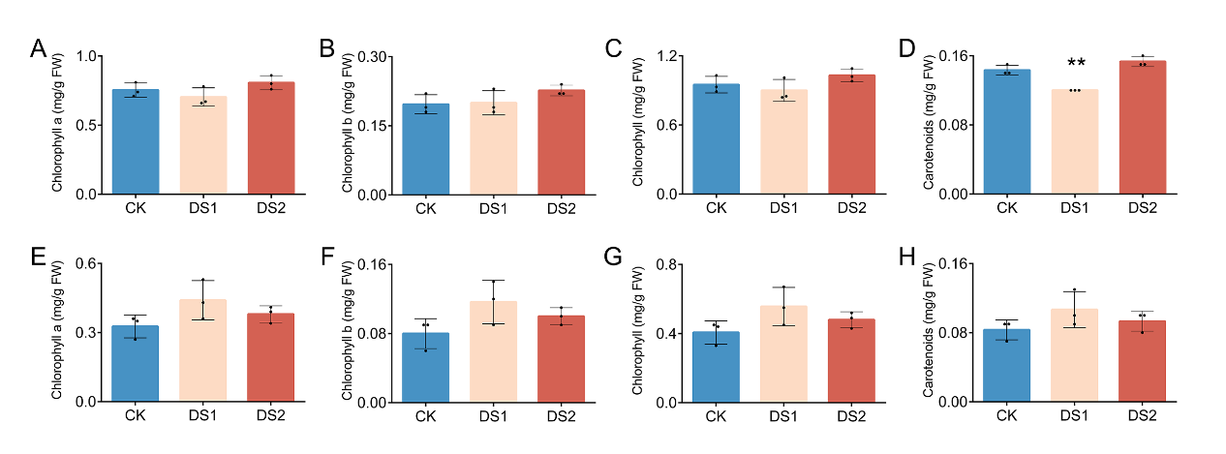

Extended Data Fig. 15 D-sorbitol had little effects on chlorophyll content in Brassica rapa leaves
A–D. Photosynthetic pigment contents in the Beijing greenhouse trial, 2023: chlorophyll a (A), chlorophyll b (B), total chlorophyll (C), and carotenoids (D).
E–H. Photosynthetic pigment contents in the Zhangjiakou greenhouse trial, 2024: chlorophyll a (E), chlorophyll b (F), total chlorophyll (G), and carotenoids (H).
CK: 0g/L D-sorbitol, DS1: 1g/L D-sorbitol, DS2: 2g/L D-sorbitol. In A-H, n = 3 biological replicates, one-way analysis of variance (ANOVA) followed by Tukey’s multiple comparison test was used to determine the p values. * p < 0.05, ** p < 0.01, ***p < 0.001. Values are presented as the mean ± SD.
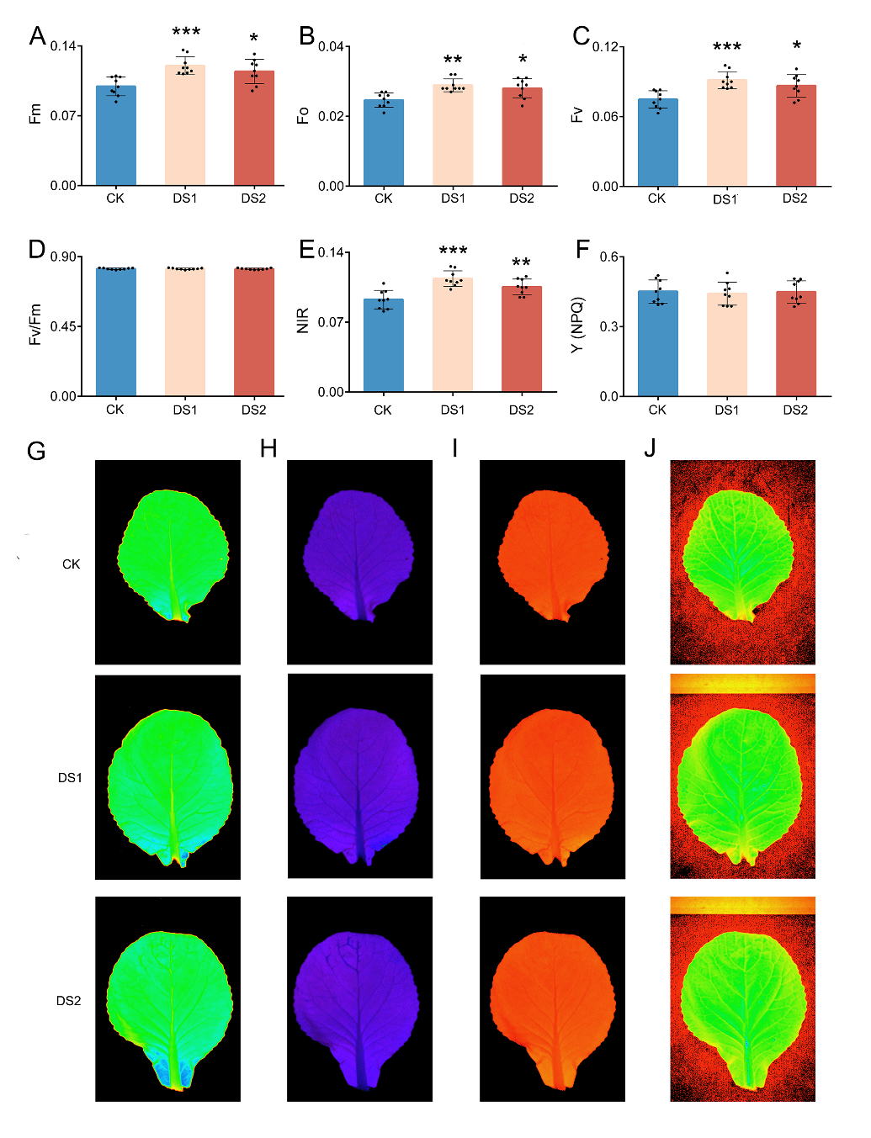

Extended Data Fig. 16 D-sorbitol exerts no stress effect on the photosynthetic system in Brassica rapa leaves
A–D. Chlorophyll fluorescence parameters measured under Beijing growth chamber conditions, 2024: maximum fluorescence (Fm, A), minimal fluorescence (Fo, B), variable fluorescence (Fv, C), and maximum quantum efficiency of PSII (Fv/Fm, D).
E, F. Additional photosynthetic parameters: NIR (E) and non‑photochemical quenching (NPQ, F).
G–J. Corresponding phenotypes: Fm (G), Fv/Fm (H), Fo (I), and NIR (J).
CK: 0g/L D-sorbitol, DS1: 1g/L D-sorbitol, DS2: 2g/L D-sorbitol. In A-H, n = 9 biological replicates, one-way analysis of variance (ANOVA) followed by Tukey’s multiple comparison test was used to determine the p values. * p < 0.05, ** p < 0.01, ***p < 0.001. Values are presented as the mean ± SD.
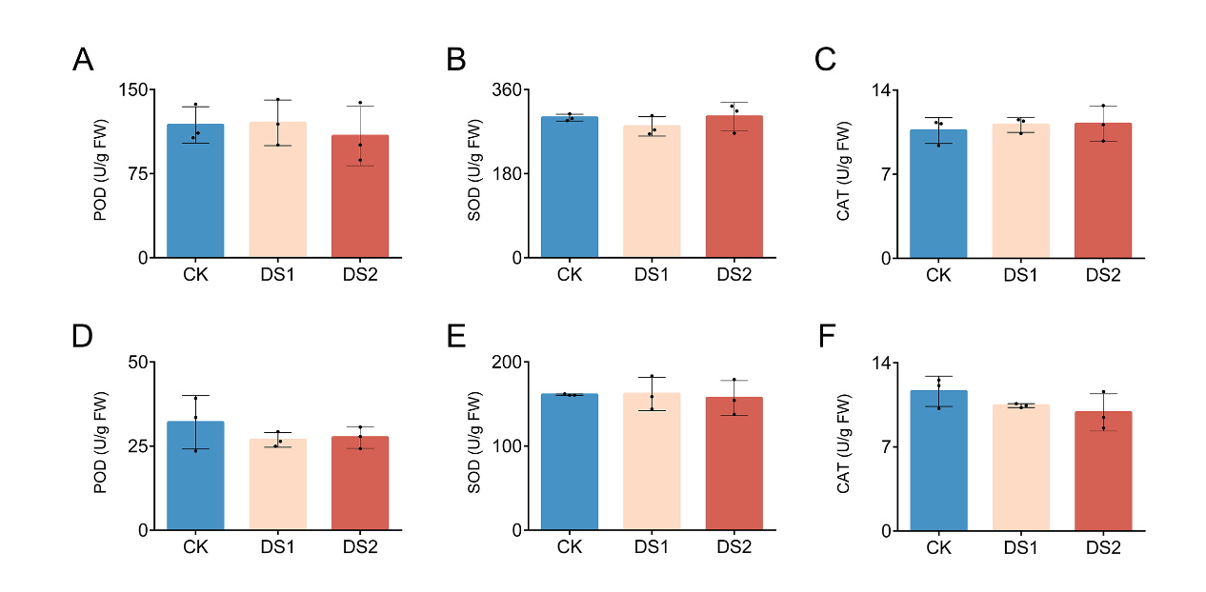

Extended Data Fig. 17 D-sorbitol does not affect the activity of antioxidant enzymes in Brassica rapa leaves
A–C. Antioxidant enzyme activities in the Beijing greenhouse trial, 2024: peroxidase (POD, A), superoxide dismutase (SOD, B), and catalase (CAT, C).
D–F. Antioxidant enzyme activities under Zhangjiakou growth chamber conditions, 2024: POD (D), SOD (E), and CAT (F).
CK: 0g/L D-sorbitol, DS1: 1g/L D-sorbitol, DS2: 2g/L D-sorbitol. In A-F, n = 3 biological replicates, one-way analysis of variance (ANOVA) followed by Tukey’s multiple comparison test was used to determine the p values. * p < 0.05, ** p < 0.01, ***p < 0.001. Values are presented as the mean ± SD.
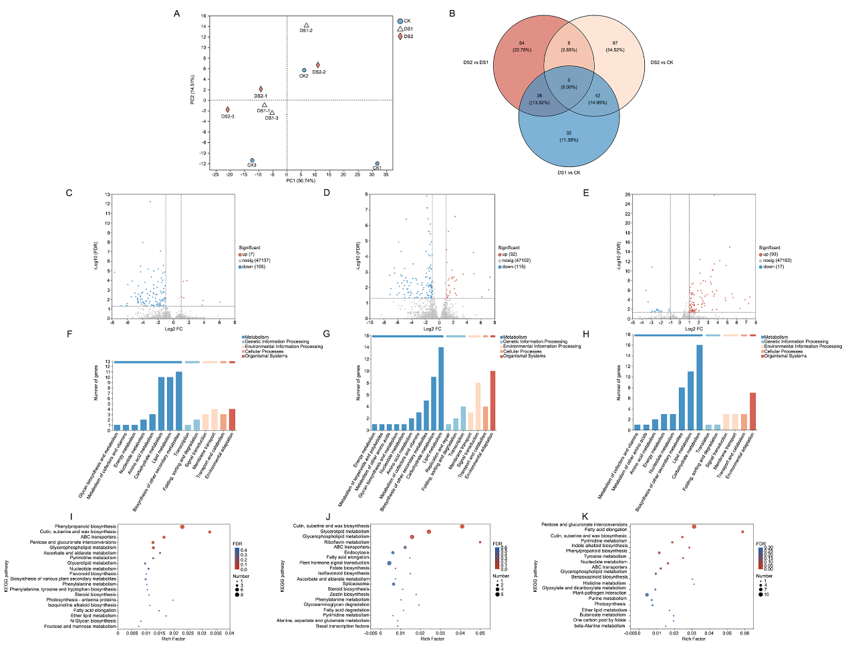

Extended Data Fig. 18 D-sorbitol regulates gene expression in pathways such as carbohydrate metabolism in Brassica rapa leaves
A. Principal component analysis (PCA) of samples from CK, DS1, and DS2 groups (blue, red, and encircled by treatment; n = 3).
B. Venn diagram of differentially expressed genes (DEGs) across comparisons.
C–E. Volcano plots of DEGs for CK/DS1 (C), CK/DS2 (D), and DS1/DS2 (E). Gray: non‑significant; blue: down‑regulated; red: up‑regulated (FDR < 0.05).
F–H. KEGG pathway classification bar charts for CK/DS1 (F), CK/DS2 (G), and DS1/DS2 (H). Colors indicate functional categories.
I–K. KEGG enrichment bubble plots for CK/DS1 (I), CK/DS2 (J), and DS1/DS2 (K). Dot size corresponds to gene count; color gradient (blue to red) represents decreasing FDR.
CK: 0g/L D-sorbitol, DS1: 1g/L D-sorbitol, DS2: 2g/L D-sorbitol.
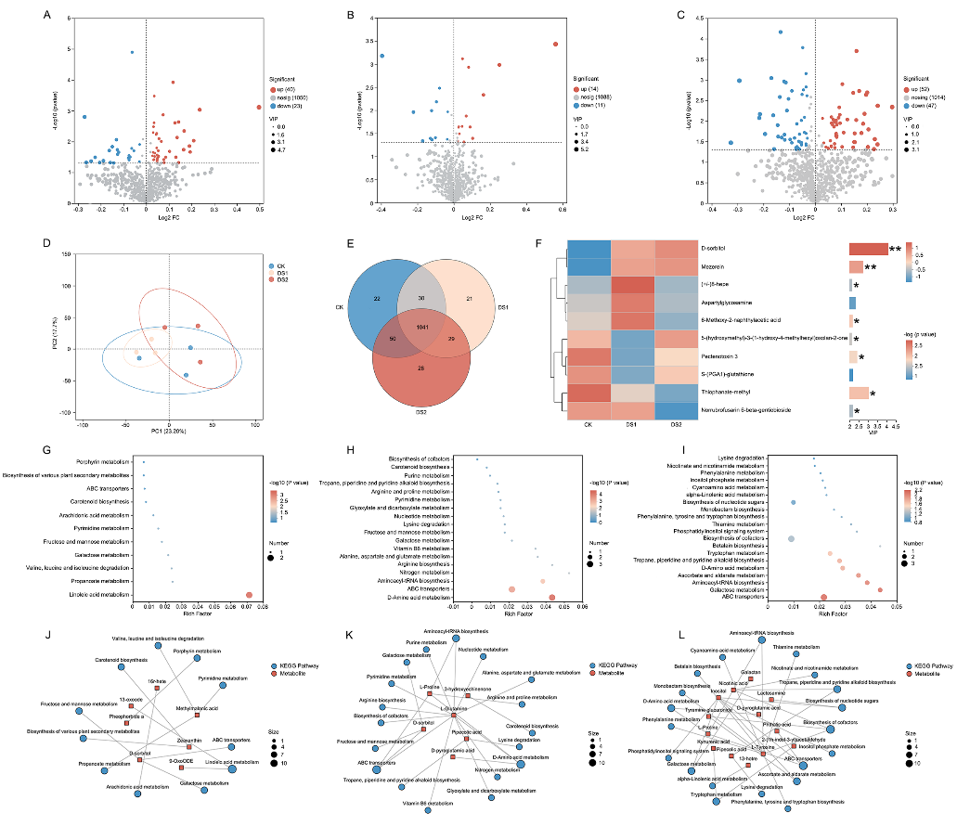

Extended Data Fig. 19 D-sorbitol regulates metabolic pathways such as galactose metabolism and ABC transporters in Brassica rapa leaves
A–C. Volcano plots of differential metabolites (FDR < 0.05) for comparisons CK/DS1 (A), CK/DS2 (B), and DS1/DS2 (C). Gray: non‑significant; blue: down‑regulated; red: up‑regulated.
D. Principal component analysis (PCA) of samples from CK, DS1, and DS2 groups (n = 3).
E. Venn diagram of metabolite groups across treatments.
F. VIP‑based hierarchical clustering heatmap of metabolite abundance (left) with corresponding VIP bar plot (right; bar length reflects contribution to group separation).
G–I. KEGG enrichment analysis of differential metabolites for CK/DS1 (G), CK/DS2 (H), and DS1/DS2 (I). Bubble size indicates number of compounds; color represents enrichment *p*‑value.
J–L. KEGG pathway‑metabolite network for CK/DS1 (J), CK/DS2 (K), and DS1/DS2 (L). Red squares: metabolites; blue circles: KEGG pathways (node size scales with metabolite count).
CK: 0g/L D-sorbitol, DS1: 1g/L D-sorbitol, DS2: 2g/L D-sorbitol. In A-L, n = 3 biological replicates. In F, one-way analysis of variance (ANOVA) followed by Tukey’s multiple comparison test was used to determine the p values (FDR). * p < 0.05, ** p < 0.01, ***p < 0.001. Values are presented as the mean ± SD.
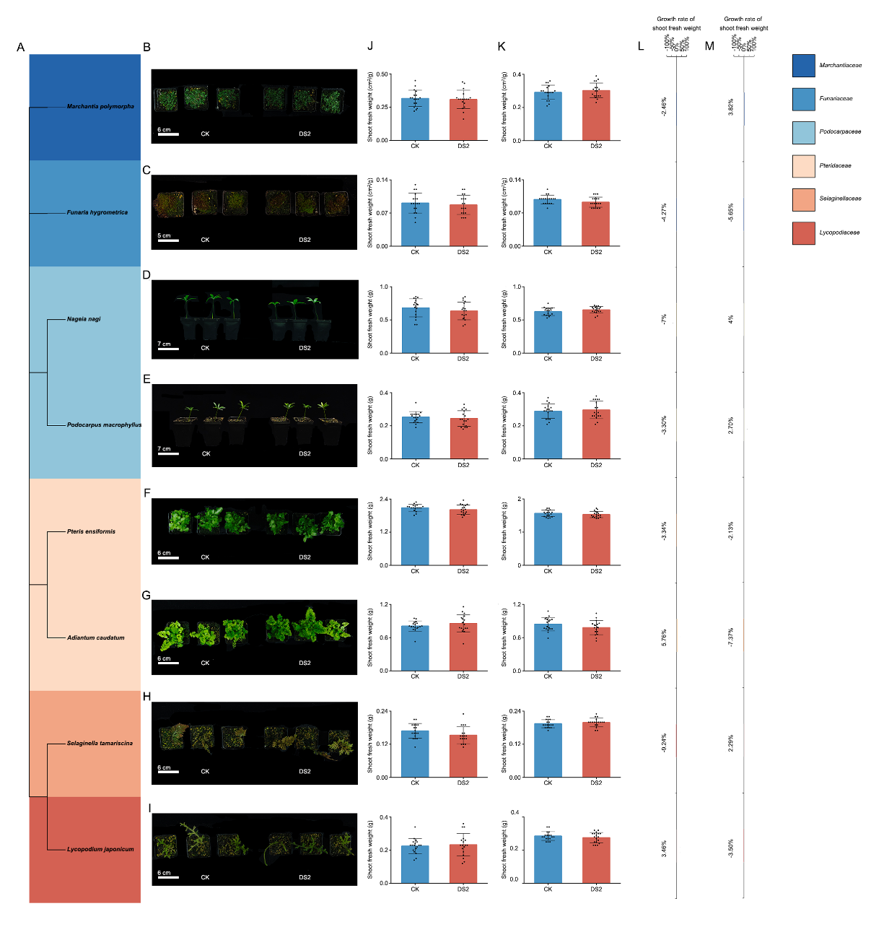

Extended Data Fig. 20 Foliar application of D-sorbitol has no significant effect on the growth of non-angiosperm plants
A. Phylogenetic tree of the non‑angiosperm species included in the experiment.
B–I. Growth performance of the eight species studied: Marchantia polymorpha (B), Funaria hygrometrica (C), Pteris ensiformis (D), Adiantum venustum (E), Selaginella tamariscina (F), Lycopodium japonicum (G), Nageia nagi (H), and Podocarpus macrophyllus (I). Colors indicate taxonomic families.
J, K. Shoot fresh weight of plants grown in Zhangjiakou (March 2025; J) and Beijing (May 2025; K) growth chambers.
L, M. Relative growth rate (RGR) of biomass (DS2 vs. CK) for all cultivated plants in Zhangjiakou (March 2025; L) and Beijing (May 2025; M) growth chambers.
CK: 0g/L D-sorbitol, DS2: 2g/L D-sorbitol, PPFD: 300μmol m^{–2} s^{–l}. In B-M, n = 18 biological replicates. In J-K, a two-tailed Student’s t-test was used to determine p values. * p < 0.05, ** p < 0.01, ***p < 0.001. Values are presented as the mean ± SD.
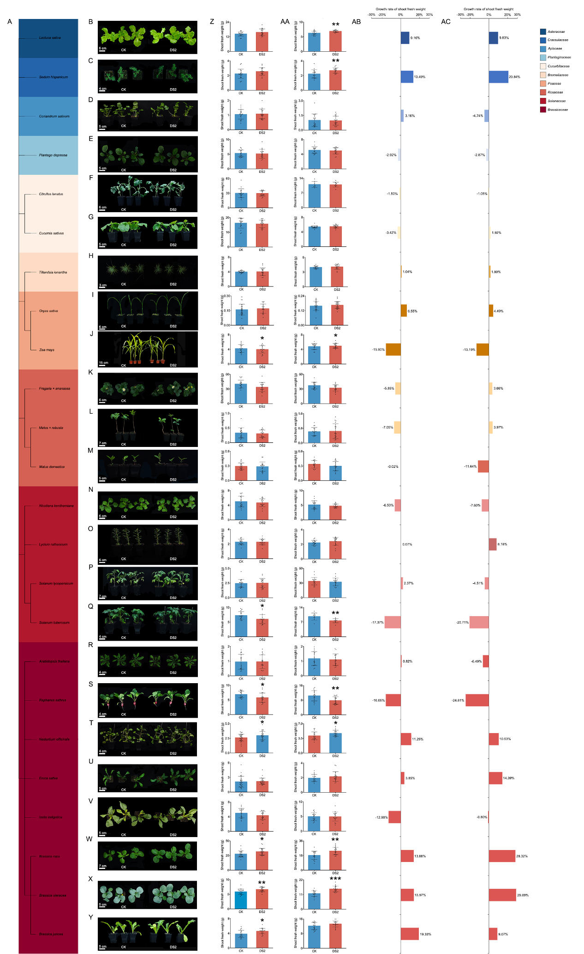

Extended Data Fig. 21 Foliar application of D-sorbitol specifically regulates the growth of angiosperms
A. Phylogenetic tree of the angiosperms included in the cultivation experiments.
B–Y. Growth performance of the 25 cultivated species: Lactuca sativa (B), Sedum hispanicum (C), Coriandrum sativum (D), Plantago depressa (E), Citrullus lanatus (F), Cucumis sativus (G), Tillandsia ionantha (H), Oryza sativa (I), Zea mays (J), Fragaria × ananassa (K), Malus × robusta (L), Malus domestica (M), Nicotiana benthamiana (N), Lycium ruthenicum (O), Solanum lycopersicum (P), Solanum tuberosum (Q), Arabidopsis thaliana (R), Raphanus sativus (S), Nasturtium officinale (T), Eruca sativa (U), Isatis indigotica (V), Brassica rapa (W), Brassica oleracea (X), and Brassica juncea (Y). Colors represent taxonomic families.
Z, AA. Shoot fresh weight of plants grown in Beijing (2024; Z) and Zhangjiakou (2025; AA) growth chambers.
AB, AC. Relative growth rate (RGR) of biomass (DS2 vs. CK) for all cultivated plants in Beijing (2024; AB) and Zhangjiakou (2025; AC) growth chambers.
CK: 0g/L D-sorbitol, DS2: 2g/L D-sorbitol, PPFD: 300μmol m^{–2} s^{–l}. In B-AC, n = 18 biological replicates. In J-K, a two-tailed Student’s t-test was used to determine p values. * p < 0.05, ** p < 0.01, ***p < 0.001. Values are presented as the mean ± SD.
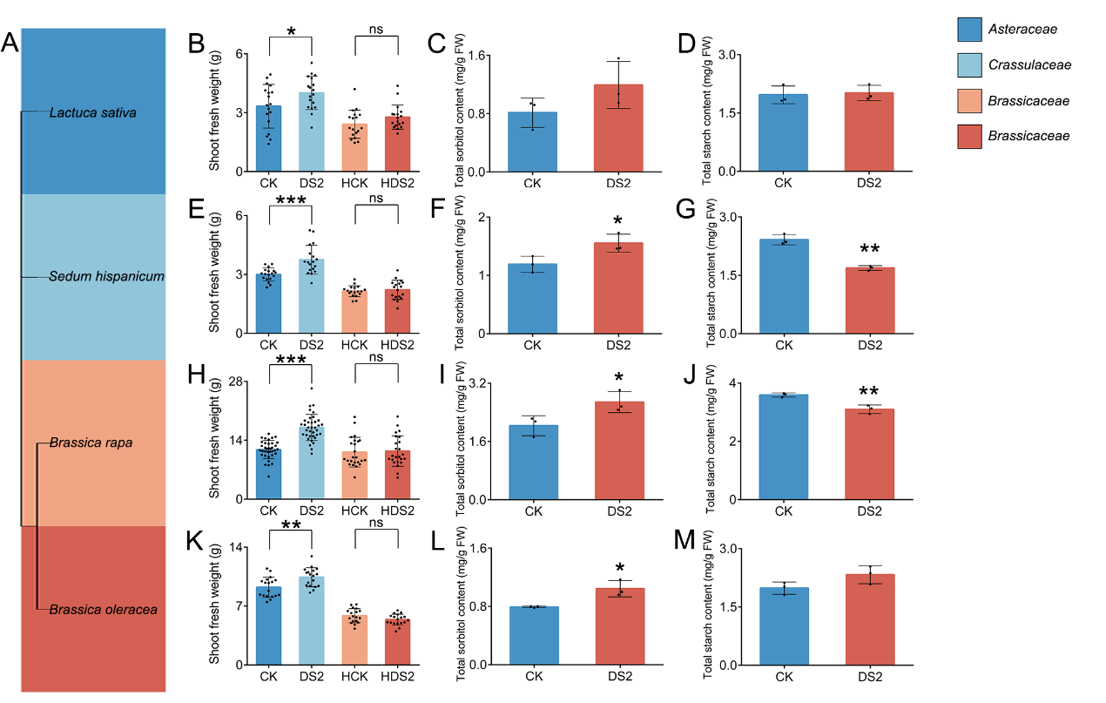

Extended Data Fig. 22 Light intensity and D-sorbitol -induced regulation of growth and energy metabolism across plant species
A. Phylogenetic tree of the experimental plant species.
B–M. Physiological measurements of four species under Beijing growth chamber conditions, May 2025: Lactuca sativa: shoot fresh weight (B), D-sorbitol content in leaves (C), starch content in leaves (D). Sedum hispanicum: shoot fresh weight (E), D-sorbitol content in leaves (F), starch content in leaves (G). Brassica rapa: shoot fresh weight (H), D-sorbitol content in leaves (I), starch content in leaves (J). Brassica oleracea: shoot fresh weight (K), D-sorbitol content in leaves (L), starch content in leaves (M).
CK: 0g/L D-sorbitol + PPFD: 300μmol m^{–2} s^{–l}, DS2: 2g/L D-sorbitol + PPFD: 300μmol m^{–2} s^{–l}, HCK: 0g/L D-sorbitol + PPFD: 150μmol m^{–2} s^{–l}, HDS2: 2g/L D-sorbitol + PPFD: 150μmol m^{–2} s^{–l}. Colors indicate the respective taxonomic families of each species. In B, E, H, K, n = 18 biological replicates. In C, D, F, G, I, J, L, M, n = 3 biological replicates. In B - Q, a two-tailed Student’s t-test was used to determine p values. * p < 0.05, ** p < 0.01, ***p < 0.001. Values are presented as the mean ± SD.
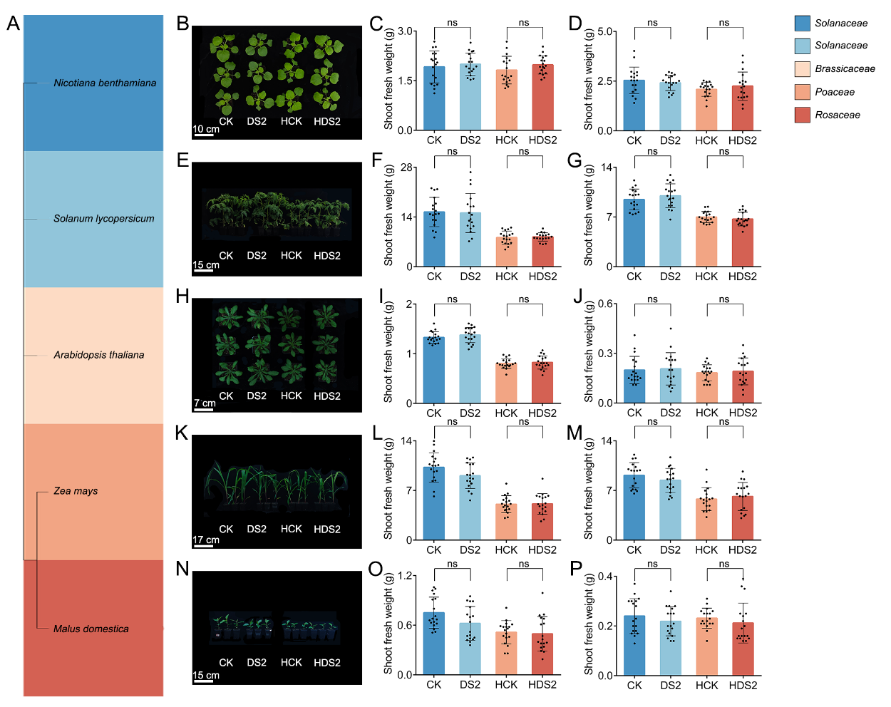

Extended Data Fig. 23 Light intensity and D-sorbitol has no significant effect on the growth of multiple model plants
A. Phylogenetic tree of the experimental plants.
B–P. Growth analysis of five species across two experimental conditions: Nicotiana benthamiana growth performance (B) and shoot fresh weight measured in Zhangjiakou (March 2025, C) and Beijing (May 2025, D). Solanum lycopersicum growth performance (E) and shoot fresh weight measured in Zhangjiakou (March 2025, F) and Beijing (May 2025, G). Arabidopsis thaliana growth performance (H) and shoot fresh weight measured in Zhangjiakou (March 2025, I) and Beijing (May 2025, J). Zea mays growth performance (K) and shoot fresh weight measured in Zhangjiakou (March 2025, L) and Beijing (May 2025, M). Malus domestica growth performance (N) and shoot fresh weight measured in Zhangjiakou (March 2025, O) and Beijing (May 2025, P).
CK: 0g/L D-sorbitol+ PPFD: 300μmol m^{–2} s^{–l}, DS2: 2g/L D-sorbitol+ PPFD: 300μmol m^{–2} s^{–l}, HCK: 0g/L D-sorbitol+ PPFD: 150μmol m^{–2} s^{–l}, HDS2: 2g/L D-sorbitol+ PPFD: 150μmol m^{–2} s^{–l}. Colors indicate the taxonomic family of each species. In B - P, n = 18 biological replicates. a two-tailed Student’s t-test was used to determine p values. * p < 0.05, ** p < 0.01, ***p < 0.001. Values are presented as the mean ± SD.
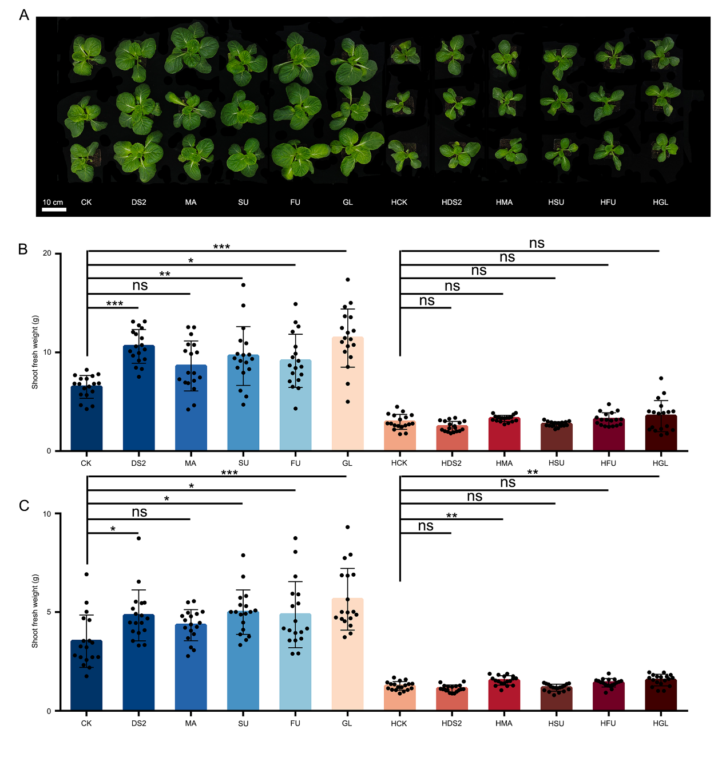

Extended Data Fig. 24 Light intensity-sugar specific interaction regulates Brassica rapa growth
A-C. Brassica rapa growth performance (A) and shoot fresh weight measured in Zhangjiakou (March 2025, B) and Beijing (May 2025, C).
CK: Water+ PPFD: 300μmol m^{–2} s^{–l}, DS2: 2g/L D-sorbitol+ PPFD: 300μmol m^{–2} s^{–l}, MA: 2g/L mannitol+ PPFD: 300μmol m^{–2} s^{–l}, SU: 2g/L sucrose+ PPFD: 300μmol m^{–2} s^{–l}, FU: 2g/L fructose+ PPFD: 300μmol m^{–2} s^{–l}, GL: 2g/L glucose+ PPFD: 300μmol m^{–2} s^{–l}, HCK: Water+ PPFD: 150μmol m^{–2} s^{–l}, HDS2: 2g/L D-sorbitol+ PPFD: 150μmol m^{–2} s^{–l}. HMA: 2g/L mannitol+ PPFD: 150μmol m^{–2} s^{–l}, HSU: 2g/L sucrose+ PPFD: 150μmol m^{–2} s^{–l}, HFU: 2g/L fructose+ PPFD: 150μmol m^{–2} s^{–l}, HGL: 2g/L glucose+ PPFD: 150μmol m^{–2} s^{–l}. In A-C, Beijing, growth chamber, 2024. In B-C, n = 18 biological replicates. one-way analysis of variance (ANOVA) followed by Tukey’s multiple comparison test was used to determine the p values. * p < 0.05, ** p < 0.01, ***p < 0.001. Values are presented as the mean ± SD.
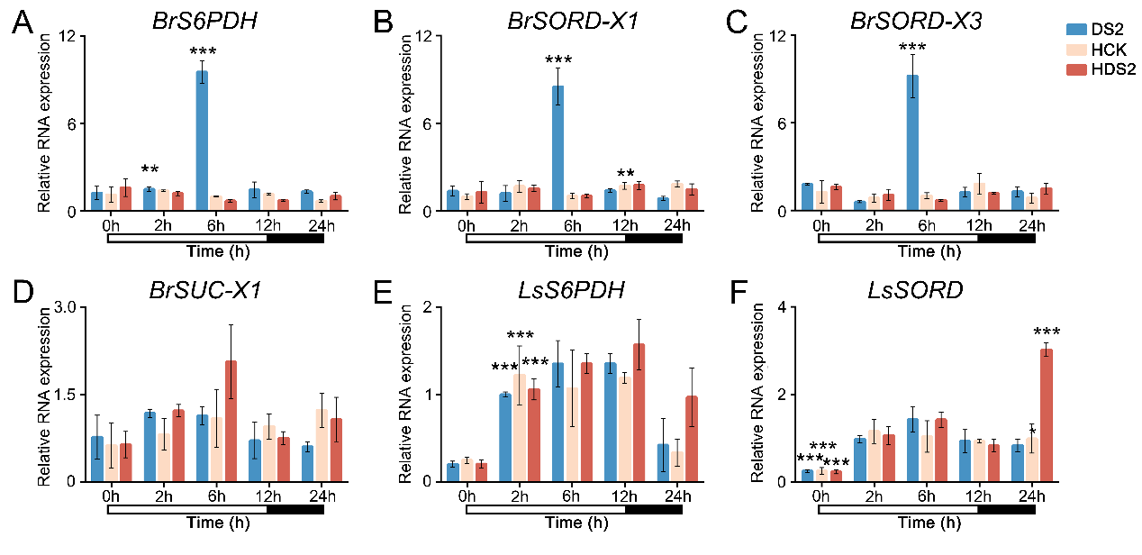

Extended Data Fig. 25 Light intensity and D-sorbitol induces the upregulation of canonical D-sorbitol-metabolizing enzymes gene expression in Brassica rapa and Lactuca sativa
A–D. Relative expression levels in Brassica rapa: BrS6PDH (A), BrSORD‑X1 (B), BrSORD‑X3 (C), and BrSUC‑X1 (D).
E, F. Relative expression levels in Lactuca sativa: LsS6PDH (E) and LsSORD (F).
DS2: 2g/L D-sorbitol+ PPFD: 300μmol m^{–2} s^{–l}, HCK: 0g/L D-sorbitol+ PPFD: 150μmol m^{–2} s^{–l}, HDS2: 2g/L D-sorbitol+ PPFD: 150μmol m^{–2} s^{–l}. In A–F, Samples were collected from 6-leaf seedlings of Brassica rapa and Lactuca sativa grown in a growth chamber under a 12-h light/12-h dark photoperiod at 26°C. All leaves from individual plants were harvested for RNA extraction at the start of the light period (8:00 AM, designated as 0 h) and four additional time points: 2 h (10:00 AM), 6 h (2:00 PM), 12 h (8:00 PM), and 24 h (8:00 AM the next day). White bars below the x-axis indicate the light period (0–12 h); black bars indicate the dark period (12–24 h). Statistical analysis was performed using Student’s t-test; compared with CK at the same time point, * p < 0.05, ** p < 0.01, ***p < 0.001. Data are presented as mean ± SD (n = 3 biological replicates).
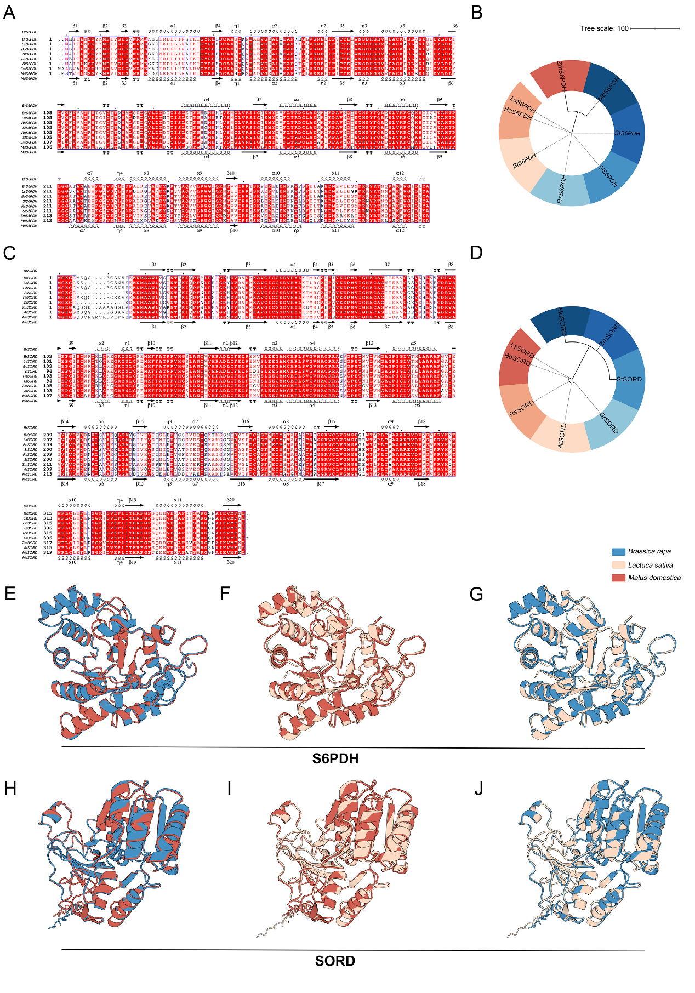

Extended Data Fig. 26 Sequence alignment and structural analysis of canonical D-sorbitol-metabolizing enzymes and their orthologous proteins in angiosperms
A, C. Sequence alignments of S6PDH (A) and SORD (C) with their angiosperm orthologs. Identical residues are shaded red, similar residues in red font, and conserved regions boxed in blue. Dots indicate gaps; secondary structures (β‑sheets/α‑helices) are annotated above/below the alignments.
B, D. Maximum‑likelihood phylogenetic trees of S6PDH (B) and SORD (D) orthologs, constructed in MEGA 7 (JTT model, 1000 bootstrap replicates; branches with > 50% support are labeled). Colors denote taxonomic families.
E–J. Structural alignments (modeled with AlphaFold 3) of S6PDH (E–G) and SORD (H–J) proteins across species, with each color representing a different plant.
S6PDH (NADP-dependent D-sorbitol-6-phosphate dehydrogenase), SORD (sorbitol dehydrogenase). All panels include species names and corresponding NCBI/BRAD sequence IDs (see Tab. S6).
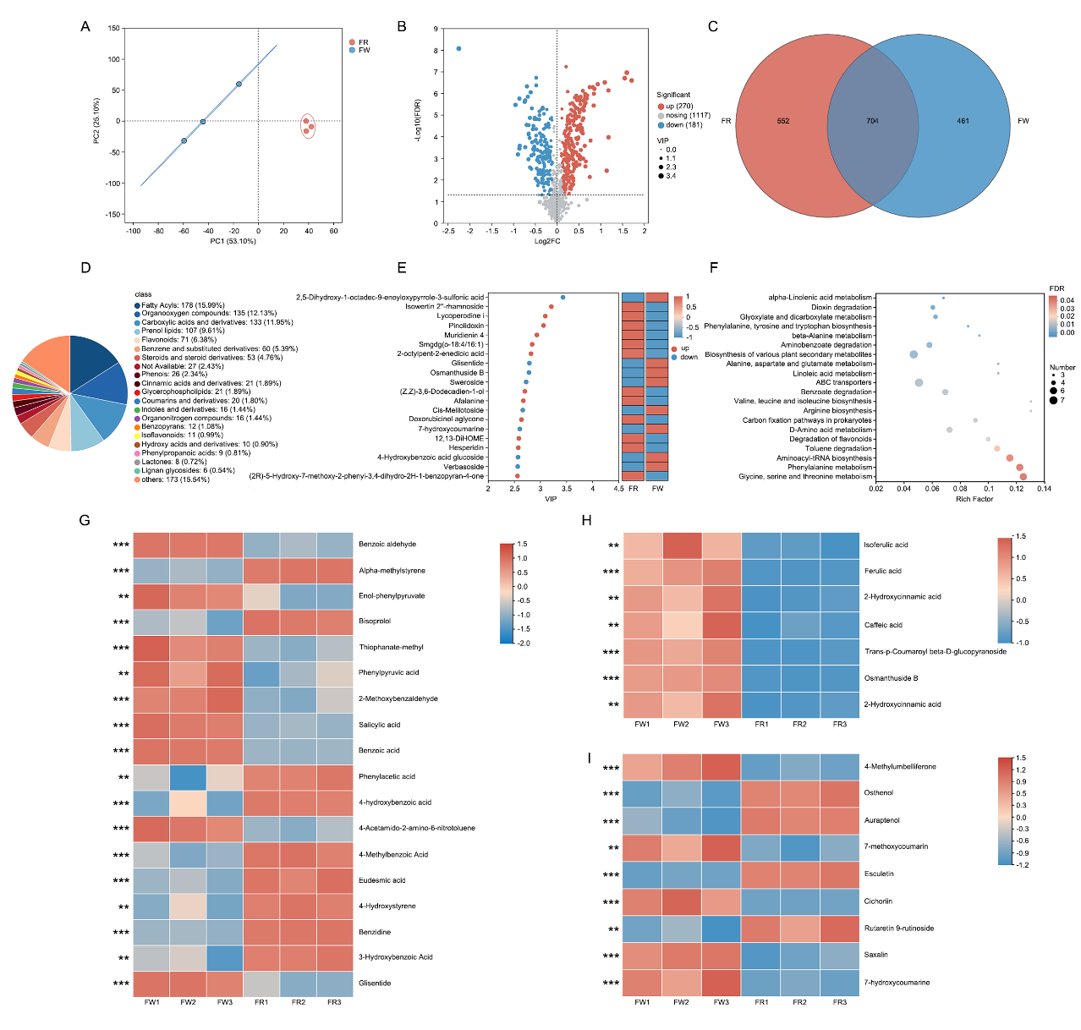

Extended Data Fig. 27 The LP-WCFS1-mediated rapid fermentation system significantly reduces the abundance of metabolites in the cinnamic acids and derivatives pathway in fresh watermelon aerial parts
A. Principal component analysis (PCA) of samples from FW and FR groups (blue and red, respectively; replicates are encircled).
B. Volcano plot of differential metabolites. All analyses were based on FDR < 0.05. Gray indicates no significant difference in gene expression; blue indicates significantly downregulated gene expression; red indicates significantly upregulated gene expression.
C. Venn diagram. Different colors represent comparison groups of differential metabolites.
D. HMDB compound classification at the class level; pie‑chart areas represent the relative proportions of metabolites in each class.
E. VIP value analysis: metabolites (y‑axis) ranked by descending VIP values (x‑axis).
F. KEGG pathway enrichment analysis. Bubble size corresponds to the number of enriched compounds; color gradient indicates significance (p‑value).
G–I. Differential metabolites in the benzene and substituted derivatives (G), cinnamic acids and derivatives (H), and coumarins and derivatives (I) pathways.
FW: Fresh watermelon aerial parts; FR: Fermentation residues. A two-tailed Student’s t-test was used to determine p values. * p < 0.05, ** p < 0.01, ***p < 0.001. Values are presented as the mean ± SD. All differential metabolite analyses were based on FDR. (n = 3 biological replicates).
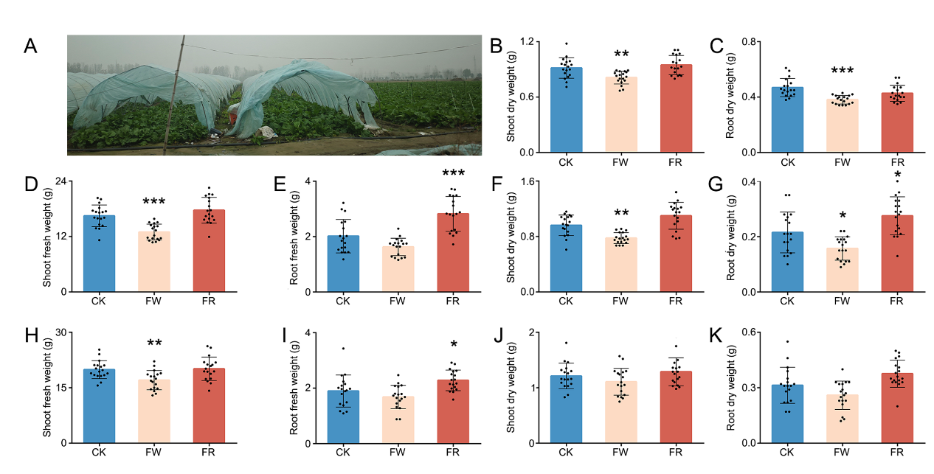

Extended Data Fig. 28 Returning fermentation residues from the LP-WCFS1-mediated rapid fermentation system to the root zone alleviates the growth inhibition of Brassica rapa compared with returning fresh stems and leaves to the root zone
A. Field practice of Brassica rapa rotated after watermelon harvest, photodocumented in Shangqiu, Henan, November 2025.
B–K. Biomass measurements of Brassica rapa: Beijing, 2023: shoot and root dry weight (B, C). Zhangjiakou, 2024: shoot and root fresh weight (D, E). Beijing, 2024: shoot fresh weight, root fresh weight, shoot dry weight, and root dry weight (H–K, respectively).
CK: No return to field; FW: 4 g/plant fresh watermelon aerial parts; FR: 2 g/plant fermentation residues. In B-K, n = 18 biological replicates, one-way analysis of variance (ANOVA) followed by Tukey’s multiple comparison test was used to determine the p values. *p < 0.05, ** p < 0.01, and *** p < 0.001. Values are presented as the mean ± SD.
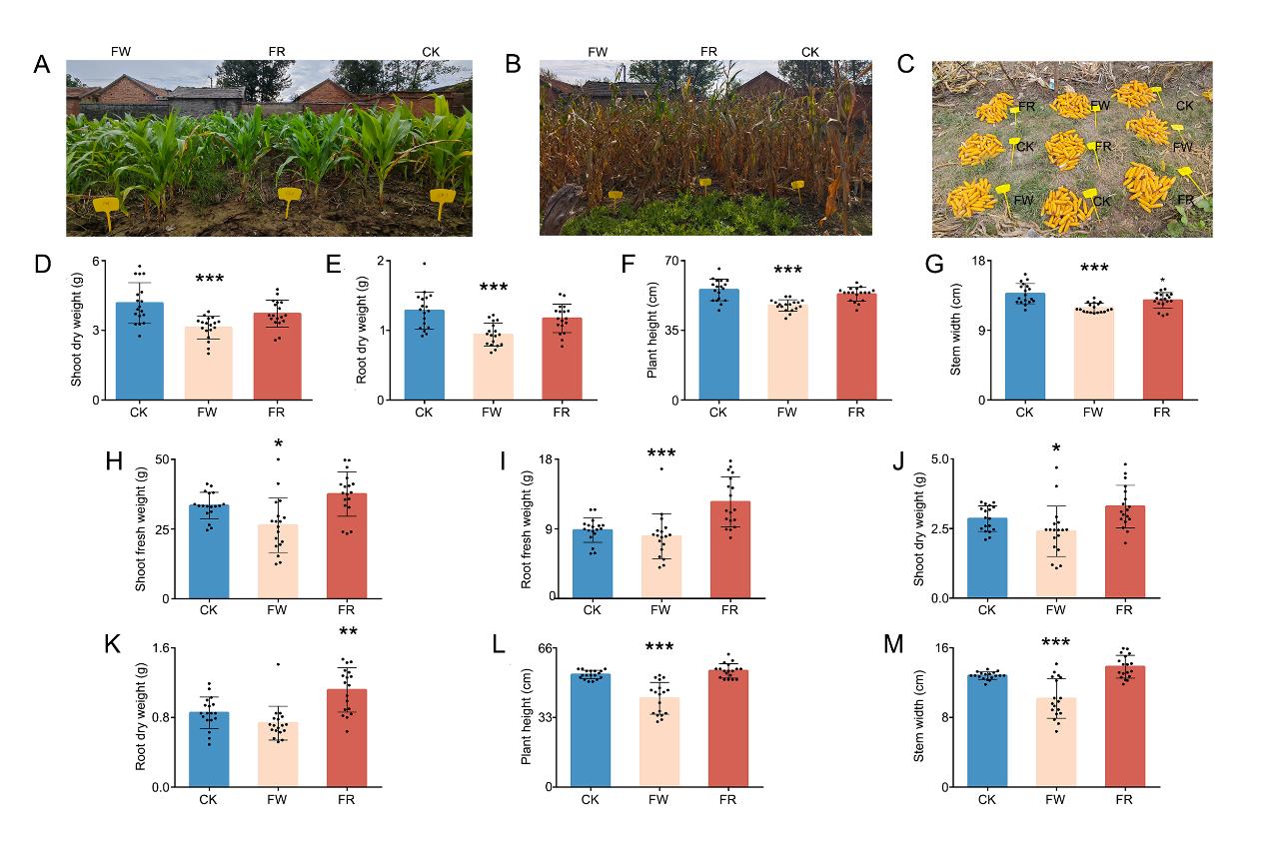

Extended Data Fig. 29 Returning fermentation residues from the LP-WCFS1-mediated rapid fermentation system to the root zone alleviates the inhibition of Zea mays growth and yield compared with returning fresh stems and leaves to the root zone
A. Phenotype of Zea mays seedlings following treatment under field conditions in Shangqiu, 2024.
B, C. Phenotype (B) and yield (C) of mature Zea mays under field conditions in Shangqiu, 2024.
D–G. Zea mays growth under solar greenhouse conditions in Beijing, 2024: shoot dry weight (D), root dry weight (E), plant height (F), and stem diameter (G).
H–M. Zea mays growth under growth chamber conditions in Zhangjiakou, 2024: shoot fresh weight (H), root fresh weight (I), shoot dry weight (J), root dry weight (K), plant height (L), and stem diameter (M).
CK: No return to field; FW: 4 g/plant fresh watermelon aerial parts; FR: 2 g/plant fermentation residues. In D - M, n = 18 biological replicates, one-way analysis of variance (ANOVA) followed by Tukey’s multiple comparison test was used to determine the p values. *p < 0.05, ** p < 0.01, and *** p < 0.001. Values are presented as the mean ± SD.
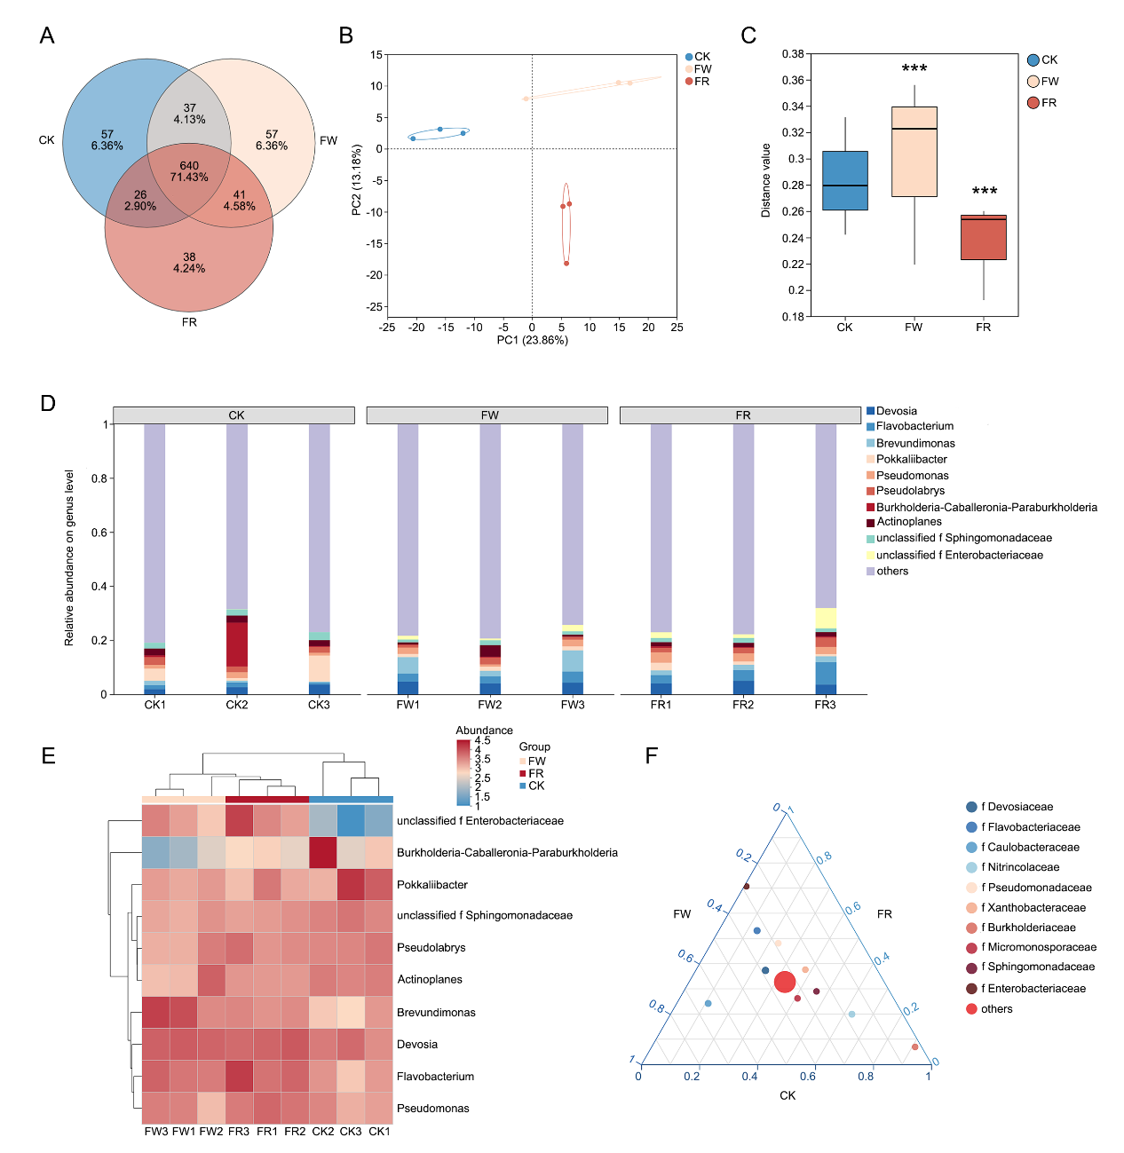

Extended Data Fig. 30 Returning fermentation residues from the LP-WCFS1-mediated rapid fermentation system to the root zone changed the rhizosphere microbial community structure
A. Venn diagram of microbial community structure.
B. Principal component analysis (PCA) of samples from CK, FW and FR groups (blue and red, respectively; replicates are encircled).
C. Analysis of intergroup differences in beta diversity. The y-axis represents beta diversity distance values between samples of different groups. Significant differences in community structure were observed among CK, FR, and FW groups.
D. Stacked bar chart of community composition. The x-axis denotes sample names, and the y-axis denotes the relative proportion of each species in the sample.
E. Heatmap of the top 10 dominant microbial species. The x-axis denotes sample names, and the y-axis denotes species names. Color gradients indicate changes in species abundance across samples, with the color scale on the right representing corresponding values.
F. Ternary plot. The three corners represent three sample groups, and the legend indicates taxonomic levels (e.g., phylum level). Solid circles in the plot represent species at the selected taxonomic level (other levels optional), with circle size corresponding to the average relative abundance of the species.
CK: No return to field; FW: 4 g/plant fresh watermelon aerial parts; FR: 2 g/plant fermentation residues. In C, n = 3 biological replicates, one-way analysis of variance (ANOVA) followed by Tukey’s multiple comparison test was used to determine the p values. *p < 0.05, ** p < 0.01, and *** p < 0.001. Values are presented as the mean ± SD.
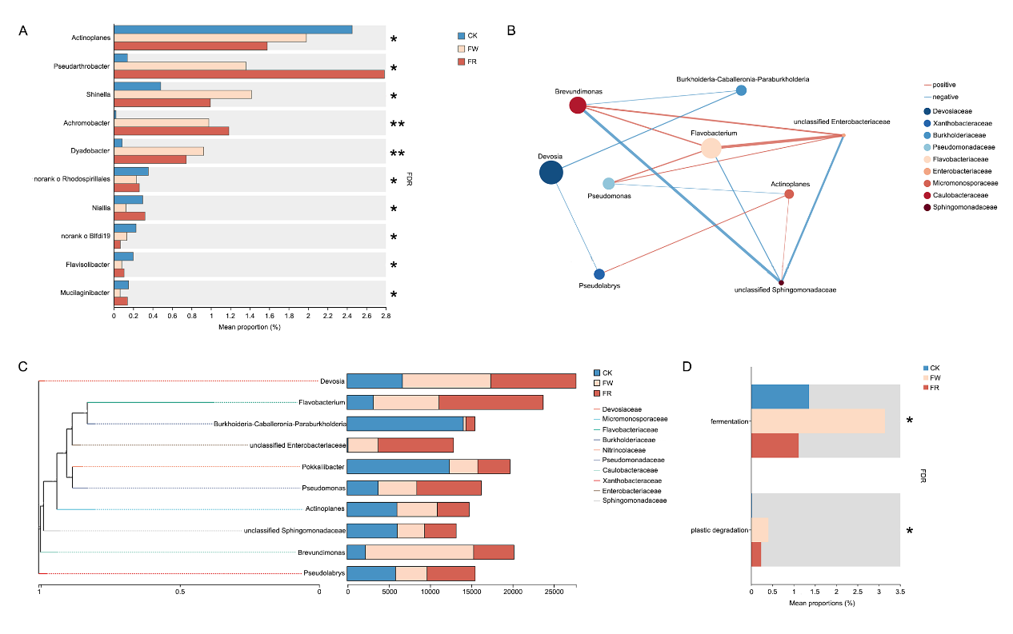

Extended Data Fig. 31 LP-WCFS1 rapid fermentation residues improve the rhizosphere microbial community structure of Chinese cabbage and reduce rhizosphere microbial fermentation functions
A. Differential abundance of species across groups, showing mean relative abundance (x‑axis) per species (y‑axis).
B. Single‑factor correlation network of the top 10 abundant species. Nodes represent species (size = abundance); edges show significant Spearman correlations (p < 0.05) with color indicating direction (red: positive, blue: negative) and thickness reflecting correlation strength.
C. Phylogenetic tree of species (left, colored by higher taxon, branch length = evolutionary distance) alongside bar charts of read proportions per group (right).
D. FAPROTAX-predicted functional profiles, displaying the relative abundance of each function across groups.
CK: No return to field; FW: 4 g/plant fresh watermelon aerial parts; FR: 2 g/plant fermentation residues. In A, D, n = 3 biological replicates, one-way analysis of variance (ANOVA) followed by Tukey’s multiple comparison test was used to determine the p values. *p < 0.05, ** p < 0.01, and *** p < 0.001. Values are presented as the mean ± SD.
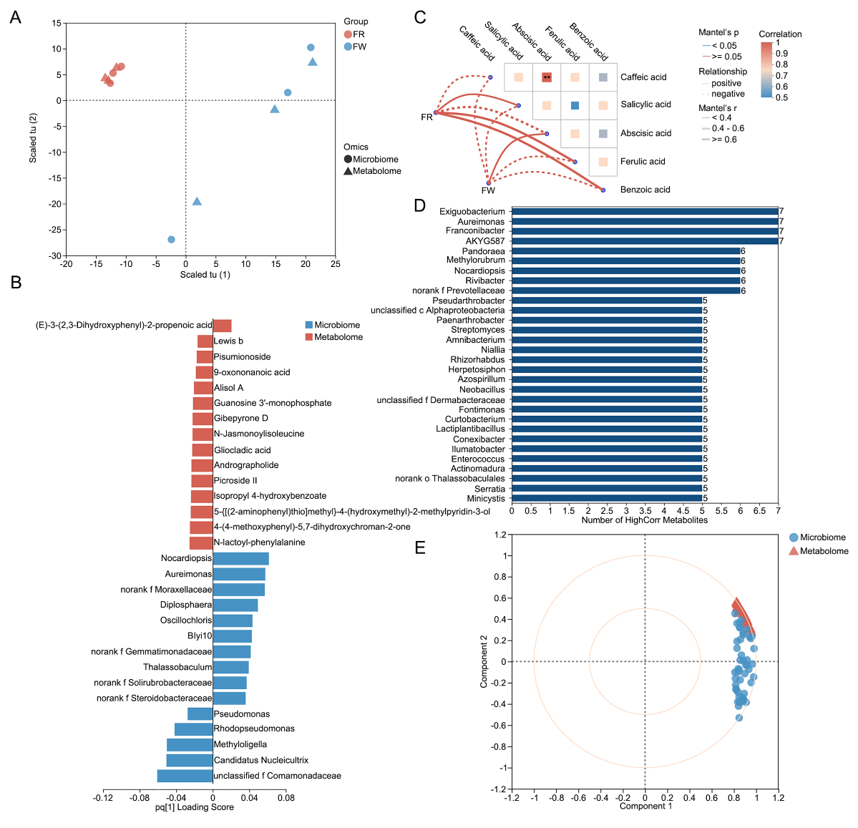

Extended Data Fig. 32 Metabolite differences between fresh watermelon aerial parts and fermentation residues influence the rhizosphere microbial community
A. O2PLS model integrating microbiome and metabolome datasets. Symbols represent omics samples (squares: microbiome; circles: metabolome), colored by group. Axes show combined scores (*t*: microbiome; *u*: metabolome). FW: 4 g/plant fresh watermelon aerial parts; FR: 2 g/plant fermentation residues.
B. O2PLS feature loadings for the top 15 species (blue) and top 15 metabolites (red). Bar length reflects absolute loading value (|pq₁|), indicating contribution to component variation; sign denotes direction of association between omics.
C. Mantel-test network heatmap. Lines denote microbiome–metabolite correlations (thickness ~ |Mantel’s *r*); heatmap shows metabolite–metabolite correlations (red: positive, blue: negative; asterisks indicate significance).
D. Frequency of high correlations between microbial diversity and metabolites, showing the 30 metabolites with the most associated microorganisms.
E. Canonical correspondence analysis (genus level). Blue dots: species; red triangles: metabolites. Distance from origin indicates strength of association; acute angles (< 90°) denote positive correlations, obtuse angles (> 90°) negative correlations. Inner/outer circles correspond to correlation coefficients of 0.5 and 1, respectively.
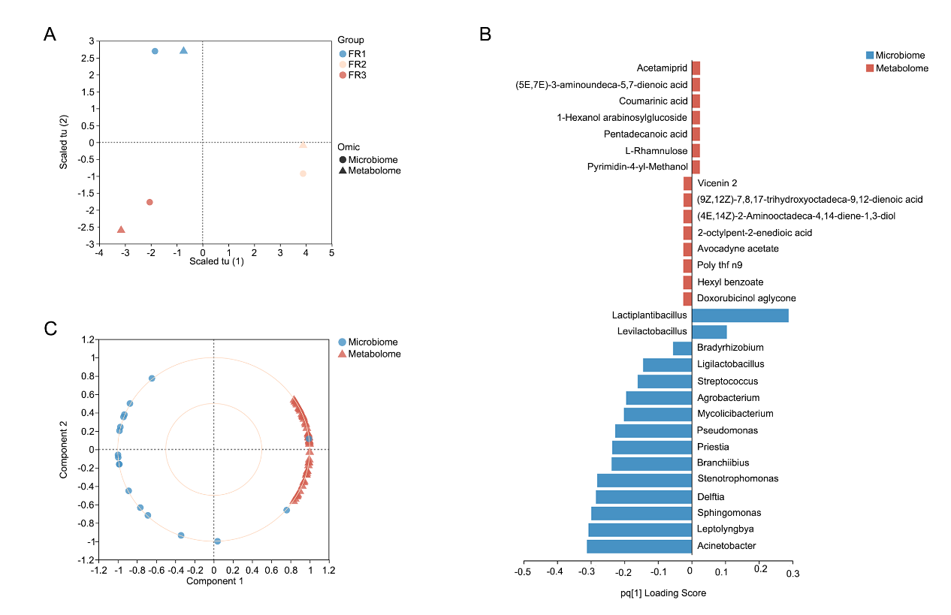

Extended Data Fig. 33 Microorganisms in the LP-WCFS1-mediated rapid fermentation system influence the metabolite composition of rapid fermentation residues
A. O2PLS model integrating microbiome and metabolome datasets (n = 3). Symbols represent omics samples (squares: microbiome; circles: metabolome), colored by group. Axes show combined scores (*t*: microbiome; *u*: metabolome). FL: 14 d; FR: Fermentation residues.
B. O2PLS feature loadings for the top 15 species (blue) and top 15 metabolites (red). Bar length reflects absolute loading value (|pq₁|), indicating contribution to component variation; sign denotes direction of association between omics.
C. Canonical correspondence analysis (genus level). Blue dots: species; red triangles: metabolites. Distance from origin indicates strength of association; acute angles (< 90°) denote positive correlations, obtuse angles (> 90°) negative correlations. Inner/outer circles correspond to correlation coefficients of 0.5 and 1, respectively.

