Appendix
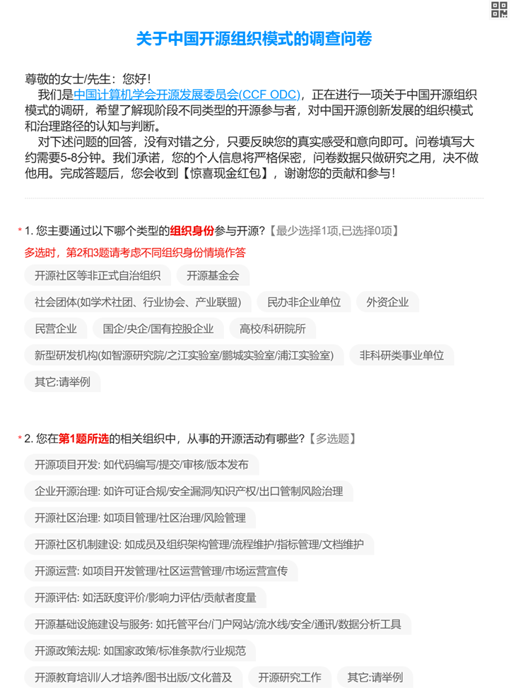

Figure A1 Survey interface (Chinese Version)

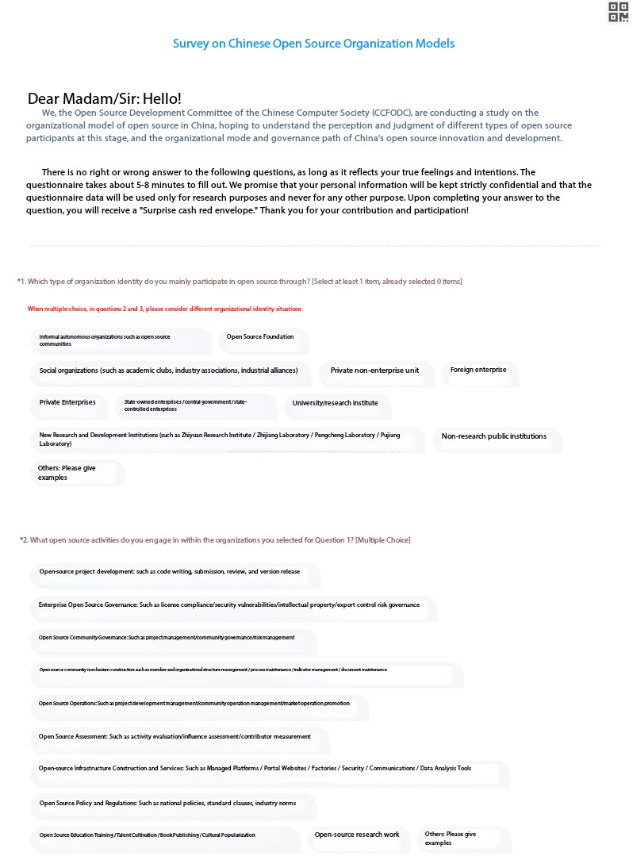

Figure A2 Survey interface (English Version)

Table A1 Summary of variables
Variables | Definitions | Measurements
OSAIOs types
Autonomies | OS organizations, often spearheaded by individual technical leaders and spontaneously formed on the Internet, encompass OS projects and their communities. These entities are typically guided by a few core technical leaders while engaging numerous highly decentralized participants. | Dummy variables
Bazaars | OS organizations consist of social entities, (e.g. academic associations), private non-enterprise entities, industry associations and federations, unofficial professional associations, and industry consortia. | Dummy variables
Firms | OS organizations consist of private enterprises, foreign-funded enterprises, Sino-foreign joint ventures, state-owned enterprises, state-owned holding enterprises, and other profit-making companies that drive OS projects and their ecosystem. | Dummy variables
Public institutions | OS organizations, led by governmental entities and their affiliated agencies such as OS foundations, central or local government departments, and research institutions designated and established under the supervision of authorities. | Dummy variables
Innovation outcomes
Knowledge convergence | The primary goal of OS innovation, which aims to facilitate the discovery of new knowledge through OS innovation activities, thereby generating a wide range of social values. | measured by multi-item scales with 5-point Likert scales (1 = completely disagree, 5 = completely agree)
Market diffusion | The second goal of OS innovation, which focuses on realizing commercial value-added and industrial applications through OS innovation activities.
Industrial collaboration | The third goal of OS innovation, which entails considering core contributors, peripheral users, related communities, organizations, and institutional environments involved in OS innovation as an ecological whole. The aim is to continuously stimulate various innovative entities to freely create and apply around OS projects.
Governance costs
Incentive coordination | The aggregation of costs arising from the disparity between organizational members’ actual engagement in OS activities and their perceived motivation for such participation. | Measured in standardized scales
Rule enforcement | The accumulation of innovation expenses resulting from the disparity between the OS organization’s preference for rule coordination in OS innovation and the judgment made by the collaborative core leader. | Measured in standardized scales
Value transformation | The disparity between the highest frequency of actual innovation output confirmed by OS organizations and the desired confirmation of output value that would better contribute to the development of OS ecology, thereby resulting in incurred governance costs. | Measured in standardized scales

Table A2 Summary of control variables (N=601)
Control variables | Definition | N | Mean | Medium | Std. dev. | Min. | Max.
Gender | The gender of respondents, 0=male 1=female | 601 | 0.250 | 0 | 0.440 | 0 | 1
Age | The birth period of respondents, 1=under 18 years old, 2=19 to 25 years old, 3=26 to 35 years old, 4=36 to 45 years old, 5=46 to 55 years old, 6= above 56 years old | 601 | 2.520 | 2 | 0.960 | 1 | 6
Education | The degree of highest educational attainment of respondents, 1=Junior high school or below, 2=High school (including technical secondary school), 3=Junior college, 4=Bachelor’s degree, 5=Master’s degree, 6=Doctoral degree | 601 | 4.830 | 5 | 0.900 | 1 | 6
Hour | The average daily time (in hours) respondents devote to open-source innovation-related activities on working days, 1=1 hour or less  2=More than 1 hour but less than or equal to 4 hours  3=More than 4 hours but less than or equal to 7 hours  4=8 hours or more | 601 | 1.750 | 2 | 0.790 | 1 | 4
Province GDP | Income level of the respondents’ usual province of residence, which is based on the survey data from the National Bureau of Statistics and the set standards of the IMF. The boundary point for 2022 is the per capita GDP of 85,700 yuan in the province. If the per capita GDP in the province in 2022 is equal to or higher than 85,700 yuan, it is classified as a relatively developed province (assigned a value of 0), otherwise it is classified as an underdeveloped province (assigned a value of 1). | 601 | 0.0700 | 0 | 0.260 | 0 | 1

Table A3 Summary of respondents’ demographics (N=601)
Characteristic | Category | Number | Percentage
Organizational Roles | Technical Contributor | 254 | 42.3%
Organizational Roles | Project Maintainer | 161 | 26.8%
Organizational Roles | Community Manager | 109 | 18.2%
Organizational Roles | Organization Leader | 77 | 12.7%
Experience in Open-source | <1 year | 47 | 7.8%
Experience in Open-source | 1-3 years | 112 | 18.6%
Experience in Open-source | 3-5 years | 215 | 35.8%
Experience in Open-source | >5 years | 227 | 37.8%
OSAIO types | Autonomies | 63 | 10.5%
OSAIO types | Bazaars | 359 | 59.7%
OSAIO types | Firms | 103 | 17.1%
OSAIO types | Public Institutions | 76 | 12.6%

Table A4 Robustness check for the results of knowledge convergence (OLS)
 | (1) | (2) |  | (3) |  | (4)
total disagreement
OSAIO types | 0.238** | -0.148 |  | -0.181** |  | -0.449**
OSAIO types | (0.281) | (0.329) |  | (0.280) |  | (0.299)
Incentive coordination costs |  | -0.869
Incentive coordination costs |  | -0.148
Rule enforcement costs rules |  |  |  | -0.328**
Rule enforcement costs rules |  |  |  | (0.159)
Value transformation costs |  |  |  |  |  | -6.265***
Value transformation costs |  |  |  |  |  | (1.100)
Constant | -1.007 | -0.078 |  | -0.446 |  | 14.130***
Constant | (1.733) | (2.223) |  | (1.829) |  | (2.637)
comparative disagreement
OSAIO types | 0.062 | 0.060 |  | -0.039 |  | -0.175**
OSAIO types | (0.483) | (0.549) |  | (0.482) |  | (0.584)
Incentive coordination costs |  | -0.227**
Incentive coordination costs |  | (0.107)
Rule enforcement costs rules |  |  |  | -0.162
Rule enforcement costs rules |  |  |  | (0.152)
Value transformation costs |  |  |  |  |  | -6.156***
Value transformation costs |  |  |  |  |  | (0.832)
Constant | -1.350 | -1.350 |  | -1.016 |  | 14.100***
Constant | (2.019) | (2.107) |  | (2.134) |  | (3.367)
neutrality
OSAIO types | -0.286* | -0.242 |  | -0.271* |  | -0.382**
OSAIO types | (0.156) | (0.172) |  | (0.156) |  | (0.166)
Incentive coordination costs |  | -0.167**
Incentive coordination costs |  | (0.080)
Rule enforcement costs rules |  |  |  | -0.096
Rule enforcement costs rules |  |  |  | (0.069)
Value transformation costs |  |  |  |  |  | -4.373***
Value transformation costs |  |  |  |  |  | (0.653)
Constant | 1.682* | 1.735* |  | 1.885* |  | 13.960***
Constant | (0.970) | (0.975) |  | (0.984) |  | (2.126)
comparative agreement
OSAIO types | -0.147** |  | -0.133 | -0.126 |  | 0.185
OSAIO types | (0.092) |  | (0.092) | (0.094) |  | (0.098)
Incentive coordination costs |  |  | -0.022
Incentive coordination costs |  |  | (0.018)
Rule enforcement costs rules |  |  |  | -0.119***
Rule enforcement costs rules |  |  |  | (0.033)
Value transformation costs |  |  |  |  |  | -2.615***
Value transformation costs |  |  |  |  |  | (0.324)
Constant | 0.982* |  | 0.964 | 1.222** | 8.571***
Constant | (0.589) |  | (0.590) | (0.595) | (1.173)
total agreement (baseline)
Control variables | INCLUDED
Pseudo R² | 0.032 | 0.057 |  | 0.061 |  | 0.061
Note：Robust standard errors in parentheses. * p < 0.1, ** p < 0.05, *** p < 0.01. Linear regression (OLS) with the continuous composite scores of the dependent variable (OSAIO types) were conducted in the robustness checks.

Table A5 Robustness check for the results of market diffusion (OLS)
 | (1) | (2) |  | (3) |  | (4)
total disagreement
OSAIO types | -0.591*** | -0.593** |  | -0.536** |  | -0.925***
OSAIO types | (0.280) | (0.286) |  | (0.291) |  | (0.295)
Incentive coordination costs |  | -1.131**
Incentive coordination costs |  | (1.057)
Rule enforcement costs rules |  |  |  | -0.457**
Rule enforcement costs rules |  |  |  | (0.230)
Value transformation costs |  |  |  |  |  | -3.994***
Value transformation costs |  |  |  |  |  | (1.047)
Constant | 1.218 | 2.501 |  | 1.916 |  | 10.480***
Constant | (1.721) | (2.604) |  | (1.842) |  | (2.702)
comparative disagreement
OSAIO types | 0.154 | 0.352 |  | 0.143 |  | -0.007
OSAIO types | (0.372) | (0.472) |  | (0.381) |  | (0.415)
Incentive coordination costs |  | -0.333*
Incentive coordination costs |  | (0.124)
Rule enforcement costs |  |  |  | 0.125*
Rule enforcement costs |  |  |  | (0.068)
Value transformation costs |  |  |  |  |  | -3.089*
Value transformation costs |  |  |  |  |  | (0.720)
Constant | -3.759** | -3.729* |  | -4.040** |  | 3.577
Constant | (1.825) | (1.929) |  | (1.830) |  | (2.984)
neutrality
OSAIO types | 0.010 | 0.016 |  | -0.009 |  | -0.037**
OSAIO types | (0.136) | (0.143) |  | (0.135) |  | (0.139)
Incentive coordination costs |  | -0.060
Incentive coordination costs |  | (0.050)
Rule enforcement costs rules |  |  |  | -0.009
Rule enforcement costs rules |  |  |  | (0.056)
Value transformation costs |  |  |  |  |  | -1.568***
Value transformation costs |  |  |  |  |  | (0.434)
Constant | -0.435 | -0.422 |  | -0.413 |  | 3.692**
Constant | (0.855) | (0.849) |  | (0.867) |  | (1.438)
comparative agreement
OSAIO types | 0.033** |  | 0.020** | 0.024** |  | 0.035**
OSAIO types | (0.095) |  | (0.095) | (0.096) |  | (0.108)
Incentive coordination costs |  |  | 0.020**
Incentive coordination costs |  |  | (0.018)
Rule enforcement costs rules |  |  |  | 0.043**
Rule enforcement costs rules |  |  |  | (0.034)
Value transformation costs |  |  |  |  |  | 3.413***
Value transformation costs |  |  |  |  |  | (0.355)
Constant | -1.192* |  | -1.164* | -1.276** | -11.170***
Constant | (0.608) |  | (0.610) | (0.611) | (1.271)
total agreement (baseline)
Control variables | INCLUDED
pseudo R² | 0.038 | 0.062 |  | 0.046 |  | 0.086
Note：Robust standard errors in parentheses. * p < 0.1, ** p < 0.05, *** p < 0.01. Linear regression (OLS) with the continuous composite scores of the dependent variable (OSAIO types) were conducted in the robustness checks.

Table A6 Robustness check for the results of industrial collaboration (OLS)
 | (1) | (2) |  | (3) |  | (4)
total disagreement
OSAIO types | -0.615*** | -0.610** |  | -0.555** |  | -1.058***
OSAIO types | (0.255) | (0.267) |  | (0.256) |  | (0.279)
Incentive coordination costs |  | -1.185**
Incentive coordination costs |  | (0.952)
Rule enforcement costs rules |  |  |  | -0.369**
Rule enforcement costs rules |  |  |  | (0.189)
Value transformation costs |  |  |  |  |  | -7.130***
Value transformation costs |  |  |  |  |  | (1.176)
Constant | 1.716 | 2.919 |  | 2.388 |  | 19.809***
Constant | (1.570) | (2.227) |  | (1.695) |  | (2.996)
comparative disagreement
OSAIO types | -0.105 | 0.216 |  | 0.105 |  | -0.083
OSAIO types | (0.450) | (0.503) |  | (0.462) |  | (0.486)
Incentive coordination costs |  | -0.127**
Incentive coordination costs |  | (0.062)
Rule enforcement costs rules |  |  |  | 0.103
Rule enforcement costs rules |  |  |  | (0.075)
Value transformation costs |  |  |  |  |  | -6.235***
Value transformation costs |  |  |  |  |  | (0.938)
Constant | -3.608* | -3.762* |  | -3.837** |  | 12.750***
Constant | (1.907) | (1.941) |  | (1.897) |  | (3.297)
neutrality
OSAIO types | -0.118 | -0.070 |  | -0.109 |  | -0.191
OSAIO types | (0.146) | (0.162) |  | (0.147) |  | (0.168)
Incentive coordination costs |  | -0.116
Incentive coordination costs |  | (0.074)
Rule enforcement costs rules |  |  |  | -0.042
Rule enforcement costs rules |  |  |  | (0.056)
Value transformation costs |  |  |  |  |  | -4.935***
Value transformation costs |  |  |  |  |  | (0.598)
Constant | 1.121 | 1.132 |  | 1.206 |  | 15.210***
Constant | (0.928) | (0.928) |  | (0.944) |  | (1.959)
comparative agreement
OSAIO types | 0.093** |  | -0.075 | -0.082 |  | -0.115
OSAIO types | (0.095) |  | (0.095) | (0.096) |  | (0.105)
Incentive coordination costs |  |  | -0.031*
Incentive coordination costs |  |  | (0.018)
Rule enforcement costs rules |  |  |  | -0.059*
Rule enforcement costs rules |  |  |  | (0.035)
Value transformation costs |  |  |  |  |  | -3.185***
Value transformation costs |  |  |  |  |  | (0.338)
Constant | 1.305** |  | 1.280** | 1.422** | 10.610***
Constant | (0.603) |  | (0.604) | (0.608) | (1.206)
total agreement (baseline)
Control variables | INCLUDED
pseudo R² | 0.042 | 0.067 |  | 0.050 |  | 0.087
Note：Robust standard errors in parentheses. * p < 0.1, ** p < 0.05, *** p < 0.01. Linear regression (OLS) with the continuous composite scores of the dependent variable (OSAIO types) were conducted in the robustness checks.

