Supplementary Figure 1
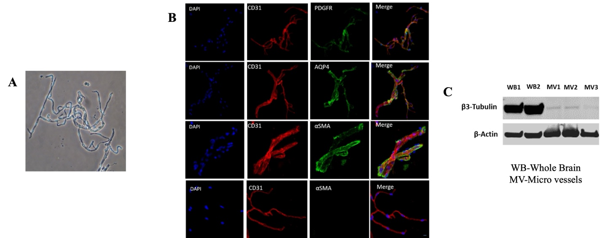
Supplementary Figure 1: Structural characterization of microvessels isolated from mouse brain cortex.
(A) Phase-contrast microscopy image showing freshly isolated cortical microvessels.
(B) Immunofluorescent staining of isolated microvessels demonstrating the presence of endothelial cells (CD31), pericytes (PDGFRβ), vascular smooth muscle cells (α-SMA), and astrocytes (AQP4).
(C) Western blot analysis for β3-tubulin, a neuronal marker, reveals markedly lower expression in isolated microvessels (MV1–3) compared to whole brain lysates (WB1–2), confirming minimal neuronal contamination.

Supplementary Figure 2
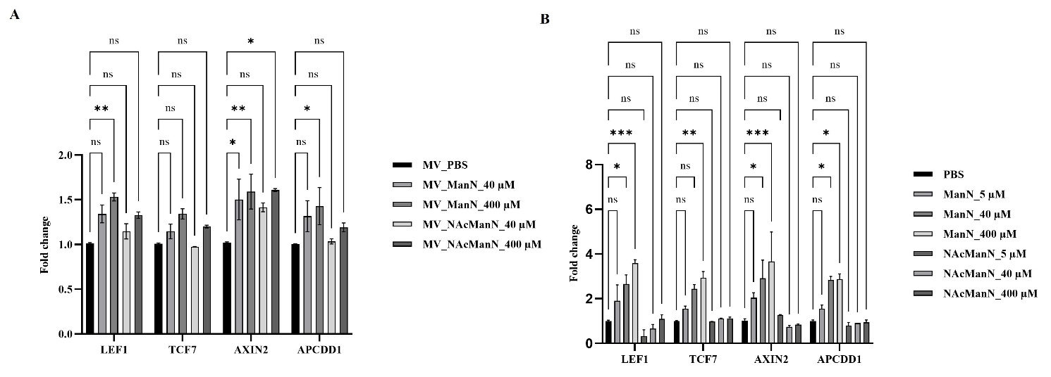
Supplementary Figure 2: ManN activates Wnt signaling in cerebral microvessels and brain microvascular endothelial cells (bEND.3).
(A) Brain-derived microvessels were treated with ManN for 6 hours. (B) bEND.3 cells were treated with ManN for 4 hours. Following treatment, total RNA was extracted, reverse transcribed into cDNA, and analyzed by qPCR to assess the expression of Wnt signaling downstream targets. The bar graph shows relative gene expression levels normalized to β-actin. No significant alterations were detected with the N-acetylated form of the compound. Data are expressed as mean ± SEM (n = 3, Two-way ANOVA). *p < 0.05, **p < 0.01, ***p < 0.001 compared to the PBS-treated group.

