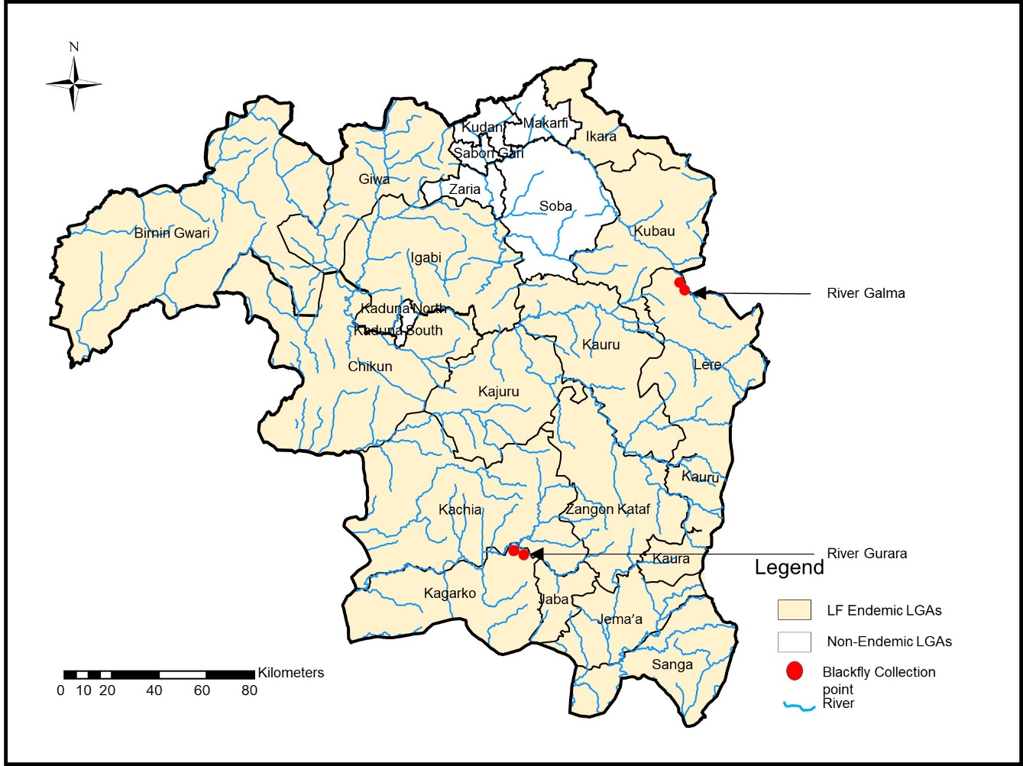
Figure 1: Map of Kaduna Showing collection sites

