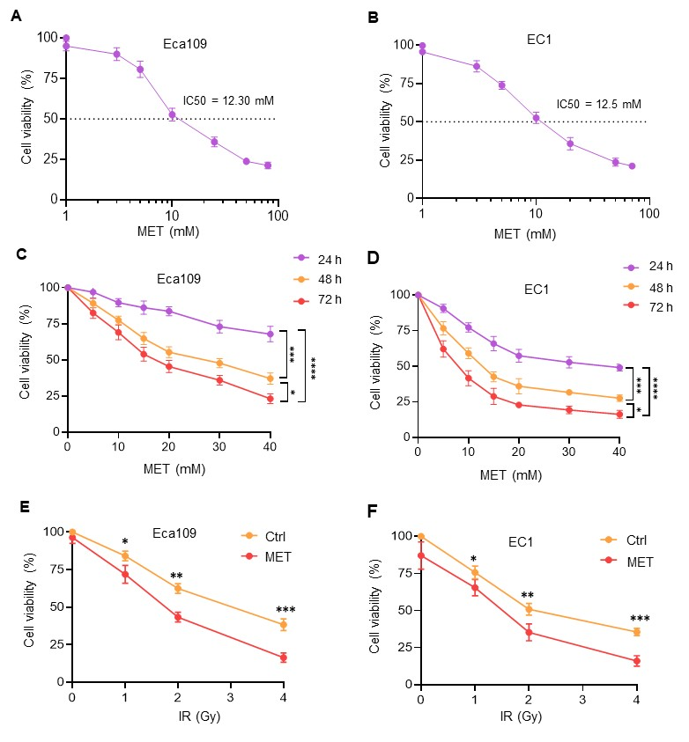
Fig. E1. MET increases IR-induced cell death.
(A, B) The cytotoxicity of MET in ESCC cells. CCK8 assay determines the IC50 value of MET in Eca109 and EC1 cell lines treated with increasing doses of MET. (C, D) The cytotoxicity in MET-treated ESCC cells at different treatment times (n=4). (E, F) MET-enhanced radiosensitization in ESCC cells (n=4). Data are presented as mean ± SD; * (p < 0.05), ** (p < 0.01), *** (p < 0.001), **** (p < 0.0001); t-test in (E, F); one-way ANOVA in (C, D).

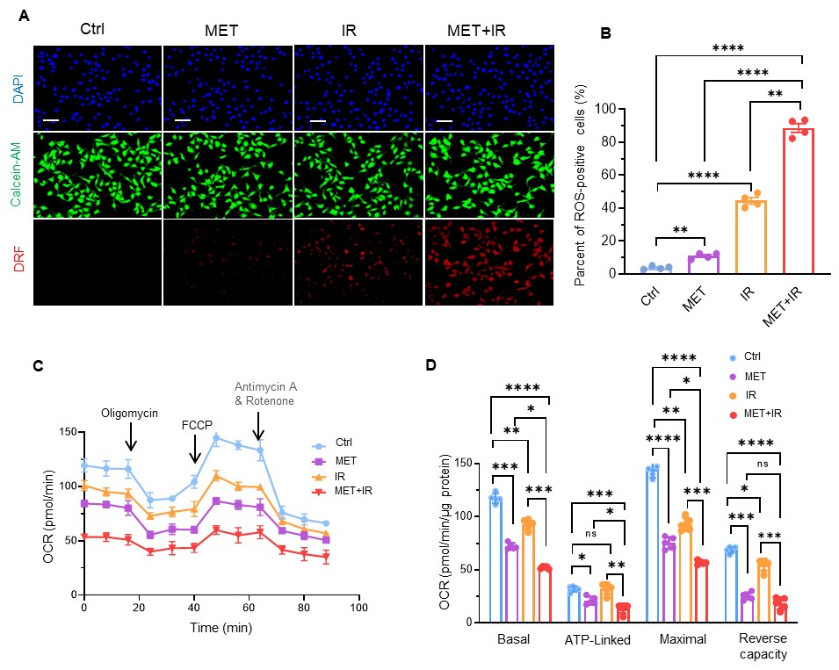
Fig. E2. MET enhances IR-induced intracellular ROS in EC1 cells.
(A, B) Fluorescent microscope with a DRF probe measures ROS in EC1 cells treated with MET, IR, or a combination of MET and IR. Calcein-AM dye was used to determine the total cells planted. (C, D) The Seahorse XT analyzer quantifies mitochondrial respiration by measuring OCR in EC1 cells treated with mM MET, IR, or both combined (n=4). Data are shown as mean ± SD; * (p < 0.05), ** (p < 0.01), *** (p < 0.001), **** (p < 0.0001); one-way ANOVA. Scale bars: 100 μm (A).

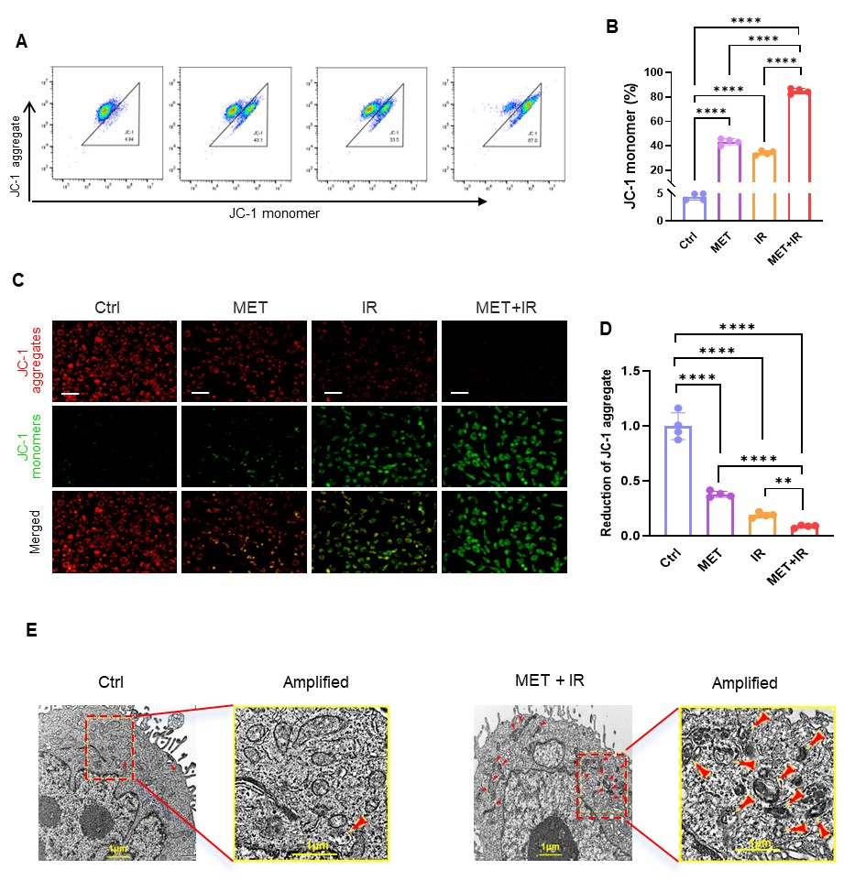
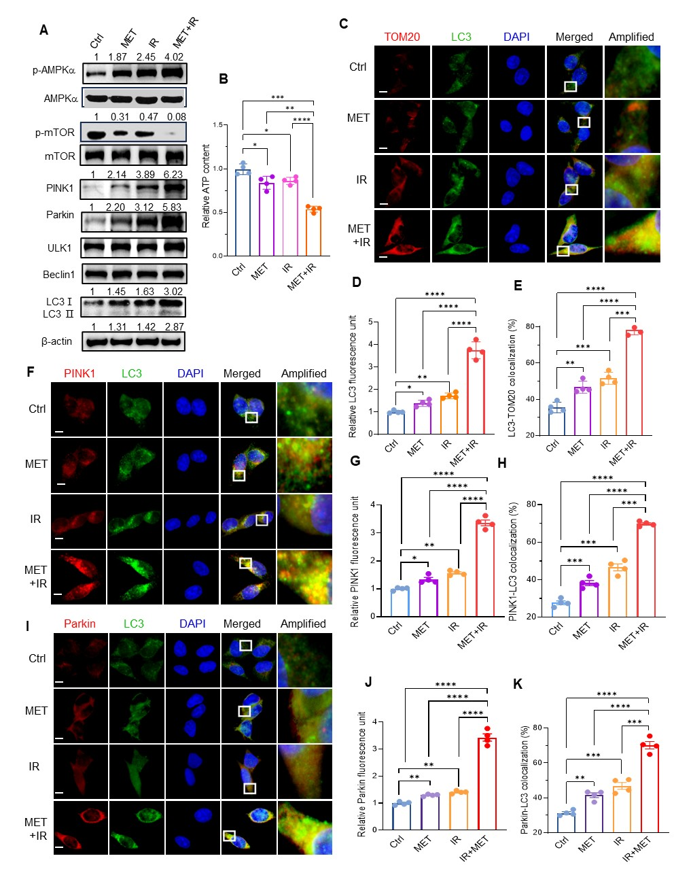
Fig. E3. MET and IR treatment affect mitochondrial structure in EC1 cells.
(A, B) Flow cytometry analyses the levels of JC-1 monomer in EC1 cells treated with MET, IR, or their combinations (n=4). (C, D) Fluorescent imaging of JC-1 aggregate form and monomer forms in the cells (n=4). (E) TEM analyzes mitochondrial damage in EC1 cells treated with MET and IR, as indicated by the red arrows. Data are presented as mean ± SD; ** (p < 0.01), *** (p < 0.001), **** (p < 0.0001); one-way ANOVA. Scale bars: 1 μm in (E).
Fig. E4. MET enhances IR-induced mitophagosome in EC1 cells.
- EC1 cells were treated with 5 mM MET, 2 Gy of IR, or both combined. Immunoblot quantifies the levels of mitophagosome-associated proteins in the cells. The fold changes in protein levels are indicated above the relative blots, except for LC3II, which is shown below the blots. (B) ATP production in the cells (n=4). (C) Confocal microscopy captures the images of LC3 (green fluorescence) and mitotracker TOM20 (red fluorescence) with DAPI nuclear staining in the cells. The merged signals were amplified from small areas indicated by white boxes. (D) The relative LC3 image in the treated cells (n=4). (E) Colocalization of LC3-TOM20 image (Co-I, %) was calculated using ImageJ (n=4). (F) Confocal microscopy captures the image of PINK1 (red fluorescence). (G, H) The colocalization of LC3-PINK1 in the cells (n=4). (I) Confocal microscopy captures the image of Parkin (red fluorescence). (J, K) The colocalization of LC3-Parkin in the cells (n=4). Data are presented as mean ± SD, * (p < 0.05), ** (p < 0.01), *** (p < 0.001), **** (p < 0.0001); one-way ANOVA. Scale bars: 20 μm (C, F, I).
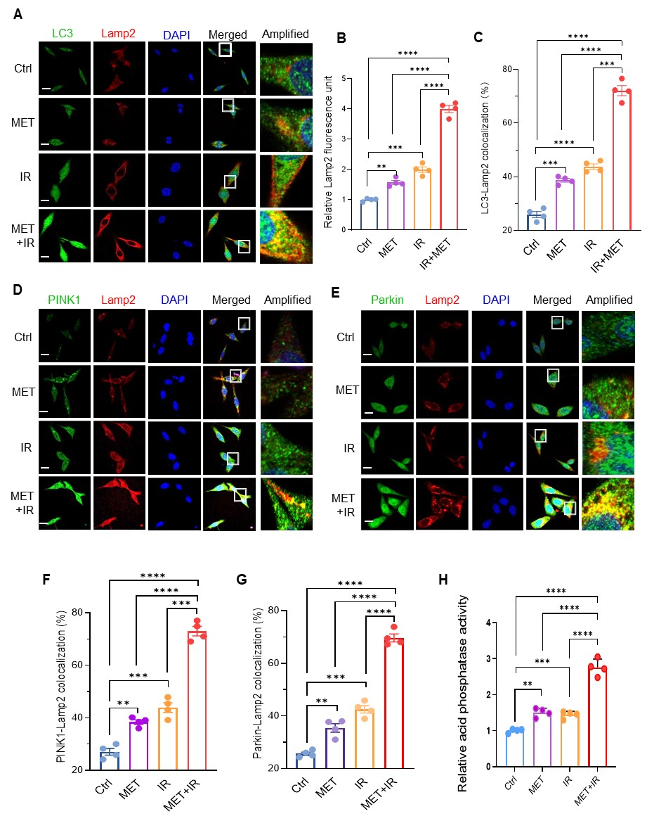

Fig. E5. MET enhances IR-induced autophagolysosome fusion in EC1 cells.
(A) After treatment as indicated, confocal microscopy captures the images of LC3 (green fluorescence) and Lamp2 (red fluorescence) with DAPI nuclear staining in the cells. The merged signals were amplified from small areas indicated by white boxes. (B) The relative Lamp2 image in the treated cells (n=4). (C) The LC3-Lamp2 colocalization (Co-l, %) was calculated using ImageJ (n=4). (D, E) Confocal microscopy captures the images of PINK1 (green fluorescence) to analyze PINK1-Lamp2 colocalization in the cells (n=4). (F, G). Confocal microscopy captures the images of Parkin (green fluorescence) to analyze Parkin-Lamp2 colocalization in the cells (n=4). (H) The relative acid phosphatase activities in the treated cells (n=4). Data are presented as mean ± SD; ** (p < 0.01), *** (p < 0.001), **** (p < 0.0001); one-way ANOVA. Scale bars: 20 μm (A, D, E).

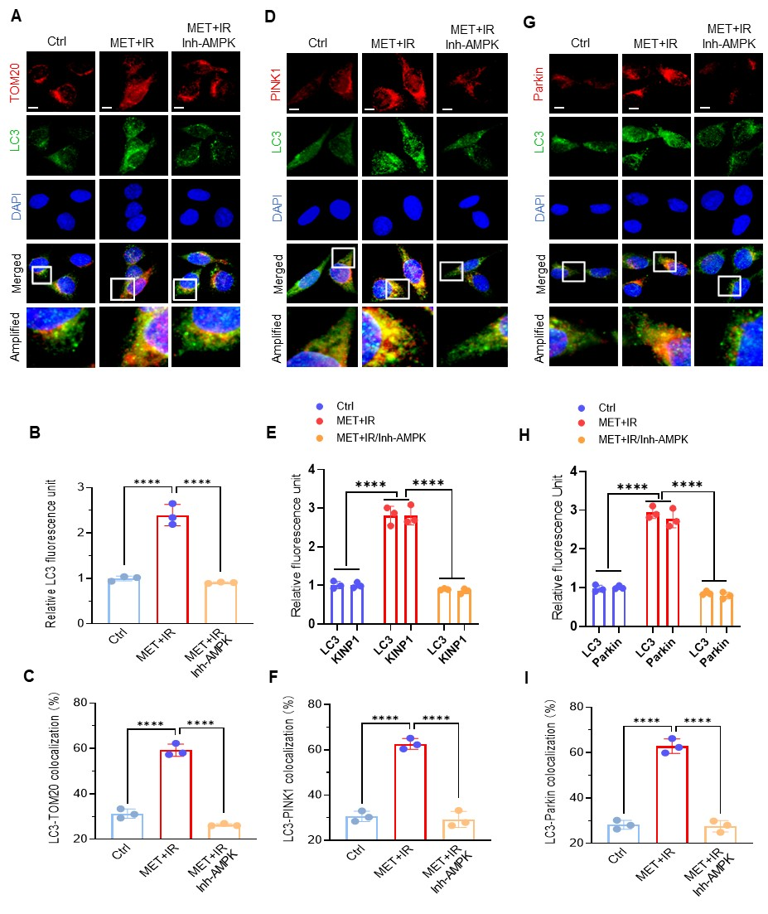
Fig. E6. AMPK inhibitor blocks treatment-induced mitophagy.
(A) Eca109 cells were pretreated with the AMPK inhibitor and then treated with MET, IR, or both combined. Confocal microscopy analyzes the colocalization of LC3-TOM20 in the cells. The merged signals were amplified from small areas indicated by white boxes. (B) The relative LC3 image normalized in the cells (n=4). (C) The LC3-TOM20 colocalization (Co-l, %) was calculated using ImageJ (n=4). (D, E, F) The effect of the AMPK inhibitor on the images of LC3, PINK1, and LC3-PINK1 colocalization in the cells (n=4). (G, H, I) The effect of the AMPK inhibitor on the images of LC3, Parkin, and LC3-Parkin colocalization in the cells (n=4). Data are presented as mean ± SD; **** (p < 0.0001); t-test. Scale bars: 20 μm (A, D, G).

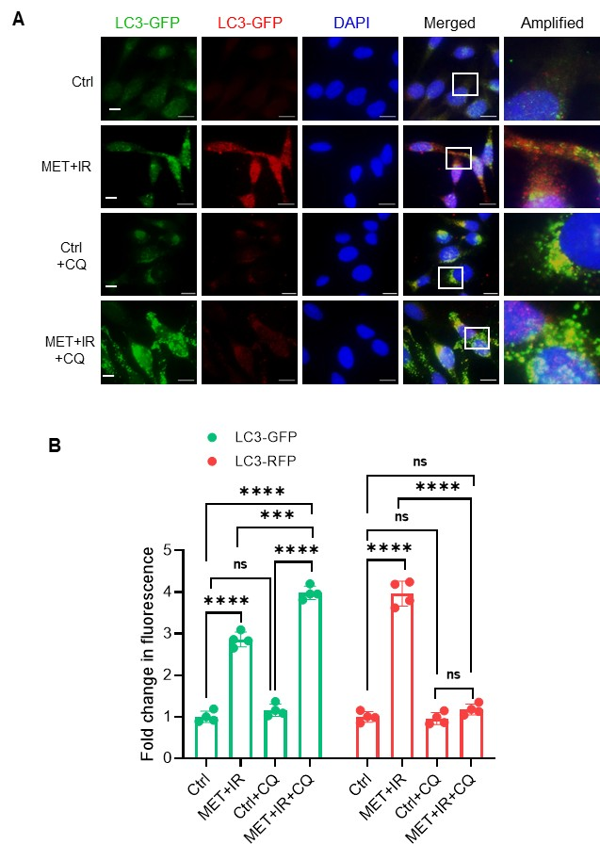
Fig. E7. CQ increases mitophagosome by inhibiting autophagolysosome in EC-1 cells.
(A) Dual fluorescence-cogitated LC3 was ectopically expressed in EC1 cells. After treatment, mitophagosomes and autophagolysosomes were analyzed by quantifying green and red fluorescence. (B) The fold changes in dual fluorescence intensities in the treated cells were normalized with the untreated cells (n=4). Data are presented as mean ± SD; (p < 0.01), *** (p < 0.001), **** (p < 0.0001), ns, no significance; one-way ANOVA. Scale bars: 15 μm (A).

