Supplementary

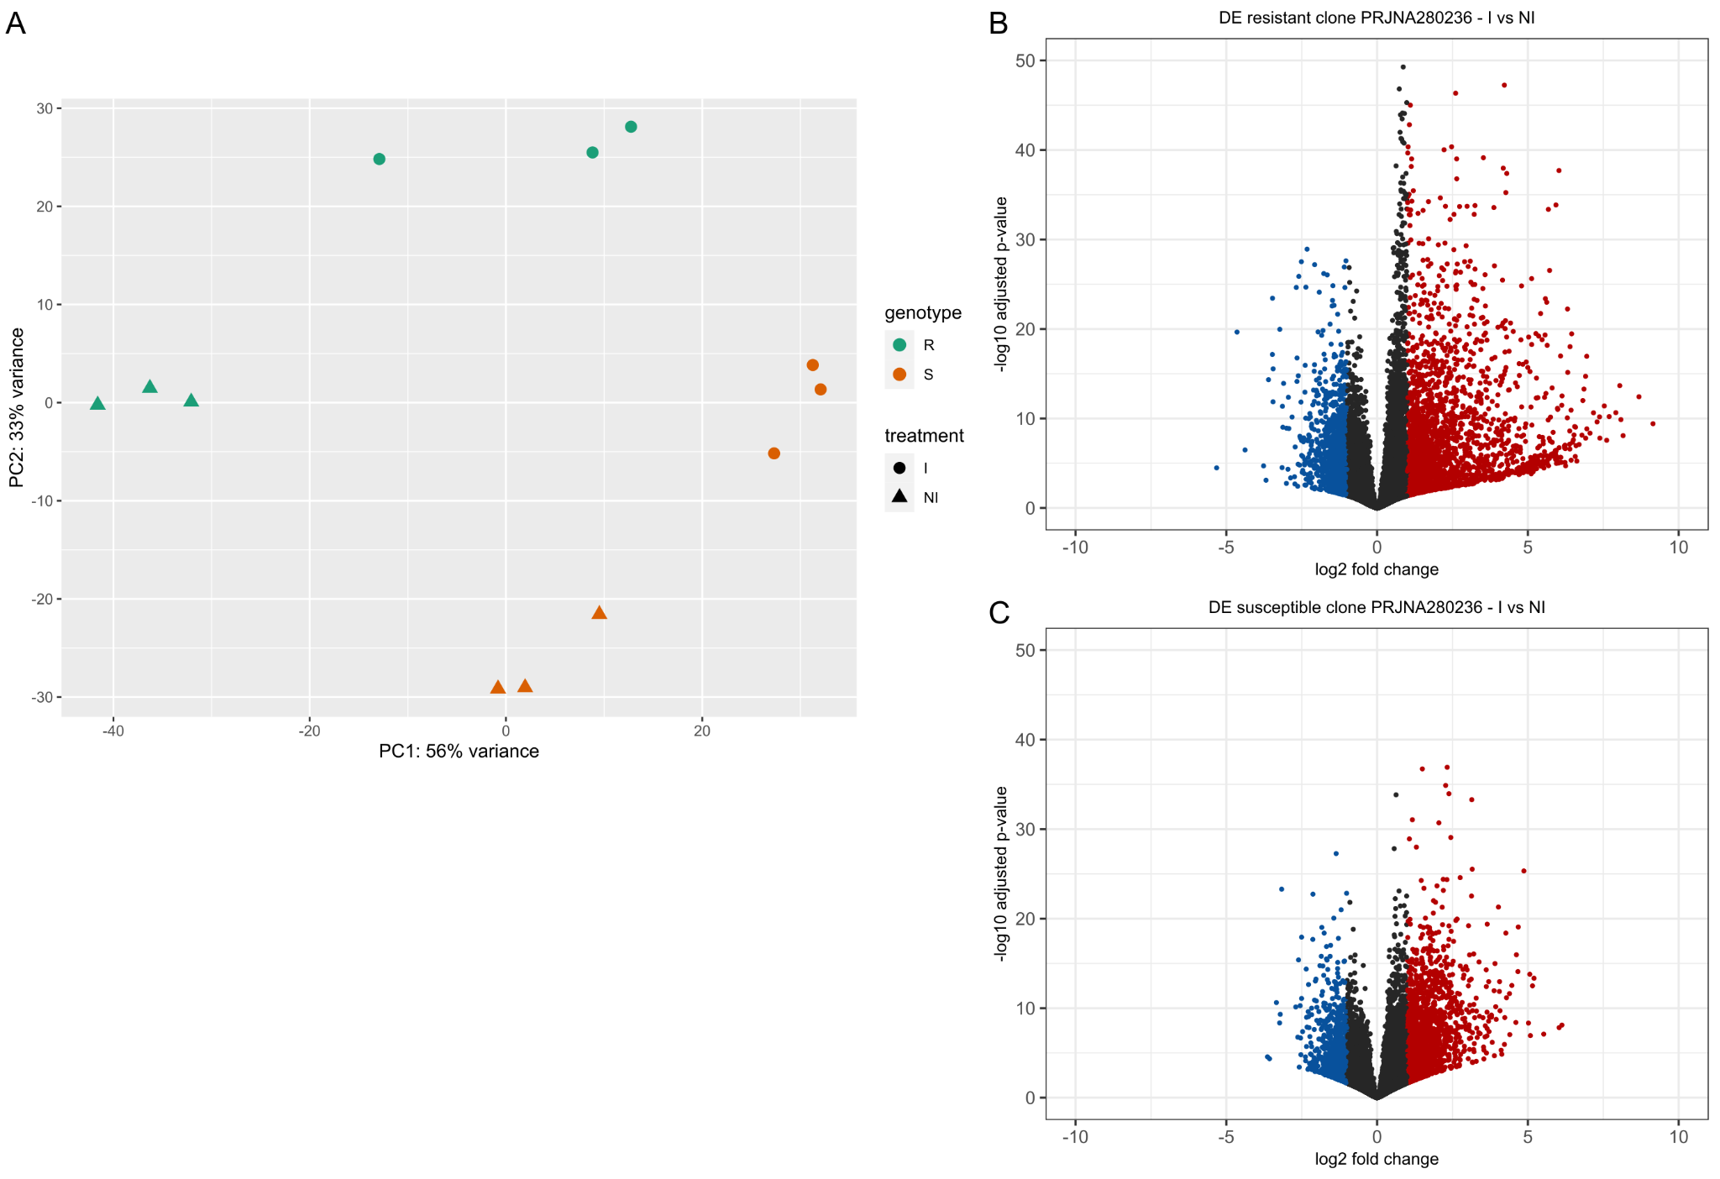
Suppl. Inf. 2 PCA and volcano plots of RNAseq assays included on the meta-analysis for Chrysoporthe austroafricana. A. PCA showing sample separation by genotype (resistant, R; susceptible, S) and treatment (inoculated, I; non-inoculated, NI). B, C. Volcano plots for the resistant (B) and susceptible (C) clones, showing the distribution of differentially expressed (DE) genes between inoculated (I) and non-inoculated (NI) conditions.

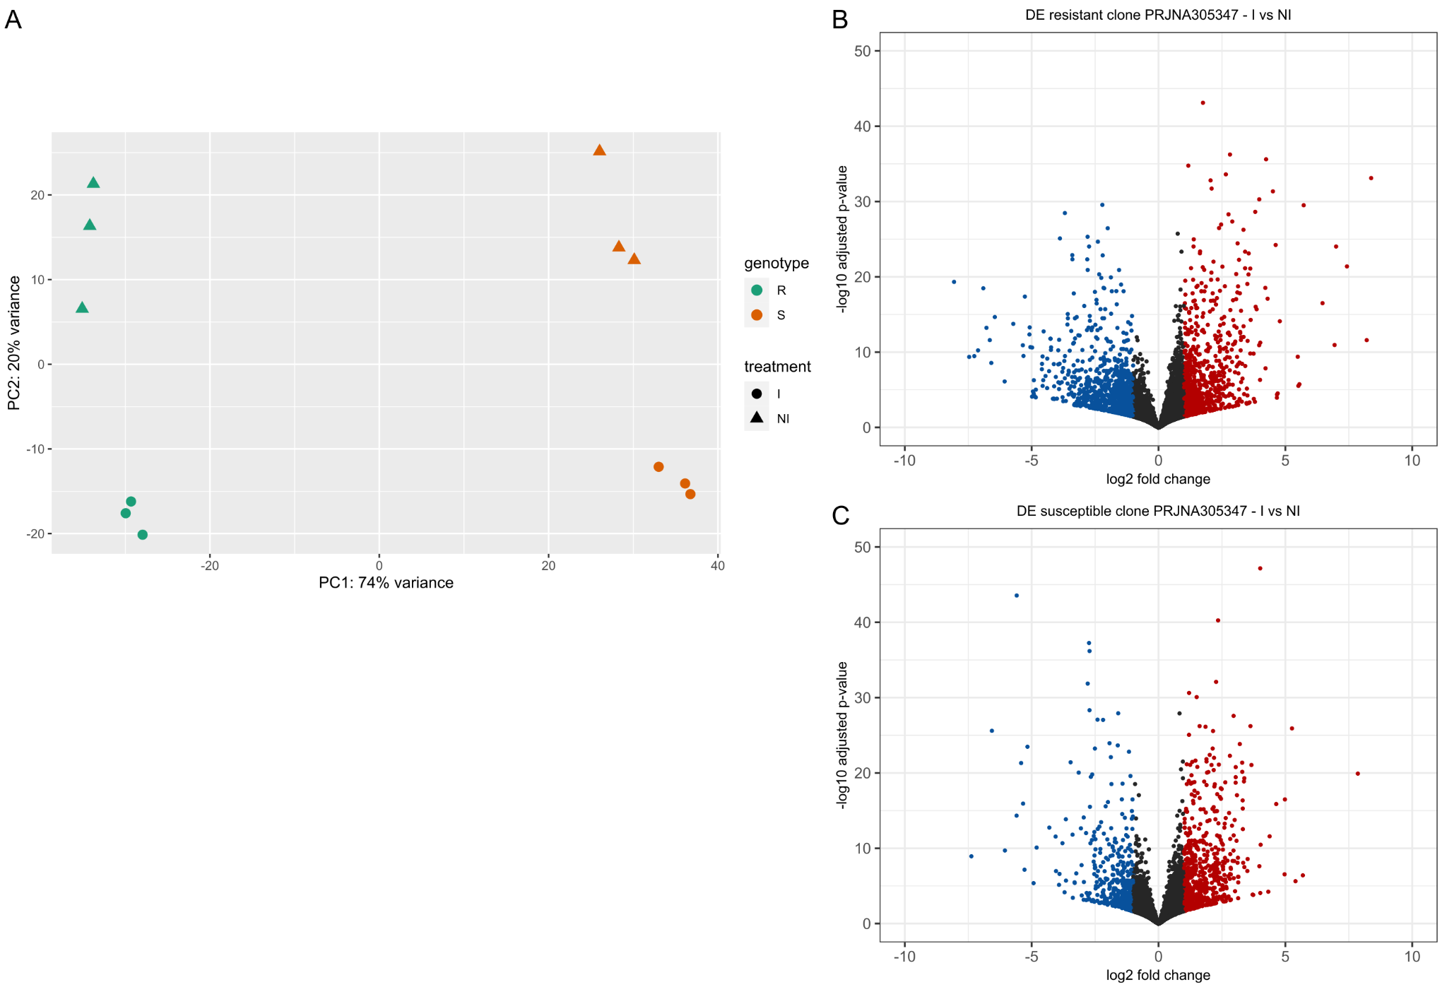
Suppl. Inf. 3 PCA and volcano plots of RNAseq assays included on the meta-analysis for Leptocybe invasa. A. PCA showing sample separation by genotype and treatment. B, C. Volcano plots for the resistant (B) and susceptible (C) clones, showing the distribution of differentially expressed (DE) genes between inoculated (I) and non-inoculated (NI) samples.

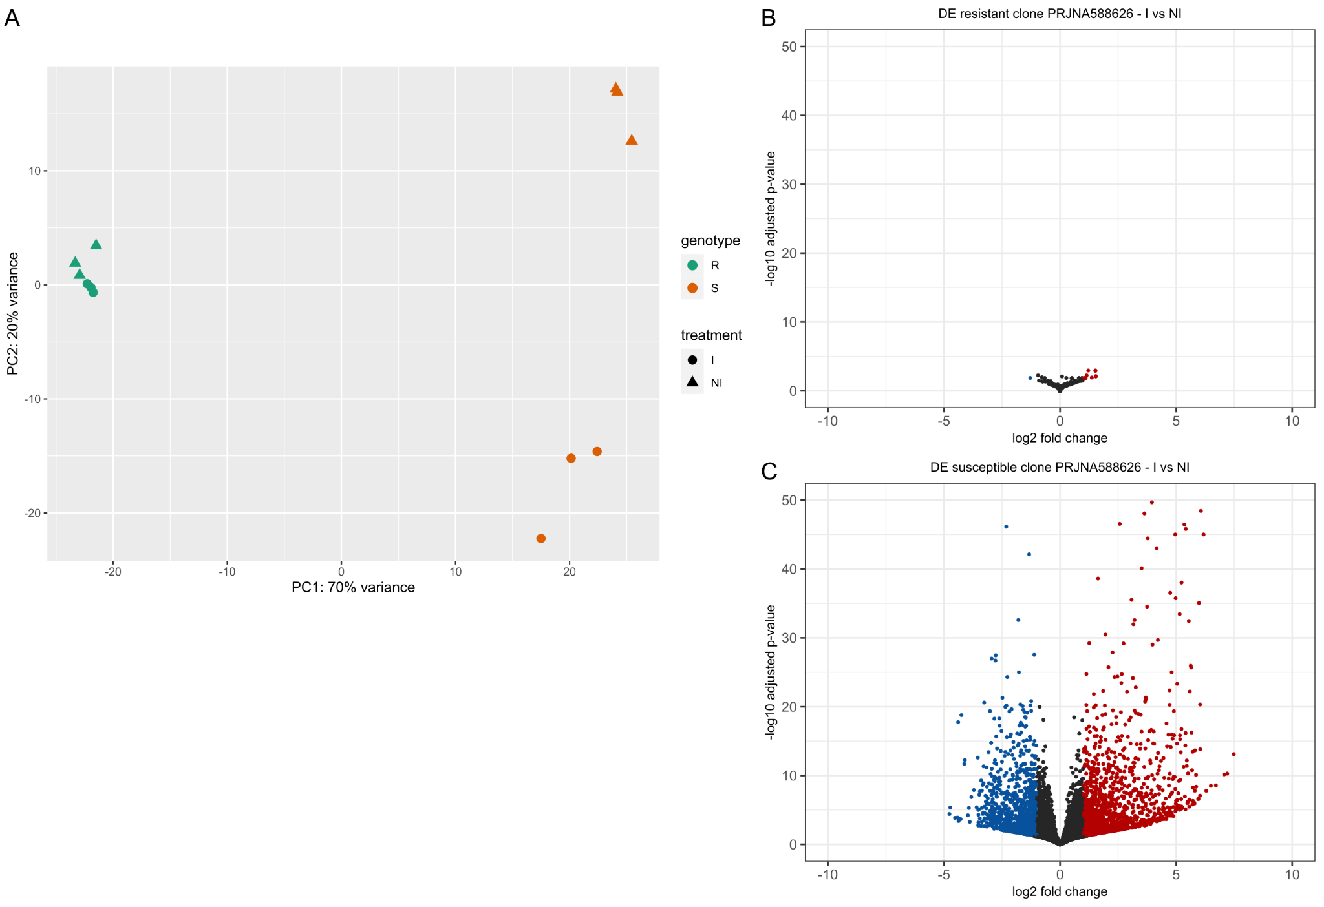
Suppl. Inf. 4 PCA and volcano plots of RNAseq assays included on the meta-analysis for Austropuccinia psidii. A. PCA showing sample separation by genotype and treatment. B, C. Volcano plots of differentially expressed genes for the resistant (B) and susceptible (C) clones (I vs NI). DE results from the resistant clone (panel B) were not considered in subsequent analyses.

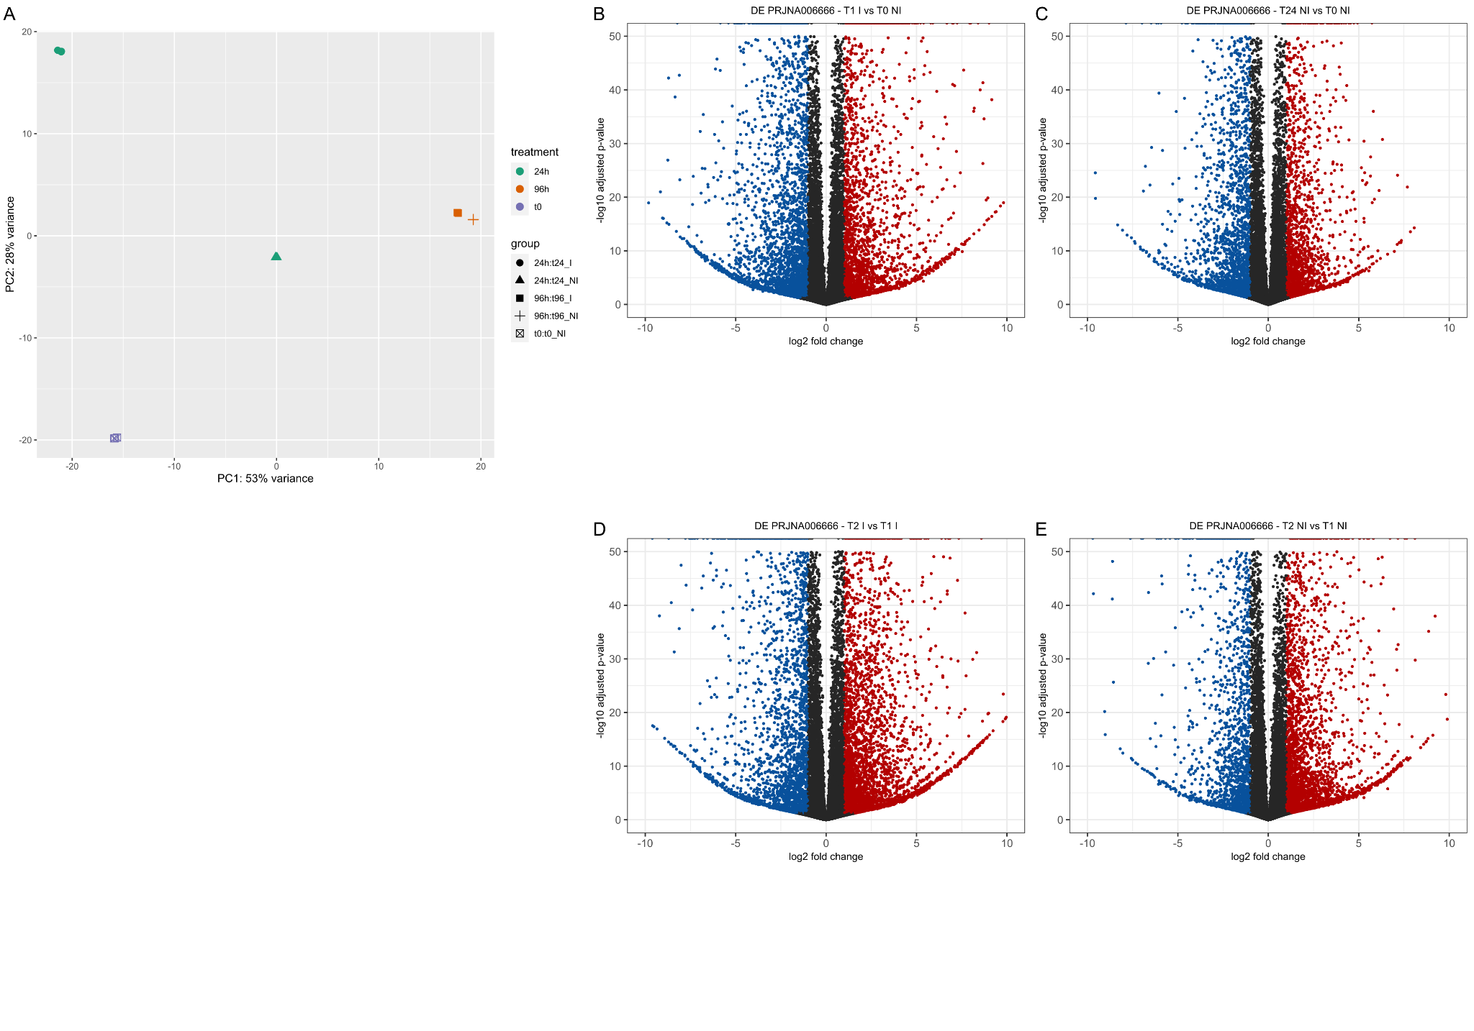

Suppl. Inf. 5 PCA and volcano plots of RNAseq assays included on the meta-analysis for Ralstonia solanacearum. A. PCA showing the separation of samples according to treatment (24 h, 96 h, T0) and inoculation status (I vs NI). B, E. Volcano plots of differentially expressed genes for each comparison (T1 I vs T0 NI, T24 NI vs T0 NI, T2 I vs T1 I, T2 NI vs T1 NI).

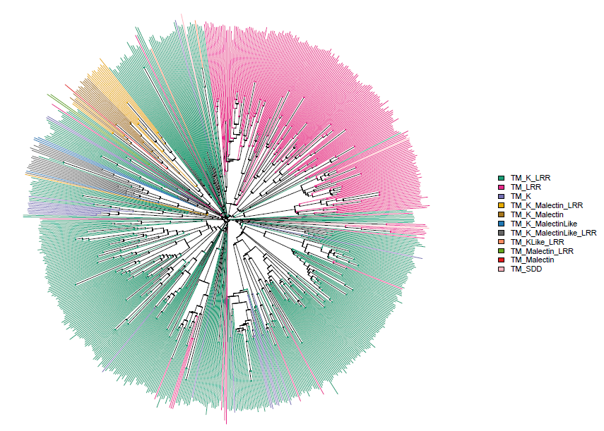

Suppl. Inf. 6 Phylogenetic tree for the 730 PRR by categories identified.

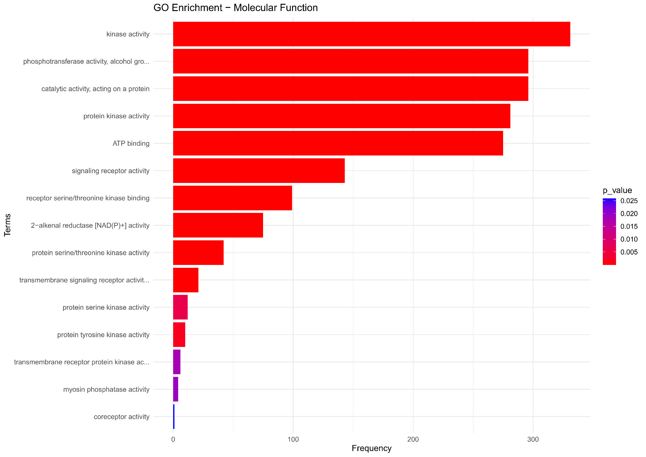
Suppl. Inf. 7A New annotation GO (Molecular Function) enrichment for the 730 PRR genes identified by the three strategies.

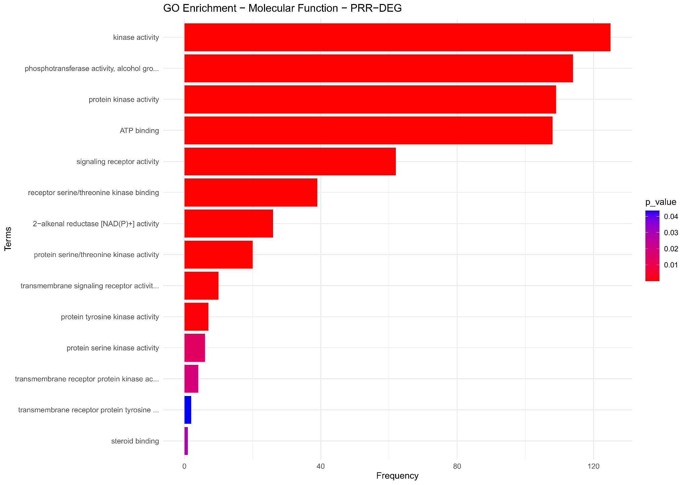
Suppl. Inf. 7B New annotation GO Enrichment (Molecular Function) for the 283 PRR-DEGs.

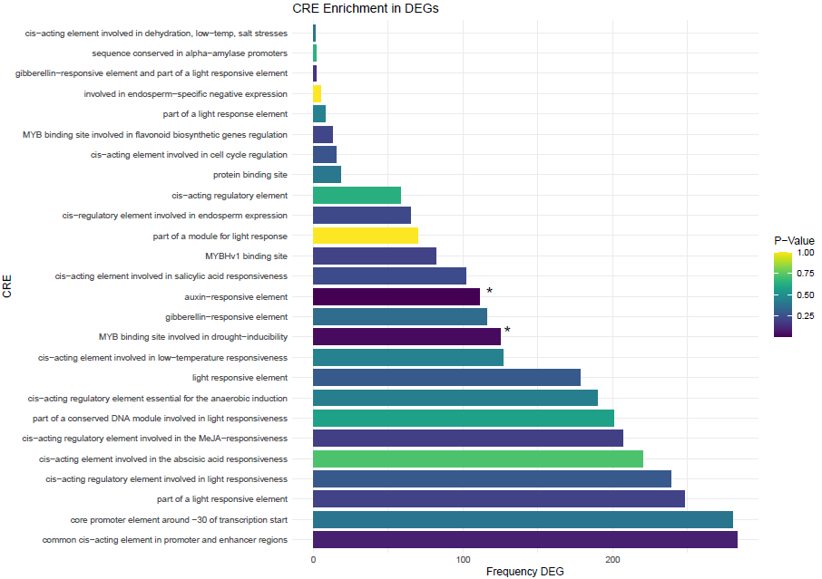
Suppl. Inf. 8 Enrichment of cis-regulatory elements (CREs) in PRR-DEGs. Bar plot showing the 26 CREs significantly enriched (p < 0.05) in PRR-DEGs compared with genes with no differential expression evidence. Among the enriched CREs, auxin-responsive and drought-responsive elements exhibited the highest significance.

