APPENDICES
Appendix A
The Integration of Technology-based Educational Platforms into Teaching English In University Context: A Comparative Study between Turkey and Pakistan
Dear Academicians/ Experts/ Colleagues,

I am working as an academician at Samsun University, and I am a student at Anadolu University, Educational Sciences Institute, English Teaching Doctorate Program. I am currently conducting research called "The Integration of Technology-based Educational Platforms into Teaching English In University Context: A Comparative Study between Turkey and Pakistan".

In this study, with a few open-ended questions, it is aimed to learn whether you use technology-based educational platforms in your English lesson practices and if you use, which ones you use, and to learn your perceptions of technology in English teaching. In addition, semi-structured interviews will be conducted to get detailed information about how technology is transferred to the lesson. Your answers for the research will be considered completely confidential. At the end of the form, you will be asked a question about whether you would like to participate in semi-structured interviews. Interviews will be held with volunteers who want to participate.

This study is carried out for scientific purposes and does not include an individual evaluation. Your participation in this study is invaluable in terms of validity and reliability studies. Your participation will contribute to science. If you have any comments, please contact via e-mail.

Thank you in advance for your time and contribution to the study.
Zekiye SEİS
Anadolu University/ Turkey -Samsun University-Turkey
Phd Student/ English Lecturer
zekiye_seis@anadolu.edu.tr
Pakistani Collaborator: Hina BUTT (PhD) (hinakhalid047@gmail.com)
Appendix A
OPEN-ENDED QUESTIONNAIRE
- I have read the above information and participate in this study completely voluntarily.
- E-mail address:
- Institution:
- Country: Turkey Pakistan
- Province:
- Do you use any technology-based educational platforms (Google classroom, Kahoot, etc) in your English classes to teach vocabulary?
- What technology-based educational platforms do you use in your English classes while teaching vocabulary?
- Have you ever had any training to use these technology-based educational platforms before?
- If yes, then was it mandatory or your own choice? And if no, then do you think it must be mandatory?
- Is there a written requirement in the curriculum for the use of technology in your university system?
- If not, do you think that there should be a written requirement in the curriculum?
- How do you perceive the role of technology-based educational platforms in your classroom vocabulary practices?
- What was your experience with using such platforms in your classroom practices? Was it different from how you had perceived it?
- Would you like to hold a Zoom meeting to discuss these issues with us in more detail? We thank you for your contribution.

Appendix B
INTERVIEW QUESTIONS
1. What tools do you consider when you hear someone saying technology-based educational platforms?
2. What do you think about the use of technology-based educational platforms in foreign language lessons?
3. Have you ever used these platforms in your lessons? If yes, why?
3a. If the answer is “No”, what are the reasons for you NOT being willing to incorporate such platforms in teaching language?
3b. If the reasons are external (e.g. curriculum obligations, government policy etc.), then would you still prefer these platforms in the absence of these external obligations?
4. When did you start using them in your lessons?
5. What are the reasons for you to start using technology-based educational platforms?
6. At what stage of your lessons do you use these platforms to benefit while teaching vocabulary?
7. What kind of activities do you do to include these platforms in your lessons?
8. Educational platforms are useful teaching and learning tools in foreign language teaching. Do you perceive them as a learning tool to enhance vocabulary knowledge?
9. According to you, what are the strengths and weaknesses of educational platforms as a teaching tool in vocabulary classes?
10. What do you think is the pedagogical potential of these platforms in general?
11. In your opinion, compared to traditional education, how do these educational platforms contribute to the learning and teaching process in ELT?
12. Do you think they SHOULD be made mandatory by the institution or the government to be used for learning foreign languages? Please explain Why or Why Not?

Appendix C
OBSERVATION FORM
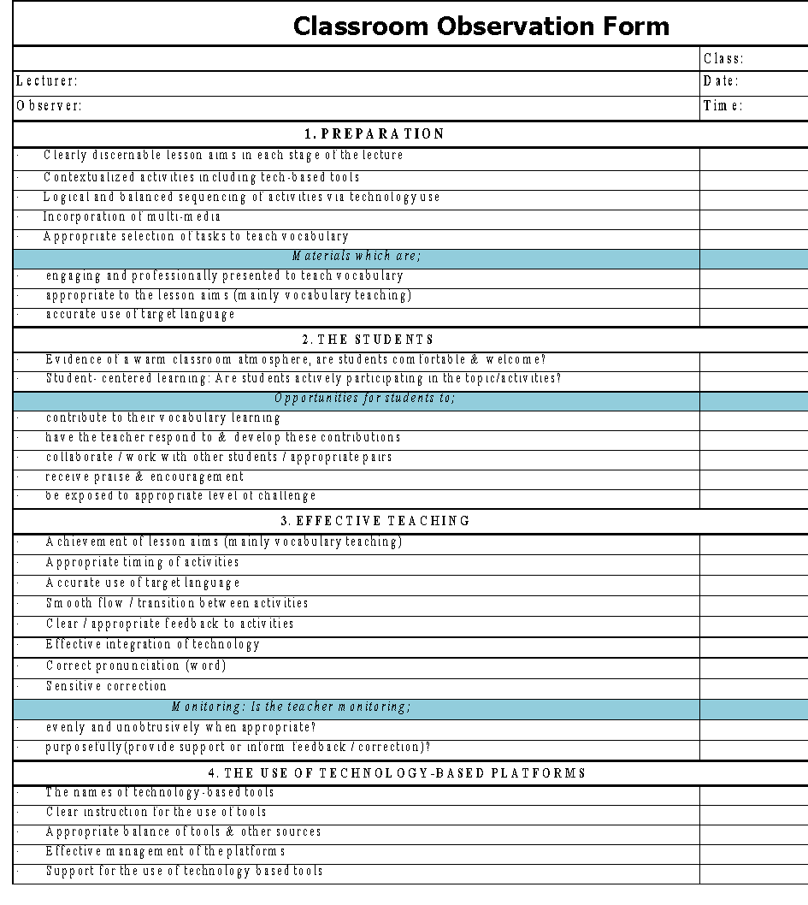

Appendix D
ETHICAL COMMISSION REPORT
