Supplementary material

In vitro adsorption of Fumonisin B1 by multiple algae-modified clay formulations

Letícia Aliberti Galego Alves da Silvaª, Morgane Malard^{b}, Patricia Aparecida de Campos Bragaª, Adriana Pavesi Arissetto Bragottoª, Marie Gallissot^{b}, Pi Nyvall Collen^{b}, Juliana Bueno^{c}, Liliana de Oliveira Rocha^{a,*}

ª State University of Campinas (UNICAMP), Food Engineering School (FEA), Department of Food Science and Nutrition (DECAN), Campinas, São Paulo, Brazil (leticia.aliberti@hotmail.com; pbraga@unicamp.br; pavesi@unicamp.br; lrocha@unicamp.br).
^{b} Olmix Group, Bréhan, France (mmalard@olmix.com; mariegalissot@hotmail.com; pnyvall@olmix.com)
^{c} Olmix Group, Piracicaba, Brazil (jbueno@olmix.com).
*Corresponding author: Rocha, L. O. Department of Food Science and Nutrition (DECAN), Food Engineering Faculty (FEA), State University of Campinas (UNICAMP), Monteiro Lobato Street, 80, Campinas, São Paulo, Brazil, 13083- 862. E-mail: lrocha@unicamp.br.

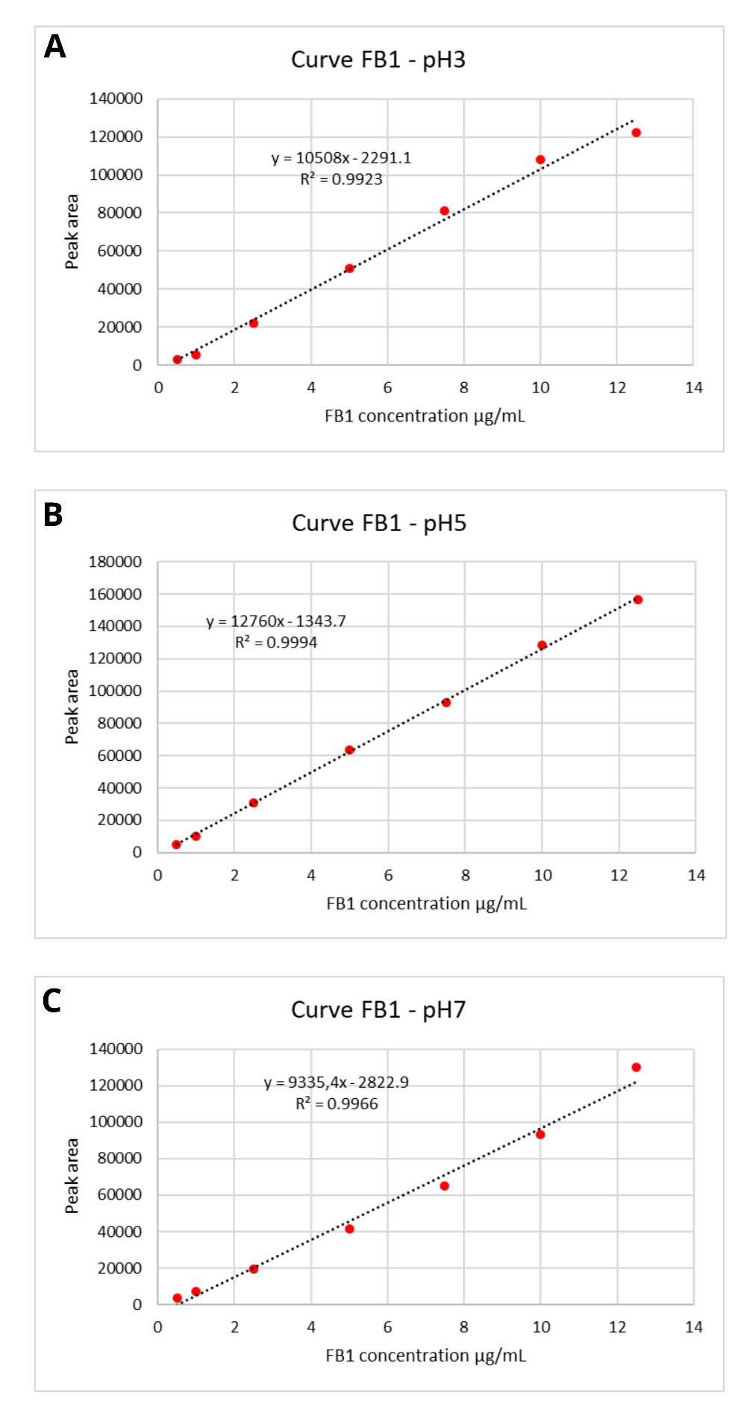
Fig. S1. Calibration curves for FB1 in citrate buffer at pH 3, 5 and 7. A: Calibration curve for FB1 at pH 3 (R² 0.9923); B: Calibration curve for FB1 at pH 5 (R² 0.9994); C: Calibration curve for FB1 at pH 7 (R² 0.9966).
Table S1. Limits of detection (LOD) and quantification (LOQ) for FB1 in citrate buffer at pH 3, 5, and 7.
Matrix | LOD (µg/mL) | LOQ (µg/mL)
Citrate Buffer pH 3 | 0.013 | 0.039
Citrate Buffer pH 5 | 0.061 | 0.184
Citrate Buffer pH 7 | 0.127 | 0.385

Table S2. Method precision for FB1 analysis. Intra-day precision was evaluated using five replicates at each FB1 concentration on the same day at pH 5. Inter-day precision was assessed over three separate days, with five replicates per level analyzed each day at pH 5.
 |  |  | Precision
FB1 concentration (µg/mL) | Mean FB1 levels recovered (µg/mL) | SD | Intra-day (%) | Inter-day (%)
2.5 | 2.04 | 0.23 | 8.9% | 11.4%
5.0 | 4.63 | 0.59 | 13.5% | 12.7%
7.5 | 7.71 | 0.12 | 7.3% | 1.5%
SD: standard deviation.

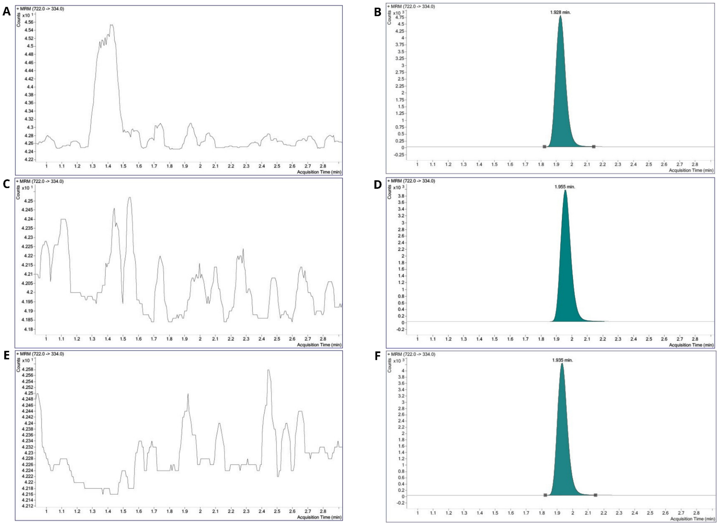

Figure S2. Selectivity results for FB1 analysis. A: Blank of citrate buffer at pH 3; B: FB1 qualifier transition peak (m/z 722 → 334) in citrate buffer at pH 3 (RT: 1.928 min); C: Blank of citrate buffer at pH 5; D: FB1 qualifier transition peak (m/z 722 → 334) in citrate buffer at pH 5 (RT: 1.955 min); E: Blank of citrate buffer at pH 7; F: FB1 qualifier transition peak (m/z 722 → 334) in citrate buffer at pH 7 (RT: 1.935 min.

