Updated IPCC-assessed emissions scenarios cannot limit warming to 1.5°C: Supplementary material
Laila K. Gohar⁷, Camilla Mathison^{7,8}, Benjamin M. Sanderson³, Marit Sandstad³, Chris Smith^{1,2}, Tristram Walsh⁴, Nathan Gillett⁵, Aurélien Ribes⁶, Jarmo S. Kikstra^{2,9}, Zebedee Nicholls^{2,10,11}, Wim Thiery¹, Carl-Friedrich Schleussner^{2,12}, Joeri Rogelj^{2,9}

- Department of Water and Climate, Vrije Universiteit Brussel, 1050 Brussels, Belgium
- Energy, Climate and Environment Program, International Institute for Applied Systems Analysis (IIASA), 2361 Laxenburg, Austria
- CICERO Center for International Climate Research, Oslo, Norway
- University of Oxford, United Kingdom
- Canadian Centre for Climate Modelling and Analysis, Environment and Climate Change Canada, Victoria, BC, Canada
- CNRM, Université de Toulouse, Météo-France, CNRS, Toulouse, France
- Met Office Hadley Centre, Exeter, EX1 3PB, United Kingdom
- Department of Geography, University of Leeds, LS2 9JT, United Kingdom
- Imperial College, London, United Kingdom
- Climate Resource, Melbourne, Australia
- University of Melbourne, Australia
- Humboldt University zu Berlin, Berlin, Germany

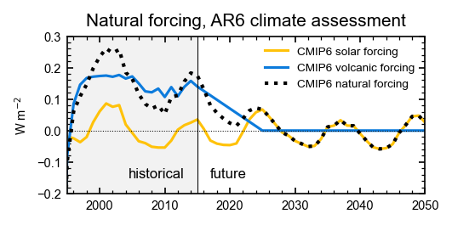
Extended Data Figure 1 | Historical (to 2015) and future natural forcings in the AR6 assessment of scenario pathways. Black line shows the combined solar (orange) and volcanic (blue) forcings.
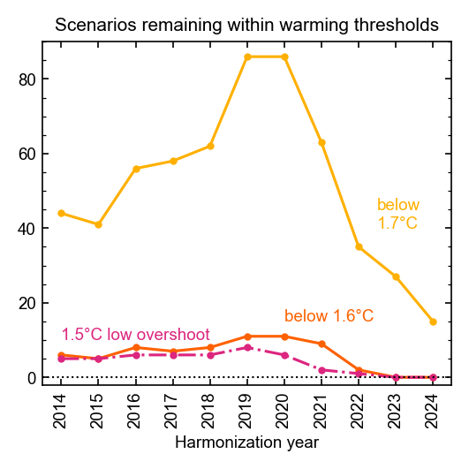

Extended Data Figure 2 | Time evolution of the number of scenarios limiting warming to 1.5°C with low or no overshoot, and peak warming (50th percentile) below 1.6°C and 1.7°C. Results are presented for projections with anthropogenic forcings only, using the 2024 calibration of fair-2.2.2.
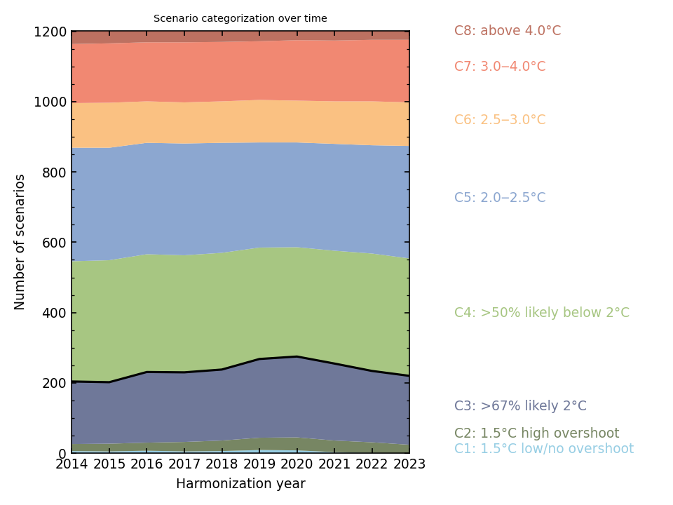
Extended Data Figure 3 | evolution over time of the scenario categorization taking into account reharmonization of historical emissions in years between 2014 and 2023. Results are presented using the 2023 calibration of fair-2.2.2 with anthropogenic forcings only.
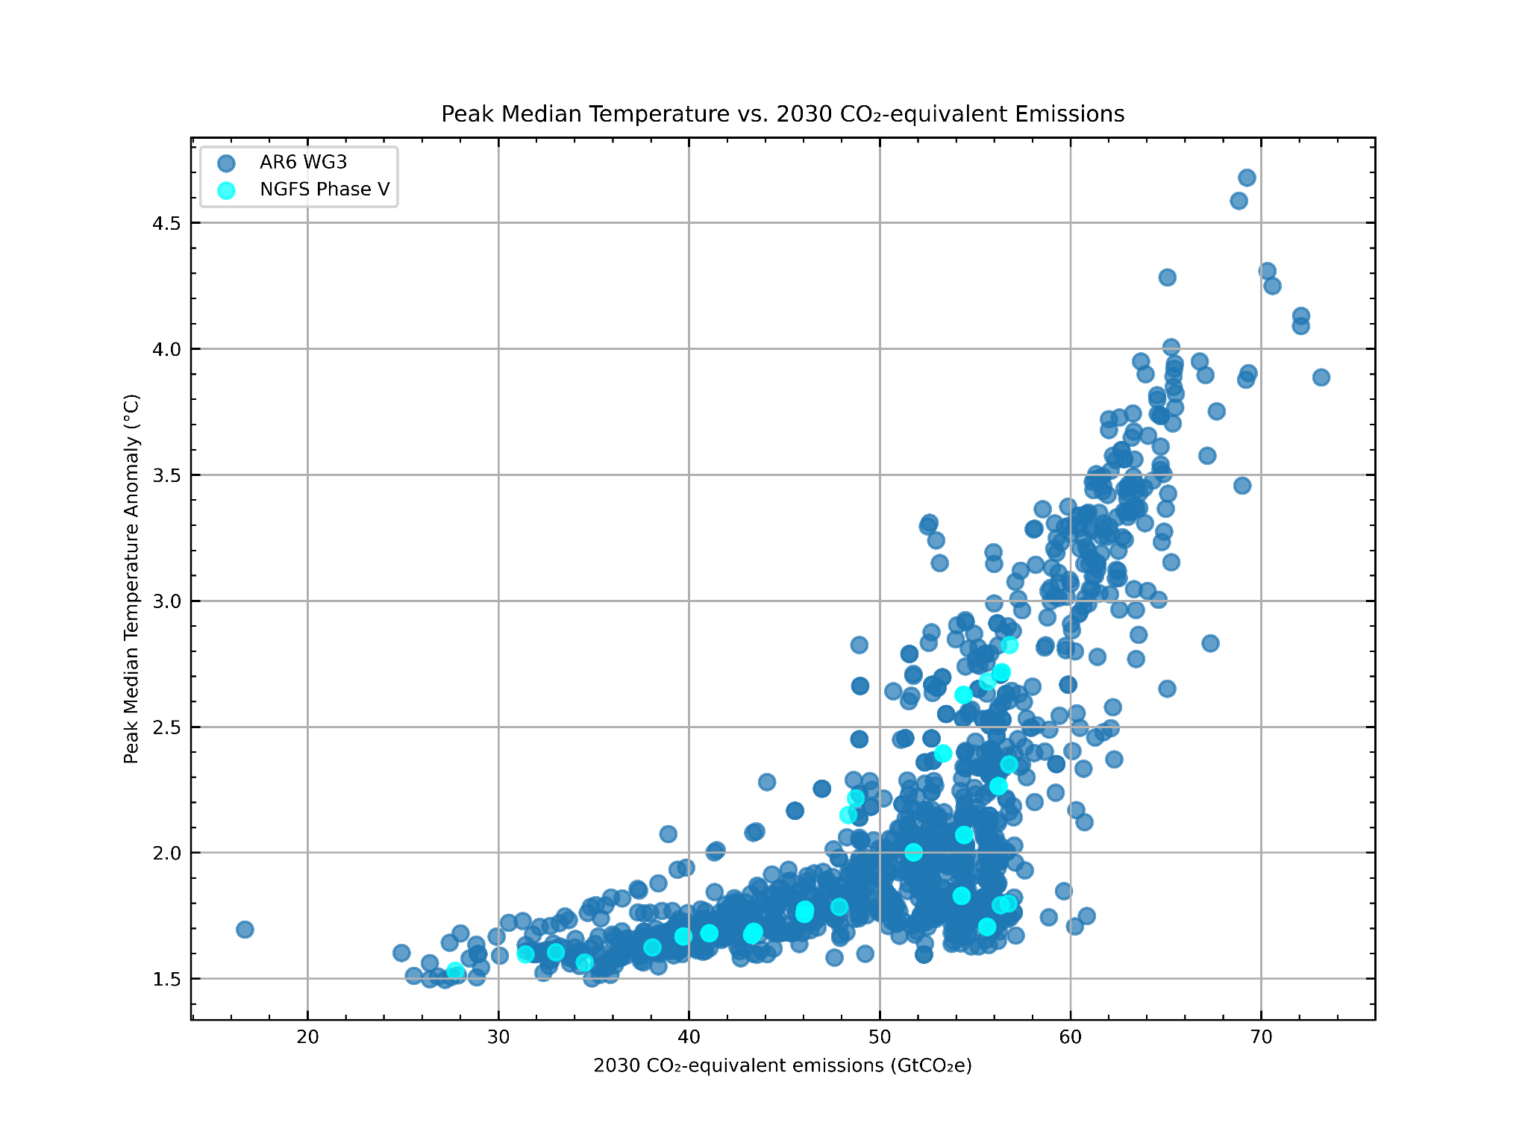
Extended Data Figure 4 | comparison of 2030 GHG emissions and peak warming for AR6 WG3 scenarios (dark) and Network for Greening the Financial System (NGFS) Phase V scenarios (light).
Extended Data Table 1 | Constraints used in the fair-2.2.2 ensemble in this paper. Calibration v1.5.1 is a set similar to the AR6 WG1 set of constraints for climate emulators that were used to run the emissions scenarios in AR6 WG3. Calibration v1.5.0 is the update using historical emissions up to 2024 and climate constraints from Indicators of Global Climate Change 2024. Ranges are quoted as 5‒95 percentiles. RMSD=root-mean-square difference.

Constraining step | Metric | v1.5.1 (AR6 WG3-like) | v1.5.0 (2024 calibration)
1 | Historical global mean surface temperature timeseries | RMSD to best estimate observations 1850‒2020 < 0.19°C, run with CMIP6 historical emissions extended with SSP2-4.5 | RMSD to best estimate observations 1850‒2024 < 0.19°C, run with CMIP7 historical emissions extended to 2024
2 | Recent 20-year warming with respect to 1850‒1900 | 0.85 [0.67‒0.98]°C (1995‒2014) | 1.09 [0.93‒1.20]°C (2005‒2024)
2 | Earth’s energy uptake relative to 1971 | 434.9 ± 110.4 ZJ (2018) | 465.3 ± 108.5 ZJ (2020)
2 | CO₂ concentration | 397.55 ± 0.4 ppm (2014) | 422.77 ± 0.4 ppm (2024)
2 | Effective radiative forcing from aerosol-radiation interactions (1750 to 2005‒14 mean) | ‒0.28 ± 0.28 W m^{‒2} | ‒0.3 ± 0.3 W m^{‒2}
2 | Effective radiative forcing from aerosol-cloud interactions (1750 to 2005‒14 mean) | ‒0.87 [‒1.41 to ‒0.33] W m^{‒2} | ‒1.0 ± 0.7 W m^{‒2}
2 | Effective radiative forcing from aerosols, total (1750 to 2005‒14 mean) | ‒1.15 [‒1.68 to ‒0.60] W m^{‒2} | ‒1.3 ± 0.7 W m^{‒2}
2 | Equilibrium climate sensitivity (ECS) | 3 [2‒5]°C
2 | Transient climate response (TCR) | 1.8 ± 0.6 °C
2 | Airborne fraction of CO₂ | AF_{8×CO2} > AF_{4×CO2} > AF_{2×CO2}
Extended Data Table 2 | 10-year mean Global Warming Index (GWI) values used as the baseline to determine future anthropogenic warming for each harmonization year.
Harmonization year | All forcings baseline period | All forcings temperature anomaly relative to 1850‒1900 (°C) | Anthropogenic baseline period | Anthropogenic temperature anomaly relative to 1850‒1900 (°C)
2014 | 1995‒2014 | 0.85 | 2005‒2014 | 0.966
2015 |  |  | 2006‒2015 | 0.988
2016 |  |  | 2007‒2016 | 1.010
2017 |  |  | 2008‒2017 | 1.035
2018 |  |  | 2009‒2018 | 1.061
2019 |  |  | 2010‒2019 | 1.087
2020 |  |  | 2011‒2020 | 1.114
2021 |  |  | 2012‒2021 | 1.142
2022 |  |  | 2013‒2022 | 1.168
2023 |  |  | 2014‒2023 | 1.194

Extended Data Table 3 | Scenario category definitions as used in SR1.5 and AR6 WG3. This is reproduced from the AR6 report. Table 14 | Classification of global pathways into warming levels using MAGICC (Chapter 3, Section 3.2)
AR6 Scenarios  Categories (Model group | AR6 Scenario description | SR 1.5 scenarios | SR1.5 Scenario description
C1 | Limit to 1.5°C (>50%) with no or limited OS  Reach or exceed 1.5°C during the 21st century with a likelihood of ≤67%, and limit  warming to 1.5°C in 2100 with a likelihood >50%.  Limited overshoot refers to exceeding 1.5°C by up to about 0.1°C and for up to several decades | 1.5°C or  1.5°C-consistent | Below-1.5°C pathways limiting peak warming to below 1.5°C during the entire 21st century with 50–66% likelihood
C1 |  | 1.5°C or  1.5°C-consistent | 1.5°C-low-OS pathways limiting median warming to below 1.5°C in 2100 and with a 50–67% probability of temporarily overshooting that level earlier, generally implying less than 0.1°C higher peak warming than Below-1.5°C pathways
C2 | Return to 1.5°C (>50%) after high OS | 1.5°C or  1.5°C-consistent | 1.5°C-high-OS pathways limiting median warming to below 1.5°C in 2100 and with a >67% probability of temporarily overshooting that level earlier, generally implying 0.1‒0.4°C higher peak warming than Below-1.5°C pathways
C3 | Limit to 2°C (>67%) | 2°C or 2°C-consistent | Lower-2°C pathways limiting peak warming to below 2°C during the entire 21st century with greater than 66% likelihoodª
C4 | Limit to 2°C (>50%) | 2°C or 2°C-consistent | Higher-2°C pathways assessed to keep peak warming to below 2°C during the entire 21st century with 50–66% likelihood
C5 | Limit to 2.5°C (>50%) | Above 2°C
C6 | Limit to 3.0°C (>50%) | Above 2°C
C7 | Limit to 4.0°C (>50%) | Above 2°C
C8 | Exceed 4.0°C (≥50%) | Above 2°C
ªAR6 defined the boundary as a 67% likelihood and SR1.5 a 66% likelihood of remaining below 2°C, which has been interpreted to be equivalent in intent if not in implementation.

