Functional attrition and Quality of Life in Advanced Cancer Trial: modeling patients’ trajectories and evaluating the impact of missing outcome data handling on quality-of-life prognostic.

Supplementary File: Additional Tables
Table S1. Baseline characteristics by state (A, F, D) at week 12 and week 24
Baseline characteristics by state (A, F, D) at week 12
Characteristic | Active (n =192) | Death (n = 58) | Attrition (n = 102) | p-value
Age, mean (SD) | 64.8 (10.3) | 69.2 (9.0) | 64.0 (9.3) | 0.004
Male sex, n (%) | 114 (59.4) | 28 (48.3) | 54 (52.9) | 0.264
ECOG performance, mean (SD) | 0.85 (0.60) | 1.31 (0.65) | 0.90 (0.57) | <0.001
Baseline FACT, mean (SD) | 76.3 (15.6) | 66.3 (16.9) | 73.3 (16.4) | <0.001
Baseline HADS-Anxiety, mean (SD) | 6.8 (3.2) | 7.4 (3.9) | 7.9 (3.8) | 0.033
Baseline HADS-Depression, mean (SD) | 4.9 (3.7) | 7.9 (4.5) | 5.8 (4.6) | <0.001
Tumor type, n (%) |  |  |  | 0.334
– Esophageal/GEJ/Gastric | 15 (7.8) | 3 (5.2) | 10 (9.8)
– Hepatic/Biliary/Pancreatic/Other | 53 (27.6) | 23 (39.7) | 35 (34.3)
– Lung | 124 (64.6) | 32 (55.2) | 57 (55.9)
Arm 2, n (%) | 100 (52.1) | 32 (55.2) | 51 (50.0) | 0.820
Education, n (%) |  |  |  | 0.096
– College+ | 110 (58.8) | 26 (46.4) | 41 (42.7)
– High school | 62 (33.2) | 24 (42.9) | 42 (43.8)
– Low | 15 (8.0) | 6 (10.7) | 13 (13.5)
Race/ethnicity, n (%) |  |  |  | 0.972
– Asian | 8 (4.3) | 2 (3.5) | 4 (4.4)
– Black | 22 (11.7) | 6 (10.5) | 14 (15.4)
– Minority | 3 (1.6) | 1 (1.8) | 2 (2.2)
– White | 155 (82.4) | 48 (84.2) | 71 (78.0)
Not married, n (%) | 65 (34.6) | 24 (42.1) | 41 (41.0) | 0.424
Number of visits, mean (SD) | 1.64 (1.91) | 2.41 (2.85) | 1.79 (2.81) | 0.092
Caregiver present, n (%) | 142 (74.0) | 41 (70.7) | 65 (63.7) | 0.187
Baseline characteristics by state (A, F, D) at week 24
Characteristic | Active (n = 148) | Death (n = 110) | Attrition (n = 94) | p-value
Age, mean (SD) | 65.0 (10.4) | 66.3 (9.8) | 64.5 (9.3) | 0.373
Male sex, n (%) | 82 (55.4) | 58 (52.7) | 56 (59.6) | 0.615
ECOG performance, mean (SD) | 0.80 (0.58) | 1.13 (0.64) | 0.96 (0.60) | <0.001
Baseline FACT, mean (SD) | 76.7 (15.7) | 69.5 (17.0) | 74.2 (15.9) | 0.002
Baseline HADS-Anxiety, mean (SD) | 7.3 (3.3) | 7.1 (3.6) | 7.3 (3.8) | 0.927
Baseline HADS-Depression, mean (SD) | 5.0 (3.7) | 6.7 (4.6) | 5.5 (4.3) | 0.004
Tumor type, n (%) |  |  |  | 0.532
– Esophageal/GEJ/Gastric | 8 (5.4) | 10 (9.1) | 10 (10.6)
– Hepatic/Biliary/Pancreatic/Other | 48 (32.4) | 37 (33.6) | 26 (27.7)
– Lung | 92 (62.2) | 63 (57.3) | 58 (61.7)
Arm 2, n (%) | 80 (54.1) | 60 (54.5) | 43 (45.7) | 0.366
Education, n (%) |  |  |  | 0.855
– College+ | 75 (52.4) | 53 (50.5) | 49 (53.8)
– High school | 54 (37.8) | 43 (41.0) | 31 (34.1)
– Low | 14 (9.8) | 9 (8.6) | 11 (12.1)
Race/ethnicity, n (%) |  |  |  | 0.683
– Asian | 7 (4.9) | 3 (2.8) | 4 (4.7)
– Black | 17 (11.8) | 10 (9.4) | 15 (17.4)
– Minority | 3 (2.1) | 2 (1.9) | 1 (1.2)
– White | 117 (81.2) | 91 (85.8) | 66 (76.7)
Not married, n (%) | 52 (35.6) | 45 (42.5) | 33 (35.5) | 0.476
Number of visits, mean (SD) | 1.69 (1.95) | 2.35 (3.07) | 1.37 (1.95) | 0.010
Caregiver present, n (%) | 108 (73.0) | 75 (68.2) | 65 (69.1) | 0.670

Variable | Outcome A | Outcome F | Outcome D
Average Marginal Effects (AME) for Transitions T0 → T12
Age (per year) | -0.004 | -0.002 | +0.006
ECOG (per unit) | -0.082 | -0.042 | +0.124
FACT baseline (per point) | +0.002 | +0.001 | -0.003
Anxiety (HADS-A, per point) | -0.002 | +0.018 | -0.016
Depression (HADS-D, per point) | -0.009 | -0.008 | +0.017
Male (vs Female) | +0.050 | -0.019 | -0.031
Tumor: Hepatobiliary vs Esophageal/GEJ | -0.033 | -0.010 | +0.042
Tumor: Lung vs Esophageal/GEJ | +0.104 | -0.061 | -0.042
Caregiver present (Yes vs No) | +0.109 | -0.096 | -0.013
Average Marginal Effects (AME) for Transitions T12 → T24
Age (per year) | +0.001 | -0.001 | ≈0.000
ECOG (per unit) | -0.097 | +0.066 | +0.032
FACT baseline (per point) | +0.002 | ≈0.000 | -0.002
Anxiety (HADS-A, per point) | +0.027 | -0.010 | -0.017
Male (vs Female) | -0.008 | +0.027 | -0.019
Tumor: Hepatobiliary vs Esophageal/GEJ | +0.297 | -0.021 | -0.277
Tumor: Lung vs Esophageal/GEJ | +0.210 | -0.010 | -0.200
Arm 2 vs Arm 1 | +0.076 | -0.041 | -0.035
Table S2. Average Marginal Effects (AME) for Transitions T0 → T12 and T12 → T24
Change in predicted probability of each outcome associated with a one-unit increase in the covariate; reference categories: Female, Esophageal/GEJ/Gastric, No caregiver, College+
Note: AMEs represent the average change in predicted probability of each outcome associated with a one-unit increase in the covariate (for continuous predictors) or a shift from the reference to the comparison category (for categorical predictors). Values are expressed in probability points (e.g., 0.10 = 10 percentage points). For interpretation, consider the magnitude in absolute probability points: <0.01 ≈ negligible, 0.01–0.05 small, 0.05–0.10 moderate, >0.10 large. These thresholds are intended as pragmatic guidance rather than strict rules.

Table S3. Predicted Probabilities for T0 → T12 and T12 → T24 Transitions by Clinical Profile
Clinical Profile | Active (A) | Functional attrition (F) | Death (D)
Predicted Probabilities for T0 → T12 Transitions by Clinical Profile
Young fit, low anxiety, caregiver, Esophageal/GEJ/Gastric, College+ | 0.754 | 0.222 | 0.024
Young fit, high anxiety, caregiver, Esophageal/GEJ/Gastric, College+ | 0.647 | 0.341 | 0.012
Old fragile, low anxiety, caregiver, Hepatic/Biliary/Pancreatic/Unknown primary, Low | 0.336 | 0.267 | 0.397
Old fragile, high anxiety, caregiver, Hepatic/Biliary/Pancreatic/Unknown primary, Low | 0.281 | 0.380 | 0.339
Young fit, low anxiety, no caregiver, Esophageal/GEJ/Gastric, College+ | 0.640 | 0.333 | 0.028
Young fit, high anxiety, no caregiver, Esophageal/GEJ/Gastric, College+ | 0.511 | 0.476 | 0.013
Old fragile, low anxiety, no caregiver, Hepatic/Biliary/Pancreatic/Unknown primary, Low | 0.249 | 0.349 | 0.402
Old fragile, high anxiety, no caregiver, Hepatic/Biliary/Pancreatic/Unknown primary, Low | 0.198 | 0.475 | 0.327
Predicted Probabilities for T12 → T24 Transitions by Clinical Profile
Young fit, high anxiety, Esophageal/GEJ, Arm1 | 0.679 | 0.189 | 0.131
Young fit, low anxiety, Lung, Arm1 | 0.560 | 0.268 | 0.172
Young fit, high anxiety, Lung, Arm1 | 0.802 | 0.163 | 0.034
Old fragile, low anxiety, Hepatic/Biliary, Arm2 | 0.548 | 0.339 | 0.113
Old fragile, high anxiety, Hepatic/Biliary, Arm2 | 0.775 | 0.203 | 0.022
Old fragile, low anxiety, Lung, Arm2 | 0.431 | 0.275 | 0.294
Old fragile, high anxiety, Lung, Arm2 | 0.732 | 0.198 | 0.070
Note: Probabilities of being in A, F, or D are calculated relative to being active (A) in the previous state.

Threshold for QoL deterioration (FACT score change) | Total patients (n) | Events, n (%)
≥ 0 | 137 | 60 (43.8)
≥ –5 | 137 | 32 (23.4)
≥ –7 | 137 | 27 (19.7)
≥ –10 | 137 | 23 (16.8)
Table S4. Incidence of quality-of-life (QoL) deterioration across different thresholds of FACT score change.

Table S5. Summary of parameter estimates under different truncation bounds.

Truncation Bounds | ESS | Min | Q1 | Median | Mean | Q3 | Max
1–99% | 126.9 | 0.690 | 0.866 | 1.011 | 1.064 | 1.143 | 2.190
5–95% | 129.2 | 0.717 | 0.866 | 1.011 | 1.051 | 1.143 | 1.718
10–90% | 131.6 | 0.773 | 0.866 | 1.011 | 1.036 | 1.143 | 1.466

Supplementary File: Additional Figures
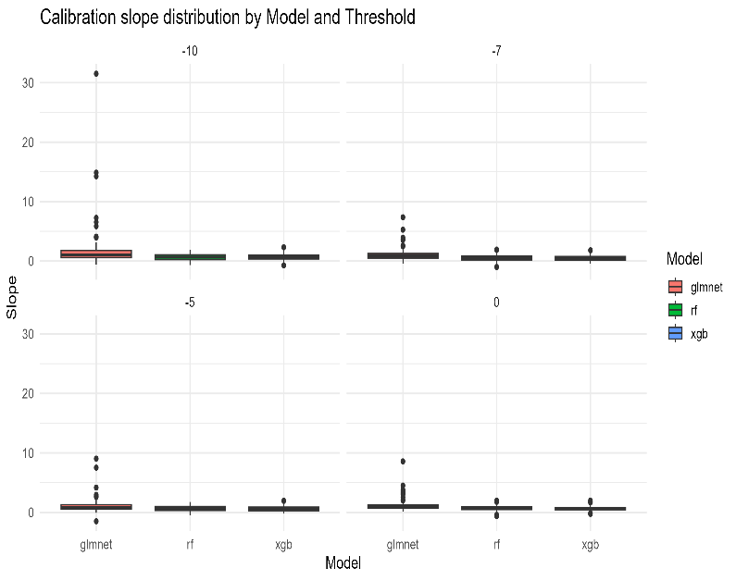
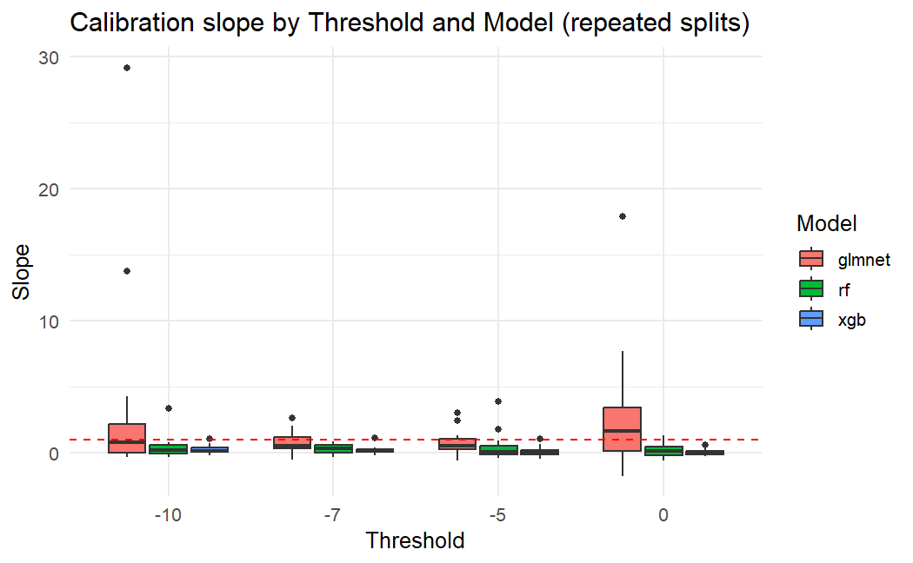
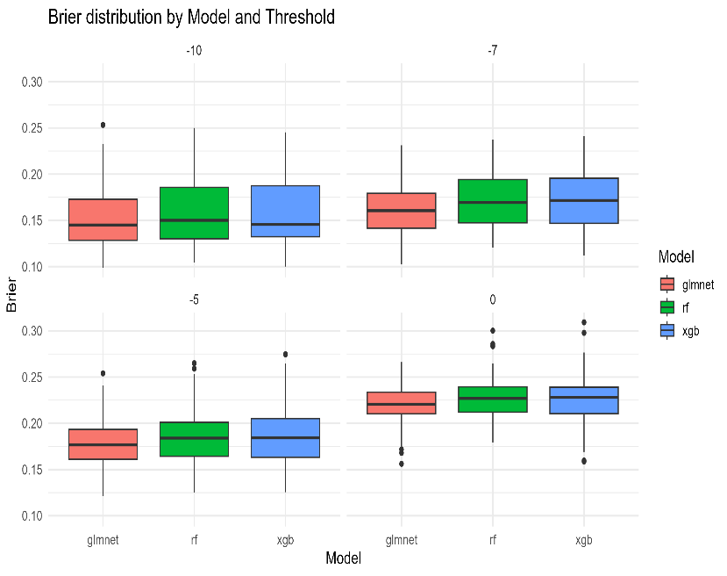
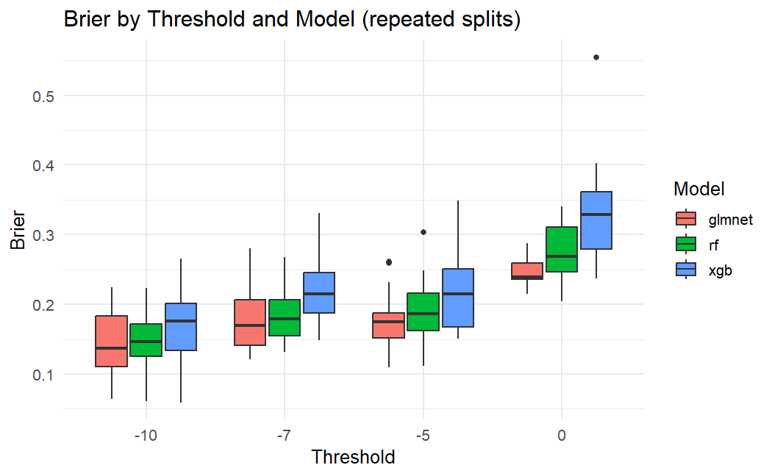
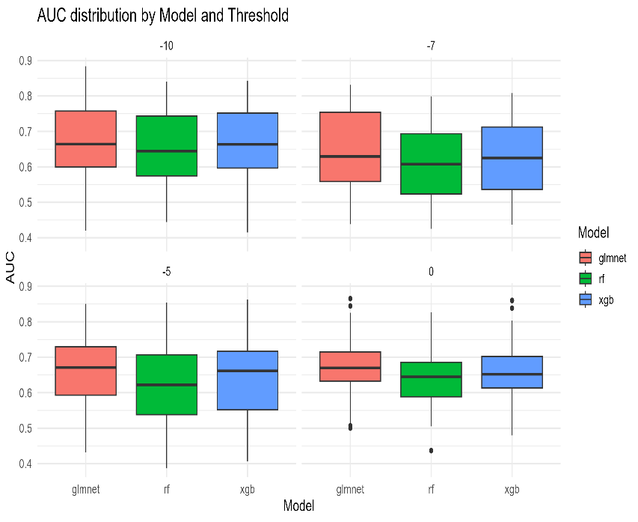
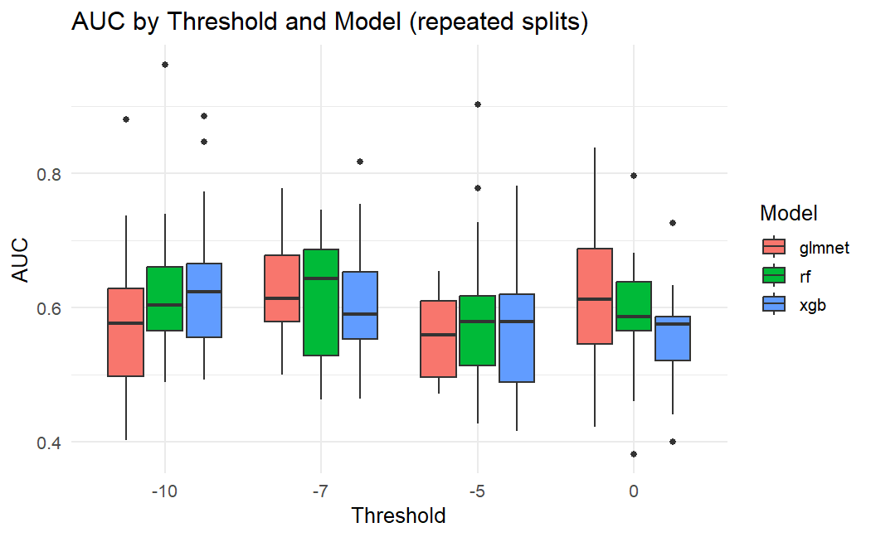

figure S1. Comparison of Model discrimination, accuracy and Calibration

