Supplementary information
Sonication-Free Pollen Microgel-Enabled CNT Conductive Inks with 3D/Screen Printability and Layered Self-Assembly
Changdan Gao¹, Di Yang¹, Jingwen Liang¹, Zongyu Wang¹, Mingyu Zhao², Ze Zhao¹*, and Hongbing Deng¹*
¹ Hubei Key Laboratory of Biomass Resource Chemistry and Environmental Biotechnology, Hubei International Scientific and Technological Cooperation Base of Sustainable Resource and Energy, School of Resource and Environmental Science, Wuhan University, Wuhan 430079, P. R. China
² Department of Prosthodontics, State Key Laboratory of Oral & Maxillofacial Reconstruction and Regeneration, Key Laboratory of Oral Biomedicine Ministry of Education, Hubei Key Laboratory of Stomatology, School & Hospital of Stomatology, Wuhan University, Wuhan, 430079, China
*E-mail: zhaoze@whu.edu.cn; hbdeng@whu.edu.cn

1. Supplementary note
Supplementary note 1
Calculation method of reflection loss (SER) and absorption loss (SEA)
For conductive shielding materials, the reflection loss calculated by the Fresnel equation is as follows:
SER(dB) = 39.5 + 10 log$\frac{σ}{2πfμ}$
SEA(dB) = 8.7$\frac{t}{δ}$= 8.7t$\sqrt{πfμσ}$
Where σ and μ are the electrical conductivity and magnetic permeability of the EMI shielding material, f is the frequency of the incident EM waves, and t is the thickness of the EMI shielding material.
Calculation method of reflection coefficient and absorption coefficient based on the scattering parameters (S₁₁ and S₂₁)
R = |S₁₁| ²
T = |S₂₁| ²
A = 1 − R − T

2. Supplementary Figures (1-17)

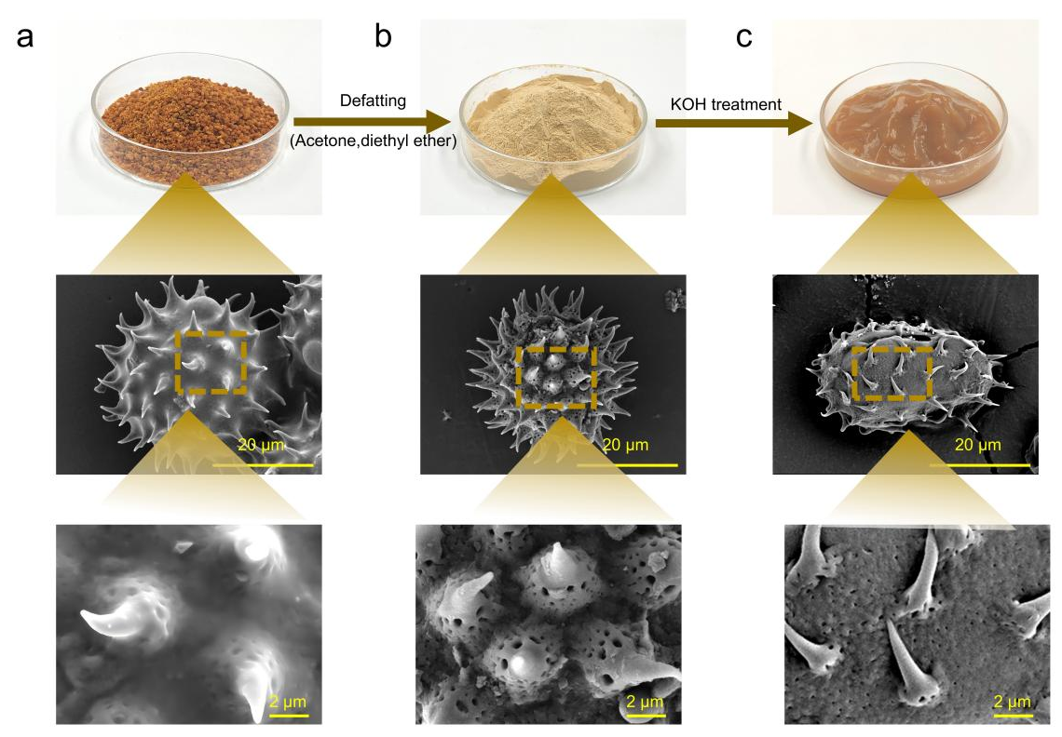
Supplementary Fig. 1 | Fabrication and structural evolution of pollen microgels. a Raw pollen grains and corresponding SEM images showing their native spiny exine architecture with lipid on the outer layer. b Defatted pollen particles obtained by acetone/diethyl ether extraction, with SEM images revealing a cleaned but intact sporopollenin shell. c Pollen microgels produced by alkaline (KOH) treatment, with SEM images showing softened structures and partially collapsed wall morphology characteristic after drying.

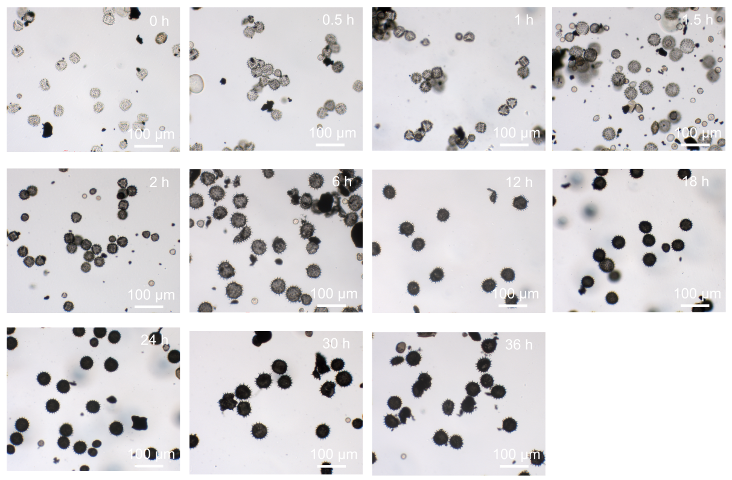
Supplementary Fig. 2 | Time-resolved optical microscopy of pollen microgels during CNT loading. Optical microscope images showing the morphological evolution of pollen microgels stirred with CNTs over different durations. The dispersion contained 2 wt% alginate and 15 mg mL⁻¹ CNTs.

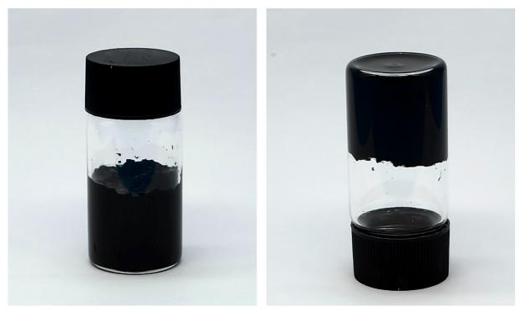
Supplementary Fig. 3 | Long-term stability of the PAC ink. Photographs of the PAC ink after six months of storage, showing no visible precipitation or phase separation upon inversion.
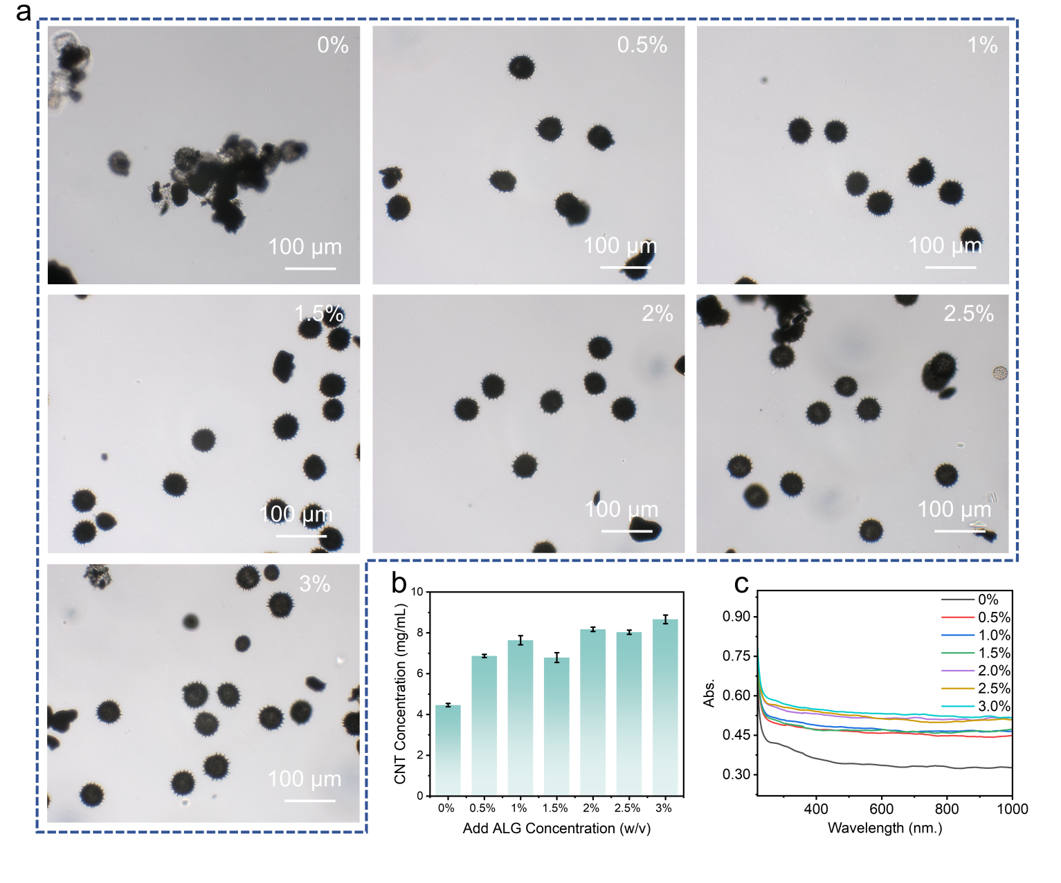
Supplementary Fig. 4 | Effect of alginate concentration on CNT loading in PAC inks. a Optical microscopy images of PAC microgels prepared with different ALG concentrations (0–3 wt%). b Measured CNT loading in PAC inks formulated with 20 mg mL⁻¹ CNT feed concentration and varying ALG concentrations. c UV–vis spectra of PAC dispersions as a function of ALG concentration, where increased absorption indicates enhanced CNT incorporation.
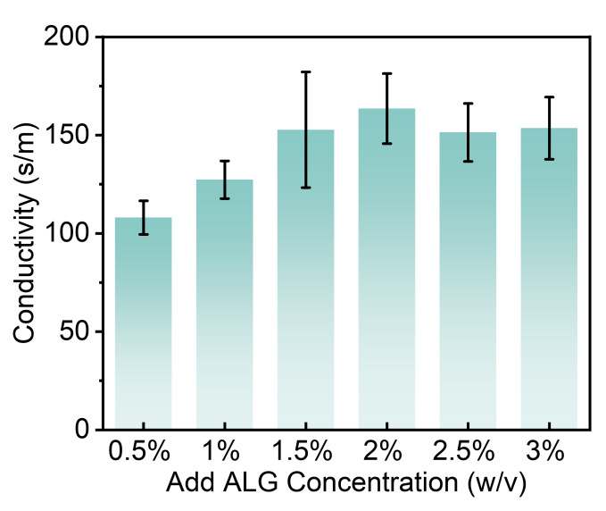
Supplementary Fig. 5 | Electrical conductivity of PAC films formulated with different alginate concentrations. Conductivity of PAC films prepared with 20 mg mL⁻¹ CNT feed concentration and varying ALG contents (0.5–3 wt%), showing enhanced electrical performance at intermediate ALG levels.
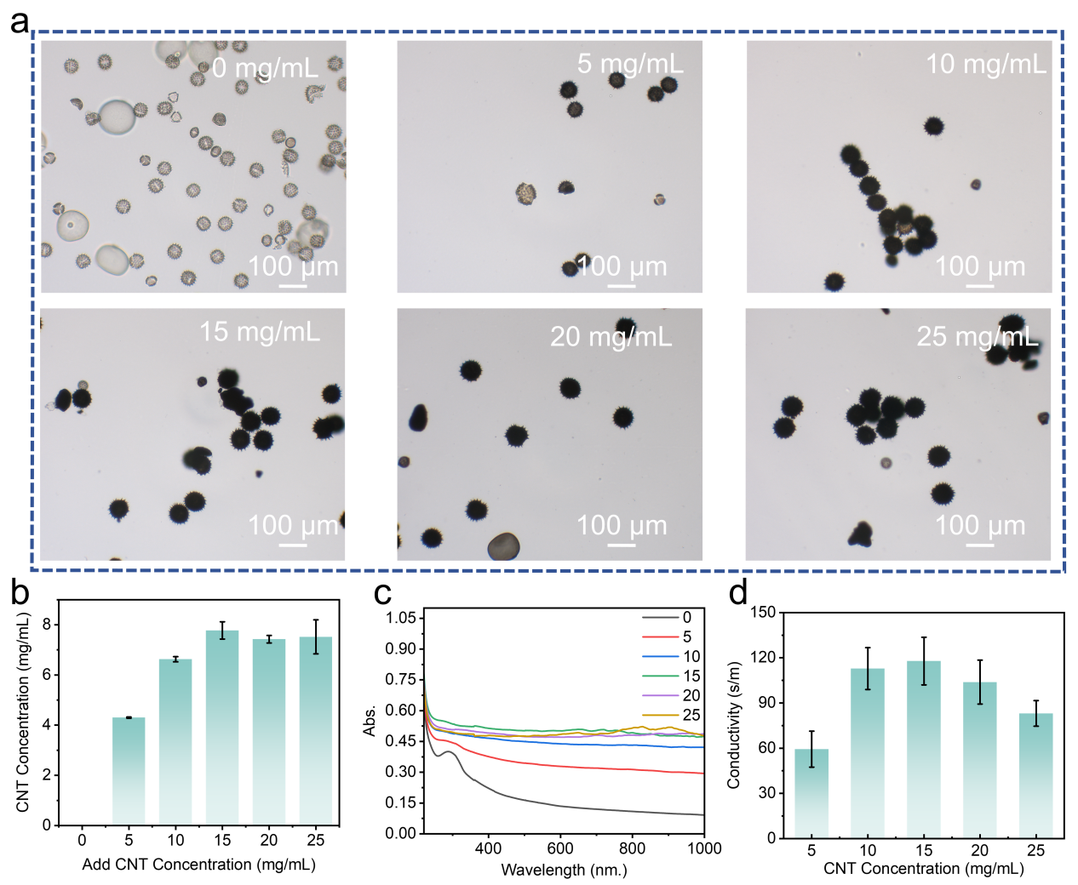
Supplementary Fig. 6 | Effect of CNT concentration on the formation and properties of PAC inks. a Optical microscopy images of pollen microgels prepared with different CNT feed concentrations (0–25 mg mL⁻¹), showing progressive darkening and increasingly uniform CNT coating at higher CNT levels. b Measured CNT loading in PAC inks formulated with varying CNT feed concentrations and 2 wt% ALG. c UV–vis spectra of PAC dispersions as a function of CNT concentration, where elevated absorbance reflects increased CNT incorporation. d Electrical conductivity of PAC films prepared with different CNT concentrations (2 wt% ALG), highlighting optimal performance near 15 mg mL⁻¹ CNT feed concentration.
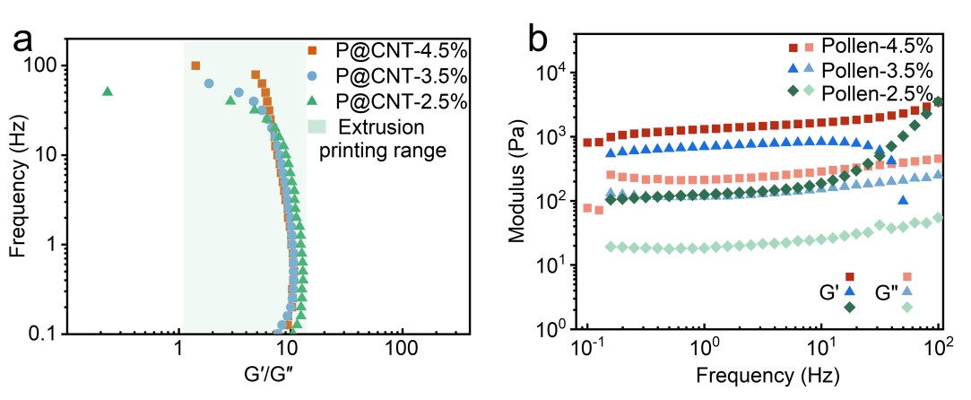
Supplementary Fig. 7 | Viscoelastic behavior of PAC inks and pollen microgels. a Frequency-dependent G′/G′′ ratios of PAC inks with different solid contents, showing a broad elastic-dominant regime (G′/G′′ > 1) relevant for extrusion printing. b Storage (G′) and loss (G′′) moduli of pollen microgel dispersions with varying solid contents as a function of oscillatory frequency, demonstrating concentration-dependent enhancement in viscoelasticity.

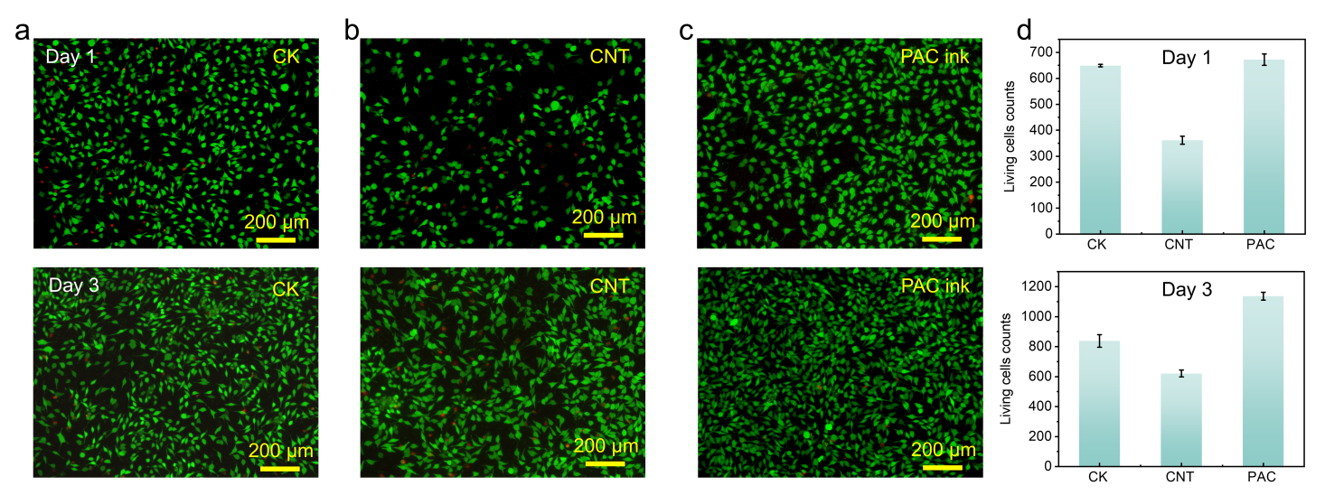
Supplementary Fig. 8 | Cytocompatibility of PAC inks. Fluorescence microscopy images of L929 fibroblasts cultured for 1 day and 3 days with extracts from the control group (a), CNT dispersion (b), and PAC ink (c), showing predominantly viable cells (green). d Quantified live-cell densities after 1 and 3 days of incubation, indicating that PAC extracts maintain high cell viability compared with CNT-only extracts.

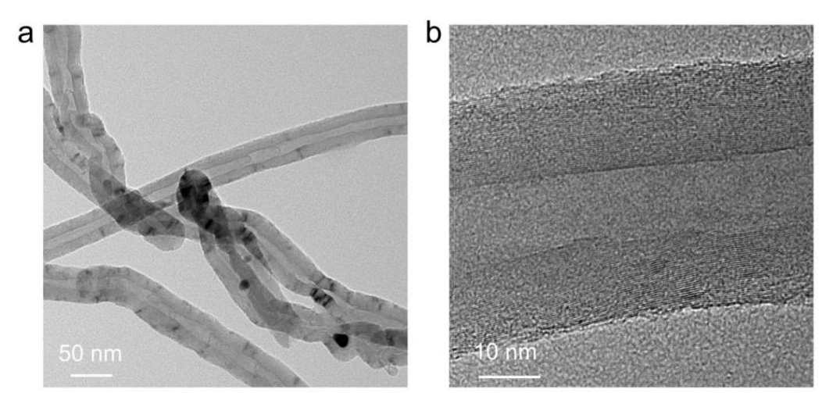
Supplementary Fig. 9 | TEM characterization of pristine CNTs. a Low-magnification TEM image showing the morphology and bundled structure of raw multi-walled carbon nanotubes. b High-resolution TEM image revealing well-defined graphitic lattice fringes characteristic of multi-walled CNTs.

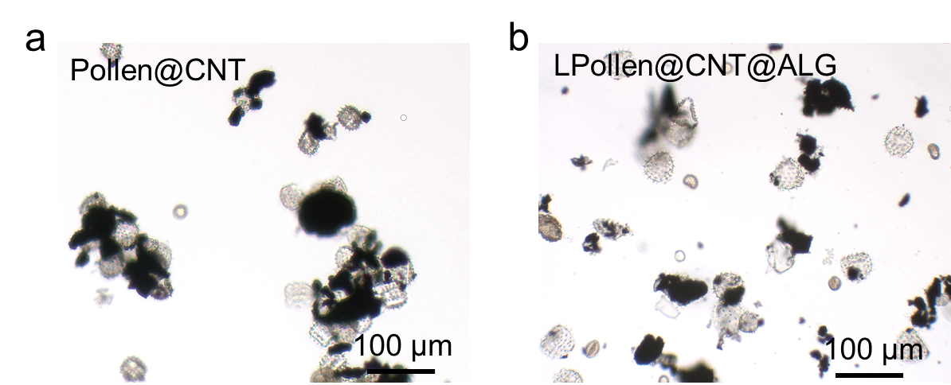
Supplementary Fig. 10 | Effect of mixing sequence on CNT dispersion. a Optical microscopy image of the Pollen@CNT mixture after 24 h of stirring, showing incomplete CNT dispersion and large CNT aggregates without ALG. b Optical microscopy image of the LPollen@CNT@ALG mixture prepared by stirring low-concentration pollen with CNTs and ALG, resulting in insufficient CNT dispersion due to limited pollen–CNT collision events.

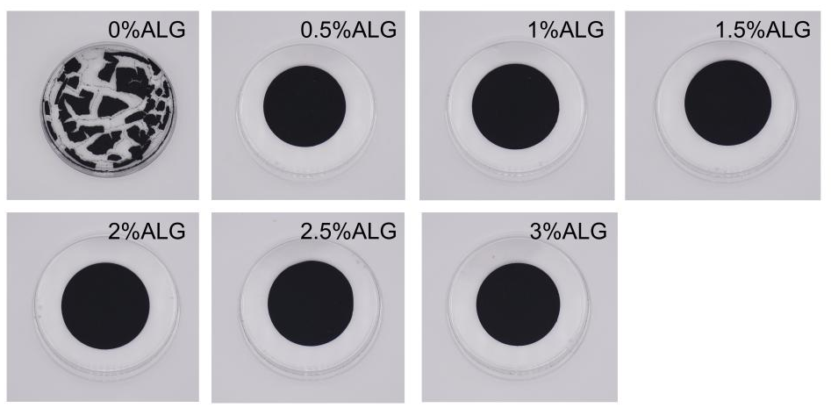
Supplementary Fig. 11 | Effect of alginate concentration on PAC film formation. Photographs of PAC films prepared with different ALG concentrations (0–3 wt%), showing that increasing ALG content improves film integrity and prevents cracking during drying.

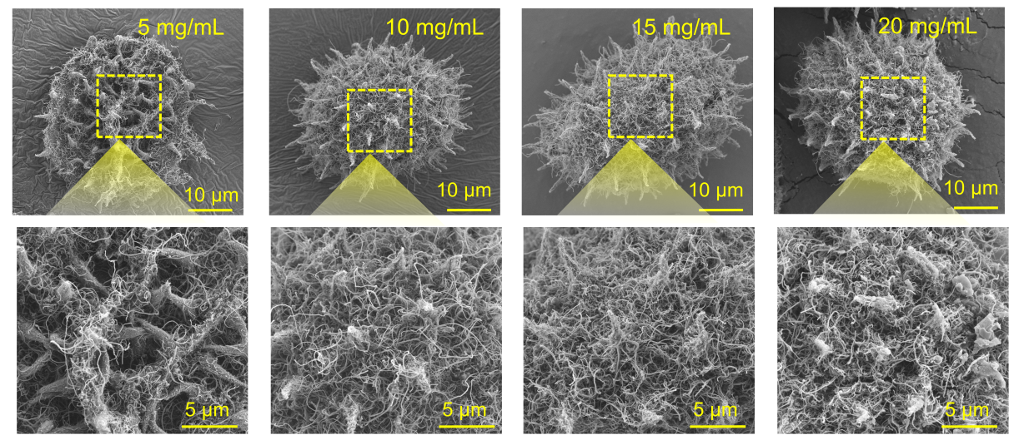
Supplementary Fig. 12 | CNT coverage on pollen microgels at different CNT concentrations. SEM images of PAC microgels prepared with varying CNT feed concentrations (5–20 mg mL⁻¹, 2 wt% ALG), showing progressively denser and more uniform CNT networks on the pollen surface as CNT concentration increases.

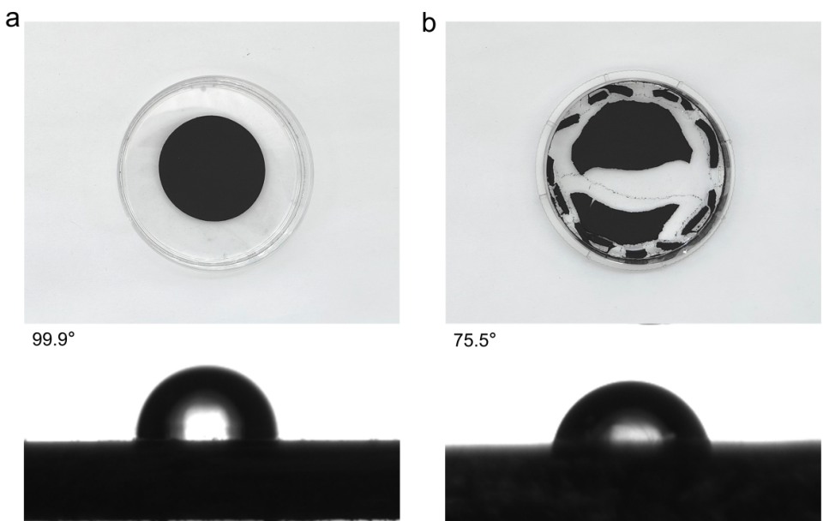
Supplementary Fig. 13 | Effect of substrate wettability on the drying morphology of PAC-15 films. a PAC-15 ink dried on a hydrophobic Petri dish (water contact angle≈99.9°) forms an intact, uniform film due to reduced adhesion between the ink and substrate. b PAC-15 ink dried on a hydrophilic Petri dish (water contact angle≈75.5°) exhibits severe cracking and nonuniform shrinkage, indicating strong ink–substrate interactions that hinder coherent film formation.

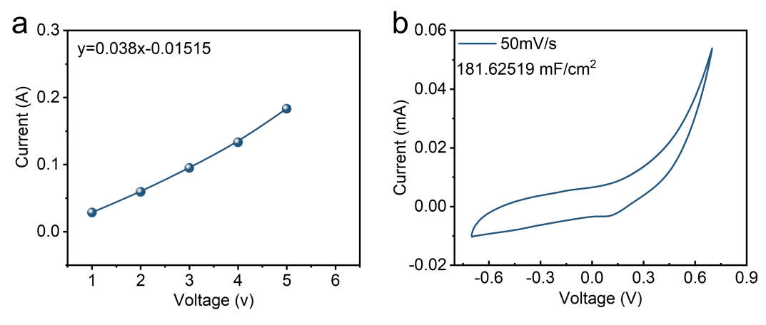
Supplementary Fig. 14 | The electrical properties of PAC film. a I-V curve of the PAC film. b Normalized cyclic voltammogram (CV) of PAC film at 5 mV·s⁻¹.

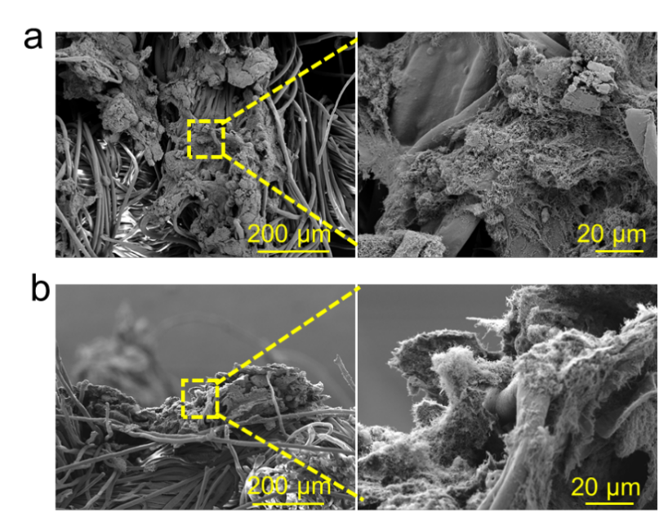
Supplementary Fig. 15 | The SEM images show the (a) surface and (b) cross-sectional views of the conductive pathways printed on linen with the dye.

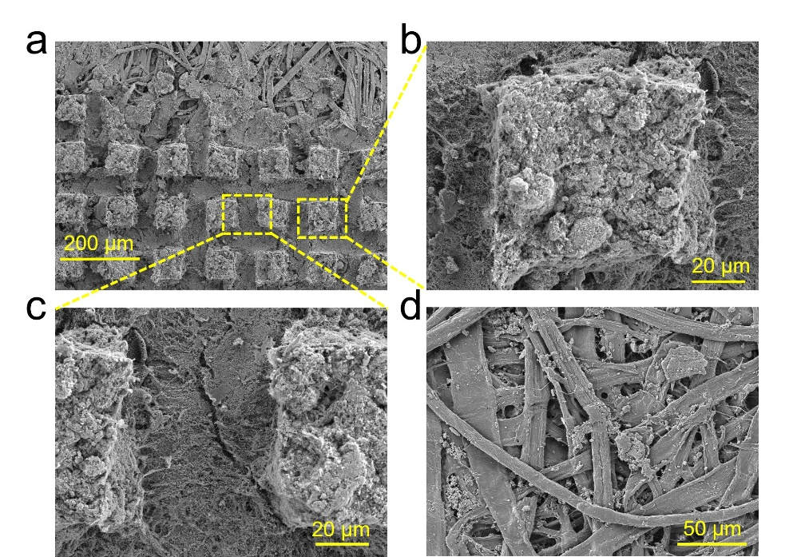
Supplementary Fig. 16 | Microstructural characterization of screen-printed PAC inks on paper substrates. a Top-view SEM image of a screen-printed PAC micro-pillar array on paper. b Magnified SEM image of an individual PAC micro-pillar. c SEM image of the interconnecting region between adjacent micro-pillars, revealing continuous conductive pathways formed by a thin layer of PAC ink. d SEM image of the pristine paper substrate for comparison.
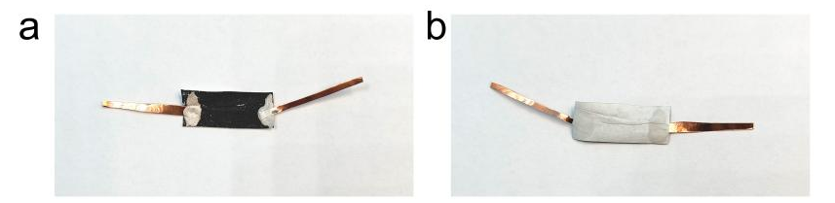
Supplementary Fig. 17 | Photo of the sensor prepared by printing. a The front of the sensor. b The back of the sensor.

3. Supplementary Table
Table S1. Relationship between shielding effectiveness (dB) and shielding efficiency (%).

Shielding effectiveness (dB) | Shielding efficiency (%)
0 | 0
10 | 90
20 | 99
30 | 99.9
40 | 99.99
50 | 99.999
60 | 99.9999
68.9 | 99.99998

Table S2. Comparison of EMI shielding performance between 90% CNT/CTS aerogel and various shielding materials.
Sample | Density  (g ·cm-³) | SE(dB) | SSE (dB ·cm³g-¹) | Ref.
Cu-wrapped nanofiber membranes | 1.6 | 53.2 | 33.25 | ¹
Ag-wrapped nanofiber membranes | 1.97 | 55.1 | 27.97 | ¹
Densified CNT film | 1.39 | 51.2 | 36.83 | ²
Densified CNT film | 1.39 | 73.3 | 52.73 | ²
Densified CNT film | 1.39 | 84.5 | 60.79 | ²
Densified CNT film | 1.39 | 101.4 | 72.95 | ²
FC-ANF/CNT | 0.0403 | 41.9 | 1039.7 | ³
FC-ANF/CNT | 0.0403 | 35.6 | 883.37 | ³
FC-ANF/CNT | 0.0403 | 27.8 | 689.83 | ³
FC-ANF/CNT | 0.0403 | 22.7 | 563.28 | ³
Graphene film | 1.49 | 38.1 | 25.57 | ⁴
Graphene film | 1.49 | 44.5 | 29.87 | ⁴
Graphene film | 2.25 | 27.8 | 12.36 | ⁴
Al foil | 2.7 | 66 | 24.4 | ⁵
Cu foil | 8.97 | 70 | 7.8 | ⁵
Ti₃C₂Tx | 2.39 | 68 | 28.4 | ⁵
Ti₃C₂Tx/SA | 2.32 | 57 | 24.6 | ⁵
MXene film (Blade coating) | 4.3 | 53.5 | 12.44 | ⁶
d-Ti3C2Tx/CNFs | 1.14 | 25 | 22 | ⁷
d-Ti3C2Tx/CNFs | 1.625 | 26 | 16 | ⁷
d-Ti3C2Tx/CNFs | 2 | 24 | 12 | ⁷
CNT/epoxy composites | 0.3372 | 14.331 | 42.5 | ⁸
CNT/epoxy composites | 0.3374 | 22.1672 | 65.7 | ⁸
GCF | 0.91 | 48.9 | 53.7 | ⁹
MCS film | 2.489 | 58 | 23.3 | ¹⁰
BF/ANF/CNT Composite Paper | 0.66393 | 40.5 | 61 | ¹¹
PAC | 0.5597 | 41.0776 | 73.3922 | This work
PAC | 0.5597 | 40.3621 | 72.1137 | This work

1. Zeng Z, et al. Flexible and Ultrathin Waterproof Cellular Membranes Based on High‐Conjunction Metal‐Wrapped Polymer Nanofibers for Electromagnetic Interference Shielding. Advanced Materials 32, (2020).
2. Wan YJ, et al. Ultrathin Densified Carbon Nanotube Film with "Metal-like" Conductivity, Superior Mechanical Strength, and Ultrahigh Electromagnetic Interference Shielding Effectiveness. ACS nano 14, 14134-14145 (2020).
3. Hu P, et al. Multifunctional Aramid Nanofiber/Carbon Nanotube Hybrid Aerogel Films. ACS nano 14, 688-697 (2019).
4. Zhou T, et al. Second Time-Scale Synthesis of High-Quality Graphite Films by Quenching for Effective Electromagnetic Interference Shielding. ACS nano 14, 3121-3128 (2020).
5. Faisal Shahzad MA, Christine B. Hatter,Babak Anasori,Soon Man Hong, Chong Min Koo,Yury Gogotsi3. Electromagnetic interference shielding with 2D transition metal carbides (MXenes). Science 353，6304, (2016).
6. Zhang J, et al. Scalable Manufacturing of Free‐Standing, Strong Ti3C2Tx MXene Films with Outstanding Conductivity. Advanced Materials 32, (2020).
7. Cao W-T, et al. Binary Strengthening and Toughening of MXene/Cellulose Nanofiber Composite Paper with Nacre-Inspired Structure and Superior Electromagnetic Interference Shielding Properties. ACS nano 12, 4583-4593 (2018).
8. Mao Y-J, et al. Effective electromagnetic interference shielding properties of micro-truss structured CNT/Epoxy composites fabricated based on visible light processing. Composites Science and Technology 221, (2022).
9. Zhou E, et al. Synergistic effect of graphene and carbon nanotube for high-performance electromagnetic interference shielding films. Carbon 133, 316-322 (2018).
10. Li X, Ma Z, Wang L, Li S, Duan Y, Wu M. Flexible sandwich-structured MXene@CNT/SA@MXene film with high electromagnetic shielding performance. Journal of Materials Science 59, 1968-1988 (2024).
11. Song S, Li L, Ji D, Zhao J, Wu Q, Wang Q. Flexible Basalt Fiber/Aramid Nanofiber/Carbon Nanotube Electromagnetic Shielding Paper with Outstanding Environmental Stability and Joule Heating Performance. ACS Applied Materials & Interfaces 15, 35495-35506 (2023).

References

