Extended Figures:
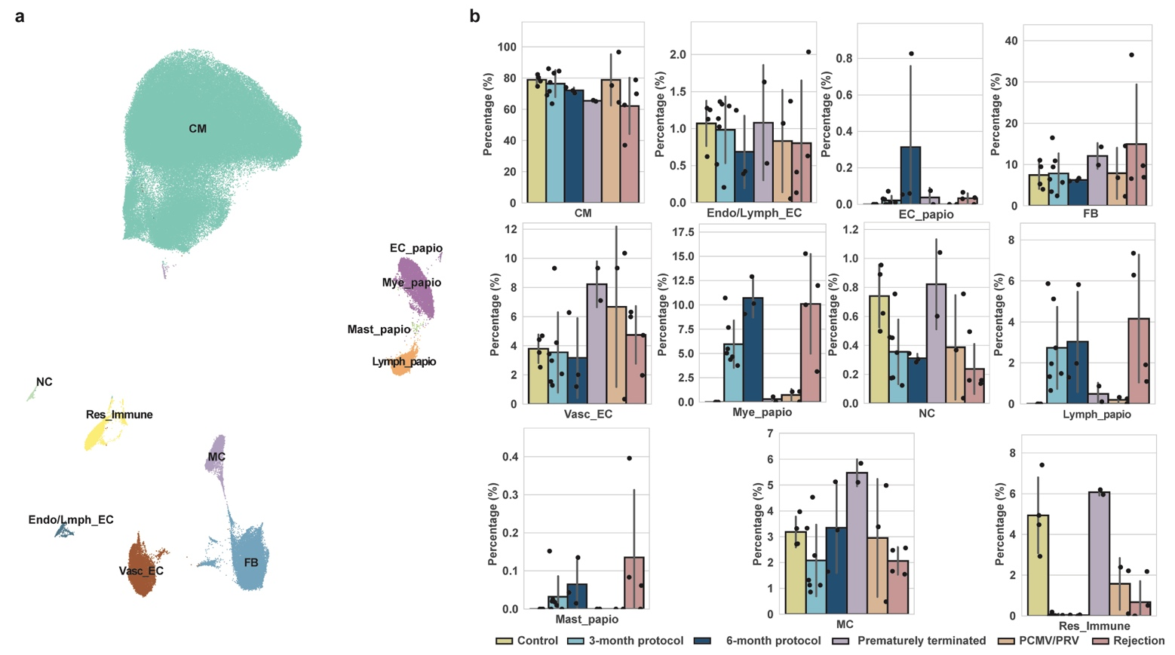
Extended Figure 1: Cell types of pig-to-baboon cohort. (a) UMAP embedding of 186,947 nuclei revealing eleven major cardiac cell types, including seven of Sus scrofa and four of Papio anubis/hamadryas origin (indicated by ‘_papio’). (b) Bar plots displaying proportions of all cell types across conditions.
CM: Cardiomyocytes, NC: Neuronal cells, Res_Immune: Resident immune cells, Endo/Lymph: Endocardial/Lymphatic, Vasc: Vascular, EC: Endothelial cells, MC: Mural cells, FB: Fibroblasts, Mast: Mast cells, Mye: Myeloids, Lymph: Lymphoids, UMAP: Uniform manifold approximation and projection.

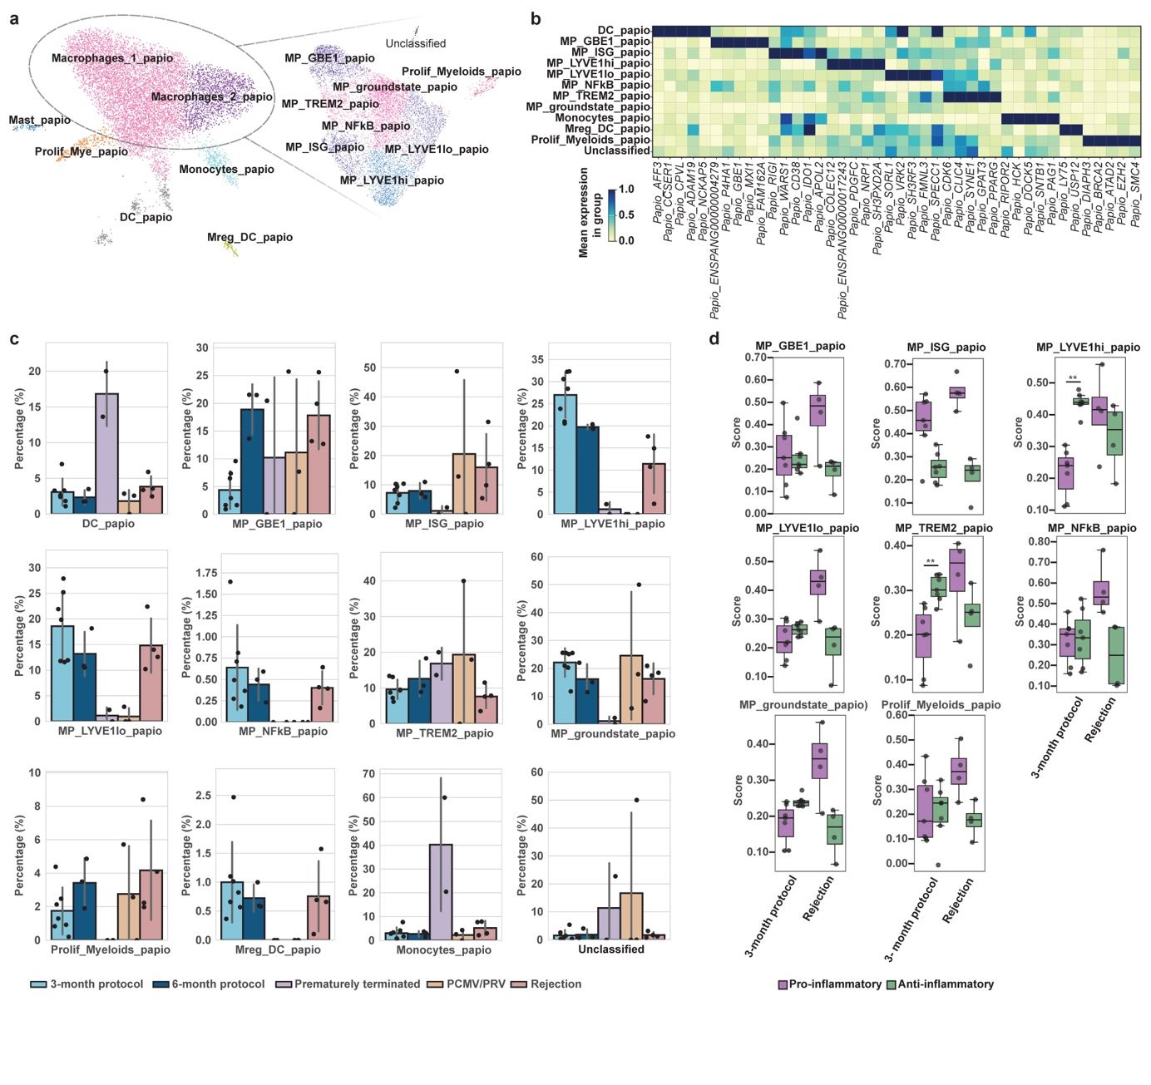
Extended Figure 2: Infiltrating myeloids (Mye_papio) and macrophages (MPs). (a) UMAP embedding reveals seven Mye_papio infiltrating myeloids cell states and nine MP cell states. Insets display subclusters comprising nine MP cell states of Papio anubis/hamadryas origin. (b) Matrix plot indicating differentially expressed genes across infiltrating mye_papio cell states. Mean normalized expression calculated based on expression inside vs outside each dedicated cell state. (c) Bar plots displaying proportions of mye_papio and MP cell states across conditions. (d) Comparative box plots showing MP polarization gene set scores across different MP states in rejection and ‘3-month protocol’. Proportion of cell types across all control and transplanted samples. Statistical testing was done by Mann-Whitney U test and P value<0.05 was considered statistically significant. Dots represent individual samples.
Mye: Myeloids, Mast: Mast cells, DC: Dendritic cells, Prolif: Proliferating, MP: Macrophages, ISG: Interferon stimulated genes, Papio: Papio anubis/hamadryas, UMAP: Uniform manifold approximation and projection.

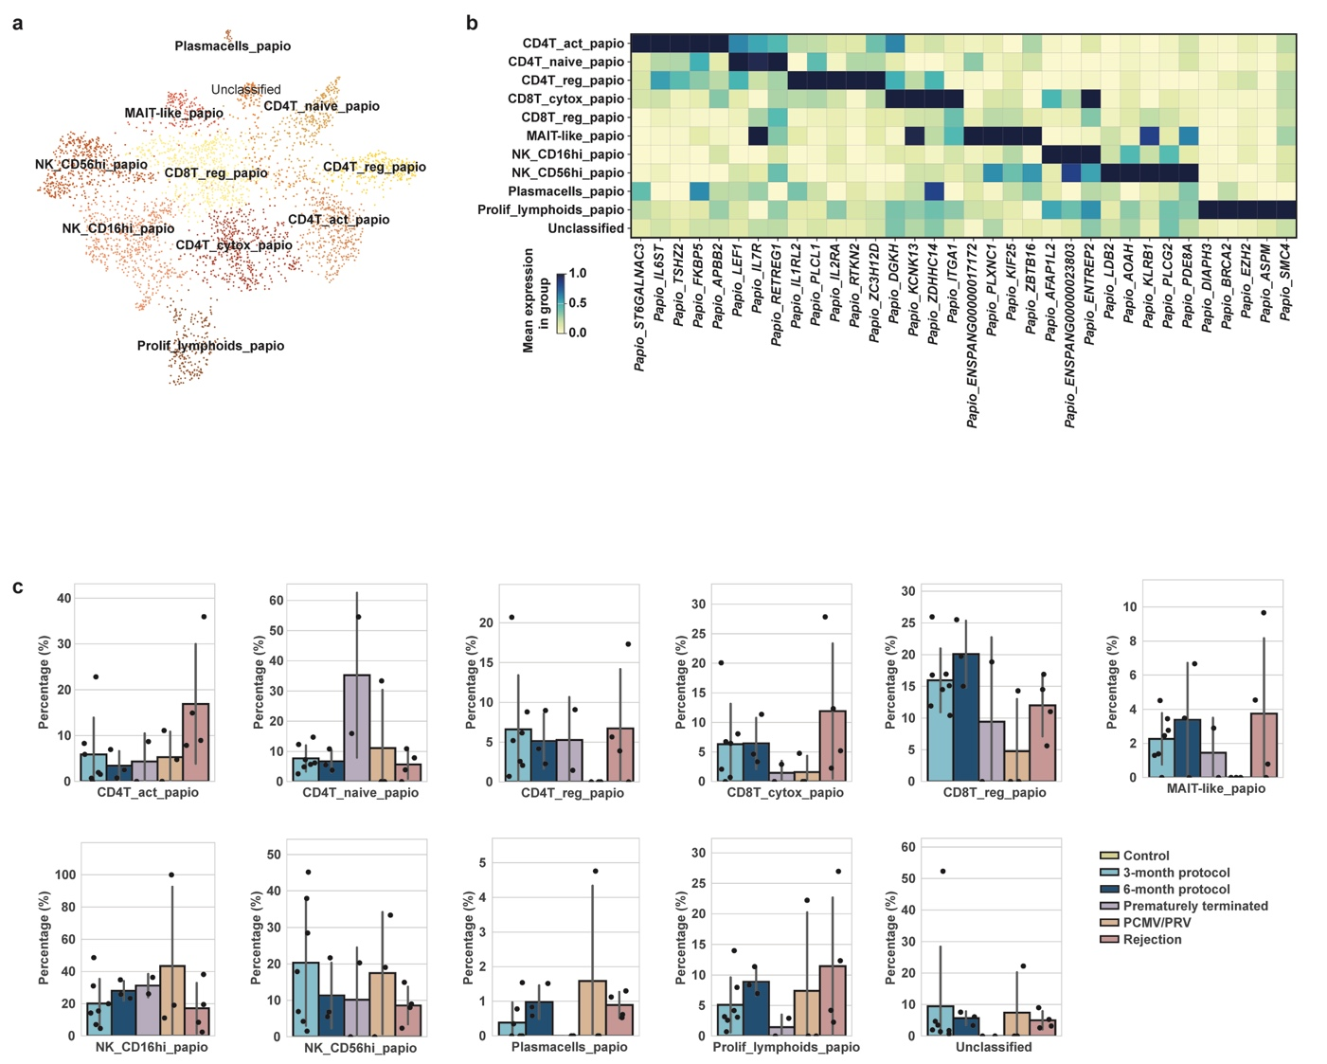
Extended Figure 3: Infiltrating lymphoids (Lymph_papio). (a) UMAP embedding reveals seven infiltrating Lymph_papio cell states. (b) Matrix plot indicating differentially expressed genes across infiltrating Lymph_papio cell states. Mean normalized expression calculated based on expression inside vs outside each dedicated cell state. (c) Bar plots displaying proportions of different lymph_papio cell states across conditions.
CD4T: CD4 positive T-cells, CD8T: CD8 positive T-cells, MAIT: Mucosal-associated invariant T-cells, NK: Natural killer cells, Reg: Regulatory, Act: Activated, Cytox: Cytotoxic, Prolif: Proliferating, Papio: Papio anubis/hamadryas, UMAP: Uniform manifold approximation and projection.

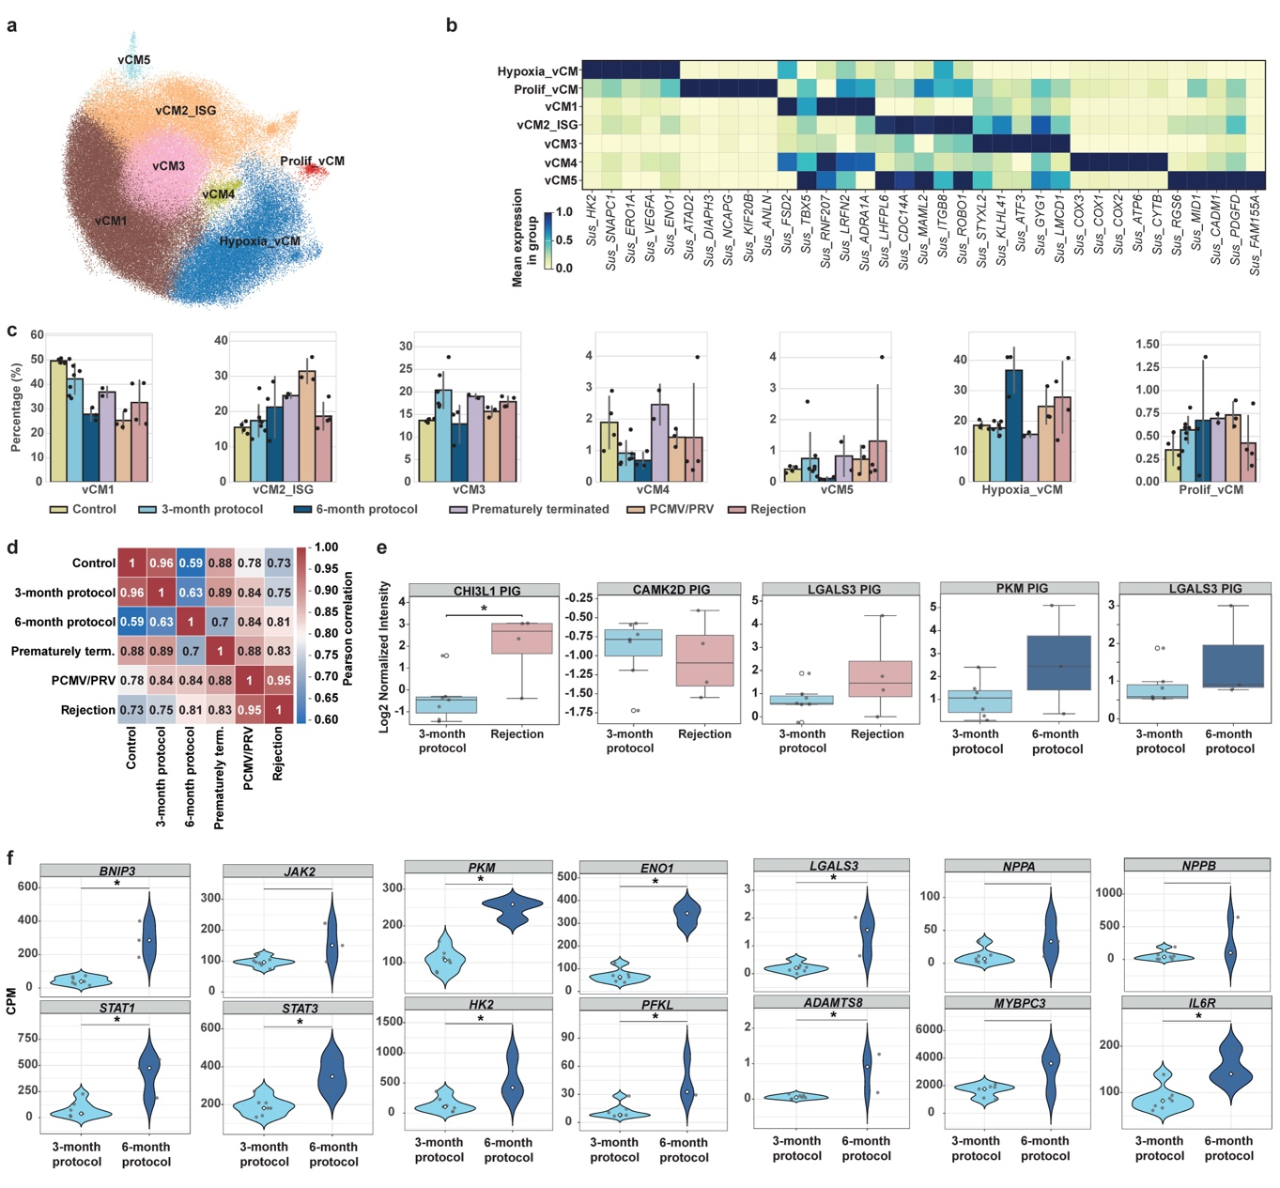
Extended Figure 4: Cardiomyocytes (CM). (a) UMAP of CMs showing seven cell states. (b) Matrix plot indicating differentially expressed genes across vCM cell states. Mean normalized expression calculated based on expression inside vs outside each dedicated cell state. (c) Bar plots displaying proportions of all vCM cell states across conditions. (d) Heatmap indicating Pearson correlations between metabolic pathways gene set scores across all conditions. (e) Box plots showing plasma proteomics changes in rejection vs ‘3-month protocol’ and ‘6-month protocol’ vs ‘3-month protocol’ xenografts. Statistical testing was done by Mann-Whitney U test, and a P value<0.05 was considered statistically significant. Dots represent individual samples. (f) Violin plots of CM genes in ‘6-month protocol’ vs ‘3-month protocol’ xenografts. Statistics as in (e).
vCM: Ventricular cardiomyocytes, Prolif: Proliferating, ISG: Interferon stimulated genes, term.: terminated, UMAP: Uniform manifold approximation and projection, CPM: Counts per million.

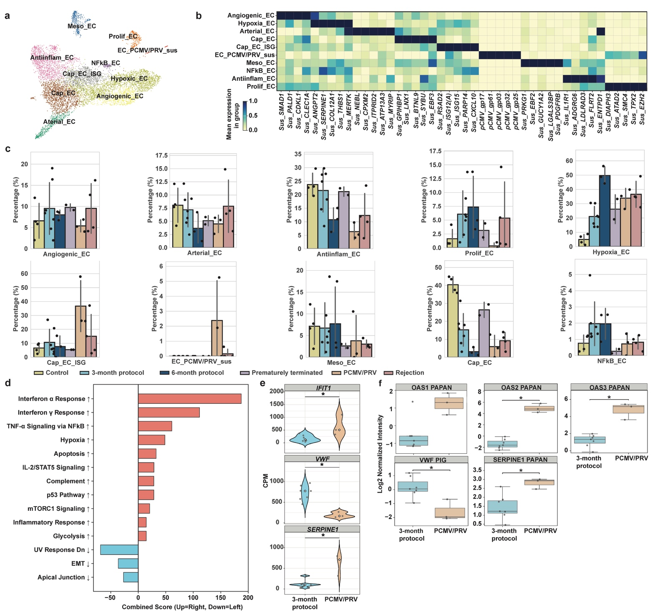
Extended Figure 5: Vascular endothelial cells (Vasc_EC). (a) UMAP of Vasc_ECs showing ten cell states. (b) Matrix plot indicating differentially expressed genes across Vasc_ECs cell states. Mean normalized expression calculated based on expression inside vs outside each dedicated cell state. (c) Bar plots displaying proportions of all Vasc_ECs cell states across conditions. (d) Pathway enrichment in Vasc_ECs of PCMV/PRV vs ‘3-month protocol’ grafts. Bars represent combined enrichment scores (red, upregulated; blue, downregulated). (e) Violin plots of Vasc_EC genes in PCMV/PRV vs ‘3-month protocol’ xenografts. Statistical testing was done by Mann-Whitney U test, and a P value<0.05 was considered statistically significant. Dots represent individual samples. (f) Box plots showing plasma proteomics changes in ‘PCMV/PRV’ vs ‘3-month protocol’ xenografts. Statistics as in (e).
EC: Endothelial cells, Meso: Mesothelial, Prolif: Proliferating, Antiinflam: Antiinflammatory, Cap: Capillary, ISG: Interferon stimulated genes, EMT: Epithelial-to-mesenchymal transition, PCMV/PRV: Porcine cytomegalovirus/porcine roseolovirus, PCMV/PRV: Porcine cytomegalovirus/porcine roseolovirus, UMAP: Uniform manifold approximation and projection, CPM: Counts per million.

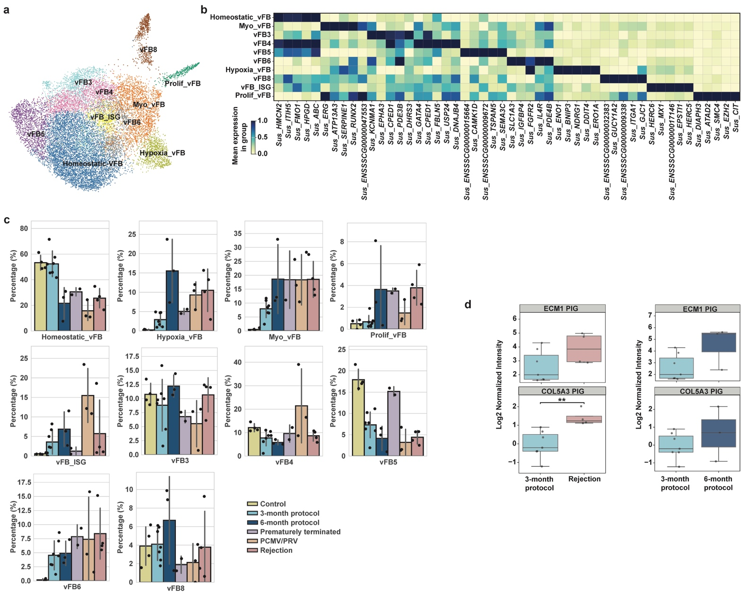
Extended Figure 6: Fibroblasts (FB). (a) UMAP of FBs showing ten cell states. (b) Matrix plot indicating differentially expressed genes across FBs cell states. Mean normalized expression calculated based on expression inside vs outside each dedicated cell state. (c) Bar plots displaying proportions of all FBs cell states across conditions. (d) Box plots showing plasma proteomics changes in ‘rejection’ vs ‘3-month protocol’ and ‘6-month protocol’ vs ‘3-month protocol’ xenografts. Statistical testing was done by Mann-Whitney U test, and a P value<0.05 was considered statistically significant. Dots represent individual samples.
vFB: Ventricular Fibroblasts, Myo_FB: Myofibroblasts, Prolif: Proliferating, ISG: Interferon stimulated genes, PCMV/PRV: Porcine cytomegalovirus/porcine roseolovirus, UMAP: Uniform manifold approximation and projection, CPM: Counts per million.

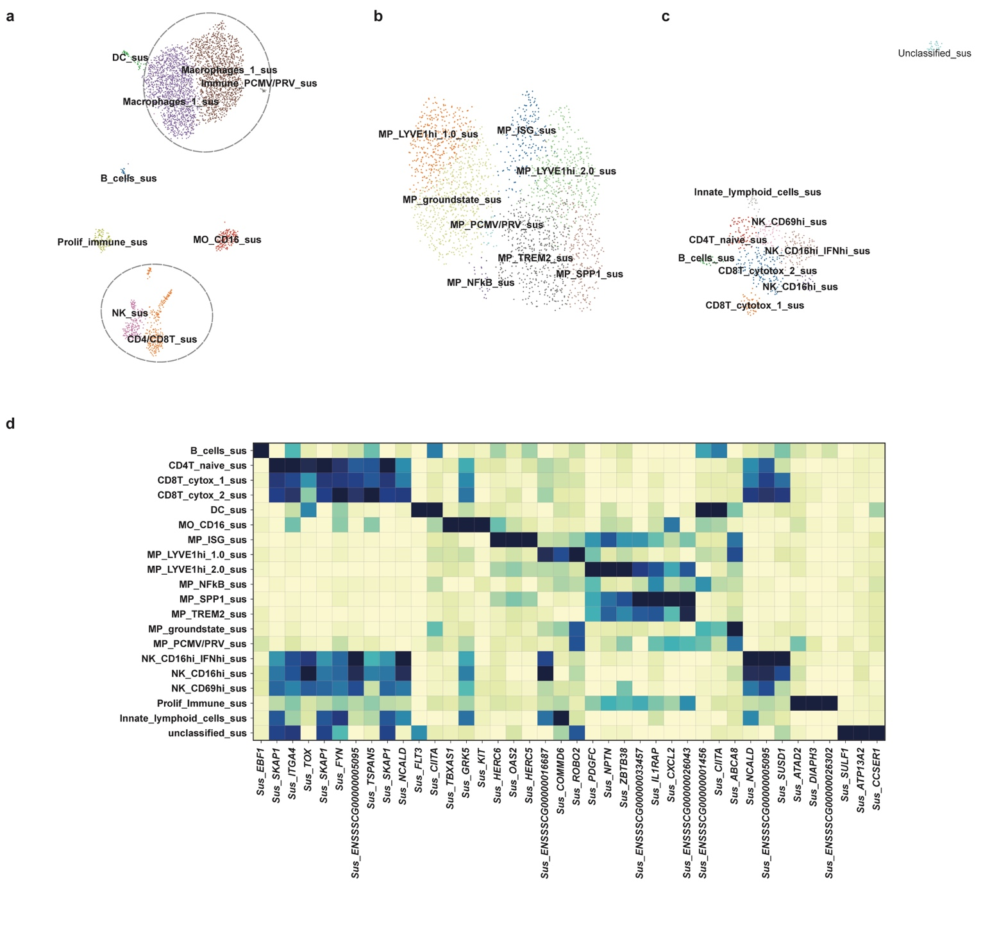
Extended Figure 7: Resident pig-derived immune cells (Res_immune) (1). (a) UMAP of Res_Immune showing nine cell states (dashed circles highlight macrophages and lymphoids that were further investigated at higher resolution) (b) Higher resolution UMAP of Sus scrofa originated MPs showing eight cell states. (c) Higher resolution UMAP of Sus scrofa originated lymphoids showing nine cell states. (d) Matrix plot indicating differentially expressed genes across Res_Immune cell states. Mean normalized expression calculated based on expression inside vs outside each dedicated cell state.
DC: Dendritic cells, Sus: Sus scrofa, Prolif: Proliferating, MO: Monocytes, NK: Natural killer cells, CD4T: CD4 positive T-cells, CD8T: CD8 positive T-cells, MP: Macrophages, Cytotox: Cytotoxic, PCMV/PRV: Porcine cytomegalovirus/porcine roseolovirus, UMAP: Uniform manifold approximation and projection.

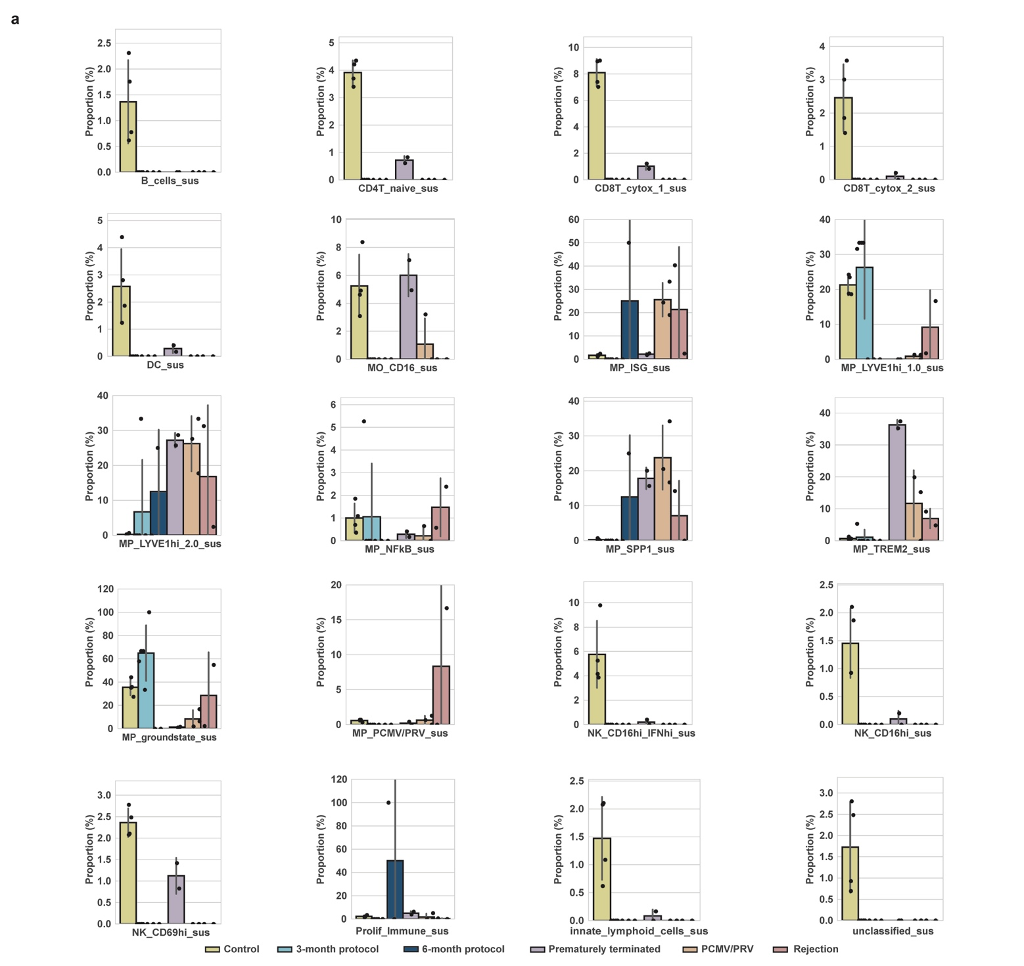
Extended Figure 8: Resident pig-derived immune cells (2). (a) Bar plots displaying proportions of all Resident immune cell states across conditions.
Sus: Sus scrofa, CD4T: CD4 positive T-cells, CD8T: CD8 positive T-cells, Cytotox: Cytotoxic, DC: Dendritic cells, MO: Monocytes, MP: Macrophages, ISG: Interferon stimulated genes, PCMV/PRV: Porcine cytomegalovirus/porcine roseolovirus, NK: Natural killer cells, Prolif: Proliferating.

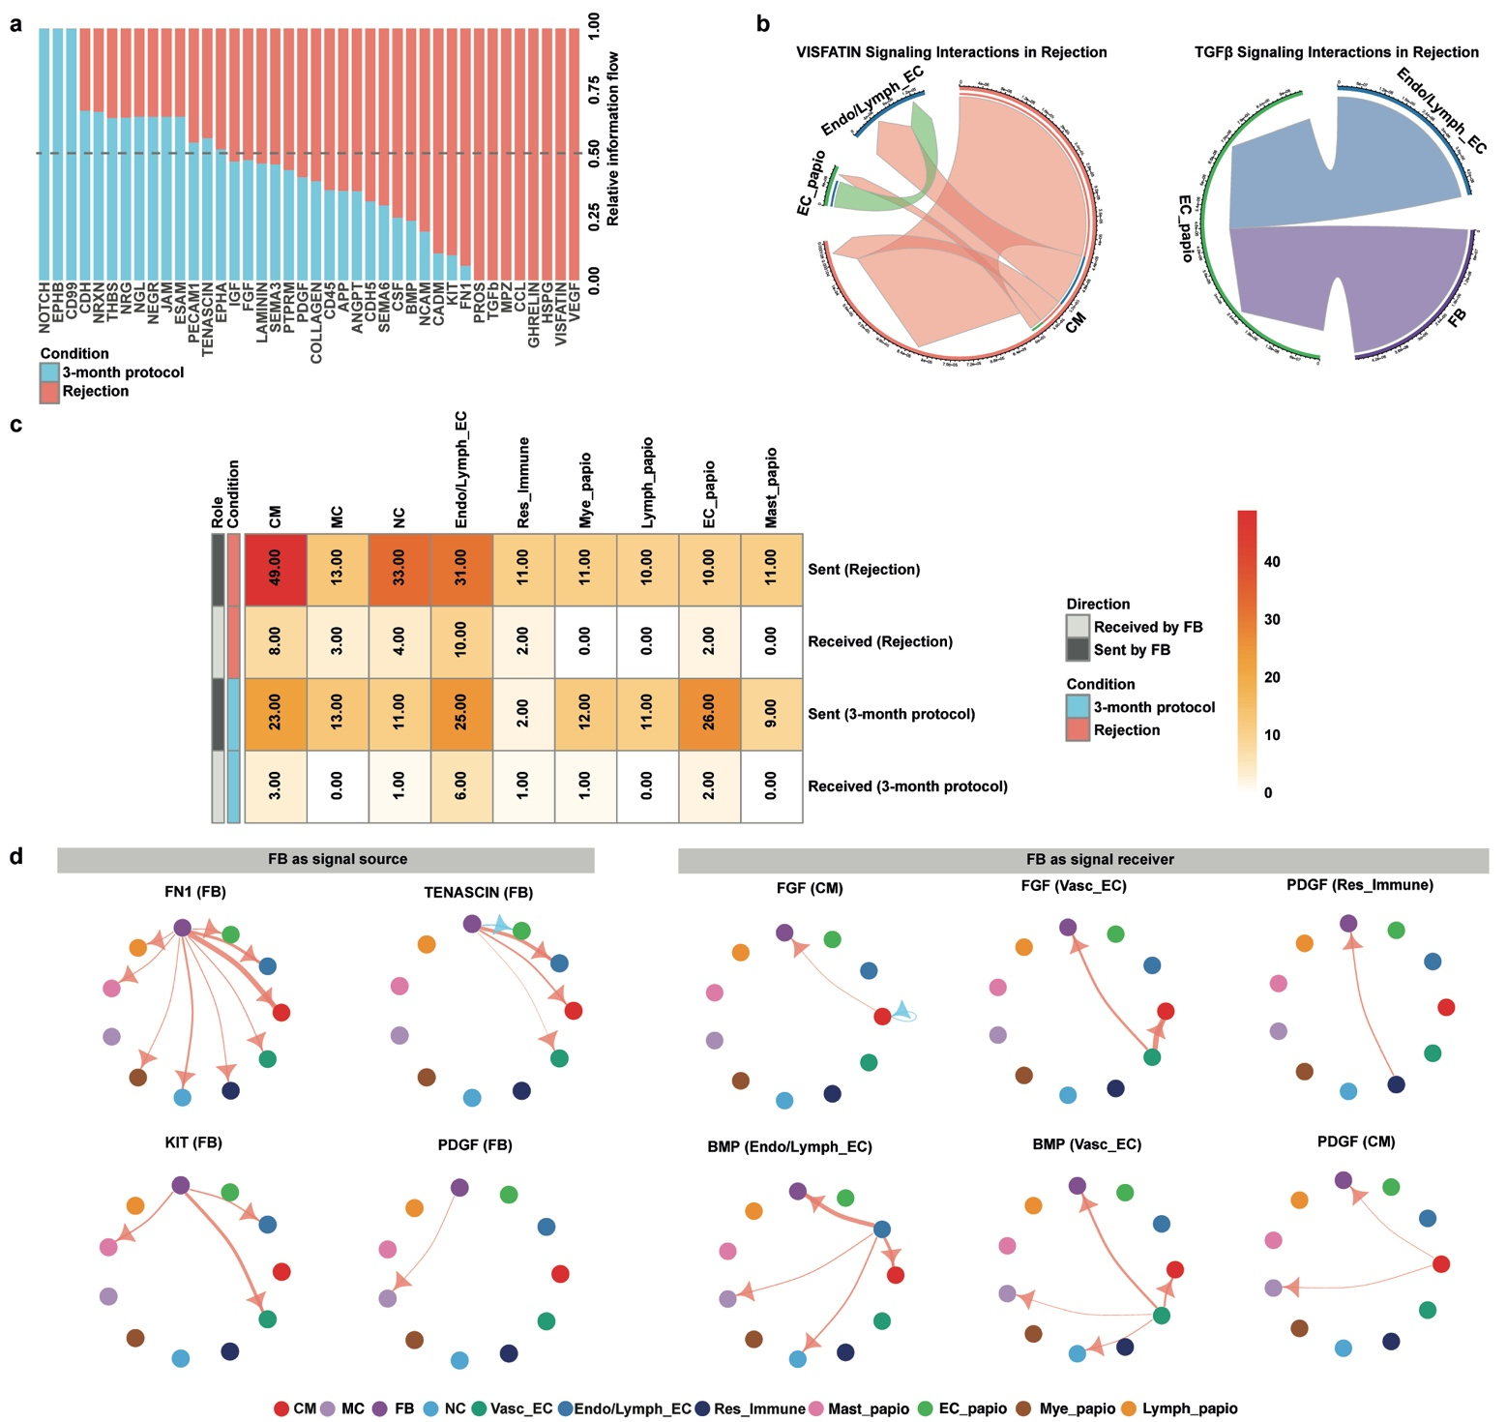
Extended Figure 9: Cell Chat in Rejection. (a) Comparative barplot of differential CellChat analysis displaying communication probabilities of different pathways in ‘rejection’ and ‘3-month protocol’ cohorts. (b) Circos plots of VISFATIN and TGFβ pathway source-target interaction probabilities among different cell types in rejection. Arrows indicate signaling direction. Line thickness reflects interaction strength. Significance was determined by non-parametric permutation testing (P values ≤ 0.05). (c) Differential heatmap showing the number of signaling pathways received or sent from FBs in ‘rejection’ and ‘3-month protocol’ cohorts. (d) Differential cell-cell communication chord plots between ‘6-month protocol’ and ‘3-month protocol’ xenografts. Statistics as in (c). Salmon: higher in rejection; blue: higher in ‘3-month protocol’.
CM: Cardiomyocytes, NC: Neuronal cells, Res_Immune: Resident immune cells, Endo/Lymph: Endocardial/Lymphatic, Vasc: Vascular, EC: Endothelial cells, MC: Mural cells, FB: Fibroblasts, Mast: Mast cells, Mye: Myeloids, Lymph: Lymphoids, Papio: Papio anubis/hamadryas,

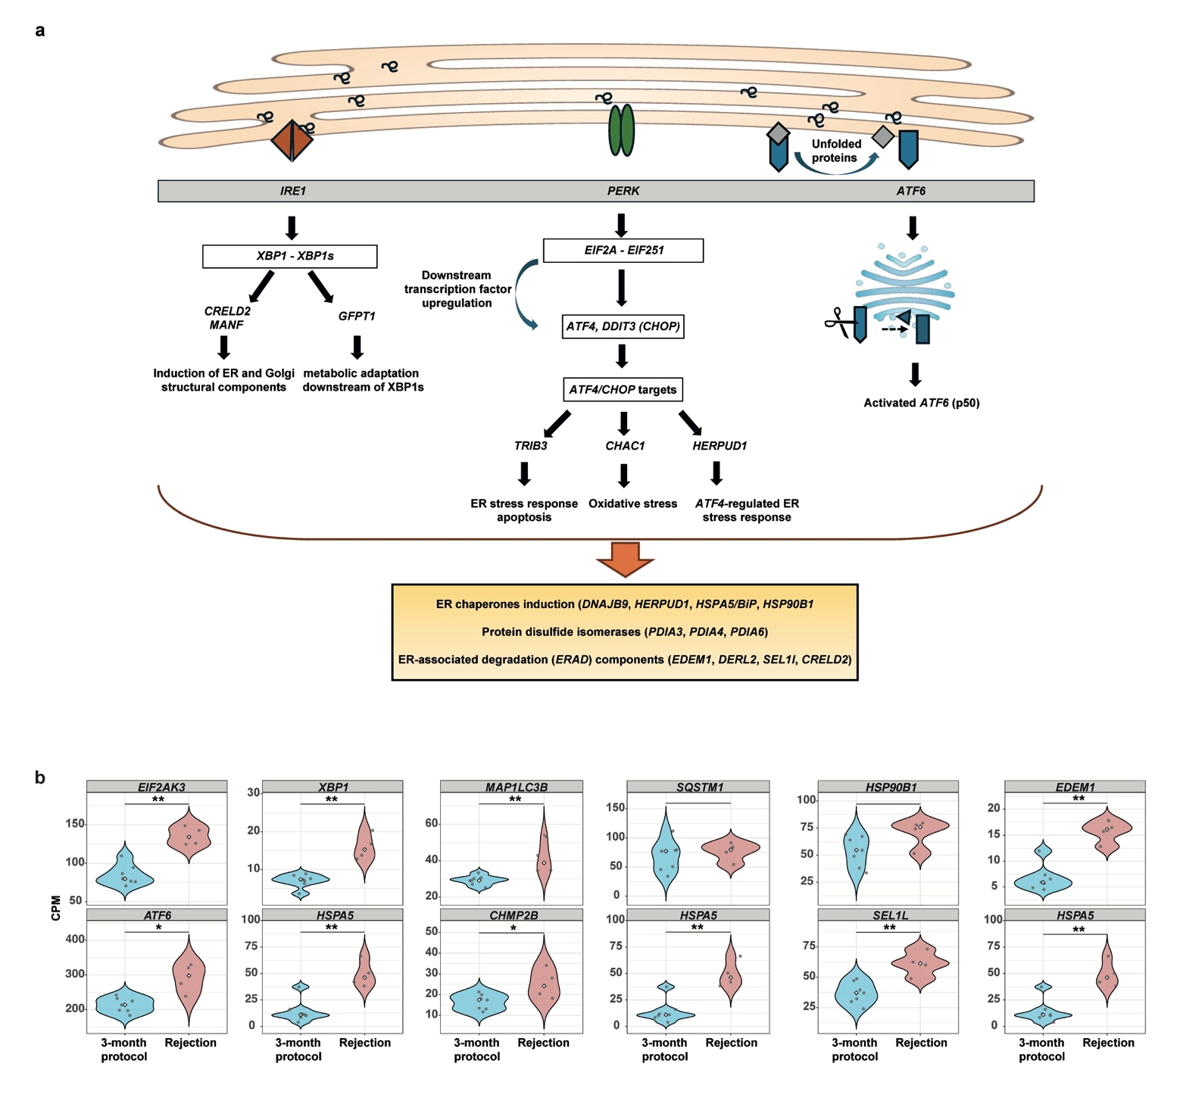
Extended Figure 10: Unfolded Protein Response (UPR) system. (a) Schematic of the UPR system. (b) Violin plots of UPR-related genes in ‘rejection’ vs ‘3-month protocol’ xenografts. P values calculated by Mann-Whitney U-test and multiple testing correction by Benjamini-Hochberg (* FDR ≤ 0.05).
UPR: Unfolded protein response, ER: Endoplasmic reticulum, CPM: Counts per million, FDR: False discovery rate.

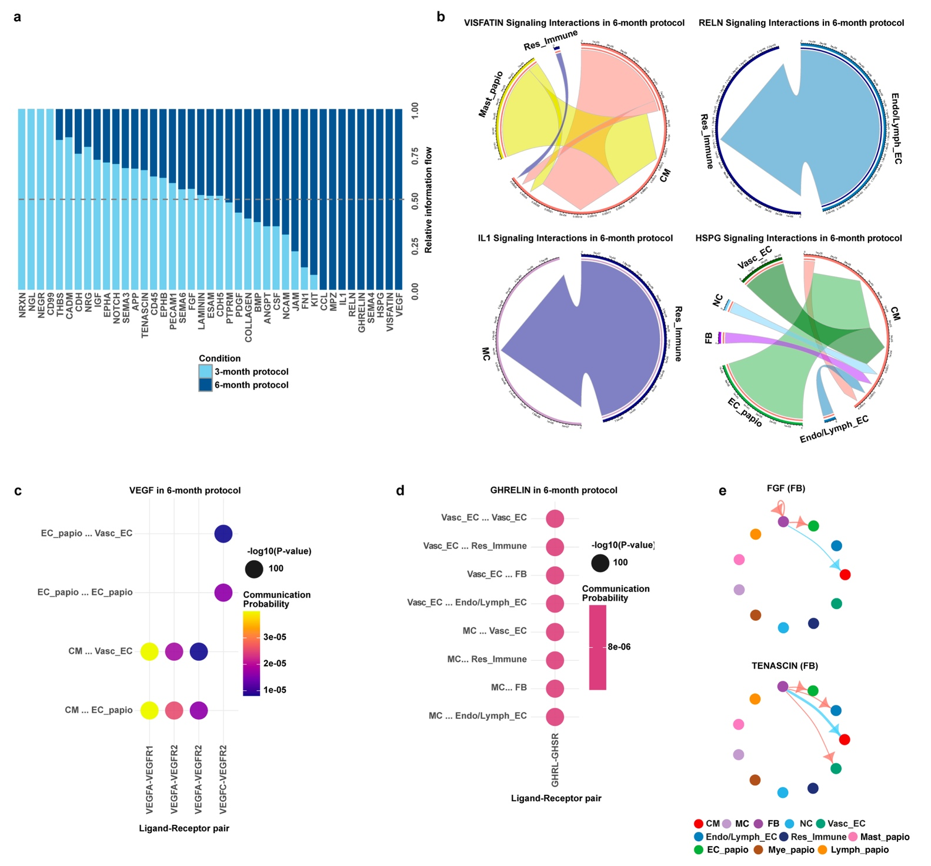
Extended Figure 11: Cell Chat in ‘6-month protocol’. (a) Comparative barplot of differential CellChat analysis displaying communication probabilities of different pathways in ‘6-month protocol’ and ‘3-month protocol’. (b) Circos plots of VISFATIN, RELN, IL1, HSPG pathways source-target interaction probabilities among different cell types in ‘6-month protocol’. Arrows indicate signaling direction. Line thickness reflects interaction strength. Significance was determined by non-parametric permutation testing (P values ≤ 0.05). (c) Bubble plot showing ligand-receptor pairs for VEGF signaling among different cell types in 6-month protocol. (d) Bubble plot showing ligand-receptor pairs for GHRELIN signaling among different cell types in 6-month protocol. (e) Differential cell-cell communication chord plots between ‘6-month protocol’ and ‘3-month protocol’ xenografts. Statistics as in (b). Salmon: higher in rejection; blue: higher in ‘3-month protocol’.
CM: Cardiomyocytes, NC: Neuronal cells, Res_Immune: Resident immune cells, Endo/Lymph: Endocardial/Lymphatic, Vasc: Vascular, EC: Endothelial cells, MC: Mural cells, FB: Fibroblasts, Mast: Mast cells, Mye: Myeloids, Lymph: Lymphoids, Papio: Papio anubis/hamadryas,

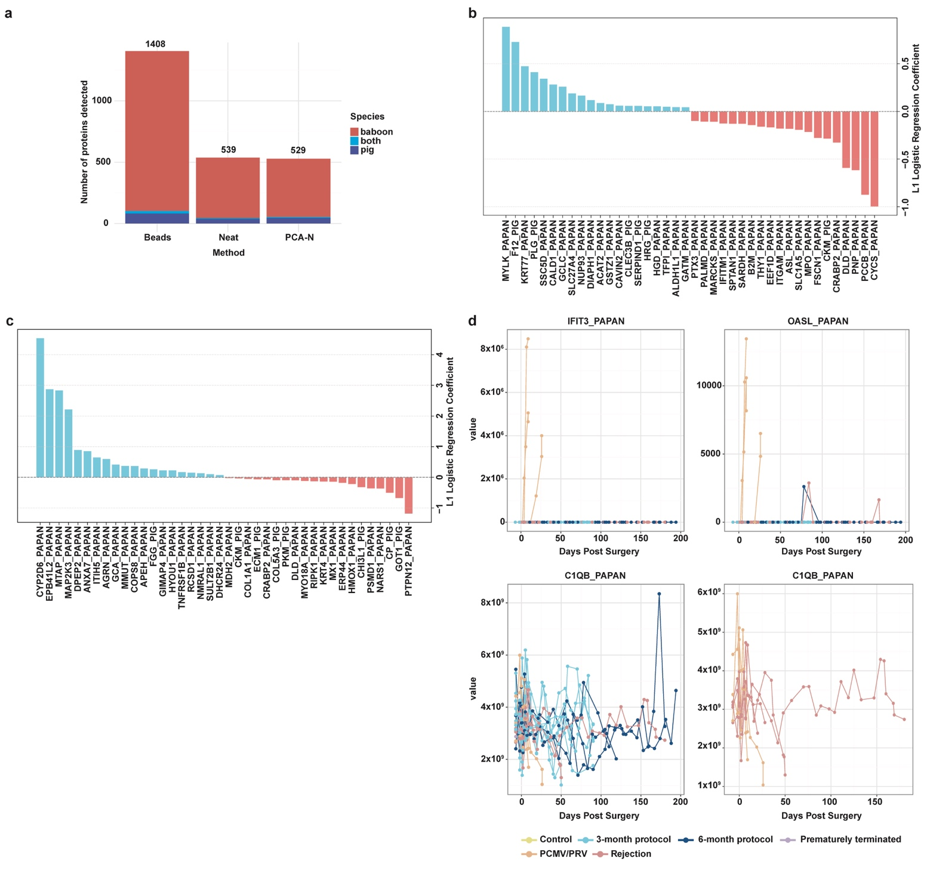
Extended Figure 12: Plasma proteomics risk prediction model. (a) Total number of detected baboon (red) and pig (purple) proteins per sample preparation workflow. Proteins that could not be assigned uniquely to one species are shown in light blue. (b, c) Top 20 features of L1 logistic regression coefficient models with coefficients comparing ‘3-month protocol’ vs. (b) PCMV/PRV-positive and (c) rejecting baboons. Features with a positive coefficient are shown in blue, while proteins with a negative coefficient are shown in red. The species origin is indicated in the suffix of each gene (x-axis; PIG: Sus scrofa, PAPAN: Papio anubis/hamadryas).

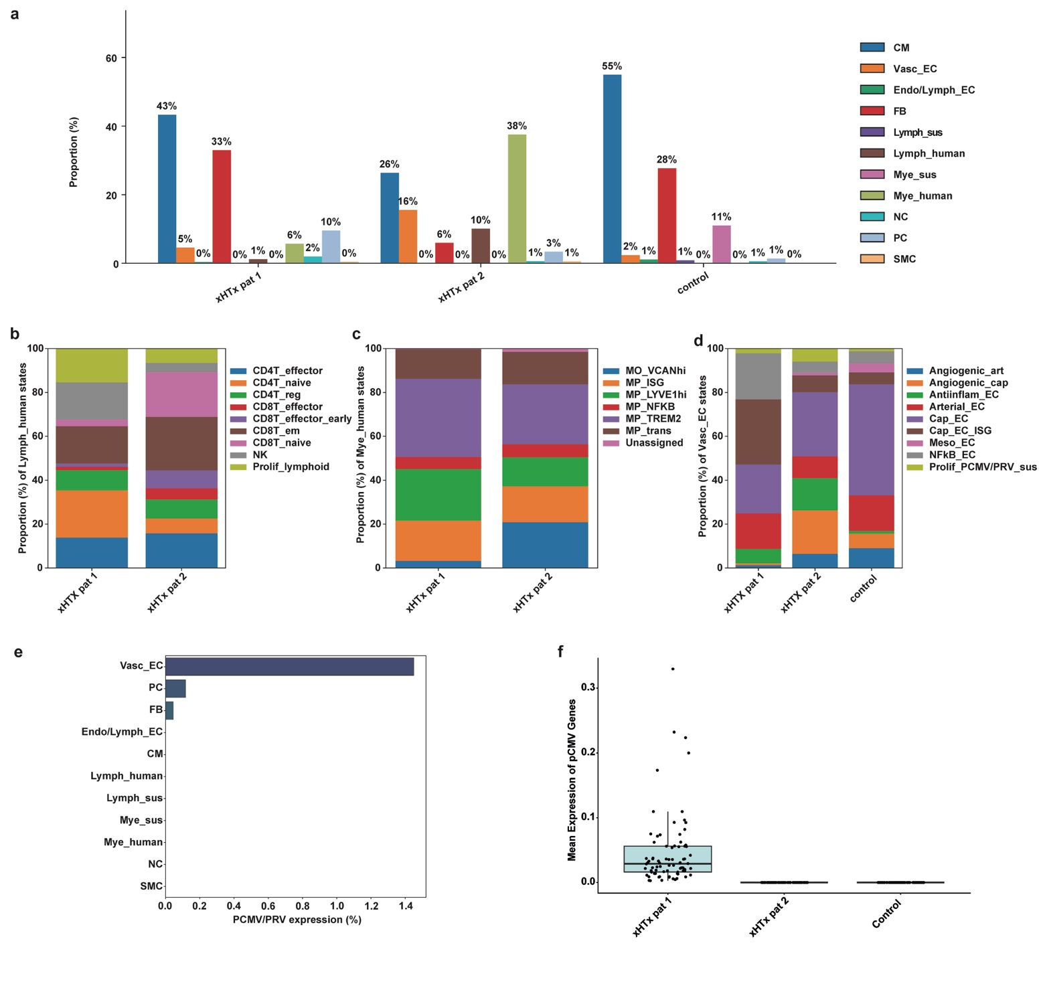
Extended Figure 13: Clinical xHTx samples. (a) Proportion of major cell types across different samples. (b) Proportion of Lymph_human cell states across different samples. (c) Proportion of Mye_human cell states across xHTx samples. (d) Proportion of Vasc_ECs cell states across xHTx samples. (e) Proportion of nuclei with detectable PCMV/PRV transcripts across major cell types. Viral positivity was defined by ≥2 unique PCMV/PRV genes and ≥10 counts. (f) Mean expression of PCMV/PRV genes across two xHTx and one not-transplanted control.
xHTx: Cardiac xenotransplantation, Pat: Patient, CM: Cardiomyocytes, EC: Endothelial cells, FB: Fibroblasts, Lymph: Lymphoids, Mye: Myeloids, NC: Neuronal cells, PC: Pericytes, SMC: Smooth muscle cells, CD4T: CD4 positive T-cells, CD8T: CD8 positive T-cells, Sus: Sus scrofa, reg: Regulatory, em: effector memory, Prolif: Proliferating, MO: Monocytes, MP: Macrophages, ISG: Interferon stimulated genes, trans: transitional, art: arterial, cap: capillary, Meso: Mesothelial cells, PCMV/PRV: Porcine cytomegalovirus/porcine roseolovirus.

