Clinical and nutritional management in subjects with different intestinal failure types: characterization of intestinal bacterial communities in a case series

Riccardo Coletta^{1,}†, Sofia Chioccioli^{1,2}†, Niccolò Meriggi³, Michele Maria Cantagalli^{1,2}, Francesca Gigola¹, Chiara Oreglio¹, Elisabetta Lacava¹, Mariela Mejia Monroy^{4,3}, Sonia Renzi⁵, Benedetta Cerasuolo⁵, Duccio Cavalieri⁵, Carlotta De Filippo³*, Antonino Morabito^{1,2}*

^{1.} Department of Paediatric Surgery, Meyer Children’s Hospital IRCCS, Florence, Italy
^{2.} Department of Neurosciences, Psychology, Drug Research and Child Health (NEUROFARBA), University of Florence, Florence, Italy.
^{3.} Institute of Agricultural Biology and Biotechnology (IBBA), National Research Council (CNR), Pisa, Italy.
^{4.} Department of Molecular and Developmental Medicine, University of Siena, Italy.
^{5.} Department of Biology, University of Florence, Italy.

† Researcher who equally contributed as first author to this work.

* Corresponding authors
Antonino Morabito: antonino.morabito@unifi.it
Carlotta De Filippo: carlotta.defilippo@cnr.it

Supplementary methods
16S rRNA gene sequencing
Faecal samples were acquired at the juncture of referral, pre-operatively, and post-operatively at Department of Paediatric and Neonatal Surgery (Meyer Children’s Hospital IRCCS, Florence, Italy). After collection and within 24 hours from patient recruitment, all faecal samples were transported under refrigerated conditions and stored at -20°C at the laboratory of the Department of Neuroscience, Psychology, Pharmaceutical Area and Child Health (NEUROFARBA) of the University of Florence (Italy) for the downstream analysis. Total DNA from faecal samples was isolated by using DNeasy PowerLyzer PowerSoil Kit (Qiagen). The DNA libraries were constructed based on the 16S (V3-V4) rRNA genes using primer pairs 341F (5'-CCTACGGGNGGCWGCAG-3') and 805R (5'-GACTACNVGGTWTCTAATCC-3'), associated with Illumina overhang adapters. The library's sequencing was performed on MiSeq (Illumina) platform in paired-end mode (2x300). To obtain an appropriate sequencing depth some samples were re-sequenced and added to the inference pipeline. To respect the dependence of DADA2 error models from the run, counts from re-sequenced samples were summed together after the variant inference step and the correlation between sample replicates were assessed (correlation coefficients ranged from 0.99 to 1) (Figure S4b). The rarefaction curves reached a plateau highlighting that the sequencing was effective in sampling all the diversity within the sample dataset (Figure S4a).

Amplicon sequence variance inference and data analysis

Amplicon Sequence Variants (ASVs) were inferred using DADA2 pipeline version 1.26.0 [1]. The taxonomic assignment was obtained using DECIPHER package version 1.26.0 against the pre-formatted Silva small-subunit reference database SSU version 138 available at: http://www2.decipher.codes/Downloads.html [2]. Sample replicates were merged using the merge_samples function from “phyloseq” package version 1.42 [3]. ASVs not assigned to the Bacteria domain or assigned to chloroplasts and mitochondria sequences were removed.
Statistical analyses were performed in R environment version 4.2.2 [4]. Differences in beta diversity were assessed by using Permutational Multivariate Analysis of Variance Using Distance Matrices (adonis PERMANOVA) using adonis2 function of “vegan” package version 2.6.4 [5] performed on model formula which included patient and IF class variables, setting 1000 number of permutations. Pairwise adonis among IF classes was performed by using "pairwiseAdonis" package version 0.4 [6], setting 1000 number of permutations (p-value adjusted with Holm method). Sample distributions were displayed by Principal Coordinates Analysis (PCoA) based on Bray-Curtis distance using the cmdscale function of the “stats” package. Before PCoA analysis, counts present less than 1 time within the sample dataset were removed, then all counts were transformed using relative abundance transformation to reduce sequencing coverage bias. Alpha diversity metrics were generated by the estimate_richness function of “phyloseq” package version 1.42 [3]. Differences in alpha diversity values were inspected by analysis of variance (ANOVA) test and pairwise comparisons were inspected by Wilcoxon rank sum test adjusted using Benjamini-Ockbert adjusted method. After relative abundance transformation (i.e. the count of each taxon is divided by the total count for the sample, then multiplied by 100) the hypergeometric test was performed using the phyper function. Figures were generated using the “ggplot2” package version 3.4.4 [7] and edited using the open source graphic editor Inkscape version 1.1.2 (https://inkscape.org/) to improve the graphic rendering.

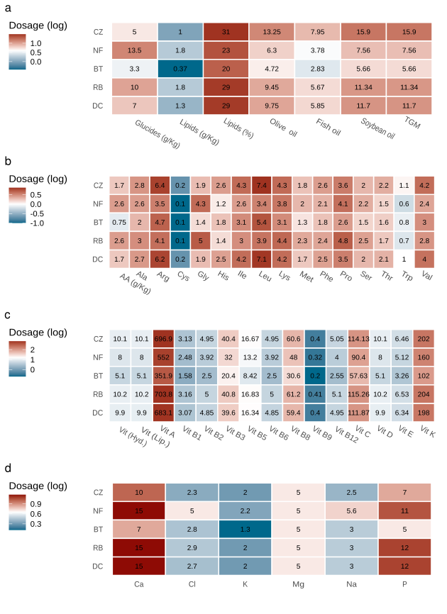
Supplementary Figure 1. Nutrients provided via parenteral nutrition. The heatmaps resume the levels of the nutrients, administered via parenteral nutrition in each patient. The color gradient represents the base 10 logarithm of the nutrient's levels while the effective value is reported inside heatmap cells.

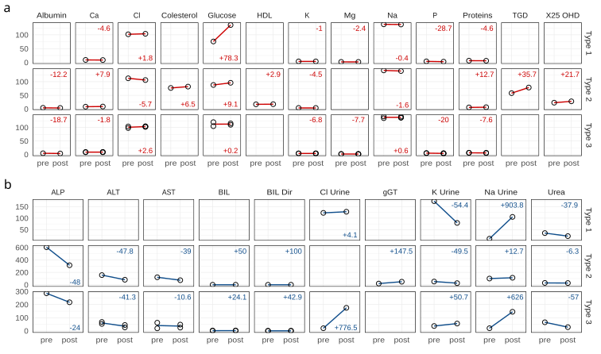
Supplementary Figure 2. Characterization of blood and urine metabolites according to the IF classification. a-b Trend of variation in blood (red lines in panel a) and urine (blue lines in panel b) analyte concentrations before (pre) and after (post) surgery intervention across IF categories. The percentage of positive (+) or negative (-) variation between the pre- and post-surgery values is indicated within each panel. Analytes concentrations are reported on the y-axis.
Note: Blood and urine analytes were reported by using the following abbreviation: Ca: calcium, Cl: chlorine, HDL: High density lipoprotein, K: potassium, Mg: magnesium, Na: sodium, P: phosphorous, TGD: Total Glucose Disposal, X25 OHD: 25-hydroxyvitamin D3, ALP: alkaline phosphatase, ALT: alanine transaminase, AST: aspartate transaminase, BIL: Bilirubin , BIL Dir: Bilirubin direct, gGT: gamma-glutamyl transferase.

Supplementary Table 1. Adonis PERMANOVA table. The table reports the results from adonis PERMANOVA analysis carried out on Bray-Curtis distance matrix on model formulas that include the variables IF and patient.
Factor | Df | SumOfSqs | R2 | F | Pr(>F)
IF | 2 | 4326.163 | 0.164 | 5.350 | 0.001
Colon anatomy | 1 | 3116.496 | 0.118 | 7.708 | 0.001
Patient | 3 | 7648.421 | 0.290 | 6.306 | 0.001
Residual | 28 | 11321.049 | 0.429
Total | 34 | 26412.129 | 1.000

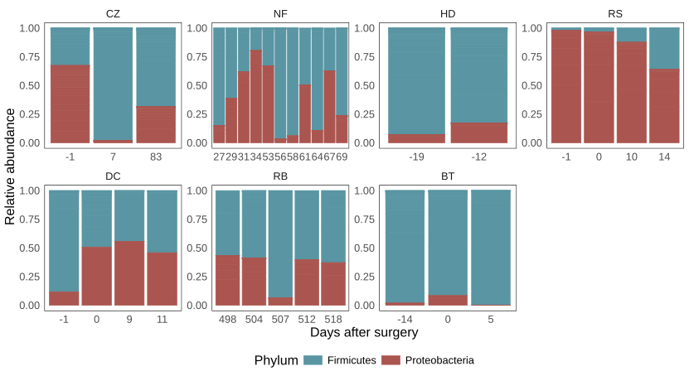
Supplementary Figure 3. Variations in the relative abundance of Firmicutes and Proteobacteria Phyla (color code). The relative abundance variations are reported for each time point before or after surgical intervention (referred as days after surgery) for each patient.

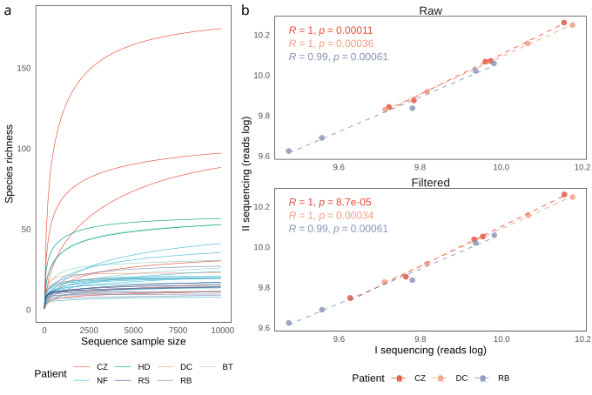
Supplementary Figure 4. Sample sequencing assessment. a Line chart reports the rarefaction curves on species richness (Total number of ASVs) for the total sample reads among patients. b Scatter plot reports the sample’s sequencing depth for each sample replicate, before and after quality filtering. Results from Pearson correlation were reported within each panel.

References

- Callahan BJ, McMurdie PJ, Rosen MJ, Han AW, Johnson AJ, Holmes SP. DADA2: High-resolution sample inference from Illumina amplicon data. Nat Methods. 2016;13(7):581-583. doi:10.1038/nmeth.3869
- Quast C, Pruesse E, Yilmaz P, Gerken J, Schweer T, Yarza P, Peplies J, Glöckner FO. The SILVA ribosomal RNA gene database project: improved data processing and web-based tools. Nucleic Acids Res. 2013;41doi:10.1093/nar/gks1219
- McMurdie PJ and Holmes S. phyloseq: an R package for reproducible interactive analysis and graphics of microbiome census data. PLoS One. 2013;8(4):e61217. doi:10.1371/journal.pone.0061217
- R Core Team. A language and environment for statistical computing. 2022. https://www.R-project.org
- Oksanen J, Simpson GL, Blanchet FG, Kindt R, Legendre P, Minchin PR, O’Hara RB, Solymos P, Stevens MHH, Szoecs E, Wagner H, Babour M et al. Vegan: community ecology package. R package version 2.6.4. 2022 doi: 10.32614/CRAN.package.vegan https://CRAN.R-project.org/package=veganet
- Arbizu PM. _pairwiseAdonis: Pairwise Multilevel Comparison using Adonis_. R package version 0.4. 2017.
- Wickham H. ggplot2: Elegant Graphics for Data Analysis. New York, NY: Springer New York; 2009. https://doi.org/10.1007/978-0-387-98141-3

