APPENDIX

Fig.3 and Table 1 attached in the appendix are from the data collection from the pilot study that later informed the MDTL framework.
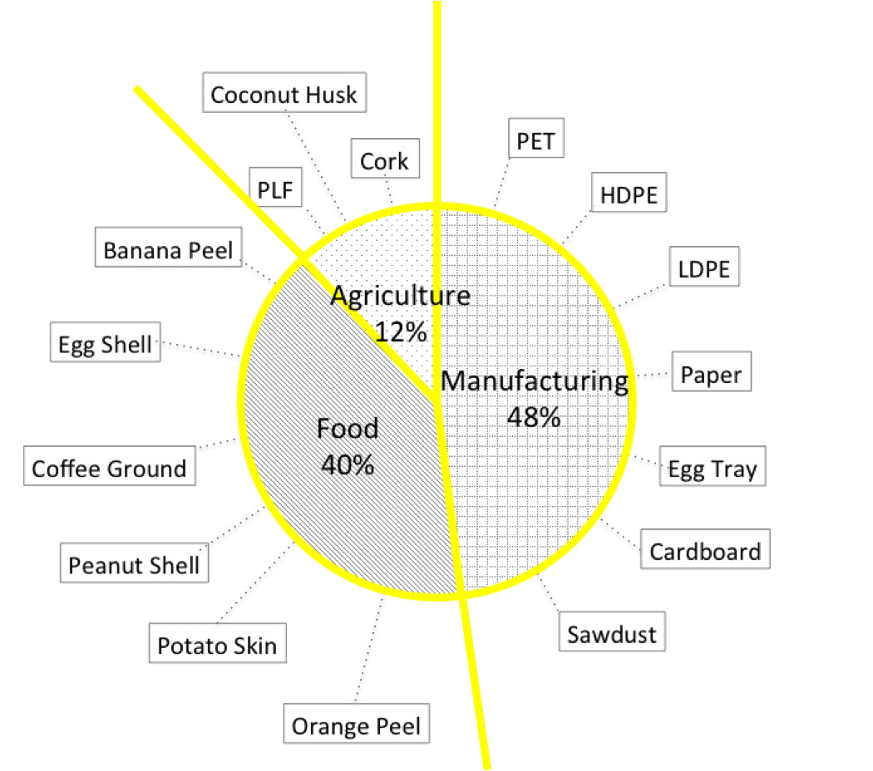

Fig. 3: Categorization of Selected Recyclable Waste

 | Material Type | Before | After | Test Results | Proposed Use
Food | Orange Peel | 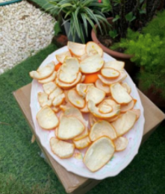 | 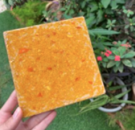 | Moderate strength, water resistant, moderate smooth surface, non recyclable. | Wall tiles, accessories, decorative.
Food | Potato Skin | 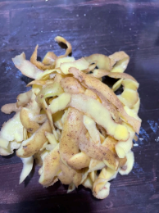 | 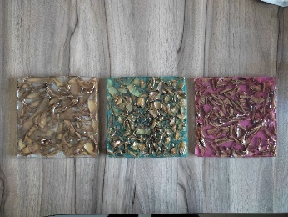 | Moderate strength, water resistance, tactile surface, non recyclable. | Wall tiles, accessories, decorative.
Food | Peanut Shell | 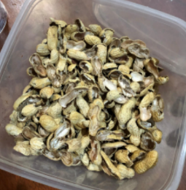 | 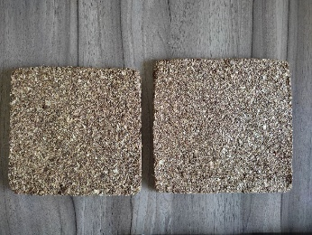 | Moderate strength, biodegradable, non water proof, tactile surface, biodegradable. | Acoustic panel, insulation.
Food | Coffee Grounds | 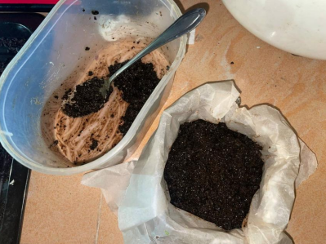 | 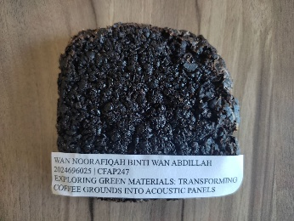 | Low strength, non water proof, tactile surface, strong smell, biodegradable. | Acoustic panel, accessories.
Food | Egg Shell | 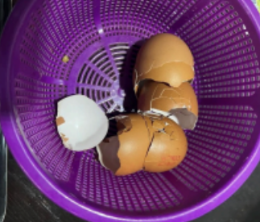 | 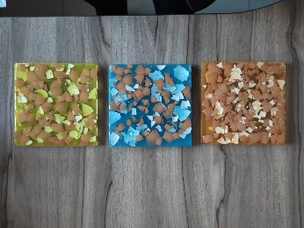 | Moderate strength, water resistance, smooth surface, non recyclable. | Wall tiles, accessories, decorative.
Food | Banana Peel | 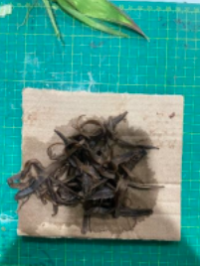 | 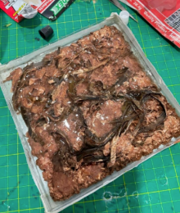 | Very low strength, non water proof, tactile surface, strong smell, biodegradable. | Not for design use.
Agricultural Waste | PFL | 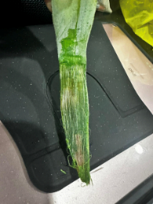 | 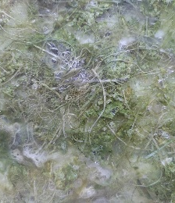 | Very low strength, non water proof, tactile surface, strong smell, biodegradable. | Not for design use.
Agricultural Waste | Coconut Husk | 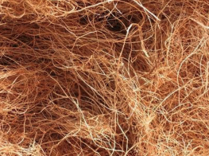 | 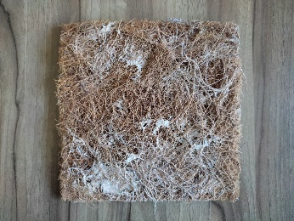 | Low strength, biodegradable, non water proof, tactile surface, biodegradable. | Acoustic panel, insulation.
Agricultural Waste | Cork | 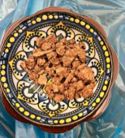 | 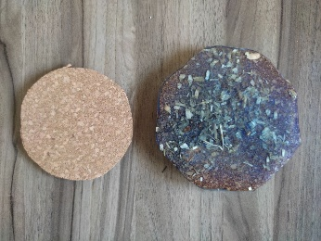 | Moderate Strength, non water proof, smooth surface, biodegradable. | Acoustic panel, insulation, decorative.
Manufacturing | PET | 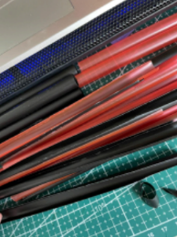 | 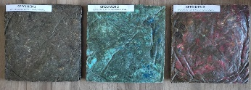 | Moderate strength, waterproof, smooth surface, recyclable. | Wall tiles, surface tops, accessories, decorative.
Manufacturing | HDPE | 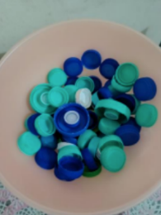 | 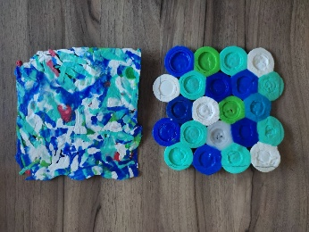 | Moderate strength, waterproof, tactile surface, recyclable. | Wall tiles, accessories, decorative.
Manufacturing | LDPE | 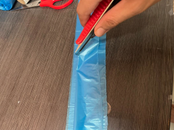 | 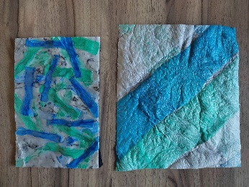 | Low strength, waterproof, soft surface, recyclable. | Decorative.
Manufacturing | Paper | 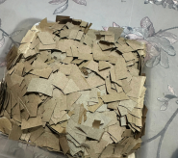 | 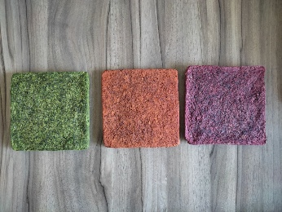 | Moderate strength, non waterproof, tactile surface, recyclable. | Acoustic panel, insulation, decorative.
Manufacturing | Egg Tray | 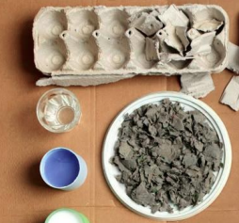 | 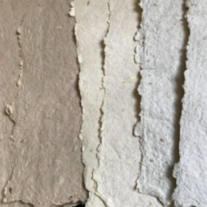 | Low strength, non waterproof, smooth surface, recyclable. | Wall panel, decorative, accessories.
Manufacturing | Sawdust | 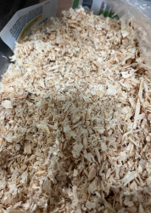 | 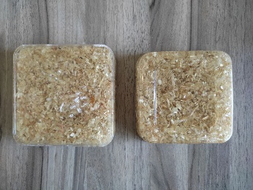 | Moderate strength, waterproof, smooth surface, non recycleable. | Blocks, wall tiles, insulation.

Table 1: New Material Sample, basic testing and proposed use

