Supplementary Information
Additive-Free 3D Printing of Ti₃C₂T_{x} MXene-Based Ceramic Inks via Bayesian Optimisation

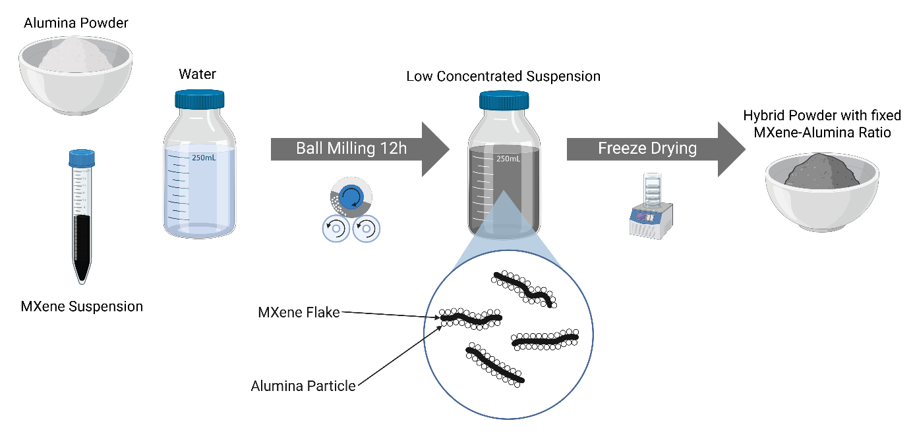
Figure S1: Detailed Scheme of hybrid powder production. Created in BioRender. Scholl, M. (2026) https://BioRender.com/k3k5xlf

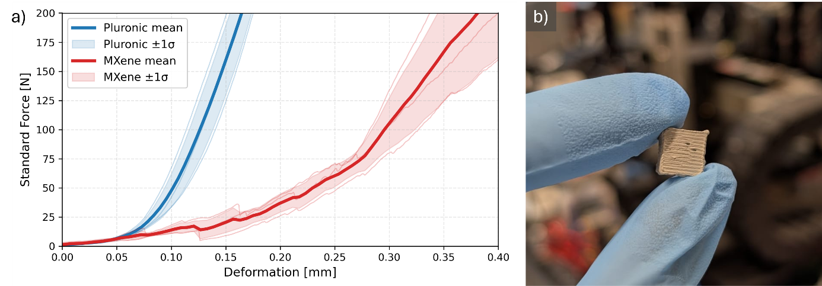
Figure S2: a) compression test of printed and dried green bodies, bold red curve shows the average behaviour of MXene based alumina ink with 1.5 wt.% MXene content, thin red curves show the three individual measurements, bold blue curve shows the average behaviour of a hydrogel (Pluronic F127) based alumina ink, thin blue curves show the three individual measurements. At a force of 100 N the deformation is at 0.3 mm which can partially be attributed to the rough surface of the cuboid sample. b) Photograph of a dried sample during handling showing the stability of the sample without further binders.

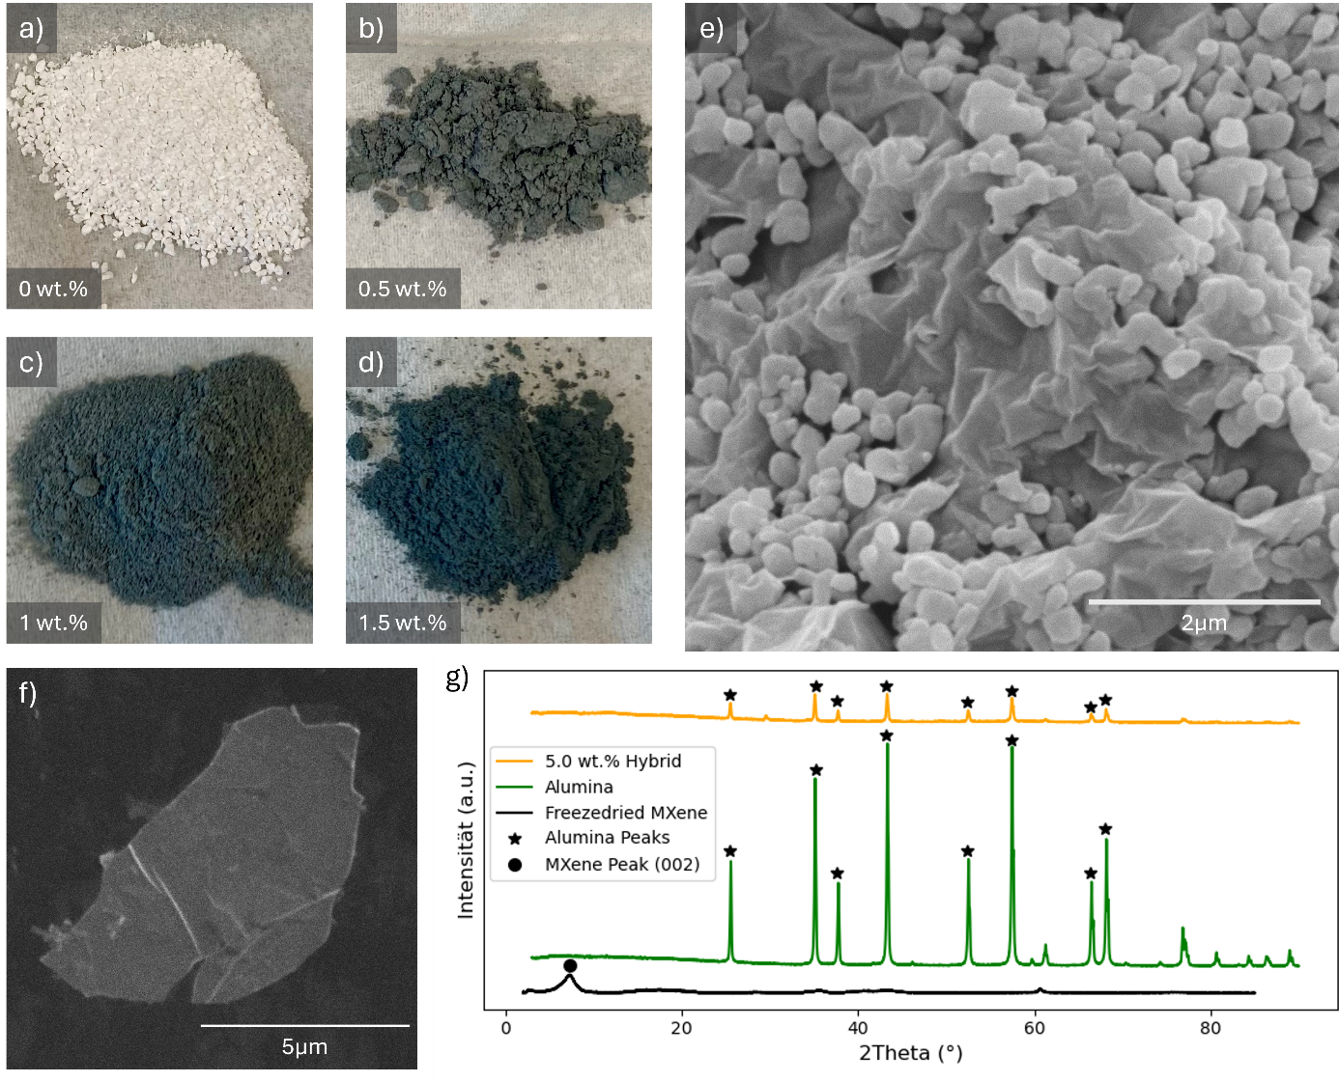
Figure S3: Supplementary information on Hybrid powder. The photographs a) to d) show the freeze dried powders with varying MXene contents, the colour gets darker with increasing MXene concentration. e) shows an SEM image of a hybrid powder with 5 wt.% Ti₃C₂T_{x}-content, Al₂O₃ particles are attached to a MXene flake. f) shows an SEM image of a single MXene flake after synthesis and delamination. g) shows the XRD analysis of freeze dried MXene, Al₂O₃ and hybrid powder with a MXene content of 5 wt.%, the characteristic peaks are indicated by markers for MXene and alumina, the MXene peak at approx. 7◦ corresponds to the (002) plane, the hybrid powder only shows alumina peaks, as the MXene signal in the hybrid powder is not strong enough compared to the strong crystalline peaks of alumina.

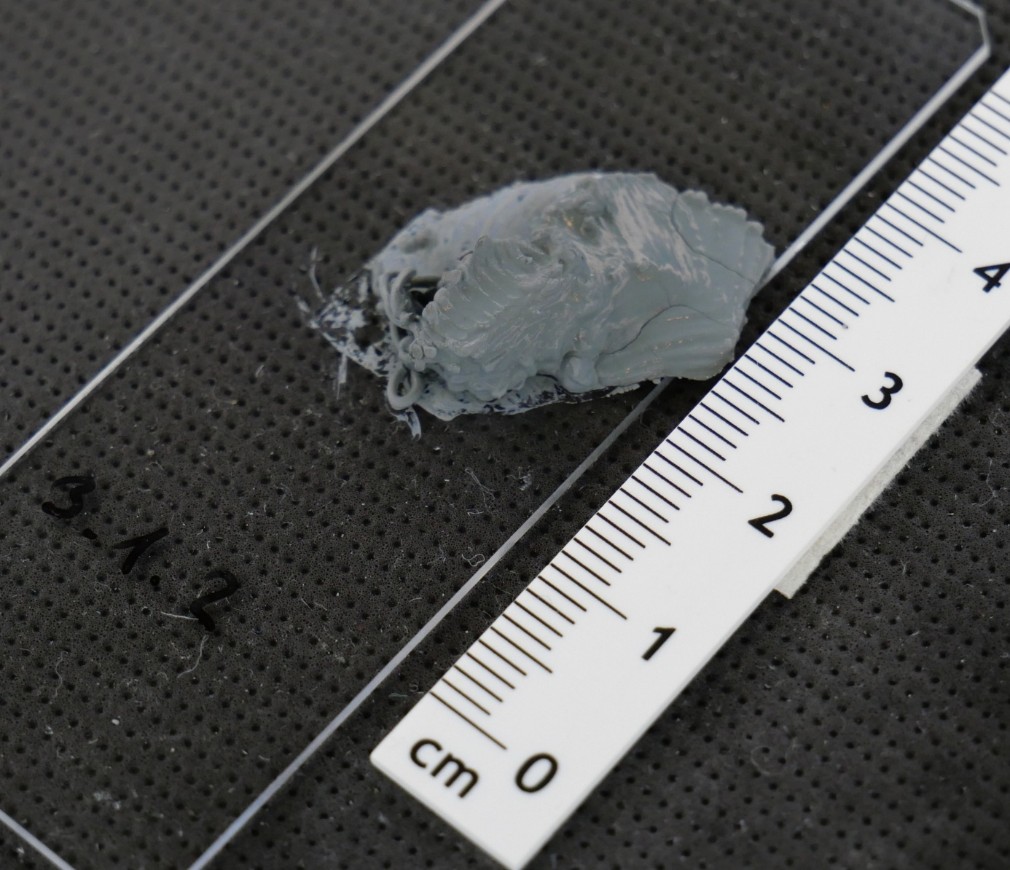
Fig. S4: Photograph of the sample with the highest shape deviation (print 3 of set 3.1), even exceeding not printable inks, the layer height of 0.1 mm leads to the print being pushed away by the following layers, the high shape deviation results from the high volume outside of the desired area, added to the missing volume inside the desired area the shape error is larger than a not printable ink which only accounts for the missing volume.

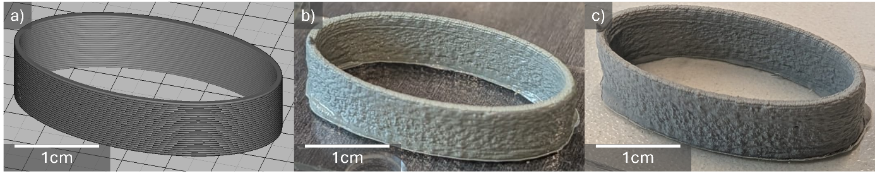
Fig. S5: Ellipse demonstrator print a) Slicer preview of an ellipsoid shell. b) printed part in wet state. c) the same part after drying (min. 12 hours), showing minimal distortion.

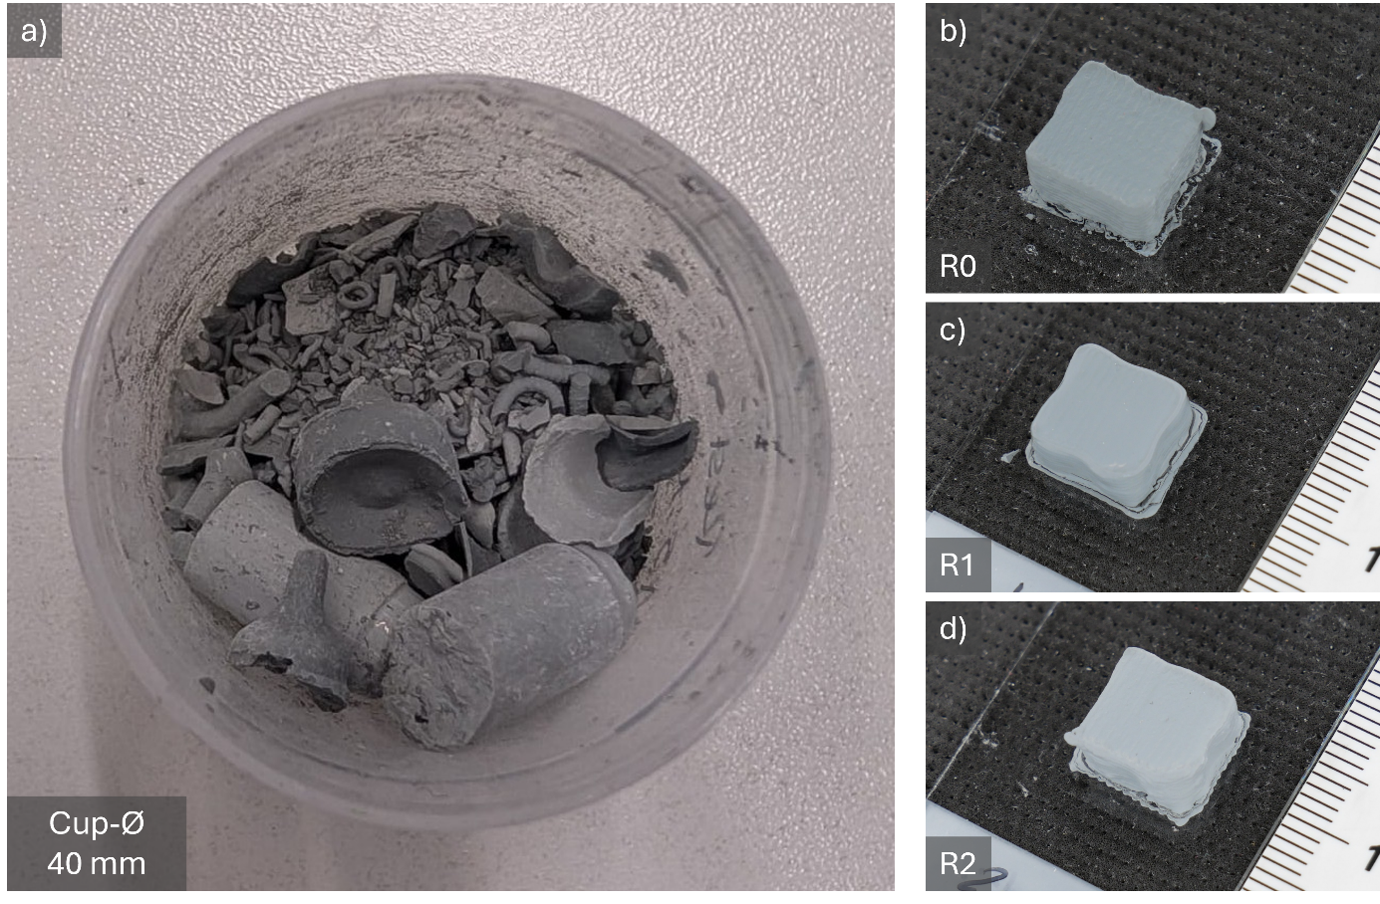
Fig. S6: a) Photograph of dried residual paste with 1.5 wt.% Ti₃C₂T_{x} ready for re-dispersion and freeze-drying to produce recycled hybrid powder. b-d) Photographs of dried green bodies produced from pristine powder (R0) and after one (R1) and two (R2) recycling steps. While variations in shape are visible immediately after the first recycling step, the overall quality remains satisfactory. The progressive lightening of the green body colour with multiple recycling steps may suggest partial degradation or modification of the MXene phase.

