Authors: Crippa Monica¹, Guizzardi Diego¹, Pisoni Enrico¹, Ciarlantini Sara², Melchiorri Michele¹, Schiavina Marcello³, Hormigos Feliu Clara¹, Dijkstra Lewis¹
¹European Commission, Joint Research Centre (JRC), Ispra, Italy
² Unisystems, Milan S.A, Italy
³NTT DATA, Rue de Spa 8, 1000 Brussels, Belgium
Title: GHG emission in cities, towns and rural areas

Supplementary information
S.1 A fifth of global emissions occurs in urban centres
Table S1 provides an overview of GHG emissions in the year 2024 by aggregated degree of urbanisation (cities, towns and semi-dense areas, and rural areas) by world region. Regional groupings are based on IPCC AR6 definition and include: Africa; Australia, Japan, and New Zealand; Eastern Asia; Eastern Europe and West-Central Asia; Europe; Latin America and Caribbean; Middle East; North America; South-East Asia and Pacific; Southern Asia (refer to Table S2). Globally around 21% of GHG emissions occurs in cities because a high fraction of global population (45%) lives there. However, depending on the country and region, this share spans from 13% (for North America) and 33% (for Australia, Japan, and New Zealand).
Table S1 – GHG emissions by degree of urbanisation by world region. GHG emissions are ranked by decreasing GHG emissions in cities and are expressed in Gt CO2_{eq} (using a Global Warming Potential for 100 years from IPCC AR5), while population is in million people. Only emissions from populated areas are included; emissions occurring over remote areas and sea (e.g. flaring overseas, coastal fishing, domestic shipping) and from international shipping and aviation are excluded. As a result, percentages may not sum to 100%.
Region, year 2024 | GHG emissions  (GtCO2eq), (%) |  |  | Population  (million people), (%)
Region, year 2024 | Cities | Towns and semi-dense areas | Rural areas | Cities | Towns and semi-dense areas | Rural areas
World | 10.99 (21%) | 12.46  (24%) | 27.73  (53%) | 3,666 (45%) | 2,744 (33%) | 1,796 (22%)
Eastern Asia | 4.14 (25%) | 5.80  (35%) | 6.72 (40%) | 719 (47%) | 535  (35%) | 285 (19%)
Southern Asia | 1.41  (27%) | 2.10  (40%) | 1.71  (33%) | 806  (41%) | 841  (42%) | 337  (17%)
North America | 0.89 (13%) | 0.65  (10%) | 5.08  (76%) | 158  (41%) | 123  (32%) | 103 (27%)
Eastern Europe and West-Central Asia | 0.73  (20%) | 0.74  (20%) | 2.18  (59%) | 129  (44%) | 95  (33%) | 69  (24%)
Middle East | 0.73 (22%) | 0.58  (17%) | 1.79 (54%) | 178 (61%) | 68  (23%) | 46  (16%)
Europe | 0.69 (16%) | 0.80  (18%) | 2.82 (65%) | 265  (42%) | 187  (29%) | 183  (29%)
South-East Asia and Pacific | 0.68 (21%) | 0.88  (27%) | 1.64  (50%) | 319 (45%) | 239  (34%) | 154  (22%)
Africa | 0.64  (19%) | 0.41  (12%) | 2.19 (66%) | 626 (41%) | 464  (30%) | 447  (29%)
Australia, Japan, and New Zealand | 0.56  (33%) | 0.23  (13%) | 0.92  (53%) | 101  (66%) | 34  (22%) | 19  (12%)
Latin America and Caribbean | 0.52 (15%) | 0.28  (8%) | 2.67  (76%) | 364  (54%) | 158  (23%) | 153  (23%)

Table S2 – Definition of regional country aggregations.
IPCC AR6 region | Countries
Africa | Algeria; Angola; Benin; Botswana; Burkina Faso; Burundi; Cabo Verde; Cameroon; Central African Republic; Chad; Comoros; Congo; Côte d’Ivoire; Democratic Republic of the Congo; Djibouti; Egypt; Equatorial Guinea; Eritrea; Eswatini; Ethiopia; Gabon; Ghana; Guinea; Guinea-Bissau; Kenya; Lesotho; Liberia; Libya; Madagascar; Malawi; Mali; Mauritania; Mauritius; Morocco; Mozambique; Namibia; Niger; Nigeria; Rwanda; Réunion; Saint Helena, Ascension and Tristan da Cunha; Senegal; Seychelles; Sierra Leone; Somalia; South Africa; Sudan and South Sudan; São Tomé and Príncipe; Tanzania; The Gambia; Togo; Tunisia; Uganda; Western Sahara; Zambia; Zimbabwe.
Australia, Japan, and New Zealand | Australia; Japan; New Zealand.
Eastern Asia | China; Hong Kong; Macao; Mongolia; North Korea; South Korea; Taiwan.
Eastern Europe and West-Central Asia | Armenia; Azerbaijan; Belarus; Georgia; Kazakhstan; Kyrgyzstan; Moldova; Russia; Tajikistan; Turkmenistan; Ukraine; Uzbekistan.
Europe | Albania; Austria; Belgium; Bosnia and Herzegovina; Bulgaria; Croatia; Cyprus; Czechia; Denmark; Estonia; Faroes; Finland; France and Monaco; Germany; Gibraltar; Greece; Greenland; Hungary; Iceland; Ireland; Italy, San Marino and the Holy See; Latvia; Lithuania; Luxembourg; Malta; Netherlands; North Macedonia; Norway; Poland; Portugal; Romania; Serbia and Montenegro; Slovakia; Slovenia; Spain and Andorra; Sweden; Switzerland and Liechtenstein; Türkiye; United Kingdom.
Latin America and Caribbean | Anguilla; Antigua and Barbuda; Argentina; Aruba; Bahamas; Barbados; Belize; Bermuda; Bolivia; Brazil; British Virgin Islands; Cayman Islands; Chile; Colombia; Costa Rica; Cuba; Curaçao; Dominica; Dominican Republic; Ecuador; El Salvador; Falkland Islands; French Guiana; Grenada; Guadeloupe; Guatemala; Guyana; Haiti; Honduras; Jamaica; Martinique; Mexico; Nicaragua; Panama; Paraguay; Peru; Puerto Rico; Saint Kitts and Nevis; Saint Lucia; Saint Vincent and the Grenadines; Suriname; Trinidad and Tobago; Turks and Caicos Islands; Uruguay; Venezuela.
Middle East | Bahrain; Iran; Iraq; Israel and Palestine, State of; Jordan; Kuwait; Lebanon; Oman; Qatar; Saudi Arabia; Syria; United Arab Emirates; Yemen.
North America | Canada; Saint Pierre and Miquelon; United States.
South-East Asia and Pacific | Brunei; Cambodia; Cook Islands; Fiji; French Polynesia; Indonesia; Kiribati; Laos; Malaysia; Myanmar/Burma; New Caledonia; Palau; Papua New Guinea; Philippines; Samoa; Singapore; Solomon Islands; Thailand; Timor-Leste; Tonga; Vanuatu; Viet Nam.
Southern Asia: | Afghanistan; Bangladesh; Bhutan; India; Maldives; Nepal; Pakistan; Sri Lanka.

S.2 Sectoral contribution to the emissions

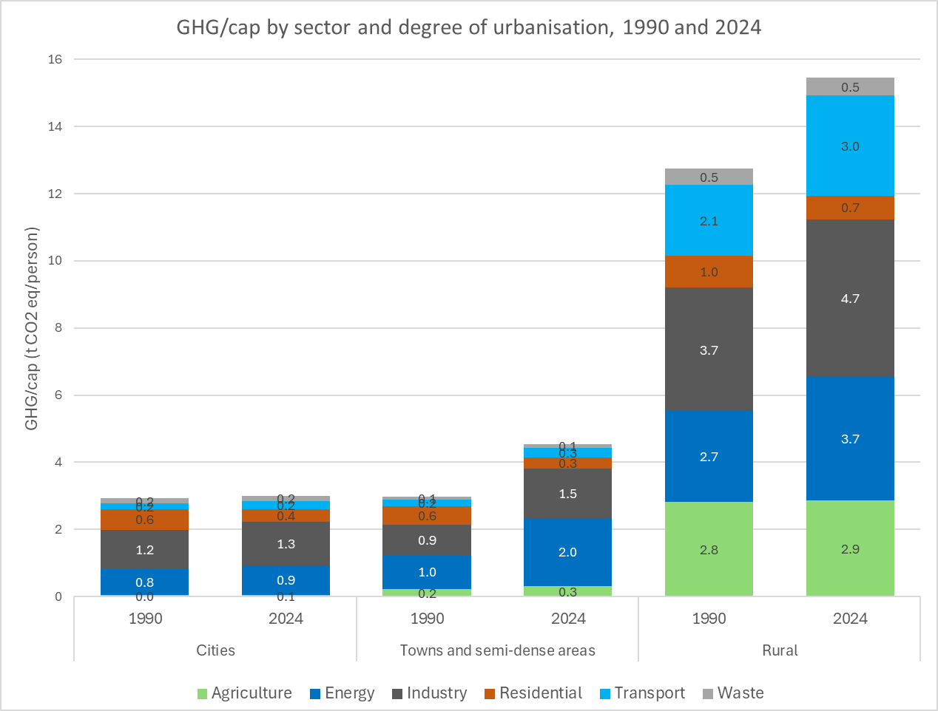
Figure S1– Sectoral total GHG emissions per capita by degree of urbanisation over time.

S.3 Comparison of national and city patterns
Cities with higher GHG emission per capita than national average are often affected by the presence of point sources, as shown in Fig. S2.
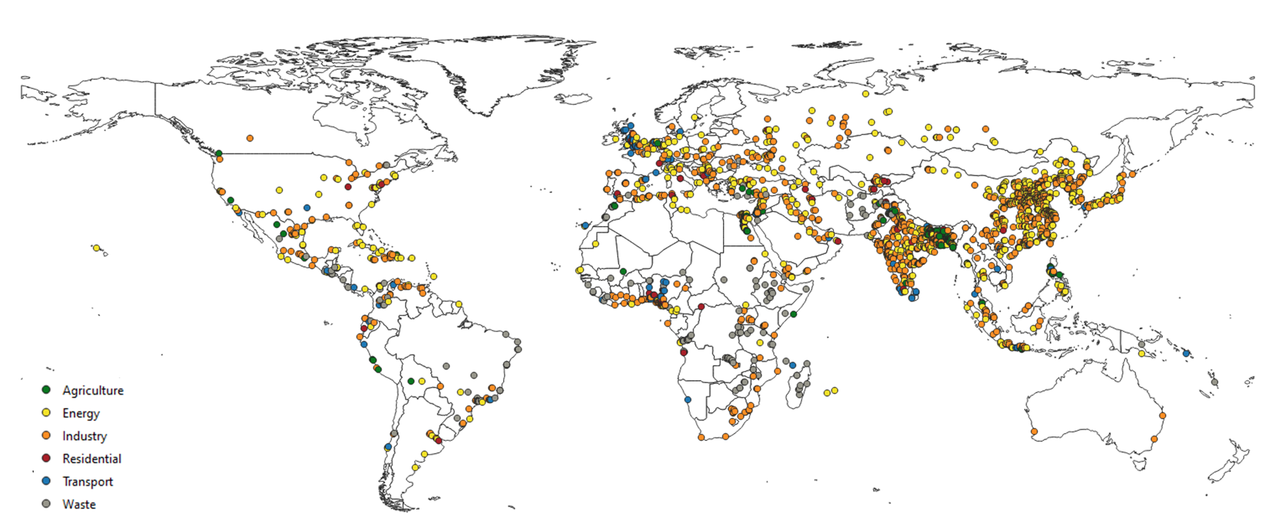
Figure S2 – Cities with higher GHG emission per capita than national average are often affected by the presence of point sources.

Table S3 – Degree of urbanisation terms for the classification of grid cells and municipalities.
Code level 1 | Spatial unit terms level 1 | Code level 2 | Spatial unit terms level 2
3 | City | 30 | City
2 | Town and semi-dense area | 23 | Dense towns
2 | Town and semi-dense area | 22 | Semi-dense town
2 | Town and semi-dense area | 21 | Suburban or peri-urban area
1 | Rural Area | 13 | Village
1 | Rural Area | 12 | Dispersed rural area
1 | Rural Area | 11 | Very dispersed rural area

