Supplementary Table 2.
(A).
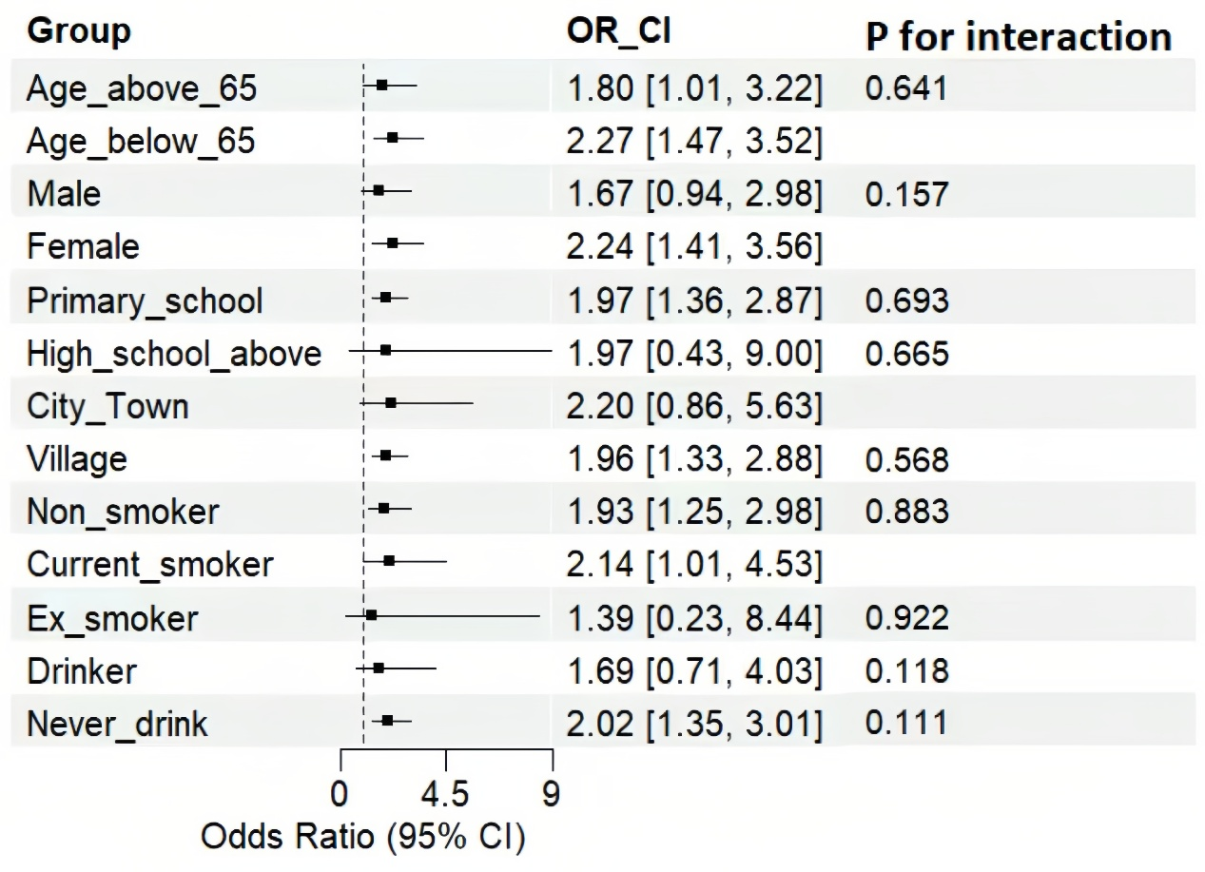
(B).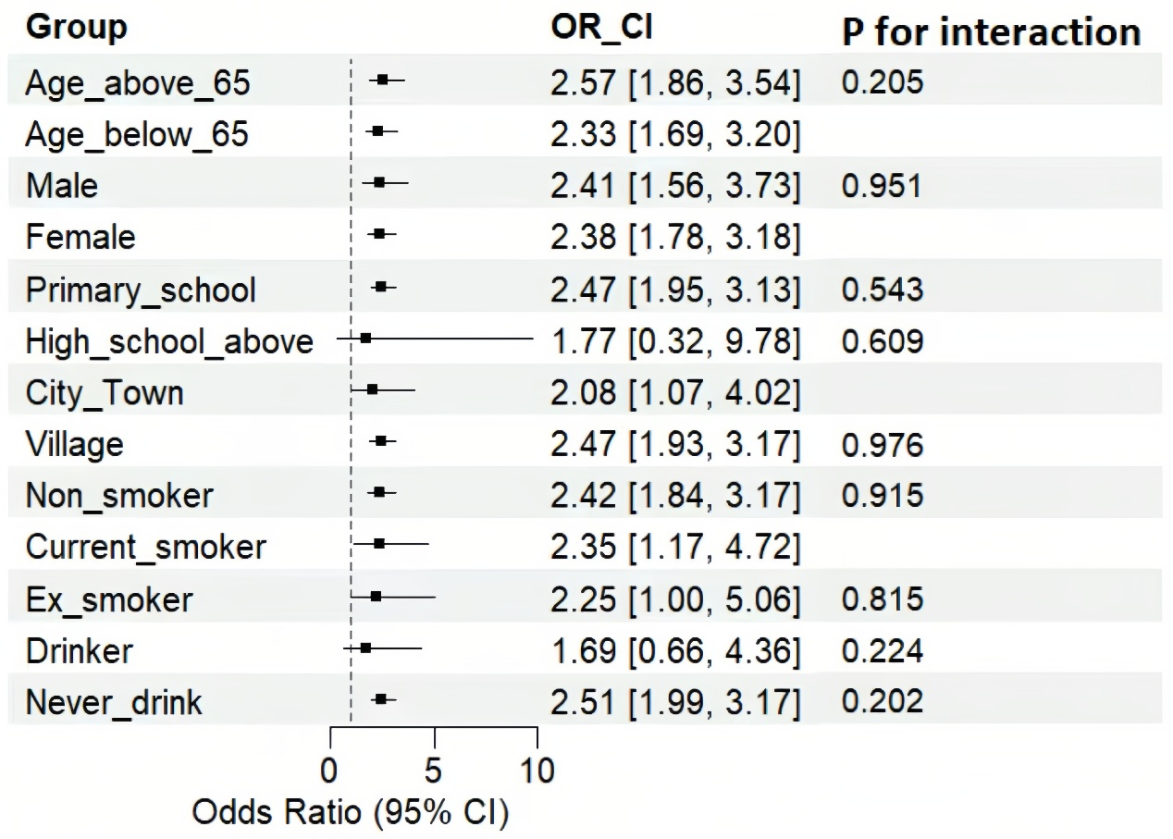
(C).
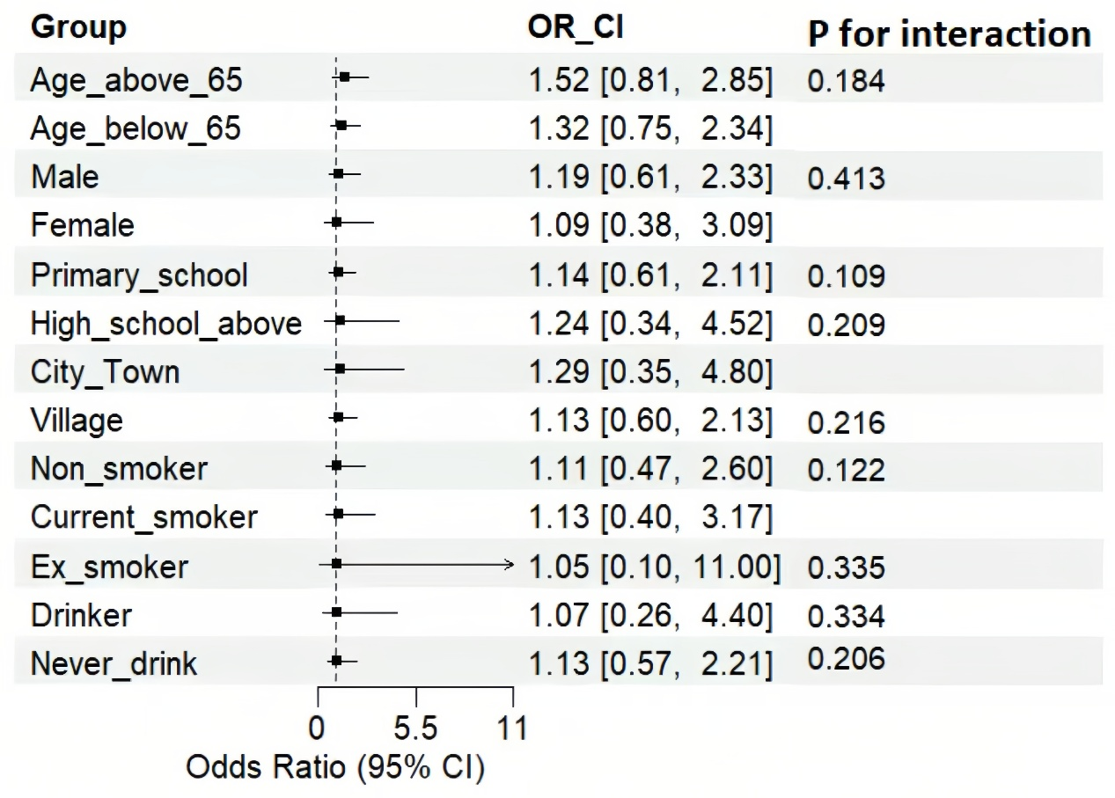
Subgroup analysis. Forest maps of the association between seven alternative IR indices and the risk of incident SA by age, sex, location, education, smoking, and drinking. Odds ratios were adjusted for age, sex, location, education, smoking, drinking, WBC, CRP, HCT, MCV, PLT, TC and LDL. OR, odds ratio; 95%CI, 95% confidence interval; (A) CVAI, (B) TG/HDL, (C) TyG.

