Supplementary Table 1.
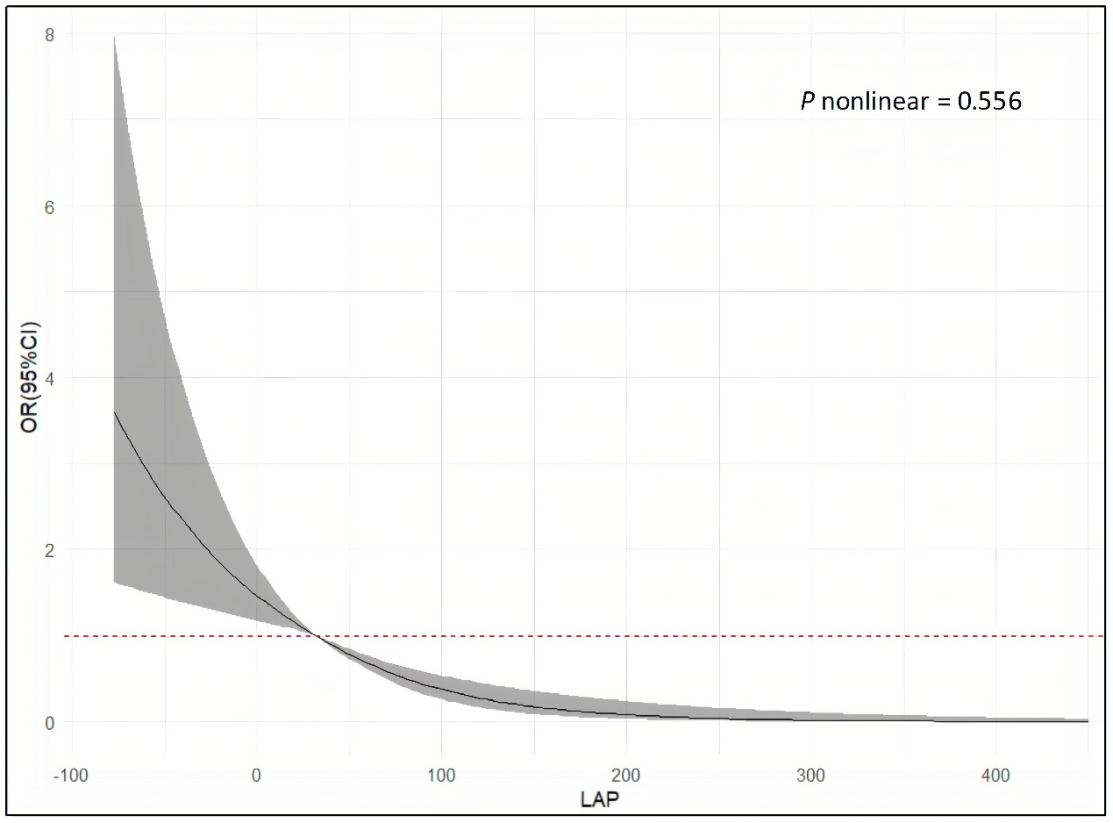
Adjusted cubic spline model of the relationship between seven alternative IR indices and SA risk. All models were adjusted for various factors, including age, sex, marriage, location, education, smoking, drinking, WBC, CRP, HCT, MCV, PLT, TC and LDL. The solid line and grey area represent the estimated adjusted OR and 95% CI, respectively. The horizontal dotted line represents the odds ratio of 1.0.; LAP, Lipid Accumulation Product.

