––Supporting Information––
Influence of Pressure on Structure, Stability and Ionic Conductivity of Lithium Argyrodite Solid Electrolytes
Jemma L. Cox¹, Jack M. Hemingway¹, James A. Quirk¹, Erli Lu² and James A. Dawson^{1,}*
¹Chemistry – School of Natural and Environmental Sciences, Newcastle University, Newcastle upon Tyne, UK
²School of Chemistry, University of Birmingham, Birmingham, UK
Li₆PS₅Cl
Li₆PS₅Br

0 GPa
1 GPa
2 GPa
3 GPa
4 GPa
10 GPa

Figure S1. Projected electronic density of states for Li₆PS₅X (X = Cl or Br) with 0% site exchange as a function of pressure. The valence band maximum is set to 0 eV.
Figure S2. Pressure dependence of Li-ion activation energy (E_{a}) for Li₆PS₅Cl_{0.5}Br_{0.5}, Li₆PS₅Cl_{0.75}Br_{0.25} and Li₆PS₅Cl_{0.25}Br_{0.75} with 0% and 75% S²⁻/X⁻ site exchange.

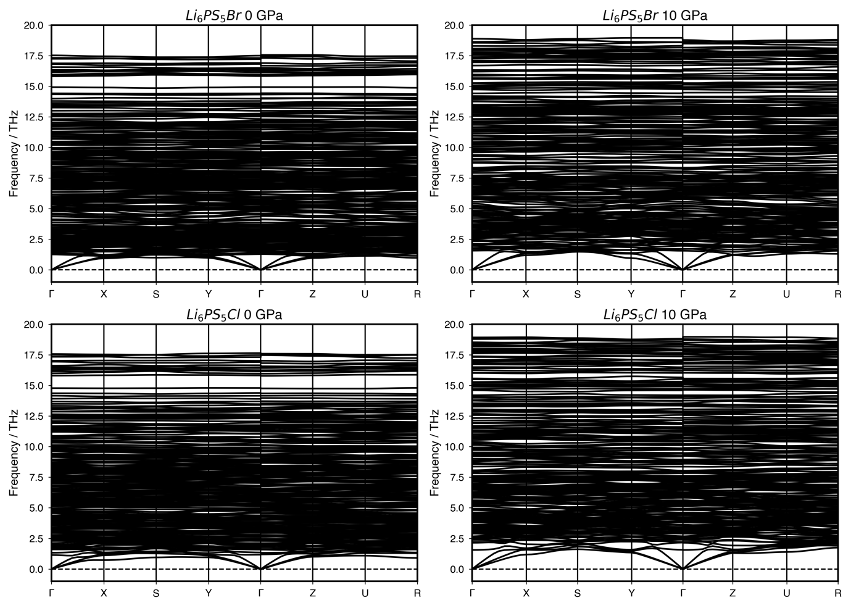
Figure S3. Phonon dispersion spectra of Li₆PS₅X (X = Cl and Br) at 0 and 10 GPa.

