Supplementary Files

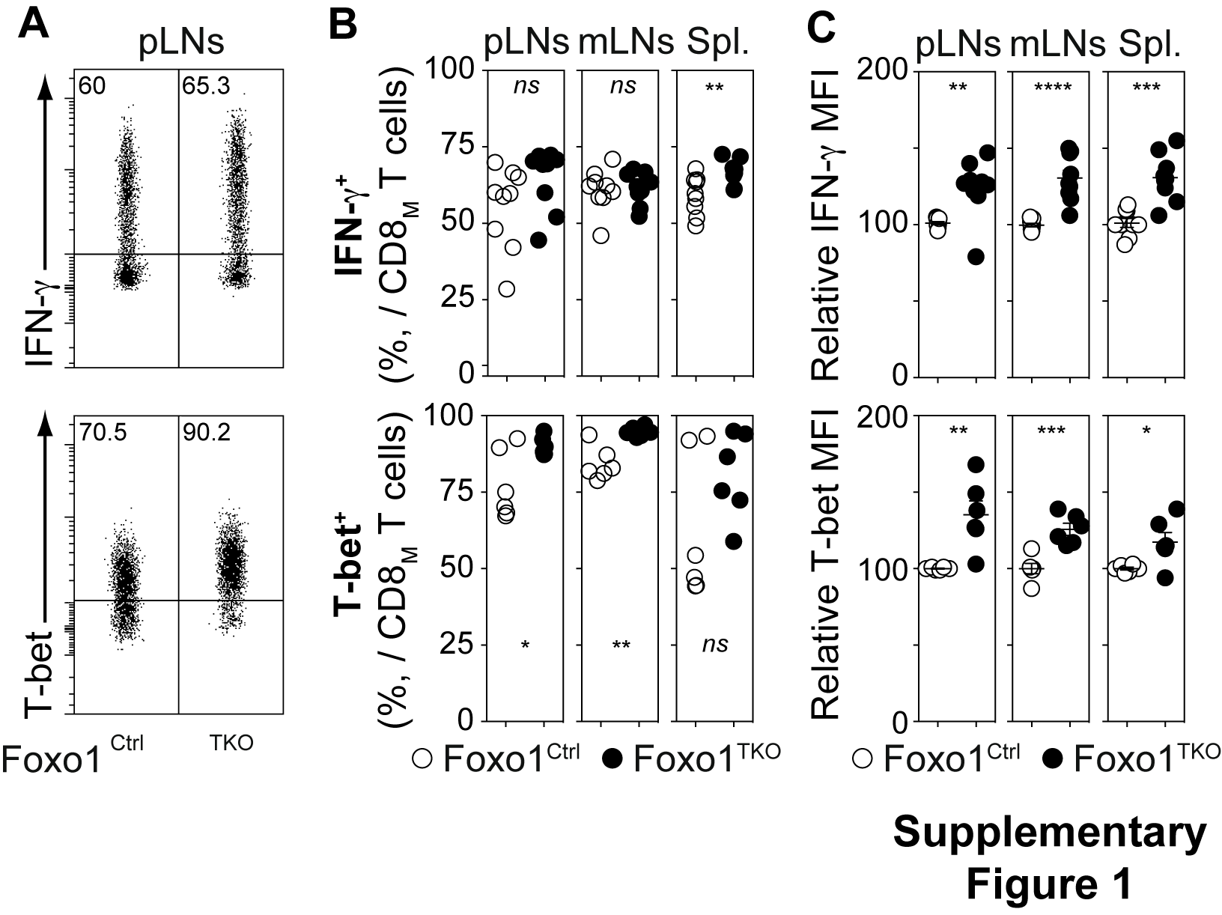

Fig. S1 Increased expression of IFN-γ and T-bet by memory CD8 T cells from Foxo1^{TKO} mice. Peripheral lymph nodes (pLNs), mesenteric lymph nodes (mLNs) and spleen of a 6- to 8-week-old Foxo1^{Ctrl} and Foxo1^{TKO} mice were recovered and stained. A, CD8/IFN-γ (upper panel) and CD8/T-bet (lower panel) representative dot-plots are shown for CD8_{M} cells from the pLNs of 6-8-week-old Foxo1^{Ctrl} and Foxo1^{TKO} mice. B, Percentages of IFN-γ- (upper panel) and T-bet- (lower panel) expressing cells among CD8_{M} cells. C, IFN-γ- (upper panel) and T-bet- (lower panel) relative MFI of IFN-γ- and T-bet-expressing CD8_{M} cells. *p < 0.05, **p < 0.01, ***p < 0.001. ****p < 0.0001, ns, not significant.

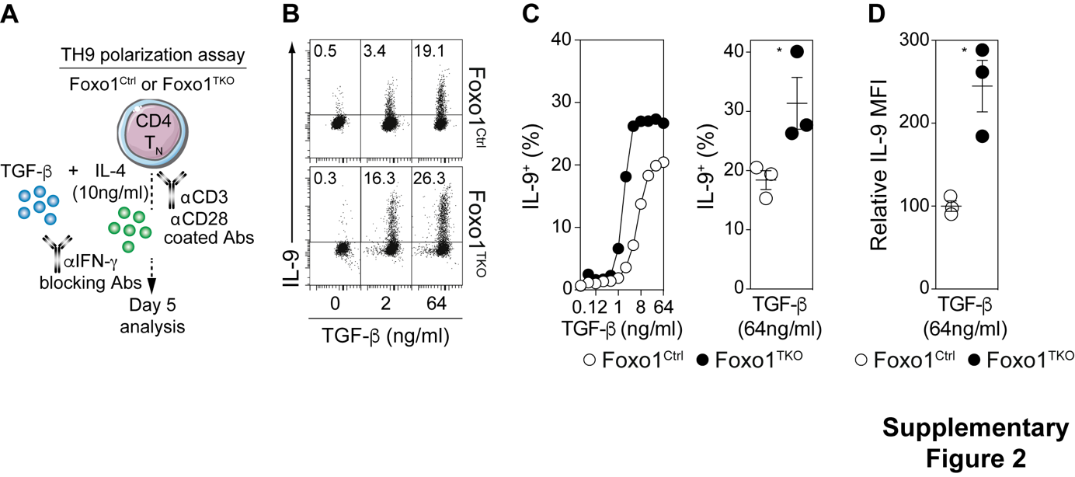

Fig. S2 Foxo1 deficiency does not impair CD4_{N} cell- ability to differentiate into TH9 cells. CD4_{N} cells from Foxo1^{TKO} and Foxo1^{Ctrl} mice were purified and cultured in TH9- (A-D) or iTreg- (E-H) polarizing conditions. A, Diagram illustrating the TH9 polarization assay. B, CD4?/IL-9 representative dot-plots are shown for CD4 T cells at different concentrations of TGF-β. C, A representative experiment showing the proportion of IL-9-producing cells among CD4 T cells as a function of TGF-β concentration (left panel) and quantification for TGF-β = 64 ng/ml (right panel). D, IL9 relative MFI of IL-9 producing CD4 cells for TGF-β = 64 ng/ml.

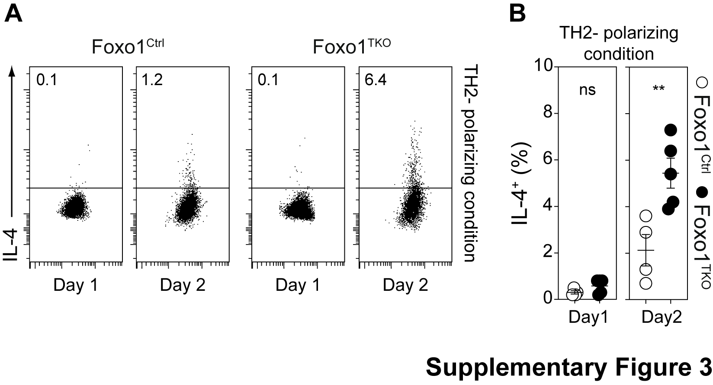

Fig. S3 Foxo1-deficient CD4_{N} cells boost the differentation potential of WT CD4_{N} cells towards TH1- and TH2-cell lineages. CD4_{N} cells from Foxo1^{TKO} and Foxo1^{Ctrl} mice were purified and cultured in TH2-polarizing conditions. A, CD4/IL-4 (lower panel) representative dot-plots are shown for CD4 T cells after 1 and 2 days of culture in TH2-polarizing conditions. B, Percentages of IL-4-producing cells among CD4 cells from Foxo1^{TKO} and Foxo1^{Ctrl} mice after 1 and 2 days of culture in TH2-polarizing conditions. *p < 0.05, **p < 0.01, ***p < 0.001. ****p < 0.0001, ns, not significant.

