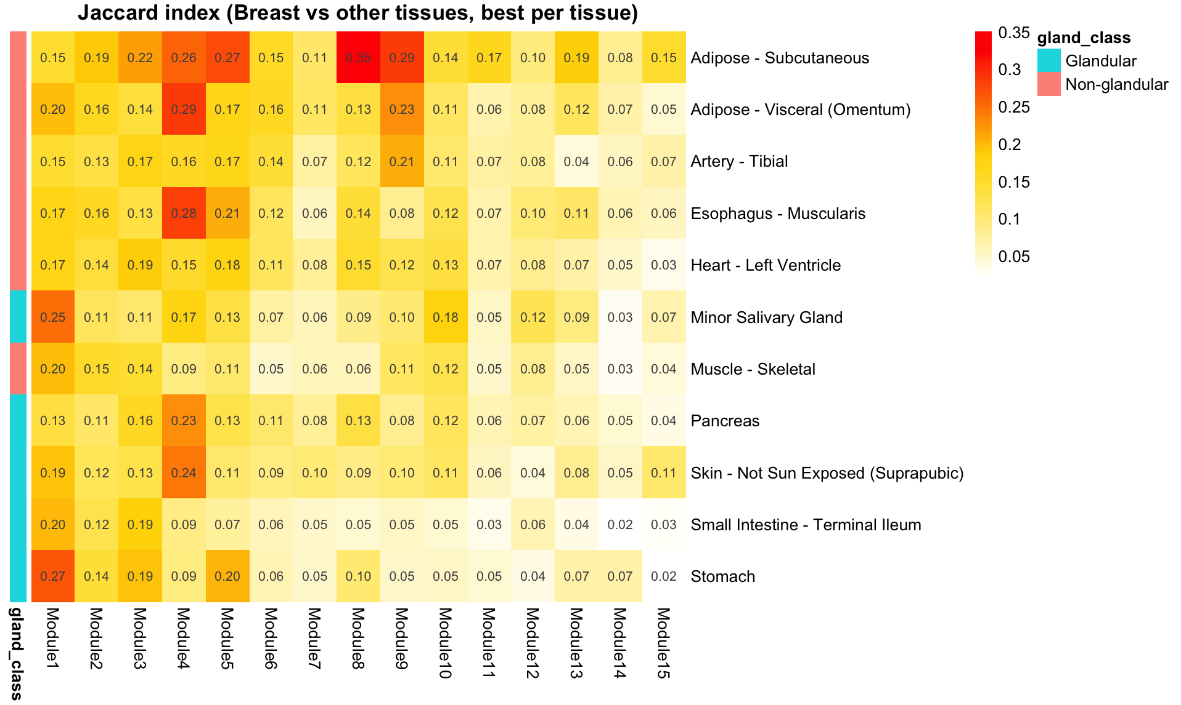

Figure S1. Cross-tissue overlap of mammary co-expression modules.
Heatmap showing Jaccard indices between mammary gland co-expression modules and modules derived from other GTEx tissues. For each non-mammary tissue, the Jaccard index represents the maximum overlap observed between a given mammary module and any module from that tissue (“best-per-tissue” overlap). Rows correspond to comparison tissues, and columns correspond to mammary co-expression modules. Tissues are annotated as glandular or non-glandular based on tissue classification. Warmer colors indicate higher Jaccard similarity.

