Lone-pair-electron Governed Gas-recognizable Flexibility in an Ultra-stable MOF for Boosting C₃H₆/C₃H₈ Separation and Its Aqueous Scalable Synthesis
Yuhang Liu,† Zhiyong Lu*†, Bufeng Wang,† LiLei Zhang,¶ Banghao Wei,† Yingpeng Jiang,† Junfeng Bai*†

Table of contents
- Materials and General Methods
- Crystallography
- Density Functional Theory Calculations
- Single-component Gas Adsorption
- Synthesis of Ligands and MOFs
- Column Breakthrough Experiment
- Figures and Tables
- Reference

1. Materials and General Methods
Materials. All reagents were obtained from commercial vendors and, unless otherwise noted, were used without further purification.
Physical Methods and Instrumentation.
Thermogravimetric Analysis (TGA)
TGA were performed using a STA 209 F1 (NETZSCH Instruments) thermo-microbalance, heating from room temperature to 600 °C at a rate of 2°C/min under nitrogen flow.
Fourier transform infrared spectrometer (FT-IR)
FT-IR spectra were recorded on a Nicolet iS10 spectrometer equipped with a DTGS detector. The samples, diluted in KBr and prepared under ambient conditions, were measured against a KBr background. Spectra were collected at a resolution of 4 cm⁻¹, averaging 16 scans over the spectral range of 400-4000 cm⁻¹.
¹H NMR Spectroscopy
2 mg of sample was placed into a 1.5 mL vial, 20 drops of DMSO were added. Then the clear supernatant solution was transferred to an NMR tube. ¹H NMR spectra were recorded with a JNM-ECZ401S NMR spectrometer (400 MHz; 8 scans).
Powder X-ray Diffraction Patterns Powder X-ray diffraction (PXRD)
PXRD patterns were collected on a Bruker D8 ADVANCE diffractometer equipped with a Cu/Kα radiation source (40 kV, 40 mA) and a graphite monochromator. Data were recorded with a scan rate of 10° min⁻¹ and a step size of 0.02°.
In-situ variable-temperature PXRD (VT-PXRD) and In-situ variable-pressure PXRD patterns
In-situ variable-temperature PXRD (VT-PXRD)
In situ variable-temperature PXRD measurements were conducted on a Bruker D8 ADVANCE diffractometer over a 2θ range of 3-30° under ambient atmosphere. An Anton Paar TCU 750 temperature-control unit was employed to regulate the sample temperature with a heating rate of 2 °C min⁻¹, holding each temperature for at least 30 min. Diffraction patterns were collected under vacuum across the variable temperature range.
In-situ variable-pressure PXRD patterns
In-situ variable-pressure PXRD experiments were performed on a Bruker D8 ADVANCE diffractometer (40 kV, 40 mA) equipped with an Anton Paar TTK 600 stage. The chamber, connected to a turbomolecular vacuum pump and gas injection line, allowed controlled evacuation and dosing. Samples (NJU-Bai5, NJU-Bai5-bip, NJU-Bai5-bib) were pre-activated under vacuum at 120 °C. PXRD patterns were collected after introducing propylene or propane, once equilibrium was reached (<1% pressure change within 10 min), the pattern was then collected from 3-30° with the scanning rate of 10 ° min⁻¹.

2. Crystallography
Single-crystal X-ray data were obtained from Rigaku XtaLAB Synergy-DW single crystal diffractometer equipped with graphite-monochromatic Cu/Kα radiation (λ=1.54184 Å) at room temperature. The structures were solved by intrinsic phasing (SHELXT) methods and refined with full-matrix least squares technique using the SHELXL package. Non-hydrogen atoms were refined with anisotropic displacement parameters during the final cycles. Organic hydrogen atoms were placed in calculated positions with isotropic displacement parameters set to 1.2 × U_{eq} of the attached atom. The unit cell includes a large region of disordered solvent molecules, which could not be modeled as discrete atomic sites. We employed PLATON/SQUEEZE to calculate the diffraction contribution of the solvent molecules and thereby, to produce a set of solvent-free diffraction intensities; structures were then refined again using the data generated. Crystallographic data for the NJU-Bai5a, NJU-Bai5-bip, NJU-Bai5-bip-act, NJU-Bai5-bib, NJU-Bai5-bib-act, NJU-Bai5-bib-act@C₃H₆, and NJU-Bai5-bib-act@C₃H₈ structures in CIF format have been deposited in the Cambridge Crystallographic Data Centre (CCDC) under deposition numbers CCDC: 2494651-2494657. The data can be obtained free of charge via www.ccdc.cam.ac.uk/data_request/cif (or from the Cambridge Crystallographic Data Centre, 12 Union Road, Cambridge CB2 1EZ, U.K.) Detailed crystal data and structure refinements for the crystals are listed in Tables S4 and S5.
3. Density Functional Theory Calculations
Periodic density functional theory (DFT) calculations were performed with the CP2K software package to study the adsorption and diffusion of propane and propylene within the metal-organic framework (MOF). The Perdew-Burke-Ernzerhof (PBE) functional, augmented with Grimme's D3 dispersion correction, was used. The MOF framework was kept fixed at its experimental geometry, while the guest molecules were fully relaxed. Adsorption energies were calculated from the difference in energy between the adsorbed system and the separated MOF and molecule. The climbing image nudged elastic band (CI-NEB) method was employed to locate the minimum energy paths and transition states for molecular diffusion between adsorption sites. To assess the flexibility of the organic linker, a dihedral angle scan was conducted on an isolated ligand molecule using Gaussian 16. The potential energy surface (PES) was generated by optimizing the molecular structure at the B3LYP/6-311G(D) level of theory while constraining the relevant dihedral angle, with all other geometrical parameters allowed to relax freely. This provided the rotational energy barrier for the ligand.

4. Single-component Gas Adsorption
General Gas Measurements
Gas adsorption measurements of Ar, N₂, CO₂, CH₄, SF₆, C₃H₆ and C₃H₈ were carried out using an Anton Paar Autosorb 7600 gas adsorption analyzer. An appropriate amount of each sample was loaded into a sample tube and activated under vacuum at 100 °C for 12 h to remove guest solvent molecules prior to measurements. The adsorption isotherms of C₃H₆ and C₃H₈ for NJU-Bai5, NJU-Bai5-bip, and NJU-Bai5-bib were collected at 273K and 298 K. For other gases, adsorption measurements were performed at 77 K for N₂, 87 K for Ar, 195 K for CO₂, 298 K for SF₆, and at both 273 K and 298 K for CH₄.
Water-vapor adsorption and cycle stability measurement
Water adsorption isotherms were performed using a Micromeritics 2020 instrument. The samples were maintained at 25 °C using a Micromeritics ISO controller, the water source was maintained at 35 °C. In full isotherms, adsorption and desorption data points were collected from 0.05–0.76 relative pressure using an equilibration interval of 10 s.

5. Synthesis of Ligands and MOFs
Synthesis of N,N',N″-tris(carboxymethyl)-1,3,5-benzenetricarboxamide (TCMBT)
A total of 112.6 g (1.5 mol) of glycine was weighed into a 1.5 L round-bottom flask, followed by the addition of 250 mL of a sodium hydroxide solution (prepared by dissolving 120 g of NaOH in 1 L of water). Trimesoyl chloride (132.74 g) was then introduced to the reaction mixture in ten portions under ice-bath cooling, after which the remaining 750 mL of NaOH solution was added. The mixture was stirred at room temperature overnight. The pH was subsequently adjusted to 2-3 using concentrated hydrochloric acid to induce precipitation. The resulting solid was collected by vacuum filtration and washed thoroughly with deionized water (10 L) and a 1:1 ethanol/water mixture (500 mL). The product was then dried at 70 °C overnight to yield a white powder (190 g, 99.7%). ¹H-NMR (400 MHz): 9.08 (t, 3H), 8.45 (s, 3H), 3.92 (d, 6H).
Scheme 1. The synthetic route of TCMBT.
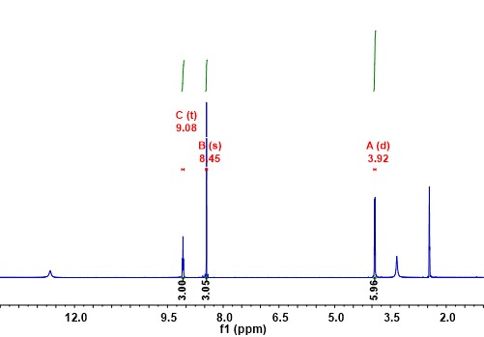
Figure S1. ¹H-NMR spectra of TCMBT in DMSO-d₆.
Synthesis of 1,4-bis(imidazol-1-yl)-butane (bib)¹
Imidazole (13.6 g, 0.2 mol), potassium hydroxide (16.8 g, 0.3 mol), and dimethyl sulfoxide (50 mL) were mixed and stirred at 80 °C for 30 minutes, then cooled to room temperature. A dimethyl sulfoxide solution (50 mL) of 1,4-dibromo-3-methylbutane (21.6 g, 0.1 mol) was added dropwise, and the reaction mixture was stirred at 80 °C for an additional 8 hours. The reaction mixture was then diluted with water (1L), and the water/DMSO mixture was removed under reduced pressure. The resulting solid residue was treated with boiling ethyl acetate to extract the organic product. The extract was distilled under vacuum to afford a white crystalline solid (18.07 g, 95% yield). ¹H-NMR (400 MHz): 7.55 (s, 2H), 7.08 (t, 2H), 6.81 (d, 2H), 3.90 (m, 4H), 1.55 (m, 4H).
Scheme 2. The synthetic route of bib.
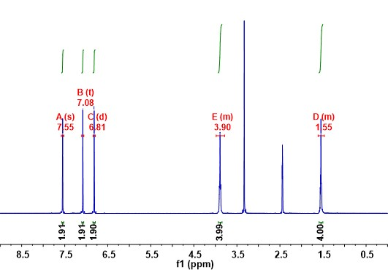
Figure S2. ¹H-NMR spectra of bib in DMSO-d₆.

Synthesis of NJU-Bai5
NJU-Bai5 was prepared according to our reported literature.² Briefly, CuCl₂·2H₂O (0.1 mmol, 17.0 mg), TCMBT (N,N',N″-tris(carboxymethyl)-1,3,5-benzenetricarboxamide) (0.1 mmol, 38.1 mg), bpp (1,3-bis(4-pyridyl)propane) (0.2 mmol, 39.7 mg), and a mixture of H₂O/MeOH (10 mL, v/v = 1:1) were combined. The resulting mixture was stirred for approximately 30 minutes under ambient air conditions, then transferred to a 20 mL Teflon-lined autoclave. The autoclave was sealed and heated at 100°C for 3 hours. After slowly cooling to room temperature, blue block-shaped crystals formed. The crystals were filtered, washed with a small amount of water, and dried in a vacuum desiccator, yielding 47.5 mg.
Synthesis of NJU-Bai5-bip
NJU-Bai5-Bip was synthesized following a procedure analogous to that of NJU-Bai5, with the key variation being the substitution of bpp by bip (1,3-di-(1H-imidazol-1-yl)propane) as the pillar ligand.
Synthesis of NJU-Bai5-bib
NJU-Bai5-Bip was prepared by adopting a synthetic procedure analogous to that of NJU-Bai5, with the sole modification of substituting bpp with bib (1,4-bis(imidazol-1-yl)-butane) as the pillar ligand.
Large-scale aqueous synthesis of NJU-Bai5-bib
A mixture of CuCl₂·2H₂O (17 g) and TCMBT (38.1 g) was dissolved in 1 L of deionized water, followed by 30 min of ultrasonication to afford a clear solution. The solution was then transferred into a 2.5 L blue-cap reagent bottle equipped with a screw cap. Separately, bip (38 g) was dissolved in 1 L of deionized water with sonication until a clear solution was obtained, and this solution was subsequently added to the reaction vessel. The reaction mixture was heated at 100 °C overnight, then cooled to room temperature, collected, and washed successively with DMF and deionized water, yielding 43.14 g of NJU-Bai5-Bib crystal.
Sample activation
Solvent-exchanged crystals were prepared by immersing the as-synthesized samples in dry MeOH for 3 days to remove the solvents, and the extract was decanted every 8 h and fresh MeOH was replaced. The completely activated sample was obtained by heating the solvent-exchanged samples at 25°C for 2 h and then 100°C for 12 h under a dynamic high vacuum.

6. Column Breakthrough Experiment
Dynamic breakthrough experiments were conducted in a dynamic gas breakthrough setup equipped with a gas mixing system and an online gas chromatography (GC) system. The initially activated NJU-Bai5-bib sample (weight 0.4877 g) was tightly packed into a stainless steel column (φ = 0.30 cm, L = 20 cm). Before the breakthrough measurements, the column was activated again, then Helium flow was used to sweep the column until no other gases were detected by gas chromatography (GC). Then, a mixed gas of C₃H₆/C₃H₈ (50/50, v/v) was then introduced into the column at a flow rate of 0.5 mL min⁻¹. The breakthrough point was determined via GC analysis. Regeneration between cycling experiments was achieved by evacuating the column under vacuum at 100 °C for 60 minutes. The feed gas pressure was maintained at 1 bar.

7. Figures and Tables
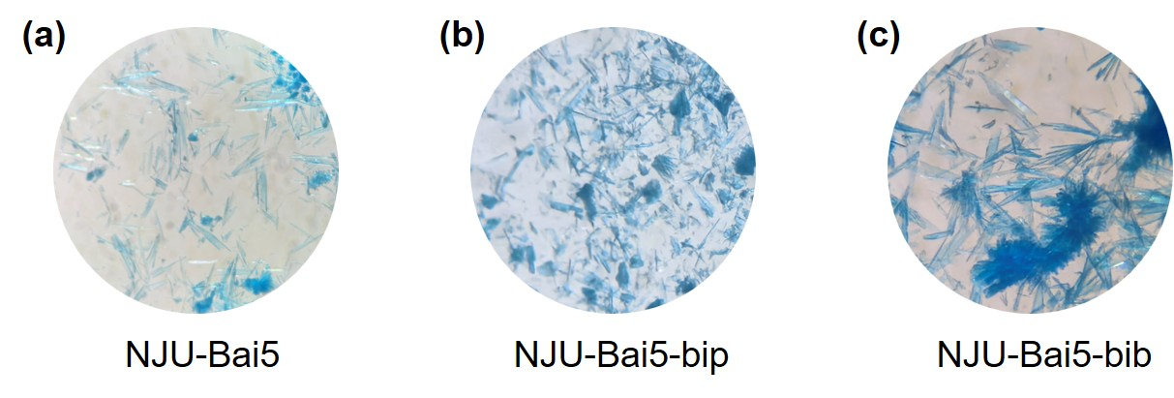
Figure S3. Crystal photographs of NJU-Bai5 (a), NJU-Bai5-bip (b), and NJU-Bai5-bib (c) under an optical microscope.
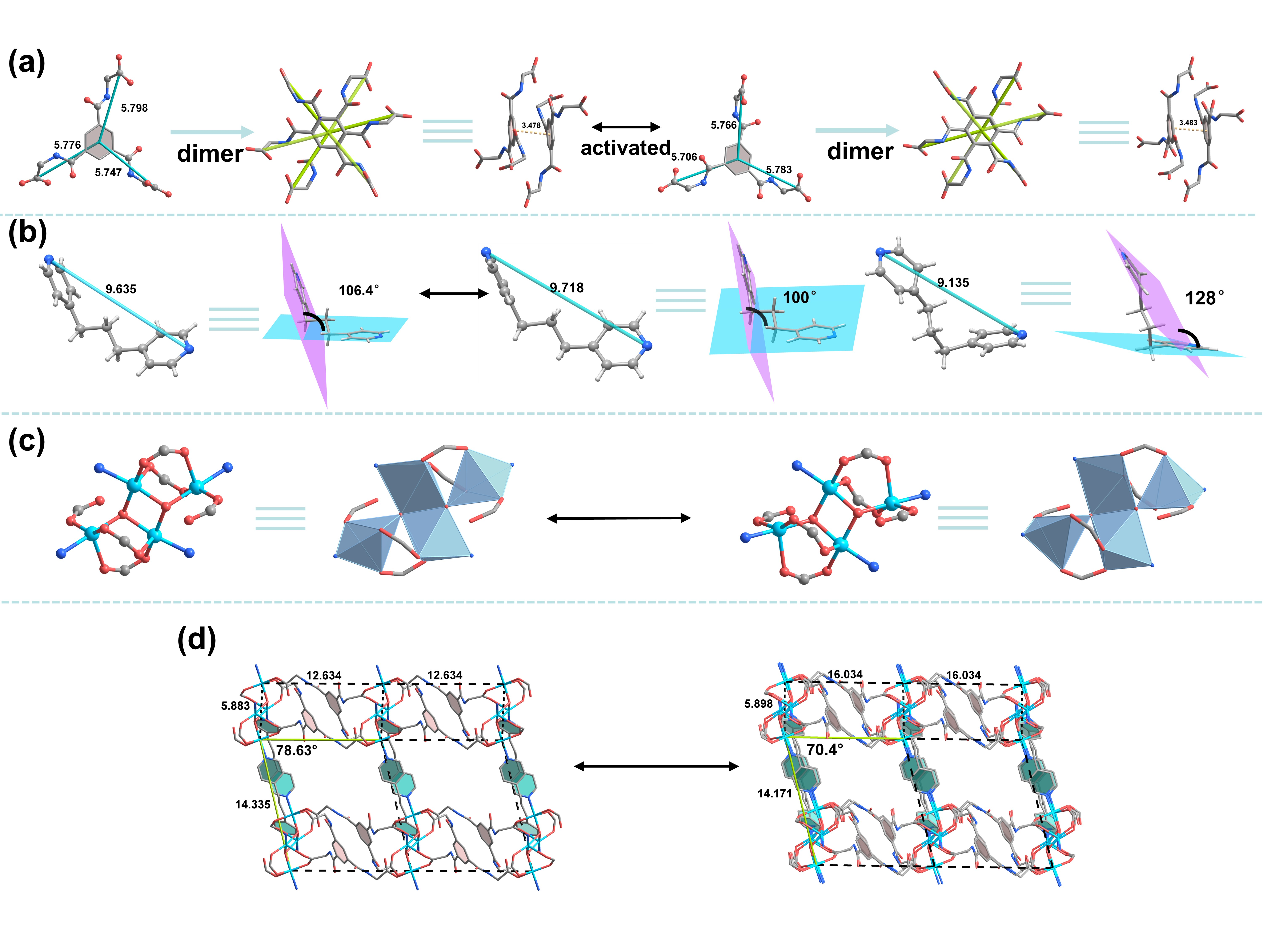
Figure S4. Crystal structure of NJU-bai5 before and after activation. (a) structural changes of the TCMBT dimer; (b) conformational adjustment of the pillar ligand bpp; (c) tetranuclear [Cu₄(μ₃-OH)₂N₄(COO)₆] cluster; (d) structrual change of three-dimensional framework.
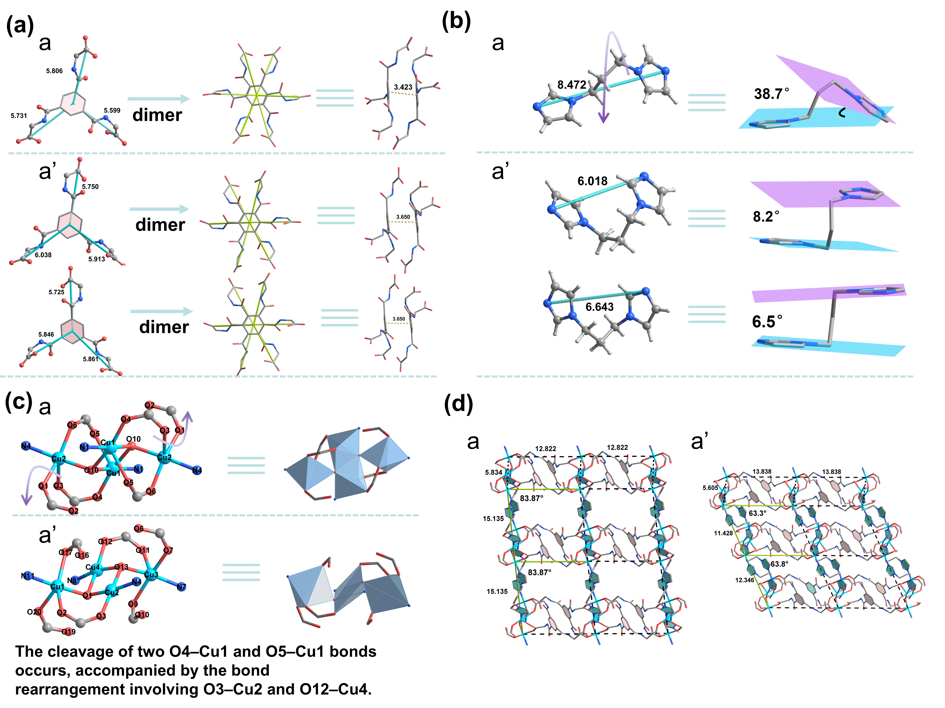
Figure S5. Crystal structure of NJU-bai5-bip before and after activation. (a) structural changes of the TCMBT dimer; (b) conformational changes of the pillar ligand bip with associated torsion angles; (c) cleavage of O-Cu bonds and subsequent rearrangement of tetranuclear Cu cluster; (d) structrual change of three-dimensional framework from as-synthesized phase to activated phase.
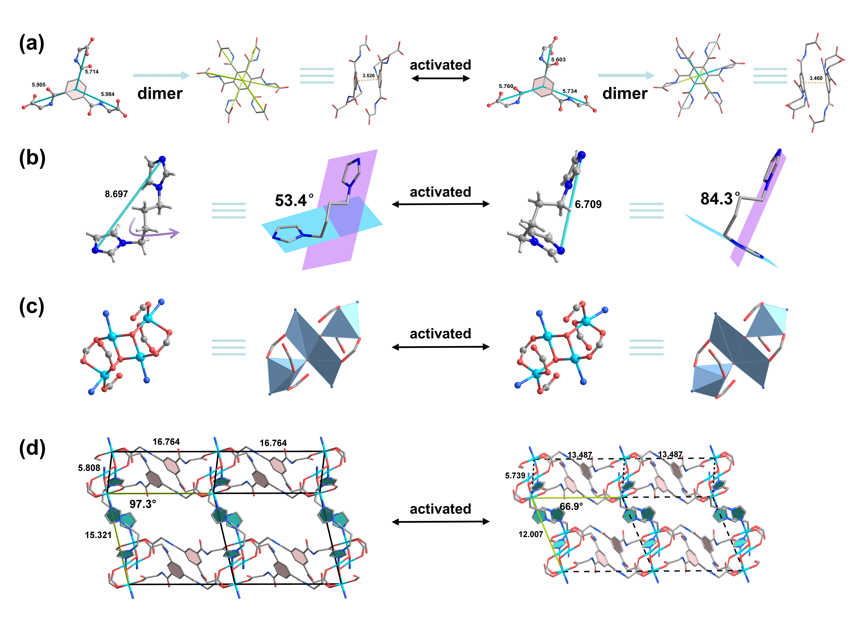
Figure S6. Crystal structure of NJU-bai5-bib before and after activation. (a) structural changes of the TCMBT dimer; (b) conformational changes of the pillar ligand bib with associated torsion angles; (c) tetranuclear [Cu₄(μ₃-OH)₂N₄(COO)₆] cluster; (d) structrual change of three-dimensional framework from as-synthesized phase to activated phase.

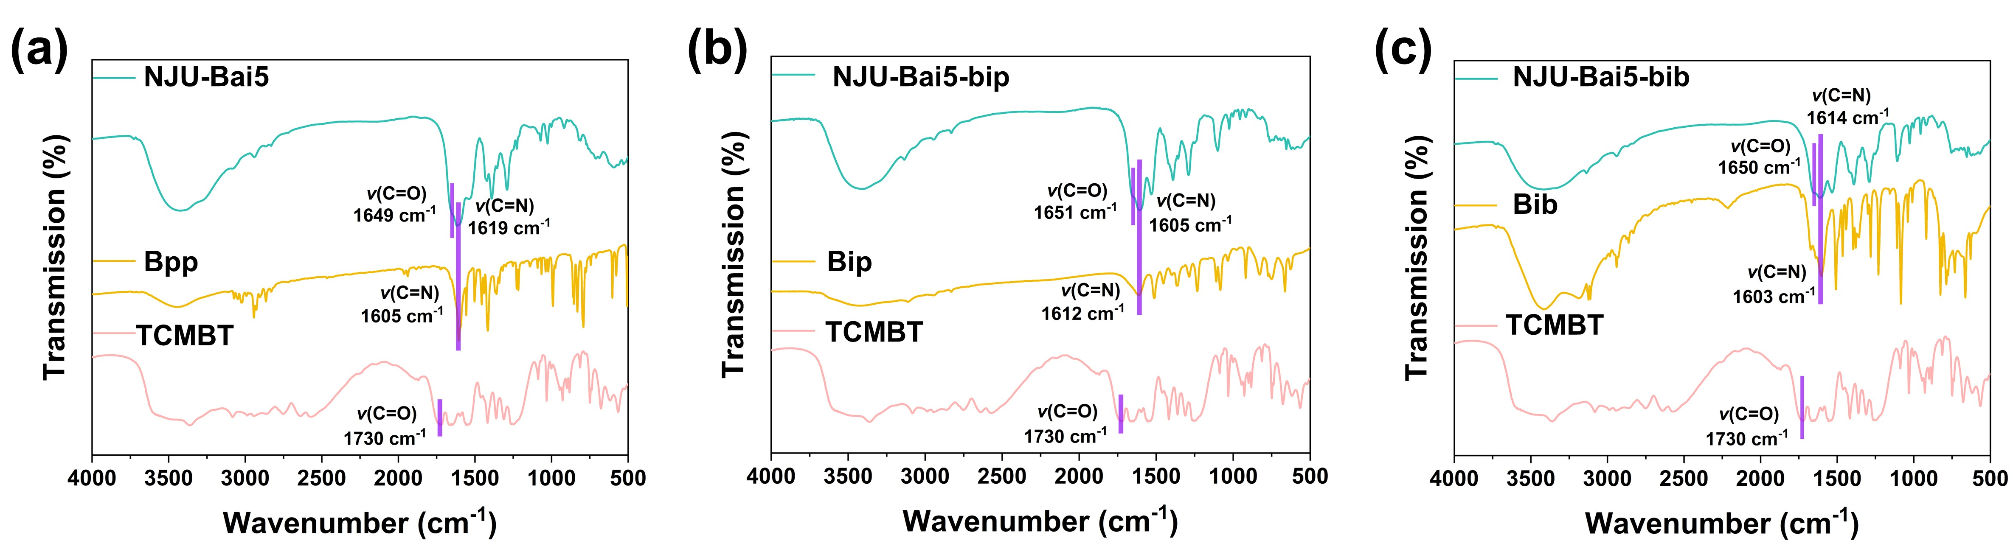Figure S7. FT-IR spectra of NJU-Bai5, TCMBT and bpp (a), NJU-Bai5-bip (b), and NJU-Bai5-bib (c).
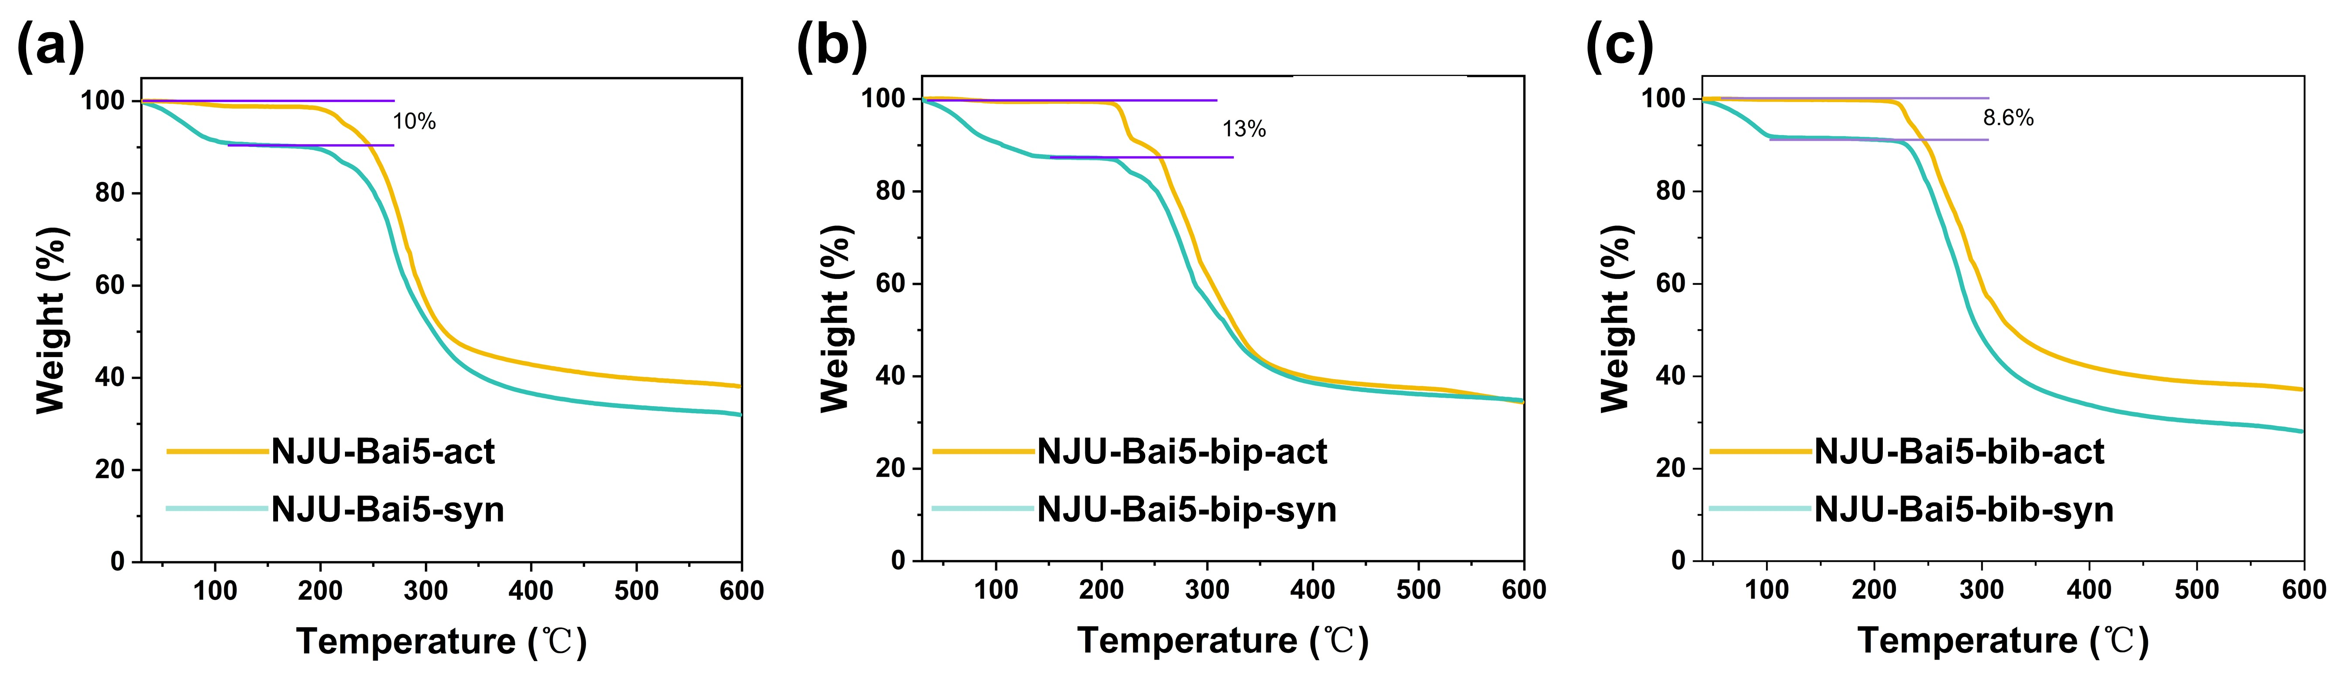
Figure S8. TG curves of NJU-Bai5-syn and NJU-Bai5-act (a), NJU-Bai5-bip-syn and NJU-Bai5-bip-act (b), and NJU-Bai5-bib-syn and NJU-Bai5-bib-act (c), recorded under N₂ atmosphere with a heating rate of 2 °C min⁻¹.
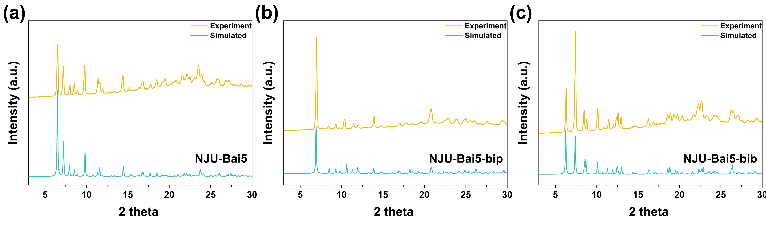
Figure S9. Simulated and experimental PXRD patterns of NJU-Bai5 (a), NJU-Bai5-bip (b), and NJU-Bai5-bib (c).
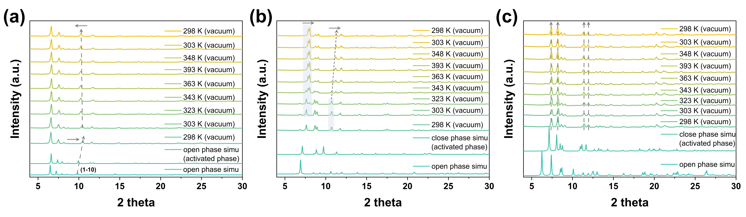
Figure S10. Variable-temperature PXRD of NJU-Bai5 (a), NJU-Bai5-bip (b), and NJU-Bai5-bib (c).

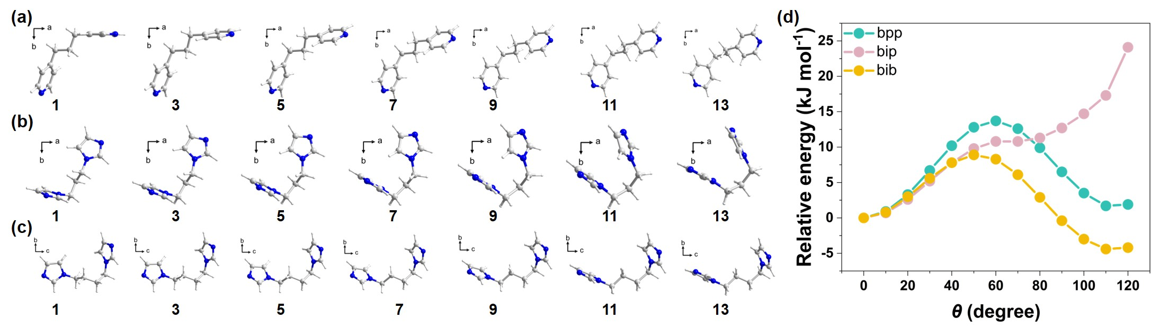
Figure S11. Rotational energies of bpp, bip, and bib at different rotation angles.
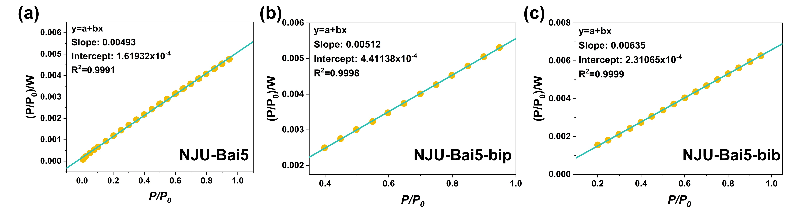
Figure S12. Langmuir plot of NJU-Bai5 (a), NJU-Bai5-bip (b) and NJU-Bai5-bib (c), with Langmuir surface area of 1177 m² g⁻¹, 1134 m² g⁻¹ and 914 m² g⁻¹, respectively.
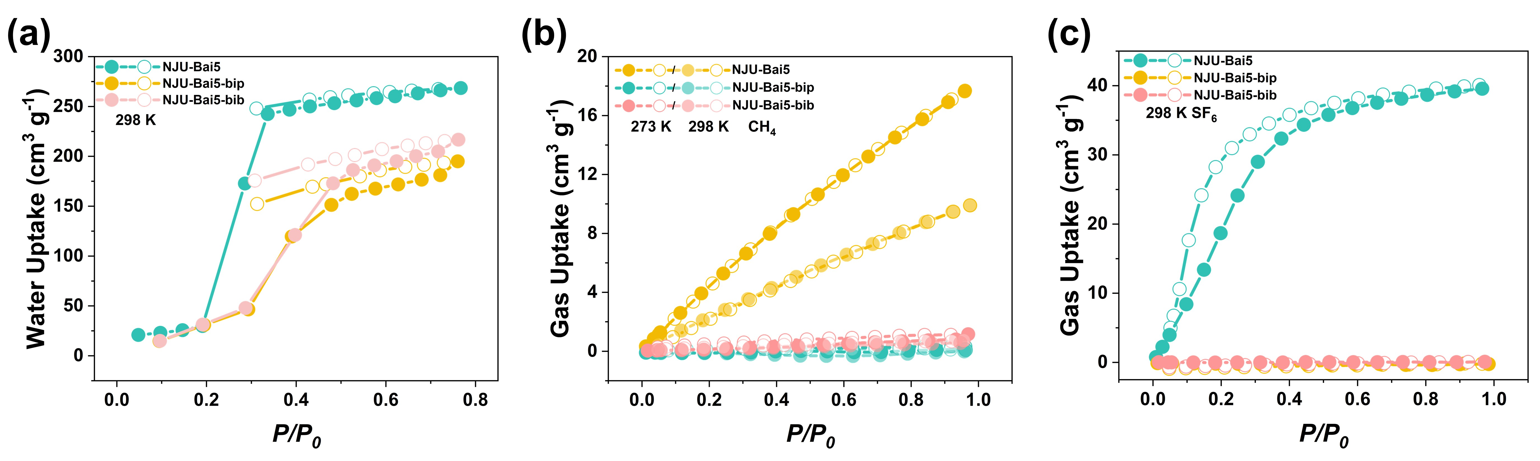
Figure S13. (a) The water-vapor adsorption isotherms of NJU-Bai5, NJU-Bai5-bip and NJU-Bai5-bib at 298K. The CH₄ isotherms (b) and SF₆ isotherms (c) of NJU-Bai5, NJU-Bai5-bip, and NJU-Bai5-bib.

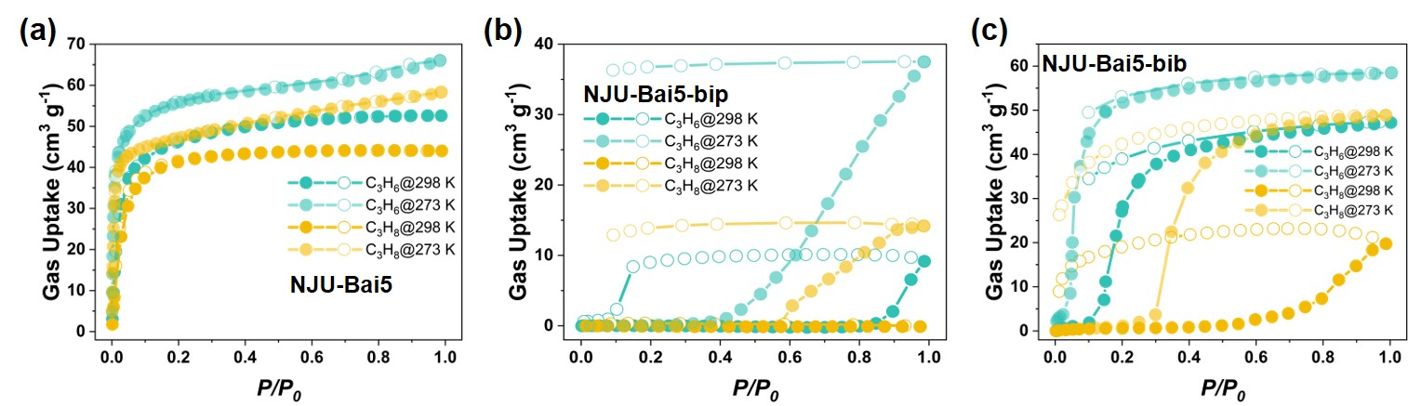
Figure S14. C₃H₆ and C₃H₈ isotherms at 298 K and 273K of NJU-Bai5 (a), NJU-Bai5-bip (b), and NJU-Bai5-bib (c).
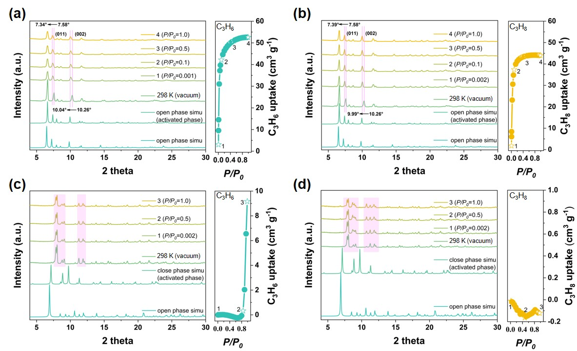
Figure S15. In situ pressure-dependent PXRD patterns and their corresponding adsorption isotherms of NJU-Bai5 (a and b), NJU-Bai5-bip (c and d) under C₃H₆ and C₃H₈ atmospheres.
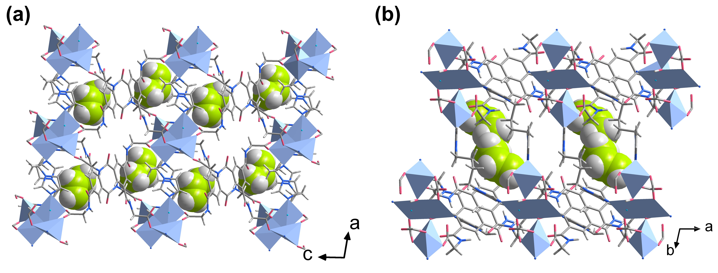
Figure S16. Single-crystal structure of C₃H₆@NJU-Bai5-bib along b-axis (b), and c-axis (c), respectively.
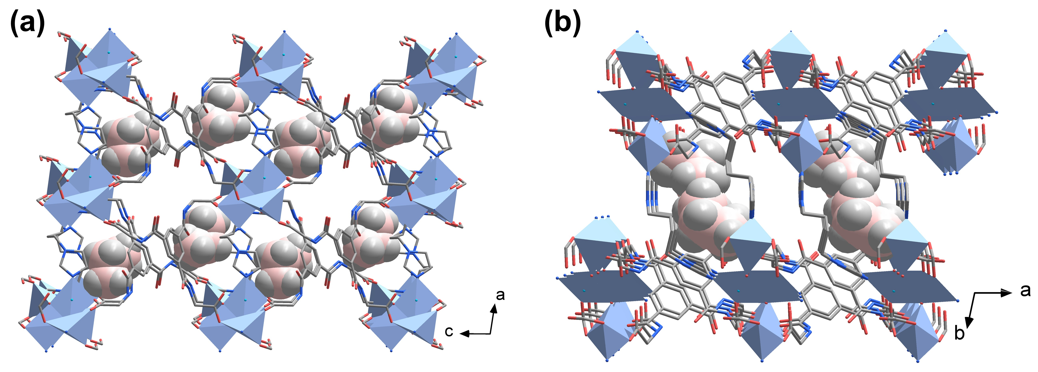
Figure S17. Single-crystal structure of C₃H₈@NJU-Bai5-bib along b-axis (b), and c-axis (c), respectively.

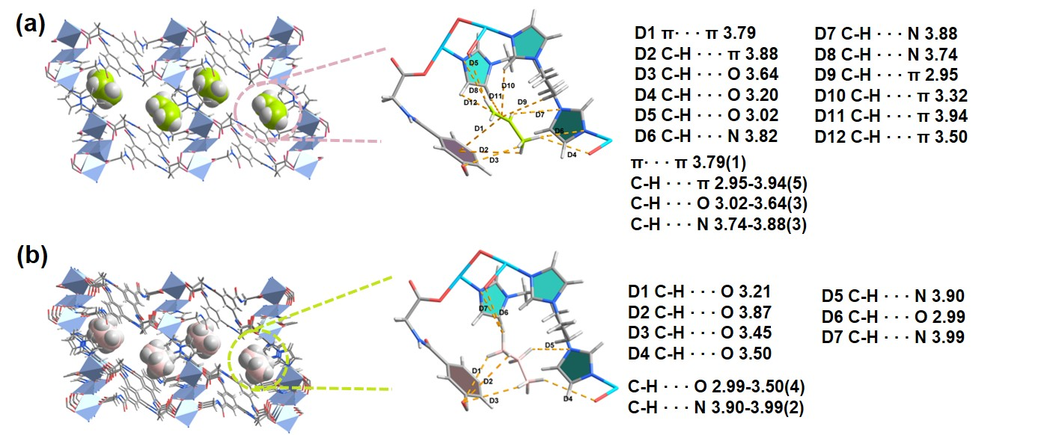
Figure S18. The detailed list of close-contact interactions of C₃H₆ (a) and C₃H₈ (b) with the framwork in C₃H₆@NJU-Bai5-bib and C₃H₈@NJU-Bai5-bib.

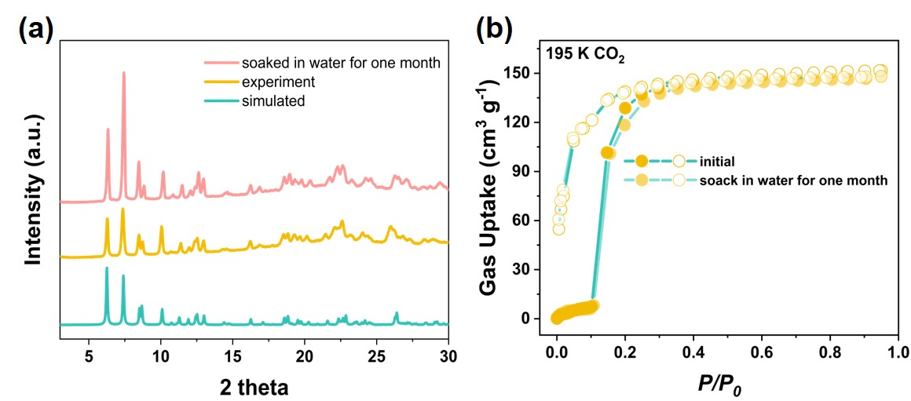
Figure S19. (a) PXRD patterns of NJU-Bai5-bib: simulated, as-synthesized, and after immersion in water for one month; (b) CO₂ adsorption isotherms at 195 K for NJU-Bai5-bib before and after soaking in water for one month.
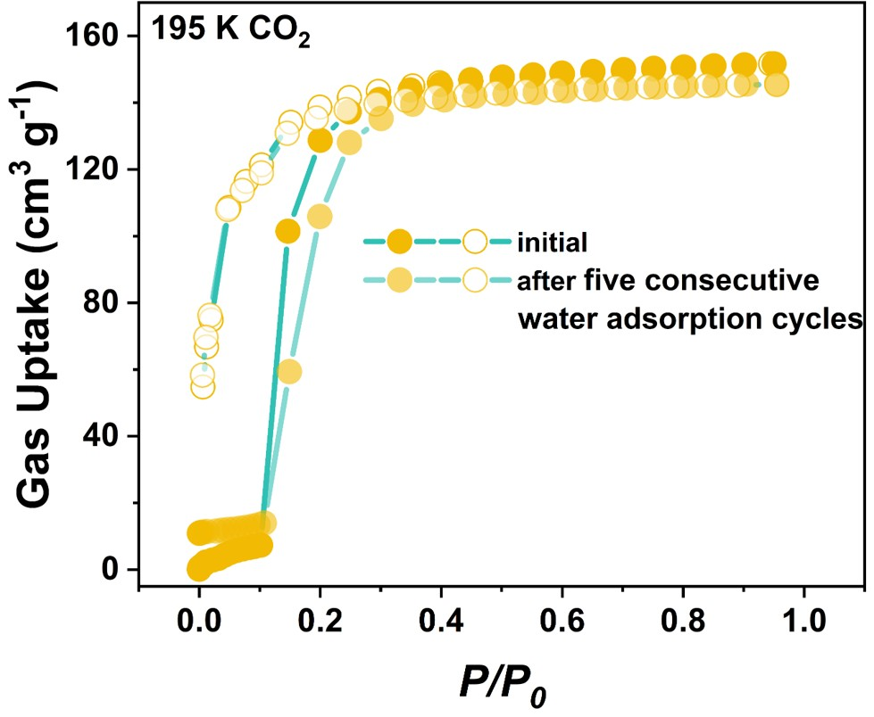
Figure S20. CO₂ adsorption isotherms collected at 195 K before and after five water-vapor adsorption cycles.

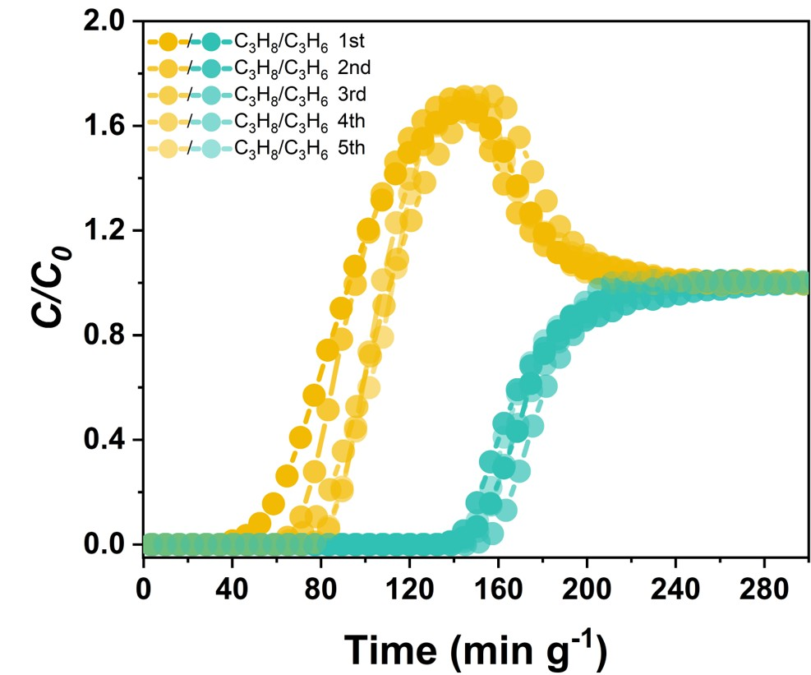
Figure S21. Breakthrough tests for NJU-Bai5-bib over five consecutive cycles.

Table S1. Comparison of physical parameters of C₃H₆ and C₃H₈.³
Gas | Kinetic  diameter  (Å) | Boiling  point  (K) | Polarizability  (10⁻²⁵ cm³) | Dipole moment  (10⁻¹⁸ esu cm)
C₃H₆  C₃H₈ | 4.7  5.1 | 225.5  231.1 | 62.6  62.9-63.7 | 0.366  0.084

Table S2. Comparison of the C₃H₆ and C₃H₈ adsorption capacities and uptake ratios of top-performing porous materials at 298 K and 0.5 bar.
Adsorbents | C₃H₆ uptake at 0.5 bar (cm³ g⁻¹) | C₃H₈ uptake at 0.5 bar (cm³ g⁻¹) | Uptake ratio | Ref.
Co-gallate | 51.22 | 4.01 | 12.78 | ⁴
KAUST-7 | 44.86 | 2.24 | 20 | ⁵
ZU-609 | 52.64 | 1.89 | 27.8 | ⁶
NTU-85-WNT | 0.56 | 0.0019 | 12.8 | ⁷
Y-abtc | 43 | 2.66 | 16.17 | ⁸
CALF-20 | 101 | 83.8 | 1.25 | ⁹
NCU-20 | 91.62 | 4.12 | 22.2 | ⁹
HIAM-301 | 66.04 | 5.98 | 11.04 | ¹⁰
Y-dbai | 52.86 | 2.06 | 25.7 | ¹¹
UTSA-400 | 80.8 | 2.53 | 34 | ¹²
HAF-1 | 99.66 | 2.8 | 35.6 | ¹³
NTU-65-CoTi | 57.44 | 1.55 | 37.05 | ¹⁴
NJU-Bai5 | 50.90 | 43.75 | 1.16 | This work
NJU-Bai5-bib | 42.61 | 1.24 | 34.36 | This work

Table S3. Summary of crystallographic parameters for NJU-Bai5/NJU-Bai5-act and NJU-Bai5-bip/NJU-Bai5-bip-act.
MOFs | NJU-Bai5 | NJU-Bai5-act | NJU-Bai5-bip | NJU-Bai5-bip-act
Empirical Formula | C₂₈H₃₉Cu₂N₅O₁₆ | C₅₆H₈₂Cu₄N₁₀O₃₄ | C₂₄H₄₁Cu₂N₇O₁₈ | C₅₁H₆₅Cu₄N₁₄O_{24.5}
CCDC number | 735377 | 2494657 | 2494652 | 2494651
Space group | P$\overline{1}$
a / Å | 11.575(2) | 14.1707(8) | 10.6343(4) | 11.2443(9)
b / Å | 12.634(3) | 16.0339(6) | 12.8223(3) | 13.8381(3)
c / Å | 14.335(2) | 17.8246(5) | 13.1197(6) | 20.9642(5)
α / deg | 101.3690(10) | 85.968(3) | 94.922(3) | 74.805(2)
β / deg | 102.935(3) | 89.984(4) | 101.606(3) | 77.381(5)
γ / deg | 96.457(2) | 70.448(4) | 92.635(2) | 78.414(5)
Volume / Å³ | 1976.0(6) | 3805.8(3) | 1742.23(11) | 3036.0(3)
Z | 2 | 2 | 2 | 2
ρ_{calc} / g cm⁻³ | 1.393 | 1.478 | 1.606 | 1.663
μ / mm⁻¹ | 1.146 | 2.051 | 2.274 | 2.396
F(000) | 856.0 | 1752.0 | 872.0 | 1562.0
Goodness-of-fit on F² | 1.087 | 1.670 | 1.036 | 1.087
Final R indexes  [I > 2σ (I)] | R₁=0.0558, wR₂=0.1196 | R₁=0.1701, wR₂=0.4533 | R₁=0.1273, wR₂=0.3375 | R₁=0.1061, wR₂=0.2415
Final R indexes  [all data] | R₁=0.0763, wR₂=0.1236 | R₁=0.2106, wR₂=0.4846 | R₁=0.1337, wR₂=0.3424 | R₁=0.1378, wR₂=0.2605
R₁=∑||F_{o}|-|F_{c}||/∑|F_{o}|; wR₂=[∑w(𝐹_{𝑜}²-𝐹_{𝑐}²)²/∑w(𝐹_{𝑜}²)²]^{1/2}
Table S4. Summary of crystallographic parameters for NJU-Bai5-bib/NJU-Bai5-bib-act and C₃H₆@NJU-Bai5-bib and C₃H₈@NJU-Bai5-bib.
MOFs | NJU-Bai5-bib | NJU-Bai5-bib-act | C₃H₆@NJU-Bai5-bib | C₃H₈@NJU-Bai5-bib
Empirical Formula | C₂₅H_{41.78}Cu₂N₇O_{17.39} | C₂₅H₂₈Cu₂N₇O₁₁ | C₂₈H_{33.97}Cu₂N₇O_{10.48} | C₂₈H_{35.95}Cu₂N₇O_{10.6}
CCDC number | 2494654 | 2494655 | 2494653 | 2494656
Space group | P$\overline{1}$
a / Å | 10.2484(3) | 10.2313(18) | 10.1572(3) | 10.1460(5)
b / Å | 12.2442(4) | 12.0072(13) | 12.8450(4) | 12.8511(7)
c / Å | 14.5936(5) | 13.4874(13) | 14.1344(4) | 14.1910(9)
α / deg | 103.210(3) | 66.873(10) | 103.369(3) | 102.549(5)
β / deg | 96.588(3) | 83.215(13) | 95.565(3) | 95.846(4)
γ / deg | 91.397(3) | 81.022(12) | 100.928(3) | 100.375(4)
Volume / Å³ | 1770.01(10) | 1502.1(4) | 1762.3(2) | 1757.34(18)
Z | 2 | 2 | 2 | 2
ρ_{calc} / g cm⁻³ | 1.587 | 1.613 | 1.455 | 1.450
μ / mm⁻¹ | 2.228 | 2.365 | 2.052 | 2.039
F(000) | 876.0 | 746.0 | 786.0 | 792.0
Goodness-of-fit on F² | 1.031 | 0.866 | 1.051 | 1.187
Final R indexes  [I > 2σ (I)] | R₁=0.0656,  wR₂=0.1724 | R₁=0.0747, wR₂=0.1594 | R₁=0.0497,  wR₂=0.1399 | R₁=0.1248,  wR₂=0.3144
Final R indexes  [all data] | R₁=0.0794,  wR₂=0.1834 | R₁=0.2526, wR₂=0.2383 | R₁=0.0606,  wR₂=0.1472 | R₁=0.1850,  wR₂=0.3594
R₁=∑||F_{o}|-|F_{c}||/∑|F_{o}|; wR₂=[∑w(𝐹_{𝑜}²-𝐹_{𝑐}²)²/∑w(𝐹_{𝑜}²)²]^{1/2}
Table S5. Host-guest interactions between the NJU-Bai5-bib with C₃H₆.
Host-guest interactions | Distance (Å)
D1: π···π¹ | 3.79
D-H···A | Distance (Å) | ∠D-H···A (°)
D2: C26--H26B···π²  D3: C26--H26C···O7  D4: C26--H26A···O9  D5: C28--H28B···O5  D6: C26--H26A···N7  D7: C27--H27A···N7  D8: C28--H27B···N4  D9: C21--H21A···π  D10: C25--H25···π  D11: C17--H17···π  D12: C16--H16···π | 3.88  3.64  3.20  3.02  3.82  3.88  3.74  2.95  3.32  3.94  3.50 | 109.3  124.6  146.8  149.8  134.3  137.4  152.8  163.5  131.4  90.7  104.6
¹π···π: interaction between the benzene π-center and the C=C bond of C₃H₆.
²C-H···π interaction between the benzene π-center and a hydrogen atom of the C₃H₆ molecule.

Table S6. Host-guest interactions between the NJU-Bai5-bib with C₃H₈.
Host-guest interactions | Distance (Å) | ∠D-H···A (°)
D-H···A
D1: C28--H28C···O7  D2: C28--H26B···O7  D3: C26--H26C···O7  D4: C26--H28A···O9  D5: C27--H27B···N6  D6: C28--H28A···O5  D7: C28--H28A···N4 | 3.21  3.87  3.45  3.50  3.90  2.99  3.99 | 132.9  87.0  138.3  135.2  127.4  156.3  133.7

Table S7. Cost of raw materials required for kilogram-scale MOF production.
Materials | Reagent | Price ($ kg⁻¹) | Product cost ($ kg⁻¹) | Reference
NJU-Bai5-bib | TCMBT | 108.65 | 158.3 | This work
NJU-Bai5-bib | Bib | 8.5 | 158.3 | This work
NJU-Bai5-bib | CuCl₂·2H₂O | 9.94 | 158.3 | This work
ZU-609 | Cu(NO₃)₂·xH₂O  4,4’-dipyridyl sulfide  Disodium 1,2-  Ethanedisulfonate | 73.00  400000  339.45 | 19173.69 | ⁶
UTSA-400 | UTSA-400  Ni(NO₃)₂·6H₂O  pyrazine | 161.9  15720  62.49 | 6320.21 | ⁷
HAF-1 | ZnSO₄·7H₂O  AtzH | 9.94  21.59 | 389 | ⁸
NTU-65-Co-Ti | Co(BF₆)₂·6H₂O  (NH₄)₂TiF₆·6H₂O  1,4-di(1H-imidazolyl)benzene | 1704.31  46.87  25564.91 | 8428.86 | ¹⁰

Table S8. Comparison of Integrated Performance.
MOFs | C₃H₆/C₃H₈ uptake ratio | Cost  ($ kg⁻¹) | Scale-up  (g) | Scalable cost | Green synthesis | Water-  related stability | Synthesis time (h)
This work | 34.36 | 158.3 | 43 | 1 | 1.0  (H₂O) | 1 | 10
ZU-609 | 27.8 | 19173.69 | 0.054 | 0.3 | 0.7  (MeOH/Ethyle-ne glycol) | 0.8 | 336
UTSA-400 | 34 | 6320.21 | 0.03448 | 0.5 | 0.4  (H₂O/HF) | 0.8 | 24
HAF-1 | 35.6 | 389 | 418 | 0.85 | 1.0  (H₂O) | 0.8 | 12
NTU-65-Co-Ti | 37.05 | 8428.86 | 0.16 | 0.4 | 0.6  (DMF/H₂O) | 0.8 | 168

8. Reference
(1) Barsukova, M.; Samsonenko, D.; Goncharova, T.; Potapov, A.; Sapchenko, S.; Dybtsev, D.; Fedin, V., Coordination polymers with adjustable dimensionality based on Cu^{II} and bis-imidazolyl bridging ligand. Russian Chemical Bulletin 2016, 65 (12), 2914-2919.
(2) Lu, Z.; Xing, H.; Sun, R.; Bai, J.; Zheng, B.; Li, Y., Water Stable Metal–Organic Framework Evolutionally Formed from a Flexible Multidentate Ligand with Acylamide Groups for Selective CO₂ Adsorption. Cryst. Growth Des. 2012, 12 (3), 1081-1084.
(3) Gao, M.-Y.; Song, B.-Q.; Sensharma, D.; Zaworotko, M. J., Crystal engineering of porous coordination networks for C3 hydrocarbon separation. SmartMat 2021, 2 (1), 38-55.
(4) Liang, B.; Zhang, X.; Xie, Y.; Lin, R.-B.; Krishna, R.; Cui, H.; Li, Z.; Shi, Y.; Wu, H.; Zhou, W.; Chen, B., An Ultramicroporous Metal–Organic Framework for High Sieving Separation of Propylene from Propane. J. Am. Chem. Soc. 2020, 142 (41), 17795-17801.
(5) Cadiau, A.; Adil, K.; Bhatt, P. M.; Belmabkhout, Y.; Eddaoudi, M., A metal-organic framework–based splitter for separating propylene from propane. Science 2016, 353 (6295), 137-140.
(6) Cui, J.; Zhang, Z.; Yang, L.; Hu, J.; Jin, A.; Yang, Z.; Zhao, Y.; Meng, B.; Zhou, Y.; Wang, J., A molecular sieve with ultrafast adsorption kinetics for propylene separation. Science 2024, 383 (6679), 179-183.
(7) Dong, Q.; Huang, Y.; Wan, J.; Lu, Z.; Wang, Z.; Gu, C.; Duan, J.; Bai, J., Confining Water Nanotubes in a Cu₁₀O₁₃-Based Metal–Organic Framework for Propylene/Propane Separation with Record-High Selectivity. J. Am. Chem. Soc. 2023, 145 (14), 8043-8051.
(8) Wang, H.; Dong, X.; Colombo, V.; Wang, Q.; Liu, Y.; Liu, W.; Wang, X.-L.; Huang, X.-Y.; Proserpio, D. M.; Sironi, A.; Han, Y.; Li, J., Tailor-Made Microporous Metal–Organic Frameworks for the Full Separation of Propane from Propylene Through Selective Size Exclusion. Adv. Mater., 2018, 30 (49), 1805088.
(9) Deng, Z.; Yang, L.; Xiong, H.; Liu, J.; Liu, X.; Zhou, Z.; Chen, S.; Wang, Y.; Wang, H.; Chen, J.; Deng, S.; Chen, B.; Wang, J., Green and Scalable Preparation of an Isomeric CALF-20 Adsorbent with Tailored Pore Size for Molecular Sieving of Propylene from Propane. Small Methods 2025, 9 (1), 2400838.
(10) Yu, L.; Han, X.; Wang, H.; Ullah, S.; Xia, Q.; Li, W.; Li, J.; Da Silva, I.; Manuel, P.; Rudic, S., Pore distortion in a metal–organic framework for regulated separation of propane and propylene. J. Am. Chem. Soc. 2021, 143 (46), 19300-19305.
(11) Tu, S.; Yu, L.; Wu, Y.; Chen, Y.; Wu, H.; Wang, L.; Liu, B.; Zhou, X.; Xiao, J.; Xia, Q., A new yttrium-based metal–organic framework for molecular sieving of propane from propylene with high propylene capacity. AIChE Journal 2022, 68 (3), e17551.
(12) Xie, Y.; Shi, Y.; Cedeño Morales, E. M.; El Karch, A.; Wang, B.; Arman, H.; Tan, K.; Chen, B., Optimal Binding Affinity for Sieving Separation of Propylene from Propane in an Oxyfluoride Anion-Based Metal–Organic Framework. J. Am. Chem. Soc. 2023, 145 (4), 2386-2394.
(13) Tian, Y.-J.; Deng, C.; Zhao, L.; Zou, J.-S.; Wu, X.-C.; Jia, Y.; Zhang, Z.-Y.; Zhang, J.; Peng, Y.-L.; Chen, G., Pore configuration control in hybrid azolate ultra-microporous frameworks for sieving propylene from propane. Nat. Chem. 2024, 17 (1), 141-147.
(14) Liu, S.; Huang, Y.; Wan, J.; Zheng, J.-J.; Krishna, R.; Li, Y.; Ge, K.; Tang, J.; Duan, J., Fine-regulation of gradient gate-opening in nanoporous crystals for sieving separation of ternary C3 hydrocarbons. Chem. Sci. 2024, 15 (17), 6583-6588.

