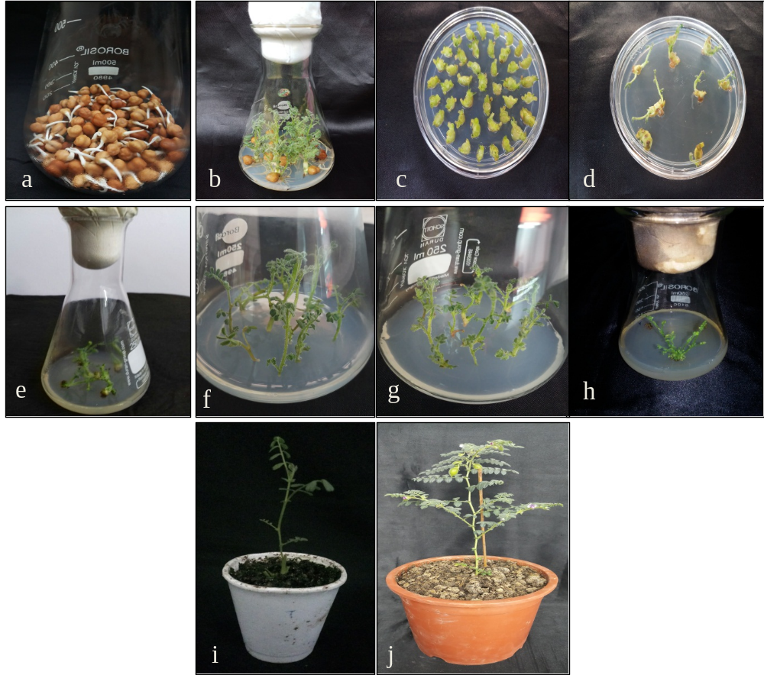
Fig.S2 Agrobacterium-mediated transformation of chickpea. a Germinated seed. b Axillary and shoot meristem arising from seeds. c Excised nodes on MS medium supplemented with L-cysteine (100 mg/l). d Regeneration from nodes on cefotaxime (500 mg/l) medium. e Shoots transferred to hygromycin (5 mg/l) selection. f Transfer of shoots to 2nd selection (10 mg/l). g Transfer of shoots to 3rd selection (15 mg/l). h Surviving shoots transferred to regeneration medium. i Grafted shoots on seedling stocks for hardening and acclimatization.
j Flower and pod setting.

