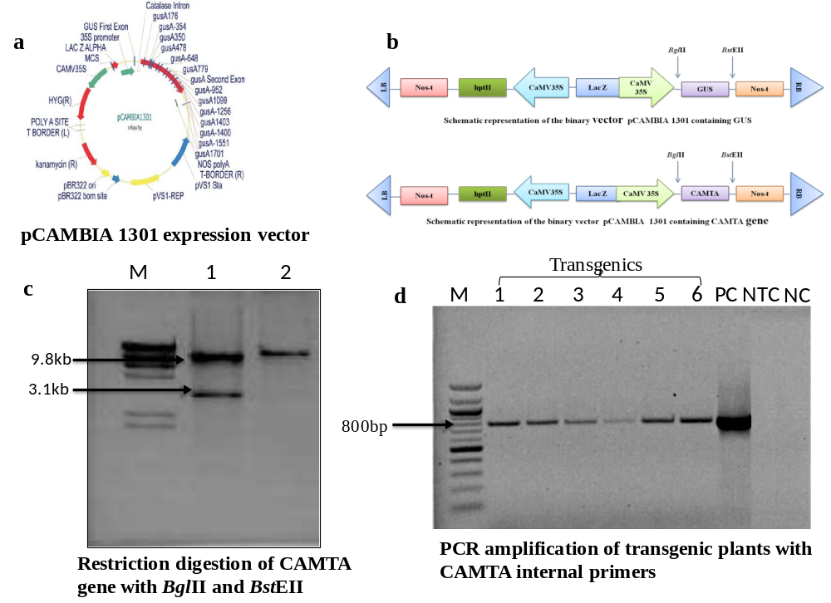
Fig.S1 Schematic representation, characterization, and validation of the T-DNA region of the construct harboring the CAMTA1 gene. a pCAMBIA 1301 plant expression vector. b 3.1 kb fragment of CAMTA1 gene containing restriction sites, BglII and BstEII. c Restriction digestion of CAMTA gene with BglII and BstEII. d Validation of CAMTA1 gene by PCR with internal primers and band size of 800 bp was obtained. (M- 100bp marker, Lane 1 to 6 – putative transformants, PC- positive control, NTC- non-template control, and NC- negative control.

