Supplemental data
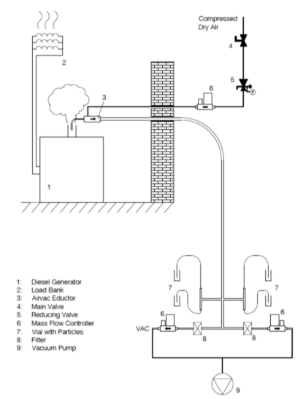
Figure S1. Schematic overview of the diesel exposure setup.

Table S1A. Temperature program inlet
 | Rate (C/min) | temp | Hold time (min) | Run time (min)
Initial |  | 40 ºC | 0,01 | 0,01
Ramp | 700 | 320 ºC | 0 | 22

Table S2. Temperature program oven (see Figure S2)
 | Rate (C/min) | temp | Hold time (min) | Run time (min)
Initial |  | 60 ºC | 1 | 1
Ramp 1 | 10 | 100 ºC | 0 | 5
Ramp 2 | 20 | 320 | 6 | 22

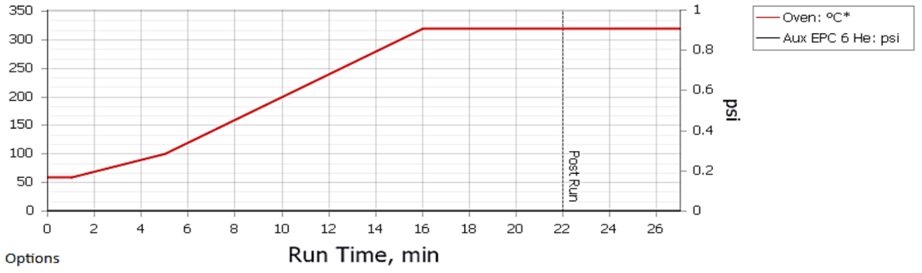
Figure S2. Temperature program for PAH analysis

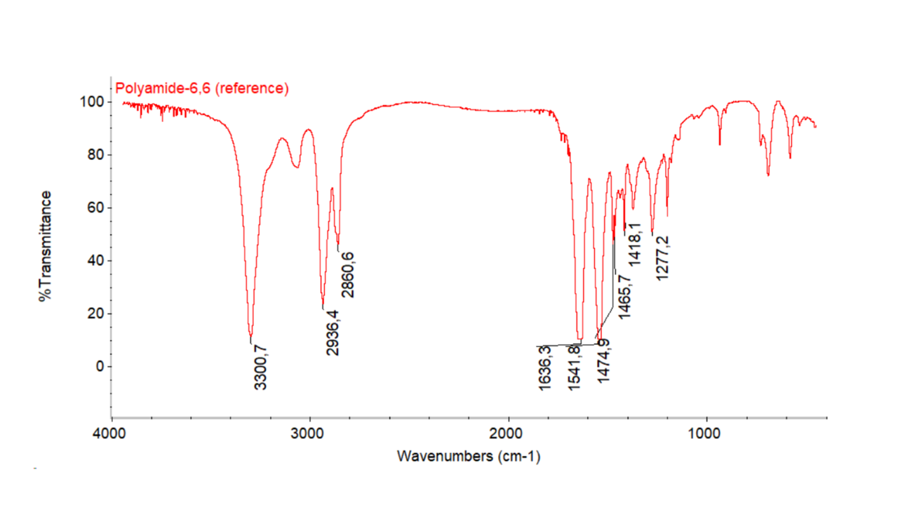
Figure S3. Reference FTIR spectrum of nylon-6,6

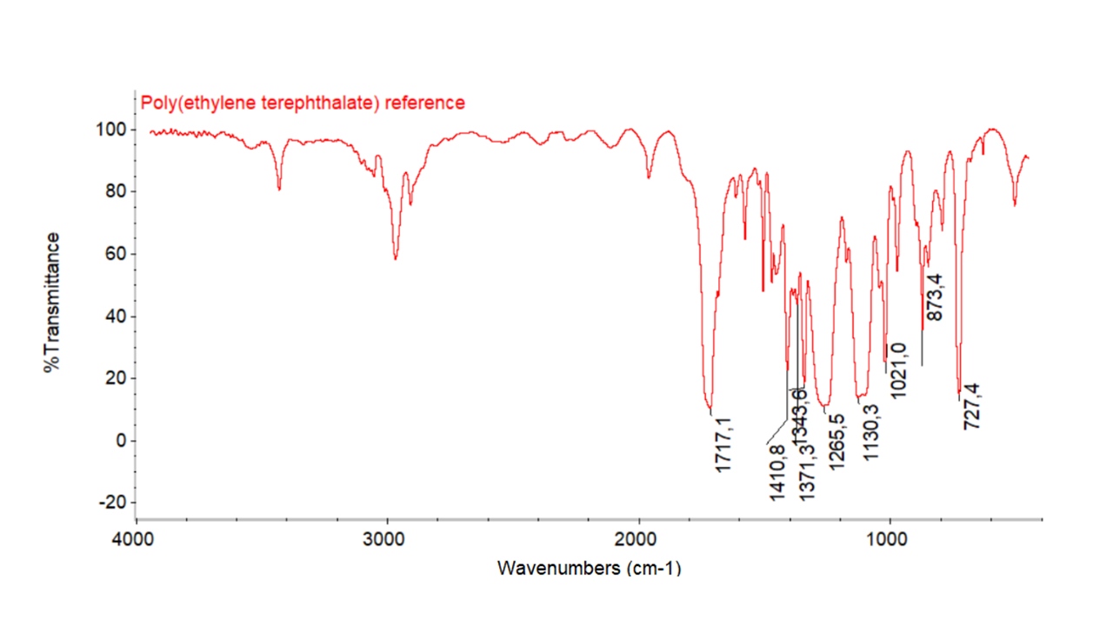
Figure S4. Reference FTIR spectrum of PET

