Supplemental methods and results for:
BTN3A2 protects against Escherichia coli infection: insights from genome-wide association and Mendelian randomization

Michael Marks-Hultström^{1,2}, Mikael Eriksson¹, Finn Schulz³, Bram Burger¹, Kristoffer Strålin^{4,5}, Volkan Özenci^{6,7}, Anders Krifors^{3,8}, Fredrik Sjövall^{9,10}, Guillaume Butler-Laporte^{11,12}, Miklos Lipcsey^{1,13}.

1: Anaesthesiology and Intensive Care Medicine, Department of Surgical Sciences, Uppsala University, Uppsala, Sweden.
2: Integrative Physiology, Department of Medical Cell Biology, Uppsala University, Uppsala, Sweden.
3: Department of Medical Sciences, Uppsala University, Uppsala, Sweden.
4: Department of Medicine, Huddinge, Karolinska Institutet, Stockholm, Sweden.
5: Department of Infectious Diseases, Karolinska University Hospital, Stockholm, Sweden.
6: Division of Clinical Microbiology, Department of Laboratory Medicine, Karolinska Institutet,
7: Department of Clinical Microbiology, Karolinska University Hospital, Huddinge, Stockholm, Sweden
8: Centre for Clinical Research, Region Västmanland-Uppsala University, Västmanland Hospital Västerås, Västerås, Sweden.
9: Department of Intensive and Perioperative Care, Skane University Hospital, Malmö, Sweden.
10: Department of Clinical Sciences, Lund University, Malmö, Sweden.
11: Division of Infectious Diseases, McGill University Health Centre, Montréal, Canada.
12: Lady Davis Institute for Medical Research, Jewish General Hospital, Montréal, Canada.
13: Hedenstierna Laboratory, Department of Surgical Sciences, Uppsala University, Uppsala, Sweden.

Table of contents Page
Supplemental tables 4
Supplemental Table S1. E. coli susceptibility cohort 4
Supplemental Table S2. Severe E. coli infection cohort 5
Supplemental table S3: Genome-wide significant and suggestive loci for E. coli susceptibility 6
Supplemental table S4: Genome-wide significant and suggestive loci for severe E. coli infection 7
Supplemental table S5: Gene expression QTL (eQTL) and splice-form WQTL (sQTL) for the lead SNP rs9366673 for E. coli susceptibility, only hit was in Pituitary. 8
Supplemental table S6: Gene expression QTL (eQTL) and splice-form QTL (sQTL) for the lead SNP rs9366673 for Severe E. coli infection in Whole blood and EBV-transformed lymphocytes 9
Supplemental table S7: Genetic instruments for BNTN3A2 Mendelian randomisation 10
Supplemental table S8: Results of BTN3A2 Mendelian randomisation and sensitivity analyses 11
Supplemental figures 12
Supplemental Figure S1. Histogram of age for the case and control populations. 12
Supplemental Figure S2. Susceptibility Quantile-Quantile (Q-Q) plot. 13
Supplemental Figure S3. Severe infection Quantile-Quantile (Q-Q) plot. 14
Supplemental Figure S4. Locus Zoom E. coli susceptibility Chr 6 rs9366673 (1.71E-07) 15
Supplemental Figure S5. Locus Zoom E. coli susceptibility Chr 13 rs1287556 (3.93e-7) 16
Supplemental Figure S6. Locus Zoom E. coli susceptibility Chr 14 rs72702956 (p=1.86E-07) 17
Supplemental Figure S7. Locus Zoom E. coli susceptibility Chr 17 rs147709654 (1.96E-06) 18
Supplemental Figure S8. Locus Zoom Severe E. coli infection Chr 3 rs62238581 (3.80E-07) 19
Supplemental Figure S9. Locus Zoom Severe E. coli infection Chr 3 rs113293261 (4.56E-07) 20
Supplemental Figure S10. Locus Zoom Severe E. coli infection Chr 16 rs7203634 (6.69E-07) 21
Supplemental Figure S11. Locus Zoom Severe E. coli infection Chr 2 rs74451679 (8.48E-07) 22
Supplemental Figure S12. ABT1 Blood Protein Atlas 23
Supplementary data Description of Pre-imputation QC per cohort 24
Epihealth genotype data QC and imputation 24
COSM-C genotype data 25
SIMPLER genotype data 25
SMCC genotype data 26

Supplemental tables

Supplemental Table S1. E. coli susceptibility cohort
Number of individuals and basic demography from each contributing subcohort.
 | MAICS | Epihealth | Simpler | STR
E. coli infection
Total sample size (n) | 56044 | 19148 | 24690 | 12206
Effective sample size (n) | 39856 | 10588 | 20302 | 7590
Sex
Men | 26604 | 8467 | 13214 | 4923
Women | 29440 | 10681 | 11476 | 7283
Age (median [min, max]) | 70 (0, 104) | 64 (31, 87) | 77 (48, 104) | 40 (0, 101)
Cases
n | 12962 | 3173 | 7439 | 2350
Sex
Men | 4640 | 885 | 3160 | 595
Women | 8322 | 2288 | 4279 | 1755
Age (median [min, max]) | 74 (0, 104) | 66 (31, 87) | 80 (48, 104) | 58 (0, 101)
Controls
N | 43082 | 15975 | 15975 | 9856
Sex
Men | 21964 | 7582 | 10054 | 4328
Women | 21118 | 8393 | 7197 | 5528
Age (median [min, max]) | 69 (10, 101) | 64 (41, 82) | 76 (56, 101) | 37 (10, 99)

Supplemental Table S2. Severe E. coli infection cohort
Number of individuals and basic demography from each contributing subcohort.
Severe E. coli infection | MAICS | Epihealth | Simpler | STR
Total sample size (n) | 50649 | 16792 | 22143 | 11714
Effective sample size (n) | 23568 | 3108 | 15211 | 4028
Sex
Men | 25365 | 7955 | 12441 | 4969
Women | 25284 | 8837 | 9702 | 6745
Age (median [min, max]) | 70 (0, 104) | 64 (31, 87) | 77 (48, 104) | 39 (0, 101)
Cases
n | 6807 | 817 | 4877 | 1113
Sex
Men | 3142 | 373 | 2377 | 392
Women | 3665 | 444 | 2500 | 721
Age (median [min, max]) | 78 (0, 104) | 69 (31, 87) | 81 (48, 104) | 64 (0, 101)
Controls
n | 43842 | 15975 | 17266 | 10601
Sex
Men | 22223 | 7582 | 10064 | 4577
Women | 21619 | 8393 | 7202 | 6024
Age (median [min, max]) | 69 (10, 101) | 64 (41, 82) | 76 (56, 101) | 37 (10, 99)

Supplemental table S3: Genome-wide significant and suggestive loci for E. coli susceptibility

SNP | RSID | A1 | A2 | N | AF1 | BETA | SE | P
4:36479467:T:C | rs6819738 | C | T | 55273 | 0.731777 | 0.09368 | 0.0166344 | 1.78E-08
6:26893329:C:G | rs9366673 | G | C | 55850 | 0.187162 | -0.0988479 | 0.0189069 | 1.71E-07
14:101591920:G:A | rs72702956 | A | G | 55761 | 0.077079 | 0.143902 | 0.0276071 | 1.86E-07
13:84758142:G:A | rs1287556 | A | G | 55079 | 0.185506 | -0.0967701 | 0.0190781 | 3.93E-07
18:53225637:T:C | rs11152211 | C | T | 54977 | 0.963867 | -0.192208 | 0.0396648 | 1.26E-06
2:31606361:G:A | rs45568731 | A | G | 55979 | 0.0101824 | 0.354945 | 0.0737137 | 1.47E-06
7:112107887:A:G | rs1024568 | G | A | 55377 | 0.123011 | -0.108307 | 0.0225149 | 1.51E-06
18:57807392:A:G | rs58762507 | G | A | 55146 | 0.125775 | -0.10726 | 0.0222991 | 1.51E-06
17:10960943:C:A | rs147709654 | A | C | 54437 | 0.00773371 | 0.414805 | 0.0871854 | 1.96E-06
10:121200210:G:A | rs143056635 | A | G | 55526 | 0.0119313 | 0.321365 | 0.0676671 | 2.04E-06
3:133365891:A:G | rs76299719 | G | A | 55735 | 0.0409168 | 0.174835 | 0.0369692 | 2.25E-06
1:188435045:A:G | rs72655825 | G | A | 55602 | 0.00714902 | 0.425047 | 0.0899777 | 2.31E-06
9:124778945:A:C | rs450818 | C | A | 53654 | 0.0510307 | -0.160907 | 0.0342588 | 2.64E-06
21:34403770:C:T | rs62216116 | T | C | 54633 | 0.348187 | 0.0730189 | 0.0155878 | 2.81E-06
9:10094898:A:T | rs75153929 | T | A | 55759 | 0.371823 | -0.0710687 | 0.015196 | 2.91E-06
6:107991007:C:T | rs846986 | T | C | 55059 | 0.887557 | 0.108653 | 0.0233652 | 3.32E-06
20:10085054:A:G | rs6074095 | G | A | 55228 | 0.517174 | -0.0680711 | 0.0148671 | 4.68E-06
18:8703191:C:A | rs682026 | A | C | 55120 | 0.0392235 | 0.174151 | 0.0383921 | 5.73E-06
12:17518587:A:T | rs2936208 | T | A | 55530 | 0.626769 | -0.0689474 | 0.0153125 | 6.71E-06
5:121517760:G:A | rs114492711 | A | G | 55942 | 0.00978692 | 0.33594 | 0.0747062 | 6.90E-06
19:47305124:C:T | rs147552569 | T | C | 55559 | 0.0237675 | -0.216582 | 0.0483415 | 7.46E-06
6:116132030:G:T | rs11757012 | T | G | 54805 | 0.0467476 | 0.158284 | 0.0353862 | 7.71E-06
1:37636457:G:T | rs78459977 | T | G | 55691 | 0.020084 | 0.236922 | 0.0529863 | 7.77E-06
12:28113733:T:C | rs2347591 | C | T | 55522 | 0.933144 | -0.131792 | 0.029492 | 7.87E-06
16:64261060:A:T | rs146640358 | T | A | 55404 | 0.0121923 | -0.303905 | 0.0682795 | 8.55E-06
7:158470826:A:G | rs80353907 | G | A | 56007 | 0.00645455 | 0.409487 | 0.0922255 | 8.99E-06
13:81960044:G:C | rs2774078 | C | G | 53426 | 0.939645 | -0.139533 | 0.0315105 | 9.50E-06

Supplemental table S4: Genome-wide significant and suggestive loci for severe E. coli infection
SNP | RSID | A1 | A2 | N | AF1 | BETA | SE | P
6:26472114:A:G | rs198820 | G | A | 50626 | 0.163829 | -0.145716 | 0.0260359 | 2.18E-08
3:18623942:C:G | rs62238581 | G | C | 48660 | 0.117386 | 0.156856 | 0.0308846 | 3.80E-07
3:151320010:C:T | rs113293261 | T | C | 48333 | 0.483324 | -0.0995347 | 0.0197337 | 4.56E-07
16:57590680:G:T | rs7203634 | T | G | 50101 | 0.357408 | 0.100851 | 0.0202912 | 6.69E-07
2:147198082:C:A | rs74451679 | A | C | 49264 | 0.0196289 | 0.358107 | 0.0727259 | 8.48E-07
19:743362:G:A | rs116962250 | A | G | 50043 | 0.030194 | 0.274954 | 0.0575354 | 1.76E-06
7:120927399:T:G | rs78523979 | G | T | 50404 | 0.0079954 | 0.536856 | 0.112879 | 1.97E-06
10:24048936:G:A | rs11013702 | A | G | 50603 | 0.0193269 | 0.338431 | 0.0712777 | 2.05E-06
5:137256349:G:C | rs75262693 | C | G | 50259 | 0.0304224 | 0.272201 | 0.0575294 | 2.23E-06
5:137310557:C:T | rs34379089 | T | C | 50332 | 0.0224112 | 0.311732 | 0.0662834 | 2.56E-06
9:80354904:C:T | rs2642414 | T | C | 50167 | 0.00738533 | -0.550978 | 0.117623 | 2.81E-06
2:224898452:A:T | rs201006800 | T | A | 50153 | 0.0242358 | 0.298791 | 0.0644439 | 3.54E-06
2:218321965:T:C | rs111290890 | C | T | 50014 | 0.0112269 | 0.45332 | 0.0978578 | 3.61E-06
10:126596007:C:T | rs111837772 | T | C | 49977 | 0.0428697 | 0.221847 | 0.0479541 | 3.72E-06
6:26124243:G:A | rs9358945 | A | G | 50191 | 0.40312 | 0.0901965 | 0.0196259 | 4.31E-06
20:42196498:A:G | rs55848276 | G | A | 48959 | 0.0439449 | -0.220235 | 0.0488208 | 6.45E-06
9:14828944:G:C | rs191253377 | C | G | 49790 | 0.155332 | -0.121053 | 0.0268501 | 6.53E-06
5:15598330:C:T | rs182539376 | T | C | 49949 | 0.0438347 | 0.21366 | 0.0474647 | 6.75E-06
6:27357671:A:G | rs71559025 | G | A | 49877 | 0.358903 | 0.0902393 | 0.0201546 | 7.56E-06
3:73508373:C:T | rs9289851 | T | C | 50425 | 0.00628656 | 0.568911 | 0.127313 | 7.87E-06
8:28071119:T:C | rs6986290 | C | T | 50366 | 0.356401 | -0.0895598 | 0.0201147 | 8.49E-06
1:220910011:A:C | rs73092791 | C | A | 50560 | 0.0301721 | 0.253875 | 0.057163 | 8.94E-06

Supplemental table S5: Gene expression QTL (eQTL) and splice-form WQTL (sQTL) for the lead SNP rs9366673 for E. coli susceptibility, only hit was in Pituitary.

Gene Symbol | SNP Id | P-Value | NES | Tissue
NWD2 | rs6819738 | 0.000031 | 0.33 | Pituitary

Supplemental table S6: Gene expression QTL (eQTL) and splice-form QTL (sQTL) for the lead SNP rs9366673 for Severe E. coli infection in Whole blood and EBV-transformed lymphocytes

eQTL
Gene Symbol | SNP Id | P-Value | NES | Tissue
BTN3A2 | rs9366673 | 1.70E-36 | -0.44 | Whole blood
PRSS16 | rs9366673 | 3.60E-07 | 0.22 | Whole blood
ABT1 | rs9366673 | 0.000078 | 0.087 | Whole blood
HMGN4 | rs9366673 | 0.00016 | -0.11 | Whole blood
BTN3A2 | rs9366673 | 2.3e-15 | -0.50 | Cells - EBV-transformed lymphocytes
ENSG00000287966 | rs9366673 | 9.6e-14 | 0.58 | Cells - EBV-transformed lymphocytes
LINC00240 | rs9366673 | 1.7e-8 | 0.44 | Cells - EBV-transformed lymphocytes
sQTL
Gene Symbol | Intron ID | P-Value | NES
BTN2A1 | 26474396:26476161:clu_44502_+ | 8.40E-21 | 0.38 | Whole blood
HMGN4 | 26538501:26545127:clu_44504_+ | 4.30E-16 | 0.52 | Whole blood
BTN2A1 | 26474396:26476161:clu_42069_+ | 1.00E-19 | 0.75 | Cells - EBV-transformed lymphocytes
BTN2A1 | 26466088:26467948:clu_42069_+ | 2.10E-16 | -0.78 | Cells - EBV-transformed lymphocytes
BTN3A2 | 26374798:26375797:clu_42056_+ | 3.50E-10 | 0.53 | Cells - EBV-transformed lymphocytes
HMGN4 | 26540026:26545127:clu_42070_+ | 4.90E-10 | -0.68 | Cells - EBV-transformed lymphocytes
HMGN4 | 26538501:26545127:clu_42070_+ | 5.60E-10 | 0.65 | Cells - EBV-transformed lymphocytes
HMGN4 | 26538501:26539901:clu_42070_+ | 9.00E-10 | -0.67 | Cells - EBV-transformed lymphocytes

Supplemental table S7: Genetic instruments for BNTN3A2 Mendelian randomisation
Table S7. Instrumental variable statistics and association with BTN3A2
SNP | EA | OA | EAF | p-value | beta | s.e
rs9357006 | C | A | 0.112 | 1.00 x 10⁻²⁰⁰ | -1.3446 | 0.0102
rs71557332 | T | C | 0.112 | 3.69 x 10⁻⁷⁴ | -1.3106 | 0.0719
rs1624064 | C | T | 0.473 | 4.95 x 10⁻⁵⁰ | 0.5736 | 0.0385
rs3799378 | G | A | 0.2256 | 1.00 x 10⁻²⁰⁰ | -0.7806 | 0.0083
SNP single nucleotide polymorphism; EA, effect allele; OA, other allele; EAF, effect allele frequency; beta, logistic regression coefficient of additive effect of the effect allele on BTN3A2; s.e, standard error.

Supplemental table S8: Results of BTN3A2 Mendelian randomisation and sensitivity analyses
Table 2. MR results including test for horizontal pleiotropy
 |  |  |  | MR Egger
Outcome | Method | OR (95 % CI) | p-value | Intercept | p-value
E-coli infection | IVW  MR-Egger  WM | 1.06 (1.03-1.08)  1.11 (1.05-1.18)  1.06 (1.04-1.09) | <0.005  0.065  <0.005 | -0.053 | 0.194
Severe E-coli infection | IVW  MR-Egger  WM | 1.09 (1.05-1.13)  1.17 (1.09-1.26)  1.10 (1.07-1.14) | <0.005  0.054  <0.005 | -0.072 | 0.181
Odds ratios representing the effect of one standard deviation increase in BTN3A2 on the risk of the outcome. MR, Mendelian randomization; OR, odds ratio; CI, confidence interval; IVW, Inverse variant weighted meta-analysis; WM, weighted median meta-analysis.

Supplemental figures

Supplemental Figure S1. Histogram of age for the case and control populations.
The horizontal axis represents the age at which the first positive culture was taken for cases (black bars). For controls (blue bars), the age corresponds to either the median date of the first positive culture in the case group or the age at death, whichever is lower.

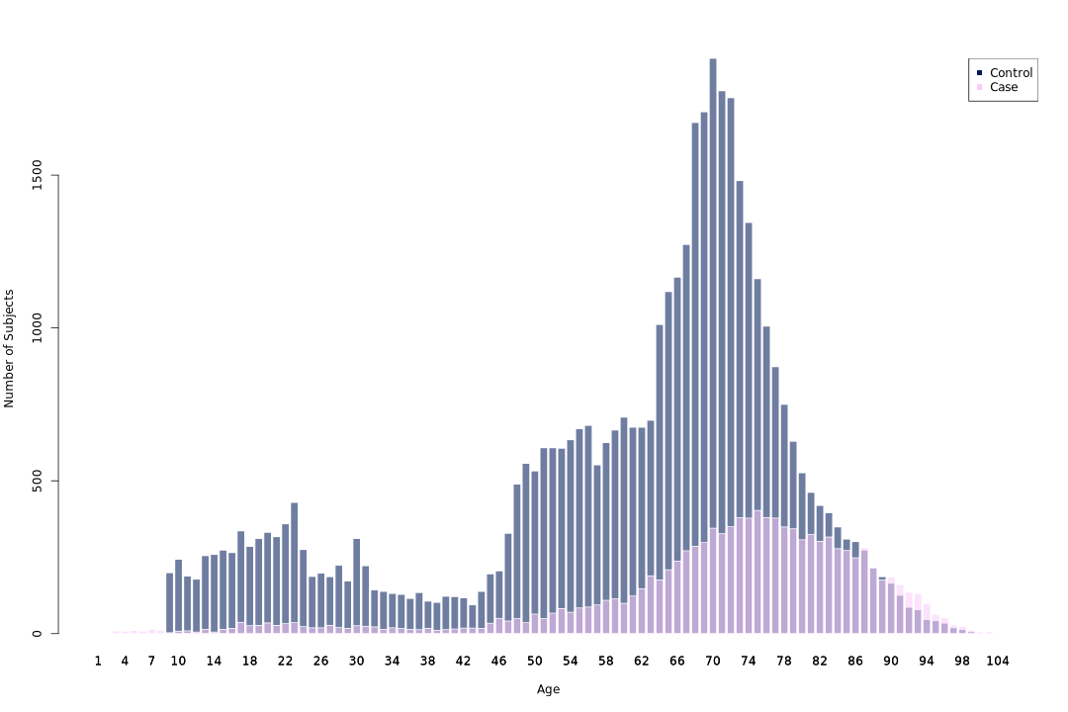

Supplemental Figure S2. Susceptibility Quantile-Quantile (Q-Q) plot.
The Q-Q plot of the genome-wide association study shows a deviation from the expected null distribution, with a genomic inflation factor (λ) of 0.96215, indicating that the observed deviation is unlikely to be due to random noise or population stratification.

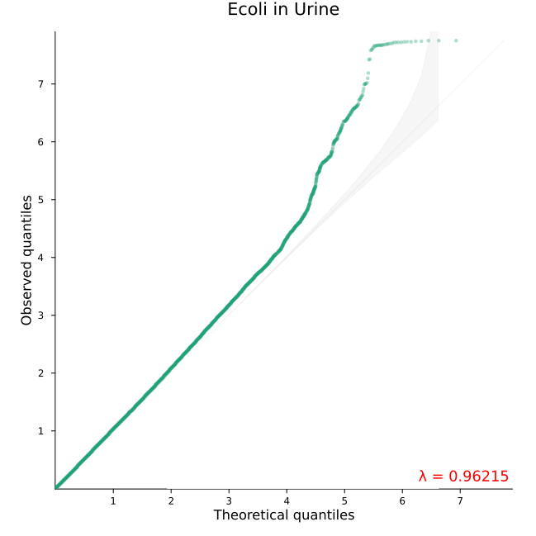

Supplemental Figure S3. Severe infection Quantile-Quantile (Q-Q) plot.
The Q-Q plot of the genome-wide association study shows a deviation from the expected null distribution, with a genomic inflation factor (λ) of 0.98013, indicating that the observed deviation is unlikely to be due to random noise or population stratification.

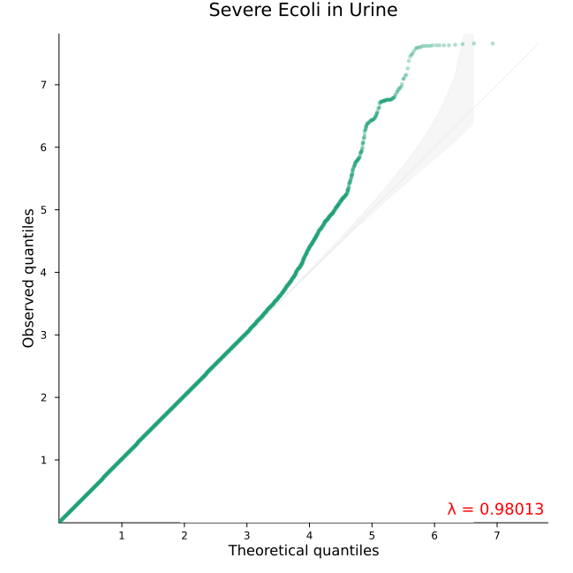

Supplemental Figure S4. Locus Zoom E. coli susceptibility Chr 6 rs9366673 (1.71E-07)

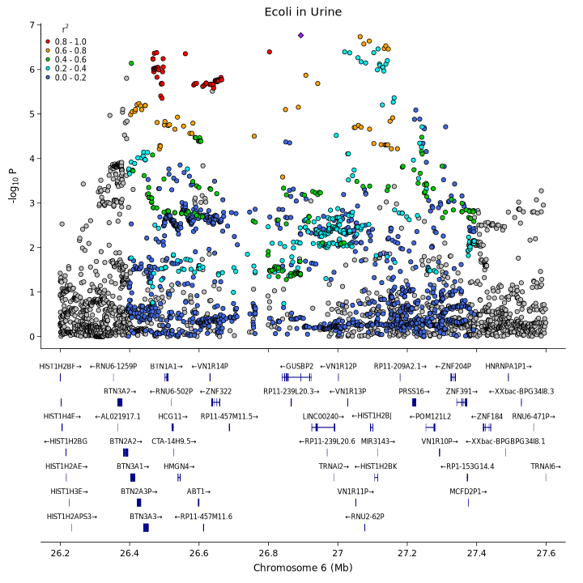
Colocalizes with the genome-wide significant locus for Severe E. coli infection.

Supplemental Figure S5. Locus Zoom E. coli susceptibility Chr 13 rs1287556 (3.93e-7)
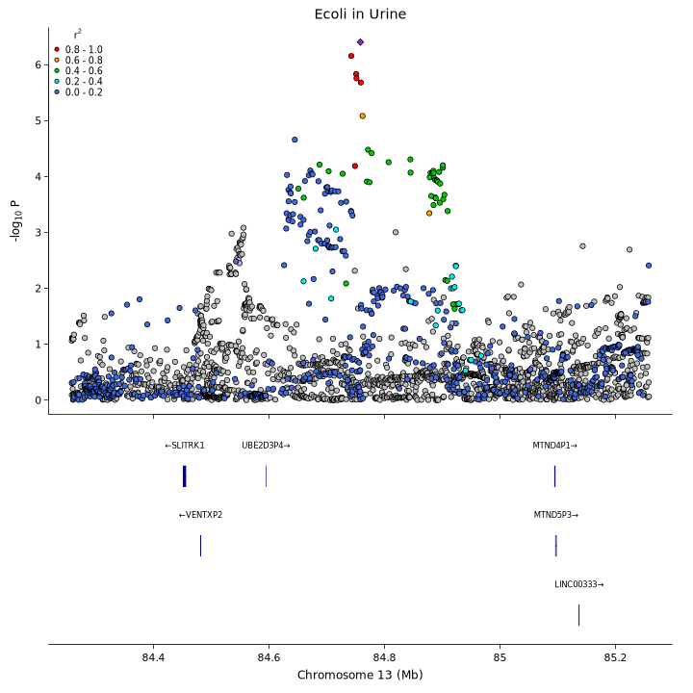

No hits in the GWAS catalog.
No significant eQTLs were found for SNP chr13_81385909_G_C_b38
in tissue All eQTL Tissues

Supplemental Figure S6. Locus Zoom E. coli susceptibility Chr 14 rs72702956 (p=1.86E-07)

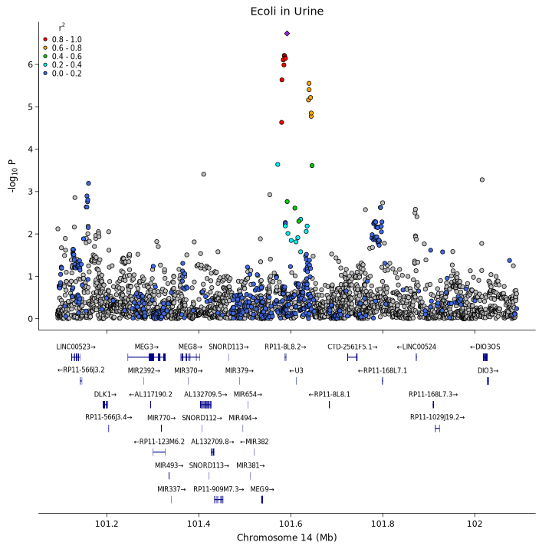

Supplemental Figure S7. Locus Zoom E. coli susceptibility Chr 17 rs147709654 (1.96E-06)

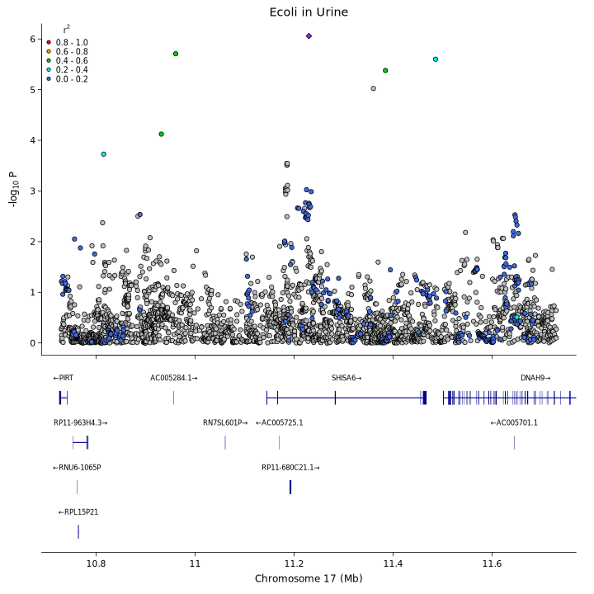

Supplemental Figure S8. Locus Zoom Severe E. coli infection Chr 3 rs62238581 (3.80E-07)

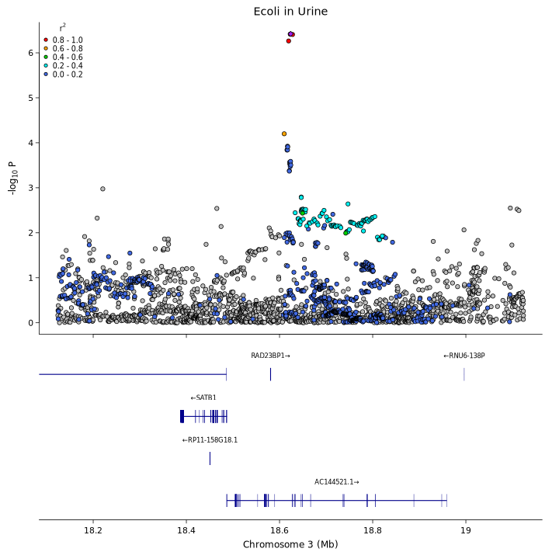

Supplemental Figure S9. Locus Zoom Severe E. coli infection Chr 3 rs113293261 (4.56E-07)

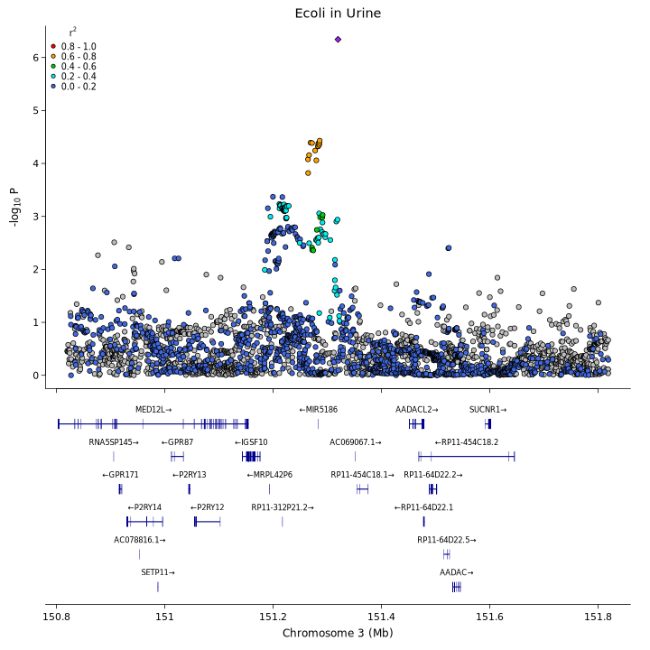

Supplemental Figure S10. Locus Zoom Severe E. coli infection Chr 16 rs7203634 (6.69E-07)

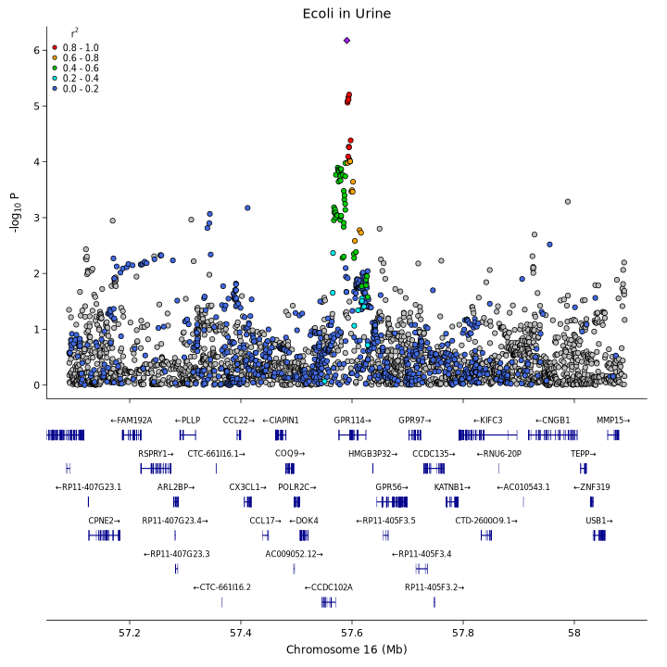

Supplemental Figure S11. Locus Zoom Severe E. coli infection Chr 2 rs74451679 (8.48E-07)

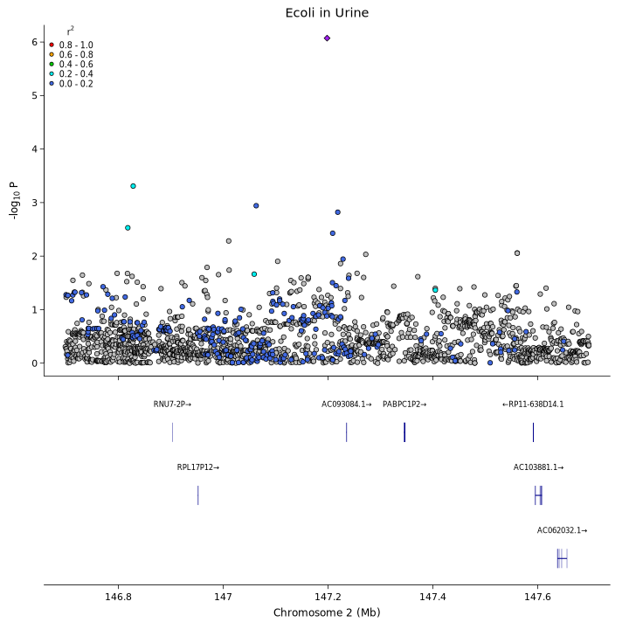

Supplemental Figure S12. ABT1 Blood Protein Atlas
ABT1 blood protein expression from the Protein Atlas show no regulation in the studied infections; COVID-19, Malaria and Tuberculosis (https://www.proteinatlas.org/ENSG00000146109-ABT1/blood, accessed 20251211).

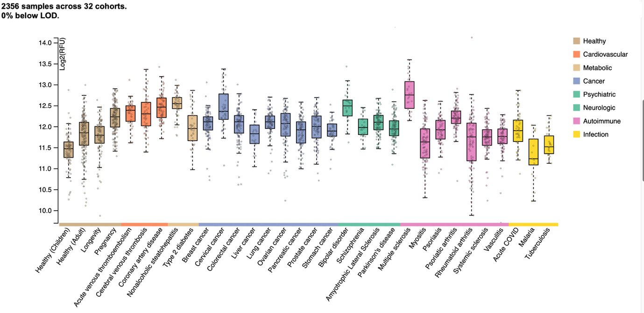

Supplementary data Description of Pre-imputation QC per cohort

Epihealth genotype data QC and imputation
Genotyping of blood samples from participants of Epihealth, [Epidemiology for health](https://www.epihealth.se/For-scientists/Research-Application-/).

Raw data
- Data received from the [SNP&SEQ Technology Platform](https://www.medsci.uu.se/snpseq_technology_platfom/).
- Illumina Infinium Global Screening Array Multiple Disease.
- GRCh37.
- PLINK data: PLUS strand.

Pre-imputation QC settings
Data was genotyped and called in 4 separate batches. QC was performed for each batch:

- Per-sample exclusion filters:
- Missing > 2% or > 5% (for the autosomes and chrX, respectively).
- Non-European ancestry (before HRC imputation).
- Heterozygosity outliers -/+3xIQR from Q1/Q3. Adjusted for ancestry.
- Extreme X-chromosome sex-check outliers based on the F-statistic.
- Per-site exclusion filters:
- Missing > 2%.
- HWE exact p-value < 1e-7 (--hwe midp).
- MAF < 0.5%.
- Not present in 1000G/HRC with matching alleles.
- Allele frequency difference > 0.20 compared with 1000G/HRC.
- Duplicated (first copy kept).
- Not bi-allelic and/or indel.

The per-batch QC:ed data was merged, including sites passing QC in all batches.
Relatedness and PCA were recalculated for the merged data.

Relatedness was tested using the KING algorithm, the maximum unrelated subset (down to 2nd degree) was used.

Imputation
- Software:
- chr1-22,X: Michigan Imputation Server v1.4.1 using Eagle v2.4 + minimac v4.
- Panels:
- HRC v1.1 in in hrc1.1/

COSM-C genotype data
Genotyping of ~4.7k men and ~2.8k women of the [Cohort of Swedish Men Clinical study] (https://www.simpler4health.se/researchers/cohorts/cosmc/).

Raw data
- Data received from [Eurofins](https://www.eurofinsgenomics.eu/en/genotyping-gene-expression/).
- pilot: blood and saliva triplicates to evaluate genotyping concordance.
- b1: first batch of genotyping of the blood samples.
- Illumina Infinium Global Screening Array version 3 (GSAv3).
- GRCh37.
- PLINK data: Forward strand.

Pre-imputation QC settings
- Per-sample exclusion filters:
- Missing > 2% or > 5% (for the autosomes and chrX, respectively).
- Non-European ancestry.
- Heterozygosity outliers -/+3*IQR from Q1/Q3.
- Extreme X-chromosome sex-check outliers based on the F-statistic.
- Per-site exclusion filters:
- Missing > 2%.
- HWE exact p-value < 1e-7 (--hwe midp).
- MAC < 20.
- Not present in 1000G/HRC with matching alleles.
- Allele frequency difference > 0.15 compared with 1000G/HRC.
- Duplicated (first copy kept).
- Not bi-allelic and/or indel.

533,425 sites and 6,903 samples

Relatedness was tested using the KING algorithm, the maximum unrelated subset (down to 2nd degree) was used.

Imputation
- Software:
- chr1-22,X: Michigan Imputation Server v1.2.4 using Eagle v2.4 + minimac v4.
- Panels:
- HRC v1.1 in in hrc1.1/
- Only sites with MAC >= 1 included.

SIMPLER genotype data
Genotyping of saliva samples from ~33k participants of SIMPLER, [Swedish Infrastructure for Medical Population-based Life-course and Environmental Research](https://www.simpler4health.se/researchers/cohorts/).

Raw data
- Data received from [Eurofins] (https://www.eurofinsgenomics.eu/en/genotyping-gene-expression/).
- Illumina Infinium Global Screening Array version 3 (GSAv3).
- GRCh37.
- PLINK data: Forward strand.

Pre-imputation QC settings
Data was genotyped and called in five separate batches. QC was performed for each batch:

- Per-sample exclusion filters:
- Missing > 2% or > 5% (for the autosomes and chrX, respectively).
- Non-European ancestry.
- Heterozygosity outliers -/+3xIQR from Q1/Q3. Adjusted for ancestry.
- Extreme X-chromosome sex-check outliers based on the F-statistic.
- Per-site exclusion filters:
- Missing > 2%.
- HWE exact p-value < 1e-7 (--hwe midp).
- MAF < 0.5%.
- Not present in 1000G/HRC with matching alleles.
- Allele frequency difference > 0.20 compared with 1000G/HRC.
- Duplicated (first copy kept).
- Not bi-allelic and/or indel.

The per-batch QC:ed data was merged, including sites passing QC in all batches.
Relatedness and PCA were recalculated for the merged data.

Relatedness was tested using the KING algorithm, the maximum unrelated subset (down to 2nd degree) was used.

Imputation:
- Software:
- chr1-22,X: Michigan Imputation Server v1.5.7 using Eagle v2.4 + minimac v4.
- Panels:
- HRC v1.1 in in hrc1.1/
- Only sites with MAC >= 1 included.

SMCC genotype data
Genotyping of ~5k women of the [Swedish Mammography Cohort Clinical study] (http://www.simpler4health.se/researchers/cohorts/smcc/).
Raw data
- Data received from the [SNP&SEQ Technology Platform](https://www.medsci.uu.se/snpseq_technology_platfom/).
- Illumina Infinium Global Screening Array Multiple Disease version 1 (GSA-MD_v1).
Pre-imputation QC settings
- Per-sample exclusion filters:
- Missing > 2% (calculated separately for the autosomes and chrX).
- Non-European ancestry.
- Heterozygosity outliers -/+3*IQR from Q1/Q3.
- Extreme X-chromosome sex-check outliers based on the F-statistic.
- Per-site exclusion filters:
- Missing > 2%.
- HWE exact p-value < 1e-7 (--hwe midp).
- MAC < 20.
- Not present in 1000G/HRC with matching alleles.
- Allele frequency difference > 0.2 compared with 1000G/HRC.
- Duplicated (first copy kept).
- Not bi-allelic and/or indel.

535,329 sites and 4,724 samples

Relatedness was tested using the KING algorithm, the maximum unrelated subset (down to 2nd degree) was used.

Imputation:
- Software:
- chr1-22: Michigan Imputation Server v1.0.4 using Eagle v2.3 + minimac v3.
- chrX: Michigan Imputation Server v1.2.4 using Eagle v2.4 + minimac v4.
- Panels:
- HRC v1.1 in in hrc1.1/
- Only sites with MAC >= 1 included.

