Generational Differences in Perceptions of Family Functioning, Parenting, and Cyberbullying Victimization in Arab Families
This document contains the supplementary tables and analyses referenced in the main manuscript.
Appendix 1
Table S1. Items measuring barriers to reporting cyberbullying to parents among parents
Item No. | Item code | Item Description
1 | Ashamed or embarrassed | Ashamed or embarrassed to tell Me
2 | Handles it themselves | My child handles it themselves
3 | Afraid of punishment | Afraid of being punished by bully if they tell
4 | Doesn’t bother enough | Sometimes it Doesn’t bother them enough to tell
5 | Tells when severe | They only told Me about it when bullying became severe
6 | Doesn’t think I can help | My child Doesn’t think I can understand or help
7 | Quits telling me | It happens so much my child quit telling Me about it
8 | Kids can adjust | Bullying is common/Kids adjust to it
9 | Not sure why | I’m not sure why they Don’t tell Me
10 | Doesn’t recognize it | They Don’t always recognize They’ve been cyberbullied

Table S2. Items measuring barriers to reporting cyberbullying to parents among adolescents
Item No. | Item code | Item Description
1 | Parents would not believe | I don’t think my parent/guardian would understand or believe me
2 | Parents Don’t know to help | I don’t think my parent/guardian would know how to stop it
3 | Could be my fault | I could get myself into trouble because I could also be at fault
4 | Might get into trouble | I could get myself into trouble, even if I had done nothing wrong
5 | Cyberbully might retaliate | The cyberbully could get back at me and make things even worse
6 | Students would make fun | Other students could make fun of me
7 | Parents restrict access | My parents could find out and might restrict my access to the Internet or other technologies
8 | Deal with it alone | I need to learn to deal with cyberbullying by myself
9 | No big deal / ignore it | Cyberbullying is no big deal. People should just ignore it

Appendix 2
Table S3. Simple effects of cyberbullying victimization and willingness to report by gender and age.
 |  |  |  |  |  |  |  | 95% CI
 | Variable |  | B | SE | Wald z | p | OR | L | U
CVictimization | Gender | Female | 0.31 | 0.46 | 0.67 | 0.502 | 1.36 | 0.55 | 3.33
CVictimization |  | Male | -1.91 | 0.47 | -4.06 | <.001 | 0.15 | 0.06 | 0.37
CVictimization | Age | 13 | -1.74 | 0.59 | -2.94 | 0.003 | 0.18 | 0.05 | 0.56
CVictimization |  | 14 | -1.15 | 0.54 | -2.12 | 0.034 | 0.32 | 0.11 | 0.92
CVictimization |  | 15 | -0.83 | 0.60 | -1.40 | 0.163 | 0.44 | 0.14 | 1.40
CVictimization |  | 16 | 0.51 | 0.78 | 0.65 | 0.516 | 1.66 | 0.36 | 7.67
Report to parent | Gender | Female | -0.03 | 0.08 | -0.33 | 0.739 | 0.97 | 0.83 | 1.15
Report to parent |  | Male | 0.70 | 0.10 | 7.23 | <.001 | 2.02 | 1.67 | 2.45
Report to parent | Age | 13 | 0.16 | 0.12 | 1.31 | 0.191 | 1.17 | 0.92 | 1.49
Report to parent |  | 14 | 0.29 | 0.10 | 2.87 | 0.004 | 1.34 | 1.10 | 1.63
Report to parent |  | 15 | 0.28 | 0.11 | 2.53 | 0.011 | 1.32 | 1.07 | 1.65
Report to parent |  | 16 | 0.62 | 0.17 | 3.62 | <.001 | 1.86 | 1.33 | 2.61

Table S4. Pearson’s correlation between the multivariate multiple regression variables
Variable | 1 | 2 | 3 | 4
1. Cyberbullying Frequency | __ | -0.044 | -0.279*** | -0.007
2. Report to Parent | 0.086 | __ | 0.238*** | 0.280***
3. Family Functioning | -0.168*** | 0.362*** | __ | 0.368***
4. Positive Parenting | -0.040 | 0.255*** | 0.393*** | __
Note. * p < .05, * p < .01, ** p < .001 . Parent dataset is presented below the diagonal, and adolescent dataset is presented above the diagonal.

Appendix 3

Table S5. Assumptions check values of regression analysis
Parents |  | Adolescents
Predictors: FAD General Functioning,  APQ Positive Parenting  Outcome: Cyberbullying frequency | Durbin–Watson Statistic: 1.516  Collinearity Statistics - VIF: 1.183  Tolerance: 0.846  Standardized Residuals: –1.17 to 3.16 | Predictors: FAD General Functioning,  APQ Positive Parenting  Outcome: Cyberbullying frequency | Durbin–Watson Statistic: 1.354  Collinearity Statistics - VIF: 1.1978  Tolerance: 0.8349  Standardized Residuals: –3.34 to 3.34
Predictors: FAD General Functioning,  APQ Positive Parenting  Outcome: Report to parent | Durbin–Watson Statistic: 1.265  Collinearity Statistics-VIF: 1.183  Tolerance: 0.846  Standardized Residuals: –3.25 to 2.27 | Predictors: FAD General Functioning,  APQ Positive Parenting  Outcome: Report to parent | Durbin–Watson Statistic: 1.773  Collinearity Statistics-VIF: 1.157  Tolerance: 0.864  Standardized Residuals: –2.41 to 2.04

Table S6. Assumptions check values of LMM analysis
Parents | Adolescents
Q-Q Plot  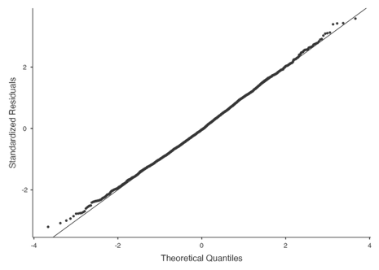 | Q-Q Plot  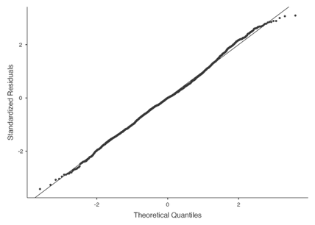
Residual histogram  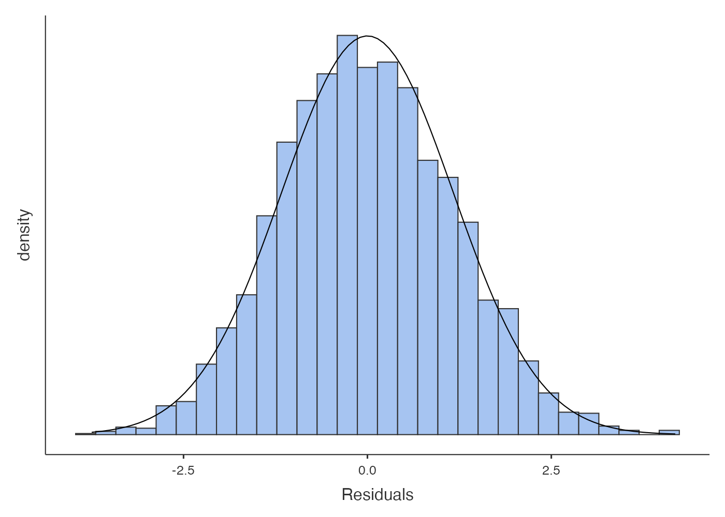 | Residual histogram  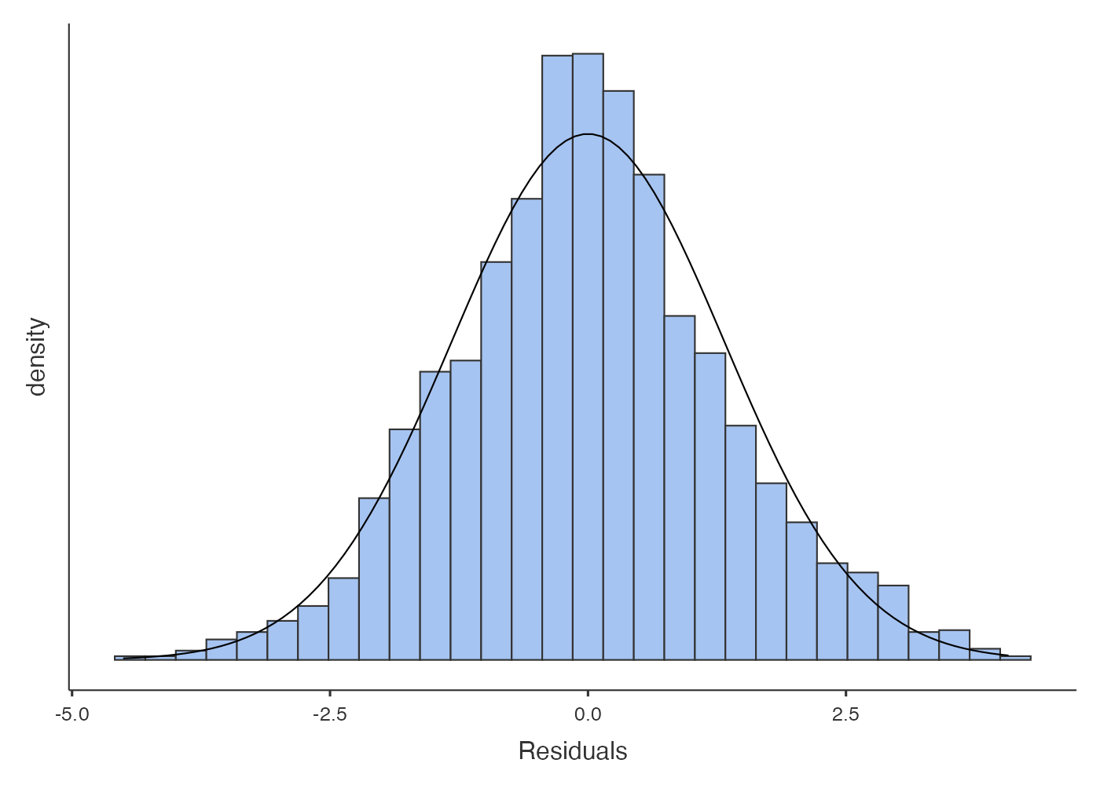
Residual-Predicted Scatterplot  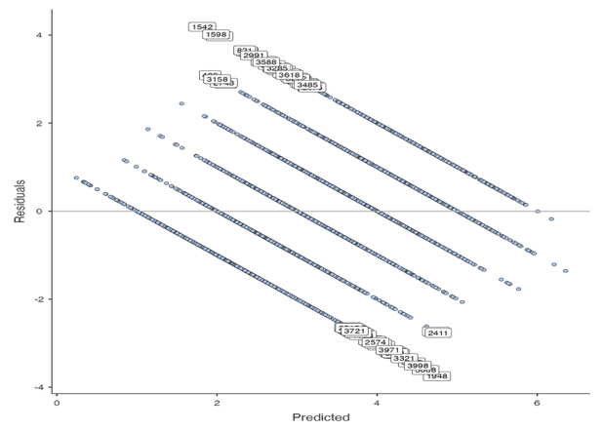 | Residual-Predicted Scatterplot  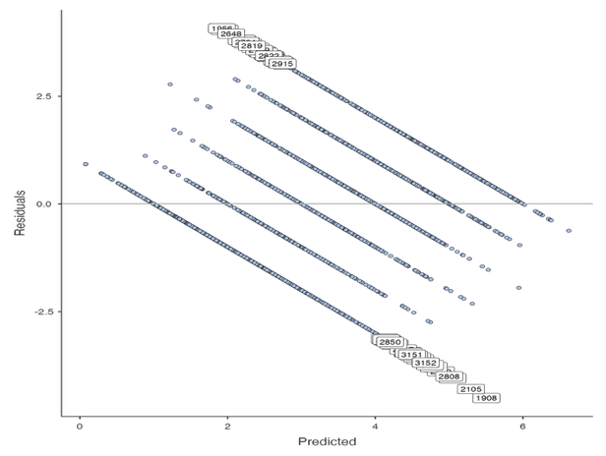
Random coefficients histogram  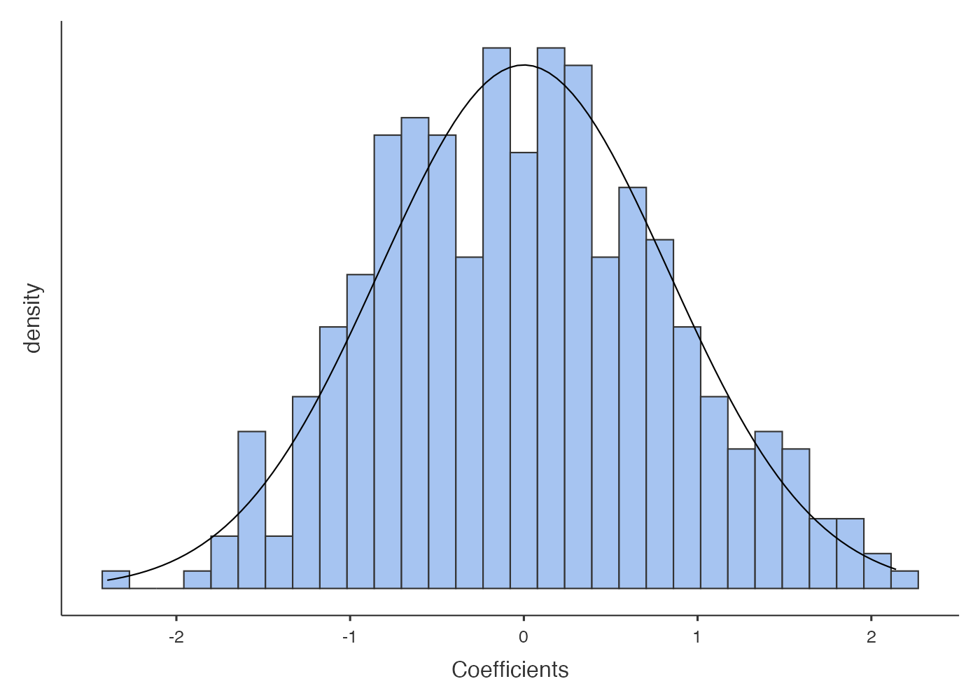 | Random coefficients histogram

