Table S1. Assumptions check values of regression analysis
Parents |  | Adolescents
Predictors: FAD General Functioning,  APQ Positive Parenting  Outcome: Cyberbullying frequency | Durbin–Watson Statistic: 1.516  Collinearity Statistics - VIF: 1.183  Tolerance: 0.846  Standardized Residuals: –1.17 to 3.16 | Predictors: FAD General Functioning,  APQ Positive Parenting  Outcome: Cyberbullying frequency | Durbin–Watson Statistic: 1.354  Collinearity Statistics - VIF: 1.1978  Tolerance: 0.8349  Standardized Residuals: –3.34 to 3.34
Predictors: FAD General Functioning,  APQ Positive Parenting  Outcome: Report to parent | Durbin–Watson Statistic: 1.265  Collinearity Statistics-VIF: 1.183  Tolerance: 0.846  Standardized Residuals: –3.25 to 2.27 | Predictors: FAD General Functioning,  APQ Positive Parenting  Outcome: Report to parent | Durbin–Watson Statistic: 1.773  Collinearity Statistics-VIF: 1.157  Tolerance: 0.864  Standardized Residuals: –2.41 to 2.04

Table S2. Assumptions check values of LMM analysis
Parents | Adolescents
Q-Q Plot  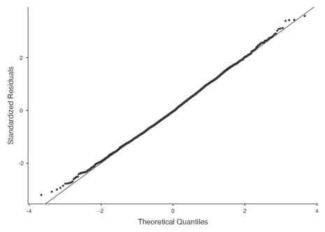 | Q-Q Plot  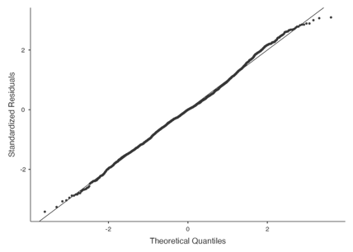
Residual histogram  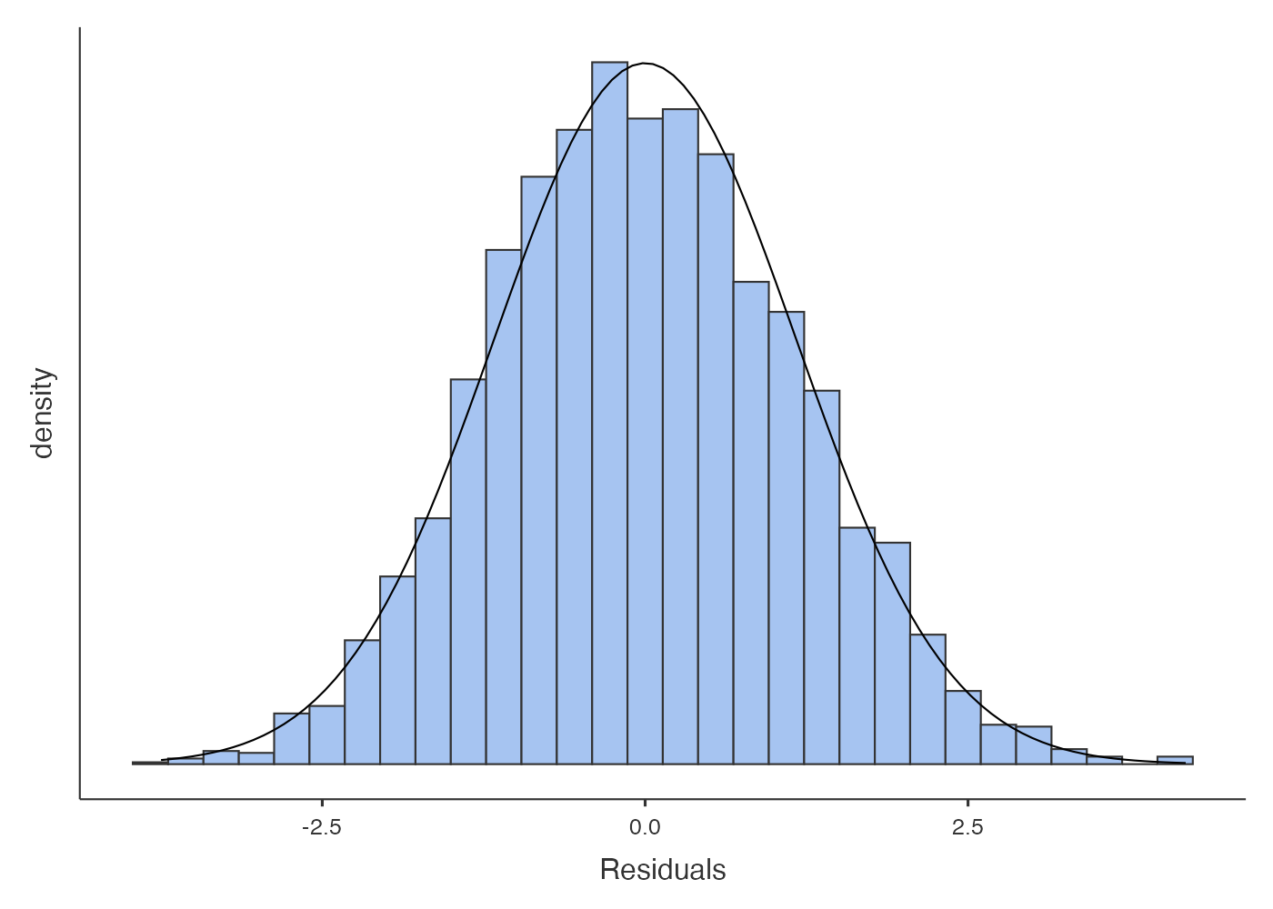 | Residual histogram  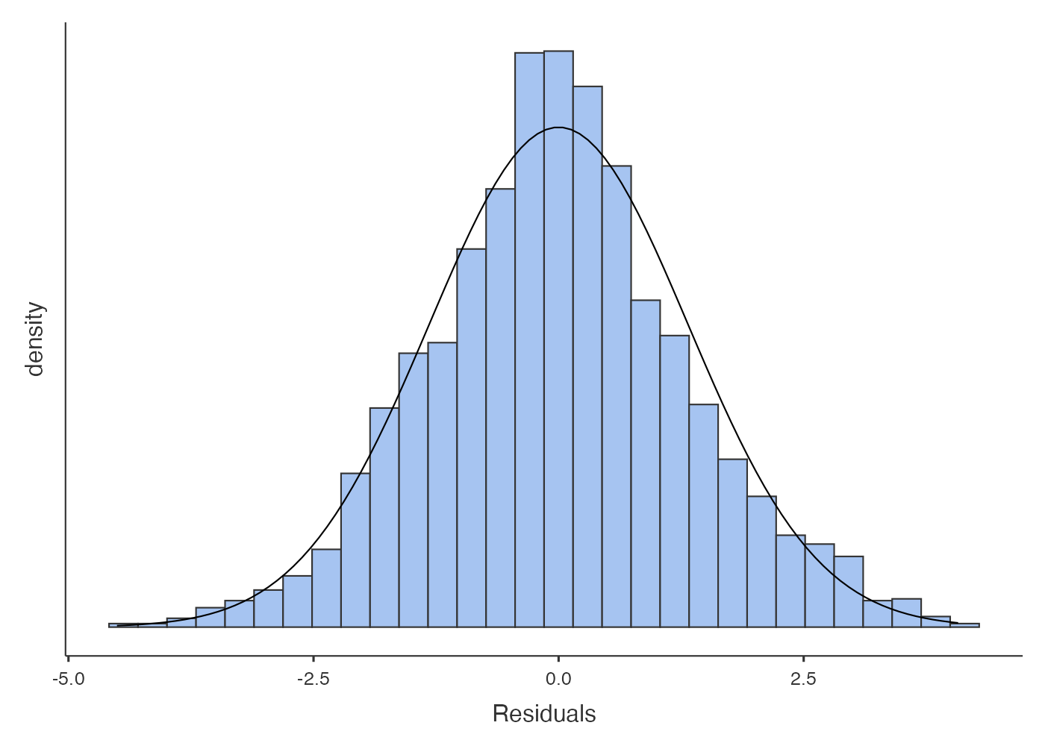

Residual-Predicted Scatterplot  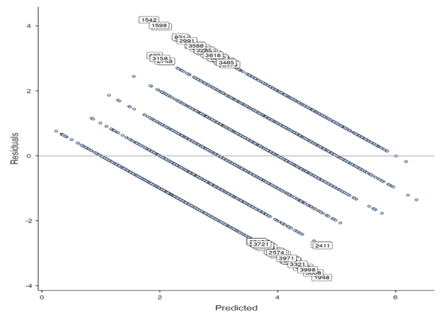 | Residual-Predicted Scatterplot  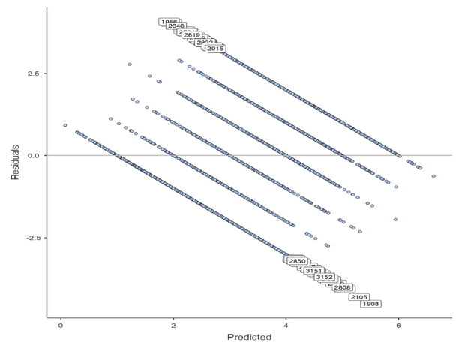
Random coefficients histogram  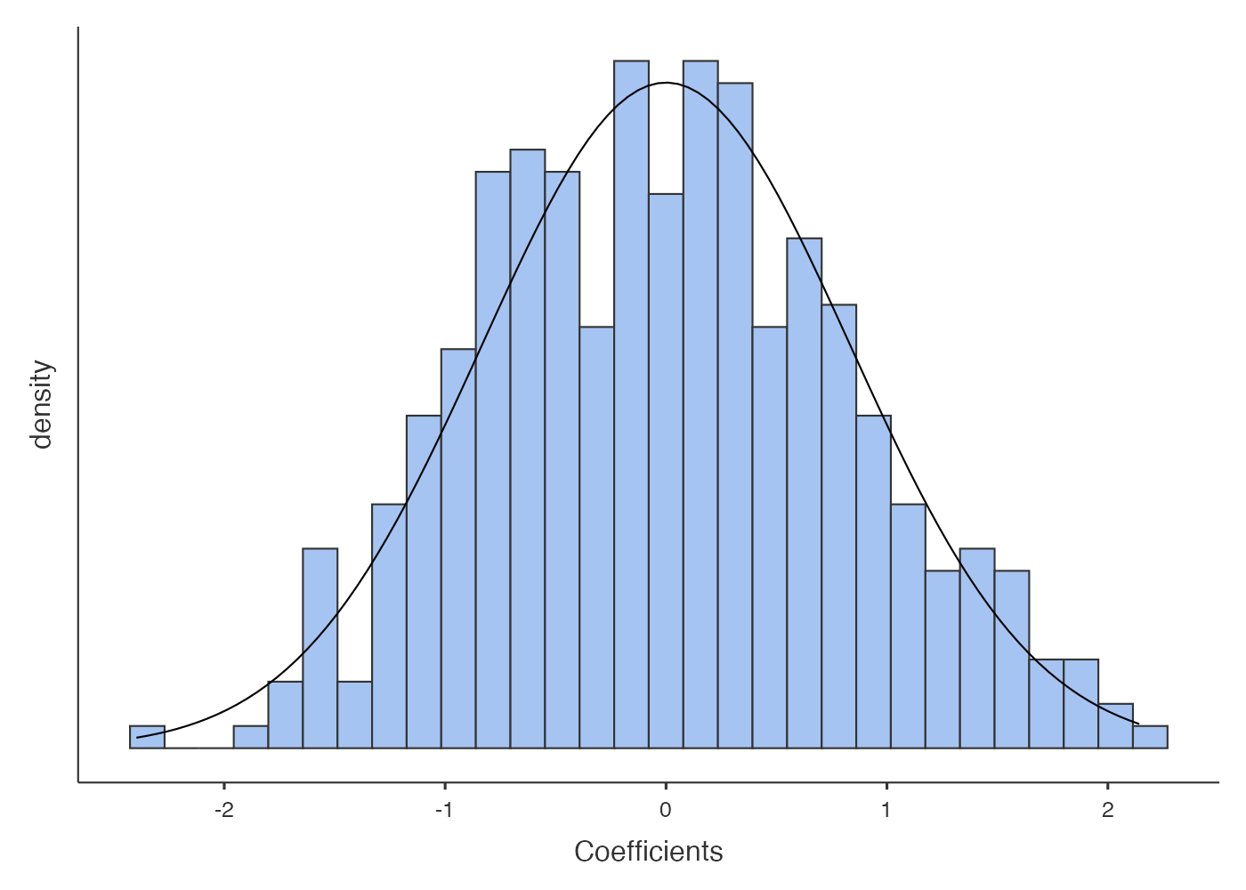 | Random coefficients histogram

