Comprehensive Analysis of Maternal and Infant Microbiome Profiles: Maternal Microbial Transmission Shapes Offspring Somatic Growth Trajectory

Supplementary Note

We employed two strategies for this benchmarking between 150bp and 100bp: (1) using external 150 bp FASTQ data to compare against trimmed 100 bp FASTQ reads, and (2) resequencing our 100 bp sample DNA with 150 bp paired-end sequencing on DNBSEQ platform

(1) Using external 150 bp FASTQ data to compare against trimmed 100 bp FASTQ reads
Specifically, we randomly selected eight samples from the well-known mother–infant microbiome cohort study, the Health and Early-Life Microbiota (HELMi) project (PRJEB52774). According to Dubois et al., these paired-end runs were sequenced at 2 × 150 bp.

Our benchmarking analysis proceeded as follows:

Quality control (QC):
We performed QC using the identical pipeline and computational environment described in the published workflow (https://github.com/SegataLab/preprocessing). The only modifications involved reference databases, as our study used the Homo sapiens hg38 reference genome and the Illumina PhiX174 spike-in sequence
(https://www.ncbi.nlm.nih.gov/datasets/genome/GCA_000819615.1/).

Read trimming:
Post-QC FASTQ files were trimmed to 100 bp to simulate sequencing with shorter read lengths.

Taxonomic profiling:
We applied MetaPhlAn4 annotation exactly as in our primary analysis, separately for original post-QC FASTQ files and trimmed FASTQ files.

The benchmarking results are provided in the supplementary revision. In brief, we first compared the total number of identified before and after trimming. Across all eight matched samples, more than 90% of strain-level clade identified from the trimmed 100 bp FASTQ files were also recovered from the original 150 bp FASTQ files. At the same time, more than 99.6% of strain-level clade identified from the original 150 bp FASTQ files were also recovered from the trimmed 100 bp FASTQ files. Only one strain (from ERR9752131) was uniquely identified in the original 150 bp FASTQ files (Figure 1).
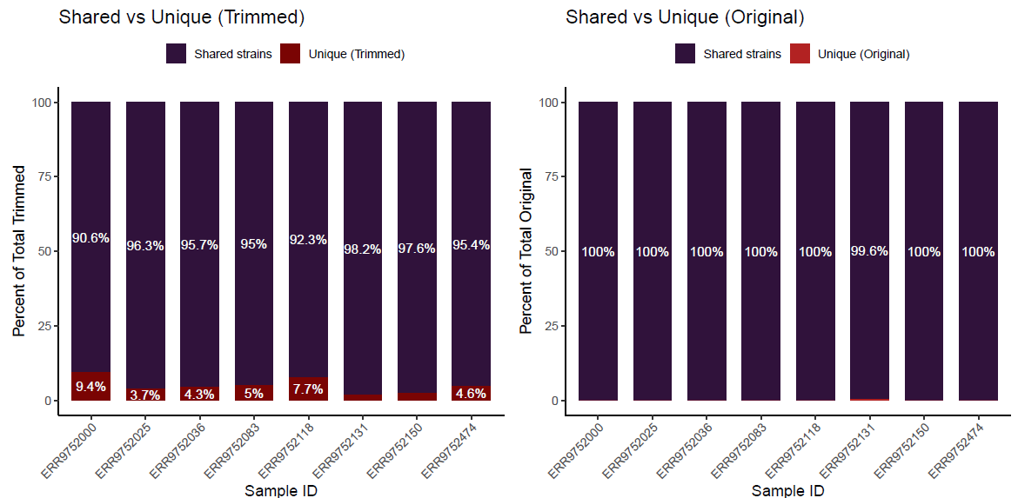
Figure 1 Strain-level clade identified before and after trimming

Furthermore, strain-level clade uniquely detected in the trimmed 100 bp data were of extremely low abundance: even the most abundant strain had a relative abundance <0.01 (Figure 2). Given that our downstream differential abundance analysis using MaAsLin2 applied a minimum abundance threshold of 0.01, these differences are not expected to influence our statistical results.

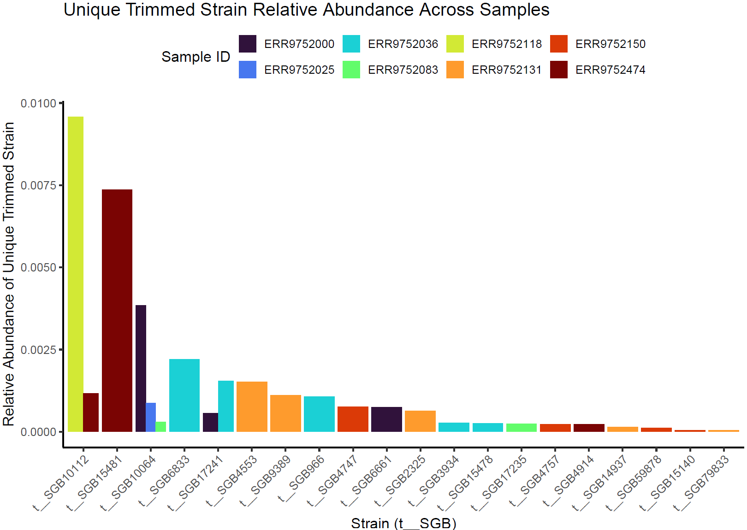
Figure 2 Relative abundance of strain-level clade identified uniquely in the trimming FASTQ.

We further compared the overlap in strain profiles between original and trimmed data. For strain-level clade detected in both datasets, the distribution of abundance differences per sample included both positive and negative values, with most absolute differences <0.3 (Figure 3). To evaluate significance, we restricted the analysis to strains with ≥3 observations and selected the top 10 most variable strain-level clade (based on median differences across samples). Wilcoxon tests revealed no significant differences in relative abundance between original (150 bp) and trimmed (100 bp) datasets (Figure 4).
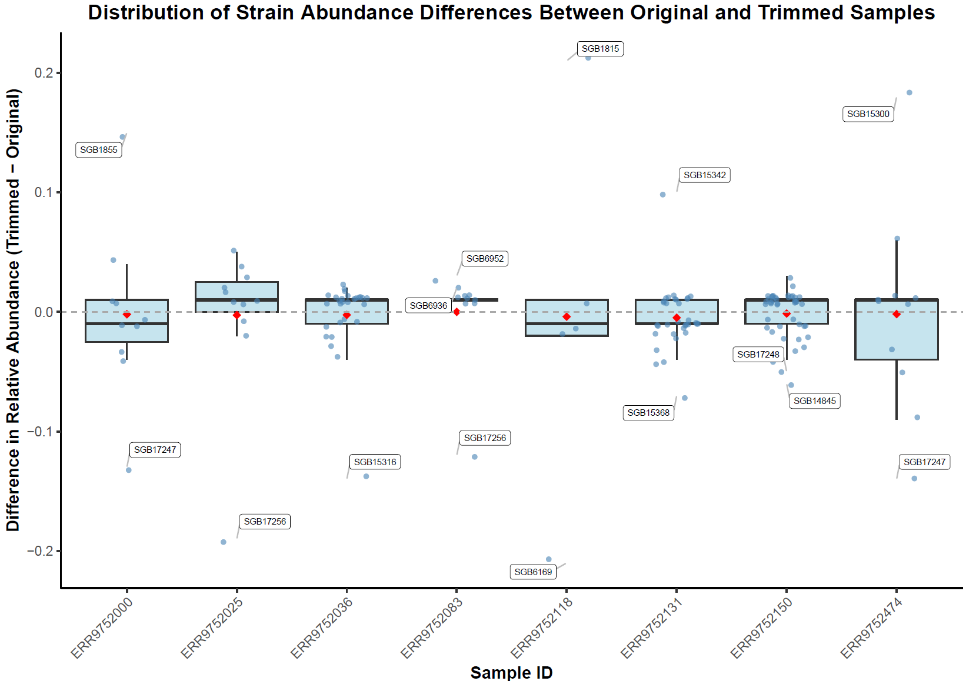
Figure 3 Strain-level clade abundance differences per sample
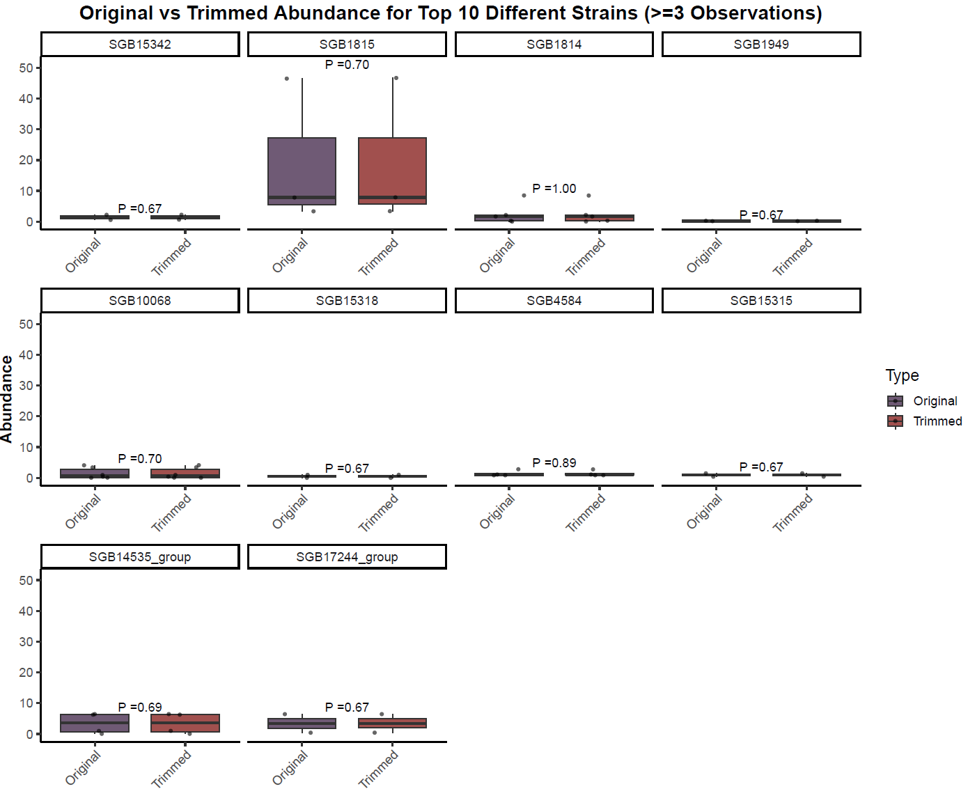
Figure 4 Statistical analysis for the top 10 most variable strain-level clade

(2) Resequencing our 100 bp sample DNA with 150 bp paired-end sequencing.
We selected previously collected samples with sufficient DNA library material for resequencing, using the same experimental procedures except for generating 150 bp paired-end reads. All downstream analyses were performed identically to those described for the 100 bp paired-end data in the manuscript.

As described above, we first compared the total number of strain-level clade identified from the original 100 bp FASTQ files and the re-sequenced 150 bp FASTQ files. Across all eight matched samples, more than 90% of the strain-level clade detected in the trimmed 100 bp datasets were also recovered from the corresponding 150 bp datasets. The overlap was similarly above 90% when considering strain-level clade unique to the 100 bp data, although the absolute number of 100 bp–specific strains was higher (Figure 5).
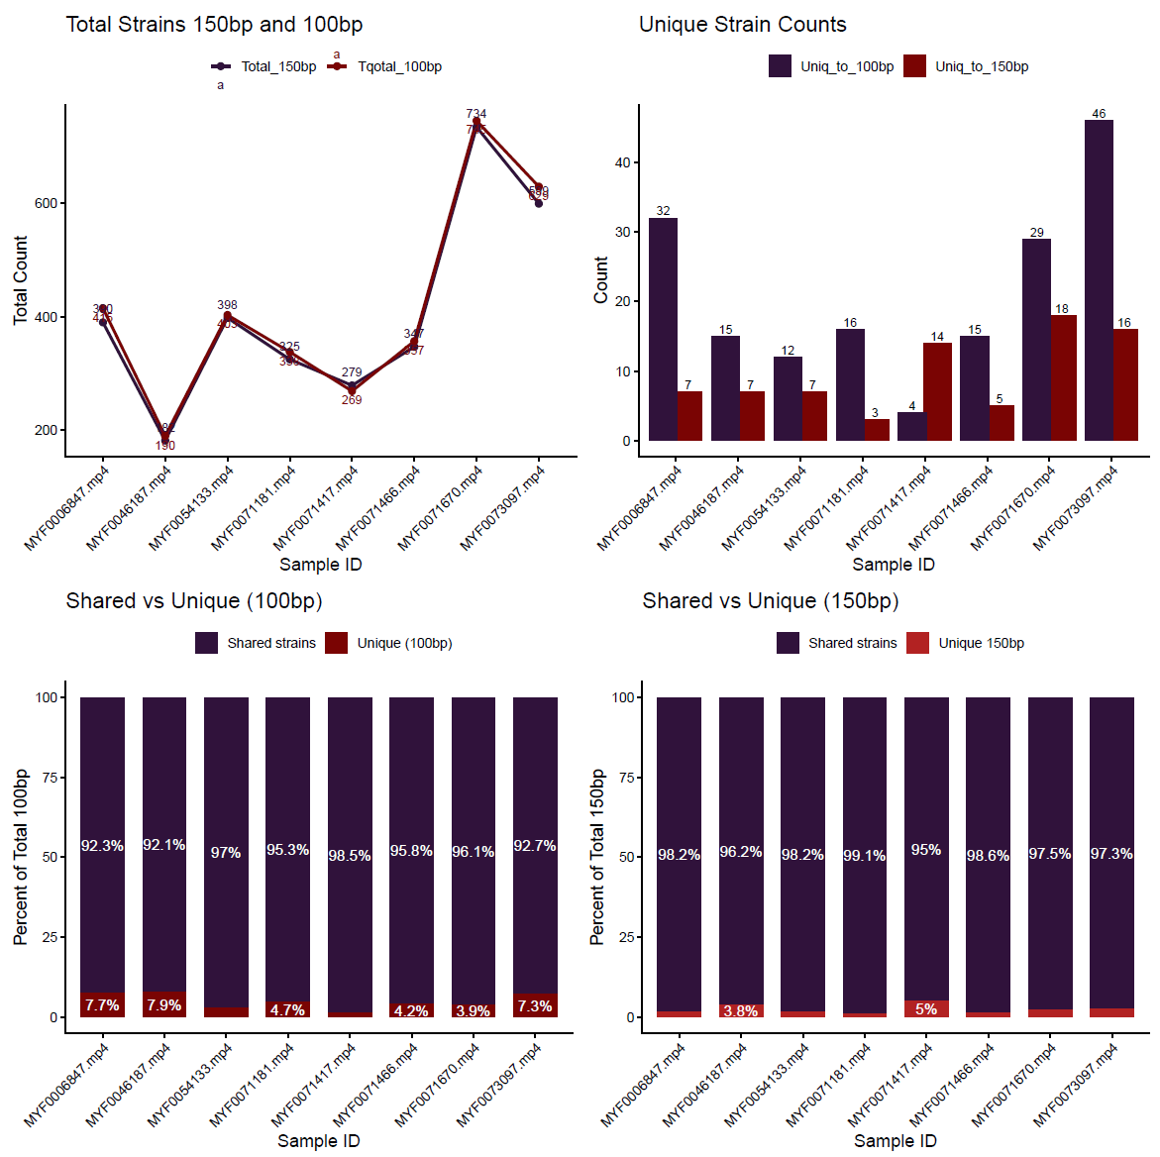
Figure 5 Strain-level clade identified in the 100bp sequencing and 150 sequencing

Likewise, we evaluate the strain-level clade uniquely detected in the trimmed 100 bp data, they were of very low abundance: the most abundant strain had a relative abundance of 0.01168 for SGB1855 (Figure 6). Given that our downstream differential abundance analysis using MaAsLin2 applied a minimum abundance threshold of 0.01, these differences are not expected to influence greatly to our statistical results.
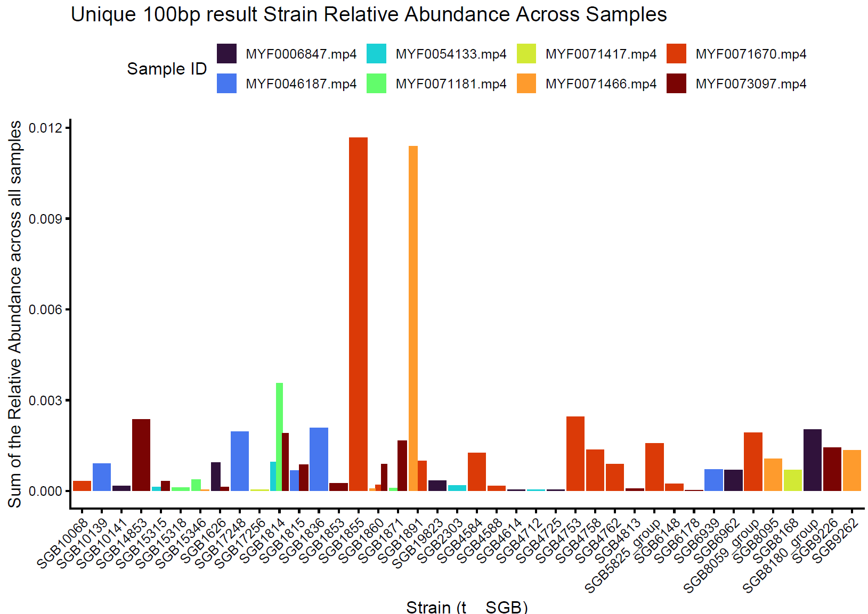
Figure 6 Relative abundance of strain-level clade identified uniquely in the 100bp sequencing

We further compared the overlap in strain-level clade between 150bp and 100bp data. For strain-level clade detected in both datasets, the distribution of abundance differences per sample included both positive and negative values, with most absolute differences <3 (Figure 7). To evaluate whether these differences are significant, we restricted the analysis to strain-level clade with ≥3 observations and selected the top 10 most variable strains (based on median differences across samples). Wilcoxon tests revealed no significant differences in relative abundance between 150 bp and 100 bp datasets (Figure 8).
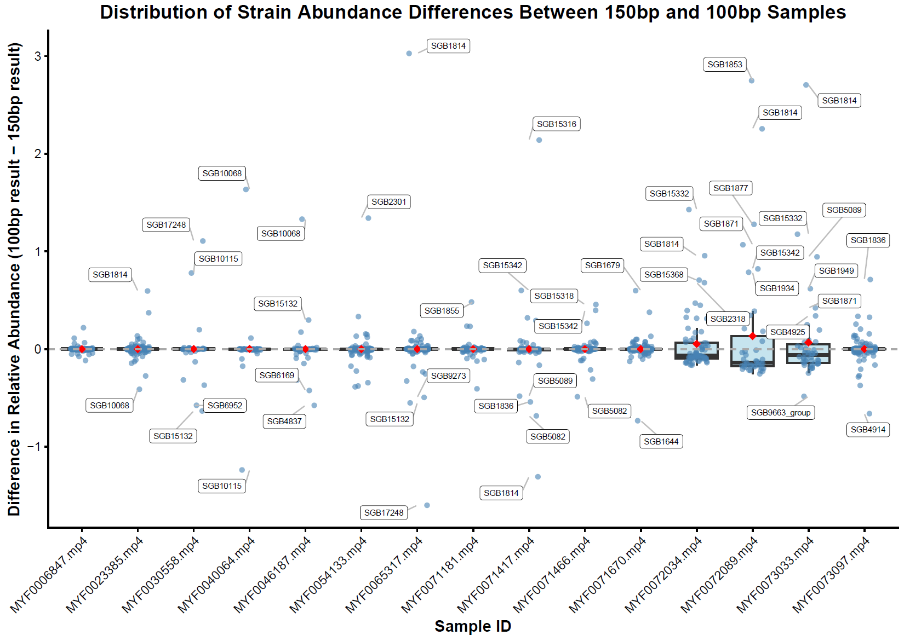
Figure 7 Strain-level clade abundance differences per sample in the 100bp sequencing and 150 sequencing

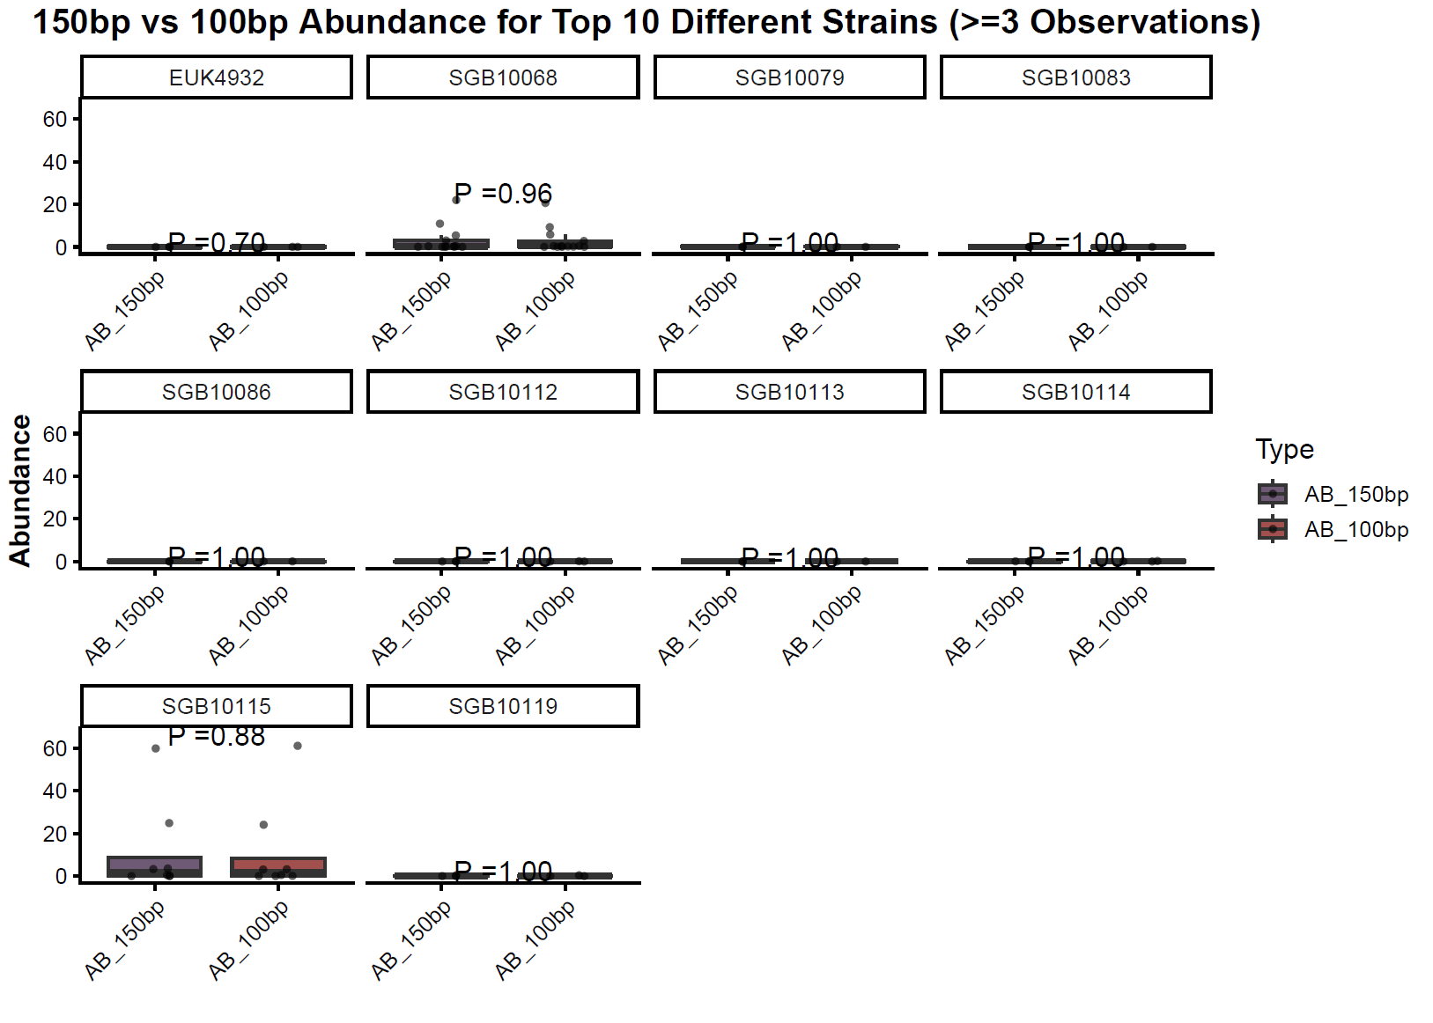
Figure 8 Statistical analysis for the top 10 most variable strain-level clade in the 100bp sequencing and 150 sequencing
In conclusion, although 100 bp can result in some of unique strain calls (more noise), these taxa of very low relative abundance and fall below the thresholds applied in our statistical analyses. For strains consistently detected in both FASTQ files, relative abundance differences were minimal and statistically insignificant. Together, these results indicate that the use of 100 bp reads does not materially affect the robustness of our conclusions.

